Supplementary Material
The pathogenic role of inflammation in idiopathic intracranial hypertension: an assessment based on genetic evidence

Table S1. The association between inflammatory regulatory factors and idiopathic intracranial hypertension

Sheet 1: Characteristics of the genetic instrument variables for the cytokines in the Mendelian randomization study at level P < 5 × 10^{–6}.
Sheet 2: MR analysis of 41 cytokines and IIH risk.
Sheet 3: Heterogeneity analysis of 41 cytokines and IIH risk.
Sheet 4: MR-Egger intercept analysis of the association between 41 cytokines and IIH risk.
Sheet 5: MR-PRESSO analysis of the association between 41 cytokines and IIH risk.

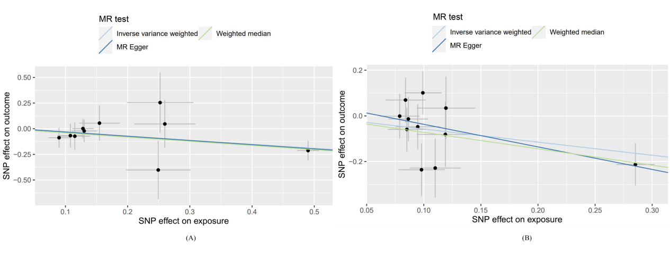
Figure S1. Scatter plots of MR analyses for VEGF and IL-10 in IIH.
Footnotes: In the graphical representation, individual inverse variance (IV) associations with cytokine risk are depicted as black dots, while individual IV associations with IIH are also represented. Vertical and horizontal lines denote the 95% confidence intervals (CI) of the odds ratio for each IV. The slope of the lines reflects the estimated causal effect determined through MR methods.
(A) Scatter plots for the exposure of VEGF.
(B) Scatter plots for the exposure of IL-10.

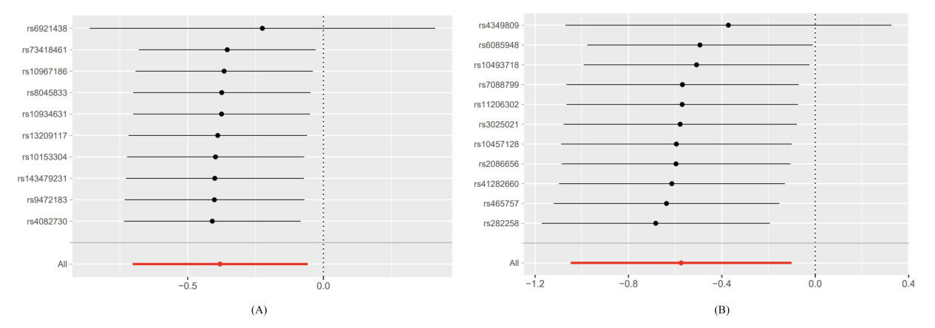
Figure S2. Leave-one-out plots of MR analyses for VEGF and IL-10 in IIH.
Footnotes: Each black dot represents the estimated effect size obtained by excluding a particular individual. Accompanying each dot, a horizontal line is typically depicted, representing the 95% confidence interval (CI) of the estimated effect size. The distribution and pattern of these dots, along with the corresponding confidence intervals, allow for an assessment of the stability of the overall estimated effect when individual participants are sequentially excluded from the analysis.
(A) Leave-one-out plots for the exposure of VEGF.
(B) Leave-one-out plots for the exposure of IL-10.

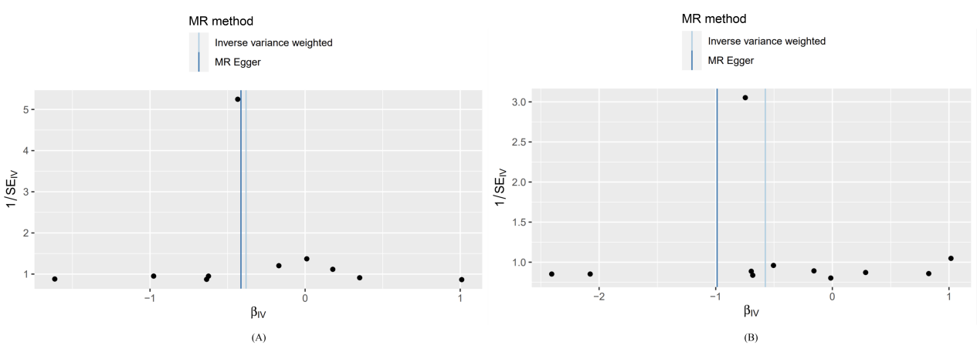
Figure S3. Funnel plots of MR analyses for VEGF and IL-10 in IIH.
Footnotes: The funnel plots illustrate the IVW estimate for each cytokine SNP in relation to IIH, plotted against the reciprocal of the standard error (1/SE).
(A) Funnel plots for the exposure of VEGF.
(B) Funnel plots for the exposure of IL-10.

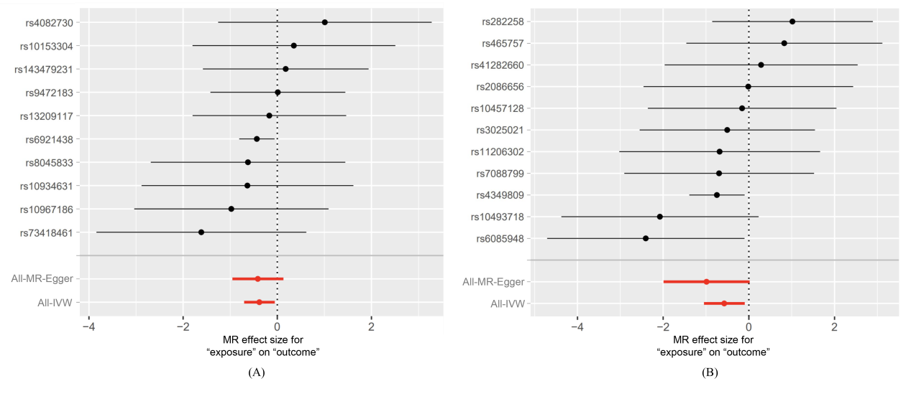
Figure S4. Forest plots of MR analyses for VEGF and IL-10 in IIH.
Footnotes: The forest plot displays the IVW estimates for each cytokine SNP in relation to IIH, along with the overall IVW estimate and MR-Egger estimate.
(A) Forest plots for the exposure of VEGF.
(B) Forest plots for the exposure of IL-10.

