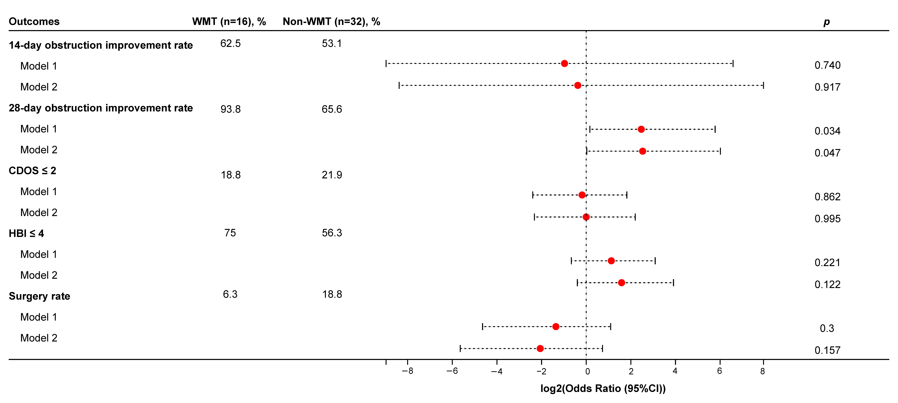
Supplementary Figure 2. Post-matching Firth logistic regression. Model 1: unadjusted. Model 2: adjusted for “Duration” and “Fistula”.

