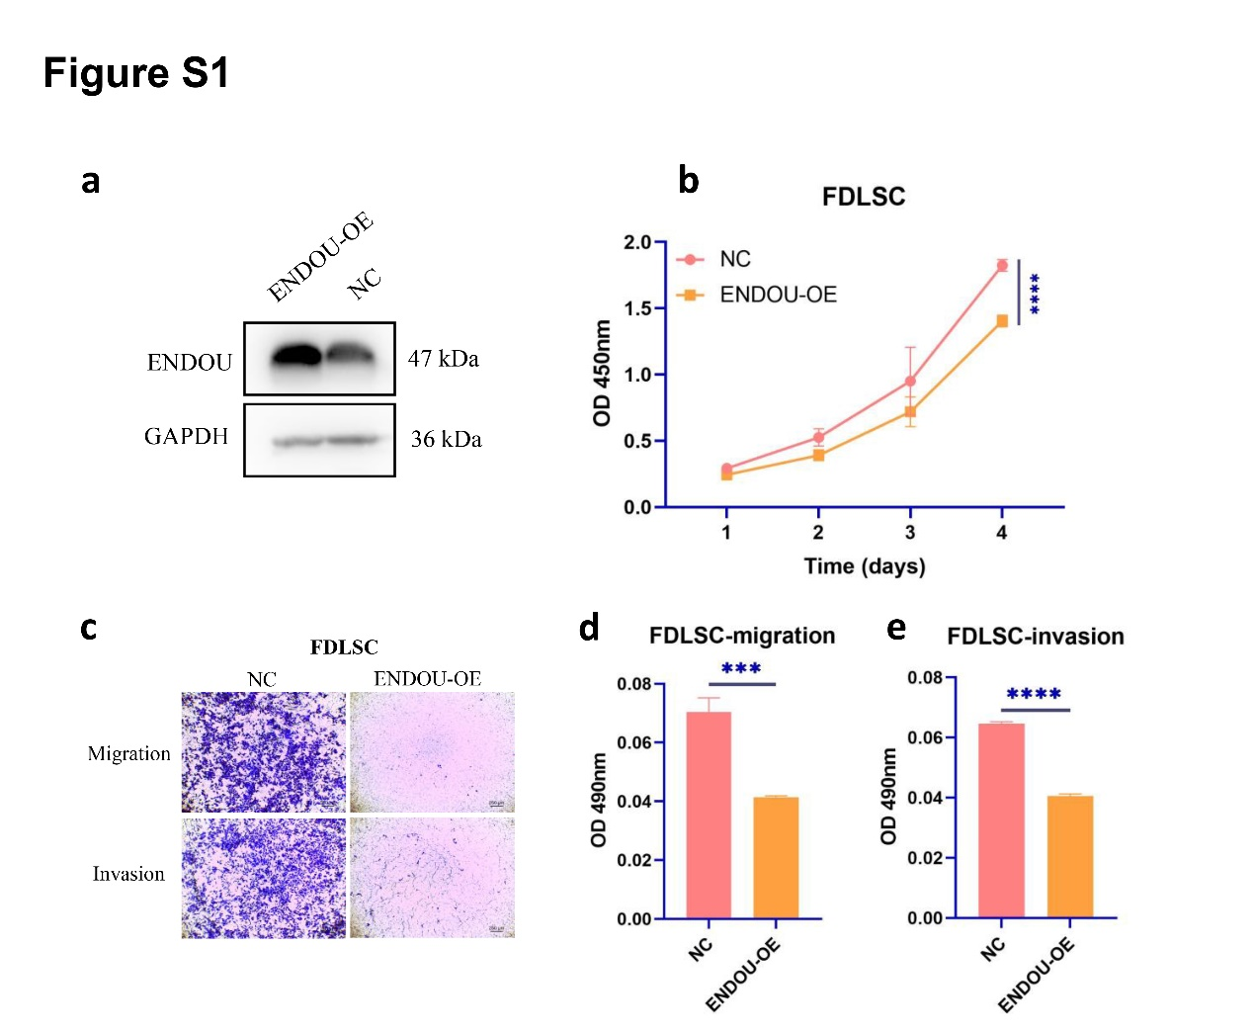

Supporting Information: Figure S1 ENDOU overexpression inhibits the proliferation, migration, and invasion of FDLSC cell lines. (a) Western blot analysis to determine ENDOU expression level in HNSCC cells treated with ENDOU-overexpressing plasmid (with oe-NC as control), normalized to GAPDH. (b) Cell viability in FDLSC cells detected using CCK-8 assay. (c−e) Transwell assay to analyze the migration and invasion of FDLSC cells. Values obtained from three independent experiments in triplicate are expressed as mean ± SD and analyzed by one-way ANOVA followed by Tukey’s post hoc test among multiple groups, and by repeated measures ANOVA followed by Bonferroni at different time points. ***p < 0.001; ****p < 0.0001.
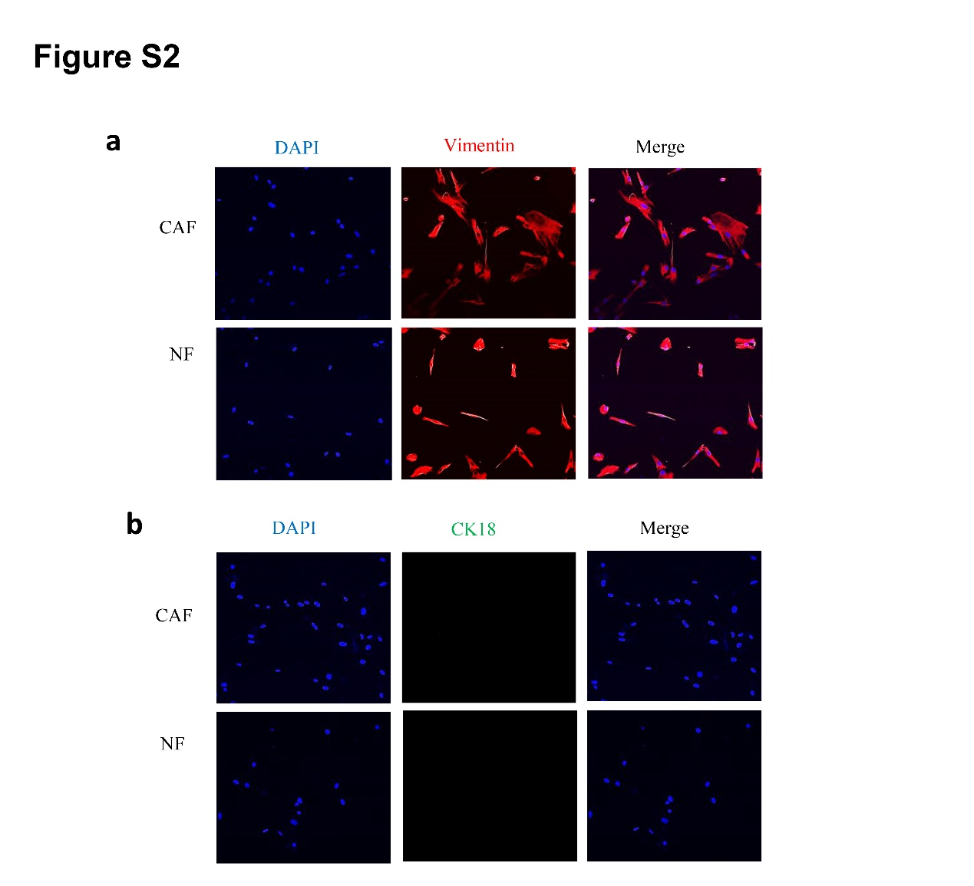

Supporting Information: Figure S2 Expression of interstitial marker vimentin and epithelial marker CK18 between NFs and CAFs.
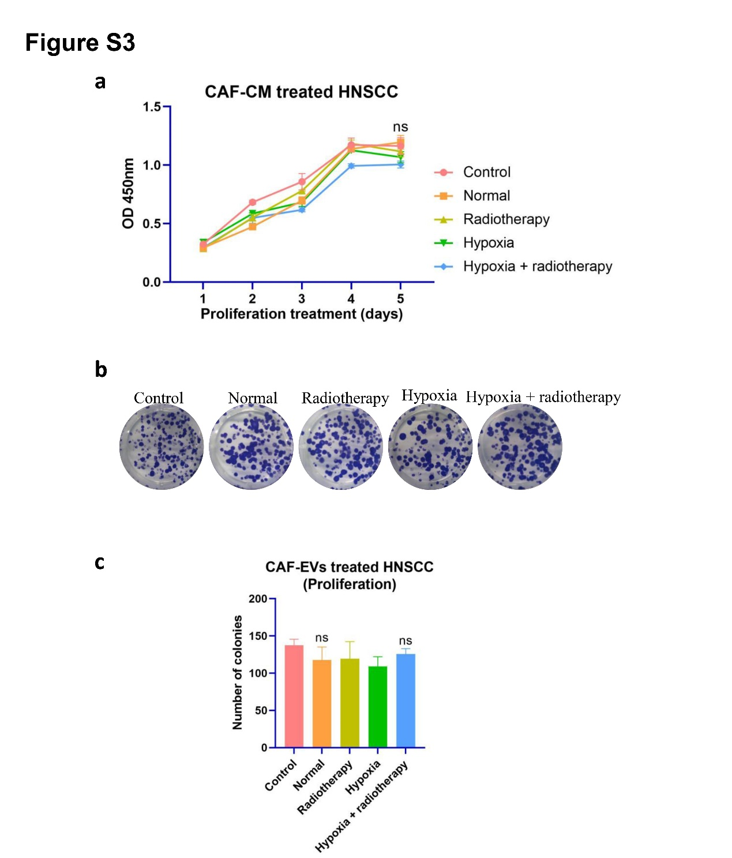

Supporting Information: Figure S3 CAF-CM has no effect on the proliferation of HNSCC. (a) Growth curve of HNSCC cells detected using CCK-8 assay. (b and c) Colony formation ability of HNSCC cells detected using colony formation assay. Values obtained from three independent experiments in triplicate are expressed as mean ± SD and analyzed by one-way ANOVA followed by Tukey’s post hoc test among multiple groups, and repeated measures ANOVA followed by Bonferroni at different time points. ns, not significant.
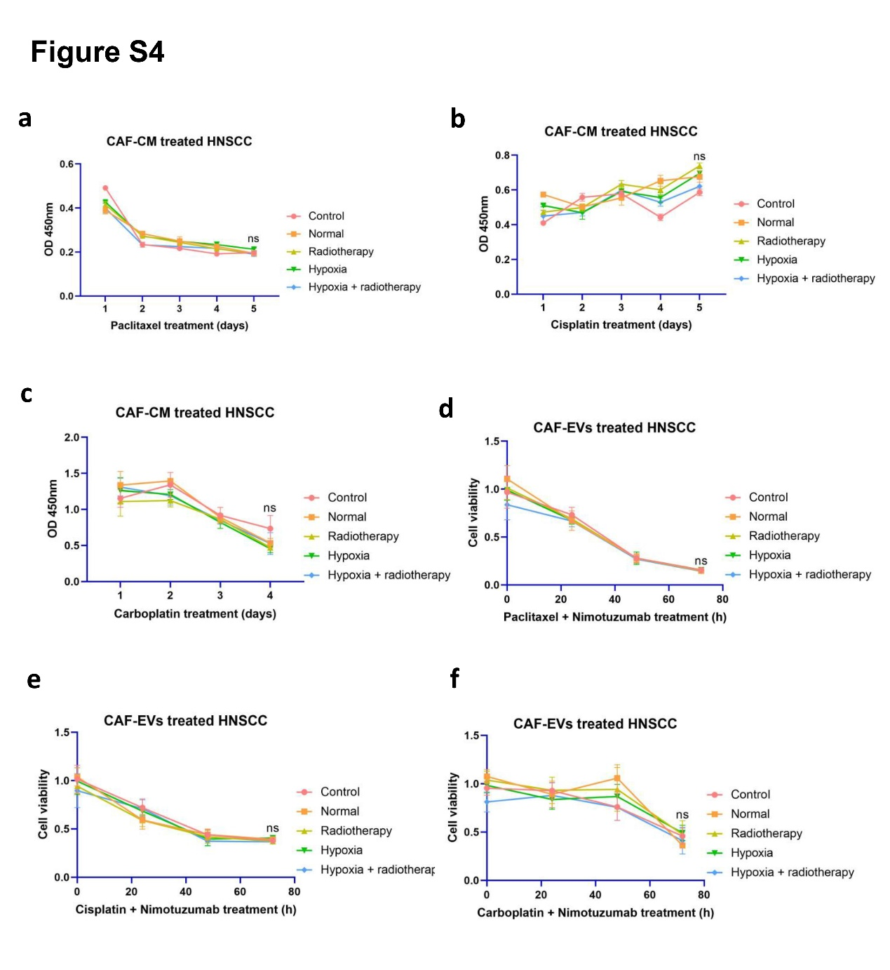
Supporting Information: Figure S4 CAF-CM has no effect on the chemosensitivity of HNSCC. Chemosensitivity of HNSCC co-cultured with CAF-CM with different treatments detected using CCK-8 assay (Paclitaxel, Cisplatin, Carboplatin, Paclitaxel combined Nimotuzumab, Cisplatin combined Nimotuzumab and Carboplatin combined Nimotuzumab). Values obtained from three independent experiments in triplicate are expressed as mean ± SD and analyzed by repeated measures ANOVA followed by Bonferroni at different time points. ns, not significant.
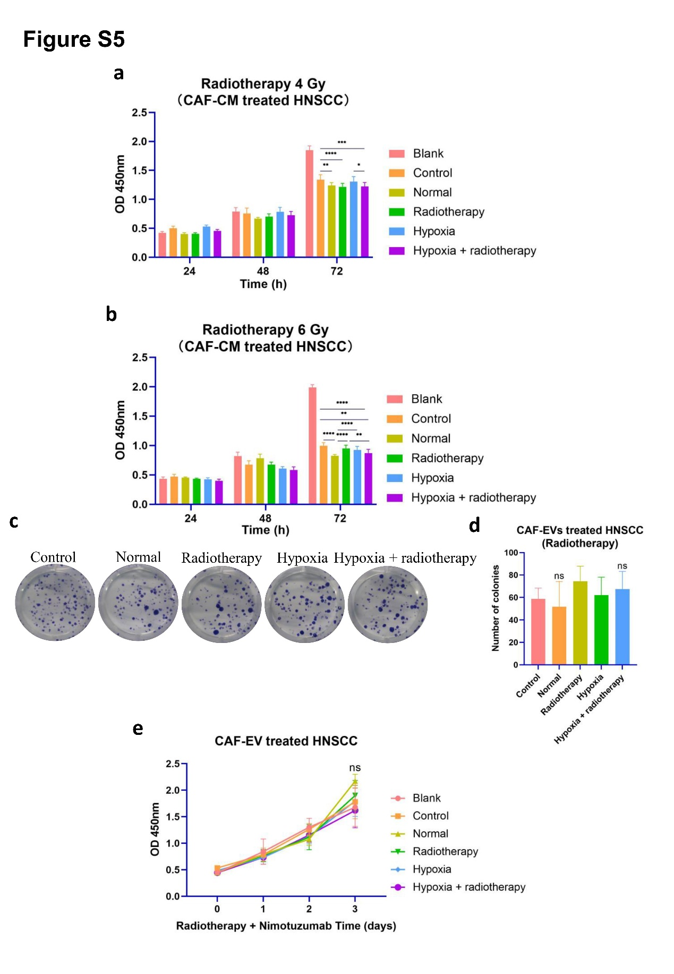
Supporting Information: Figure S5 CAF-CM has no effect on the radiosensitivity of HNSCC. (a and b) Radiosensitivity of HNSCC co-cultured with CAF-CM with different treatments detected using CCK-8 assay. (c and d) Colony formation ability of HNSCC cells co-cultured with CAF-EVs with different treatments detected using colony formation assay. (e) Radiosensitivity of HNSCC co-cultured with CAF-EVs with different treatments detected using CCK-8 assay. Values obtained from three independent experiments in triplicate are expressed as mean ± SD and analyzed by one-way ANOVA followed by Tukey’s post hoc test among multiple groups, and repeated measures ANOVA followed by Bonferroni at different time points. ns, not significant, *p < 0.05; **p < 0.01; ***p < 0.001; ****p < 0.0001.

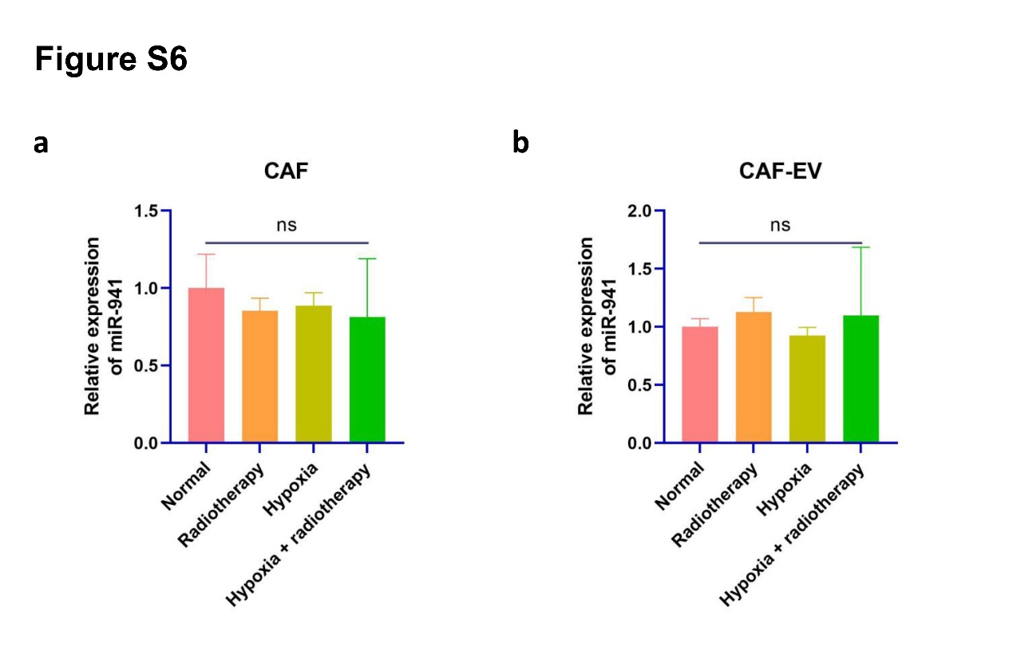

Supporting Information: Figure S6 miR-941 expression in CAFs and EVs with different treatments. (a) miR-941 expression in CAFs with different treatments determined by qRT-PCR, normalized to U6. (b) miR-941 expression in CAF-derived EVs with different treatments determined by qRT-PCR, normalized to U6. Values obtained from three independent experiments in triplicate are expressed as mean ± SD and analyzed by one-way ANOVA followed by Tukey’s post hoc test among multiple groups, and repeated measures ANOVA followed by Bonferroni at different time points. ns, not significant.
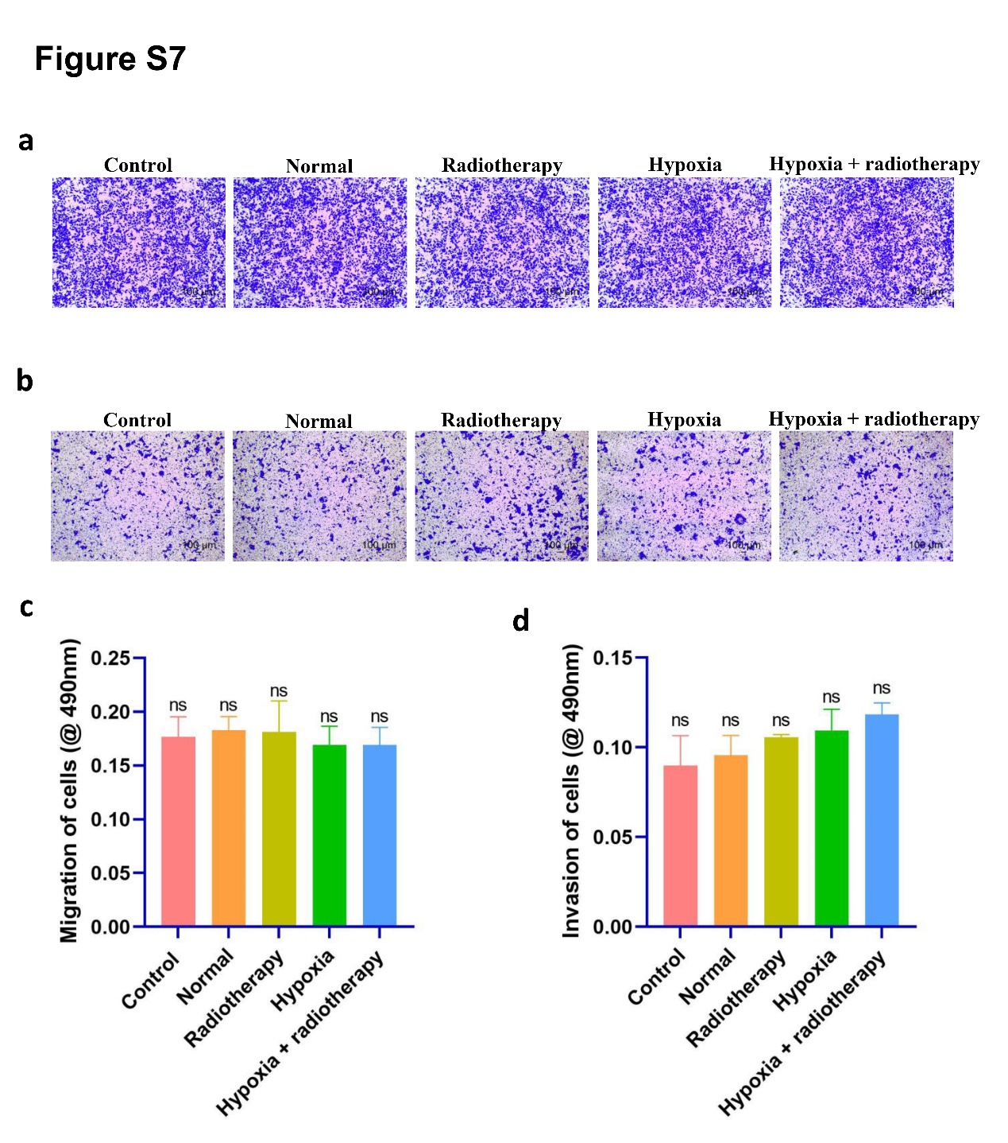
Supporting Information: Figure S7 CAF-CM after GW4869 treatment does not promote migration and invasion of HNSCC. (a) Migration of HNSCC treated with CAF-CM after GW4869 treatment with different treatments (control, radiation, hypoxia, and hypoxia combined with radiation) verified by Transwell assay. (b) Transwell assay to verify invasion of HNSCC treated with CAF-CM after GW4869 treatment with different treatments (same grouping in the same panel a). (c and d) Quantitative analysis of d and e. Values obtained from three independent experiments in triplicate are expressed as mean ± SD and analyzed by one-way ANOVA followed by Tukey’s post hoc test among multiple groups. ns, not significant.
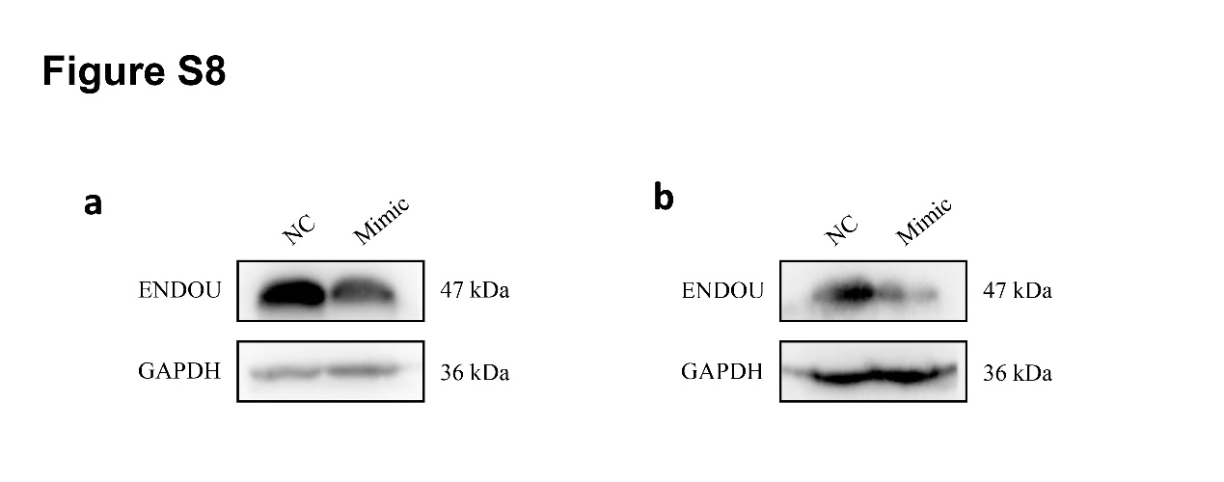
Supporting Information: Figure S8 ENDOU expression of HNSCC cells co-cultured with CAF-EVs overexpressing miR-23b-5p. (a) ENDOU protein expression in CAL-27 cells determined by western blot analysis, normalized to GAPDH. (b) ENDOU protein expression in FDLSC cells determined by western blot analysis, normalized to GAPDH.

RNA (Human) Primer sequence (5’ to 3’)
ENDOU Forward: GTGTAGTGACCACGAGGTCTC
Reverse: GGCAGCGATCCACTTGGTT

GAPDH Forward: GGAGCGAGATCCCTCCAAAAT
Reverse: GGCTGTTGTCATACTTCTCATGG

miR-23b-5p Forward: CGTGGGTTCCTGGCATGC
Reverse: AGTGCAGGGTCCGAGGTATT

miR-941 Forward: CACCCGGCTGTGTGCAC
Reverse: AGTGCAGGGTCCGAGGTATT
Supporting Information: Table S1 Primer sequences for qRT-PCR in this study.

