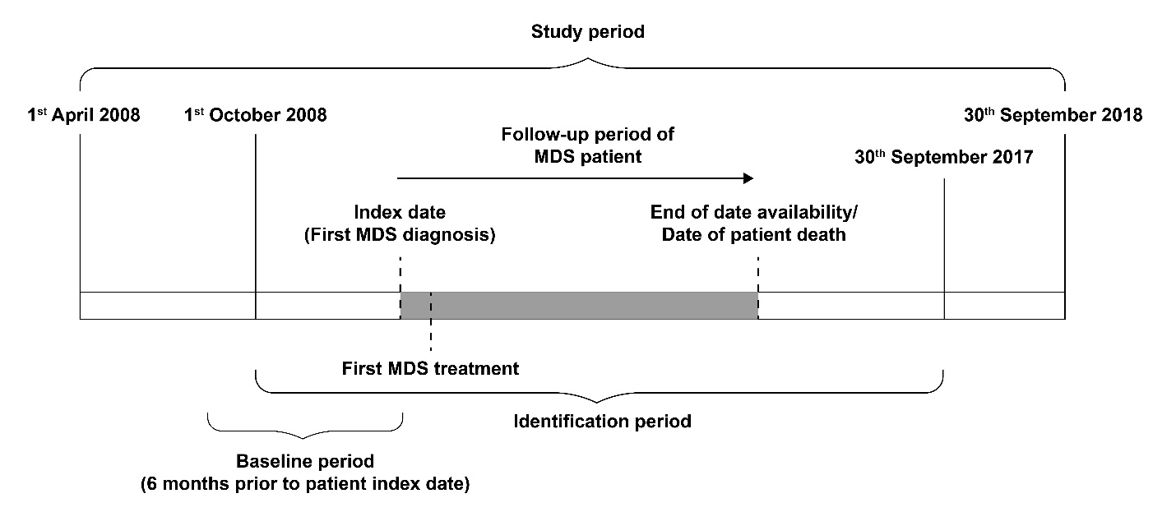
Supplementary figure 1 Study design

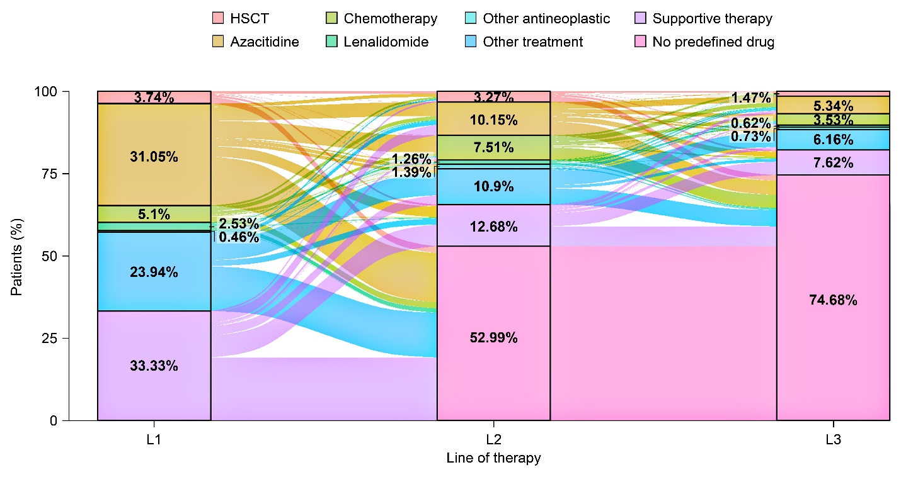
Supplementary figure 2 Sankey diagram of treatment patterns by line of therapy in main cohort

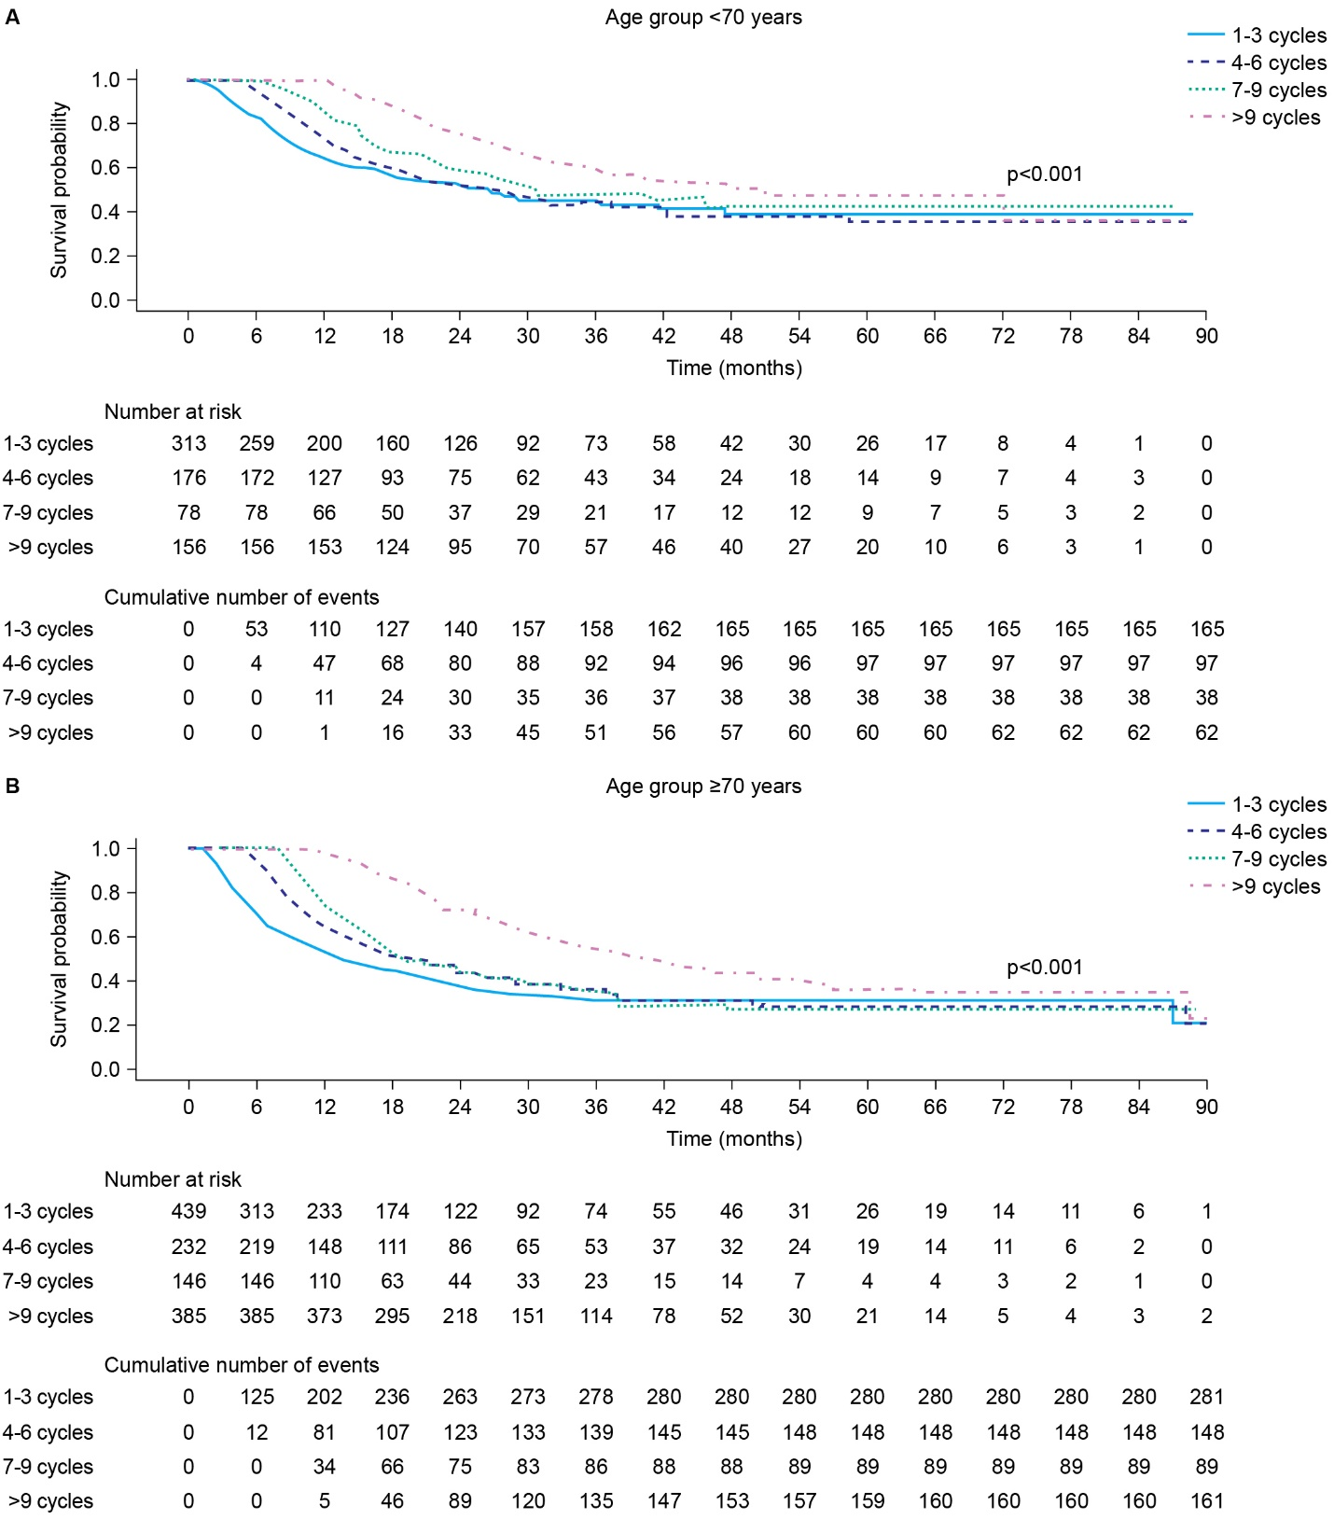
Supplementary figure 3 Kaplan-Meier curve: Overall survival by AZA treatment administration schedules in L1-AZA cohort stratified by age groups (< 70 and ≥ 70 years). AZA, azacitidine. L1-AZA cohort: Patients from the main cohort who have had AZA as their first line of treatment with 7-day AZA dosing schedule or 5-day AZA dosing schedule and excluded patients who received other or mixed AZA treatment administration schedules.

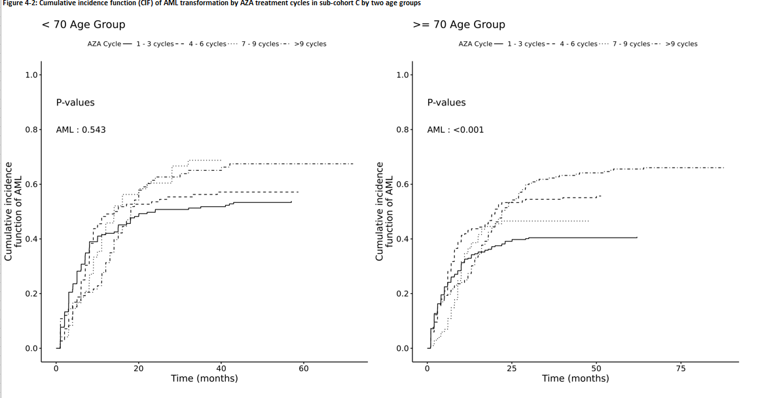
Supplementary figure 4 Kaplan-Meier curve: cumulative incidence function of acute myeloid leukemia by AZA treatment administration schedules in L1-AZA cohort stratified by age groups (< 70 and ≥ 70 years). AZA, azacitidine. L1-AZA cohort: Patients from the main cohort who have had AZA as their first line of treatment with 7-day AZA dosing schedule or 5-day AZA dosing schedule and excluded patients who received other or mixed AZA treatment administration schedules.

Supplementary table 1 Proportion of patients with different AZA treatment administration schedules categorized by number of treatment cycles in L1-AZA cohort
AZA dosing schedule | Number of AZA treatment cycles
AZA dosing schedule | 1–3 cycles, n (%) | 4–6 cycles, n (%) | 7–9 cycles, n (%) | > 9 cycles, n (%)
ª7-0-0 | 405 (65.2) | 101 (16.3) | 39 (6.3) | 76 (12.2)
^{b}5-0-0 | 175 (39.1) | 112 (25.1) | 46 (10.3) | 114 (25.5)
ª7-0-0 includes 7-0-0, 6-1-1 and 5-2-2 administration schedules.
^{b}5-0-0 includes 5-0-0 administration schedule.

