Supporting Information: Table S1 ICD-10 codes for cancers included in the study.
Cancer site | ICD-10
Oral cavity and pharynx | C00–10, C12–14
Esophagus | C15
Stomach | C16
Colorectum | C18–21
Liver | C22
Gallbladder | C23–24
Pancreas | C25
Larynx | C32
Lung | C33–34
Breast | C50
Cervix | C53
Uterus | C54–55
Ovary | C56
Prostate | C61
Kidney | C64–66, C68
Bladder | C67
Brain* | C70–72
Thyroid | C73
Lymphoma | C81–85, C88, C90, C96, D46
Leukemia | C91–C95, D47
All others | /
All sites | C00–96, D46–47
*Brain and central nervous system.

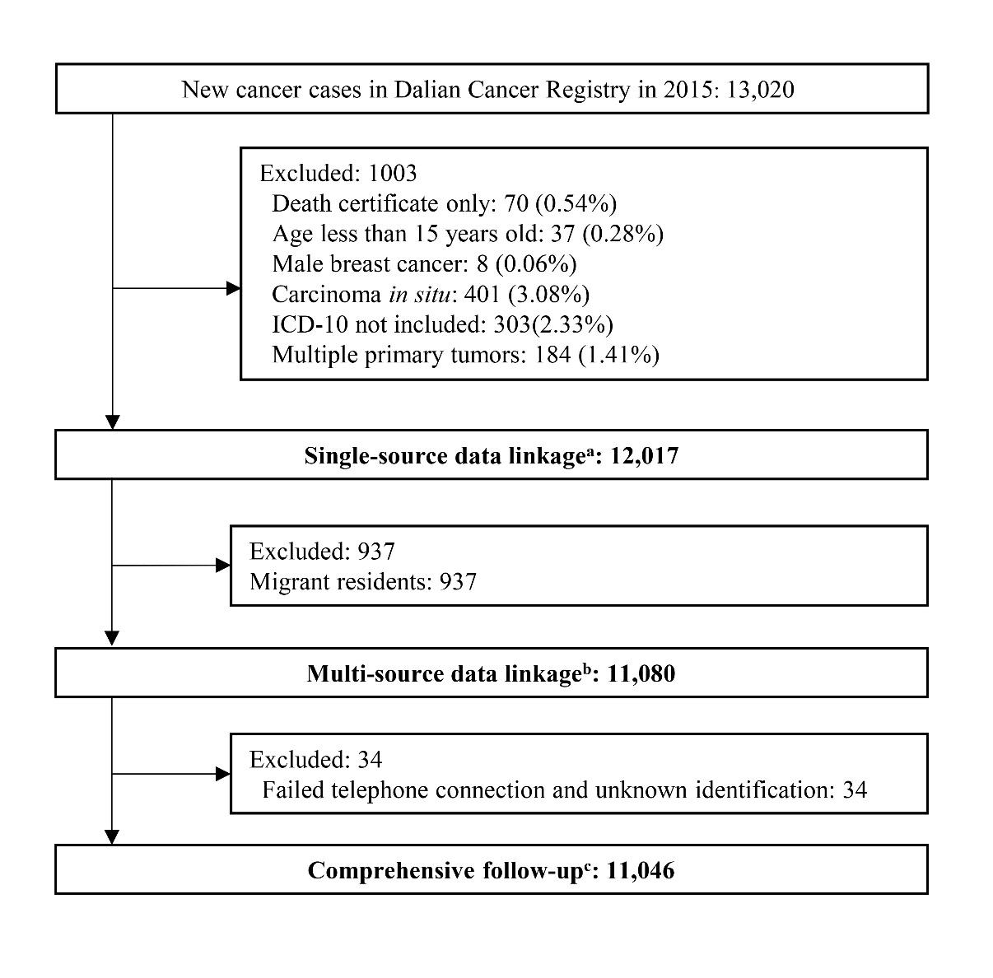
Supporting Information: Figure S1 Flowchart of the study population in Dalian, China. ªThe vital status of patients was obtained through data linkage with the Vital Statistics System only. ^{b}The vital status of patients was obtained through data linkage with Vital Statistics System, Household Registration System, and hospital medical records. ^{c}The vital status of patients was obtained through multi-source data linkage and active follow-up.
Supporting Information: Figure S2 Relative differences^{c} of 5-year observed survival and age-standardized relative survival (ASRS) in single-source data linkage and multi-source data linkage compared to comprehensive follow-up^{d} (%). (a) Relative difference of 5-year observed survival. (b) Relative difference of 5-year ASRS. ªThe vital status of patients was obtained through data linkage with the Vital Statistics System only. ^{b}The vital status of patients was obtained through data linkage with Vital Statistics System, Household Registration System, and hospital medical records. ^{c}Relative difference = (survival estimate under single-source data linkage or multi-source data linkage − survival estimate under comprehensive follow-up)/survival estimate under comprehensive follow-up. ^{d}The vital status of patients was obtained through multi-source data linkage and active follow-up.

