ZmHOP2a Coordinates Meiotic Recombination and Synapsis in Maize
Nan Wu¹, Wojciech P Pawlowski², Yan He^{1,3,*} and Jinghan Liu^{3,*}
¹State Key Laboratory of Maize Bio-breeding, National Maize Improvement Center, College of Agronomy and Biotechnology, China Agricultural University, Beijing 100193, China.
²Section of Plant Biology, School of Integrative Plant Science, Cornell University, Ithaca, NY 14853, USA.
³Key Laboratory of Seed Innovation, Institute of Genetics and Developmental Biology, Chinese Academy of Sciences, Beijing 100101, China.
*Correspondence authors:
Jinghan Liu (jhliu@genetics.ac.cn);
Yan He (yh352@genetics.ac.cn)

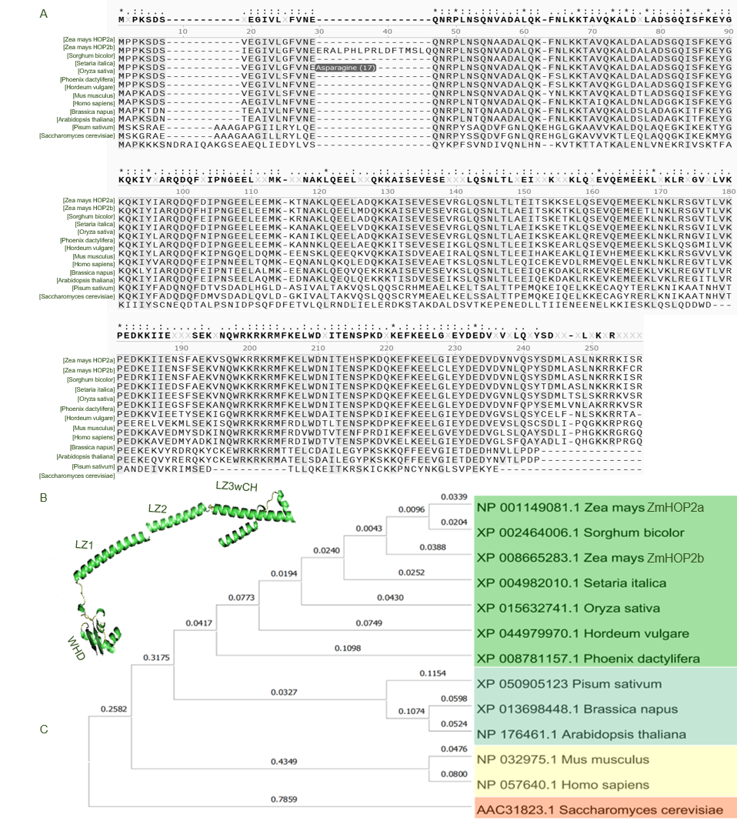
Fig.S1 Comparative analysis of HOP2 homologs across species.
(A) Multiple sequence alignment of HOP2 proteins. The color gradient from dark to light indicates the degree of amino acid conservation (from high to low). Functional domains are marked. (B) AlphaFold-predicted structures of HOP2 homologs from budding yeast, mouse, human, rice, and maize. Conserved functional domains are highlighted in yellow; the red arrow indicates the WHD domain of maize HOP2a. (C) HOP2 neighbour-joining phylogenetic tree based on an alignment of amino acid sequences. The scale bar represents the number of changes per amino acid position.

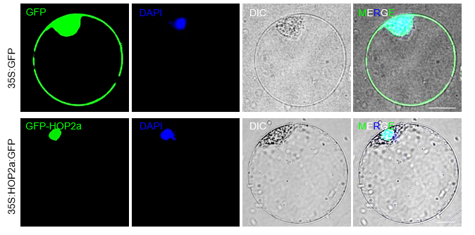
Fig. S2. Subcellular localization of HOP2a in maize protoplasts.
35S::HOP2a-eGFP fusion construct was transiently expressed in maize protoplasts to determine the subcellular localization of HOP2a, and 35S::eGFP served as a negative control. Images from left to right show GFP fluorescence (Green), DAPI staining of nuclei (Blue), bright-field, and merged images. Scale bars =10 μm.

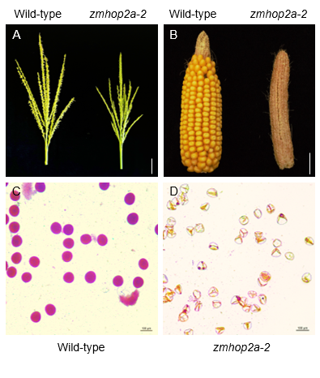
Fig. S3. Characterization of zmhop2a-2 mutant.
(A) Tassels from zmhop2a-2 at the flowering stage. Scale bars = 5 cm. (B) Mature ears of zmhop2a-2 pollinated with wild-type pollen grains. Scale bars = 5 cm. (C,D) Mature pollen grains from wild-type and zmhop2a-2 stained with Alexander solution. Scale bars = 100 μm.

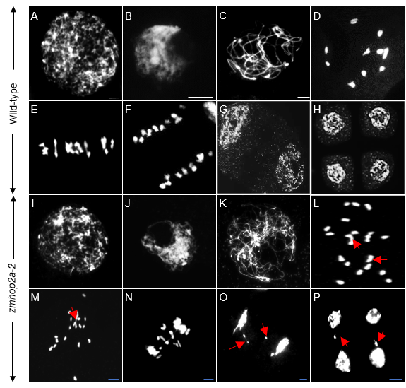

Fig. S4. Meiotic chromosome behaviors in zmhop2a-2 male meiocytes.
(A) to (H) The wild-type. (I) to (P) in zmhop2a-2. (A, I) Leptotene. (B, J) Zygotene. (C, K) Pachytene. (D, L) Diakinesis. (E, M) Metaphase I. (F, N) Anaphase I. (G, O) Dyads. (H, P) Tetrads. Meiotic Chromosomes Stained with DAPI. Scale bar = 10 μm.
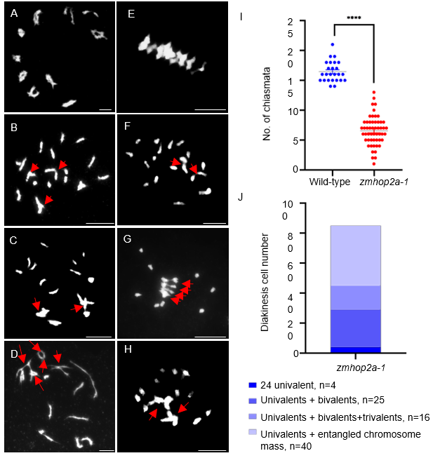
Fig. S5 Statistical analysis of meiotic chromosome behavior and chiasma frequency.
(A) Wild-type diakinesis. (B–D) zmhop2a-1 diakinesis. (E) Wild-type metaphase I. (F–H) zmhop2a-1 metaphase I. Red arrows indicate abnormal chromosome associations. (I) Quantification of chiasma frequency in the wild type and zmhop2a-1. Horizontal lines indicate the means. ****, P < 0.0001 (two-tailed Student’s t-test). The mean chiasma number was 16.44 (n = 25) in the wild type and 6.55 (n = 53) in zmhop2a-1. (J) Quantification of four types of chromosome behavior at metaphase I in zmhop2a-1. Scale bar = 10 μm.

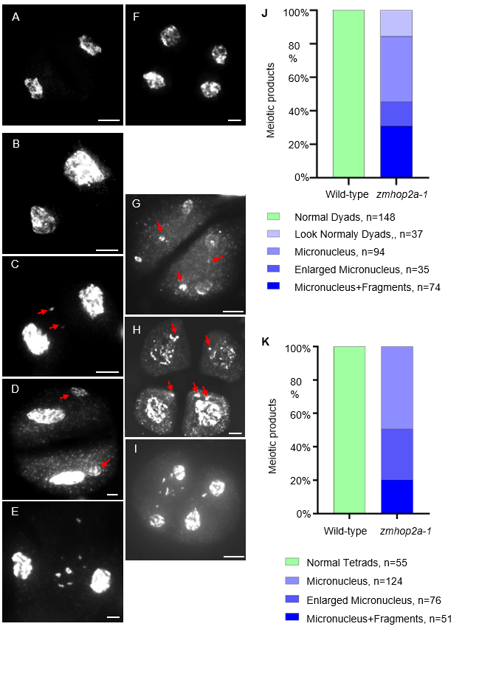
Fig.S6 Statistical analysis of abnormal chromosome behavior at the dyad and tetrad stages in wild type and zmhop2a-1.
(A) Dyad in wild type. (B–E) Representative dyads in zmhop2a-1. (F) Tetrad in wild type. (G–I) Representative tetrads in zmhop2a-1. (J) Quantification of four types of dyad-stage chromosome behavior in zmhop2a-1. (K) Quantification of three types of tetrad-stage chromosome behavior in zmhop2a-1.

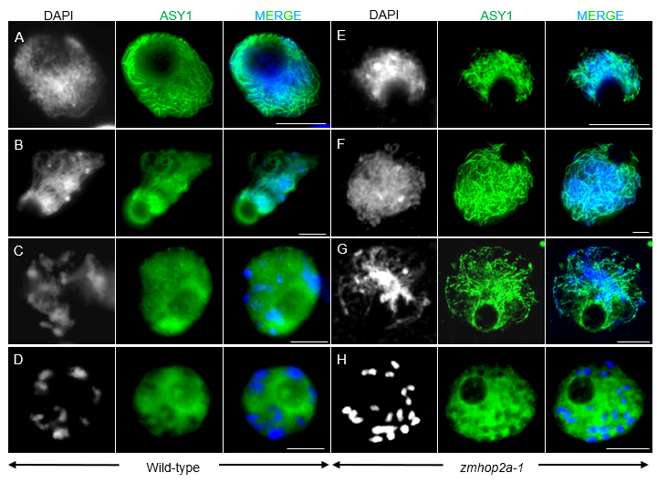
Fig. S7. Immunolocalization of ASY1 in wild-type and zmhop2a-1 meiocytes during meiosis.
Wild-type (A–D) and zmhop2a-1 (E–H) meiocytes at zygotene (A, E), pachytene (B, F), diplotene (C, G), and diakinesis (D, H). From left to right, images show DAPI-stained chromosomes (blue), ASY1 signals (green), and merged images. Scale bar = 10 μm.

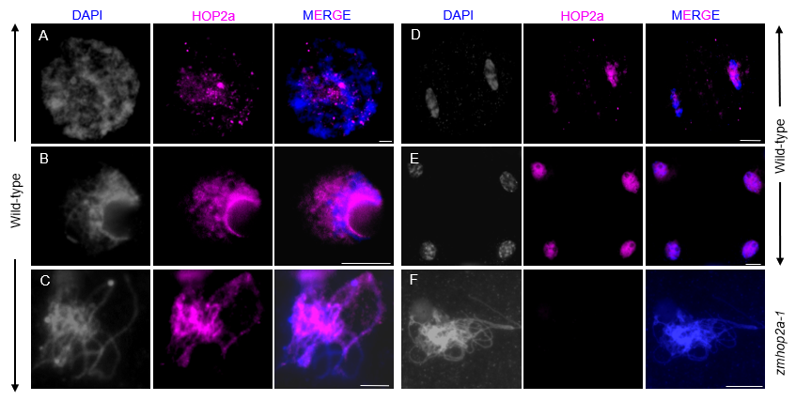
Fig. S8. ZmHOP2a is dynamically localized during maize meiosis.
Immunolocalization of ZmHOP2a in wild-type pollen mother cells (PMCs) at leptotene (A), zygotene (B), pachytene (C), dyad (D), and tetrad (E), and in zmhop2a-1 PMCs (F). In wild-type meiocytes, ZmHOP2a is detected as punctate chromosome-associated foci during meiotic progression. Chromosomes were stained with DAPI (blue), and ZmHOP2a signals are shown in magenta. Images were acquired using a Nikon wide-field microscope. Scale bars = 10 μm.

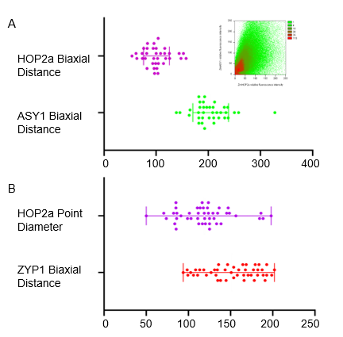
Fig. S9. Quantitative analysis of the spatial relationships among ASY1, ZYP1, and ZmHOP2a.
(A) Pearson’s correlation coefficient (Pearson’s r) between ZmHOP2a and ASY1 signals, and quantification of the fluorescence peak distances for ZmHOP2a and ASY1. (B) Quantification of the fluorescence peak distances for ZmHOP2a and ZYP1.

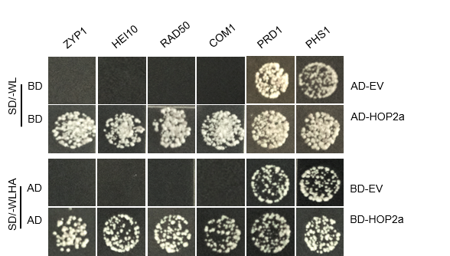
Fig. S10. ZmHOP2a interacts with known meiotic homologous recombination proteins.
Yeast two-hybrid assays were performed to test the interactions between ZmHOP2a and known meiotic homologous recombination proteins. AD indicates pGADT7, BD indicates pGBKT7, and EV indicates empty vector.
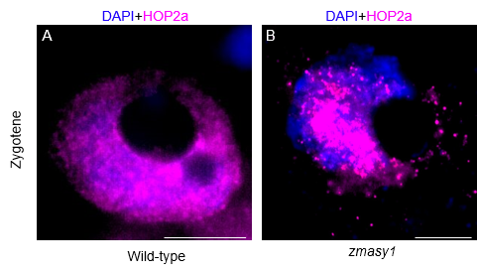
Fig. S11. Localization of ZmHOP2a in zmasy1 mutants.
Immunolocalization of ZmHOP2a at zygotene in wild-type (A) and zmasy1 mutant (B) meiocytes. Chromosomes were stained with DAPI (blue), and ZmHOP2a signals are shown in magenta. Scale bar = 10 μm.

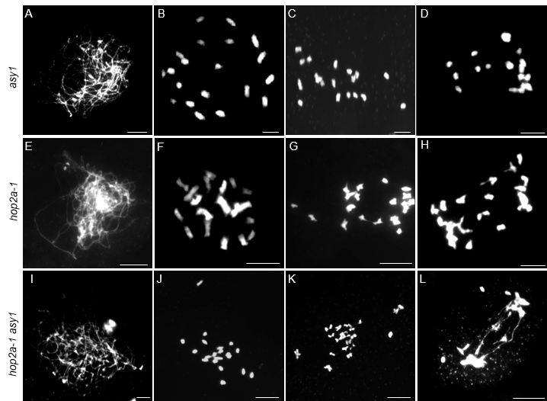
Fig. S12. Meiotic chromosome behaviors in zmhop2a and zmasy1/zmhop2a-1 male meiocytes.
(A to D) Wild type. (E to H) zmhop2a-1. (I to L) zmasy1 zmhop2a-1. (A, E, I) Leptotene. (B, F, J) Diakinesis. (C, G, K) Metaphase I. (D, H, L) Anaphase I. Meiotic chromosomes were stained with DAPI. Scale bar = 10 μm.
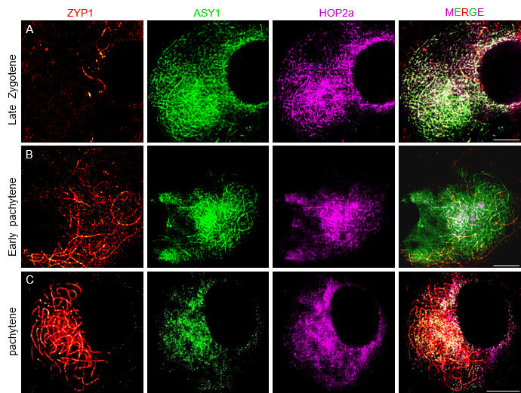
Fig. S13. Immunolocalization of ASY1, ZYP1, and ZmHOP2a during synaptonemal complex formation.
(A–C) Immunolocalization of ASY1, ZYP1, and ZmHOP2a in wild-type meiocytes at different stages of early pachytene. ZmHOP2a signals were detected using a rabbit-derived antibody (magenta), while ASY1 and ZYP1 were detected using mouse-derived and rat-derived antibodies (green), respectively. (A) onset of ZYP1 loading; (B) partial ZYP1 loading; (C) complete ZYP1 loading. Scale bar = 10 μm.

Table S1. Raw data for distance measurement statistics of ASY1 and ZmHOP2a.
ASY1 Relative Intensity | HOP2a Relative Intensity
1.0000 | 2.0554
1.0000 | 2.8858
1.4187 | 3.6471
1.7716 | 4.2076
2.2976 | 2.3010
6.4083 | 6.9931
12.2076 | 19.5190
19.8893 | 38.9516
29.9377 | 51.9066
39.5433 | 34.6263
41.7682 | 19.5571
35.0000 | 12.0000
24.4948 | 7.1419
19.0381 | 7.3322
25.1557 | 12.7924
37.1592 | 24.7093
38.3945 | 43.5087
33.9965 | 61.4464
27.6505 | 53.1419
15.0865 | 26.0035
7.1765 | 9.6228
1.8858 | 2.8824
1.0554 | 1.4706
0.7509 | 1.2491
1.3218 | 1.0000
1.9862 | 1.0000
2.2422 | 0.7578
1.7059 | 1.0865
1.0000 | 2.0000

Table S2. Raw data for distance measurement statistics of ZYP1 and ZmHOP2a.
ZYP1 Relative Intensity | HOP2a Relative Intensity
20.4167 | 53.9167
17.3667 | 64.2839
15.2578 | 68.7356
15.8883 | 67.8683
21.3589 | 66.5978
38.5694 | 65.8333
62.8067 | 65.4333
74.4183 | 69.5967
66.9922 | 76.2211
54.5083 | 77.0817
54.5556 | 70.0556
63.6483 | 63.5194
64.7433 | 62.4067
53.8956 | 62.6211
36.6622 | 62.3622
22.3333 | 63.5417
14.3178 | 62.1589
10.0656 | 54.0172
10.2800 | 47.2200
13.7172 | 47.6178
17.1667 | 57.3333

