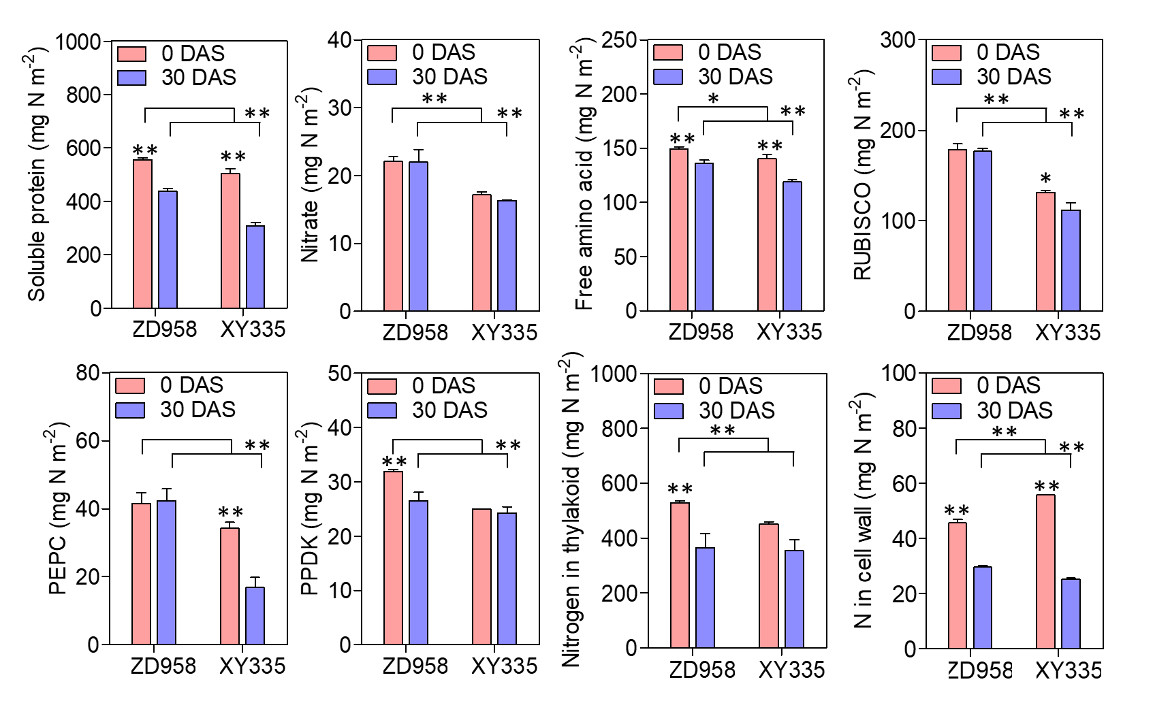
Figure S1. Physiological and metabolic differences between ZD958 and XY335 during senescence.

Figure S2. Expression pattern of the protease genes in turquoise module during leaf senescence and N remobilization in ZD958 and XY335.

Figure S3. Expression pattern of the amino acids and peptide transporters in turquoise.

Table S1. Characteristics of hybrids used in experiment 1 (Shunyi, Beijing).
Hybrids | Year of release | Period of Promotion | Parental combination | Breeding institution
Jinhuanghou | 1930 | 1950s | — | —
Xiaolihong | 1940 | 1950s | — | —
Yinglizi | 1943 | 1950s | — | —
Weier 156 | 1963 | 1960s | (WF9 × Os420) × (M14 × CI187-2) | —
sishuang 1 | 1965 | 1960s | (Ying 64 × Tie 84) × (M14 × W20) | Siping Agricultural Science Institute
Jidan 101 | 1967 | 1970s | Ji 63 × M14 | Jilin Academy of Agricultural Sciences
Tiedan 4 | 1970 | 1980s | Ji 69 ×Zi 330 | Tieling Academy of Agricultural Sciences
Zhongdan 2 | 1973 | 1970s | MO17×Zi 330 | Chinese Academy of Agricultural Sciences
Danyu 13 | 1979 | 1980s | Mo17 × E28 | Dandong Academy of Agricultural Sciences
Shendan 7 | 1982 | 1980s | 5003 × E28 | Shenyang Academy of Agricultural Sciences
Yedan 4 | 1982 | 1980s | Ye 8112×Huangzao 4 | Laizhou Academy of Agricultural Sciences
Benyu 9 | 1982 | 1990s | 7884-7H1×MO17Ht | Benxi Academy of Agricultural Sciences
Yedan 2 | 1983 | 1980s | Ye 107×Huangzao 4 | Laizhou Maize Research Institute
Nongda 60 | 1985 | 1980s | 5003 × Zong 31 | China Agricultural University
Yedan 13 | 1989 | 1990s | Ye 478 × Dan 340 | Laizhou Academy of Agricultural Sciences
Yedan 19 | 1989 | 1990s | Ye 478 × Ye 52106 | Laizhou Academy of Agricultural Sciences
Yudan 18 | 1989 | 1990s | 478 You × Zheng 22 | Henan Academy of Agricultural Science
Ludan 50 | 1990 | 1990s | Luyuan 92 × Qi 319 | Shandong Academy of Agricultural Science
Nongda 108 | 1991 | 1990s | Huang C × 178 | China Agricultural University
Nongda 3138 | 1991 | 1990s | Zong 31 × P138 | China Agricultural University
Jidan 159 | 1994 | 1990s | Ji 846 × Dan 340 | Jilin Academy of Agricultural Sciences
Denghai 9 | 1995 | 2000s | DH65232 × 8723 | Laizhou Academy of Agricultural Sciences
Shendan 16 | 1995 | 2000s | K12 × Shen 137 | Shenyang Academy of Agricultural Sciences
Zhengdan 958 | 1996 | 2000s | Zheng 58 × Chang 7-2 | Henan Academy of Agricultural Science
Xianyu 335 | 2000 | 2000s | PH6WC × PH4CV | Pioneer Co., Ltd at Tieling
NE9 | 2007 | 2000s | T63 × Shen 137 | China Agricultural University

Table S2. Characteristics of hybrids used in experiment 2 (Shangzhuang, Beijing) and 3 (Quzhou, Hebei).
Hybrid | Year of release | Parents | Breeding institution | Shangzhuang | Quzhou
Anyu 5 | 1991 | 478 × Chang7-2 | Academy of Agricultural Sciences in Anyang, Henan Province | ○ | ○
Nongda 108 | 1991 | 178 × HuangC | China Agricultural University | ○
Nongda 3138 | 1991 | Zong31 × P138 | China Agricultural University | ○ | ○
Zhongdan 306 | 1991 | 478 × Zhong106 | Chinese Academy of Agricultural Sciences | ○ | ○
Nongda 2238 | 1992 | P138 × 7922 | China Agricultural University | ○ | ○
Yuyu 22 | 1992 | Zong3 × Yu87-1 | Henan Agricultural University |  | ○
Lainong 14 | 1994 | L189 × H21 | Qingdao Agricultural University | ○
Mingyu 2 | 1995 | Hai9818 × Ming2325 | Liaoning Mingyu Seeds Co., Ltd. | ○ | ○
Shendan 16 | 1995 | K12 × Shen137 | Academy of Agricultural Sciences in Shenyang, Liaoning Province | ○ | ○
Liaodan 120 | 1996 | Liao8478 × Zheng22 | Academy of Agricultural Sciences in Liaoning | ○ | ○
Nongda 84 | 1996 | F349 × P25 | China Agricultural University | ○ | ○
Nongda 86 | 1996 | D141 × P1143 | China Agricultural University | ○ | ○
Zhengdan 958 | 1996 | Zheng58 × Chang7-2 | Academy of Agricultural Sciences in Henan Province | ○
Danyu 86 | 1997 | Dan988 × DanT138 | Academy of Agricultural Sciences in Dandong, Liaoning Province | ○ | ○
Dongdan 60 | 1997 | A801 × Dan598 | Liaoning Dongya Seeds Co., Ltd. | ○ | ○
Feiyu 4 | 1997 | Fei03 × Fei05 | Feixian Seeds Co., Ltd. | ○
Denghai 3622 | 1998 | DH158 × DH323 | Shandong Denghai Seeds Co., Ltd. | ○ | ○
Liaodan 565 | 1998 | Zhong106 × Liao3162 | Academy of Agricultural Sciences in Liaoning | ○ | ○
Xundan 20 | 1998 | 9058 × Xun92-8 | Academy of Agricultural Sciences in Xunxian, Henan Province | ○
Zhongyu 9 | 1998 | Fei03 × Fei04 | China National Seed Group Co., Ltd. |  | ○
Jiyuan 1 | 1999 | Langxi-1 × K12 | Hebei Xinjiyuan Seeds Co., Ltd. | ○ | ○
Zhongnong 99 | 1999 | 478 × 4-1 | China Agricultural University |  | ○
Jinhai 5 | 2000 | JH78-2 × JH3372 | Jinhai Seeds Co., Ltd. | ○ | ○
Jinhai 604 | 2000 | P138 × JH3372 | Jinhai Seeds Co., Ltd. | ○ | ○
Liansheng 15 | 2000 | 9648 × 686 | Laiyang Xinshijiliansheng Maize Research Institute | ○
Qidan 1 | 2000 | XF0138 × SX211 | Shandong Xinfeng Seeds Co., Ltd. | ○ | ○
Ruibu 1 | 2000 | B19 × Chang7-2 | Beijing Doneed Seeds Co., Ltd. |  | ○
Shenyu 21 | 2000 | Shen3336 × Shen3265 | Academy of Agricultural Sciences in Shenyang, Liaoning Province |  | ○
Xianyu 252 | 2000 | PH6JM × PHB1M | Pioneer Co., Ltd. | ○ | ○
Xianyu32D22 | 2000 | PH09B × PHPMO | Pioneer Co., Ltd. | ○ | ○
Xianyu 335 | 2000 | PH6WC × PH4CV | Pioneer Co., Ltd. | ○
Xianyu 420 | 2000 | PH6WC × PH6AT | Pioneer Co., Ltd. | ○ | ○
Xianyu 508 | 2000 | PH6WC × PH5AD | Pioneer Co., Ltd. | ○ | ○
Xianyu 696 | 2000 | PH6WC × PHB1M | Pioneer Co., Ltd. | ○ | ○
Xiuqing 73-1 | 2000 | Yong35-1 × 35-2 | China National Seed Group Co., Ltd. | ○ | ○
Fengyu 4 | 2001 | HY389 × Chang7-2 | Hebei Huafeng Seeds Co., Ltd. | ○ | ○
Jifeng 96 | 2001 | 8233 × Chang7-2 | Henan Junda Seeds Co., Ltd. | ○ | ○
Jingdan 28 | 2001 | Zheng58 × Jing024 | Beijing Academy of Agriculture And Forestry Science | ○ | ○
Chengyu 18 | 2002 | Chenxi51 × Chengxi68 | Chengde Yufeng Seeds Co., Ltd. | ○ | ○
Chengyu 8 | 2002 | Chengxi72 × Chengxi68 | Chengde Yufeng Seeds Co., Ltd. | ○ | ○
Jiyu 301 | 2002 | GS01 × 853 | Jilin Agricultural University | ○ | ○
Ruide 7 | 2002 | Chang7-2 × K29 | Shenyang Ruide Seeds Co., Ltd. |  | ○
Ruisheng 211 | 2002 | LS87-1 × LS13 | Liaoning Haihe Seeds Co., Ltd. | ○ | ○
Zhongke 11 | 2002 | CT0 × CT201 | Henan Ketai Seeds Co., Ltd. | ○ | ○
Danyu 405 | 2003 | Dan299 × DanM9-2 | Academy of Agricultural Sciences in Dandong, Liaoning Province | ○ | ○
Derui 29 | 2003 | CW108 × CW200 | China National Seed Group Co., Ltd. | ○ | ○
Kuancheng 60 | 2003 | Hai34 × K404 | Hebei Kuancheng Seeds Co., Ltd. | ○ | ○
Shengdan 219 | 2003 | SD116 × SD93 | Dalian Shengshi Seeds Co., Ltd. | ○ | ○
Tiantai 33 | 2003 | PC58 × PC68 | Shandong Tiantai Seeds Co., Ltd. | ○ | ○
Xianyu 698 | 2003 | PH6WC × PH4CN | Pioneer Co., Ltd. | ○ | ○
Danyu 406 | 2004 | Dan420 × Dan99 | Academy of Agricultural Sciences in Dandong, Liaoning Province | ○ | ○
Danyu 603 | 2004 | Dan1133 × DH34 | Academy of Agricultural Sciences in Dandong, Liaoning Province | ○ | ○
Danyu 605 | 2004 | Dan11331 × DH34 | Academy of Agricultural Sciences in Dandong, Liaoning Province | ○ | ○
Daoyuan 8 | 2004 | B14 × Chang7-2 | Hebei Tianhe Seeds Co., Ltd. |  | ○
Denghai 661 | 2004 | DH351 × DH372 | Shandong Denghai Seeds Co., Ltd. | ○ | ○
Denghai 701 | 2004 | W917 × DH382 | Shandong Denghai Seeds Co., Ltd. | ○
Liangyu 66 | 2004 | M54 × S121 | Dandong LiangYu seed industry Co., Ltd. On the sea | ○ | ○
Liangyu 88 | 2004 | M54 × S122 | Dandong LiangYu seed industry Co., Ltd. On the sea | ○ | ○
Nonghua 101 | 2004 | NH60 × S121 | Da Bei Nong Group Co., Ltd. | ○ | ○
Shenhe 201 | 2004 | Sh002 × Danhuang34 | Shenyang Nongda Seeds Co., Ltd. | ○ | ○
Wuke 2 | 2004 | 457-1 × Zheng22 | Academy of Agricultural Sciences in Wuwei, Gansu Province | ○ | ○
Denghai 605 | 2005 | DH351 × DH382 | Shandong Denghai Seeds Co., Ltd. | ○ | ○
Liangyu 188 | 2005 | M60 × S121 | Dandong LiangYu seed industry Co., Ltd. On the sea | ○ | ○
Zhongdan 909 | 2005 | Zheng58 × HD586 | Chinese Academy of Agricultural Sciences | ○ | ○
NE9 | 2007 | T63 × Shen137 | China Agricultural University |  | ○

Location | Soil
Location | Organic matter | Total N | Mineral N | Availabl P | Available K | pH
Location | (g/kg) | (g/kg) | (mg/kg) | (mg/kg) | (mg/kg)
Shunyi in 2010 and 2011 | 16.7 | 1.07 | 32.1 | 41.3 | 129.2 | 7.44
Shangzhuang in 2011 | 12.4 | 0.73 | 22.2 | 28.3 | 97.6 | 7.55
Quzhou in 2011 | 13.2 | 0.76 | 21.6 | 6.86 | 90.7 | 8.7
Shangzhuang in 2019 | 12.0 | 0.60 | 25.4 | 29.5 | 109.7 | 7.5
Greenhouse in 2011 and 2012 | 13.1 | 0.73 | 26.8 | 6.82 | 105.4 | 7.8
Table S3. Soil environment at the field and greenhouse trial locations.

