Identification of Intronic GT/AG Gain Variants Affecting Splicing in an EMS-Mutagenized Maize Population
Bao Yu^{1#}, Xia Fan^{2#}, Qin Li^{1#}, Xie Fugui¹, Guo Xiaolong¹, Yin Can² Wang Xiangfeng², Lu Xiaoduo¹
¹ Institute of Molecular Breeding for Maize, Qilu Normal University, Jinan 250200, China
² State Key Laboratory of Maize Bio-breeding / Frontiers Science Center for Molecular Design Breeding, China Agricultural University, Beijing 100094, China
# These authors contributed equally to this article.
Corresponding author. Lu Xiaoduo (lu.xiaoduo@163.com); Wang Xiangfeng (xwang@cau.edu.cn)

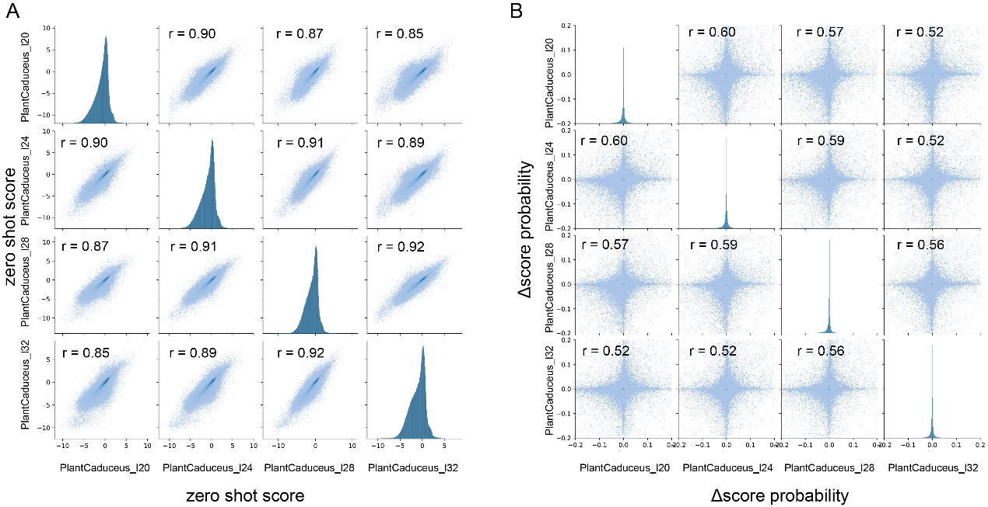
Fig. S1. Cross-model consistency analysis of PlantCaduceus predictions.
(A) Pairwise scatter plots and histograms showing the distribution of zero-shot scores across the four PlantCaduceus models (l20, l24, l28, l32). Pearson correlation coefficients range from 0.82 to 0.92, indicating high consistency among models in evaluating variant deleteriousness potential, supporting the use of averaging for initial filtering.
(B) Pairwise scatter plots and histograms showing the distribution of ΔSplice probability across the four models. Pearson correlation coefficients range from 0.52 to 0.60, indicating moderate agreement and notable variability among models, suggesting that ensemble averaging is a prudent approach to reduce model-specific variability.

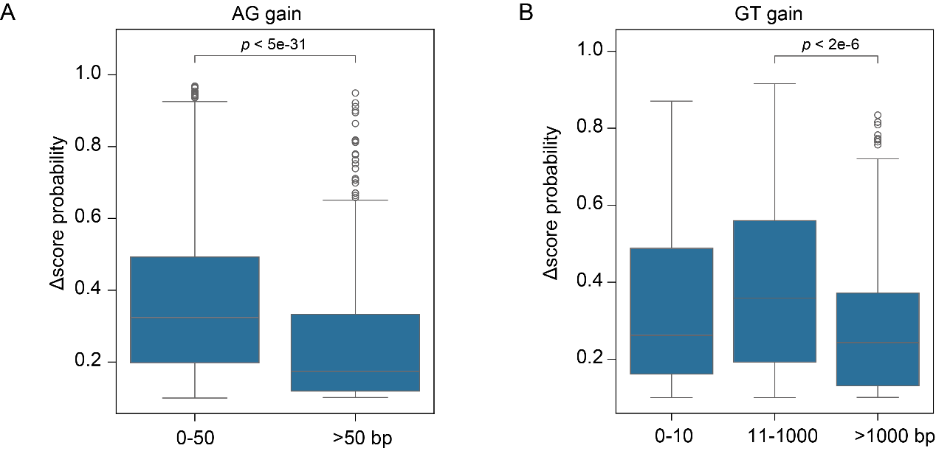
Fig. S2. Distance-grouped comparison of ΔSplice probability for AG and GT gain variants.
(A) Boxplot showing ΔSplice probability of AG gain variants grouped by distance from the canonical AG (≤50 bp and >50 bp). Statistical significance was assessed using Mann-Whitney U test.
(B) Boxplot showing ΔSplice probability of GT gain variants grouped by distance from the canonical GT (<10 bp, 10–1000 bp, and >1000 bp). Statistical significance was assessed using Mann-Whitney U test with Bonferroni correction.

