SUPPLEMENTARY MATERIALS for
Weight loss maintenance after tirzepatide cessation in people with overweight/obesity:
a real-world follow-up of the phase 3 SURMOUNT-CN trial

Supplementary Table S1 Patient characteristics at trial baseline (Week 0; EAP).
 | Tirzepatide 10 mg  (n = 57) | Tirzepatide 15 mg  (n = 51) | Placebo  (n = 44) | Total  (n = 152)
Age (years) | 35.2 (7.5) | 36.8 (9.6) | 36.1 (10.6) | 36.0 (9.1)
Female sex, n (%) | 30 (52.6) | 24 (47.1) | 17 (38.6) | 71 (46.7)
Region, n (%)
Northwest China | 1 (1.8) | 2 (3.9) | 1 (2.3) | 4 (2.6)
Northern China | 15 (26.3) | 18 (35.3) | 14 (31.8) | 47 (30.9)
Southern China | 41 (71.9) | 31 (60.8) | 29 (65.9) | 101 (66.4)
Body weight (kg) | 92.1 (16.3) | 91.3 (15.3) | 94.5 (16.7) | 92.5 (16.0)
BMI (kg/m²) | 32.7 (4.1) | 32.0 (3.6) | 32.6 (3.6) | 32.4 (3.8)
BMI category at trial baseline, n (%)
≥ 24.0 and < 28.0 kg/m² | 3 (5.3) | 4 (7.8) | 3 (6.8) | 10 (6.6)
≥ 28.0 and < 30.0 kg/m² | 12 (21.1) | 12 (23.5) | 7 (15.9) | 31 (20.4)
≥ 30.0 and < 35.0 kg/m² | 26 (45.6) | 25 (49.0) | 24 (54.5) | 75 (49.3)
≥ 35.0 kg/m² | 16 (28.1) | 10 (19.6) | 10 (22.7) | 36 (23.7)
Waist circumference, cm | 104.4 (9.8) | 104.1 (10.8) | 106.0 (10.2) | 104.8 (10.2)
Comorbidity, n (%)
Hypertension | 15 (26.3) | 12 (23.5) | 12 (27.3) | 39 (25.7)
Dyslipidemia | 39 (68.4) | 39 (76.5) | 37 (84.1) | 115 (75.7)
Obstructive sleep apnea | 5 (8.8) | 2 (3.9) | 1 (2.3) | 8 (5.3)
Atherosclerotic cardiovascular disease | 4 (7.0) | 1 (2.0) | 0 | 5 (3.3)
Pre-diabetes | NA | NA | NA | NA
None of the above | 13 (22.8) | 8 (15.7) | 6 (13.6) | 27 (17.8)
Data are mean (SD) unless otherwise specified. BMI, body mass index; EAP, eligible analysis population; NA, not applicable; SD, standard deviation.
Supplementary Table S2 Percentage and absolute change in body weight (kg) from Week 0 (EAP).
 | Tirzepatide 10 mg  (n = 57) | Tirzepatide 15 mg  (n = 51) | Placebo  (n = 44)
Change from Week 0 to Week 52
n | 56 | 49 | 42
Percentage change (%) | −15.326 (8.038) | −19.884 (8.776) | −3.798 (6.083)
Absolute change (kg) | −13.893 (7.176) | −18.078 (8.361) | −3.464 (5.706)
Change from Week 0 to Week 56
n | 54 | 48 | 40
Percentage change (%) | −12.815 (7.187) | −17.869 (8.882) | −2.871 (6.576)
Absolute change (kg) | −11.680 (6.491) | −16.233 (8.436) | −2.615 (6.262)
Change from Week 0 to Week 78
n | 54 | 49 | 39
Percentage change (%) | −8.738 (6.927) | −10.567 (10.231) | −2.472 (7.032)
Absolute change (kg) | −8.012 (6.689) | −9.688 (9.825) | −2.119 (6.647)
Weight loss category from Week 0 to Week 52
< 5% | 4 (7.0) | 3 (5.9) | 24 (54.5)
≥ 5% and < 10% | 11 (19.3) | 4 (7.8) | 10 (22.7)
≥ 10% and < 15% | 10 (17.5) | 7 (13.7) | 6 (13.6)
≥ 15% and < 20% | 16 (28.1) | 12 (23.5) | 2 (4.5)
≥ 20% | 15 (26.3) | 23 (45.1) | 0
Weight loss category from Week 0 to Week 78
n | 54 | 49 | 39
< 5% | 20 (37.0) | 15 (30.6) | 26 (66.7)
≥ 5% and < 10% | 11 (20.4) | 8 (16.3) | 7 (17.9)
≥ 10% and < 15% | 14 (25.9) | 9 (18.4) | 4 (10.3)
≥ 15% and < 20% | 4 (7.4) | 7 (14.3) | 2 (5.1)
≥ 20% | 5 (9.3) | 10 (20.4) | 0
Data are mean (SD) unless otherwise specified. EAP, eligible analysis population; SD, standard deviation.

Supplementary Table S3 Absolute change in waist circumference (cm) from Week 0 (EAP)
 | Tirzepatide 10 mg  (n = 57) | Tirzepatide 15 mg  (n = 51) | Placebo  (n = 44)
Change from Week 0 to Week 52
n | 56 | 49 | 42
Absolute change (cm) | −12.817 (6.863) | −15.592 (7.257) | −3.702 (4.513)
Change from Week 0 to Week 56
n | 54 | 48 | 40
Absolute change (cm) | −11.444 (6.759) | −14.906 (7.946) | −3.094 (4.888)
Change from Week 0 to Week 65
n | 29 | 26 | 19
Absolute change (cm) | −11.643 (7.462) | −11.519 (8.937) | −3.829 (5.871)
Change from Week 0 to Week 78
n | 54 | 49 | 39
Absolute change (cm) | −10.496 (8.074) | −10.613 (9.290) | −4.015 (7.209)
Data are mean (SD) unless otherwise specified. EAP, eligible analysis population; SD, standard deviation.
Supplementary Table S4 Percentage (%) and absolute (kg) change in body weight from Week 52 (EAP).
 | Tirzepatide 10 mg  (n = 57) | Tirzepatide 15 mg  (n = 51) | Placebo  (n = 44)
Change from Week 52 to Week 56
n | 53 | 46 | 38
Percentage change (%) | 2.984 (2.752) | 2.626 (2.105) | 0.583 (2.043)
Absolute change (kg) | 2.192 (1.770) | 1.889 (1.535) | 0.547 (1.845)
Proportion of weight regain (%)* | 30.614 (31.983) | 18.253 (41.712) | 0.620 (164.837)
Change from Week 52 to Week 65
n | 29 | 32 | 21
Percentage change (%) | 4.013 (4.419) | 7.733 (6.319) | 0.273 (3.308)
Absolute change (kg) | 2.750 (3.197) | 5.367 (4.279) | 0.369 (3.227)
Proportion of weight regain (%) | 72.784 (174.469) | 56.156 (40.135) | 76.998 (79.137)
Change from Week 52 to Week 78
n | 53 | 47 | 37
Percentage change (%) | 9.061 (7.412) | 12.326 (9.881) | 1.825 (5.166)
Absolute change (kg) | 6.502 (5.604) | 8.723 (6.857) | 1.664 (5.085)
Proportion of weight regain (%) | 100.000 (0.000) | 100.000 (0.000) | 100.000 (0.000)
Data are mean (SD) unless otherwise specified. *Proportion of weight regain = (body weight at Week 56/Week 65/Week 78 − body weight at Week 52)/(body weight at Week 78 − body weight at Week 52) × 100%. EAP, eligible analysis population; SD, standard deviation.
Supplementary Table S5 Absolute change in waist circumference (cm) from Week 52 (EAP).
 | Tirzepatide 10 mg  (n = 57) | Tirzepatide 15 mg  (n = 51) | Placebo  (n = 44)
Change from Week 52 to Week 56
n | 53 | 46 | 38
Absolute change (cm) | 1.250 (2.290) | 1.098 (1.649) | 0.243 (1.434)
Change from Week 52 to Week 65
n | 29 | 26 | 19
Absolute change (cm) | 1.478 (4.598) | 2.971 (5.750) | 0.974 (4.182)
Change from Week 52 to Week 78
n | 53 | 47 | 37
Absolute change (cm) | 2.891 (7.481) | 5.526 (6.523) | −0.516 (5.582)
Data are mean (SD) unless otherwise specified. EAP, eligible analysis population; SD, standard deviation.

Supplementary Figure S1 Patient flow diagram.
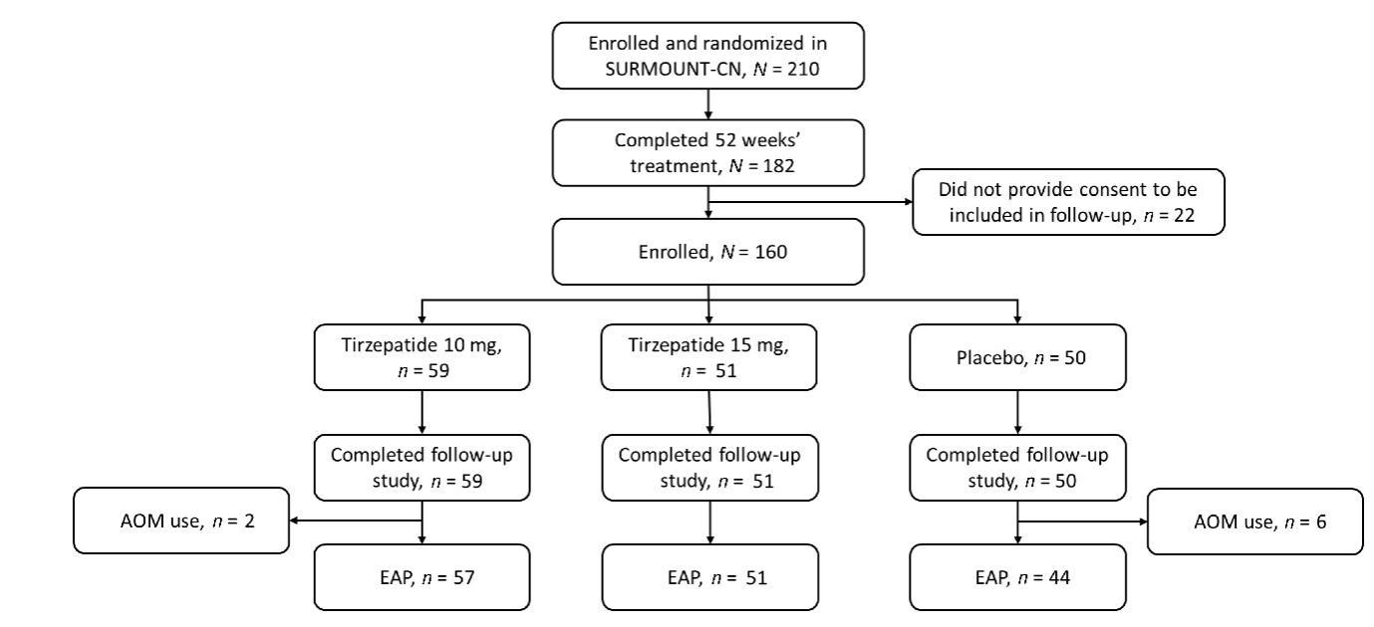
AOM, anti-obesity medication; EAP, eligible analysis population.

