Supplementary material for

Spatially segregated multiomics decodes metformin-mediated functional-specific metabolic characteristics in diabetic kidney disease

Shi Qiu¹, Dandan Xie¹, Sifan Guo¹, Zhibo Wang¹, Xian Wang¹, Ying Cai^{1,2}, Chunsheng Lin², Hong Yao³, Yu Guan², Qiqi Zhao², Qiang Yang², Yiqiang Xie^{1,*}, Songqi Tang^{1,*}, Aihua Zhang^{1,2,*}
¹International Advanced Functional Omics Platform, Scientific Experiment Center, Public Research Center, Hainan Medical University, Haikou, Hainan 571199, China
²Graduate School, Second Affiliated Hospital, Heilongjiang University of Chinese Medicine, Harbin, Heilongjiang 150040, China
³First Affiliated Hospital, Harbin Medical University, Harbin, Heilongjiang 150040, China

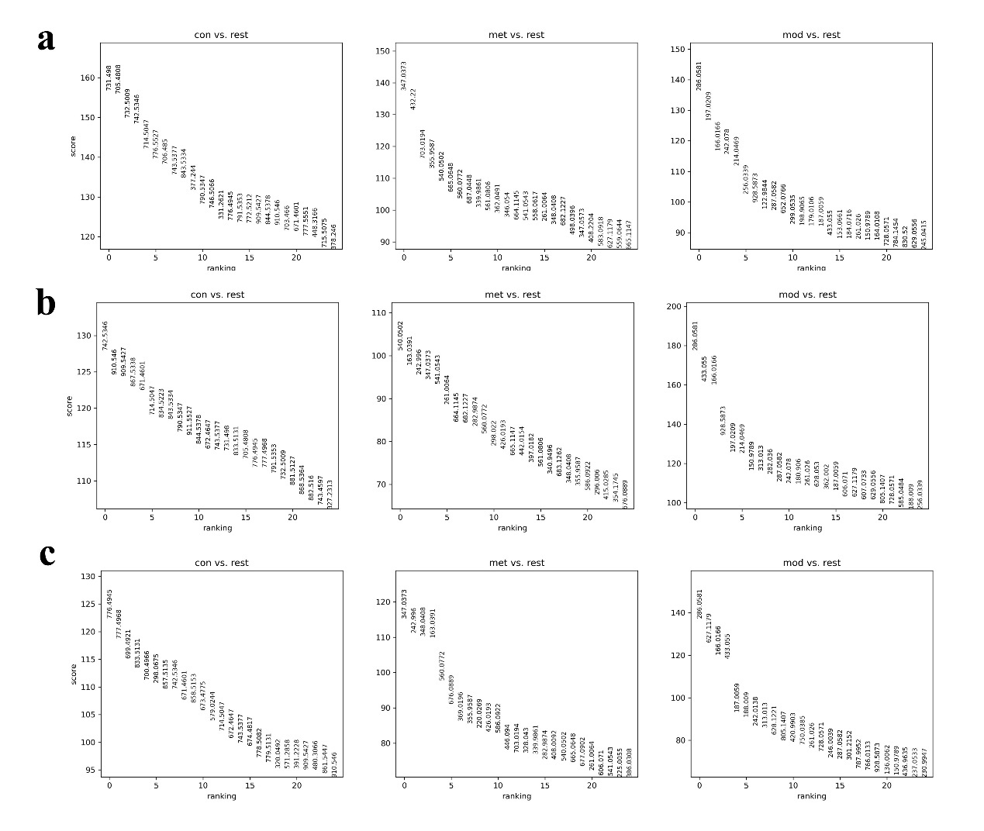
Supplementary Figure S1 Matrix diagram on the selection analysis of metabolite biomarkers in db/db mouse kidney tissues. (a) Z-score analysis of ion variation associated with kidney tissue (Cor) region in transgenic db/db mice. (b) Z-score analysis of ion ranking in mouse kidney tissue (OM) region. (c) Z-score analysis of ion changes associated with db/db mouse kidney tissue (IM) region.

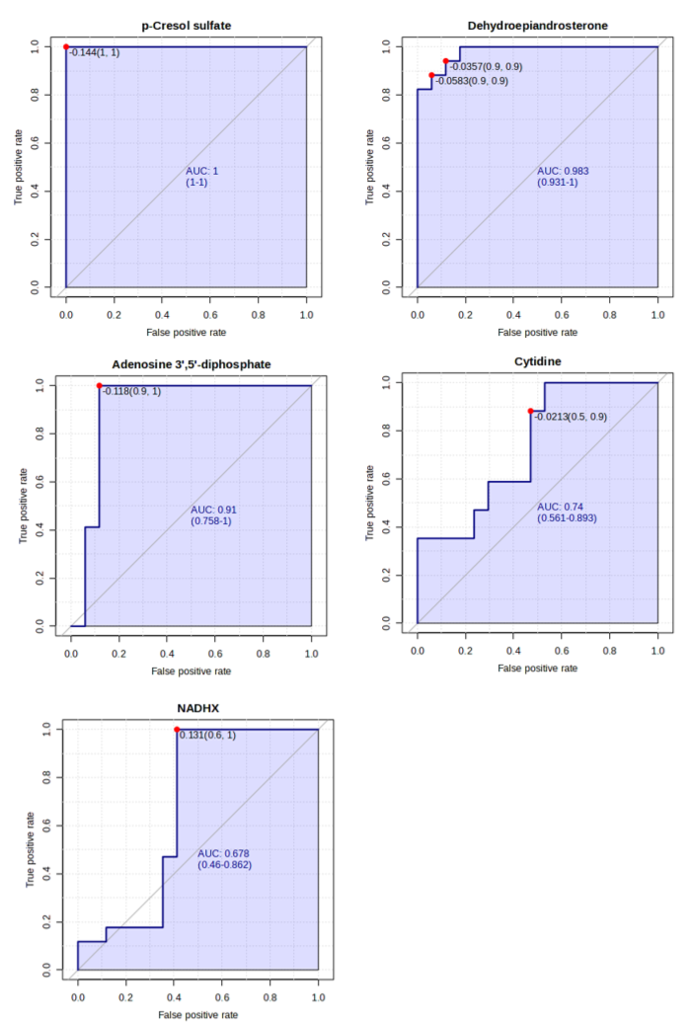
Supplementary Figure S2 The ROC analysis of serum metabolite biomarkers in DN patients.

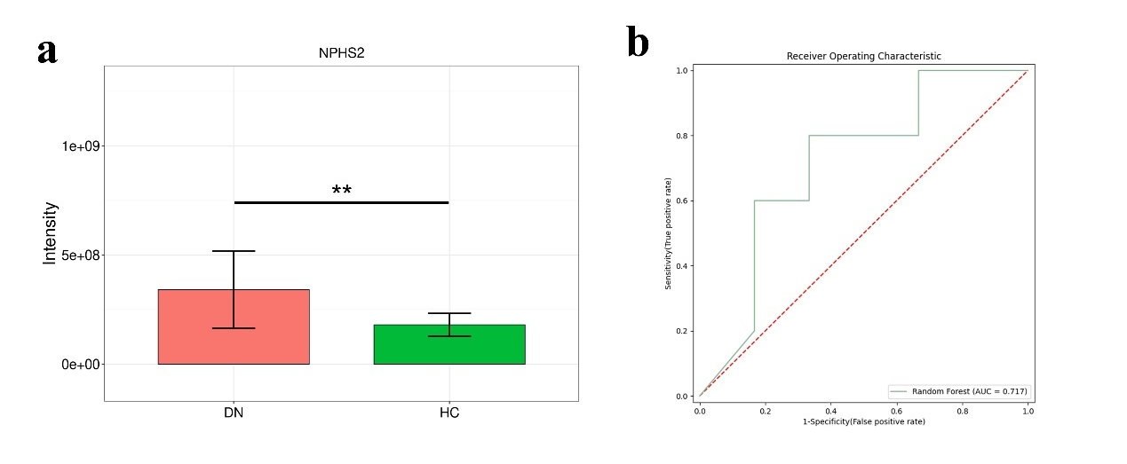
Supplementary Figure S3 The expression level and ROC analysis of NPHS2 protein in DN patients. (a) Statistical comparison of expression level of NPHS2 protein between DN patients and HCs. (b) ROC curve analysis of random forest for discriminatory power of NPHS2 protein between DN patients and HCs.

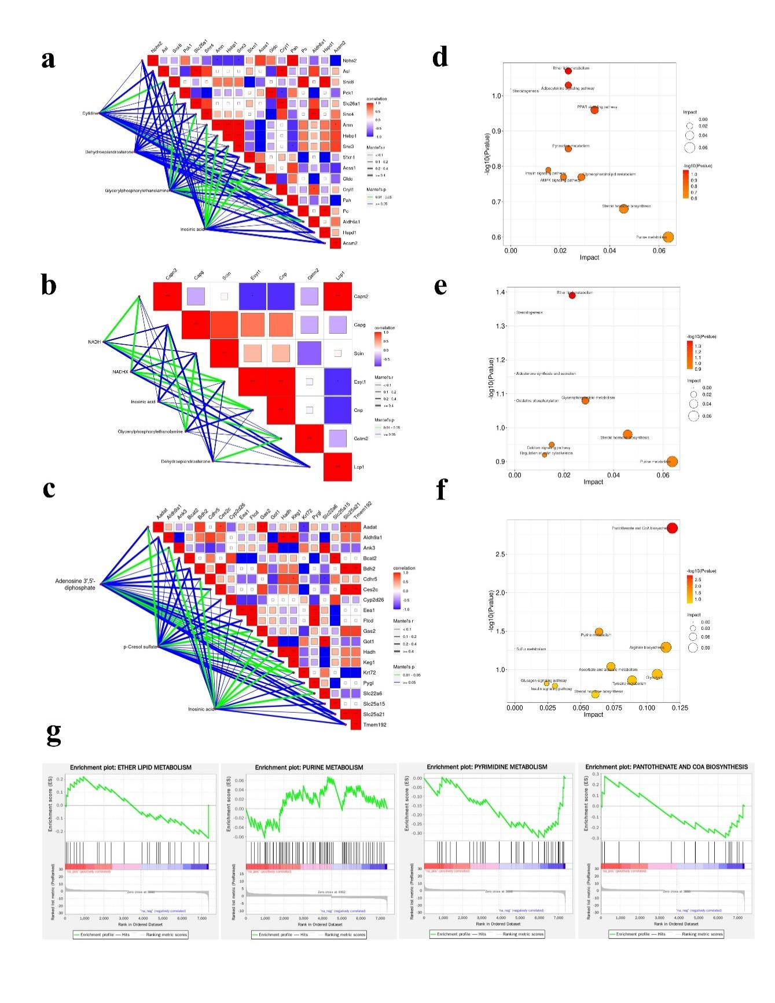
Supplementary Figure S4 Pathway enrichment and correlation analyses between metabolite and protein alterations of different kidney regions. (a) Association of the metabolite levels and protein levels in Cor region-specific changes in response to MET treatment. (b) Correlations analysis of the metabolite and protein levels in the OM region in response to MET treatment. (c) Association of the metabolite levels and protein levels in IM region-specific changes in response to MET treatment. (d) Enriched pathway sets of metabolite and protein alterations in the Cor region related to MET response. (e) Pathway enrichment analysis of metabolite and protein alterations in the OM region related to MET response. (f) Enriched pathway sets of metabolite and protein alterations in the IM region related to MET response. (g) GSEA analysis of pathway enrichment.

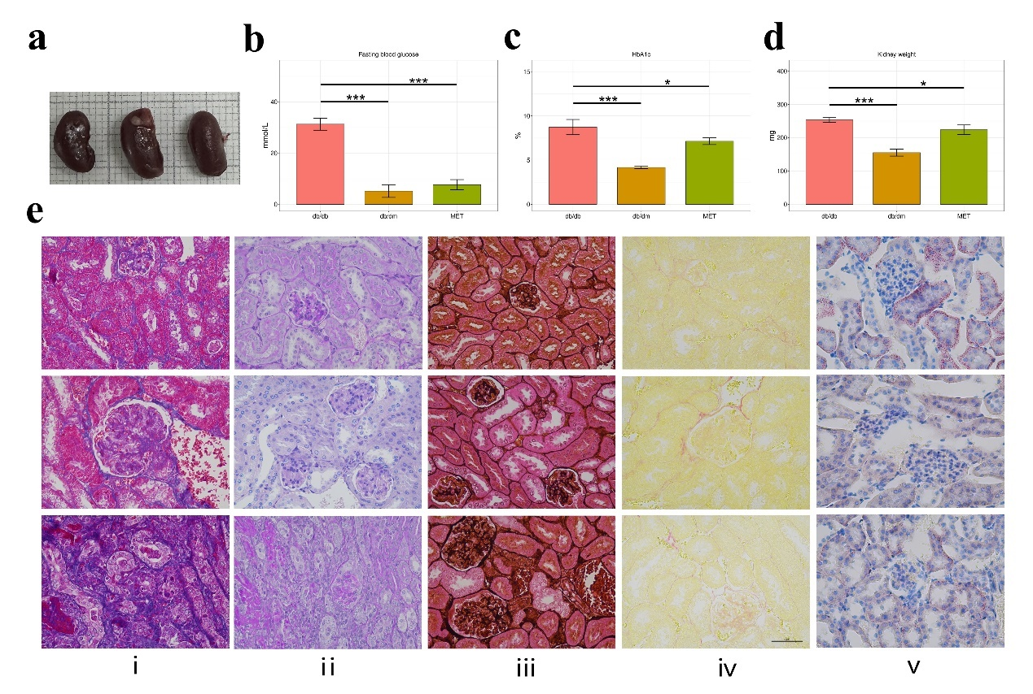

Supplementary Figure S5 MET-ameliorated pathological and biochemical indicators in db/db mice. (a) Representative mouse kidneys of db/dm mice (left), db/db (middle) mice, and MET (right) group. (b) Quantitative analysis of blood glucose. (c) HOMA-IR analysis. (d) Quantitative analysis of kidney weight. (e) Masson staining (ⅰ), PAS staining (ⅱ), PASM staining (ⅲ), PSR staining (ⅳ), Oil Red staining (ⅴ) images (magnification 400×) of kidney tissue sections in db/dm mice (up), db/db mice (middle), and MET group (down).

Supplementary Table S1 The metabolite biomarkers in db/db mouse kidney tissues selected from Z-score analysis.
Detected m/z | Ion | Adduct | Molecule Ids | Name
187.0059 | C7H8O4S-H- | M-H | HMDB0011635 | p-cresol sulfate
214.0469 | C5H14NO6P-H- | M-H | HMDB0000114 | Glycerylphosphorylethanolamine
242.078 | C9H13N3O5-H- | M-H | HMDB0000089 | Cytidine
287.0582 | C15H12O6-H- | M-H | HMDB0000077 | Dehydroepiandrosterone
347.0373 | C10H13N4O8P-H- | M-H | HMDB0000175 | Inosinic acid
426.0193 | C10H15N5O10P2-H- | M-H | HMDB0000061 | Adenosine 3’,5’-diphosphate
664.1145 | C21H29N7O14P2-H- | M-H | HMDB0001487 | NADH
682.1227 | C21H31N7O15P2-H- | M-H | HMDB0059644 | NADHX

Supplementary Table S2 The correlation analysis (Mantel test) matrix between metabolite expression levels and patient features in clinic.
Metabolites | Clinical parameters | Correlation | P value | Mantels_r | Mantels_P
NADHX | eGFR | 0.46 | 0.00* | ≥ 0.4 | < 0.01
Cytidine | BUN | 0.24 | 0.01* | 0.2−0.4 | < 0.01
NADHX | Serum creatinine | 0.20 | 0.04* | 0.2−0.4 | 0.01−0.05
p-cresol sulfate | Serum creatinine | 0.24 | 0.05 | 0.2−0.4 | ≥ 0.05
Adenosine 3’,5’-diphosphate | BUN | 0.34 | 0.06 | 0.2−0.4 | ≥ 0.05
NADHX | Blood glucose | 0.29 | 0.06 | 0.2−0.4 | ≥ 0.05
Dehydroepiandrosterone | Serum creatinine | 0.12 | 0.09 | 0.1−0.2 | ≥ 0.05
Adenosine 3’,5’-diphosphate | Serum creatinine | 0.10 | 0.17 | 0.1−0.2 | ≥ 0.05
p-cresol sulfate | eGFR | 0.02 | 0.28 | < 0.1 | ≥ 0.05
Dehydroepiandrosterone | eGFR | 0.03 | 0.32 | < 0.1 | ≥ 0.05
Dehydroepiandrosterone | BUN | 0.03 | 0.38 | < 0.1 | ≥ 0.05
Cytidine | Serum creatinine | 0.00 | 0.40 | < 0.1 | ≥ 0.05
NADHX | BUN | 0.00 | 0.43 | < 0.1 | ≥ 0.05
p-cresol sulfate | BUN | −0.04 | 0.47 | < 0.1 | ≥ 0.05
Dehydroepiandrosterone | Blood glucose | −0.02 | 0.49 | < 0.1 | ≥ 0.05
Cytidine | Blood glucose | −0.04 | 0.61 | < 0.1 | ≥ 0.05
Adenosine 3’,5’-diphosphate | Blood glucose | −0.06 | 0.62 | < 0.1 | ≥ 0.05
Adenosine 3’,5’-diphosphate | eGFR | −0.09 | 0.70 | < 0.1 | ≥ 0.05
p-cresol sulfate | Blood glucose | −0.14 | 0.81 | < 0.1 | ≥ 0.05
Cytidine | eGFR | −0.07 | 0.86 | < 0.1 | ≥ 0.05

Supplementary Table S3 The differentially expressed proteins in db/db mouse kidney Cor region.
No. | Gene name | Coverage [%] | Peptides | Unique peptides | KEGG KO No.
1 | Acsm2 | 76.17 | 53 | 53 | K01896
2 | Acss1 | 34.16 | 24 | 24 | K01895
3 | Aldh6a1 | 49.35 | 30 | 30 | K00140
4 | Amn | 27.07 | 11 | 11 | K18259
5 | Asl | 49.78 | 26 | 26 | K01755
6 | Cryl1 | 42.95 | 15 | 15 | K13247
7 | Gldc | 24.88 | 23 | 23 | K00281
8 | Hebp1 | 36.84 | 7 | 7
9 | Hspd1 | 54.8 | 42 | 42 | K04077
10 | Nphs2 | 26.75 | 9 | 9 | K18268
11 | Pah | 56.07 | 28 | 28 | K00500
12 | Pc | 50.85 | 59 | 59 | K01958
13 | Pck1 | 51.61 | 35 | 35 | K01596
14 | Sfxn1 | 34.78 | 13 | 13 | K23500
15 | Slc26a1 | 15.34 | 10 | 10 | K14700
16 | Snx3 | 42.59 | 9 | 9 | K17918
17 | Snx4 | 40 | 17 | 17 | K17919
18 | Snx8 | 17.65 | 8 | 8 | K17922

Supplementary Table S4 The differentially expressed proteins in db/db mouse kidney OM region.
No. | Gene name | Coverage [%] | Peptides | Unique peptides | KEGG KO No.
1 | Capg | 22.73 | 7 | 7 | K10368
2 | Capn2 | 26.14 | 18 | 18 | K03853
3 | Cnp | 29.76 | 12 | 12 | K01121
4 | Esyt1 | 25.37 | 28 | 28
5 | Gstm2 | 71.56 | 19 | 16 | K00799
6 | Lcp1 | 45.45 | 25 | 20 | K17276
7 | Scin | 40.14 | 28 | 28 | K05768

Supplementary Table S5 The differentially expressed proteins in db/db mouse kidney IM region.
No. | Gene name | Coverage [%] | Peptides | Unique peptides | KEGG KO No.
1 | Aadat | 44.71 | 21 | 21 | K00825
2 | Aldh9a1 | 50.4 | 29 | 29 | K00149
3 | Ank3 | 33.35 | 59 | 51 | K10380
4 | Bcat2 | 40.71 | 16 | 16 | K00826
5 | Bdh2 | 46.94 | 14 | 14 | K25939
6 | Cdhr5 | 10.23 | 8 | 8 | K16505
7 | Ces2c | 31.73 | 16 | 13 | K03927
8 | Cyp2d26 | 38.4 | 20 | 20 | K07414
9 | Eea1 | 50.11 | 71 | 70 | K12478
10 | Ftcd | 26.25 | 12 | 12 | K13990
11 | Gas2 | 33.76 | 9 | 9 | K24627
12 | Got1 | 63.44 | 27 | 27 | K14454
13 | Hadh | 40.76 | 18 | 18 | K00022
14 | Keg1 | 50.17 | 17 | 17 | K00628
15 | Krt72 | 3.65 | 2 | 1 | K07605
16 | Pygl | 35.18 | 33 | 33 | K00688
17 | Slc22a6 | 12.11 | 8 | 8 | K08203
18 | Slc25a15 | 32.23 | 10 | 10 | K15101
19 | Slc25a21 | 39.26 | 13 | 13 | K15110
20 | Tmem192 | 18.05 | 4 | 4

Supplementary Table S6 Association of the metabolite expression and protein levels in the Cor region.
Metabolite | Protein | Correlation | P value | Mantels_r | Mantels_P
Cytidine | Nphs2 | −0.87 | 0.04* | < 0.1 | ≥ 0.05
Cytidine | Asl | 0.84 | 0.10 | ≥ 0.4 | ≥ 0.05
Cytidine | Sfxn1 | 0.83 | 0.07 | ≥ 0.4 | ≥ 0.05
Cytidine | Hspd1 | 0.56 | 0.12 | ≥ 0.4 | ≥ 0.05
Cytidine | Acss1 | 0.39 | 0.27 | 0.2−0.4 | ≥ 0.05
Cytidine | Slc26a1 | 0.38 | 0.25 | 0.2−0.4 | ≥ 0.05
Cytidine | Cryl1 | 0.22 | 0.28 | 0.2−0.4 | ≥ 0.05
Cytidine | Gldc | 0.22 | 0.30 | 0.2−0.4 | ≥ 0.05
Cytidine | Aldh6a1 | 0.21 | 0.30 | 0.2−0.4 | ≥ 0.05
Cytidine | Snx4 | 0.15 | 0.30 | 0.1−0.2 | ≥ 0.05
Cytidine | Pck1 | 0.05 | 0.42 | < 0.1 | ≥ 0.05
Cytidine | Amn | 0.02 | 0.32 | < 0.1 | ≥ 0.05
Cytidine | Snx3 | 0.00 | 0.35 | < 0.1 | ≥ 0.05
Cytidine | Hebp1 | 0.00 | 0.35 | < 0.1 | ≥ 0.05
Cytidine | Pah | −0.10 | 0.50 | < 0.1 | ≥ 0.05
Cytidine | Acsm2 | −0.13 | 0.47 | < 0.1 | >= 0.05
Dehydroepiandrosterone | Nphs2 | 0.87 | 0.02 | ≥ 0.4 | 0.01 - 0.05
Dehydroepiandrosterone | Slc26a1 | 0.71 | 0.10 | ≥ 0.4 | ≥ 0.05
Dehydroepiandrosterone | Snx8 | 0.65 | 0.12 | ≥ 0.4 | ≥ 0.05
Dehydroepiandrosterone | Pc | 0.63 | 0.12 | ≥ 0.4 | ≥ 0.05
Dehydroepiandrosterone | Cryl1 | 0.57 | 0.18 | ≥ 0.4 | ≥ 0.05
Dehydroepiandrosterone | Gldc | 0.57 | 0.20 | ≥ 0.4 | ≥ 0.05
Dehydroepiandrosterone | Aldh6a1 | 0.56 | 0.20 | ≥ 0.4 | ≥ 0.05
Dehydroepiandrosterone | Sfxn1 | 0.56 | 0.12 | ≥ 0.4 | ≥ 0.05
Dehydroepiandrosterone | Snx4 | 0.50 | 0.20 | ≥ 0.4 | ≥ 0.05
Dehydroepiandrosterone | Pck1 | 0.37 | 0.23 | 0.2−0.4 | ≥ 0.05
Dehydroepiandrosterone | Hspd1 | 0.29 | 0.12 | 0.2−0.4 | ≥ 0.05
Dehydroepiandrosterone | Acss1 | 0.16 | 0.42 | 0.1−0.2 | ≥ 0.05
Dehydroepiandrosterone | Pah | 0.06 | 0.50 | < 0.1 | ≥ 0.05
Dehydroepiandrosterone | Amn | −0.09 | 0.42 | < 0.1 | ≥ 0.05
Dehydroepiandrosterone | Snx3 | −0.10 | 0.42 | < 0.1 | ≥ 0.05
Dehydroepiandrosterone | Hebp1 | −0.10 | 0.42 | < 0.1 | ≥ 0.05
Dehydroepiandrosterone | Acsm2 | −0.16 | 0.43 | < 0.1 | ≥ 0.05
Glycerylphosphorylethanolamine | Nphs2 | 0.91 | 0.03 | ≥ 0.4 | 0.01−0.05
Glycerylphosphorylethanolamine | Pah | 0.92 | 0.10 | ≥ 0.4 | ≥ 0.05
Glycerylphosphorylethanolamine | Aldh6a1 | 0.76 | 0.02 | ≥ 0.4 | 0.01−0.05
Glycerylphosphorylethanolamine | Gldc | 0.75 | 0.02 | ≥ 0.4 | 0.01−0.05
Glycerylphosphorylethanolamine | Cryl1 | 0.74 | 0.03 | ≥ 0.4 | 0.01−0.05
Glycerylphosphorylethanolamine | Slc26a1 | 0.69 | 0.10 | ≥ 0.4 | ≥ 0.05
Glycerylphosphorylethanolamine | Acsm2 | 0.59 | 0.15 | ≥ 0.4 | ≥ 0.05
Glycerylphosphorylethanolamine | Hebp1 | 0.47 | 0.30 | ≥ 0.4 | ≥ 0.05
Glycerylphosphorylethanolamine | Snx3 | 0.47 | 0.30 | ≥ 0.4 | ≥ 0.05
Glycerylphosphorylethanolamine | Amn | 0.46 | 0.30 | ≥ 0.4 | ≥ 0.05
Glycerylphosphorylethanolamine | Asl | 0.28 | 0.12 | 0.2−0.4 | ≥ 0.05
Glycerylphosphorylethanolamine | Acss1 | 0.22 | 0.27 | 0.2−0.4 | ≥ 0.05
Glycerylphosphorylethanolamine | Hspd1 | 0.10 | 0.57 | < 0.1 | ≥ 0.05
Glycerylphosphorylethanolamine | Sfxn1 | −0.06 | 0.50 | < 0.1 | ≥ 0.05
Glycerylphosphorylethanolamine | Pc | −0.10 | 0.43 | < 0.1 | ≥ 0.05
Glycerylphosphorylethanolamine | Snx8 | −0.12 | 0.43 | < 0.1 | ≥ 0.05
Inosinic acid | Nphs2 | 0.89 | 0.03 | ≥ 0.4 | 0.01−0.05
Inosinic acid | Amn | 0.83 | 0.02 | ≥ 0.4 | 0.01−0.05
Inosinic acid | Sfxn1 | 0.83 | 0.07 | ≥ 0.4 | ≥ 0.05
Inosinic acid | Snx3 | 0.82 | 0.02 | ≥ 0.4 | 0.01−0.05
Inosinic acid | Hebp1 | 0.82 | 0.02 | ≥ 0.4 | 0.01−0.05
Inosinic acid | Pc | 0.74 | 0.07 | ≥ 0.4 | ≥ 0.05
Inosinic acid | Snx8 | 0.70 | 0.07 | ≥ 0.4 | ≥ 0.05
Inosinic acid | Acsm2 | 0.69 | 0.07 | ≥ 0.4 | ≥ 0.05
Inosinic acid | Pah | 0.40 | 0.12 | 0.2−0.4 | ≥ 0.05
Inosinic acid | Asl | 0.23 | 0.18 | 0.2−0.4 | ≥ 0.05
Inosinic acid | Pck1 | 0.06 | 0.43 | < 0.1 | ≥ 0.05
Inosinic acid | Snx4 | −0.06 | 0.43 | < 0.1 | ≥ 0.05
Inosinic acid | Slc26a1 | −0.07 | 0.42 | < 0.1 | ≥ 0.05
Inosinic acid | Aldh6a1 | −0.14 | 0.43 | < 0.1 | ≥ 0.05
Inosinic acid | Cryl1 | −0.15 | 0.42 | < 0.1 | ≥ 0.05
Inosinic acid | Gldc | −0.15 | 0.43 | < 0.1 | ≥ 0.05

Supplementary Table S7 Association of the metabolite levels and protein levels in the OM region.
Metabolite | Protein | Correlation | P value | Mantels_r | Mantels_P
Adenosine 3',5'-diphosphate | Aldh9a1 | 0.99 | 0.07 | ≥ 0.4 | ≥ 0.05
Inosinic acid | Slc22a6 | 0.98 | 0.03* | ≥ 0.4 | 0.01−0.05
Adenosine 3',5'-diphosphate | Bdh2 | 0.98 | 0.07 | ≥ 0.4 | ≥ 0.05
Inosinic acid | Cdhr5 | 0.96 | 0.02* | ≥ 0.4 | 0.01−0.05
Inosinic acid | Ank3 | 0.95 | 0.03* | ≥ 0.4 | 0.01−0.05
Inosinic acid | Keg1 | 0.95 | 0.03* | ≥ 0.4 | 0.01−0.05
Inosinic acid | Hadh | 0.94 | 0.03* | ≥ 0.4 | 0.01−0.05
p-Cresol sulfate | Cyp2d26 | 0.92 | 0.10 | ≥ 0.4 | ≥ 0.05
Adenosine 3',5'-diphosphate | Tmem192 | 0.92 | 0.07 | ≥ 0.4 | ≥ 0.05
Adenosine 3',5'-diphosphate | Got1 | 0.91 | 0.05 | ≥ 0.4 | 0.01−0.05
Inosinic acid | Got1 | 0.88 | 0.03* | ≥ 0.4 | 0.01−0.05
p-Cresol sulfate | Gas2 | 0.87 | 0.02* | ≥ 0.4 | 0.01−0.05
p-Cresol sulfate | Aadat | 0.85 | 0.02* | ≥ 0.4 | 0.01−0.05
Adenosine 3',5'-diphosphate | Hadh | 0.82 | 0.07 | ≥ 0.4 | ≥ 0.05
Adenosine 3',5'-diphosphate | Ank3 | 0.81 | 0.05 | ≥ 0.4 | 0.01−0.05
Adenosine 3',5'-diphosphate | Keg1 | 0.80 | 0.07 | ≥ 0.4 | ≥ 0.05
p-Cresol sulfate | Ces2c | 0.80 | 0.03* | ≥ 0.4 | 0.01−0.05
Adenosine 3',5'-diphosphate | Slc25a21 | 0.79 | 0.07 | ≥ 0.4 | ≥ 0.05
p-Cresol sulfate | Krt72 | 0.77 | 0.03* | ≥ 0.4 | 0.01−0.05
Adenosine 3',5'-diphosphate | Slc22a6 | 0.73 | 0.05 | ≥ 0.4 | 0.01−0.05
p-Cresol sulfate | Slc25a21 | 0.73 | 0.07 | ≥ 0.4 | ≥ 0.05
Adenosine 3',5'-diphosphate | Krt72 | 0.68 | 0.05 | ≥ 0.4 | 0.01−0.05
Inosinic acid | Aldh9a1 | 0.68 | 0.07 | ≥ 0.4 | ≥ 0.05
Adenosine 3',5'-diphosphate | Ces2c | 0.64 | 0.12 | ≥ 0.4 | ≥ 0.05
p-Cresol sulfate | Tmem192 | 0.61 | 0.12 | ≥ 0.4 | ≥ 0.05
Adenosine 3',5'-diphosphate | Aadat | 0.60 | 0.17 | ≥ 0.4 | ≥ 0.05
Adenosine 3',5'-diphosphate | Gas2 | 0.59 | 0.17 | ≥ 0.4 | ≥ 0.05
Adenosine 3',5'-diphosphate | Cdhr5 | 0.50 | 0.12 | ≥ 0.4 | ≥ 0.05
p-Cresol sulfate | Bdh2 | 0.47 | 0.12 | ≥ 0.4 | ≥ 0.05
Inosinic acid | Bdh2 | 0.47 | 0.30* | ≥ 0.4 | ≥ 0.05
p-Cresol sulfate | Ftcd | 0.45 | 0.30 | ≥ 0.4 | ≥ 0.05
p-Cresol sulfate | Eea1 | 0.42 | 0.30 | ≥ 0.4 | ≥ 0.05
p-Cresol sulfate | Bcat2 | 0.42 | 0.30 | ≥ 0.4 | ≥ 0.05
Inosinic acid | Slc25a15 | 0.40 | 0.25 | 0.2−0.4 | ≥ 0.05
Inosinic acid | Pygl | 0.34 | 0.25 | 0.2−0.4 | ≥ 0.05
p-Cresol sulfate | Pygl | 0.31 | 0.27 | 0.2−0.4 | ≥ 0.05
Inosinic acid | Tmem192 | 0.30 | 0.30 | 0.2−0.4 | ≥ 0.05
p-Cresol sulfate | Aldh9a1 | 0.28 | 0.27 | 0.2−0.4 | ≥ 0.05
p-Cresol sulfate | Slc25a15 | 0.28 | 0.27 | 0.2−0.4 | ≥ 0.05
Inosinic acid | Bcat2 | 0.11 | 0.25 | 0.1−0.2 | ≥ 0.05
Inosinic acid | Eea1 | 0.10 | 0.25 | 0.1−0.2 | ≥ 0.05
Adenosine 3',5'-diphosphate | Cyp2d26 | 0.09 | 0.50 | < 0.1 | ≥ 0.05
Inosinic acid | Slc25a21 | 0.09 | 0.30 | < 0.1 | ≥ 0.05
p-Cresol sulfate | Got1 | 0.08 | 0.42 | < 0.1 | ≥ 0.05
Inosinic acid | Ftcd | 0.03 | 0.28 | < 0.1 | ≥ 0.05
Adenosine 3',5'-diphosphate | Slc25a15 | 0.01 | 0.42 | < 0.1 | ≥ 0.05
p-Cresol sulfate | Hadh | −0.01 | 0.42 | < 0.1 | ≥ 0.05
Adenosine 3',5'-diphosphate | Pygl | −0.01 | 0.42 | < 0.1 | ≥ 0.05
p-Cresol sulfate | Keg1 | −0.02 | 0.42 | < 0.1 | ≥ 0.05
p-Cresol sulfate | Ank3 | −0.03 | 0.42 | < 0.1 | ≥ 0.05
Inosinic acid | Krt72 | −0.03 | 0.35 | < 0.1 | ≥ 0.05
p-Cresol sulfate | Cdhr5 | −0.08 | 0.57 | < 0.1 | ≥ 0.05
Inosinic acid | Ces2c | −0.10 | 0.38 | < 0.1 | ≥ 0.05
Inosinic acid | Aadat | −0.12 | 0.40 | < 0.1 | ≥ 0.05
Inosinic acid | Gas2 | −0.12 | 0.43 | < 0.1 | ≥ 0.05
Adenosine 3',5'-diphosphate | Eea1 | −0.13 | 0.42 | < 0.1 | ≥ 0.05
Adenosine 3',5'-diphosphate | Bcat2 | −0.14 | 0.42 | < 0.1 | ≥ 0.05
Adenosine 3',5'-diphosphate | Ftcd | −0.15 | 0.42 | < 0.1 | ≥ 0.05
p-Cresol sulfate | Slc22a6 | −0.16 | 0.42 | < 0.1 | ≥ 0.05
Inosinic acid | Cyp2d26 | −0.17 | 0.42 | < 0.1 | ≥ 0.05

Supplementary Table S8 Association of the metabolite levels and protein levels in the IM region.
Metabolite | Protein | Correlation | P value | Mantels_r | Mantels_P
Glycerylphosphorylethanolamine | Capg | 0.99 | 0.02* | ≥ 0.4 | 0.01−0.05
NADHX | Cnp | 0.98 | 0.02* | ≥ 0.4 | 0.01−0.05
NADHX | Esyt1 | 0.96 | 0.02* | ≥ 0.4 | 0.01−0.05
Glycerylphosphorylethanolamine | Scin | 0.94 | 0.03* | ≥ 0.4 | 0.01−0.05
NADH | Capn2 | 0.91 | 0.03* | ≥ 0.4 | 0.01−0.05
NADH | Cnp | 0.87 | 0.02* | ≥ 0.4 | 0.01−0.05
Inosinic acid | Gstm2 | 0.86 | 0.02* | ≥ 0.4 | 0.01−0.05
NADH | Esyt1 | 0.79 | 0.02* | ≥ 0.4 | 0.01−0.05
NADHX | Capn2 | 0.78 | 0.03* | ≥ 0.4 | 0.01−0.05
Dehydroepiandrosterone | Scin | 0.77 | 0.07 | ≥ 0.4 | ≥ 0.05
Dehydroepiandrosterone | Gstm2 | 0.76 | 0.02* | ≥ 0.4 | 0.01−0.05
Glycerylphosphorylethanolamine | Esyt1 | 0.70 | 0.10 | ≥ 0.4 | ≥ 0.05
Inosinic acid | Scin | 0.63 | 0.15 | ≥ 0.4 | ≥ 0.05
NADH | Lcp1 | 0.62 | 0.12 | ≥ 0.4 | ≥ 0.05
Dehydroepiandrosterone | Capg | 0.58 | 0.17 | ≥ 0.4 | ≥ 0.05
Glycerylphosphorylethanolamine | Cnp | 0.57 | 0.25 | ≥ 0.4 | ≥ 0.05
NADHX | Capg | 0.54 | 0.15 | ≥ 0.4 | ≥ 0.05
NADHX | Lcp1 | 0.48 | 0.12 | ≥ 0.4 | ≥ 0.05
Inosinic acid | Capg | 0.40 | 0.30 | ≥ 0.4 | ≥ 0.05
NADHX | Scin | 0.40 | 0.30 | 0.2−0.4 | ≥ 0.05
NADH | Capg | 0.30 | 0.28 | 0.2−0.4 | ≥ 0.05
Inosinic acid | Lcp1 | 0.23 | 0.27 | 0.2−0.4 | ≥ 0.05
NADH | Scin | 0.20 | 0.30 | 0.1−0.2 | ≥ 0.05
Dehydroepiandrosterone | Esyt1 | 0.16 | 0.42 | 0.1−0.2 | ≥ 0.05
Dehydroepiandrosterone | Lcp1 | 0.10 | 0.43 | 0.1−0.2 | ≥ 0.05
Dehydroepiandrosterone | Cnp | 0.06 | 0.42 | < 0.1 | ≥ 0.05
Glycerylphosphorylethanolamine | Capn2 | 0.05 | 0.30 | < 0.1 | ≥ 0.05
Glycerylphosphorylethanolamine | Gstm2 | 0.03 | 0.35 | < 0.1 | ≥ 0.05
Inosinic acid | Esyt1 | −0.02 | 0.57 | < 0.1 | ≥ 0.05
NADH | Gstm2 | −0.04 | 0.47 | < 0.1 | ≥ 0.05
Inosinic acid | Cnp | −0.08 | 0.57 | < 0.1 | ≥ 0.05
Glycerylphosphorylethanolamine | Lcp1 | −0.09 | 0.42 | < 0.1 | ≥ 0.05
NADHX | Gstm2 | −0.10 | 0.43 | < 0.1 | ≥ 0.05
Inosinic acid | Capn2 | −0.12 | 0.42 | < 0.1 | ≥ 0.05
Dehydroepiandrosterone | Capn2 | −0.13 | 0.43 | < 0.1 | ≥ 0.05

Supplementary Table S9 KEGG enrichment analysis for metabolites and proteins in the Cor region.
Pathway_name | Hits | P value | Impact
Purine metabolism | 1 | 0.25181 | 0.063725
Steroid hormone biosynthesis | 1 | 0.20996 | 0.045685
PPAR signaling pathway | 1 | 0.10851 | 0.033898
Glycerophospholipid metabolism | 1 | 0.17012 | 0.028571
Ether lipid metabolism | 1 | 0.085905 | 0.023256
Adipocytokine signaling pathway | 1 | 0.092743 | 0.023256
Pyrimidine metabolism | 1 | 0.14253 | 0.023256
AMPK signaling pathway | 1 | 0.17012 | 0.021277
Insulin signaling pathway | 1 | 0.16383 | 0.015152
Steroidogenesis | 1 | 0.096145 | 0

Supplementary Table S10 KEGG enrichment analysis for metabolites and proteins in the OM region.
Pathway_name | Hits | P value | Impact
Purine metabolism | 1 | 0.12658 | 0.063725
Steroid hormone biosynthesis | 1 | 0.10412 | 0.045685
Glycerophospholipid metabolism | 1 | 0.083317 | 0.028571
Ether lipid metabolism | 1 | 0.041037 | 0.023256
Calcium signaling pathway | 1 | 0.11148 | 0.014925
Regulation of actin cytoskeleton | 1 | 0.1214 | 0.012048
Steroidogenesis | 1 | 0.046063 | 0
Aldosterone synthesis and secretion | 1 | 0.069223 | 0
Oxidative phosphorylation | 1 | 0.083317 | 0

Supplementary Table S11 KEGG enrichment analysis for metabolites and proteins in the IM region.
Pathway_name | Hits | P value | Impact
Pantothenate and CoA biosynthesis | 2 | 0.001446 | 0.11905
Arginine biosynthesis | 1 | 0.050984 | 0.11429
Glycolysis | 1 | 0.11409 | 0.10769
Tyrosine metabolism | 1 | 0.13713 | 0.08871
Ascorbate and aldarate metabolism | 1 | 0.090469 | 0.072727
Purine metabolism | 2 | 0.03252 | 0.063725
Steroid hormone biosynthesis | 1 | 0.20996 | 0.060914
Insulin signaling pathway | 1 | 0.16383 | 0.030303
Glucagon signaling pathway | 1 | 0.15004 | 0.024096
Sulfur metabolism | 1 | 0.053351 | 0

Supplementary Table S12 The clinical characteristics of all the subjects.
 | DN | HC | P-value
Number | 17 | 17 | -
Male/female | 4/13 | 3/14 | -
Age | 57.94 ± 7.90 | 61.94 ± 5.99 | 0.11
BMI (kg/m²) | 23.87 ± 2.49 | 24.38 ± 2.05 | 0.52
Serum creatinine (μmol/L) | 508.15 ± 261.80 | 75.61 ± 13.18 | 0.00
BUN (mmol/L) | 19.14 ± 8.54 | 4.90 ± 1.48 | 0.00
eGFR (mL/(min × 1.73 m²)) | 15.06 ± 13.80 | 95.59 ± 12.97 | 0.00
Blood uric acid (μmol/L) | 435.76 ± 135.31 | 371.88 ± 73.86 | 0.10
Fasting blood glucose (mmol/L) | 9.44 ± 2.61 | 5.19 ± 0.54 | 0.00
TC (mmol/L) | 4.73 ± 0.98 | 5.81 ± 1.36 | 0.01
TG (mmol/L) | 1.81 ± 1.32 | 1.80 ± 0.83 | 1.00
HDL (mmol/L) | 1.01 ± 0.35 | 1.20 ± 0.25 | 0.08
LDL (mmol/L) | 2.46 ± 0.69 | 3.25 ± 0.99 | 0.01
Note: BUN, blood urea nitrogen; eGFR: estimated glomerular filtration rate.

