Supplementary material Abnormal adipose tissue-derived microbes drive metabolic disorder and exacerbate postnatal growth retardation in piglet
Tongxing Song^{1,‡}, Ming Qi^{2,3,‡}, Yucheng Zhu^{1,‡}, Nan Wang^{2,3}, Zhibo Liu¹, Na Li^{4,5}, Jiacheng Yang¹, Yanxu Han¹, Jing Wang^{2,3}, Shiyu Tao¹, Zhuqing Ren¹, Yulong Yin^{2,3}, Jinshui Zheng^{4,5,*}, Bie Tan^{2,3,*}
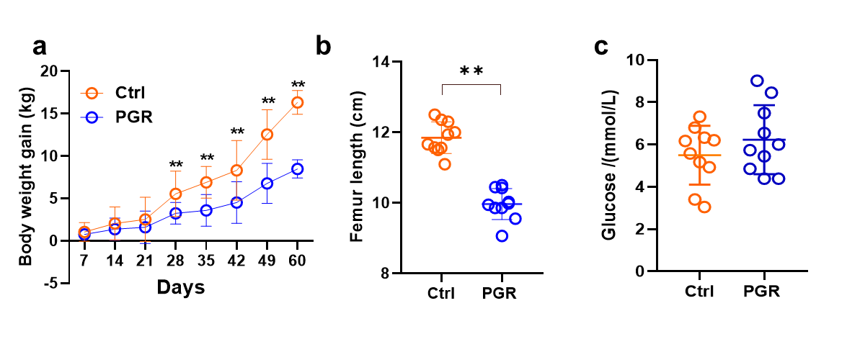
Supplementary Fig S1 Growth and metabolic performance of piglets in the Ctrl and PGR piglets. (a) Body weight gain of the Ctrl and PGR piglets. (b) Femur length of the Ctrl and PGR piglets. (c) Level of glucose in the serum of the Ctrl and PGR pigs. The statistical significance is denoted as: *P < 0.05, **P < 0.01.
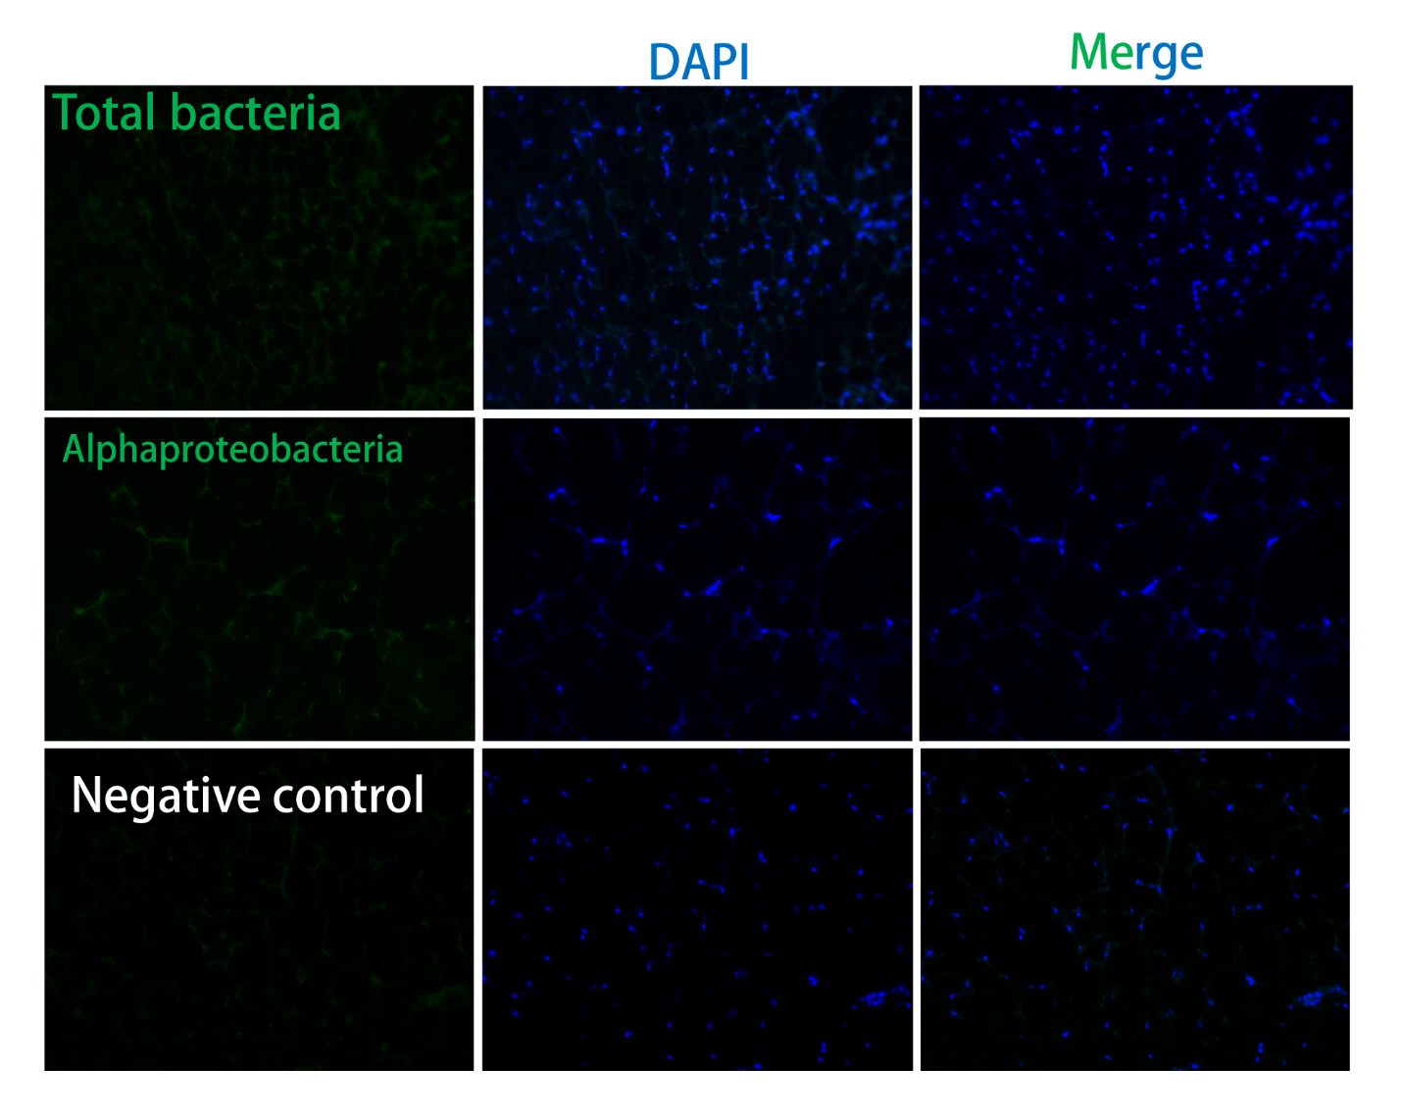
Supplementary Fig S2 CARD-FISH for adipose tissue from germ free mice. CARD-FISH analysis with total bacteria and alphaproteobacteria probes on adipose tissue section from germ-free mice. No probe serves as negative control. The magnification is 200.
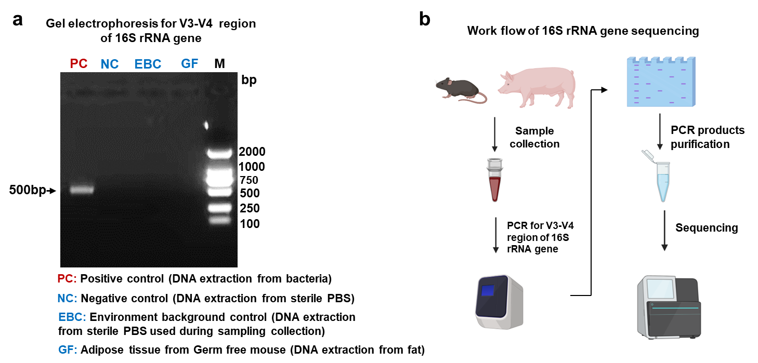
Supplementary Fig S3 PCR detection for the V3–V4 region of 16S rRNA gene. (a) Work flow of 16S rRNA gene sequencing. (b) Gel electrophoresis for V3–V4 region of 16S rRNA gene. PC: positive control (DNA extraction from bacteria); NC: negative control (DNA extraction from sterile PBS); EBC: environment background control (DNA extraction from sterile PBS used during sampling collection); GF: Adipose tissue from germ free mouse (DNA extraction from fat).

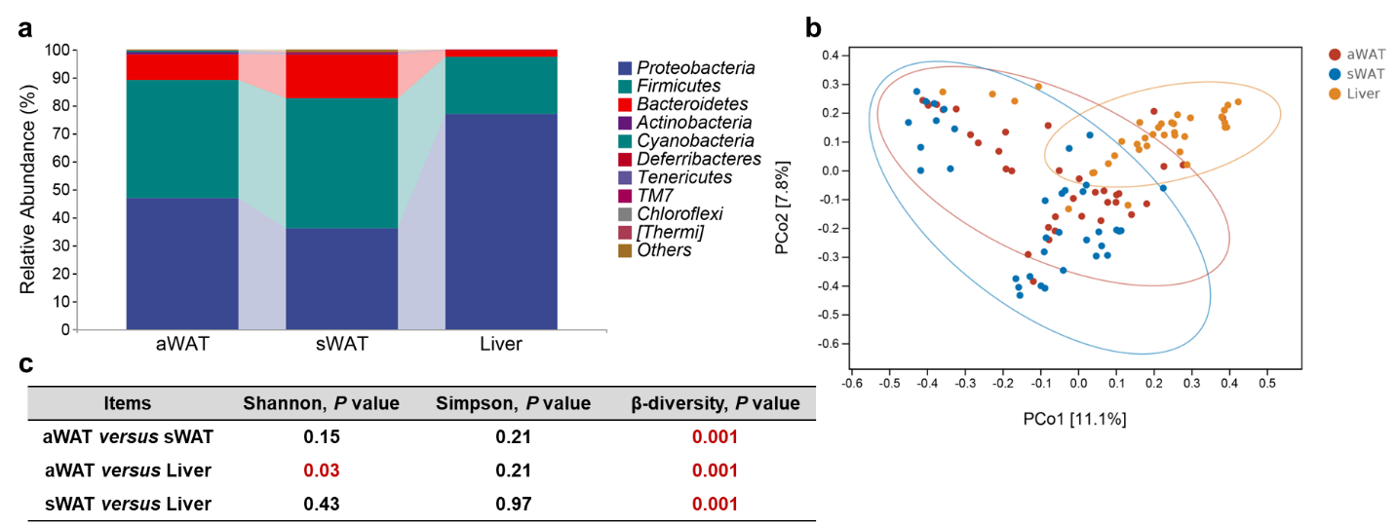
Supplementary Fig S4 Bacterial distribution across pig tissues. (a) Relative abundance of phyla in sWAT, aWAT, and liver from all piglets. (b) β-diversity analysis for sWAT, aWAT, and liver from all piglets. (c) P values for α-diversity (Shannon and Simpson index) and β-diversity analysis.

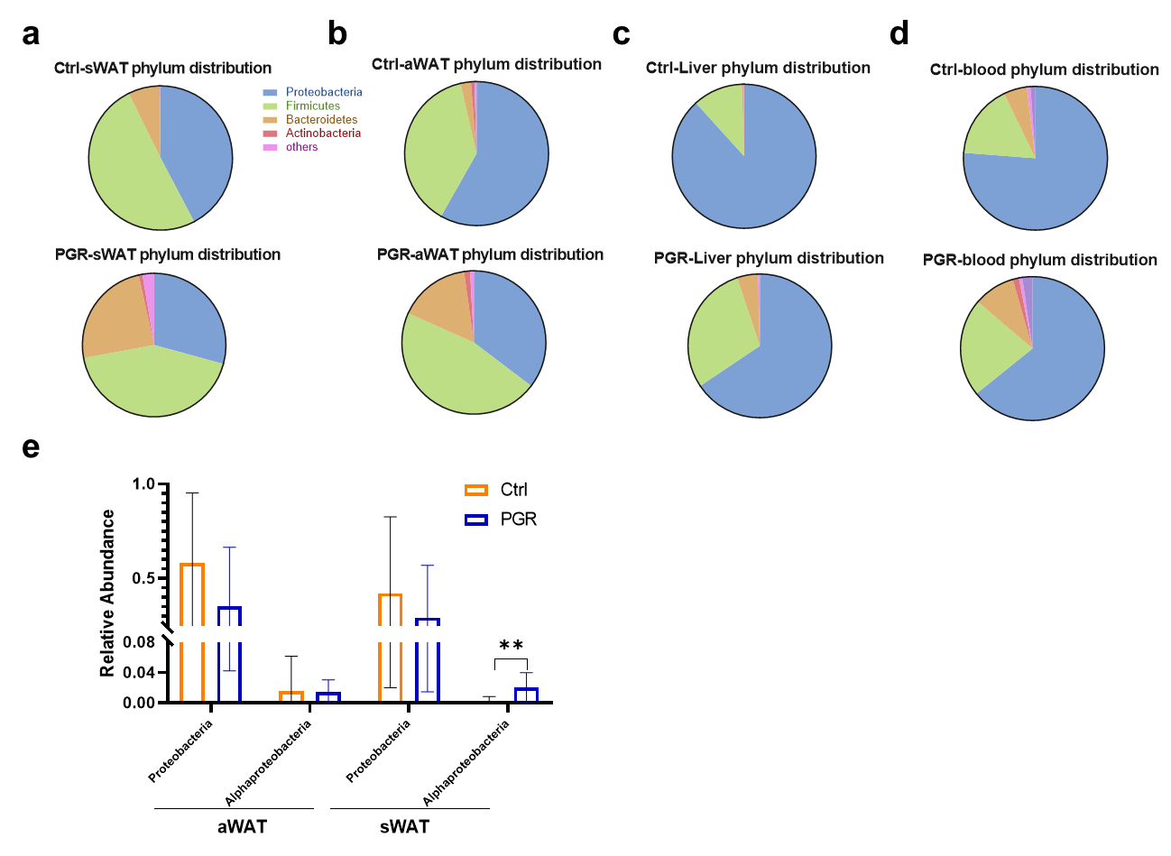
Supplementary Fig S5 Distribution of microbes in sWAT, aWAT, liver, and blood in the Ctrl and PGR groups at phylum level. (a) Relative abundance of phyla in sWAT in the Ctrl and PGR groups. (b) Relative abundance of phyla in aWAT in the Ctrl and PGR groups. (c) Relative abundance of phyla in liver in the Ctrl and PGR groups. (d) Relative abundance of phyla in blood in the Ctrl and PGR groups. (e) Comparison of relative abundance of Proteobacteria and Alphaproteobacteria in aWAT and sWAT.

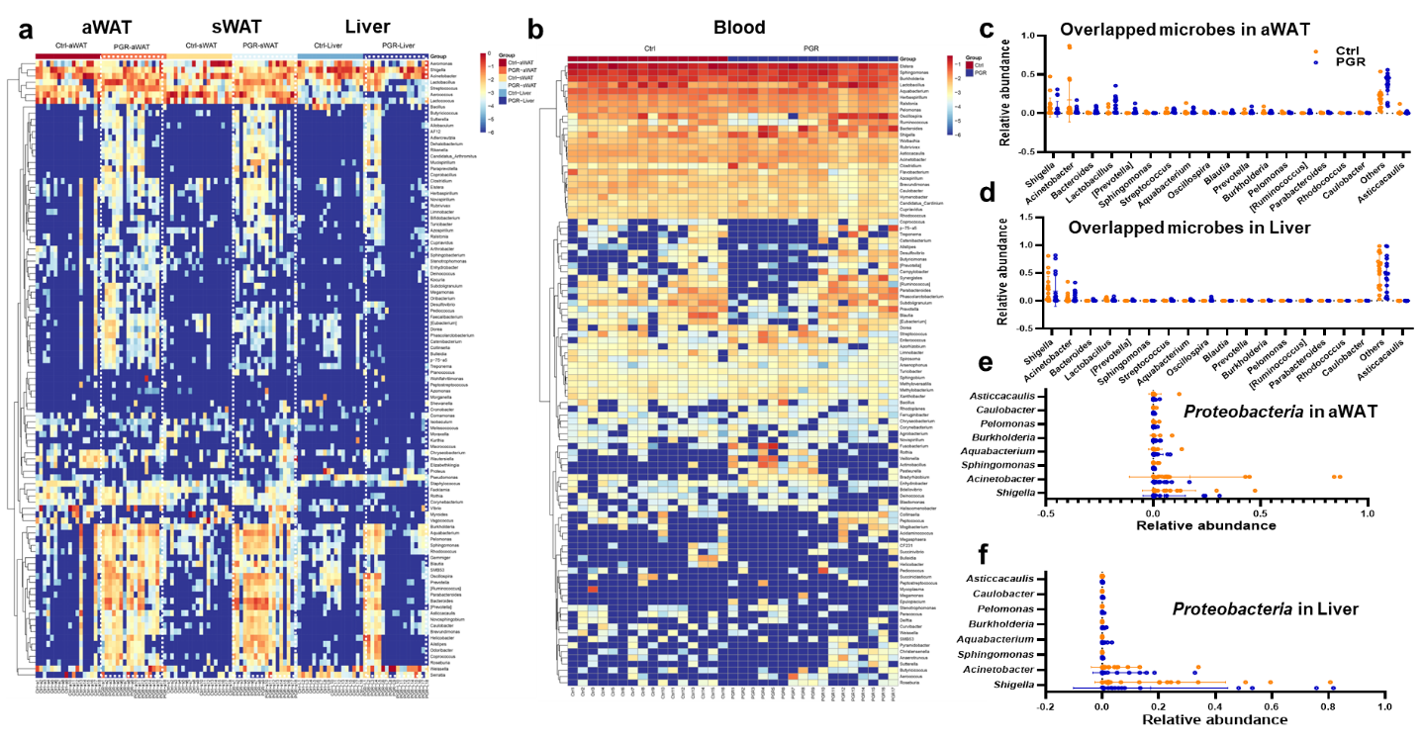
Supplementary Fig S6 Distribution of microbes in aWAT, sWAT, liver, and blood. (a and b) Heatmaps of top 100 microbes in sWAT, aWAT, and liver (a) and blood (b) of the Ctrl and PGR piglets. (c and d) Top 20 genera of aWAT (c) and liver (d). (e and f) Relative abundance of genera from Proteobacteria in aWAT (e) and liver (f). The statistical significance is denoted as: *P < 0.05, **P < 0.01.

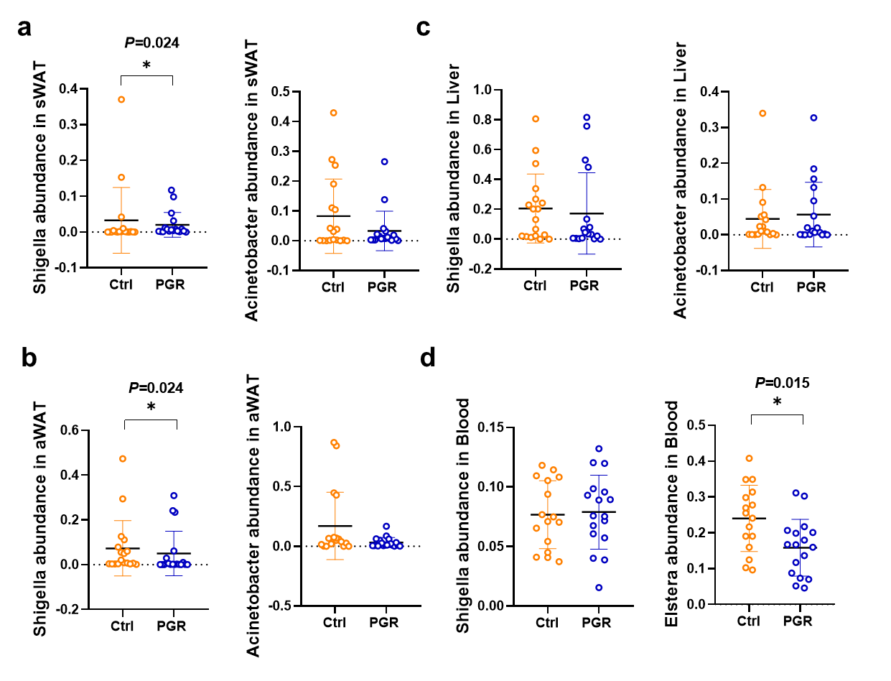
Supplementary Fig S7 Distribution of overlapped top three microbes in sWAT, aWAT, liver, and blood. (a–d) Relative abundance of the top three microbes in sWAT (a), aWAT (b), liver (c), and blood (d). The statistical significance is denoted as: *P < 0.05, **P < 0.01.

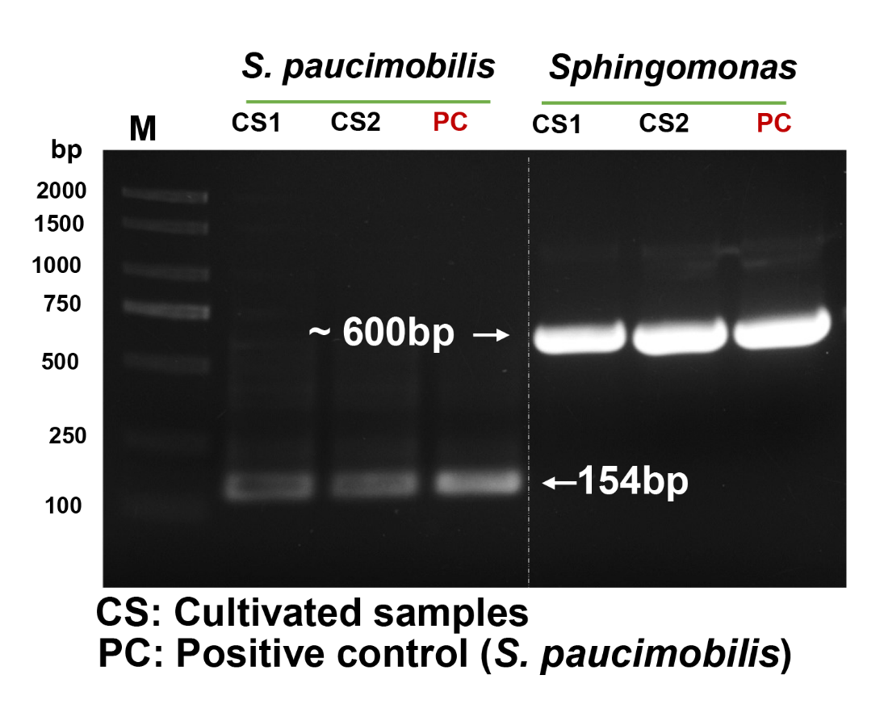
Supplementary Fig S8 PCR detection for Sphingomonas and S. paucimobilis. Gel electrophoresis for specific DNA fragment of 16S rRNA gene in Sphingomonas and S. paucimobilis. PC: positive control (S. paucimobilis); CS: cultivated samples.

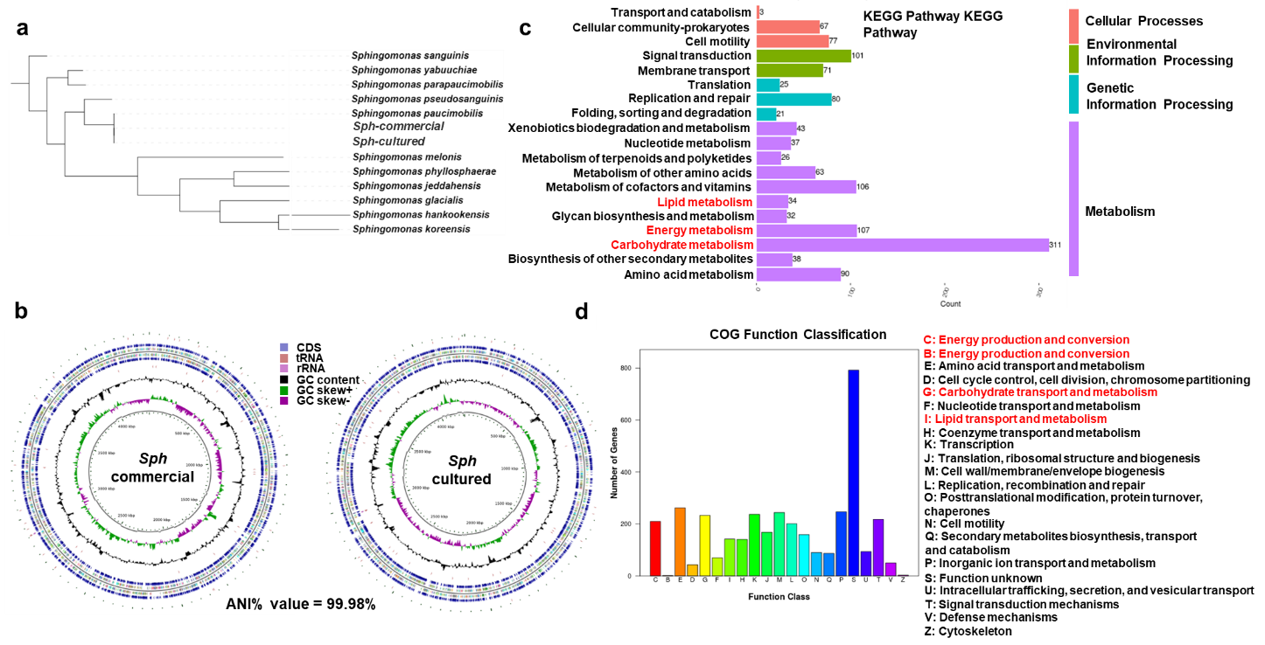
Supplementary Fig S9 Comparative genomic and functional analysis of cultivated S. paucimobilis isolates and commercial S. paucimobilis (ATCC 29837). (a) Phylogenetic analysis of S. paucimobilis isolated from sWAT and commercial S. paucimobilis based on whole genome sequences. (b) Circular representation of S. paucimobilis isolated from sWAT and commercial S. paucimobilis based on CDS, tRNA, and rRNA, GO, GC content, GC skew+, and GC skew– results. (c) KEGG analysis of the S. paucimobilis genome annotation. (d) COG distribution of the S. paucimobilis genome annotation. The statistical significance is denoted as: *P < 0.05, **P < 0.01.

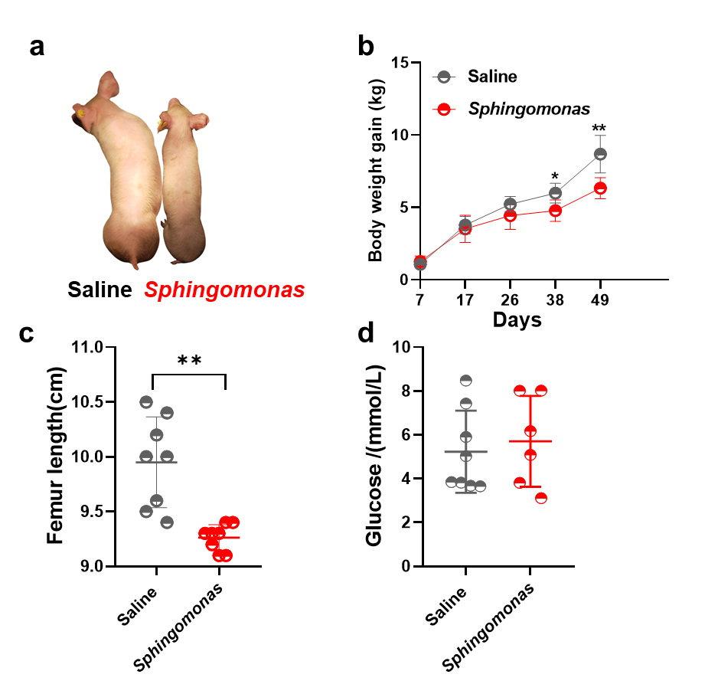
Supplementary Fig S10 Growth performance and metabolic index of piglets in Saline and Sphingomonas-gavaged piglets. (a) Body size of piglets. (b) Body weight gain of piglets. (c) Femur length of Saline and Sphingomonas-gavaged piglets. (d) Level of glucose in the serum of Saline and Sphingomonas-gavaged piglets. The statistical significance is denoted as: *P < 0.05, **P < 0.01.

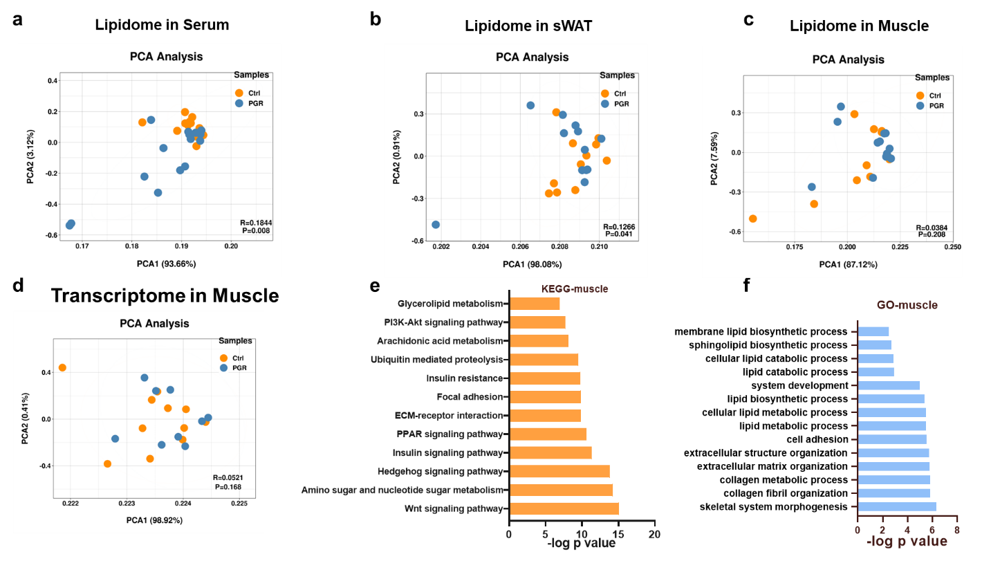
Supplementary Fig S11 Transcriptome and lipidomics signatures of muscle in the Ctrl and PGR groups. (a) Comparison of transcriptome in muscle between the Ctrl and PGR pigs, revealed by PCA (Adonis P = 0.168). (b) KEGG analysis of different expression genes (DEGs) in muscle. (c) GO analysis for DEGs in muscle. (d–f) Comparison of lipidomics in serum (d), sWAT (e), and Muscle (f) between the Ctrl and PGR groups revealed by PCA.
Supplementary Table S1 Probes used in CARD-FISH.
Probes target | Name | Sequence (5’–3’) | Reference
Total bacteria | EUB338I | GCTGCCTCCCGTAGGAGT | [45]
Total bacteria | EUB338II | GCAGCCACCCGTAGGTGT | [45]
Total bacteria | EUB338III | GCTGCCACCCGTAGGTGT | [45]
Alphaproteobacteria | α-pro | GAATTTCACCTCTACACT | [29]

Supplementary Table S2 Primers for PCR Analysis.
Species | Gene | Forward primer (5’–3’) | Reverse primer (5’–3’) | Reference
Pig | PPARγ | TGTGGACCTGTCGGTGATG | TGGAGTGGAAATGCTGGAGA | [54]
Pig | C/EBPα | CGGTGCGTCTAAGATGAGG | AGCGGTGAGTTTGCGTTT | [54]
Pig | ADIPOQ | CTGGCGAGAAGAGTGAGA | TGCTGAACGGTAGACATAGGC | [54]
Pig | FABP4 | GGAAGGTGGCTGGCATGGC | CCTCCATCTAAGGTTATGGTGCTCTTG | [54]
Pig | HSL | ACCCTCGGCTGTCAACTTCTT | ACTTTCTCCTCCTTGGTGCTAATCT | [54]
Pig | ATGL | GCCCACGAGTGATAGCATCC | CAGCAGGTTGGACAGGGTG | [54]
Pig | GLUT4 | GAAGGAAGAAGGCAATGCTG | GAGGAACCGTCCAAGAATGA | [54]
Pig | LEPTIN | AGATCCTCACCAGTCTGCCTTCC | CCAGGCTCTCCAAGGTCTCCAG | [54]
Pig | IL-1β | CAGCCATGGCCATAGTACCT | CCACGATGACAGACACCATC | [29]
Pig | IL-6 | GGCAAAAGGGAAAGAATCCAG | CGTTCTGTGACTGCAGCTTATCC | [29]
Pig | IL-8 | GCTCTCTGTGAGGCTGCAGTTC | AAGGTGTGGAATGCGTATTTATGC | [29]
Pig | TNF-α | ACAGGCCAGCTCCCTCTTAT | CCTCGCCCTCCTGAATAAAT | [29]
Pig | IFNγ | TTCAGCTTTGCGTGACTTTG | GGTCCACCATTAGGTACATCTG | [29]
Pig | NFkB | AGCCATTGACGTGATCCAGG | CGAAATCGTGGGGCACTTTG | [29]
Pig | IL10 | GGGCTATTTGTCCTGACTGC | GGGCTCCCTAGTTTCTCTTCC | [29]
Pig | ADPGK | ATTTTCGGGCCTCCGTCTTT | GCGGAGCTGAGAACAGAGAA | This manuscript
Pig | HK3 | TGGGACCCTCTACAAGCTACA | TTGCCAGACCCGTCCTTT | This manuscript
 | ACACA | TGGAGGAGAAGGAGGG | GGTGCAAGCCAGACAT | This manuscript
 | ACSL4 | AAGCACGAACAATAGACA | GACAGAGCGATATGGAC | This manuscript
 | FASN | CTCCAAGCAGGCGAACACG | CCACGAAGGGAAGCAGGGT | This manuscript
 | GPD2 | CAAATGGATGAAAACACGCTT | TCCACAACTTCGGTCTACAGG | This manuscript
 | AGPAT1 | CCTTCTACAACGGCTGGAT | GCTGTGAGGGAGGGAAGTGG | This manuscript
 | CDS2 | ATGACGGAACTAAGGCAGAGG | CACTGTCGGATGCAGTCTCT | This manuscript
 | β-actin | CTGCGGCATCCACGAAACT | AGGGCCGTGATCTCCTTCTG | This manuscript
 | 18s | CCCACGGAATCGAGAAAGAG | TTGACGGAAGGGCACCA | This manuscript
Bacteria | Sphingomonas-600 | MRGWCCAAAGATTTATCG | CMAADCACCAWGTGMCCKGA | [36]
 | Sphingomonas-154 | AAGCCGACGATCCATAGCTG | ACCCTAGGGCCTTCATCACT | This manuscript
 | Sphingomonas-207 | CATGCAAGTCGAACGAAGGC | CAGCTATGGATCGTCGGCTT | This manuscript

Supplementary Table S3 Top 100 microbes of genus level in blood.
Bacteria | Mean Ctrl | Mean PGR | P value
Elstera | 0.240258 | 0.1585 | 0.010235
Sphingomonas | 0.126654 | 0.100789 | 0.136923
Burkholderia | 0.076692 | 0.078903 | 0.832983
Lactobacillus | 0.062289 | 0.056169 | 0.815317
Aquabacterium | 0.041126 | 0.032151 | 0.1191
Oscillospira | 0.023693 | 0.038273 | 0.350265
Bacteroides | 0.005937 | 0.04131 | 0.015881
Shigella | 0.012125 | 0.030885 | 0.104732
Herbaspirillum | 0.020349 | 0.017684 | 0.314868
Ralstonia | 0.012527 | 0.012953 | 0.786925
Pelomonas | 0.012524 | 0.012086 | 0.811018
Asticcacaulis | 0.009517 | 0.009354 | 0.897811
Acinetobacter | 0.008209 | 0.009501 | 0.294431
Ruminococcus | 0.005359 | 0.008529 | 0.434198
Rubrivivax | 0.006822 | 0.006733 | 0.925224
Flavobacterium | 0.009363 | 0.00404 | 0.057989
Wolbachia | 0.005749 | 0.007073 | 0.376412
Clostridium | 0.001294 | 0.010864 | 0.137542
Subdoligranulum | 0.008806 | 0.003732 | 0.060451
Fusobacterium | 0.000179 | 0.011751 | 0.163226
Blautia | 0.008392 | 0.002847 | 0.185796
Parabacteroides | 0.004327 | 0.006052 | 0.529252
Synergistes | 0.001391 | 0.007999 | 0.141691
p-75-a5 | 0.001376 | 0.007682 | 0.187267
Phascolarctobacterium | 0.00336 | 0.005747 | 0.245711
Brevundimonas | 0.006077 | 0.003067 | 0.002753
Caulobacter | 0.004989 | 0.002569 | 0.001141
Azospirillum | 0.003404 | 0.003865 | 0.556875
Prevotella | 0.00286 | 0.004085 | 0.647158
Streptococcus | 0.001818 | 0.004791 | 0.191252
Candidatus_Cardinium | 0.002504 | 0.003501 | 0.167502
Dorea | 0.002089 | 0.003627 | 0.31134
Cupriavidus | 0.002784 | 0.002731 | 0.909981
Rhodococcus | 0.002667 | 0.002775 | 0.790137
Enterococcus | 0.000684 | 0.004601 | 0.035729
Veillonella | 2.77E-05 | 0.004991 | 0.116938
Hymenobacter | 0.002978 | 0.002212 | 0.315827
[Ruminococcus] | 0.002187 | 0.00279 | 0.687817
Actinobacillus | 0.000132 | 0.004679 | 0.090849
Mycoplasma | 0.003927 | 0 | 0.310141
Limnobacter | 0.001958 | 0.001616 | 0.628096
Pediococcus | 6.68E-05 | 0.003305 | 0.335857
Treponema | 0.000655 | 0.0027 | 0.368507
Desulfovibrio | 0.000627 | 0.002562 | 0.073553
Bacillus | 0.00065 | 0.002418 | 0.400783
[Eubacterium] | 0.001966 | 0.001097 | 0.212198
Methylobacterium | 0.001108 | 0.001394 | 0.395143
Sphingobium | 0.001102 | 0.001253 | 0.455314
Xanthobacter | 0.001103 | 0.001248 | 0.653174
[Prevotella] | 0.001001 | 0.001135 | 0.906393
Aerococcus | 5.27E-05 | 0.001833 | 0.324532
Collinsella | 0.001054 | 0.000777 | 0.715808
Campylobacter | 0.000312 | 0.001353 | 0.353172
Methyloversatilis | 0.000827 | 0.000856 | 0.889716
Catenibacterium | 0.000705 | 0.000908 | 0.762062
Bulleidia | 0.001594 | 2.33E-05 | 0.115441
Arsenophonus | 0.000642 | 0.000889 | 0.334688
Butyricimonas | 0.000395 | 0.00111 | 0.135349
Spirosoma | 0.000851 | 0.000665 | 0.40492
Peptococcus | 0.000467 | 0.001002 | 0.320707
Pasteurella | 0 | 0.001378 | 0.045003
Azorhizobium | 0.000585 | 0.000795 | 0.437668
Turicibacter | 0.000627 | 0.000532 | 0.083021
Enhydrobacter | 0.000368 | 0.000763 | 0.321357
Mogibacterium | 0.000276 | 0.000846 | 0.240802
Acidaminococcus | 0.000362 | 0.000723 | 0.579522
Bradyrhizobium | 0.000405 | 0.000626 | 0.223776
Rothia | 0.000111 | 0.000819 | 0.10378
Ferruginibacter | 0.000345 | 0.000558 | 0.238952
Succiniclasticum | 0.000859 | 5.88E-05 | 0.151708
Paracoccus | 0.00017 | 0.000695 | 0.360307
Haliscomenobacter | 0.000541 | 0.000201 | 0.059183
Deinococcus | 0.000266 | 0.000417 | 0.495836
Delftia | 0.000247 | 0.00043 | 0.411523
Stenotrophomonas | 0.000109 | 0.000546 | 0.385968
Pyramidobacter | 0.000129 | 0.000527 | 0.311334
Epulopiscium | 0.000354 | 0.0003 | 0.754383

Supplementary Table S4. Top 100 microbes of genus level in aWAT
Bacteria | Mean Ctrl | Mean PGR | P value
Shigella | 0.073165 | 0.050526 | 0.548698
Aeromonas | 0.070463 | 0.046116 | 0.61034
Acinetobacter | 0.170773 | 0.031794 | 0.046603
Aerococcus | 0.039121 | 0.009358 | 0.086018
Lactococcus | 0.143425 | 0.04032 | 0.097349
Weissella | 0.018013 | 0.039791 | 0.489419
Lactobacillus | 0.011645 | 0.096191 | 0.001929
Vibrio | 0.088994 | 0.009837 | 0.157636
Serratia | 0.041943 | 0.025601 | 0.696927
Bacteroides | 0.001179 | 0.022089 | 0.010655
Myroides | 0.007533 | 8.78E-05 | 0.116509
Streptococcus | 0.010536 | 0.030196 | 0.005196
[Prevotella] | 0.000201 | 0.01978 | 0.018588
Aquabacterium | 0.008973 | 0.018702 | 0.318961
Vagococcus | 0.002437 | 0.000624 | 0.159502
Oscillospira | 0.001575 | 0.009218 | 0.006546
Helicobacter | 0.000179 | 0.003398 | 0.015287
Wautersiella | 0.003137 | 0.001519 | 0.273707
Proteus | 0.00014 | 0.000379 | 0.527622
Prevotella | 0.00294 | 0.010644 | 0.178523
Burkholderia | 0.007052 | 0.00727 | 0.968828
Blautia | 0.000926 | 0.010683 | 0.006057
Wohlfahrtiimonas | 3.03E-06 | 0.017808 | 0.324456
Alistipes | 2.19E-05 | 0.00157 | 0.00447
Coprococcus | 0.000111 | 0.005888 | 0.044501
[Ruminococcus] | 0.000371 | 0.008309 | 0.017189
Bacillus | 1.95E-05 | 0.002004 | 0.268974
Asticcacaulis | 0.007334 | 0.002872 | 0.520062
Sphingomonas | 0.002793 | 0.002609 | 0.921911
Pelomonas | 0.002034 | 0.003587 | 0.420652
Odoribacter | 4.88E-05 | 0.001449 | 0.001476
SMB53 | 0.001574 | 0.005919 | 0.100942
Parabacteroides | 0.000853 | 0.004209 | 0.029586
Caulobacter | 0.000978 | 0.001769 | 0.396279
Paraprevotella | 0 | 0.003185 | 0.003903
Rhodococcus | 0.000791 | 0.001676 | 0.12976
Mucispirillum | 0 | 0.000303 | 0.006913
Rothia | 0.002008 | 0.002173 | 0.88337
Corynebacterium | 0.001305 | 0.002431 | 0.349387
Novosphingobium | 0.000126 | 0.001196 | 0.002882
Roseburia | 6.27E-05 | 0.002179 | 0.018901
Brevundimonas | 0.000384 | 0.001428 | 0.012942
Facklamia | 0.000813 | 0.00102 | 0.680159
Staphylococcus | 0.001421 | 0.000446 | 0.013948
[Eubacterium] | 0.000802 | 0.002125 | 0.21875
Elstera | 0.00104 | 0.000563 | 0.491449
Kurthia | 3.21E-05 | 0.000541 | 0.163449
Phascolarctobacterium | 0.000542 | 0.002262 | 0.059747
Gemmiger | 0.000226 | 0.001889 | 0.013461
Chryseobacterium | 0.001146 | 0.00042 | 0.120302
Clostridium | 0.00041 | 0.00101 | 0.19918
Rikenella | 0 | 0.000925 | 0.002841
Pseudomonas | 0.000133 | 5.45E-05 | 0.210323
Butyricicoccus | 0.00055 | 0.000633 | 0.887363
Elizabethkingia | 0.001494 | 0.000361 | 0.081755
Ralstonia | 0.000701 | 0.000729 | 0.961959
Herbaspirillum | 0.000721 | 0.000613 | 0.85888
Shewanella | 3.03E-06 | 0.000227 | 0.330827
Cronobacter | 8.39E-05 | 1.78E-05 | 0.305029
Sutterella | 4.53E-05 | 0.000742 | 0.00568
Candidatus_Arthromitus | 0 | 0.000721 | 0.005355
Dorea | 0.000283 | 0.00114 | 0.088076
Dehalobacterium | 0 | 0.00052 | 0.005998
Collinsella | 0.000396 | 0.001194 | 0.215458
Azomonas | 0 | 5.42E-06 | 0.020536
Bifidobacterium | 0.000138 | 0.000482 | 0.144339
Novispirillum | 0.000217 | 0.000163 | 0.722285
Subdoligranulum | 9.65E-05 | 0.001113 | 0.019611
Comamonas | 0.000271 | 0.00075 | 0.280689
Coprobacillus | 1.04E-05 | 0.000492 | 0.0038
Azospirillum | 0.000252 | 0.00031 | 0.821697
Megamonas | 4.71E-05 | 0.001001 | 0.132959
Faecalibacterium | 0.000296 | 0.000451 | 0.599089
p-75-a5 | 0.000397 | 0.000701 | 0.513112
Morganella | 1.66E-05 | 4.96E-06 | 0.506877
Allobaculum | 3.62E-05 | 0.00065 | 0.019115
Bulleidia | 0.000284 | 0.000733 | 0.270024

Supplementary Table S5. Top 100 microbes of genus level in sWAT
Bacteria | Mean Ctrl | Mean PGR | P value
Shigella | 0.032757 | 0.02021 | 0.591001
Aeromonas | 0.241847 | 0.078211 | 0.07991
Acinetobacter | 0.08268 | 0.03311 | 0.145495
Aerococcus | 0.202792 | 0.138872 | 0.457773
Lactococcus | 0.086085 | 0.03492 | 0.21792
Weissella | 0.000323 | 0.009598 | 0.135514
Lactobacillus | 0.003793 | 0.039844 | 0.000926
Vibrio | 0.001307 | 0.009051 | 0.100277
Serratia | 0.000288 | 0.011372 | 0.30063
Bacteroides | 9.96E-05 | 0.050541 | 0.002301
Myroides | 0.067229 | 0.000792 | 0.229327
Streptococcus | 0.013688 | 0.008266 | 0.448276
[Prevotella] | 8.13E-05 | 0.032377 | 0.000821
Aquabacterium | 0.000514 | 0.018742 | 6.84E-05
Vagococcus | 0.044782 | 0.002063 | 0.31648
Oscillospira | 9.12E-05 | 0.014937 | 6.98E-05
Helicobacter | 1.77E-06 | 0.00899 | 0.001853
Wautersiella | 0.000175 | 0.03157 | 0.299713
Proteus | 0 | 0.000229 | 0.050353
Prevotella | 0.000505 | 0.007201 | 0.002112
Burkholderia | 0.001527 | 0.006098 | 0.038097
Blautia | 0.000568 | 0.010045 | 0.049403
Wohlfahrtiimonas | 9.72E-06 | 2.11E-06 | 0.449241
Alistipes | 0 | 0.009013 | 0.001283
Coprococcus | 5.5E-05 | 0.006774 | 0.019904
[Ruminococcus] | 2.87E-05 | 0.003359 | 0.001768
Bacillus | 0 | 0.000123 | 0.12699
Asticcacaulis | 0.000144 | 0.001851 | 0.000244
Sphingomonas | 0.000987 | 0.005024 | 0.014532
Pelomonas | 0.00026 | 0.004984 | 0.00035
Odoribacter | 0 | 0.00473 | 0.000853
SMB53 | 8.01E-05 | 0.000685 | 0.001123
Parabacteroides | 1.62E-05 | 0.003189 | 0.00075
Caulobacter | 3.82E-05 | 0.002871 | 0.000236
Paraprevotella | 5.3E-06 | 0.002852 | 0.014773
Rhodococcus | 0.000474 | 0.002357 | 0.002519
Mucispirillum | 0 | 0.004075 | 0.03156
Rothia | 0.000164 | 0.000906 | 0.003131
Corynebacterium | 0.000239 | 0.00094 | 0.001113
Novosphingobium | 0 | 0.003108 | 0.017863
Roseburia | 0.000216 | 0.00178 | 0.026394
Brevundimonas | 4.76E-05 | 0.00212 | 0.000138
Facklamia | 0.000687 | 0.001385 | 0.365637
Staphylococcus | 0.00071 | 0.000375 | 0.50947
[Eubacterium] | 0.00021 | 0.000315 | 0.480051
Elstera | 0.000603 | 0.000843 | 0.642369
Kurthia | 0.000124 | 0.000996 | 0.284904
Phascolarctobacterium | 1.08E-05 | 0.000181 | 0.010677
Gemmiger | 0.000156 | 0.000475 | 0.093657
Chryseobacterium | 0.000303 | 0.000447 | 0.479002
Clostridium | 0.000236 | 0.000638 | 0.118013
Rikenella | 0 | 0.001102 | 0.002365
Pseudomonas | 7.4E-05 | 6.93E-05 | 0.934012
Butyricicoccus | 2.77E-05 | 0.000725 | 0.00975
Elizabethkingia | 0.000384 | 9.6E-05 | 0.132763
Ralstonia | 0.000122 | 0.000487 | 0.034631
Herbaspirillum | 0.000158 | 0.000535 | 0.023517
Shewanella | 2.46E-05 | 0.000175 | 0.347305
Cronobacter | 0.001474 | 0.000253 | 0.412421
Sutterella | 0 | 0.001194 | 0.019604
Candidatus_Arthromitus | 0 | 0.001144 | 0.028314
Dorea | 0.000125 | 0.000336 | 0.171449
Dehalobacterium | 0 | 0.000814 | 0.004667
Collinsella | 1.28E-05 | 0.00014 | 0.038577
Azomonas | 1.76E-06 | 0.001764 | 0.324851
Bifidobacterium | 2.99E-05 | 0.000689 | 0.144514
Novispirillum | 3.18E-05 | 0.00051 | 0.030893
Subdoligranulum | 0 | 0.000222 | 0.048903
Comamonas | 0.000271 | 5.31E-05 | 0.376461
Coprobacillus | 0 | 0.000767 | 0.03704
Azospirillum | 0.000117 | 0.000419 | 0.049261
Megamonas | 0 | 0.000167 | 0.216798
Faecalibacterium | 0.000124 | 0.000159 | 0.718778
p-75-a5 | 2.17E-05 | 7.27E-05 | 0.107151
Morganella | 0 | 1.86E-05 | 0.324375
Allobaculum | 1.04E-05 | 0.000347 | 0.045861
Bulleidia | 7.86E-06 | 4.59E-05 | 0.186046

Supplementary Table S6. Top 100 microbes of genus level in Liver
Bacteria | Mean Ctrl | Mean PGR | P value
Shigella | 0.20522 | 0.171535 | 0.691589
Aeromonas | 0.067101 | 0.016495 | 0.243104
Acinetobacter | 0.044485 | 0.056733 | 0.673252
Aerococcus | 0.000239 | 6.7E-05 | 0.076484
Lactococcus | 0.052979 | 0.001315 | 0.326883
Weissella | 0.022646 | 0.18245 | 0.059828
Lactobacillus | 0.009371 | 0.009644 | 0.967051
Vibrio | 0.000574 | 0.000652 | 0.916469
Serratia | 0.006421 | 0.007503 | 0.866079
Bacteroides | 6.62E-05 | 0.003362 | 0.119768
Myroides | 3.76E-06 | 5.11E-05 | 0.24667
Streptococcus | 0.000867 | 0.004593 | 0.147443
[Prevotella] | 4.1E-05 | 0.004354 | 0.079004
Aquabacterium | 0.000123 | 0.004935 | 0.029105
Vagococcus | 1.06E-05 | 1.17E-05 | 0.946327
Oscillospira | 0.000577 | 0.010958 | 0.051623
Helicobacter | 1.15E-05 | 0.024226 | 0.087976
Wautersiella | 2.74E-05 | 7.29E-05 | 0.269898
Proteus | 0.02381 | 0.000531 | 0.306753
Prevotella | 0.001843 | 0.001379 | 0.669677
Burkholderia | 0.000209 | 0.001835 | 0.068151
Blautia | 0.000287 | 5.24E-05 | 0.090655
Wohlfahrtiimonas | 0 | 0.00026 | 0.30777
Alistipes | 1.28E-05 | 0.006775 | 0.081997
Coprococcus | 3.83E-05 | 0.002361 | 0.064133
[Ruminococcus] | 0.000297 | 0.002296 | 0.071594
Bacillus | 0.008972 | 0.002103 | 0.201376
Asticcacaulis | 1.13E-05 | 0.000427 | 0.007768
Sphingomonas | 0.00016 | 0.000921 | 0.035367
Pelomonas | 4.12E-05 | 0.001353 | 0.021601
Odoribacter | 5.3E-06 | 0.004904 | 0.068719
SMB53 | 0.000719 | 0.000105 | 0.038388
Parabacteroides | 0.000146 | 0.000375 | 0.237372
Caulobacter | 4.45E-06 | 0.000767 | 0.011706
Paraprevotella | 0 | 0.000306 | 0.070596
Rhodococcus | 0.000299 | 0.000694 | 0.236345
Mucispirillum | 4.22E-06 | 0.001644 | 0.173355
Rothia | 0 | 1.48E-05 | 0.061985
Corynebacterium | 4.45E-05 | 3.34E-05 | 0.675643
Novosphingobium | 0 | 0.000395 | 0.021626
Roseburia | 5.39E-05 | 0.000369 | 0.096878
Brevundimonas | 0 | 0.000594 | 0.033204
Facklamia | 0 | 0 | #DIV/0!
Staphylococcus | 0.000119 | 0.000725 | 0.100541
[Eubacterium] | 0.000106 | 0 | 0.029825
Elstera | 3.36E-05 | 0.000225 | 0.120543
Kurthia | 0.001482 | 2.09E-05 | 0.331147
Phascolarctobacterium | 0.000105 | 8.66E-06 | 0.05527
Gemmiger | 0.000255 | 3.07E-05 | 0.015563
Chryseobacterium | 0.000349 | 0.000261 | 0.743361
Clostridium | 0.000221 | 0.000329 | 0.624429
Rikenella | 0 | 0.000626 | 0.06829
Pseudomonas | 0.001868 | 0.000415 | 0.047988
Butyricicoccus | 5.72E-05 | 0.000418 | 0.197725
Elizabethkingia | 5.8E-06 | 3.32E-05 | 0.16368
Ralstonia | 8.1E-06 | 0.000156 | 0.043033
Herbaspirillum | 2.29E-05 | 0.000141 | 0.059257
Shewanella | 0.001435 | 0.00031 | 0.146165
Cronobacter | 0.000269 | 2.41E-06 | 0.302979
Sutterella | 0 | 0.00011 | 0.043599
Candidatus_Arthromitus | 0 | 0.000138 | 0.03225
Dorea | 0.000113 | 1.57E-06 | 0.014461
Dehalobacterium | 0 | 0.000535 | 0.050669
Collinsella | 9.63E-05 | 1.75E-06 | 0.031167
Azomonas | 0 | 0 | #DIV/0!
Bifidobacterium | 8.26E-05 | 0.000296 | 0.212805
Novispirillum | 0 | 0.000549 | 0.039472
Subdoligranulum | 1.16E-05 | 0 | 0.078867
Comamonas | 1.18E-05 | 4.66E-05 | 0.275065
Coprobacillus | 7.78E-06 | 3.35E-05 | 0.362548
Azospirillum | 3.5E-06 | 0.000123 | 0.058936
Megamonas | 6.05E-06 | 0 | 0.324375
Faecalibacterium | 0.000172 | 1.55E-05 | 0.022382
p-75-a5 | 6.72E-06 | 1E-05 | 0.738774
Morganella | 0.001142 | 3.08E-06 | 0.325667
Allobaculum | 0 | 0.000127 | 0.039871
Bulleidia | 5.6E-05 | 3.82E-06 | 0.046736

