Supplementary Materials for

Development of cyclopeptide inhibitors specifically disrupting FXR-coactivator interaction in the intestine as a novel therapeutic strategy for MASH

Yazhou Li^{1,2,‡}, Tingying Jiao^{2,3,‡}, Xi Cheng^{1,2,‡}, Lu Liu², Mengjiao Zhang⁴, Jian Li², Jue Wang⁵, Shulei Hu², Cuina Li², Tao Yu², Yameng Liu², Yangtai Li⁶, Yu Zhang^{2,7}, Chuying Sun⁴, Jina Sun^{2,7}, Jiang Wang^{2,7,*}, Cen Xie^{2,4,*}, Hong Liu^{1,2,4,*}
Correspondence to: hliu@simm.ac.cn; xiecen@simm.ac.cn; jwang@lglab.ac.cn

This PDF file includes:

Supplementary Text
Supplementary Figures S1−S10
Supplementary Tables S1−S5

Supplementary Text
1. General information
Unless specified otherwise, the reagents were purchased from commercial sources and used without further purification. Analytical thin-layer chromatography (TLC) was performed on HSGF 254 with a 0.2−0.3 mm thickness. Column chromatography was performed on silica gel (300−400 mesh) using petroleum ether (PE)/ethyl acetate (EA) or dichloromethane (DCM)/methanol (MeOH). For reactions that require heating, the heat source was an oil bath. All products were characterized by their nuclear magnetic resonance (NMR), low-resolution mass spectrometry (LRMS), and high-resolution mass spectrometry (HRMS) spectra. Proton coupling patterns were described as singlet (s), doublet (d), triplet (t), quartet (q), multiplet (m), doublet of doublets (dd), doublet of triplets (dt), triplet of doublets (td), and doublet of doublet of doublets (ddd). The chemical shifts were reported in parts per million (ppm, δ) downfield from tetramethylsilane (TMS). HRMS were measured on a Micromass Ultra Q-TOF spectrometer. Crystal structure determination were performed on a Bruker D8 VENTURE diffractometer.
2. Chemical synthesis
General procedures for the preparation of substrates
According to the general procedure (Supplementary Figure S1), cyclopeptide substrates 1a and 1d were prepared. Triethylamine (Et₃N, 1.0 mL, 7.5 mmol) and trifluoromethanesulfonic anhydride (0.9 mL, 5.5 mmol) were slowly added to a stirred solution of compound a (5.0 mmol) in DCM (30 mL) at −78 °C. After stirring at −78 °C for 4 h, the mixture was quenched by the addition of saturated NaHCO₃ and then extracted with CH₂Cl₂ for three times. The organic layer was combined, dried over anhydrous Na₂SO₄, and concentrated under vacuum. Purification by column chromatography on silica gel (PE/EA) yielded product b.
n-butyllithium (n-BuLi, 4.1 mmol) was slowly added to a solution of compound b (2.0 mmol) in anhydrous tetrahydrofuran (THF, 20 mL) at −78 °C. After stirring at −78°C for 10 min, triisopropylsilyl chloride (TIPSCl, 0.8 mL, 4.0 mmol) was added dropwise. After stirring at −78 °C for 3 h, the reaction was quenched by adding aqueous NH₄Cl solution. The mixture was extracted with ethyl acetate (EtOAc) for three times. The organic layer was combined, dried over anhydrous Na₂SO₄, and concentrated under vacuum. The resulting residue was purified by column chromatography on silica gel to yield product c.
Lithium hydroxide (LiOH·H₂O, 10.0 mmol) was added to a solution of compound c (5.0 mmol) in THF (5.0 mL) and H₂O (2.5 mL). After stirring at room temperature for 36 h, the reaction was quenched by adding 1N HCl solution and extracted with EtOAc for three times. The organic layer was combined, dried over anhydrous Na₂SO₄, and concentrated under vacuum. The resulting residue was purified by column chromatography on silica gel to yield product d.
The (S)-4-(tert-butoxycarbonyl)morpholine-2-carboxylic acid (e, 1.0 mmol) and 4-methylmorpholine (NMM, 1.7 mmol) were dissolved in dimethyl formamide (DMF) at 0°C. Amino alcohol (1.0 mmol) and 1-hydroxy-7-azabenzotriazole (HOAT 1.2 mmol) were then added to the reaction mixture. 1-ethyl-3-(3-(dimethylamino)propyl)carbodiimide hydrochloride (EDCI, 1.2 mmol) was added in one portion at 0°C. The reaction was performed at 0°C for 1.5 h and then at room temperature for 6 h before quenched by adding H₂O. The aqueous layer was extracted with EtOAc. The organic phase was washed successively with H₂O, 0.5 N HCl solution, saturated aqueous NaHCO₃ solution, and brine before dried over anhydrous Na₂SO₄. The organic layer was evaporated to dryness under vacuum. Purification by column chromatography on silica gel (PE/EA) yielded the product f.
EDCI (0.3 mmol), 4-dimethylaminopyridine (DMAP, 0.1 mmol), and compound c (0.2 mmol) were added to a solution of compound f (0.2 mmol) in 10 mL anhydrous DCM. The resulting solution was stirred at room temperature overnight. Then, the reaction was quenched with water and extracted with DCM. The combined organic layer was washed with brine, dried over Na₂SO₄, and concentrated in vacuo. The residue was subjected to column chromatography, and product g was obtained.
HCl (4 mol/L)/1,4-dioxane (8.0 equiv.) were added to a solution of compound g (1.0 equiv.) in anhydrous dichloromethane (0.5 mol/L). After stirring at room temperature for 1 h, the reaction solution was concentrated in vacuo to yield product h.
Potassium phosphate dibasic (3.0 equiv.) and amine (h) (1.5 equiv.) were added to a solution of benzoyl peroxide (1.0 equiv.) in DMF (0.4 mol/L) at 0ºC. After 30 min, the mixture was allowed to warm to room temperature and stirred for 12 h. The reaction mixture was monitored by TLC. After disappearance of starting material, the reaction mixture was quenched with distilled water and extracted with EA (two times). The combined organic layer was washed with aqueous NaHCO₃ (two times) and brine (one time), and dried over Na₂SO₄. After removal of solvent, the residue was purified by flash chromatography on silica gel to yield a corresponding desired products 1a or 1b.
Supplementary Figure S1 Synthesis of cyclopeptide substrates 1a and 1b.
According to the general procedure (Supplementary Figure S2), cyclopeptide substrates 1c−1g are prepared.
Supplementary Figure S2 Synthesis of cyclopeptide substrates 1c−1g.

General procedures for the preparation of cyclopeptide compounds DC644−649
1a−1f (80.0 mg), Pd(CH₃CN)₂Cl₂ (20 mol %), AgOAc (2 equiv.), Na₃PO₄ (3 equiv.), and DCE (2.5 mL) were added to a 25-mL capped vial. The reaction mixture was stirred at 85ºC for 24 h. After that, the reaction mixture was filtered through a pad of celite washing with EtOAc. The organic layer was washed with saturated NaHCO₃, dried over Na₂SO₄, and concentrated in vacuo. The residue was purified by silica gel chromatography using PE/EA to yield the products DC644−DC649.
Supplementary Figure S3 Synthesis of cyclopeptide compounds DC644−DC649.

General procedures for the preparation of cyclopeptide compound BITION-DC646
Compound 1c (200.0 mg, 0.219 mmol), 1g (220.2 mg, 0.219 mmol), Pd(CH₃CN)₂Cl₂ (22.8 mg, 0.088 mmol), AgOAc (146.7 mg, 0.879 mmol), Na₃PO₄ (216.2 mg, 1.320 mmol), and DCE (5.0 mL) were added to a 25-mL capped vial. The reaction mixture was stirred at 85ºC for 24 h. After that, the reaction mixture was filtered through a pad of celite washing with EtOAc. The organic phases were washed with saturated NaHCO₃, dried over Na₂SO₄, and concentrated in vacuo. Purification by column chromatography on silica gel (PE/EA 4:1−2:1) yielded the product 1h (91.6 mg, 25%) as white solid.
Compound 1h (90.0 mg, 0.054 mmol) was dissolved in methanol (5 mL) in a 25-mL round bottom flask and Pd/C (10.0 mg) was added. The mixture was stirred under hydrogen at room temperature for 12 h. The solid was filtered through a celite pad and the filtrate was concentrated in vacuo to yield the product 1i in 88 % yield (74.9 mg).
The 1i (60 mg, 0.036 mmol) and NMM (7.28 mg, 0.072 mmol) were dissolved in DMF (5 mL) at 0°C. N-(14-amino-3,6,9,12-tetraoxatetradecyl)-5-((3aS,4S,6aR)-2-oxohexahydro-1H-thieno[3,4-d]imidazol-4-yl)pentanamide (1j, 16.6 mg, 0.036 mmol) and HOAT (5.0 mg, 0.037 mmol) were then added to the reaction mixture. EDCI (8.3 mg, 0.043 mmol) was added in one portion at 0°C. The reaction was performed at 0°C for 1.5 h and then at room temperature for 6 h before quenched by adding H₂O. The aqueous layer was extracted with EtOAc. The organic phase was washed successively with H₂O, 0.5 N HCl solution, saturated aqueous NaHCO₃ solution, and brine before dried over anhydrous Na₂SO₄. The organic layer was evaporated to dryness under vacuum. Purification by preparative TLC (DCM/MeOH = 10:1 (v/v)) yielded BIOTIN-DC646 (30.6 mg, 42%) as a white solid.
Supplementary Figure S4 Synthesis of BIOTIN-DC646.
3. Analytical data of substrates and products
(S)-2-((5-(((S)-2-(trifluoromethylsulfonamido)-3-(1-(triisopropylsilyl)-1H-indol-3-yl)propanoyl)oxy)pentyl)carbamoyl)morpholino benzoate (1a)
¹H NMR (400 MHz, CDCl₃) δ 7.99 (d, J = 7.4 Hz, 2H), 7.60 – 7.51 (m, 2H), 7.49 – 7.37 (m, 3H), 7.19 – 7.07 (m, 3H), 6.63 (s, 1H), 6.40 (d, J = 3.8 Hz, 1H), 4.51 (dd, J = 14.0, 5.9 Hz, 1H), 4.30 (d, J = 8.1 Hz, 1H), 4.11 – 3.89 (m, 5H), 3.45 (d, J = 6.3 Hz, 1H), 3.35 (d, J = 5.9 Hz, 2H), 3.28 – 3.13 (m, 2H), 2.91 (s, 1H), 2.75 (s, 1H), 1.75 – 1.59 (m, 3H), 1.59 – 1.43 (m, 4H), 1.37 – 1.22 (m, 2H), 1.11 (d, J = 7.5 Hz, 18H). ¹³C NMR (101 MHz, CDCl₃) δ 170.5, 168.5, 164.5, 141.2, 133.3, 130.6, 130.3, 129.5, 128.9, 128.5, 121.9, 119.9, 119.5 (q, J = 320.8 Hz), 118.3, 114.2, 110.5, 75.1, 66.0, 65.3, 58.7, 57.8, 56.3, 38.6, 29.4, 29.0, 27.8, 23.1, 18.1, 12.8. ¹⁹F NMR (375 MHz, CDCl₃) δ -77.6. HR-MS (ESI-TOF) m/z: [M+H]⁺ Calcd for C₃₈H₅₄F₃N₄O₈SSi 811.3378; Found 811.3372.
(S)-2-((6-(((S)-2-(trifluoromethylsulfonamido)-3-(1-(triisopropylsilyl)-1H-indol-3-yl)propanoyl)oxy)hexyl)carbamoyl)morpholino benzoate (1b)
¹H NMR (500 MHz, CDCl₃) δ 7.99 (d, J = 7.5 Hz, 2H), 7.59 – 7.50 (m, 2H), 7.47 (d, J = 7.7 Hz, 1H), 7.42 (t, J = 7.8 Hz, 2H), 7.18 – 7.08 (m, 3H), 6.62 (s, 1H), 6.39 (d, J = 1.6 Hz, 1H), 4.55 – 4.48 (m, 1H), 4.32 (s, 1H), 4.17 – 3.83 (m, 4H), 3.47 (d, J = 5.2 Hz, 1H), 3.35 (d, J = 6.0 Hz, 2H), 3.25 (d, J = 5.8 Hz, 2H), 2.92 (d, J = 5.9 Hz, 1H), 2.76 (s, 1H), 1.76 – 1.61 (m, 3H), 1.59 – 1.44 (m, 4H), 1.35 – 1.23 (m, 5H), 1.12 (d, J = 7.6 Hz, 18H). ¹³C NMR (125 MHz, CDCl₃) δ 170.4, 168.5, 164.4, 141.2, 133.3, 130.6, 130.3, 129.5, 128.9, 128.5, 121.9, 119.9, 119.5 (q, J = 320.8 Hz), 118.3, 114.1, 110.6, 75.1, 66.0, 65.3, 58.7, 57.8, 56.3, 38.7, 29.4, 29.2, 28.1, 26.1, 25.2, 18.1, 12.8. HR-MS (ESI-TOF) m/z: [M+H]⁺Calcd for C₃₉H₅₆F₃N₄O₈SSi 825.3535; Found: 825.3540.
(S)-2-(((S)-4-methyl-1-oxo-1-((4-((N^{α}-((trifluoromethyl)sulfonyl)-1-(triisopropylsilyl)-L-tryptophyl)oxy)butyl)amino)pentan-2-yl)carbamoyl)morpholino benzoate (1c)
¹H NMR (600 MHz, CDCl₃) δ 7.97 (d, J = 7.6 Hz, 2H), 7.80 (brs, 1H), 7.61 – 7.52 (m, 2H), 7.46 (d, J = 8.1 Hz, 1H), 7.41 (t, J = 7.7 Hz, 2H), 7.19 (s, 1H), 7.16 – 7.06 (m, 4H), 4.59 (s, 1H), 4.44 (dd, J = 7.4, 6.0 Hz, 1H), 4.30 (s, 1H), 4.19 – 4.10 (m, 1H), 4.08 – 3.98 (m, 1H), 3.98 – 3.80 (m, 2H), 3.38 (dd, J = 14.6, 5.4 Hz, 2H), 3.30 (dd, J = 14.6, 8.2 Hz, 1H), 3.15 (pd, J = 13.0, 6.7 Hz, 2H), 2.92 (d, J = 10.7 Hz, 1H), 2.70 (s, 1H), 1.74 – 1.52 (m, 8H), 1.49 – 1.38 (m, 2H), 1.31 – 1.19 (m, 1H), 1.10 (dd, J = 7.8, 1.7 Hz, 18H), 0.93 (d, J = 5.7 Hz, 3H), 0.90 (d, J = 5.8 Hz, 3H).¹³C NMR (150 MHz, CDCl₃) δ 171. 5, 170.2, 168.4, 164.0, 140.7, 133.0, 130.1, 129.9, 129.0, 128.2, 128.1, 121.2, 119.3, 119.0 (q, J = 320.9 Hz), 117.8, 113.6, 110.8, 74.5, 65.1, 64.8, 58.2, 57.7, 55.6, 50.7, 41.0, 38.6, 28.5, 25.2, 25.0, 24.4, 22.4, 21.4, 17.6, 12.3. HR-MS (ESI-TOF) m/z: [M+H]⁺ Calcd for C₄₃H₆₃F₃N₅O₉SSi 910.4062; Found: 910.4037.
(S)-2-(((2S,3S)-3-methyl-1-oxo-1-((4-((1-(triisopropylsilyl)-L-tryptophyl)oxy)butyl)amino)pentan-2-yl)carbamoyl)morpholino benzoate--trifluoro(hydrosulfonyl)methane (1/1) (1d)
¹H NMR (600 MHz, CDCl₃) δ 7.99 (d, J = 7.6 Hz, 2H), 7.57 (dd, J = 9.8, 3.7 Hz, 2H), 7.47 (d, J = 8.0 Hz, 1H), 7.44 (t, J = 7.8 Hz, 2H), 7.40 (d, J = 9.3 Hz, 1H), 7.21 – 7.08 (m, 4H), 6.81 (s, 1H), 4.51 – 4.44 (m, 1H), 4.38 – 4.26 (m, 2H), 4.17 – 4.10 (m, 1H), 4.08 – 4.02 (m, 1H), 3.99 (s, 1H), 3.92 (s, 1H), 3.48 – 3.35 (m, 2H), 3.32 (dd, J = 14.7, 7.6 Hz, 1H), 3.18 (dd, J = 12.8, 6.6 Hz, 2H), 2.99 – 2.90 (m, 1H), 2.73 (s, 1H), 1.87 (d, J = 6.5 Hz, 1H), 1.72 – 1.62 (m, 3H), 1.61 – 1.49 (m, 3H), 1.49 – 1.40 (m, 2H), 1.31 – 1.18 (m, 1H), 1.12 (dd, J = 7.6, 1.4 Hz, 18H), 0.93 (d, J = 6.8 Hz, 3H), 0.90 (t, J = 7.4 Hz, 3H). ¹³C NMR (150 MHz, CDCl₃) δ 170.5, 170.1, 168.3, 164.0, 140.7, 132.9, 130.1, 129.9, 129.0, 128.3, 128.1, 121.3, 119.3, 118.9 (q, J = 321.0 Hz), 117.8, 113.6, 110.6, 74.6, 65.2, 64.8, 58.3, 57.6, 56.7, 55.7, 38.5, 36.8, 28.6, 25.3, 25.0, 24.4, 17.6, 15.0, 12.3, 10.6. HR-MS (ESI-TOF) m/z: [M+H]⁺ Calcd for C₄₃H₆₃F₃N₅O₉SSi 910.4062; Found 910.4042.
(S)-2-(((S)-3-methyl-1-oxo-1-((4-((1-(triisopropylsilyl)-L-tryptophyl)oxy)butyl)amino)butan-2-yl)carbamoyl)morpholino benzoate--trifluoro(hydrosulfonyl)methane (1/1) (1e)
¹H NMR (600 MHz, CDCl₃) δ 7.99 (d, J = 7.6 Hz, 2H), 7.57 (t, J = 8.0 Hz, 2H), 7.47 (d, J = 8.0 Hz, 1H), 7.43 (t, J = 7.8 Hz, 2H), 7.31 (d, J = 9.3 Hz, 1H), 7.21 (d, J = 9.1 Hz, 1H), 7.17 – 7.08 (m, 3H), 6.80 (s, 1H), 4.53 – 4.41 (m, 1H), 4.31 (s, 2H), 4.18 – 4.08 (m, 1H), 4.04 (dt, J = 27.7, 11.3 Hz, 2H), 3.92 (s, 2H), 3.44 (d, J = 6.9 Hz, 1H), 3.35 (ddd, J = 22.1, 14.7, 6.5 Hz, 2H), 3.21 – 3.14 (m, 2H), 3.00 – 2.90 (m, 1H), 2.74 (s, 1H), 2.15 – 2.05 (m, 1H), 1.73 – 1.60 (m, 3H), 1.60 – 1.52 (m, 2H), 1.52 – 1.38 (m, 2H), 1.11 (d, J = 7.6 Hz, 18H), 0.95 (t, J = 7.5 Hz, 6H). ¹³C NMR (150 MHz, CDCl₃) δ 170.4, 170.1, 168.4, 164.0, 140.7, 132.9, 130.1, 129.9, 129.0, 128.3, 128.0, 121.3, 119.3, 119.0 (q, J = 321.0 Hz), 117.8, 113.6, 110.5, 74.6, 65.3, 64.8, 58.4, 57.6, 55.7, 38.4, 30.8, 28.7, 25.4, 24.9, 18.8, 17.8, 17.6, 12.3. HR-MS (ESI-TOF) m/z: [M+H]⁺Calcd for C₄₂H₆₁F₃N₅O₉SSi 896.3906; Found: 896.3898.
(S)-2-(((S)-3-(4-chlorophenyl)-1-oxo-1-((4-((1-(triisopropylsilyl)-L-tryptophyl)oxy)butyl)amino)propan-2-yl)carbamoyl)morpholino benzoate--trifluoro(hydrosulfonyl)methane (1/1) (1f)
¹H NMR (600 MHz, CDCl₃) δ 8.03 – 7.98 (m, 2H), 7.57 (t, J = 7.5 Hz, 1H), 7.54 (d, J = 7.3 Hz, 1H), 7.48 – 7.41 (m, 3H), 7.23 (t, J = 12.2 Hz, 3H), 7.16 – 7.08 (m, 6H), 6.40 (s, 1H), 4.68 (d, J = 7.4 Hz, 1H), 4.50 (s, 1H), 4.27 (d, J = 7.1 Hz, 1H), 4.10 – 3.96 (m, 3H), 3.90 (s, 1H), 3.78 (s, 1H), 3.42 (s, 1H), 3.39 – 3.31 (m, 2H), 3.13 – 3.03 (m, 2H), 3.02 – 2.85 (m, 3H), 2.50 (s, 1H), 1.71 – 1.61 (m, 3H), 1.46 – 1.39 (m, 2H), 1.37 – 1.27 (m, 2H), 1.11 (dd, J = 7.6, 1.0 Hz, 18H). ¹³C NMR (150 MHz, CDCl₃) δ 170.1, 169.7, 168.3, 164.0, 140.7, 134.5, 133.0, 132.4, 130.3, 130.1, 129.9, 129.0, 128.23, 128.18, 128.1, 121.3, 119.3, 119.0 (q, J = 320.9 Hz), 117.8, 113.7, 110.3, 74.3, 65.3, 64.7, 57.9, 57.5, 55.7, 53.3, 38.3, 37.5, 28.8, 25.3, 24.7, 17.6, 12.3. HR-MS (ESI-TOF) m/z: [M+H]⁺Calcd for C₄₆H₆₀ClF₃N₅O₁₀SSi 978.3516; Found 978.3505.
(S)-2-(((S)-4-(benzyloxy)-1,4-dioxo-1-((4-((N^{α}-((trifluoromethyl)sulfonyl)-1-(triisopropylsilyl)-L-tryptophyl)oxy)butyl)amino)butan-2-yl)carbamoyl)morpholino benzoate (1g)
¹H NMR (400 MHz, CDCl₃) δ 7.99 (d, J = 7.5 Hz, 2H), 7.68 (s, 1H), 7.61 – 7.51 (m, 2H), 7.50 – 7.40 (m, 3H), 7.38 – 7.27 (m, 5H), 7.19 – 7.07 (m, 3H), 6.97 (s, 1H), 6.62 (t, J = 5.6 Hz, 1H), 5.13 (s, 2H), 4.81 (dd, J = 13.0, 7.0 Hz, 1H), 4.51 (s, 1H), 4.35 (d, J = 8.0 Hz, 1H), 4.19 – 3.84 (m, 5H), 3.44 (d, J = 6.4 Hz, 1H), 3.35 (d, J = 6.1 Hz, 2H), 3.17 – 2.87 (m, 4H), 2.84 – 2.64 (m, 2H), 1.75 – 1.59 (m, 3H), 1.56 – 1.46 (m, 2H), 1.40 (dt, J = 20.8, 6.9 Hz, 2H), 1.16 – 1.06 (m, 18H).¹³C NMR (125 MHz, CDCl₃) δ 171.4, 170.5, 169.8, 168.9, 164.4, 141.3, 135.3, 133.4, 130.6, 130.4, 129.5, 128.8, 128.6, 128.5, 128.4, 128.3, 121.8, 119.9, 119.5 (q, J = 321.1 Hz), 118.3, 114.1, 110.6, 74.9, 66.9, 65.9, 65.3, 58.3, 57.9, 56.1, 48.8, 38.8, 36.0, 29.4, 26.0, 25.0, 18.1, 12.8. HR-MS (ESI): m/z calcd for C₄₈H₆₃F₃N₅O₁₁SSi [M+H]⁺: 1002.3961, found: 1002.3937.
4.2 Analytical data of products
N,N'-((1²S,1⁴R,14²S,14⁴R,4S,17S)-5,13,18,26-tetraoxo-2¹,15¹-bis(triisopropylsilyl)-2¹H,15¹H-6,19-dioxa-12,25-diaza-1(4,2),14(2,4)-dimorpholina-2,15(4,3)-diindolacyclohexacosaphane-4,17-diyl)bis(1,1,1-trifluoromethanesulfonamide) (DC644)
The general procedure is followed using compound 1a (80.0 mg, 0.098 mmol), Pd(CH₃CN)₂Cl₂ (5.1 mg, 20 mol %), AgOAc (32.9 mg, 0.19 mmol), and Na₃PO₄ (48.5 mg, 0.29 mmol) at 85 ºC in DCE (2.5 mL). Purification by column chromatography on silica gel (PE/EA 4:1-2:1) yields DC644 (21.8 mg, 32%) as white solid. m. p. 113-115 ºC.¹H NMR (500 MHz, CDCl₃) δ 11.41 (d, J = 5.6 Hz, 2H), 7.36 (d, J = 8.4 Hz, 2H), 7.19 (s, 2H), 7.11 (t, J = 8.0 Hz, 2H), 6.88 (d, J = 7.7 Hz, 2H), 6.73 (t, J = 6.1 Hz, 2H), 4.57 (dd, J = 10.9, 1.9 Hz, 2H), 4.33 – 4.17 (m, 8H), 4.06 – 3.95 (m, 2H), 3.83 (d, J = 12.7 Hz, 2H), 3.51 – 3.35 (m, 6H), 3.27 – 3.08 (m, 6H), 2.59 – 2.47 (m, 2H), 1.82 – 1.62 (m, 6H), 1.62 – 1.53 (m, 4H), 1.51 – 1.41 (m, 2H), 1.13 (dd, J = 7.5, 4.7 Hz, 36H), 1.05 (d, J = 6.8 Hz, 2H), 0.88 (t, J = 6.8 Hz, 2H). ¹³C NMR (125 MHz, CDCl₃) δ 170.8, 167.9, 142.8, 142.2, 131.4, 124.2, 121.4, 112.0, 110.0, 109.6, 74.3, 65.6, 65.1, 60.1, 59.0, 49.3, 38.0, 29.2, 29.1, 27.9, 22.7, 17.6, 17.5, 12.4. ¹⁹F NMR (375 MHz, CDCl₃) δ -78.3. LR-MS (ESI): 1377.8 [M+H]⁺. HR-MS (ESI-TOF) m/z: [M+H]⁺Calcd for C₆₂H₉₅F₆N₈O₁₂S₂Si₂ 1377.5948; Found 1377.5938.
N,N'-((1²S,1⁴R,15²S,15⁴R,4S,18S)-5,14,19,28-tetraoxo-2¹,16¹-bis(triisopropylsilyl)-2¹H,16¹H-6,20-dioxa-13,27-diaza-1(4,2),15(2,4)-dimorpholina-2,16(4,3)-diindolacyclooctacosaphane-4,18-diyl)bis(1,1,1-trifluoromethanesulfonamide) (DC645)
The general procedure is followed using compound 1b (80.0 mg, 0.097 mmol), Pd(CH₃CN)₂Cl₂ (5.0 mg, 20 mol %), AgOAc (32.3 mg, 0.19 mmol), and Na₃PO₄ (47.7 mg, 0.29 mmol) at 85 ºC in DCE (2.5 mL). Purification by column chromatography on silica gel (PE/EA 4:1-2:1) yields DC645 (20.5 mg, 30%) as white solid. m. p. 103-105 ºC. ¹H NMR (600 MHz, CDCl₃) δ 11.38 (d, J = 5.5 Hz, 2H), 7.35 (d, J = 8.4 Hz, 2H), 7.19 (s, 2H), 7.10 (t, J = 8.0 Hz, 2H), 6.88 (d, J = 7.7 Hz, 2H), 6.80 (t, J = 5.8 Hz, 2H), 4.56 (dd, J = 11.0, 2.1 Hz, 2H), 4.40 – 4.31 (m, 2H), 4.28 (d, J = 6.8 Hz, 4H), 4.23 – 4.11 (m, 2H), 4.06 – 3.97 (m, 2H), 3.82 (d, J = 12.8 Hz, 2H), 3.53 – 3.35 (m, 6H), 3.29 – 3.17 (m, 4H), 3.12 (dt, J = 19.7, 6.6 Hz, 2H), 2.61 – 2.48 (m, 2H), 1.79 – 1.60 (m, 12H), 1.60 – 1.48 (m, 4H), 1.48 – 1.35 (m, 4H), 1.12 (dd, J = 7.5, 5.0 Hz, 36H), 0.87 (dd, J = 12.8, 6.1 Hz, 2H). ¹³C NMR (150 MHz, CDCl₃) δ 171.3, 168.6, 143.3, 142.6, 131.8, 124.6, 121.8, 112.5, 110.6, 110.0, 75.0, 66.1, 65.7, 60.7, 59.7, 49.7, 38.7, 29.7, 29.3, 28.5, 26.3, 25.8, 18.0, 17.9, 12.8. ¹⁹F NMR (375 MHz, CDCl₃) δ -78.3. LR-MS (ESI): 1405.8 [M+H]⁺. HR-MS (ESI-TOF) m/z: [M+H]⁺ Calcd for C₆₄H₉₉F₆N₈O₁₂S₂Si₂ 1405.6261; Found: 1405.6264.
N,N'-((1²R,1⁴S,16²R,16⁴S,4R,13R,19R,28R)-13,28-diisobutyl-5,12,15,20,27,30-hexaoxo-2¹,17¹-bis(triisopropylsilyl)-2¹H,17¹H-6,21-dioxa-11,14,26,29-tetraaza-1(4,2),16(2,4)-dimorpholina-2,17(4,3)-diindolacyclotriacontaphane-4,19-diyl)bis(1,1,1-trifluoromethanesulfonamide) (DC646)
The general procedure is followed using compound 1c (80.0 mg, 0.088 mmol), Pd(CH₃CN)₂Cl₂ (4.6 mg, 20 mol %), AgOAc (29.3 mg, 0.17 mmol), and Na₃PO₄ (43.2 mg, 0.26 mmol) at 85 ºC in DCE (2.5 mL). Purification by column chromatography on silica gel (PE/EA 4:1-2:1) yields DC646 (27.0 mg, 39%) as white solid. m. p. 260-262 ºC. ¹H NMR (600 MHz, CDCl₃) δ 11.12 (d, J = 5.7 Hz, 2H), 7.53 (t, J = 5.0 Hz, 2H), 7.37 (d, J = 8.3 Hz, 2H), 7.32 (d, J = 9.2 Hz, 2H), 7.22 (s, 2H), 7.13 (t, J = 8.0 Hz, 2H), 6.91 (d, J = 7.7 Hz, 2H), 4.58 (dd, J = 15.0, 8.2 Hz, 2H), 4.50 (ddd, J = 19.5, 13.4, 6.9 Hz, 4H), 4.38 – 4.30 (m, 2H), 4.29 – 4.18 (m, 4H), 4.13 – 3.97 (m, 2H), 3.70 (d, J = 12.6 Hz, 2H), 3.51 (dd, J = 14.8, 4.1 Hz, 2H), 3.43 (td, J = 11.0, 4.5 Hz, 2H), 3.39 – 3.29 (m, 2H), 3.24 – 3.11 (m, 4H), 3.07 – 2.93 (m, 2H), 2.48 (t, J = 11.9 Hz, 2H), 1.83 (ddd, J = 14.6, 9.9, 5.1 Hz, 2H), 1.68 (dt, J = 14.8, 7.3 Hz, 6H), 1.61 – 1.38 (m, 12H), 1.13 (t, J = 7.8 Hz, 36H), 0.75 (t, J = 5.6 Hz, 12H). ¹³C NMR (125 MHz, CDCl₃) δ 171.0, 170.8, 168.6, 142.8, 142.2, 131.2, 124.2, 121.5, 118.8 (d, J = 321.8 Hz), 112.1, 109.9, 109.8, 74.5, 65.4, 64.1, 59.7, 59.2, 50.5, 49.3, 41.8. 38.8, 29.2, 26.3, 24.9, 24.3, 22.2, 21.9, 17.5, 17.4, 12.3. ¹⁹F NMR (375 MHz, CDCl₃) δ -78.3. LR-MS (ESI): 1576.0 [M+H]⁺. HR-MS (ESI-TOF) m/z: [M+H]⁺ Calcd for C₇₂H₁₁₃F₆N₁₀O₁₄S₂Si₂ 1575.7316; Found 1575.7312.

N,N'-((1²S,1⁴R,16²S,16⁴R,4S,13S,19S,28S)-13,28-di((S)-sec-butyl)-5,12,15,20,27,30-hexaoxo-2¹,17¹-bis(triisopropylsilyl)-2¹H,17¹H-6,21-dioxa-11,14,26,29-tetraaza-1(4,2),16(2,4)-dimorpholina-2,17(4,3)-diindolacyclotriacontaphane-4,19-diyl)bis(1,1,1-trifluoromethanesulfonamide) (DC647)
The general procedure is followed using compound 1d (80.0 mg, 0.088 mmol), Pd(CH₃CN)₂Cl₂ (4.6 mg, 20 mol %), AgOAc (29.3 mg, 0.17 mmol), and Na₃PO₄ (43.2 mg, 0.26 mmol) (80.0 mg) at 85 ºC in DCE (2.5 mL). Purification by column chromatography on silica gel (PE/EA 4:1-2:1) yields DC647 (31.9 mg, 46%) as white solid. m. p. 260-262 ºC. ¹H NMR (500 MHz, CDCl₃) δ 11.14 (d, J = 5.9 Hz, 2H), 7.49 (t, J = 5.0 Hz, 2H), 7.44 (d, J = 9.6 Hz, 2H), 7.37 (d, J = 8.3 Hz, 2H), 7.21 (s, 2H), 7.13 (t, J = 8.0 Hz, 2H), 6.93 (d, J = 7.8 Hz, 2H), 4.57 (td, J = 10.9, 2.8 Hz, 2H), 4.47 (ddd, J = 16.7, 10.2, 4.6 Hz, 4H), 4.35 – 4.20 (m, 6H), 4.11 – 3.99 (m, 2H), 3.70 (d, J = 12.5 Hz, 2H), 3.57 – 3.39 (m, 4H), 3.38 – 3.25 (m, 2H), 3.25 – 3.04 (m, 6H), 2.56 – 2.44 (m, 2H), 1.86 (ddd, J = 14.2, 10.0, 5.2 Hz, 2H), 1.78 – 1.55 (m, 12H), 1.52 – 1.36 (m, 4H), 1.13 (t, J = 7.5 Hz, 36H), 1.02 – 0.91 (m, 2H), 0.80 (d, J = 6.8 Hz, 6H), 0.74 (t, J = 7.4 Hz, 6H). ¹³C NMR (125 MHz, CDCl₃) δ 171.0, 170.1, 168.9, 142.8 142.2, 131.2, 124.2, 121.5, 118.8 (q, J = 322.4 Hz), 112.1, 109.94, 109.86, 74.8, 65.3, 63.8, 59.7, 59.6, 56.0, 49.3, 38.8, 37.9, 29.3, 26.4, 24.8, 23.9, 17.5, 17.4, 14.8, 12.3, 10.7. ¹⁹F NMR (375 MHz, CDCl₃) δ -78.3. LR-MS (ESI): 1597.8 [M+Na]⁺. HR-MS (ESI-TOF) m/z: [M-2H]⁻² C₇₂H₁₁₀F₆N₁₀O₁₄S₂Si₂ 786.3549; Found 786.3562.

N,N'-((1²S,1⁴R,16²S,16⁴R,4S,13S,19S,28S)-13,28-diisopropyl-5,12,15,20,27,30-hexaoxo-2¹,17¹-bis(triisopropylsilyl)-2¹H,17¹H-6,21-dioxa-11,14,26,29-tetraaza-1(4,2),16(2,4)-dimorpholina-2,17(4,3)-diindolacyclotriacontaphane-4,19-diyl)bis(1,1,1-trifluoromethanesulfonamide) (DC648)
The general procedure is followed using compound 1e (80.0 mg, 0.089 mmol), Pd(CH₃CN)₂Cl₂ (4.6 mg, 20 mol %), AgOAc (29.8 mg, 0.18 mmol), and Na₃PO₄ (43.9 mg, 0.27 mmol) at 85 ºC in DCE (2.5 mL). Purification by column chromatography on silica gel (PE/EA 4:1-2:1) yields DC648 (29.0 mg, 42%) as white solid. m. p. 293-295 ºC. ¹H NMR (500 MHz, CDCl₃) δ 11.19 (d, J = 5.9 Hz, 2H), 7.52 (dd, J = 14.1, 7.3 Hz, 4H), 7.40 (d, J = 8.3 Hz, 2H), 7.24 (s, 2H), 7.16 (t, J = 8.0 Hz, 2H), 6.96 (d, J = 7.8 Hz, 2H), 4.62 (td, J = 11.0, 2.4 Hz, 2H), 4.52 (ddd, J = 16.4, 10.3, 4.3 Hz, 4H), 4.36 – 4.18 (m, 6H), 4.15 – 4.02 (m, 2H), 3.73 (d, J = 12.5 Hz, 2H), 3.51 (ddd, J = 15.0, 13.0, 4.5 Hz, 4H), 3.37 – 3.11 (m, 8H), 2.64 – 2.42 (m, 2H), 2.11 – 1.95 (m, 2H), 1.90 (ddd, J = 14.1, 10.0, 4.7 Hz, 2H), 1.78 – 1.58 (m, 10H), 1.57 – 1.42 (m, 2H), 1.16 (t, J = 7.4 Hz, 36H), 0.84 (dd, J = 15.4, 6.8 Hz, 12H). ¹³C NMR (125 MHz, CDCl₃) δ 171.0, 170.0, 169.0, 142.8, 142.2, 131.2, 124.2, 121.5, 118.8 (q, J = 321.7 Hz), 112.1, 110.0, 109.8, 74.8, 65.3, 63.7, 59.7, 56.4, 49.3, 38.9, 31.9, 29.3, 26.4, 24.7, 18.8, 17.5, 17.5, 17.3. ¹⁹F NMR (375 MHz, CDCl₃) δ -78.3. LR-MS (ESI): 1547.8. HR-MS (ESI-TOF) m/z: [M+H]⁺ Calcd for C₇₀H₁₀₈F₆N₁₀O₁₄S₂Si₂ 1547.7003; Found 1547.7014.
N,N'-((1²S,1⁴R,16²S,16⁴R,4S,13S,19S,28S)-13,28-bis(4-chlorobenzyl)-5,12,15,20,27,30-hexaoxo-2¹,17¹-bis(triisopropylsilyl)-2¹H,17¹H-6,21-dioxa-11,14,26,29-tetraaza-1(4,2),16(2,4)-dimorpholina-2,17(4,3)-diindolacyclotriacontaphane-4,19-diyl)bis(1,1,1-trifluoromethanesulfonamide) (DC649)
The general procedure is followed using compound 1f (80.0 mg, 0.082 mmol), Pd(CH₃CN)₂Cl₂ (4.2 mg, 20 mol %), AgOAc (27.3 mg, 0.163 mmol), and Na₃PO₄ (40.2 mg, 0.245 mmol) at 85 ºC in DCE (2.5 mL). Purification by column chromatography on silica gel (PE/EA 4:1-2:1) yields DC649 (22.4 mg, 32%) as white solid. m. p. 136-138 ºC. ¹H NMR (500 MHz, CDCl₃) δ 11.09 (d, J = 6.0 Hz, 2H), 7.54 (d, J = 9.2 Hz, 2H), 7.40 (d, J = 8.3 Hz, 2H), 7.27 (s, 2H), 7.25 (d, J = 5.1 Hz, 2H), 7.17 (t, J = 8.0 Hz, 2H), 7.00 (d, J = 8.4 Hz, 4H), 6.98 – 6.92 (m, 6H), 4.83 (dd, J = 16.0, 7.0 Hz, 2H), 4.60 (td, J = 11.0, 2.8 Hz, 2H), 4.44 (dd, J = 11.0, 2.1 Hz, 2H), 4.27 – 4.17 (m, 6H), 4.13 – 4.01 (m, 2H), 3.61 – 3.50 (m, 4H), 3.43 (td, J = 11.6, 5.4 Hz, 2H), 3.26 – 3.03 (m, 8H), 2.91 (ddd, J = 43.7, 13.6, 6.9 Hz, 4H), 2.51 – 2.33 (m, 2H), 1.88 – 1.75 (m, 2H), 1.70 (dt, J = 15.0, 7.5 Hz, 6H), 1.66 – 1.57 (m, 2H), 1.47 – 1.35 (m, 2H), 1.31 (dd, J = 14.6, 7.3 Hz, 2H), 1.14 (t, J = 8.0 Hz, 36H). ¹³C NMR (125 MHz, CDCl₃) δ 171.6, 169.8, 169.3, 143.3, 142.6, 134.6, 132.7, 131.9, 131.0, 128.2, 124.8, 122.1, 119.3 (q, J = 321.4 Hz), 112.7, 110.6, 110.1, 75.0, 65.8, 64.0, 60.1, 59.8, 52.6, 49.9, 39.6, 39.2, 29.7, 26.8, 25.0, 18.0, 17.9, 12.8. ¹⁹F NMR (375 MHz, CDCl₃) δ -78.3. LR-MS (ESI): 1713.8 [M+H]⁺. HR-MS (ESI-TOF) m/z: [M+H]⁺Calcd for C₇₈H₁₀₇Cl₂F₆N₁₀O₁₄S₂Si₂ 1711.6224; Found 1711.6176.
N-(1-((1²S,1⁴R,16²S,16⁴R,4S,13S,19S,28S)-28-isobutyl-5,12,15,20,27,30-hexaoxo-4,19-bis((trifluoromethyl)sulfonamido)-2¹,17¹-bis(triisopropylsilyl)-2¹H,17¹H-6,21-dioxa-11,14,26,29-tetraaza-1(4,2),16(2,4)-dimorpholina-2,17(4,3)-diindolacyclotriacontaphane-13-yl)-2-oxo-6,9,12,15-tetraoxa-3-azaheptadecan-17-yl)-5-((3aS,4S,6aR)-2-oxohexahydro-1H-thieno[3,4-d]imidazol-4-yl)pentanamide (BIOTIN-DC646)
¹H NMR (500 MHz, Chloroform-d) δ = 11.23 (d, J=6.0, 1H), 11.19 (d, J=5.9, 1H), 8.13 (d, J=7.5, 1H), 7.73 – 7.42 (m, 2H), 7.39 – 7.30 (m, 4H), 7.20 (d, J=7.9, 2H), 7.10 (td, J=7.9, 5.5, 2H), 6.94 – 6.78 (m, 3H), 5.92 (s, 1H), 5.57 (d, J=89.7, 1H), 4.62 (dt, J=11.8, 4.8, 2H), 4.54 – 4.44 (m, 4H), 4.38 – 4.17 (m, 8H), 4.05 (dt, J=11.2, 5.1, 2H), 3.76 – 3.26 (m, 29H), 3.21 – 3.02 (m, 6H), 2.89 (ddd, J=32.2, 13.1, 5.4, 2H), 2.79 – 2.66 (m, 2H), 2.62 – 2.45 (m, 3H), 2.21 (dt, J=7.9, 4.0, 4H), 1.82 – 1.59 (m, 12H), 1.56 – 1.40 (m, 8H), 1.18 – 1.06 (m, 36H), 0.79 – 0.70 (m, 6H). ¹³C NMR (125 MHz, Chloroform-d) δ = 172.8, 171.2, 171.0, 170.9, 170.0, 169.2, 169.1, 168.5, 163.2, 142.8, 142.2, 131.4, 131.2, 130.4, 128.4, 124.1, 121.53, 121.45, 120.1, 117.5, 112.04, 111.98, 110.0, 109.9, 109.8, 74.6, 74.5, 70.0, 69.96, 69.92, 69.4, 67.7, 65.6, 65.5, 64.6, 64.5, 61.4, 59.9, 59.7, 59.0, 58.8, 55.0, 50.3, 50.2, 49.5, 49.3, 42.1, 40.1, 38.74, 38.67, 38.6, 38.3, 37.4, 35.2, 31.5, 29.9, 29.3, 29.2, 28.9, 27.5, 26.1, 26.0, 25.21, 25.17, 25.0, 24.3, 23.3, 22.5, 22.4, 22.2, 21.6, 17.6, 17.54, 17.51, 17.48, 13.7, 12.3, 10.5. ¹⁹F NMR (470 MHz, Chloroform-d) δ = -78.2, -78.3. HR-MS (ESI-TOF) m/z: [M+H]⁺ Calcd for C₉₀ H₁₄₃F₆N₁₄O₂₁S₃Si₂ 2021.9152; Found 2021.9150.

4. NMR spectra of substrates and products
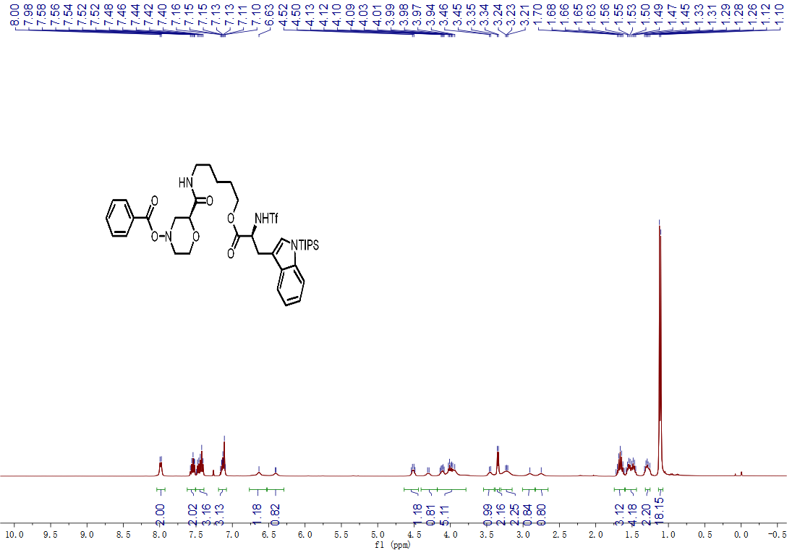
¹H-NMR spectrum of compound 1a
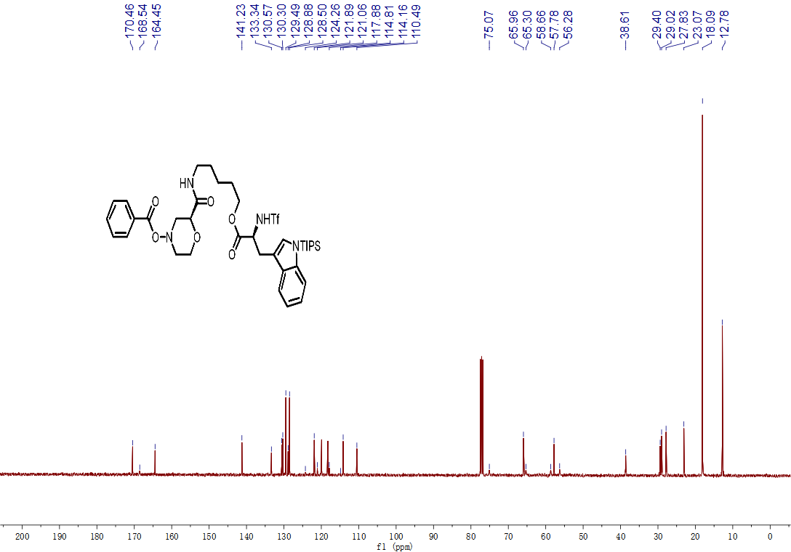
¹³C-NMR spectrum of compound 1a
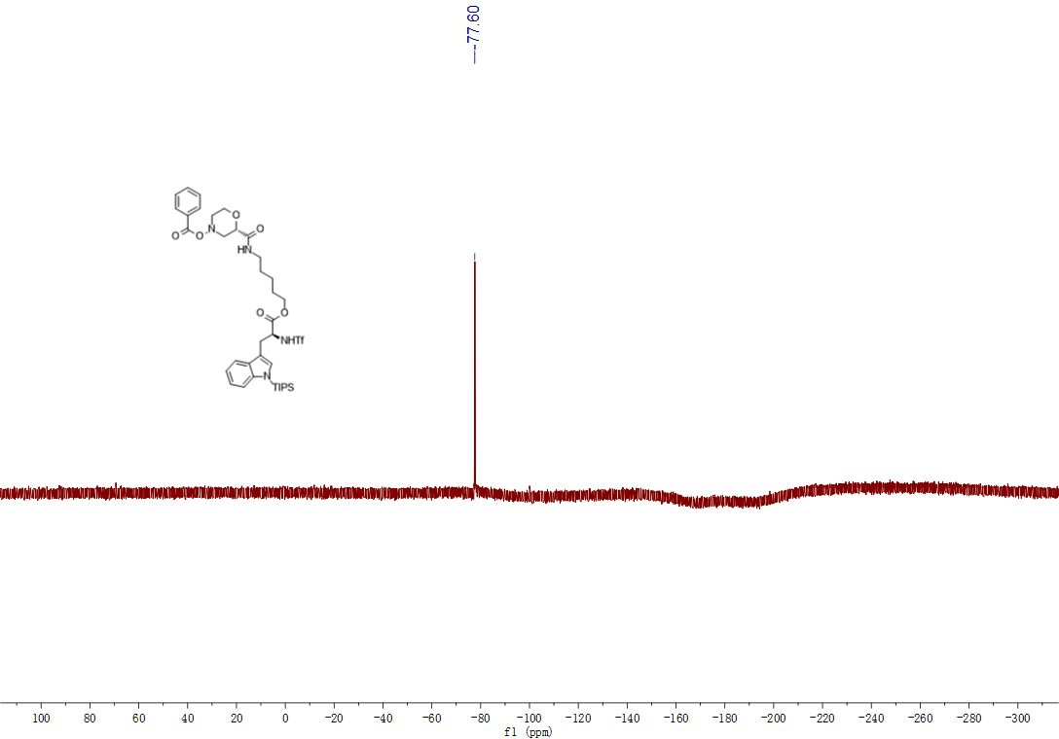
¹⁹F-NMR spectrum of compound 1a
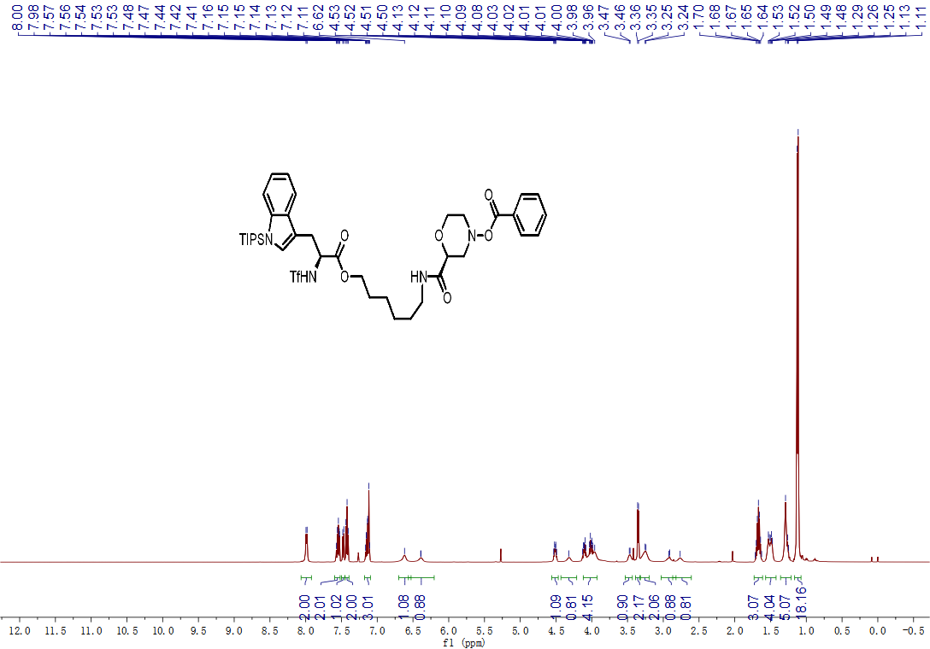
¹H-NMR spectrum of compound 1b

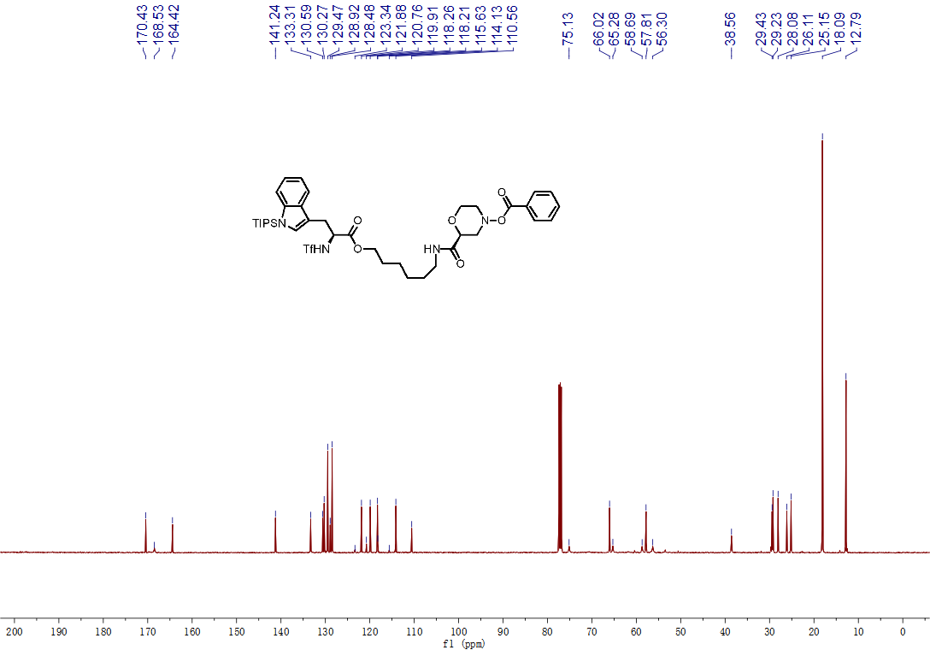
¹³C-NMR spectrum of compound 1b
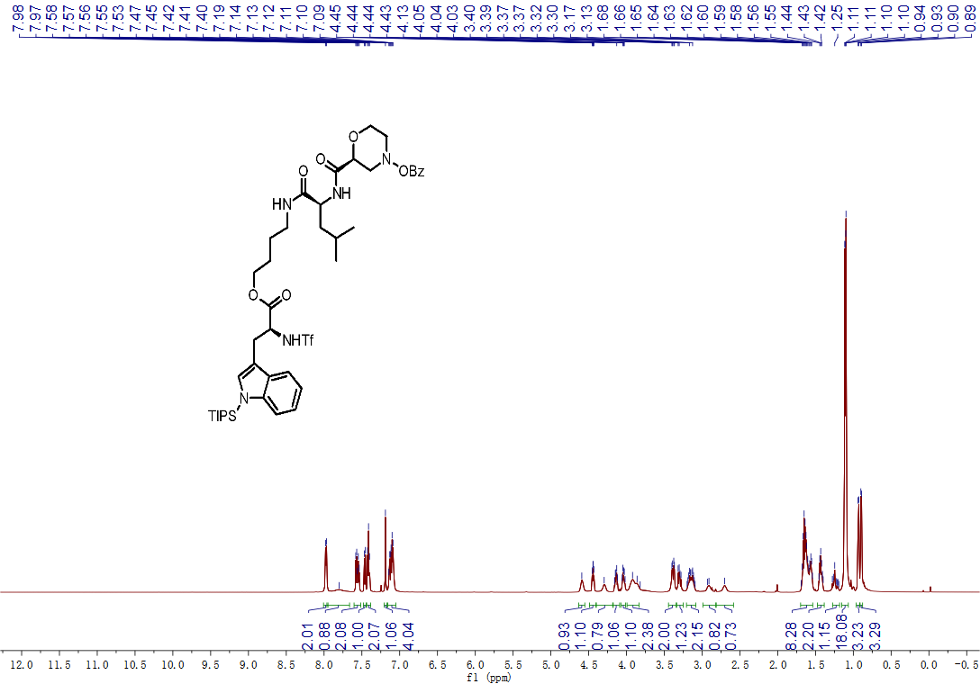
¹H-NMR spectrum of compound 1c

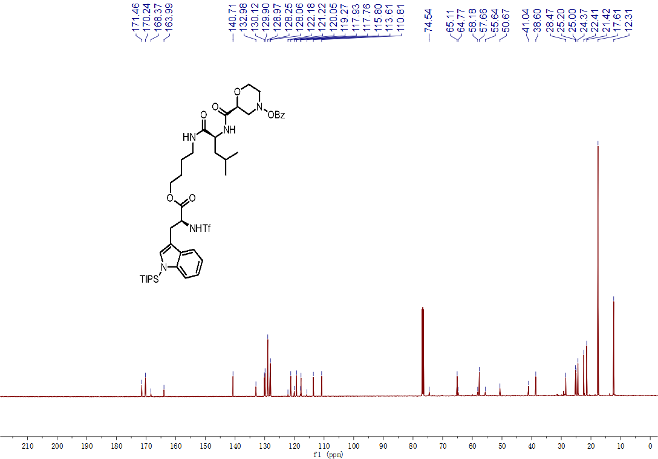
¹³C-NMR spectrum of compound 1c
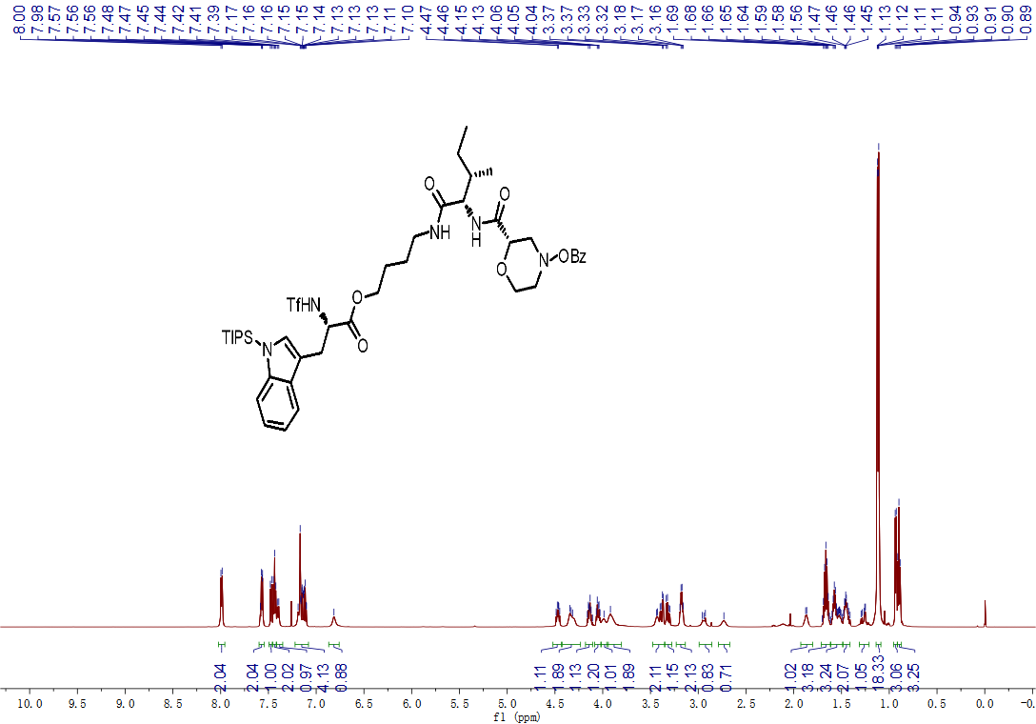
¹H-NMR spectrum of compound 1d
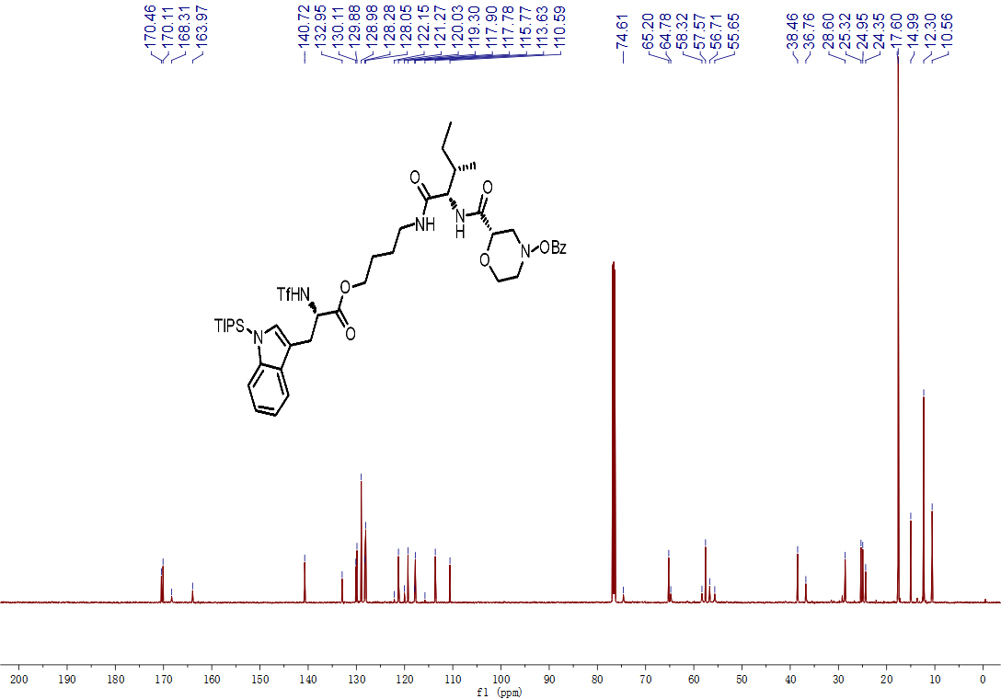
¹³C-NMR spectrum of compound 1d
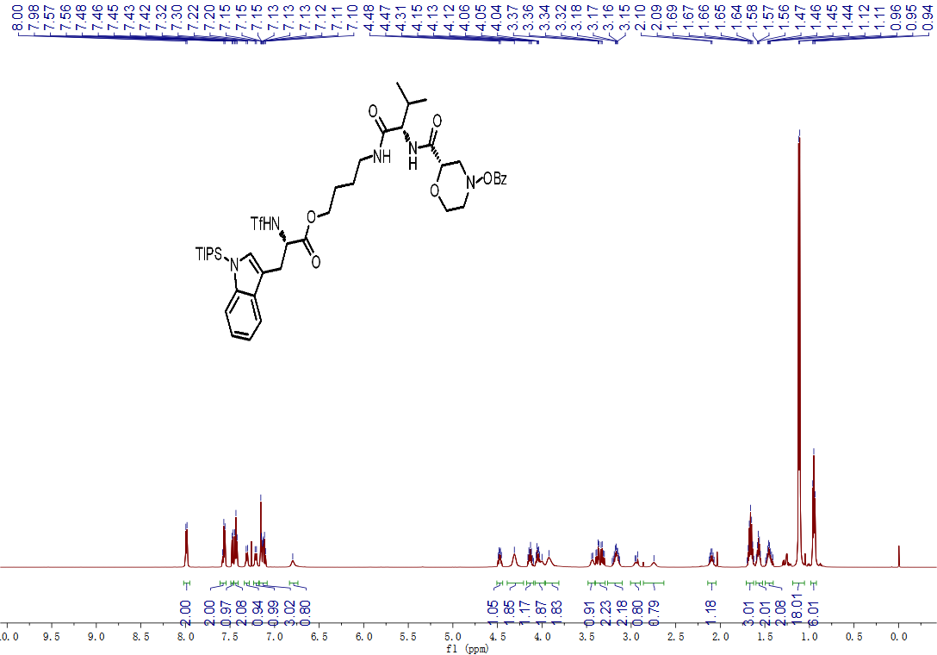
¹H-NMR spectrum of compound 1e
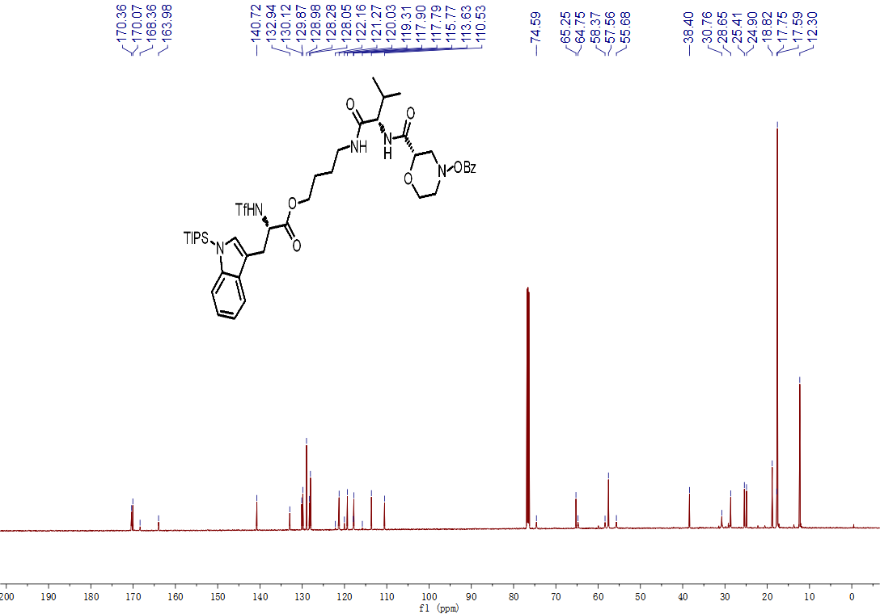
¹³C-NMR spectrum of compound 1e
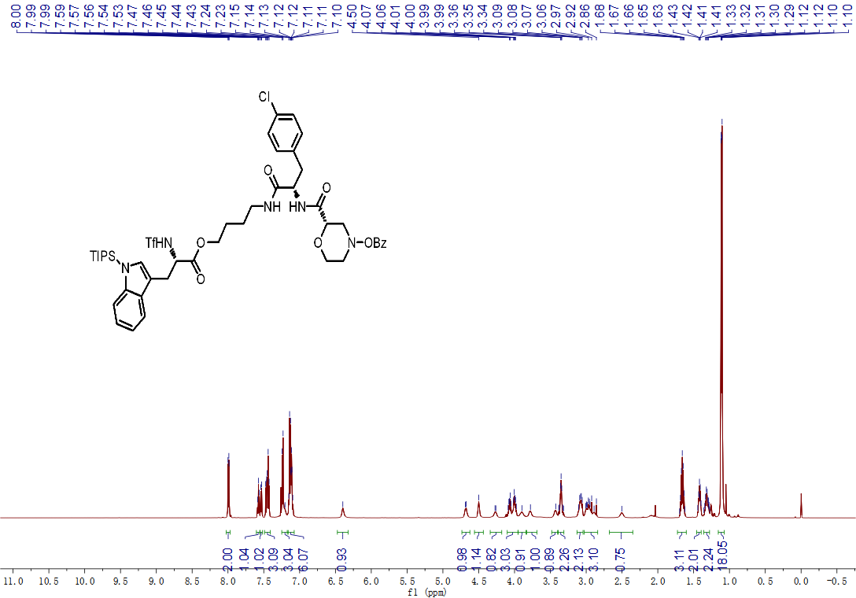
¹H-NMR spectrum of compound 1f
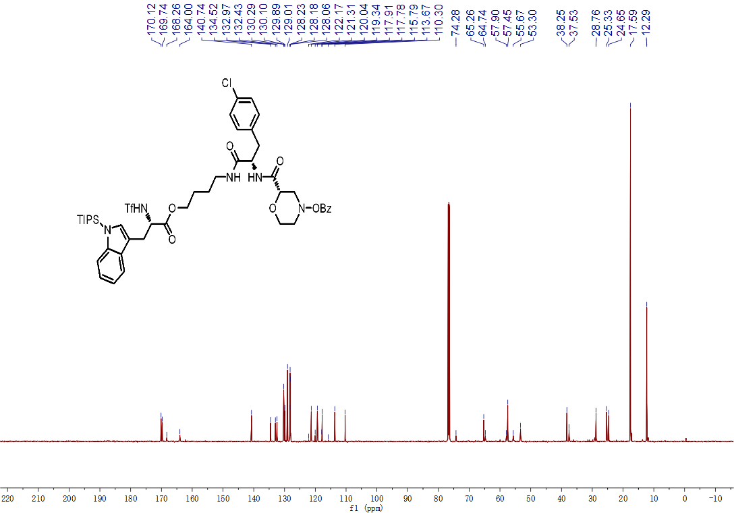
¹³C-NMR spectrum of compound 1f
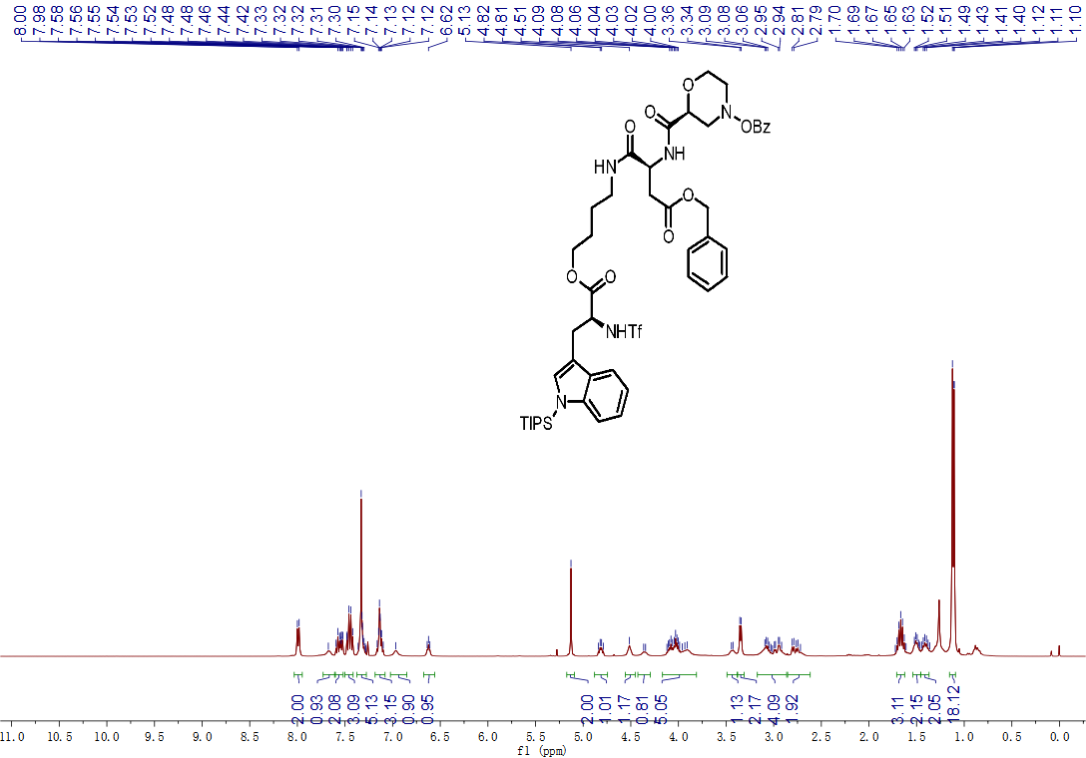
¹H-NMR spectrum of compound 1g
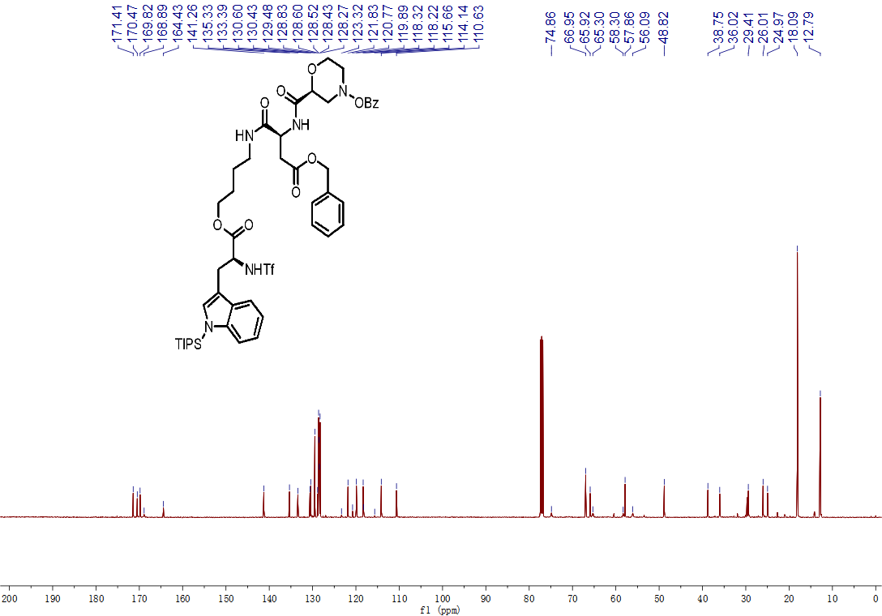
¹³C-NMR spectrum of compound 1g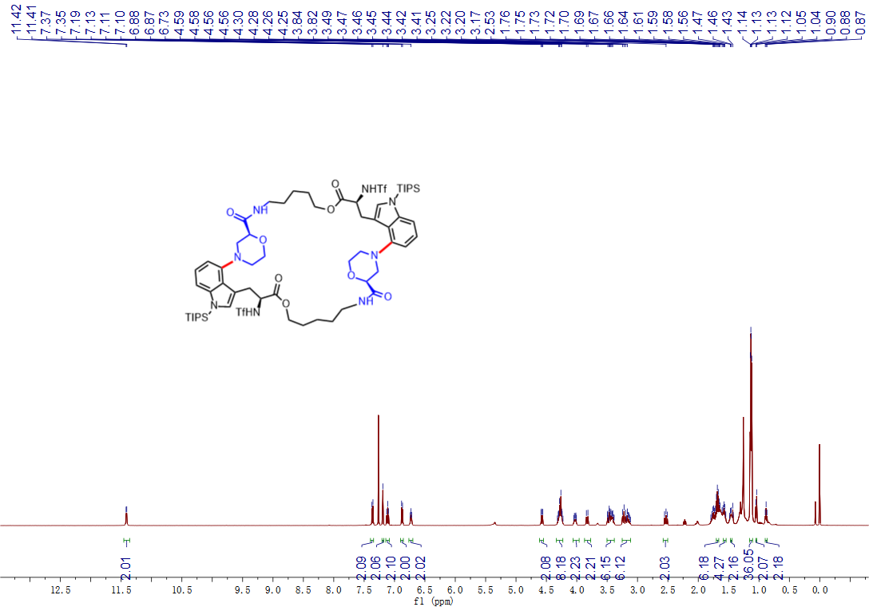
¹H-NMR spectrum of compound DC644
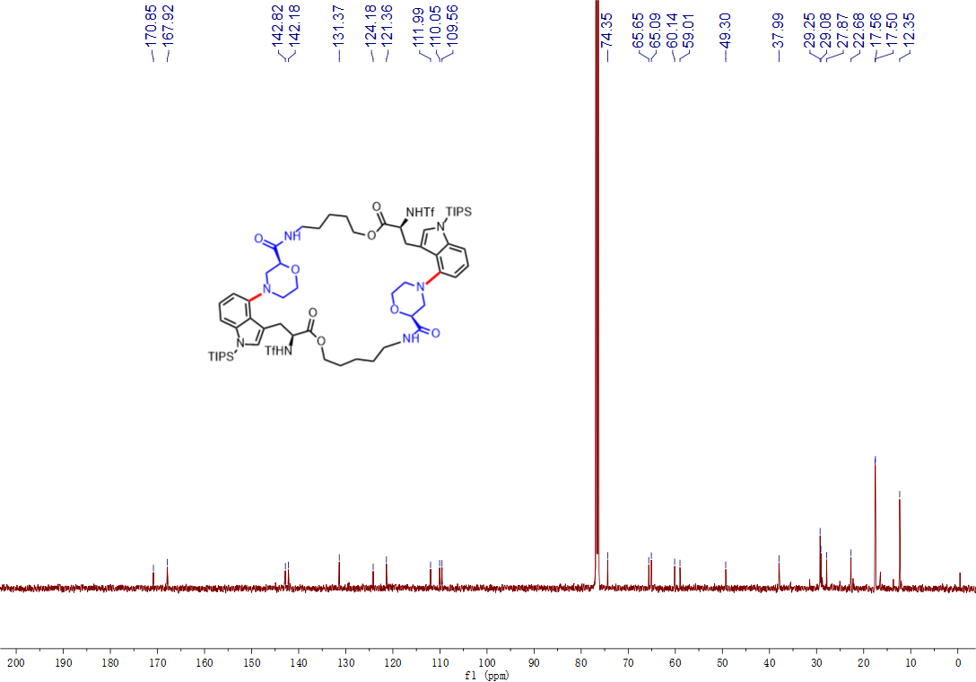
¹³C-NMR spectrum of compound DC644

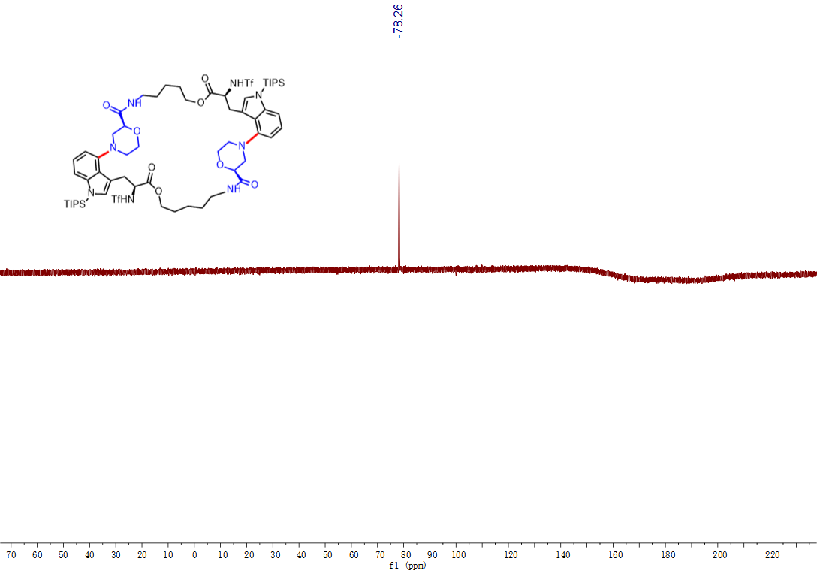
¹⁹F-NMR spectrum of compound DC644
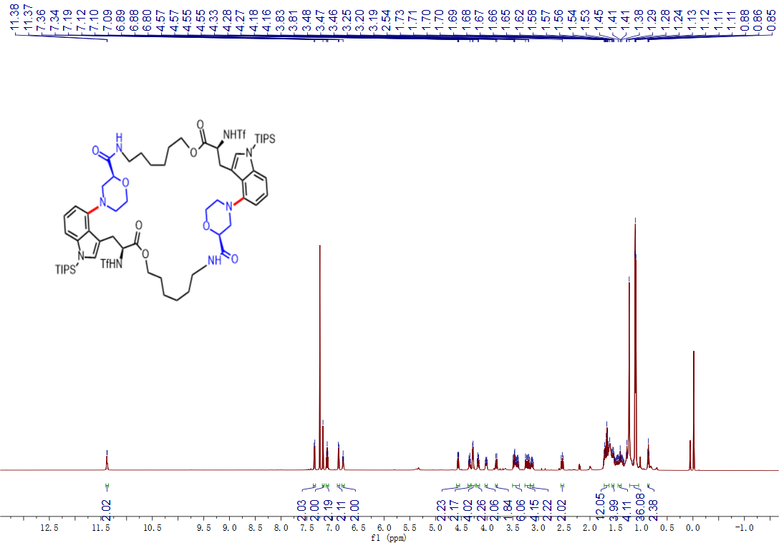
¹H-NMR spectrum of compound DC645
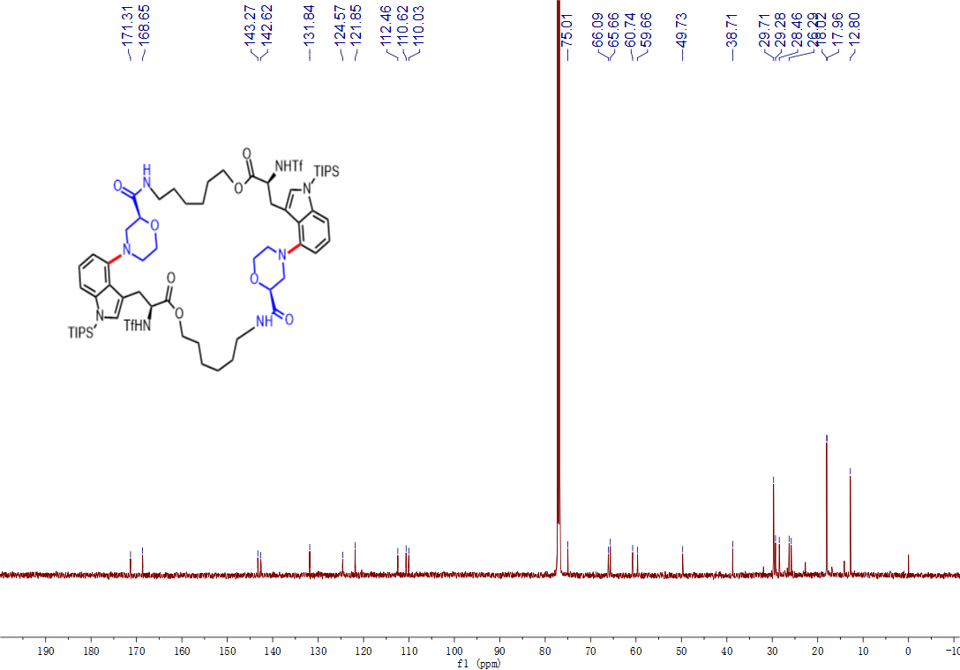
¹³C-NMR spectrum of compound DC645
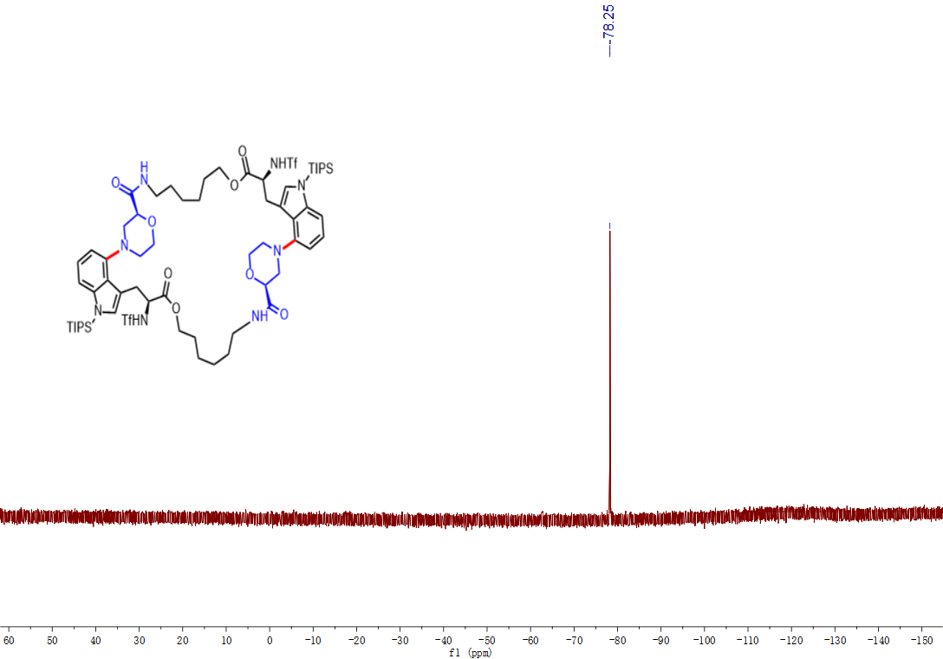
¹⁹F-NMR spectrum of compound DC645
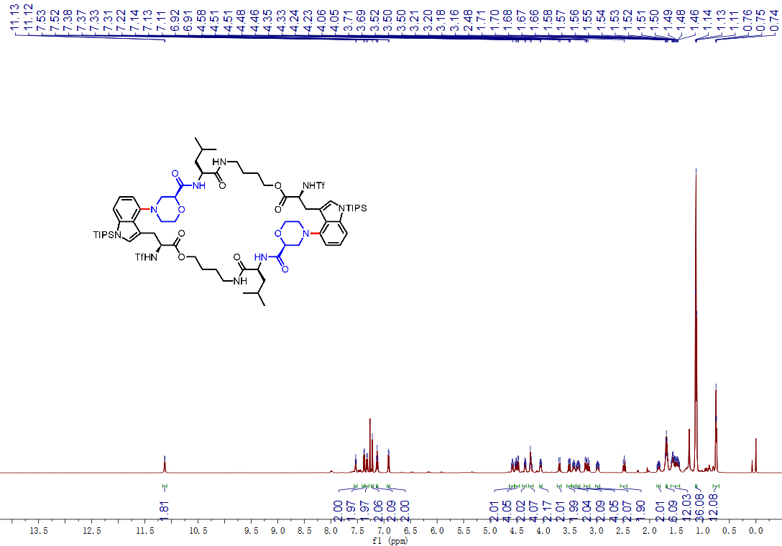
¹H-NMR spectrum of compound DC646
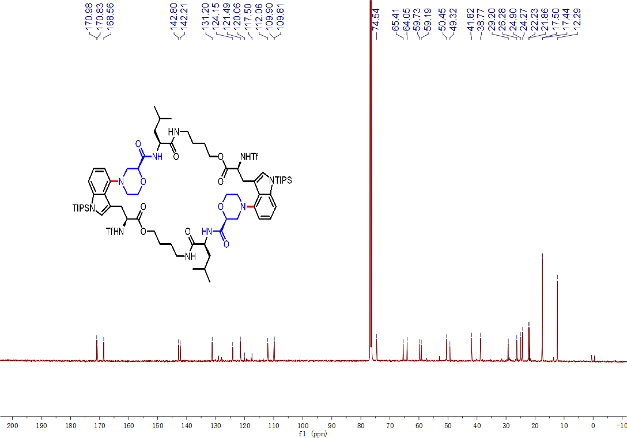
¹³C-NMR spectrum of compound DC646
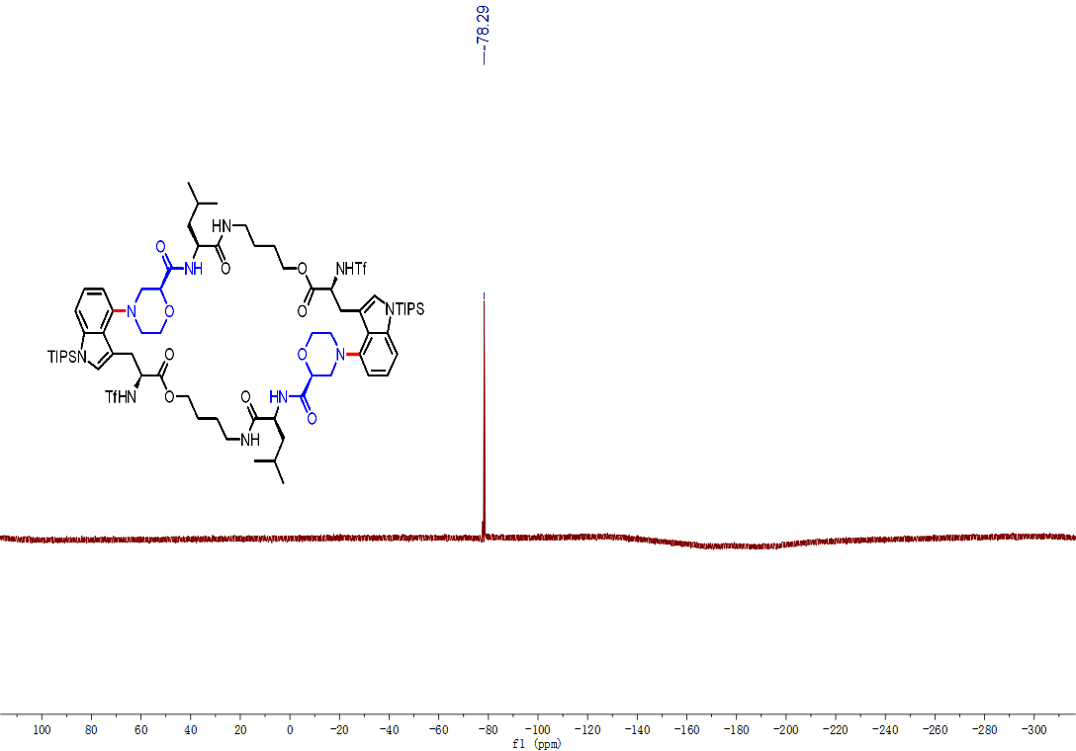
¹⁹F-NMR spectrum of compound DC646
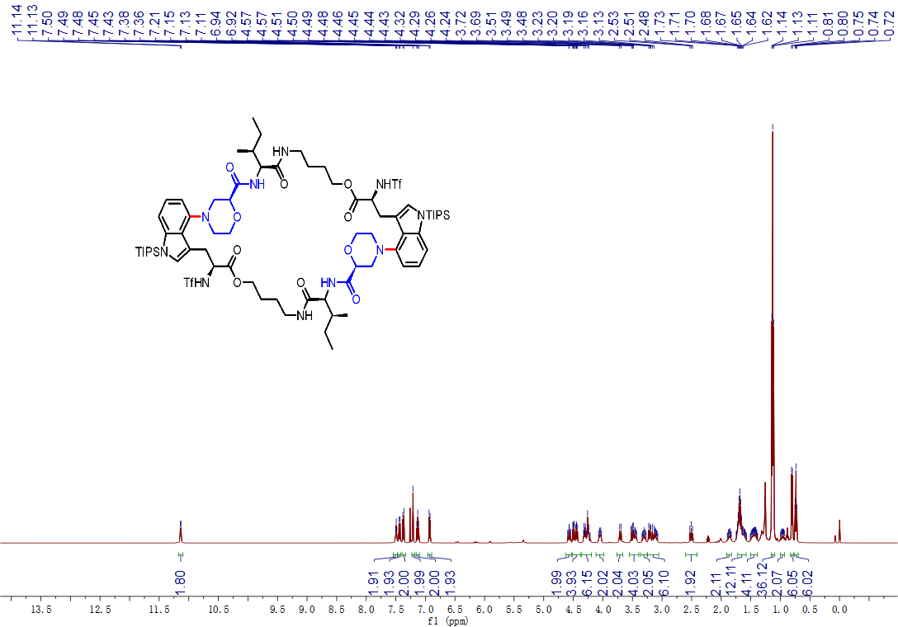
¹H-NMR spectrum of compound DC647
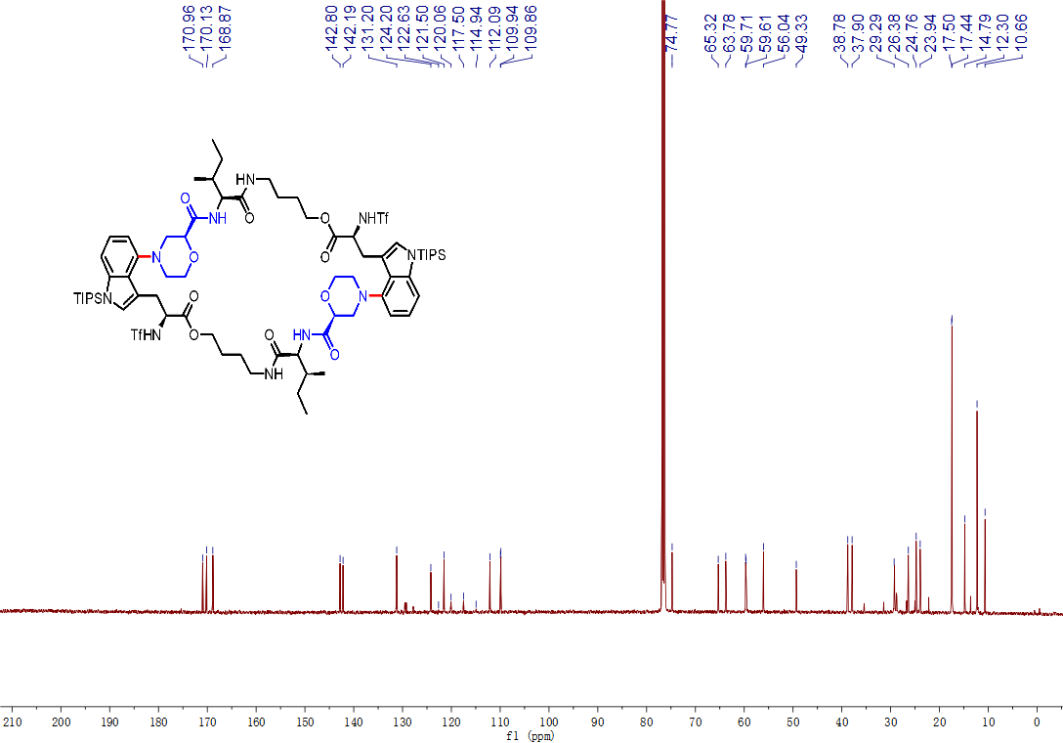
¹³C-NMR spectrum of compound DC647
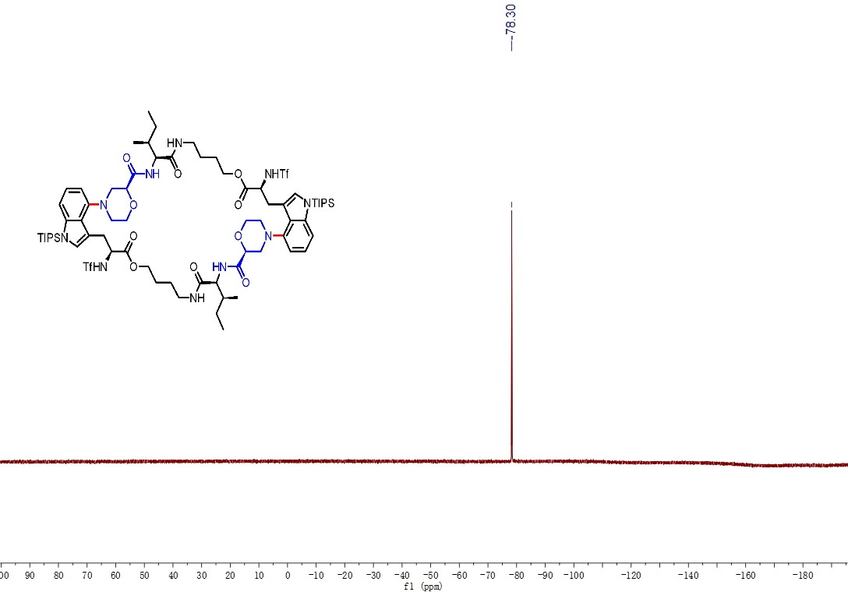
¹⁹F-NMR spectrum of compound DC647
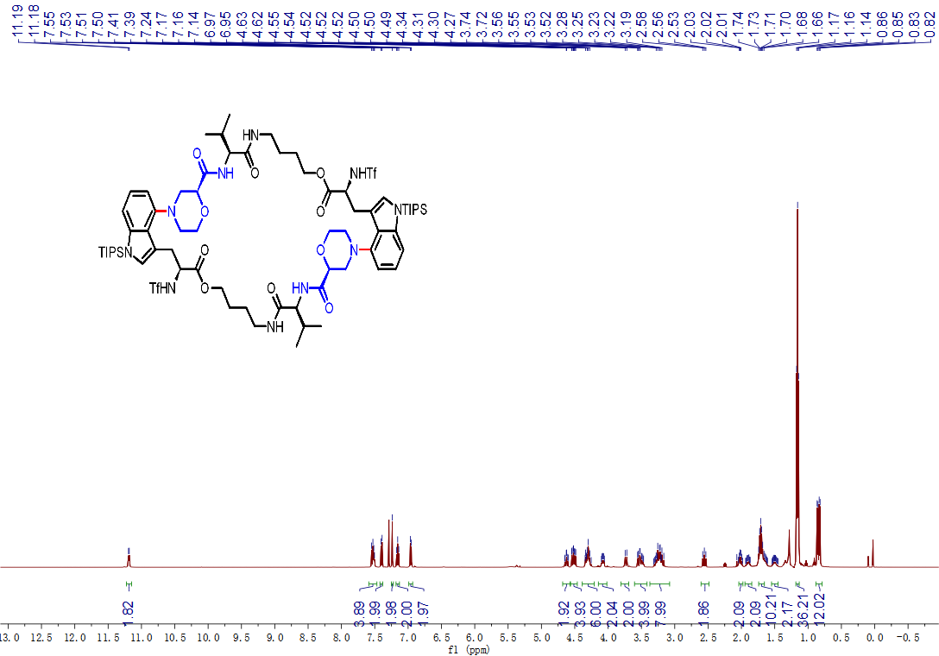
¹H-NMR spectrum of compound DC648
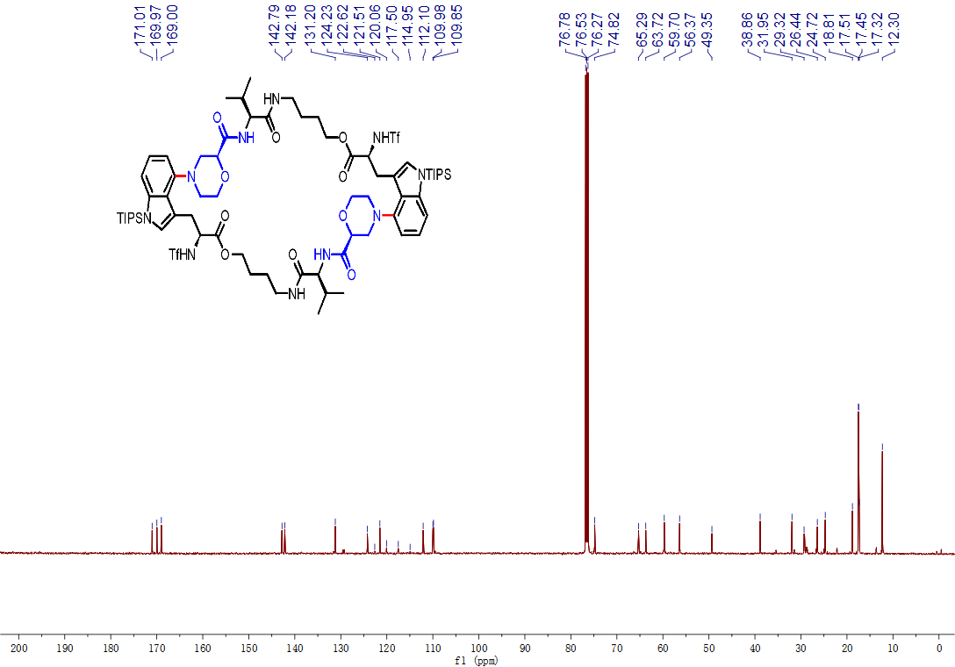
¹³C-NMR spectrum of compound DC648
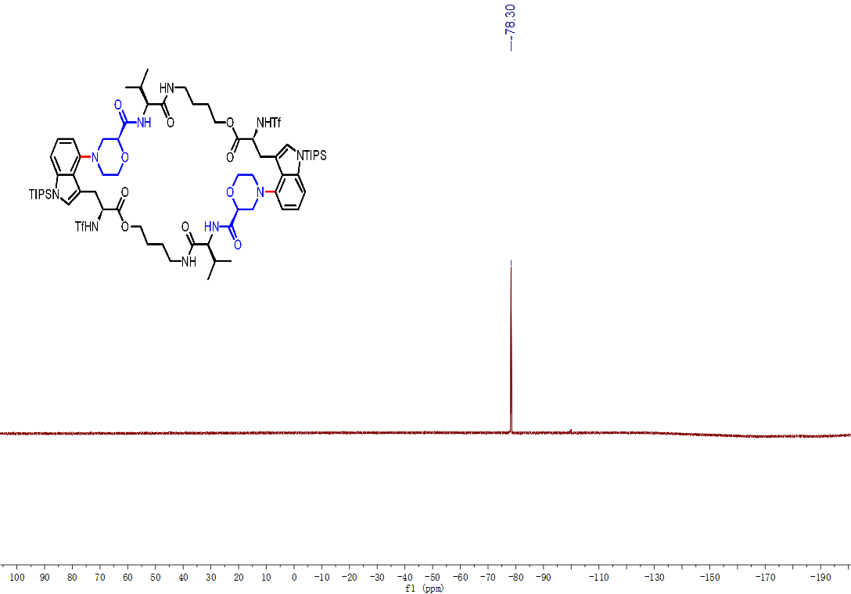
¹⁹F-NMR spectrum of compound DC648
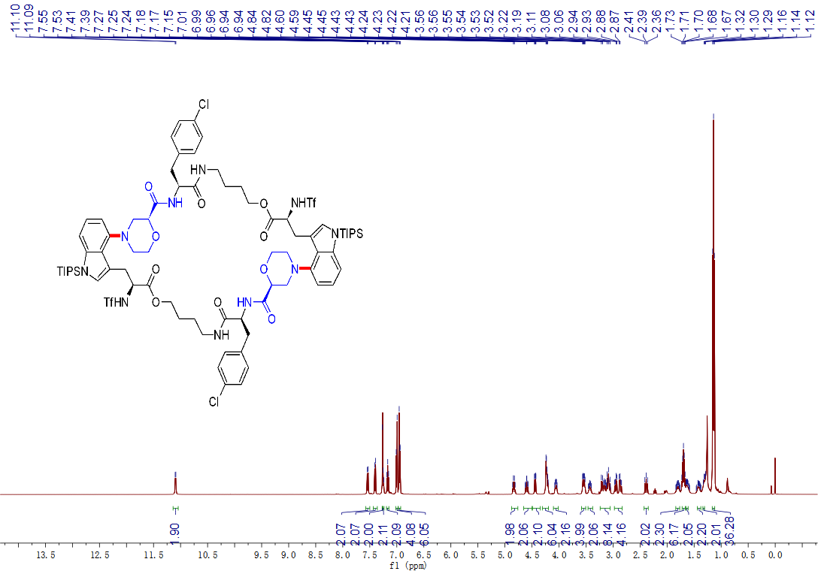
¹H-NMR spectrum of compound DC649
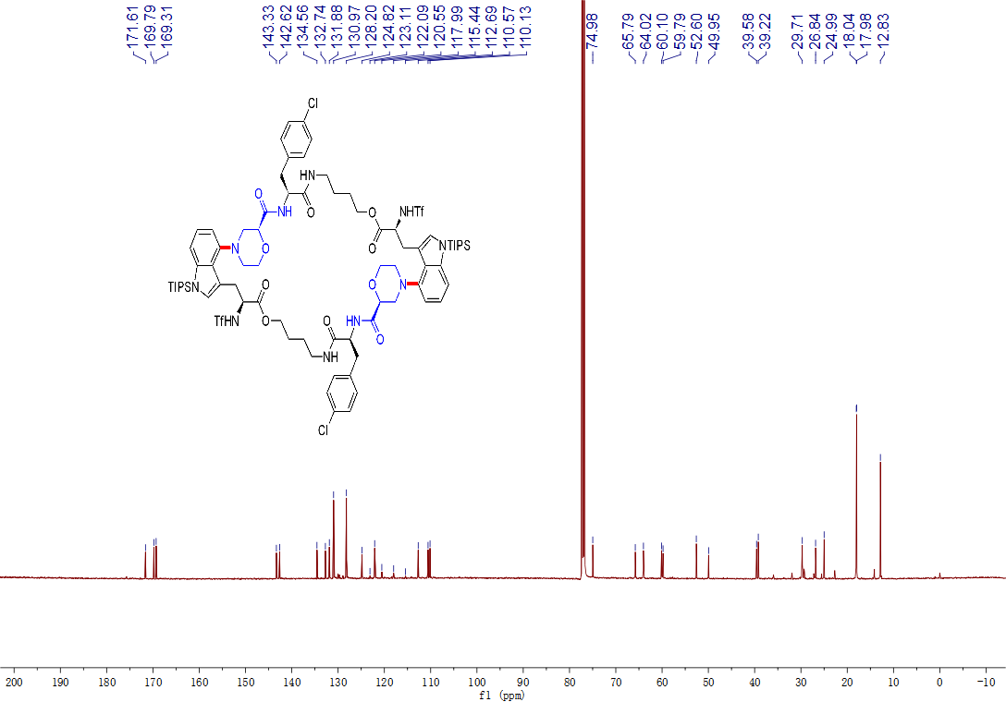
¹³C-NMR spectrum of compound DC649
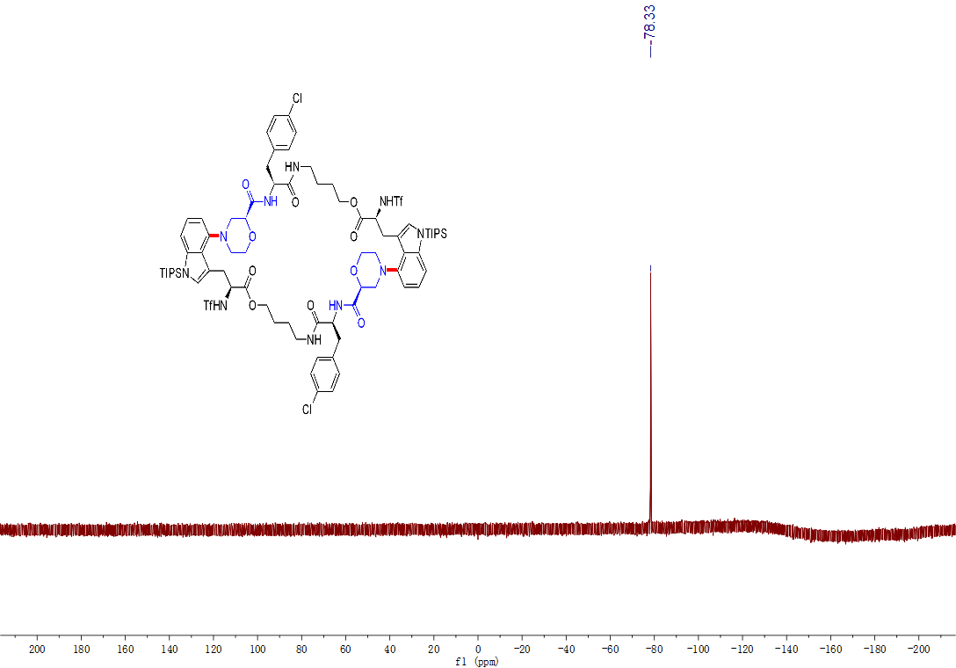
¹⁹F-NMR spectrum of compound DC649
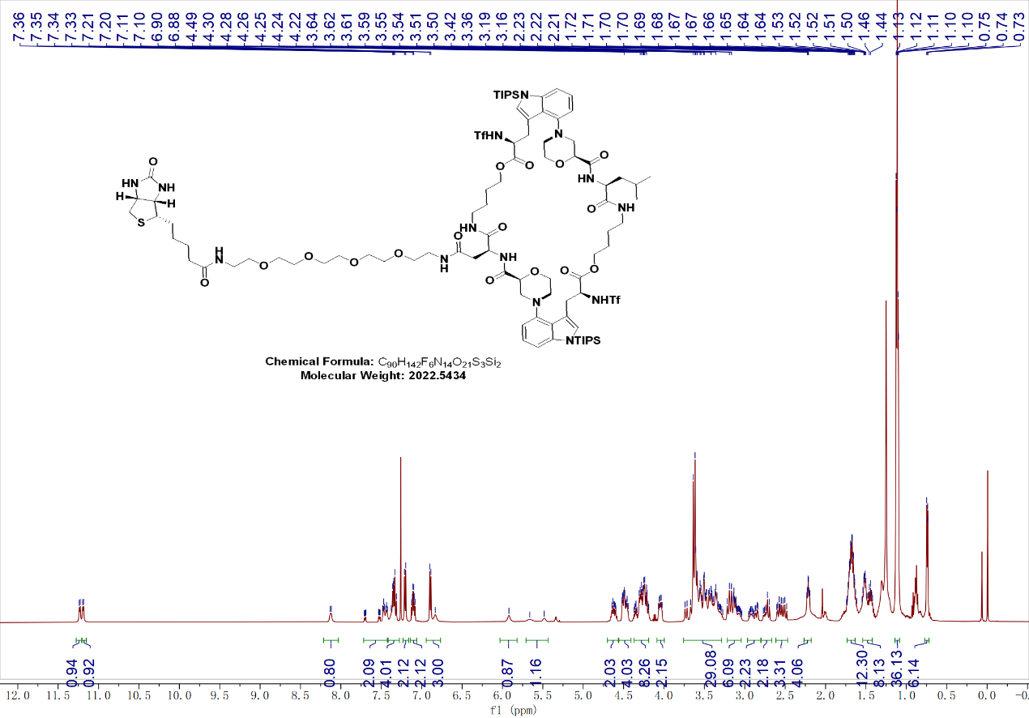
¹H-NMR spectrum of compound BIOTIN-DC646
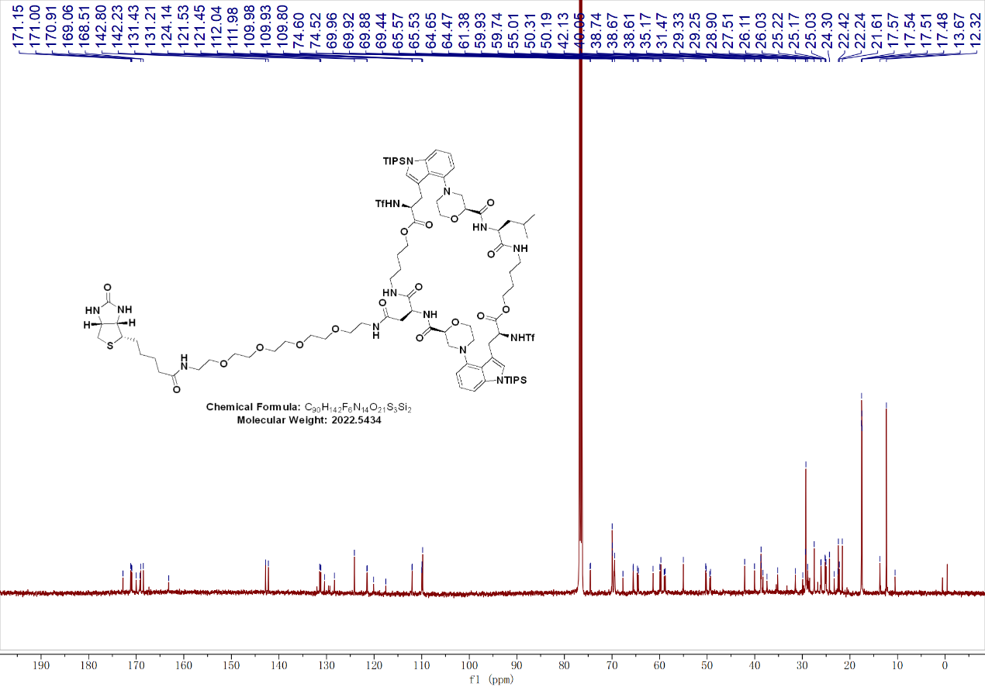
¹³C-NMR spectrum of compound BIOTIN-DC646
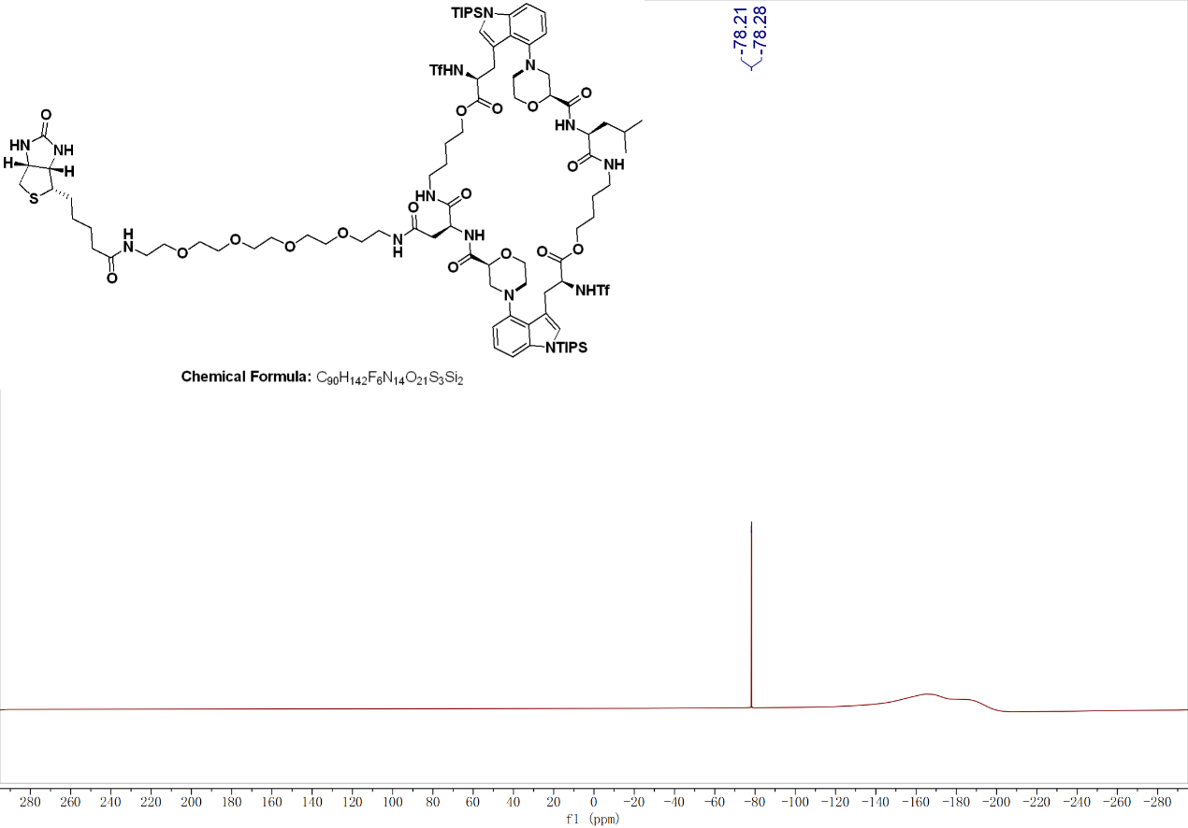
¹⁹F-NMR spectrum of compound BIOTIN-DC646

5. HR-MS (ESI) chromatogram of compounds DC644-649 and BIOTIN-DC646
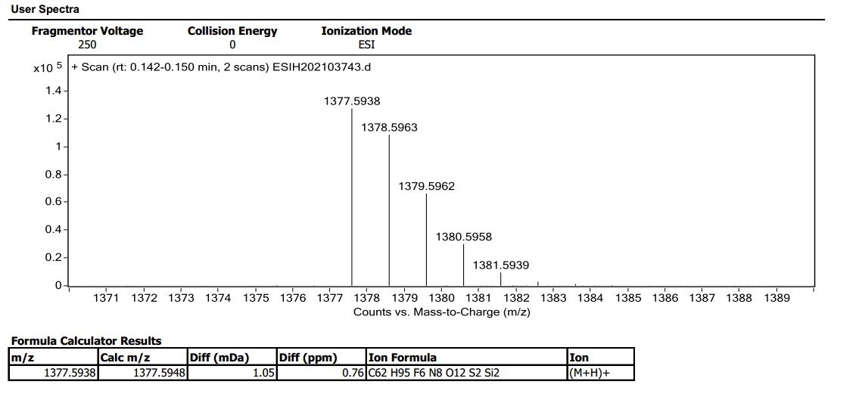
HR-MS (ESI) chromatogram of compound DC644
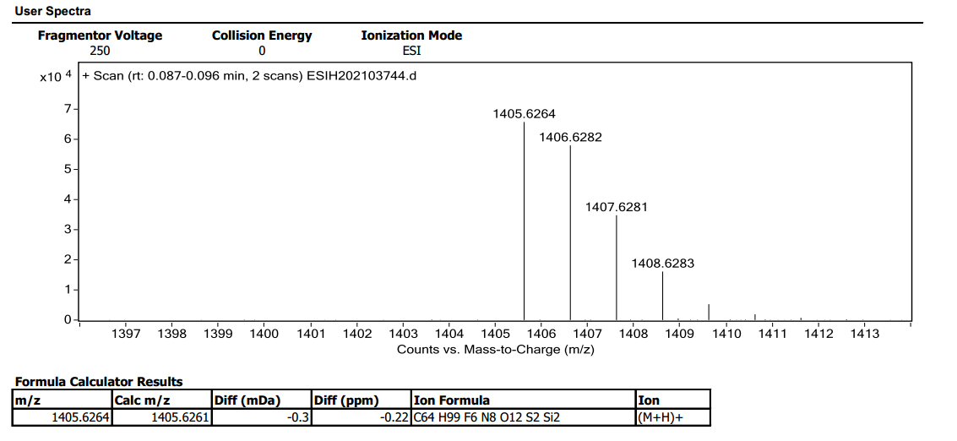
HR-MS (ESI) chromatogram of compound DC645
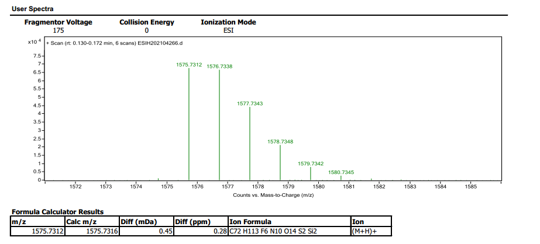
HR-MS (ESI) chromatogram of compound DC646
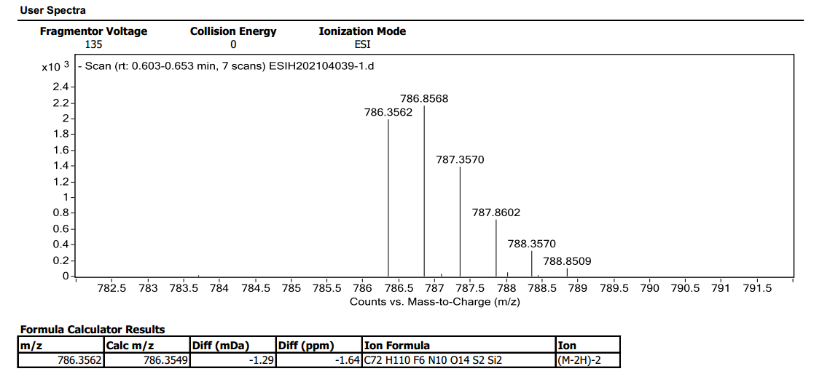
HR-MS (ESI) chromatogram of compound DC647
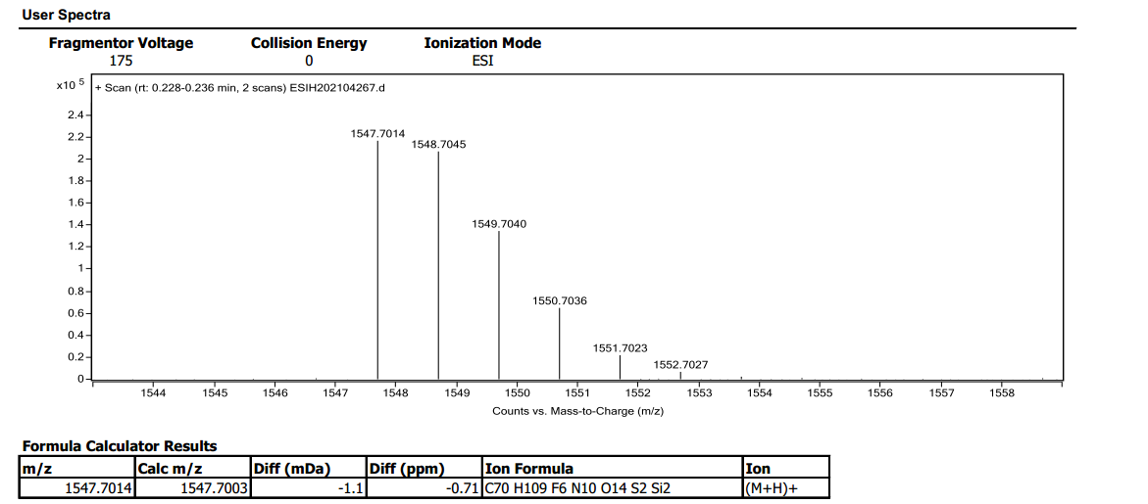
HR-MS (ESI) chromatogram of compound DC648
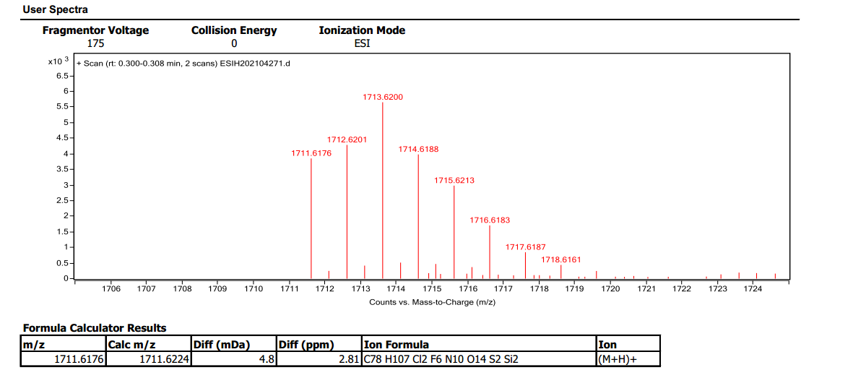
HR-MS (ESI) chromatogram of compound DC649
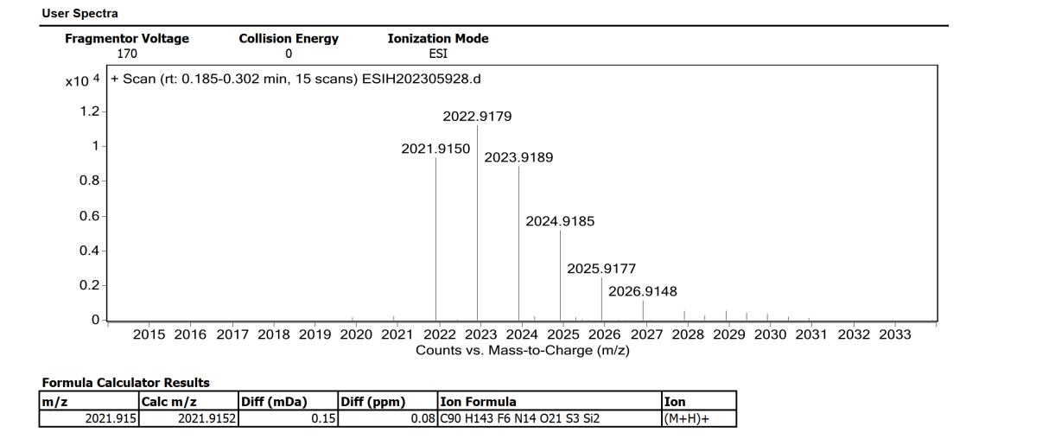
HR-MS (ESI) chromatogram of compound BIOTIN-DC646

6. X-ray crystallographic data of DC646
Compound DC646 (8 mg) is dissolved in 0.5 mL solvent (V_{DCM} : V_{MeOH} = 2:1), sealed with septum and the solvent is slowly volatilized at room temperature by inserting a fine needle, the crystal of compound DC646 is obtained after 24 h (Figure S5).
Supplementary Figure S5 X-Ray structure of compound DC646.
X-ray crystallographic data of DC646 are solutions at T = 170 K, C₇₂H₁₁₂F₆N₁₀O₁₄S₂Si₂, Mr = 1576.01, monoclinic, space group: P2₁, a = 14.813(3) Å, b = 15.887(3) Å, c = 22.189(4) Å, α = 90°, β = 105.058(13)°, γ = 90°, V = 5042.6(17) Å³, Z = 2. Displacement ellipsoids are drawn at the 50% probability level. CCDC 2172935 contains the supplementary crystallographic data for this paper (DC646). The data can be obtained free of charge from The Cambridge Crystallographic Data Centre via www.ccdc.cam.ac.uk/getstructures.

7. Supplementary Figures and tables
Supplementary Figure S6 FXR agonistic activity of DC646. Relative mRNA expression of Shp in WT (a) and Fxr^{△IE} (b) organoids treated with DMSO, DC646 (50 μmol/L), or GW4064 (10 μmol/L) with or without GW4064 (10 μmol/L) for 24 h (n = 4 in each group). Data are presented as the mean ± SEM. One-way ANOVA with Dunnett’s post hoc test. **P ≤ 0.01, ***P ≤ 0.001.
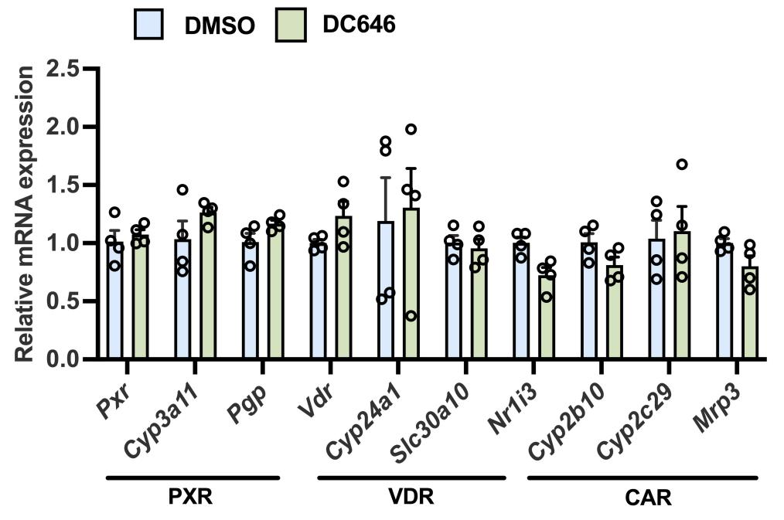
Supplementary Figure S7 Selectivity of DC646. Relative mRNA expression of PXR, VDR and CAR-downstream genes in organoids treated with DMSO or DC646 for 24 h (n = 4 in each group). Data are presented as the mean ± SEM and analyzed by unpaired t-test.
Supplementary Figure S8 The beneficial effects of DC646 on MAFLD are dependent on intestinal FXR. (a) Strategy of animal experiment. (b) Relative mRNA expression of FXR target genes in the intestine. (c) Liver to body weight ratio. (d) Serum ALT level. (e) Serum AST level. (f) Liver triglyceride contents. (g) Liver total cholesterol contents. (h) Representative H&E images. (i) NAFLD activity scoring (NAS) of each group. n = 6 in each group. Data are presented as the mean ± SEM and analyzed by unpaired t-test.

Supplementary Figure S9 DC646 antagonizes intestinal FXR, thereby reducing ceramide production and inducing GLP-1 production. (a) Relative mRNA expression of ileal FXR signaling. (b) Ileal ceramide levels (the data are normalized and centralized). (c) Relative mRNA expression of ileal ceramide-synthesis related genes. (d) Serum GLP-1 levels. HFD-fed mice were gavaged with vehicle or 10 mg/kg or 30 mg/kg DC646. n = 8 in each group. Data are presented as the mean ± SEM and analyzed by one-way ANOVA with Dunnett’s post hoc test. *P < 0.05, **P < 0.01, and ***P < 0.001, versus HFD + Vehicle group.

Supplementary Figure S10 Subacute toxicity test of DC646 at 20 mg/kg, 100 mg/kg, or 200 mg/kg. (a) Strategy of animal experiment. (b) Body weight. (c) Food intake. (d) Water intake. (e) Representative pictures of organ morphologies. (f) 1/3 Intestine length and colon length. (g) Organ weight. (h and i) Serum ALT (h) and AST(i) levels. (j) H&E staining of heart, liver, spleen, lung, and kidney. n = 5 in each group. Data are presented as the mean ± SEM and analyzed by one-way ANOVA with Dunnett’s post hoc test.

Supplementary Table S1 Sizes of the FXR-bound coactivators in the published experimental complex structures. The size is measured as the longest massive-atom distance within the molecule.
PDB  code | Size (Å)* | Sequence  length | Protein  sequence | Protein  name
3RVF | 20.0 | 11 | DHQLLRYLLDK | Nuclear receptor coactivator 1
3DCT | 20.2 | 11 | DHQLLRYLLDK | Nuclear receptor coactivator 1
3RUT | 20.8 | 11 | DHQLLRYLLDK | Nuclear receptor coactivator 1
3BEJ | 24.4 | 12 | TERHKILHRLLQ | Nuclear receptor coactivator 1
5Z12 | 20.5 | 9 | HKILHRLLQ | Nuclear receptor coactivator 2
5ICK | 20.9 | 11 | NALLRYLLDKD | Nuclear receptor coactivator 2
5IAW | 21.5 | 10 | NALLRYLLDK | Nuclear receptor coactivator 2
7D42 | 22.4 | 11 | ENALLRYLLDK | Nuclear receptor coactivator 2
7VUE | 22.5 | 11 | ENALLRYLLDK | Nuclear receptor coactivator 2
5WZX | 23.1 | 12 | ENALLRYLLDKD | Nuclear receptor coactivator 2
6HL1 | 26.6 | 13 | KENALLRYLLDKD | Nuclear receptor coactivator 2

Supplementary Table S2 Predicted sizes of the peptide candidates. The size is measured as the longest massive-atom distance within the molecule.
Peptide | Chemical structure | Size (Å)
SJN10 |  | 13.8 ± 0.1
SJN18 |  | 12.6 ± 0.0
HT14 |  | 16.8 ± 0.1
HT15 |  | 15.3 ± 0.1
HT18-2 |  | 15.4 ± 0.1
DC644 |  | 22.6 ± 3.2

Supplementary Table S3 Distribution of DC646 in the liver, intestine, and serum.
Tissue | Time | DC646
Liver  (ng/g) | 1 h | BQL$
Liver  (ng/g) | 4 h | BQL
Liver  (ng/g) | 8 h | BQL
Liver  (ng/g) | 24 h | BQL
Intestine (ng/g) | 1 h | 6350.00
Intestine (ng/g) | 4 h | 435.00
Intestine (ng/g) | 8 h | 72.00
Intestine (ng/g) | 24 h | BQL$
Serum  (ng/mL) | 1 h | BQL&
Serum  (ng/mL) | 4 h | BQL
Serum  (ng/mL) | 8 h | BQL
Serum  (ng/mL) | 24 h | BQL
$Below the quantization limit (curve range: 50.0−62500 ng/g)
&Below the quantization limit (curve range: 20.0−6000 ng/mL)

Supplementary Table S4 Selectivity of DC646 on PPARs by cell-based reporter assays.
Compd. | Con. （μmol/L） | PPARα |  | PPARδ |  | PPARγ
Compd. | Con. （μmol/L） | Inhibition% | SD% | Inhibition% | SD% | Inhibition% | SD%
DC646 | 10 | −1.3 | 17.6 | 18.9 | 8.1 | 14.0 | 4.3
Inhibition% means inhibition percentage of agonist-induced receptor activation.

Supplementary Table S5 Sequences of primers used for quantitative real-time PCR.
Gene | Primer sequence
Fxr | F: 5'-TGGGCTCCGAATCCTCTTAGA-3'
Fxr | R: 5'-TGGTCCTCAAATAAGATCCTTGG-3'
Shp | F: 5'-TCTGCAGGTCGTCCGACTATTC-3'
Shp | R: 5'-AGGCAGTGGCTGTGAGATGC-3'
Fgf15 | F: 5'-GCCATCAAGGACGTCAGCA-3'
Fgf15 | R: 5'-CTTCCTCCGAGTAGCGAATCAG-3'
Cyp7a1 | F: 5'-AACAACCTGCCAGTACTAGATAGC-3'
Cyp7a1 | R: 5'-GTGTAGAGTGAAGTCCTCCTTAGC-3'
Cyp8b1 | F: 5'-CTAGGGCCTAAAGGTTCGAGT-3'
Cyp8b1 | R: 5'-GTAGCCGAATAAGCTCAGGAAG-3'
Pxr | F: 5'-GGAAGAGCCCATCAACGTAG-3'
Pxr | R: 5'-TGCATCCTTCACACGTCAT-3'
Cyp3a11 | F: 5'-CGCCTCTCCTTGCTGTCACA-3'
Cyp3a11 | R: 5'-CTTTGCCTTCTGCCTCAAGT-3'
P-gp | F: 5'-CAGCAGTCAGTGTGCTTACAA-3'
P-gp | R: 5'-ATGGCTCTTTTATCGGCCTCA-3'
Vdr | F: 5'-CCGGAATGTGCCTCGGATCTG-3'
Vdr | R: 5'-ATGCCAATGTCCACGCAGCG-3'
Cyp24a1 | F: 5'-CTGCCCCATTGACAAAAGGC-3'
Cyp24a1 | R: 5'-CTCACCGTCGGTCATCAGC-3'
Slc30a10 | F: 5'-TGTCAGACCTGATCTCGCTGT-3'
Slc30a10 | R: 5'-GCCTCCACGAAGATGGTGAA-3'
Nr1i3 | F: 5'-ATATGGGCCGAGGAACTGTGT-3'
Nr1i3 | R: 5'-GGCGTGGAAATGATAGCCTGT-3'
Cyp2b10 | F: 5'-AAAGTCCCGTGGCAACTTCC-3'
Cyp2b10 | R: 5'-TTGGCTCAACGACAGCAACT-3'
Cyp2c29 | F: 5'-ATCTGGTCGTGTTCCTAGCG-3'
Cyp2c29 | R: 5'-CAGTAGGCTTTGAGCCCAAATA-3'
Mrp3 | F: 5'-CTGGGTCCCCTGCATCTAC-3'
Mrp3 | R: 5'-GCCGTCTTGAGCCTGGATAAC-3'
Elovl6 | F: 5'- GAAAAGCAGTTCAACGAGAACG -3'
Elovl6 | R: 5'- AGATGCCGACCACCAAAGATA -3'
Acsl1 | F: 5'- CGATGGCTGTTGGACTTTGC -3'
Acsl1 | R: 5'- CACCCAGGCTCGACTGTATC -3'
Scd1 | F: 5'- TTCTTGCGATACACTCTGGTGC -3'
Scd1 | R: 5'- CGGGATTGAATGTTCTTGTCGT -3'
Cd36 | F: 5'- AGATGACGTGGCAAAGAACAG -3'
Cd36 | R: 5'- CCTTGGCTAGATAACGAACTCTG -3'
Fabp1 | F: 5'- ATGAACTTCTCCGGCAAGTACC -3'
Fabp1 | R: 5'- CTGACACCCCCTTGA TGTCC -3'
Fabp4 | F: 5'- AAGGTGAAGAGCATCATAACCCT -3'
Fabp4 | R: 5'- TCACGCCTTTCATAACACATTCC -3'
Apoe | F: 5'- CTGACAGGATGCCTAGCCG-3'
Apoe | F: 5'- CGCAGGTAATCCCAGAAGC-3'
Cyp4a10 | F: 5'- TTCCCTGATGGACGCTCTTTA-3'
Cyp4a10 | F: 5'- GCAAACCTGGAAGGGTCAAAC-3'
Cpt1b | F: 5'- GCACACCAGGCAGTAGCTTT-3'
Cpt1b | F: 5'- CAGGAGTTGATTCCAGACAGGTA-3'
Sptlc1 | F: 5'- CGAGGGTTCTATGGCACATT -3'
Sptlc1 | R: 5'- GGTGGAGAAGCCATACGAGT -3'
Sptlc2 | F: 5'- TCACCTCCATGAAGTGCATC -3'
Sptlc2 | R: 5'- CAGGCGTCTCCTGAAATACC -3'
Degs1 | F: 5'- AATGGGTCTACACGGACCAG -3'
Degs1 | R: 5'- TGGTCAGGTTTCATCAAGGAC -3'
Cers2 | F: 5'- AAGTGGGAAACGGAGTAGCG -3'
Cers2 | R: 5'- ACAGGCAGCCATAGTCGTTC -3'
Cers4 | F: 5'- GGATTAGCTGATCTCCGCAC -3'
Cers4 | R: 5'- CCAGTATGTCTCCTGCCACA -3'
Cers6 | F: 5'- AAGCCAATGGACCACAAACT -3'
Cers6 | R: 5'- TGCTTGGAGAGCCCTTCTAAT -3'
Smpd1 | F: 5'- GTTACCAGCTGATGCCCTTC -3'
Smpd1 | R: 5'- AGCAGGATCTGTGGAGTTG -3'
Smpd2 | F: 5'- AGCAGGATCTGTGGAGTTG -3'
Smpd2 | R: 5'- CTCCAGCCATGAAGCTCAAC -3'
Smpd3 | F: 5'- CCTGACCAGTGCCATTCTTT -3'
Smpd3 | R: 5'- AGAAACCCGGTCCTCGTACT -3'
Smpd4 | F: 5'- ACCTGGCCCTCAATCCATTTG -3'
Smpd4 | R: 5'- ATAGGCACAGTCCGAAGTACG -3'
Tgfb | F: 5'- CCACCTGCAAGACCATCGAC -3'
Tgfb | R: 5'- CTGGCGAGCCTTAGTTTGGAC -3'
Col3a1 | F: 5'- TAGGACTGACCAAGGTGGCT -3'
Col3a1 | R: 5'- GGAACCTGGTTTCTTCTCACC -3'
Col4a1 | F: 5'- CACATTTTCCACAGCCAGAG -3'
Col4a1 | R: 5'- GTCTGGCTTCTGCTGCTCTT -3'
Col4a2 | F: 5'- GCCCTGTAGTCCTGGGAATC -3'
Col4a2 | R: 5'- CCAGTGCTACCCGGAGAAA -3'
Col5a2 | F: 5'- CATGGAGAAGGTTTCCAAATG -3'
Col5a2 | R: 5'- AAAGCCCAGGAACAAGAGAA -3'
Col12a12 | F: 5'- AATTGCCTCCACACCTTCAC -3'  R: 5'- TCACCAAGCTGCTCATCAAC -3'
Tnfa | F: 5'- CCACCACGCTCTTCTGTCTAC -3'
Tnfa | R: 5'- AGGGTCTGGGCCATAGAACT -3'
Pail | F: 5'- TTCAGCCCTTGCTTGCCTC -3'
Pail | R: 5'- ACACTTTTACTCCGAAGTCGGT -3'
Ccl2 | F: 5'- TTAAAAACCTGGATCGGAACCAA -3'
Ccl2 | R: 5'- GCATTAGCTTCAGATTTACGGGT -3'
Ccl3 | F: 5'- TTCTCTGTACCATGACACTCTGC -3'
Ccl3 | R: 5'- CGTGGAATCTTCCGGCTGTAG -3'
Il1b | F: 5'- GCAACTGTTCCTGAACTCAACT -3'
Il1b | R: 5'- ATCTTTTGGGGTCCGTCAACT -3'
Nlrp3 | F: 5'- ATTACCCGCCCGAGAAAGG-3'
Nlrp3 | R: 5'-CATGAGTGTGGCTAGATCCAAG-3'
Pycard | F: 5'- TGCTTAGAGACATGGGCTTAC -3'
Pycard | R: 5'- CAATGAGTGCTTGCCTGTG -3'
Gapdh | F: 5'-AGGTCGGTGTGAACGGATTTG-3'
Gapdh | R: 5'-TGTAGACCATGTAGTTGAGGTCA-3'
Actin | F: 5'-GGCTGTATTCCCCTCCATCG-3'
Actin | R: 5'-CCAGTTGGTAACAATGCCATGT-3'
18s | F: 5'-ATTGGAGCTGGAATTACCGC-3'
18s | R: 5'-CGGCTACCACATCCAAGGAA-3'

