Supplementary information
Tracing TMEM106B Fibril Deposition in Aging and Parkinson’s Disease with Dementia Brains
Wanbing Zhao ^{1,¶}, Yun Fan^{1,¶}, Qinyue Zhao², Zhen Fan³, Jue Zhao¹, Wenbo Yu¹, Wensheng Li⁴, Dan Li^{2,5,6}, Cong Liu^{7,8,}*, Jian Wang^{1,}*
¹Department of Neurology and National Research Center for Aging and Medicine & National Center for Neurological Disorders, State Key Laboratory of Medical Neurobiology, Huashan Hospital, Fudan University, Shanghai 200040, China
²Bio-X Institutes, Key Laboratory for the Genetics of Developmental and Neuropsychiatric Disorders (Ministry of Education), Shanghai Jiao Tong University, Shanghai 200030, China
³Department of Neurosurgery, Huashan Hospital, Shanghai Medical College, Fudan University, Shanghai 200040, China
⁴Department of Anatomy and Histoembryology, School of Basic Medical Sciences, State Key Laboratory of Medical Neurobiology and MOE Frontiers Center for Brain Science, Institutes of Brain Science, Fudan University, Shanghai 200032, China
⁵Zhangjiang Institute for Advanced Study, Shanghai Jiao Tong University, Shanghai 200240, China
⁶WLA Laboratories, World Laureates Association, Shanghai 201203, China
⁷Interdisciplinary Research Center on Biology and Chemistry, Shanghai Institute of Organic Chemistry, Chinese Academy of Sciences, Shanghai 201210, China
⁸State Key Laboratory of Chemical Biology, Shanghai Institute of Organic Chemistry, Chinese Academy of Sciences, Shanghai 200032, China

¶These authors contributed equally to this work.
*Correspondence: liulab@sioc.ac.cn (C.L.), wangjian_hs@fudan.edu.cn (J.W.)
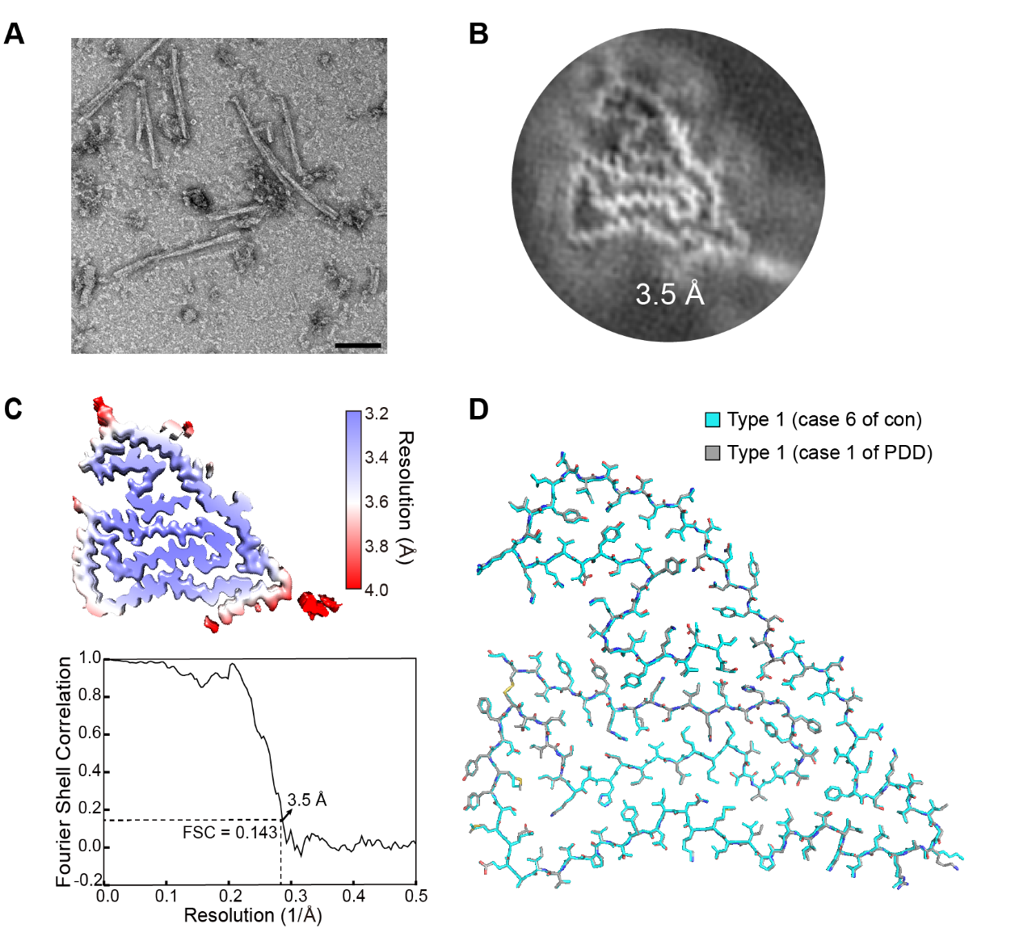
Figure S1. Cyro-EM structure determination of TMEM106B fibril derived from case 1 of PDD. The NS-TEM represent image (A) and 3D density map with resolution labeled (B) of TMEM106B fibril extracted from the frontal cortex of case 1 of PDD patient. (C) Local resolution estimation of the reconstruction (top) and gold standard Fourier shell correction curve (bottom) for case 1 of PDD derived TMEM106B fibril. Its overall resolution of is 3.5 Å. (D) Overlay of the atomic models of the Type 1 TMEM106B fibril derived from case 1 of PDD and Type 1 TMEM106B fibril (PDB ID: 7X83) from case 6 of non-ND (corresponding to normal 2 case in our previously study) as we reported¹ with a root-mean square deviation (RMSD) of 0.280 Å over 135 C-α atoms, which indicates that the ex vivo TMEM106B fibril from case 1 of PDD patient corresponds to the Type 1 TMEM106B fibril structure. Scale bar,100 nm (A).

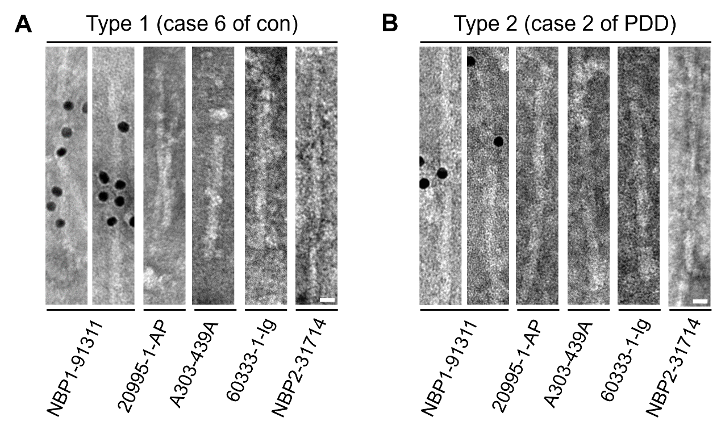Figure S2. Immunogold staining of TMEM106B fibrils derived from two other cases. Representative images of immunogold staining of Type 1 TMEM106B fibril extracted from case 6 of non-ND control (A) and Type 2 TMEM106B fibril extracted from case 2 of PDD (B) using five commercial antibodies. Scale bar, 50 nm (A and B).

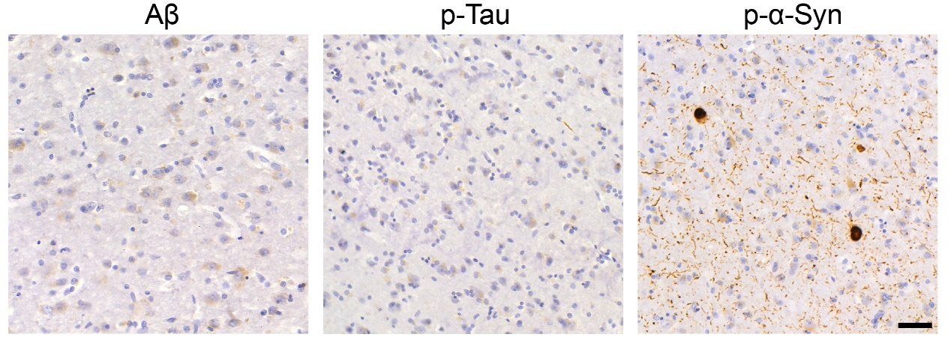
Figure S3. Pathological characterization of case 1 of PDD. IHC staining of abundant p-α-syn pathology, including Lewy bodies and Lewy neurites, but no p-Tau pathology and Aβ plaques in the cingulate cortex of case 1 of PDD patient. Scale bar, 50 μm.

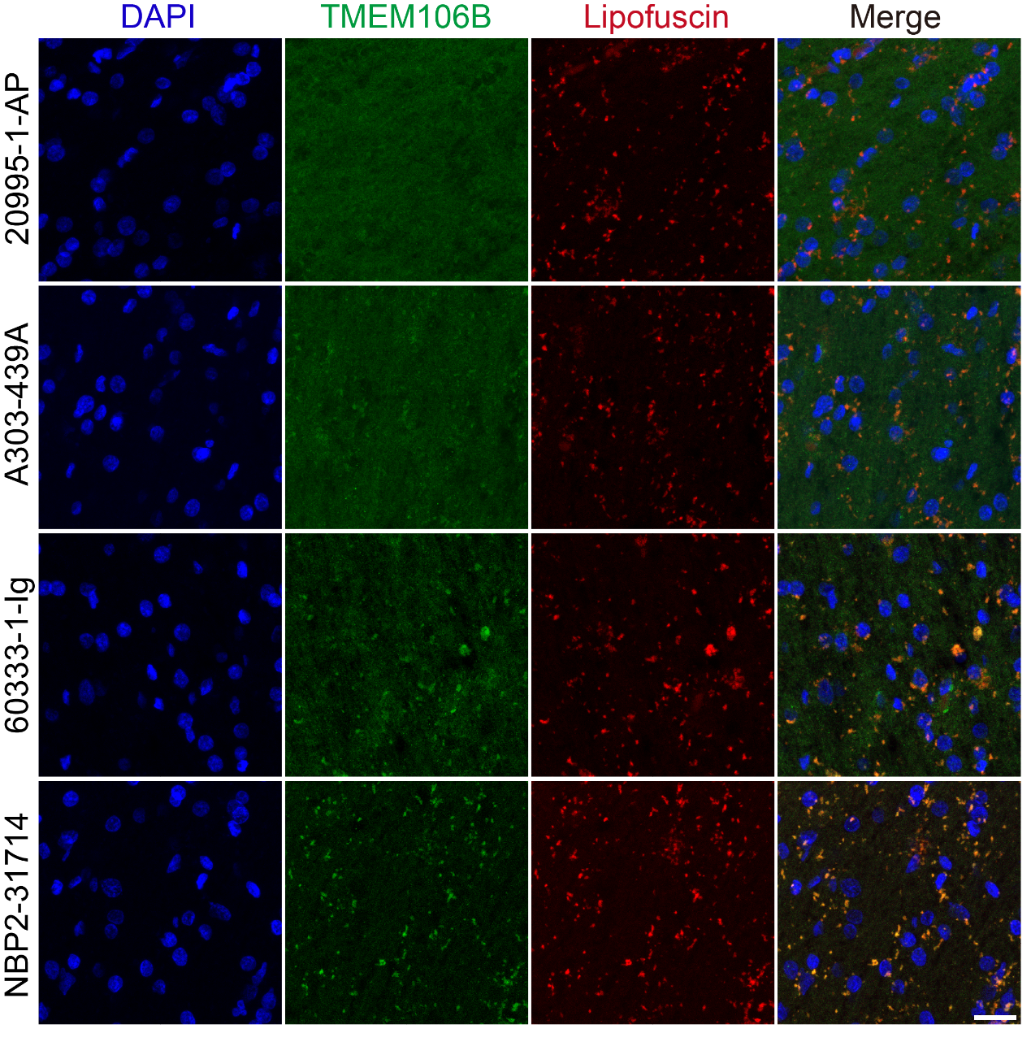
Figure S4. IF staining of TMEM106B in brain slices with heat pre-treatment in sodium citrate. The brain slices of the frontal cortex from case 1 of PDD were used. The intensity of autofluorescent lipofuscin was captured in a separate channel (red). Scale bar, 25 μm.

Table S1. Cryo-EM structural determination and
model statistics
Data collection and processing | TMEM106B  (EMD-38069)  (PDB: 8X5H)
Data Collection  Magnification | 105,000
Pixel size (Å) | 0.83
Defocus Range (μm) | −1.0 to −2.0
Voltage (kV) | 300
Camera | BioContinuum K3
Microscope | Krios G4
Exposure time (s/frame) | 0.05
Number of frames | 40
Total dose (e⁻/Å²) | 55
Reconstruction
Micrographs | 6,822
Manually picked fibrils | 5,875
Box size (pixel) | 360
Inter-box distance (Å) | 29.88
Initial particle images (no.) | 52,232
Final particle images (no.) | 2,165
Resolution (Å) | 3.5
Map sharpening B-factor (Å²) | −59.03
Helical rise (Å) | 4.83
Helical twist (° ) | −0.70
Atomic model
Non-hydrogen atoms | 3,258
Protein residues | 405
Ligands | 0
RMSD bond lengths | 0.007
RMSD bond angles | 0.75
All-atom clash score | 15.21
Rotamer outliers (%) | 0.00
Ramachandran outliers (%) | 0.00
Ramachandran allowed (%) | 13.53
Ramachandran favored (%) | 86.47
EMDB, Electron Microscopy Data Bank; PDB, Protein Data Bank.
Reference
1 Fan Y, Zhao Q, Xia W et al. Generic amyloid fibrillation of TMEM106B in patient with Parkinson's disease dementia and normal elders. Cell research 2022; 32:585-588.

