Supplementary information

Cytoplasmic DNA sensing boosts CD4⁺ T cell metabolism
for inflammatory induction

by Ye et al.

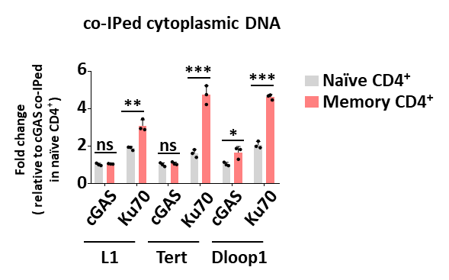
Figure S1. DNA is sensed in CD4⁺ T cells through KU complex.
qPCR analysis of co-Immunoprecipitated DNA with cGAS and KU70 in naïve CD4⁺ (CD44⁻CD62L⁺CD4⁺) and memory CD4⁺ (CD44⁺CD62L⁻CD4⁺) T cells ex vivo. Statistics, two-tailed Student’s t test. Error bars represent SD. Differences were considered to be significant at p < 0.05 and are indicated by *, those at p < 0.01 are indicated by **, and those at p < 0.001 are indicated by ***.

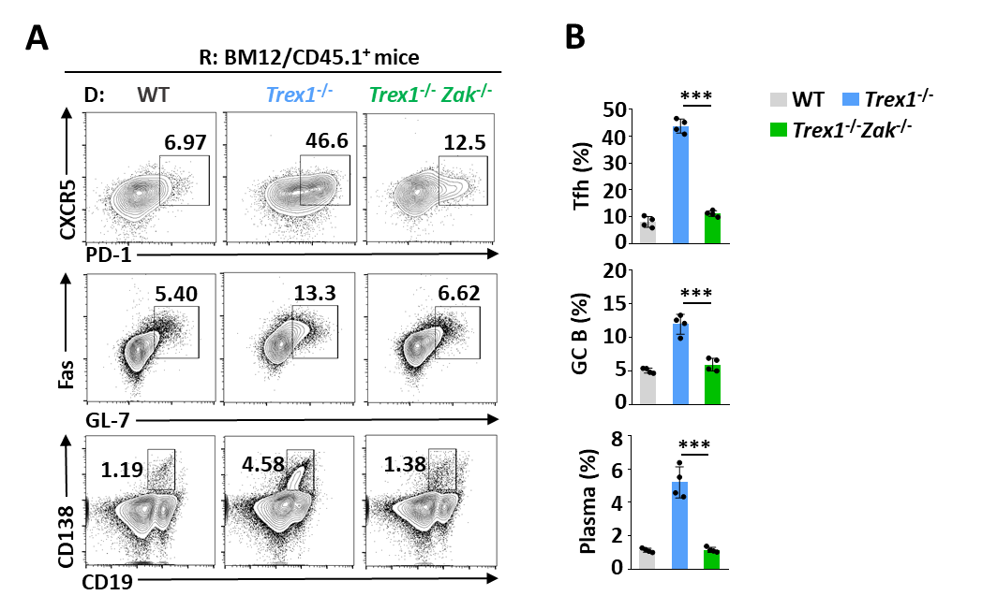
Figure S2. Zak deficiency in CD4⁺ T cells abolishes DNA-boosted generation of Tfh, GC-B and plasma cells.
(A, B) Flow cytometric analysis of Tfh (CXCR5⁺PD1⁺CD4⁺), GC B (Fas⁺GL-7⁺CD19⁺), and plasma cells (CD138⁺CD19^{lo}) in the spleen. Data are presented as the representative FACS histograms (A) and summary graphs (B). Statistics, two-tailed Student’s t test. Error bars represent SD. Differences were considered to be significant at p < 0.05 and are indicated by *, those at p < 0.01 are indicated by **, and those at p < 0.001 are indicated by ***.
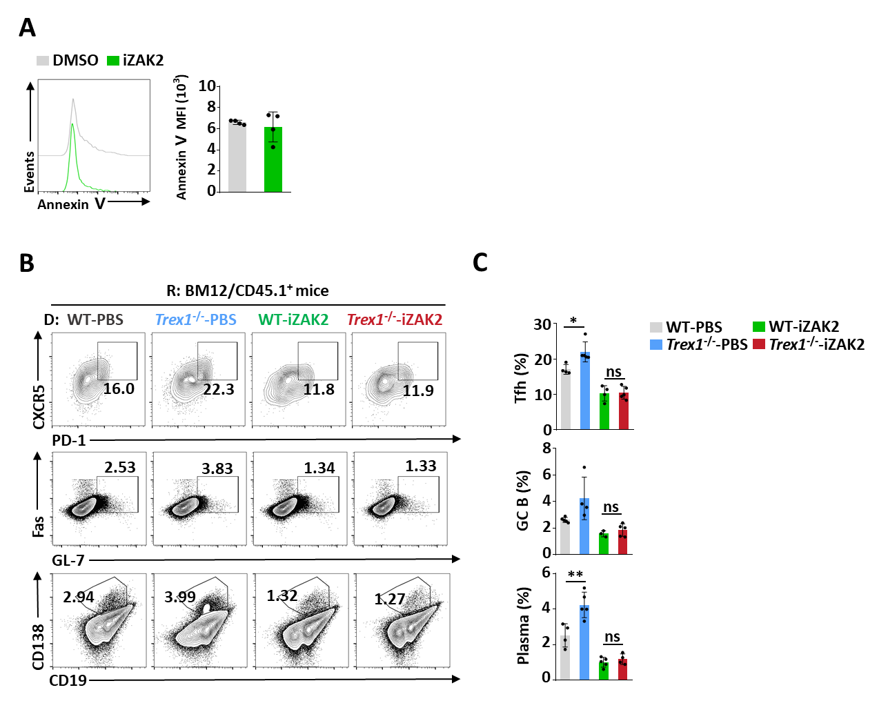
Figure S3. Targeting ZAK inhibits DNA-boosted generation of Tfh, GC-B and plasma cells.
- Apoptosis analysis of CD4⁺ T cells treated with iZAK2 (1 μM) or DMSO as vehicle. Data are presented as the representative FACS histograms (left) and summary graphs (right). (B, C) Flow cytometric analysis of Tfh (CXCR5⁺PD1⁺CD4⁺), GC B (Fas⁺GL-7⁺CD19⁺), and plasma cells (CD138⁺CD19^{lo}) in the spleen. Data are presented as the representative FACS histograms (B) and summary graphs (C). Statistics, two-tailed Student’s t test. Error bars represent SD. Differences were considered to be significant at p < 0.05 and are indicated by *, those at p < 0.01 are indicated by **, and those at p < 0.001 are indicated by ***.

Table S1. Primers used for real-time quantitative PCR

Genes | Forward primers (5'-3') | Reverse primers (5'-3')
mGlut1 | ACCATCTTGGAGCTGTTCCG | GCCTTCTCGAAGATGCTCGT
mGlut3 | GGATTCGCCAAGATAGCGGA | AACGATGCCCAGCTGGTTTA
mHk2 | TGATCGCCTGCTTATTCACGG | AACCGCCTAGAAATCTCCAGA
mPgk1 | ATGTCGCTTTCCAACAAGCTG | GCTCCATTGTCCAAGCAGAAT
mPkm2 | GCCGCCTGGACATTGACTC | CCATGAGAGAAATTCAGCCGAG
mAldoa | CGTGTGAATCCCTGCATTGG | CAGCCCCTGGGTAGTTGTC
mEno1 | TGCGTCCACTGGCATCTAC | CAGAGCAGGCGCAATAGTTTTA
mL1 | TAGGAAATTAGTTTGAATAGGTGAGAGGGT | TCCAGAAGCTGTCAGGTTCTCTGGC
mTert | CTAGCTCATGTGTCAAGACCCTCTT | GCCAGCACGTTTCTCTCGTT
mDloop1 | CCCTTCCCCATTTGGTCT | TGGTTTCACGGAGGATGG
mActin | CGTGAAAAGATGACCCAGATCA | CACAGCCTGGATGGCTACGT

