Salivary volatilome profiling in pediatric eosinophilic esophagitis: a pilot study on a non-invasive approach in clinical practice
Rosamaria Capuano^{1,#}, Carla Petrella^{2,#}, Christian Barbato², Giulia D’Arcangelo^{3,4}, Giusy Russo³, Alexandro Catini¹, Antonio Minni^{5,6,7,*}, Corrado Di Natale^{1,8,*,} Salvatore Oliva^{3,*}
¹Department of Electronic Engineering, and Interdepartmental Centre for Volatilomics “A. D’Amico”, University of Rome Tor Vergata, Rome 00133, Italy
²Institute of Biochemistry and Cell Biology (IBBC), National Research Council (CNR), Sapienza University, Rome 00161, Italy
³Pediatric Gastroenterology and Liver Unit, Maternal and Child Health Department, Sapienza University of Rome, Rome 00161, Italy
⁴Pediatric Gastroenterology, Hepatology and Cystic Fibrosis Unit, Fondazione IRCCS Cà Granda, Ospedale Maggiore Policlinico di Milano, Milan 20122, Italy
⁵Department of Sensory Organs, Sapienza University of Rome, Rome 00161, Italy
⁶Division of Otolaryngology-Head and Neck Surgery, San Camillo de Lellis Hospital, ASL Rieti-Sapienza University, Viale Kennedy, Rieti 02100, Italy
⁷Interdisciplinary Department of Well-being, Health and Environmental Sustainability (BeSSA) Sapienza University of Rome, Rieti 02100, Italy
⁸Centre for Interdisciplinary Research (CIDR), SRM University-AP, Amaravati, Andhra Pradesh 522502, India
#These authors contributed equally to this work.
*Correspondence: salvatore.oliva@uniroma1.it (S.O.), dinatale@eln.uniroma2.it (C.N.), antonio.minni@uniroma1.it (A.M.)

Supplementary Table S1.
Drift time and retention index of pure standards and the same compounds in samples.
Drift time is give in arbitrary units respect to the Reactant Ion Peak (RIP).
 | Saliva samples |  | Reference standard
Compound | Drift time (a.u.) | Retention Index | Drift time (a.u.) | Retention Index
pentan-1-ol | 1.50875 | 766.2 | 1.5096629 | 765
2-Hexanone | 1.193 | 796.3 | 1.1897453 | 792
Heptan-2-one | 1.64524 | 884.4 | 1.6339977 | 884.4

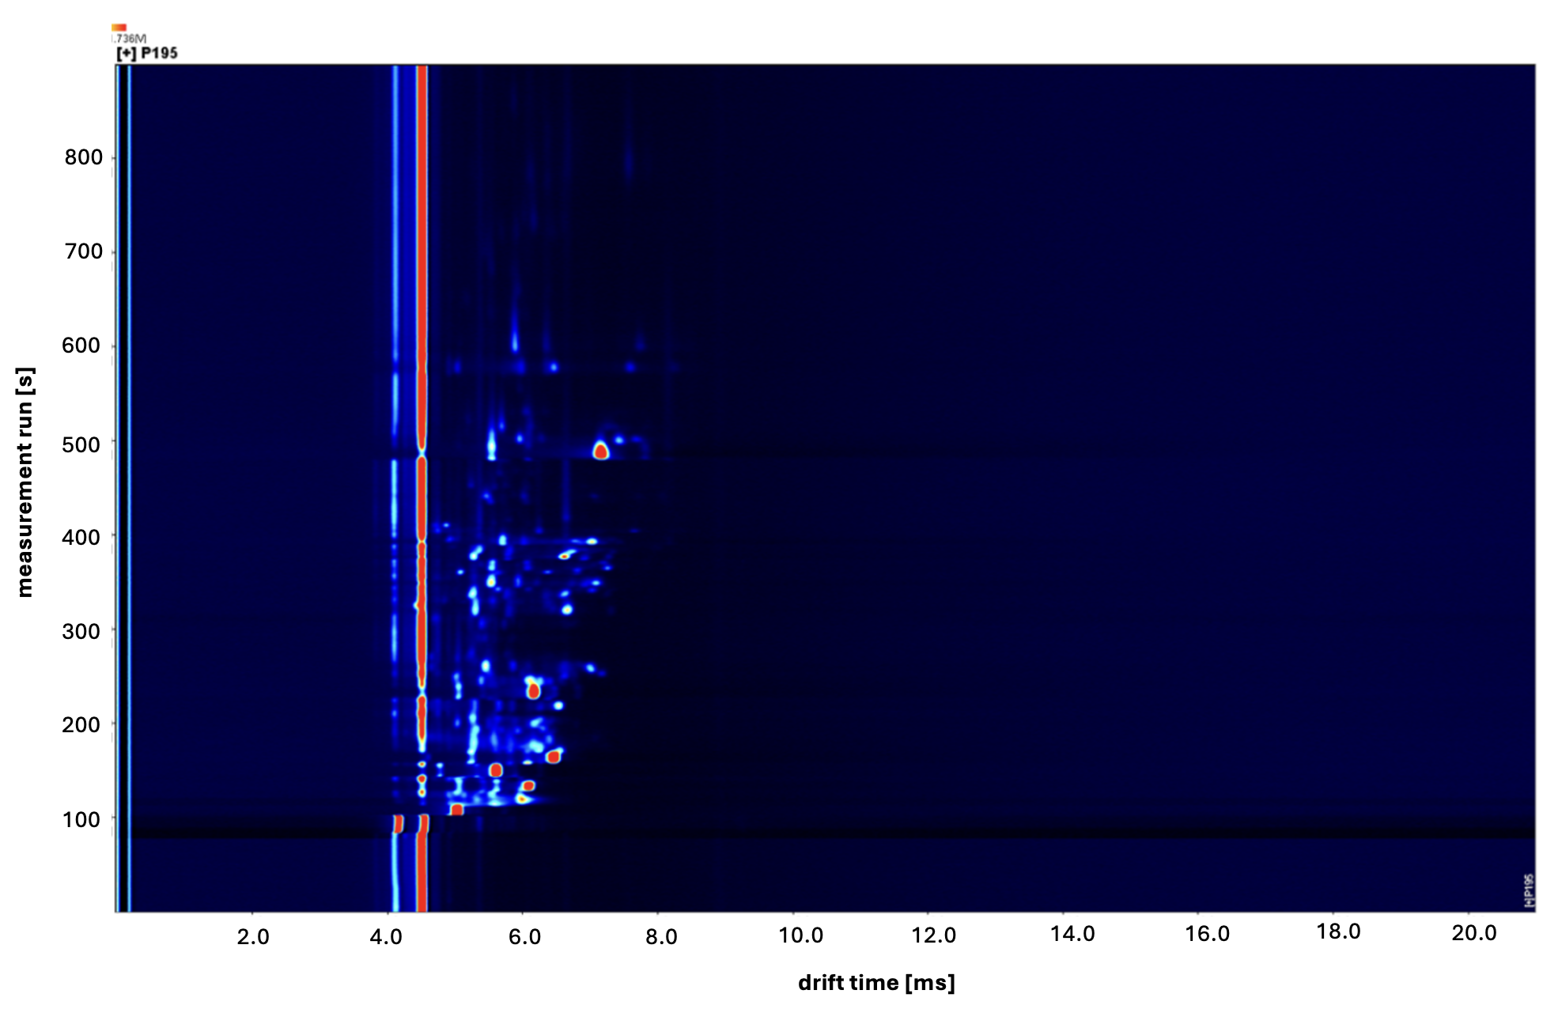

Supplementary Figure S1. Typical results of GC-IMS analysis. The intensity of signals is represented as a heat-map in the drift time (horizontal axis) vs. retention time (vertical axes) plane. Each area of the figure corresponds to a compound characterized by a retention and drift times. The integral of the signal in the area is a measure of the abundance of the corresponding VOC.

Supplementary Figure S2. Results of Kruskal–Wallis rank test of GC–IMS areas respect to the discrimination of the EoE patients vs. the healthy controls, the group of CD and HP, and between active and non-active EoE.

Supplementary Figure S3. Receiver Operating Characteristic curves of selected VOCs in the three binary classifications. The area under the ROC curve is indicated in the header of each plot.

