Supporting Information

A Novel Spraying Nanoprobe for Renal Cell Carcinoma in Humans
1. Chemistry
Synthesis of compounds 1-7
All solvents were purified and dried by standard procedures and kept over a suitable drying agent prior to use. Unless otherwise noted, all reagents were purchased from commercial sources and were used without further purification. The reactions were monitored by thin layer chromatography coated with silica gel.
¹H NMR and ¹³C NMR data were acquired in CDCl₃ as solvent on a Bruker DMX 500 spectrometer. The chemical shifts (δ) are expressed in ppm (parts per million) relative to TMS (tetramethylsilane). Spin-spin coupling constants (J) were measured directly from the spectra and were given in Hz. Exact mass (HR-MS) spectra were recorded on Thermo Fisher Scientific LTQ FT Ultra.
Compound 1-3,8 was synthesized and purified as reported (ACS Appl. Bio Mater. 2020, 3, 327−334).
Synthesis of compounds 4: Briefly, to a stirred and cooled (0°C) solution of the compound 3 (68 mg, 0.1 mmol) and phenol (18.8 mg, 0.2 mmol) in CH₂Cl₂ (2 mL), the solution of EDC-HCl (23 mg, 0.12 mmol) and DMAP (5 mg, 0.04 mmol) in CH₂Cl₂ (4 mL) was slowly added over 0.5 h. After stirring at RT for 10 h, CH₂Cl₂ (20 mL) was added. The solution was washed with saturated 1N HCl (20 mL), brine (20 mL) and then dried over Na₂SO₄. The solvent was removed to give the crude product, which was subsequently purified by silica gel column chromatography (10% v/v methanol/CH₂Cl₂) to afford the pure compounds 4 as a green solid (65 mg, 86 % yield).
Characterization of compounds 4: ¹H NMR (500 MHz, CD₃Cl, δ): 8.37-8.31 (m, 2H), 7.54-7.53 (m, 1H), 7.41-7.35 (m, 7H), 7.25-7.12 (m, 4H), 7.03-7.01 (m, 1H), 6.32-6.31 (m, 1H), 6.30-6.29 (m, 1H), 4.32-4.26 (m, 4H), 2.76-2.73 (m, 4H), 2.63-2.60 (m, 2H), 1.96-1.83 (m, 8H), 1.72-1.71 (m, 12H), 1.47 (t, J = 7.0 Hz, 3H). ¹³C NMR (125 MHz, CD₃Cl, δ): 172.1, 171.9, 150.6, 150.2, 144.5, 143.9, 129.4, 128.9, 127.6, 125.8, 125.3, 122.2, 121.5, 110.8, 101.5, 49.4, 49.2, 44.6, 39.9, 33.9, 31.9, 31.4, 30.2, 29.7, 29.4, 28.2, 28.0, 27.2, 26.6, 26.4, 24.5, 22.7, 20.7, 14.1, 12.5. HRMS: m/z [M]⁺ calc for C₄₄H₅₀ClN₂O₂⁺: 673.3555; found: 673.3550.
Synthesis of compounds 5: Briefly, to a stirred and cooled (0°C) solution of the compound 3 (68 mg, 0.1 mmol) and tert-butyl 4-hydroxyphenylcarbamate (42 mg, 0.2 mmol) in CH₂Cl₂ (2 mL), the solution of EDC-HCl (23 mg, 0.12 mmol) and DMAP (5 mg, 0.04 mmol) in CH₂Cl₂ (4 mL) was slowly added over 0.5 h. After stirring at RT for 10 h, CH₂Cl₂ (20 mL) was added. The solution was washed with saturated 1N HCl (20 mL), brine (20 mL) and then dried over Na₂SO₄. The solvent was removed to give the crude product, which was subsequently purified by silica gel column chromatography (10% v/v methanol/CH₂Cl₂) to afford the pure compounds 4 as a green solid (77 mg, 89 % yield).
Characterization of compounds 5: ¹H NMR (500 MHz, CD₃Cl, δ): 8.38-8.29 (m, 2H), 7.43-7.37 (m, 7H), 7.25-7.21 (m, 2H), 7.15-7.14 (m, 1H), 6.95-6.93 (m, 2H), 6.38-6.35 (m, 1H), 6.26-6.23 (m, 1H), 4.36-4.32 (m, 2H), 4.24-4.21 (m, 2H), 2.76-2.70 (m, 4H), 2.60-2.57 (m, 2H), 1.93-1.85 (m, 8H), 1.72-1.71 (m, 12H), 1.51 (s, 9H), 1.47 (t, J = 7.0 Hz, 3H). ¹³C NMR (125 MHz, CD₃Cl, δ): 172.4, 172.0, 171.6, 152.9, 150.2, 145.8, 144.8, 143.6, 136.4, 128.9, 128.0, 127.6, 125.6, 125.0, 122.2, 121.7, 110.8, 110.5, 101.9, 101.1, 49.5, 49.1, 44.4, 40.0, 33.8, 31.2, 29.7, 28.3, 28.1, 28.0, 27.1, 26.6, 26.3, 24.5, 22.7, 20.7, 14.4, 12.5. HRMS: m/z [M]⁺ calc for C₄₉H₅₉ClN₃O₄⁺: 788.4189; found: 788.4185.
Synthesis of compounds 6: Briefly, to a stirred and cooled (0°C) solution of the compound 3 (68 mg, 0.1 mmol) and 1-adamantaneethanol (36 mg, 0.2 mmol) in CH₂Cl₂ (2 mL), the solution of EDC-HCl (23 mg, 0.12 mmol) and DMAP (5 mg, 0.04 mmol) in CH₂Cl₂ (4 mL) was slowly added over 0.5 h. After stirring at RT for 10 h, CH₂Cl₂ (20 mL) was added. The solution was washed with saturated 1N HCl (20 mL), brine (20 mL) and then dried over Na₂SO₄. The solvent was removed to give the crude product, which was subsequently purified by silica gel column chromatography (10% v/v methanol/CH₂Cl₂) to afford the pure compounds 6 as a green solid (68 mg, 81 % yield).
Characterization of compounds 6: ¹H NMR (500 MHz, CD₃Cl, δ): 8.38-8.30 (m, 2H), 7.54-7.52 (m, 1H), 7.44-7.35 (m, 4H), 7.25-7.22 (m, 2H), 7.15-7.13 (m, 1H), 6.35-6.33 (m, 1H), 6.26-6.23 (m, 1H), 4.36-4.31 (m, 2H), 4.22-4.19 (m, 2H), 4.10 (t, J = 7.5 Hz, 2H), 2.78-2.73 (m, 4H), 2.34-2.31 (m, 2H), 2.03-1.83 (m, 8H), 1.72-1.71 (m, 12H), 1.68-1.60 (m, 7H), 1.51-1.50 (m, 6H), 1.47 (t, J = 7.0 Hz, 3H), 1.40-1.33 (m, 4H). ¹³C NMR (125 MHz, CD₃Cl, δ): 173.6, 172.3, 171.7, 150.7, 144.8, 143.7, 142.3, 128.9, 128.7, 125.5, 125.1, 122.2, 110.9, 110.6, 101.7, 101.5, 60.9, 49.4, 49.1, 44.5, 42.4, 42.3, 40.0, 36.9, 34.8, 34.0, 31.9, 31.7, 31.4, 30.2, 29.7, 29.5, 29.3, 29.1, 28.5, 28.1, 28.0, 27.1, 26.6, 26.4, 24.6, 22.7, 20.7, 14.1, 12.5. HRMS: m/z [M]⁺ calc for C₅₀H₆₄ClN₂O₂⁺: 759.4651; found: 759.4648.
Synthesis of compounds 7: Briefly, as showed in Scheme S1, to a stirred and cooled (0 °C) solution of the compound 8 (57 mg, 0.1 mmol) and phenol (18.8 mg, 0.2 mmol) in CH₂Cl₂ (2 mL), the solution of EDC-HCl (23 mg, 0.12 mmol) and DMAP (5 mg, 0.04 mmol) in CH₂Cl₂ (4 mL) was slowly added over 0.5 h. After stirring at RT for 10 h, CH₂Cl₂ (20 mL) was added. The solution was washed with saturated 1N HCl (20 mL), brine (20 mL) and then dried over Na₂SO₄. The solvent was removed to generate the crude product, which was subsequently purified by silica gel column chromatography (10% v/v methanol/CH₂Cl₂) to obtain the pure compounds 7 as a blue solid (59 mg, 91% yield).
Characterization of compounds 7: ¹H NMR (500 MHz, CD₃Cl, δ): ¹H NMR (500 MHz, CD₃Cl, δ): 8.20 (t, J = 13.0 Hz, 2H), 7.38-7.35 (m, 6H), 7.24-7.20 (m, 3H), 7.08 (t, J = 8.0 Hz, 2H), 7.05-7.03 (m, 2H), 6.85 (t, J = 12.5 Hz, 2H), 6.45 (d, J = 13.5 Hz, 1H), 6.38 (d, J = 13.5 Hz, 1H), 4.16-4.11 (m, 5H), 2.62 (t, J = 7.5 Hz, 2H), 1.88-1.82 (m, 4H), 1.76 (s, 12H), 1.42 (t, J = 7.0 Hz, 3H). ¹³C NMR (125 MHz, CD₃Cl, δ): 154.2, 154.1, 150.6, 142.1, 141.7, 141.5, 141.3, 129.4, 128.6, 126.7, 125.8, 125.0, 124.9, 122.4, 121.6, 110.3, 110.2, 103.9, 103.7, 49.4, 49.3, 44.2, 39.4, 33.9, 29.7, 28.1, 27.9, 27.2, 26.3, 24.5, 12.5. HRMS: m/z [M]⁺ calc for C₃₉H₄₅N₂O₂⁺: 573.3476; found: 573.3469.
2. Preparation and characterization of dyes with Surfactin
In brief, dyes were rapidly dissolved in Surfactin solution, and the solution was vigorous stirred at 25°C for 5 min. The mixture filtrated through 0.22 μm filter membrane to remove the unincorporated dyes aggregates.
The NIR imaging was taken using Xenogen IVIS Spectrum imaging system.
The fluorescence spectra were determined by Angilent Cary Elipse fluorescence spectrophotometer.
The size and distributions of the particles were measured by a dynamic light scattering (DLS) spectrometer using a Zetasizer Nano ZS instrument (Malvern, Worcestershire, UK).
The morphological examination of particles was performed by 120 kV JEOL JEM-1400 Plus biology transmission electron microscopy with a negative stain method (1% phosphotungstic acid).
3. Cell culture
Human 786-0 cell lines was provided by Shanghai Ninth People’s Hospital. 786-0 cells were maintained in RPMI-1640 medium (HyClone), and supplemented with 10% fetal bovine serum (FBS, Gibco BRL, USA) in a 5% CO₂/95% air humidified atmosphere at 37°C.
4. Fluorescence microscopy assay
786-0 cells (3 × 10⁵ per well) were seeded on microscope cover glass (Fisherbrand) in a six-well plate and were allowed to form a monolayer over 48 h. Then cells were exposed to dyes (2 µM) and Mito-tracker Green (200 nM) in 500 µL of fresh medium with 10% FBS. The glasses were incubated at 37°C for 0.5 h, and washed three times with PBS to remove excess dyes. Then cells were fixed with 4% formaldehyde at room temperature for 15 minutes. The glasses were then washed three times with PBS. Images were recorded by fluorescent microscopy analysis (IX83, Olympus, Japan) using a LED illuminant (SpectraX, Lumencor, Germany) infrared camera (Prime, Photometrics, USA) with excitation at 460–520 nm (for Mito-tracker Green) and emission at 810–890 nm (for dyes) wavelength.
5. Mouse xenograft model
This study was performed in strict accordance with the NIH guidelines for the care and use of laboratory animals (NIH Publication No. 85-23 Rev. 1985), and all animal protocols were approved by the Institutional Animal Care and Use Committee of Shanghai Jiao-Tong University School of Medicine (SJTUSM IACUC).
Five-week-old female nude mice were purchased from Shanghai Slack Laboratory Animal Co., LTD, and maintained in a standard environment. The mice were allowed to acclimatize for at least 1 week prior to the experiment. For subcutaneous xenograft studies, 786-0 cells (3.0×10⁶ per mouse) suspended in 0.1 mL of PBS were inoculated subcutaneously on the right flank of each mouse. Tumor size was measured by caliper.
6. NIR imaging in animal models
For mice bearing xenografted tumors, when tumor sizes reached 100-150 mm³, tumors were dissected and the test solution was immediately sprayed onto the cancerous tissue. NIR imaging was performed at 3, 6, 9 and 12 min. NIR imaging were taken using Xenogen IVIS Spectrum imaging system (compounds 1-6, excitation/emission, 745/820 nm; compounds 7, excitation/emission, 640/680 nm).
7. Verification of the active release mode
Most previously designed nanoparticles enter the target cell as a complete structure, releasing the loaded drug intracellularly. In contrast with these traditional drug delivery systems, our results indicated that our system featured an active release mode: only loaded dyes entered the targeted cell, rather than the entire nanoparticle. To verify this unconventional release mode, we prepared a contrast dye, compound 7; its structure is shown in Fig. S6A Compared to compound 4, compound 7 lacked the rigid 1-chlorocyclohexenyl substitution in the polymethine linker. Therefore, compound 7 could not specifically identify the cancer cell with OATPs (Fig. S7). In addition, the maximum emission wavelengths of compound 4 and compound 7 differed (820 nm for compound 4; 680 nm for compound 7).
A three-component nanoparticle (S-4-7-NP) was subsequently synthesized that contained compound 4, compound 7, and surfactin in a molar ratio of 0.5:0.5:5. First, the DLS data indicated that S-4-7-NP was about 85 nm in size, with good polydispersity (DPI < 0.2) (Table S1). Second, the fluorescence properties of S-4-7-NP indicated that the fluorescence of both compounds 4 and 7 was quenched in the particles (Fig. S6B-D). Finally, to verify the presence of an active release mode, we evaluated the uptake of S-4-7-NP in cancerous tissues from the mouse model. If S-4-7-NP entered the cells as whole particles via phagocytosis, compounds 4 and 7 would enter the cells together, and the signal intensities of the two dyes would exhibit the same trend. However, our imaging and quantitative analysis results showed that the range of uptake values increased by 40% and 135% for compounds 7 and 4, respectively, from 3 min to 12 min (Fig. S6E-F). This indicated that most of compound 4 was released from the nanoparticle structure and independently entered the cells via OATP recognition. The schematic diagram of the S-4-7-NP release mode is illustrated in Fig. S6G.
8. NIR imaging in clinical trials
This study has been approved by the ethics committee of Shanghai Ninth People’s Hospital (Shanghai, China).
The entire process was completed under the supervision of professional pathologist.
The tissue was removed from patient. The surgeon determined detection location of excised tissue and cut into piece （3–5 mm thick）by scalpel. The test solution was sprayed onto the section. The optical imaging is gained with an intraoperative NIR imaging device (Nuoyuan, Nanjing, China).
9. Statistical analysis
Results of quantitative measurements were expressed as mean ± standard deviation (SD). All statistical analyses were performed with the SPSS software package (version 17.0, SPSS, Inc., Chicago, IL).

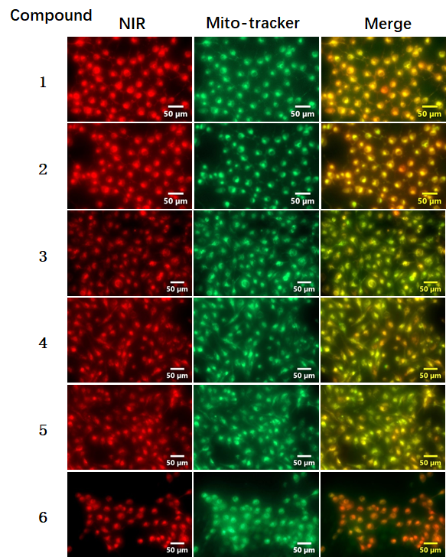
Figure S1. Representative fluorescent images for dyes in 786-0 cells by fluorescent microscopy analysis. Mito-tracker Green was used as mitochondria-specific dye.

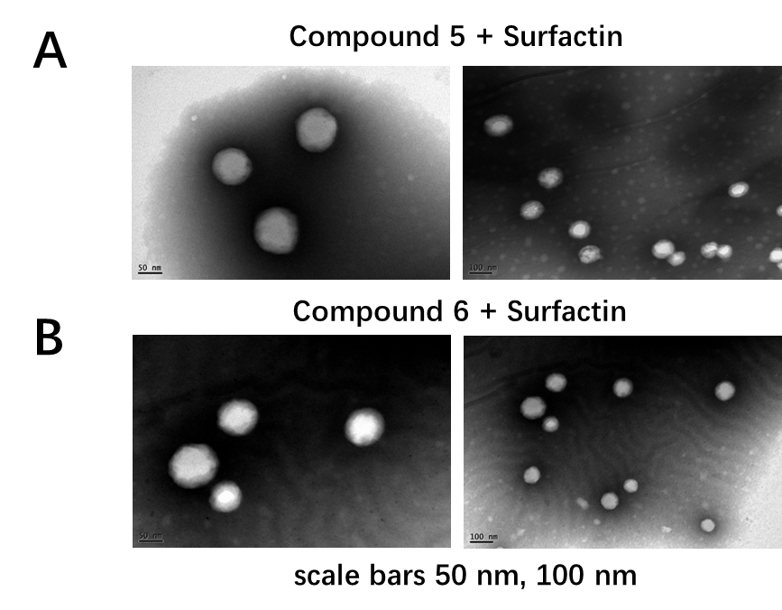
Figure S2. Transmission electron microscopy images of dyes combined with surfactin in a 1:5 molar ratio: (A) compound 5, (B) compound 6. Scale bars: 50 nm, 100 nm. NIR, near-infrared.

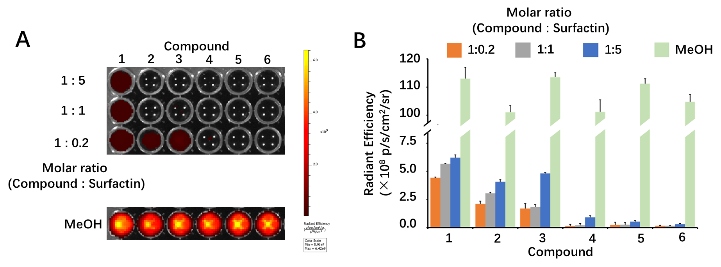
Figure S3. (A) Representative fluorescence images of dyes combined with surfactin. (B) Quantitative analysis of the fluorescence images.

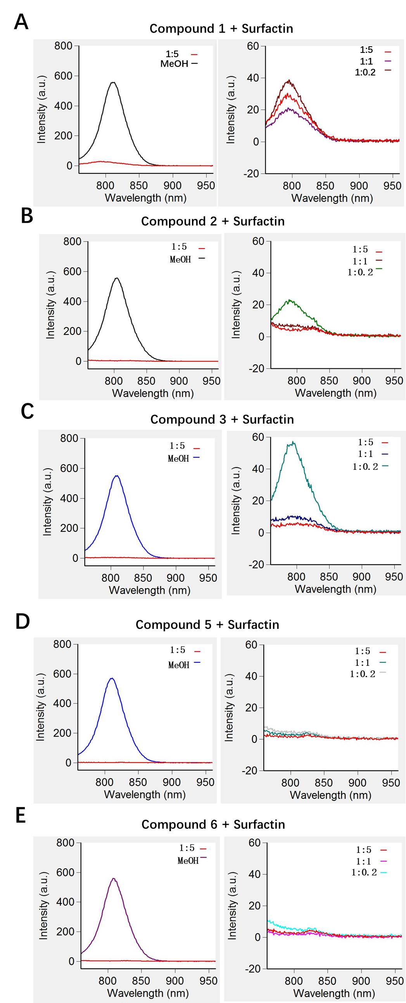
Figure S4. The fluorescence spectra of dyes with Surfactin (excitation at 730 nm and the emission from 750 to 960 nm): (A) for compound 1, (B) for compound 2, (C) for compound 3, (D) for compound 5, (E) for compound 6.
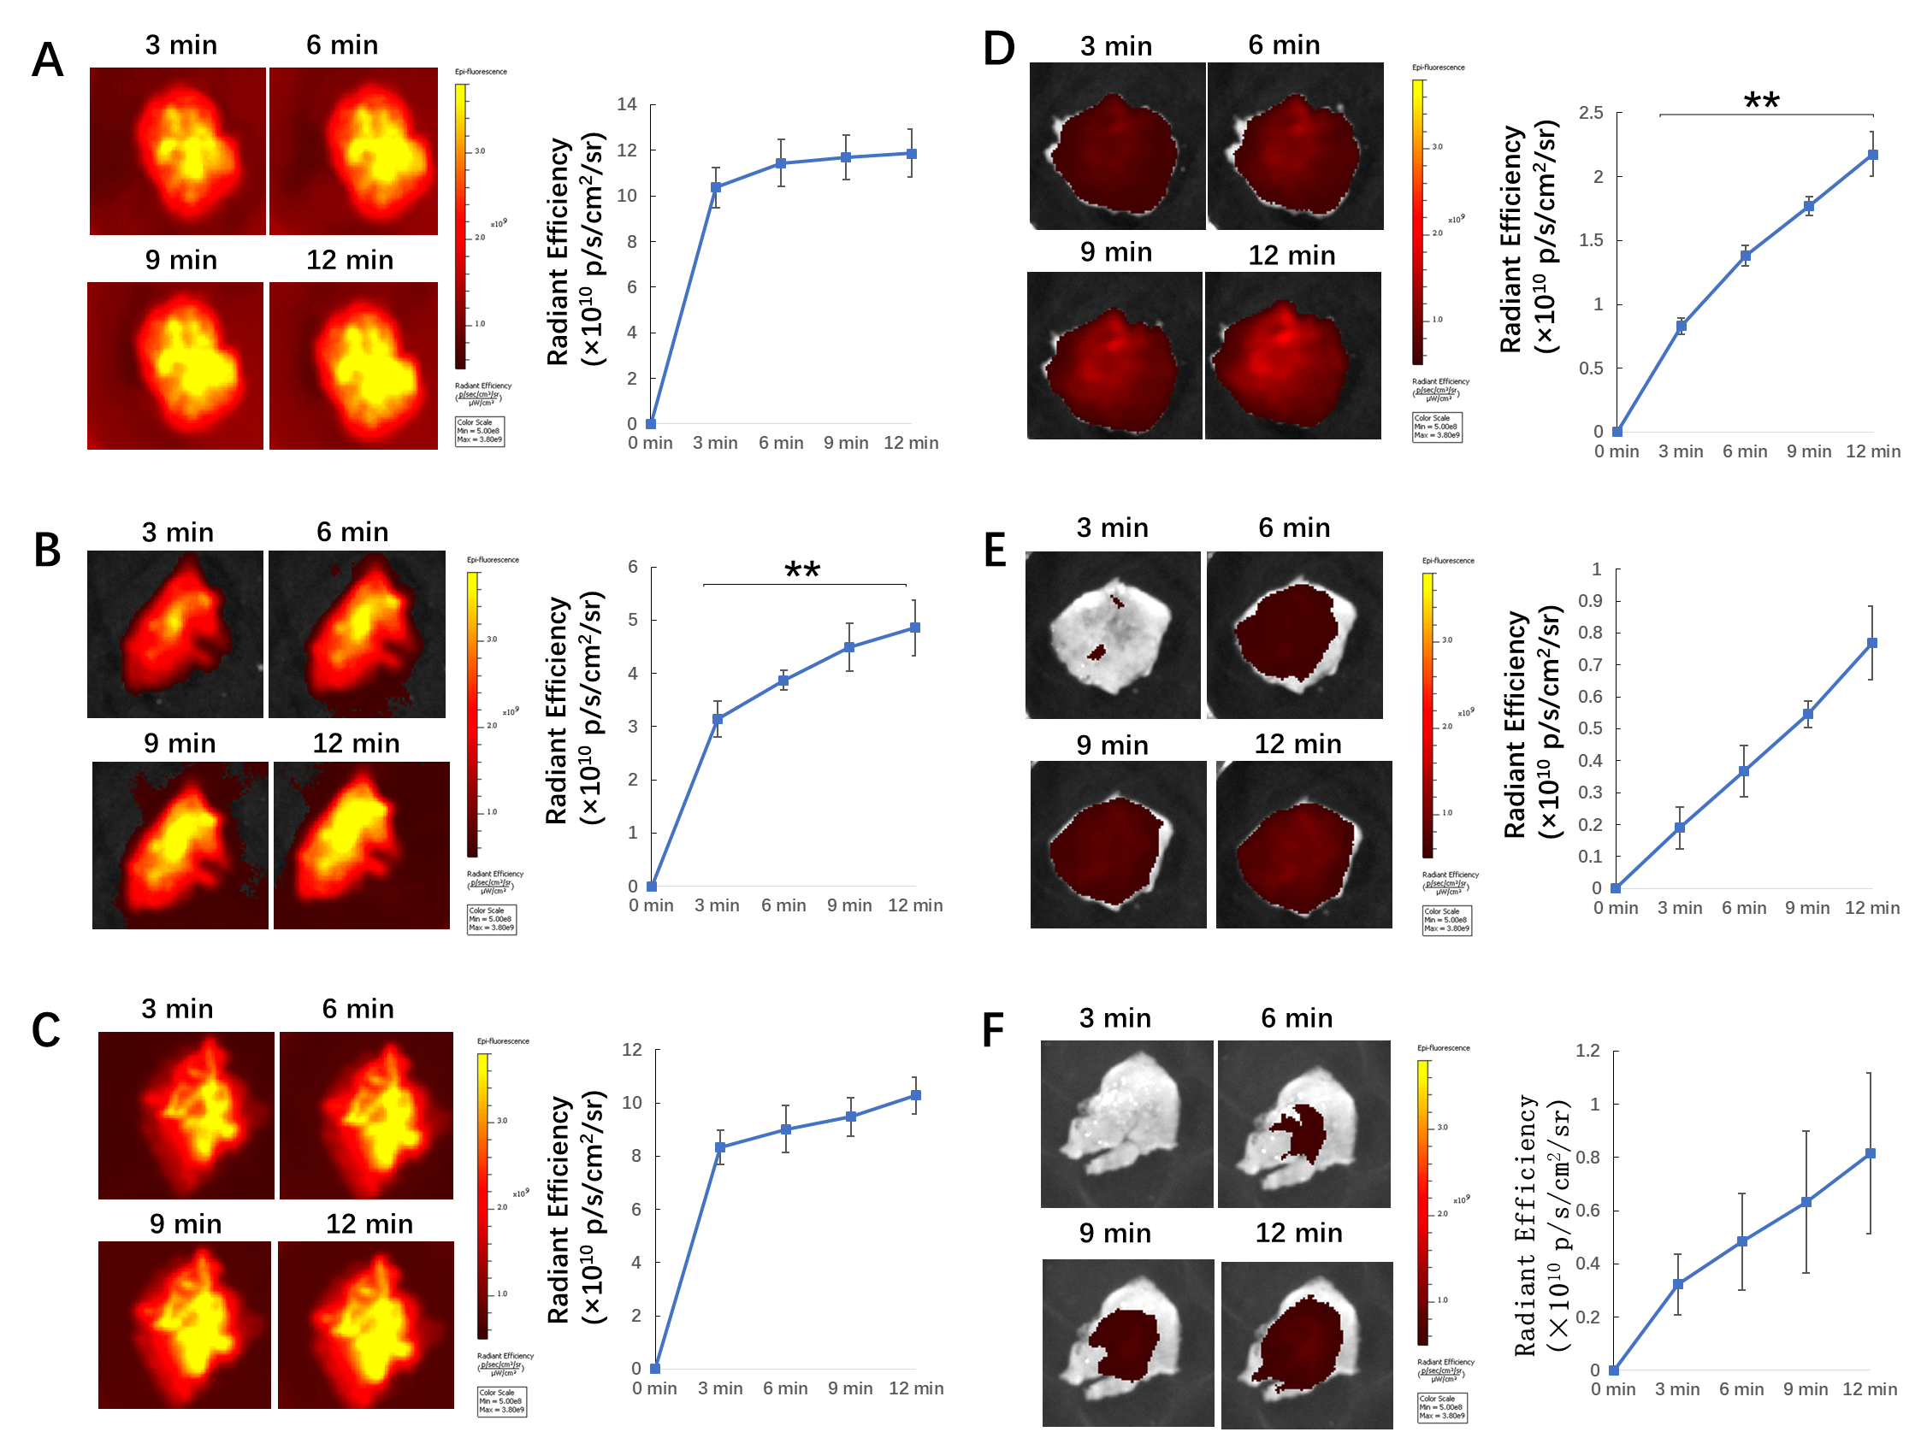
Figure S5. NIR imaging study of 786-0 tumor-bearing mice (n = 3) (representative fluorescence images, left; quantitative analysis results, right): (A) compound 1, (B) compound 2, (C) compound 3, (D) compound 5, (E) compound 6, and (F) compound 4 with bromosulfophthalein (50 times eq.). **p < 0.01.

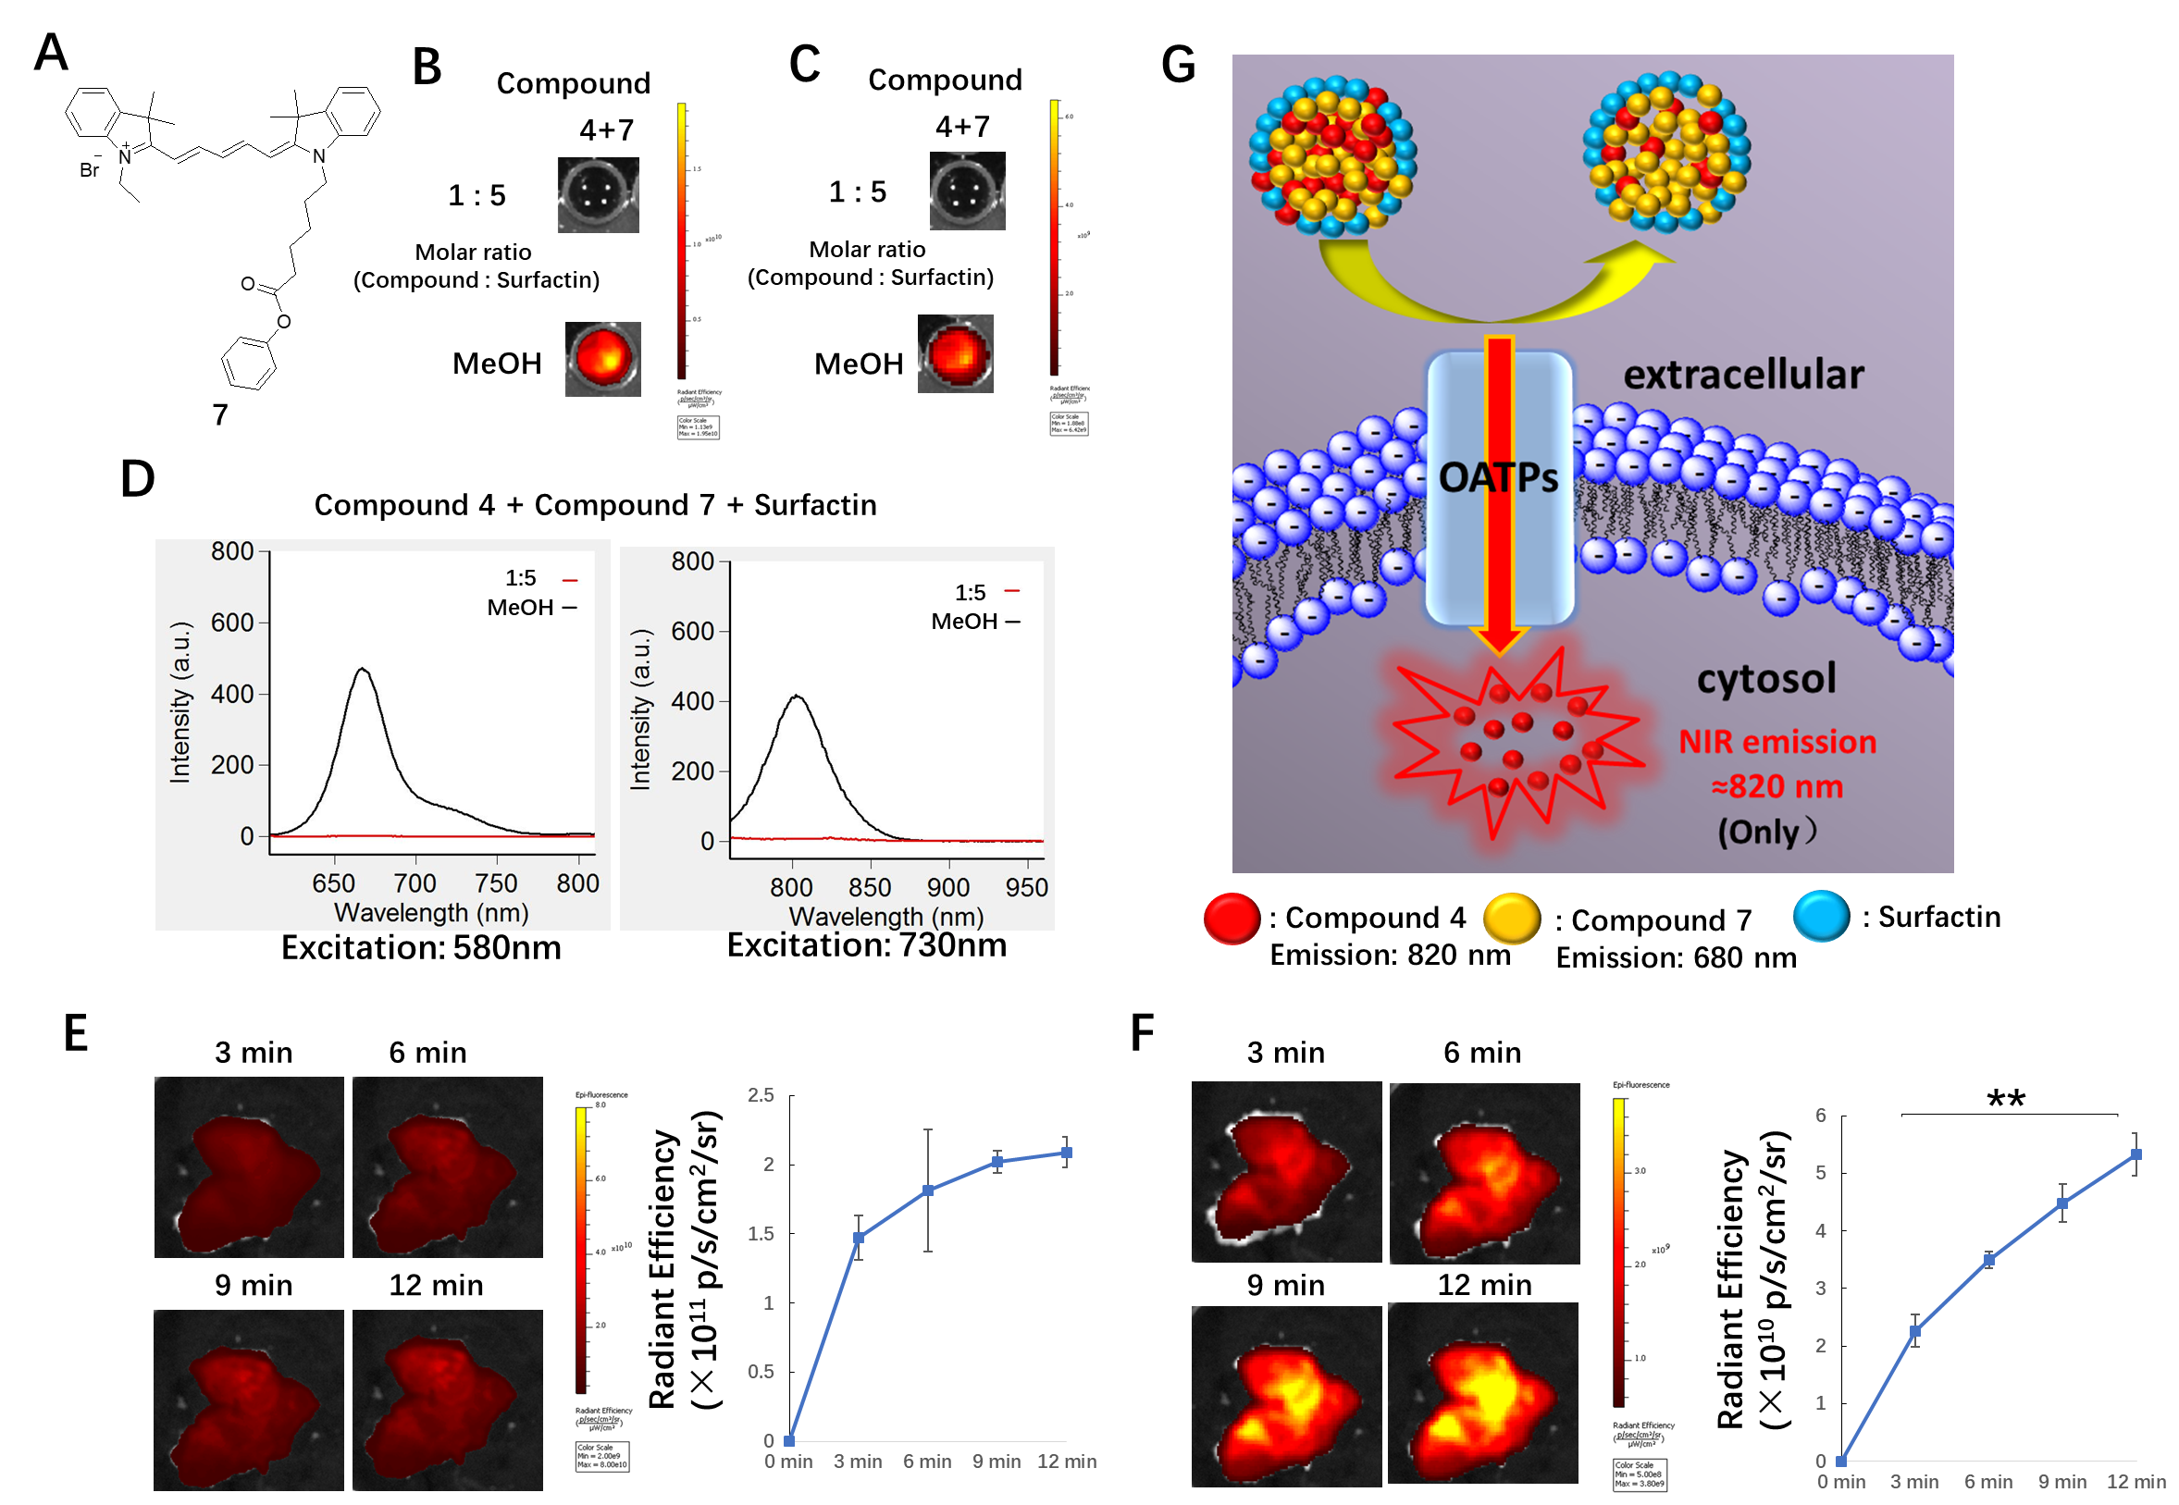
Figure S6. (A) The structure of compound 7. Representative fluorescence images of S-4-7-NP: (B) compound 7 signal (excitation/emission, 640/680 nm); (C) compound 4 signal (excitation/emission, 745/820 nm). (D) The fluorescence spectra of S-4-7-NP (excitation at 580 nm and emission from 610 to 810 nm for compound 7; excitation at 730 nm and emission from 750 to 960 nm for compound 4). NIR imaging study of S-4-7-NP (n = 3): (E) compound 7 signal (excitation/emission, 640/680 nm); (F) compound 4 signal (excitation/emission, 745/820 nm). (G) A schematic illustration showing the cell uptake mode of S-4-7-NP. **p < 0.01. OATPs, organic anion-transporting polypeptides; NIR, near-infrared.

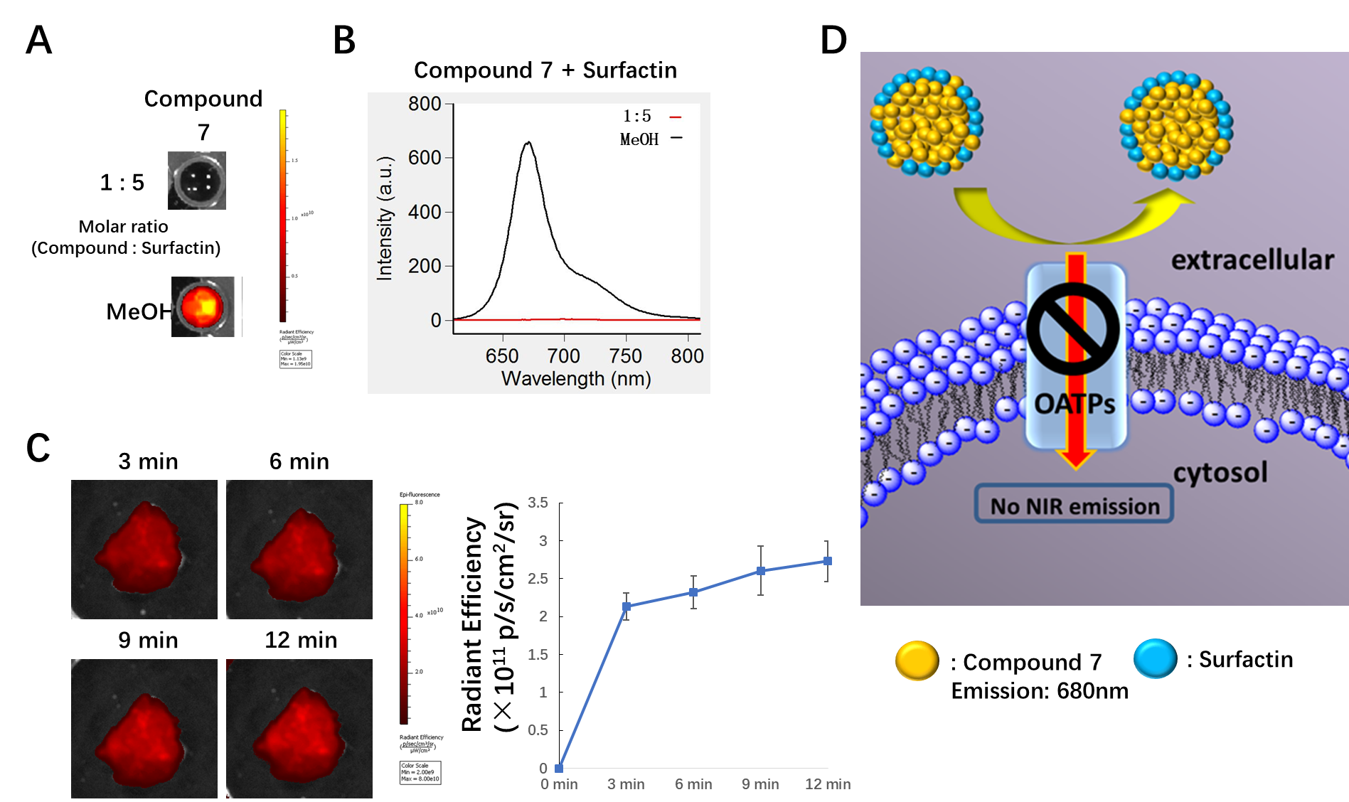
Figure S7. Study of compound 7 with Surfactin (S-7-NP). (A) Representative fluorescent images of S-7-NP: for compound 7 signal (excitation/emission, 640/680 nm) (B) The fluorescence spectra of S-7-NP (excitation at 580 nm and the emission from 610 to 810 nm). (C) NIR imaging study of S-7-NP (n = 3) (excitation/emission, 640/680 nm) using 786-0 xenograft mouse models. (D) A schematic illustration showing the cell uptake mode of S-7-NP.

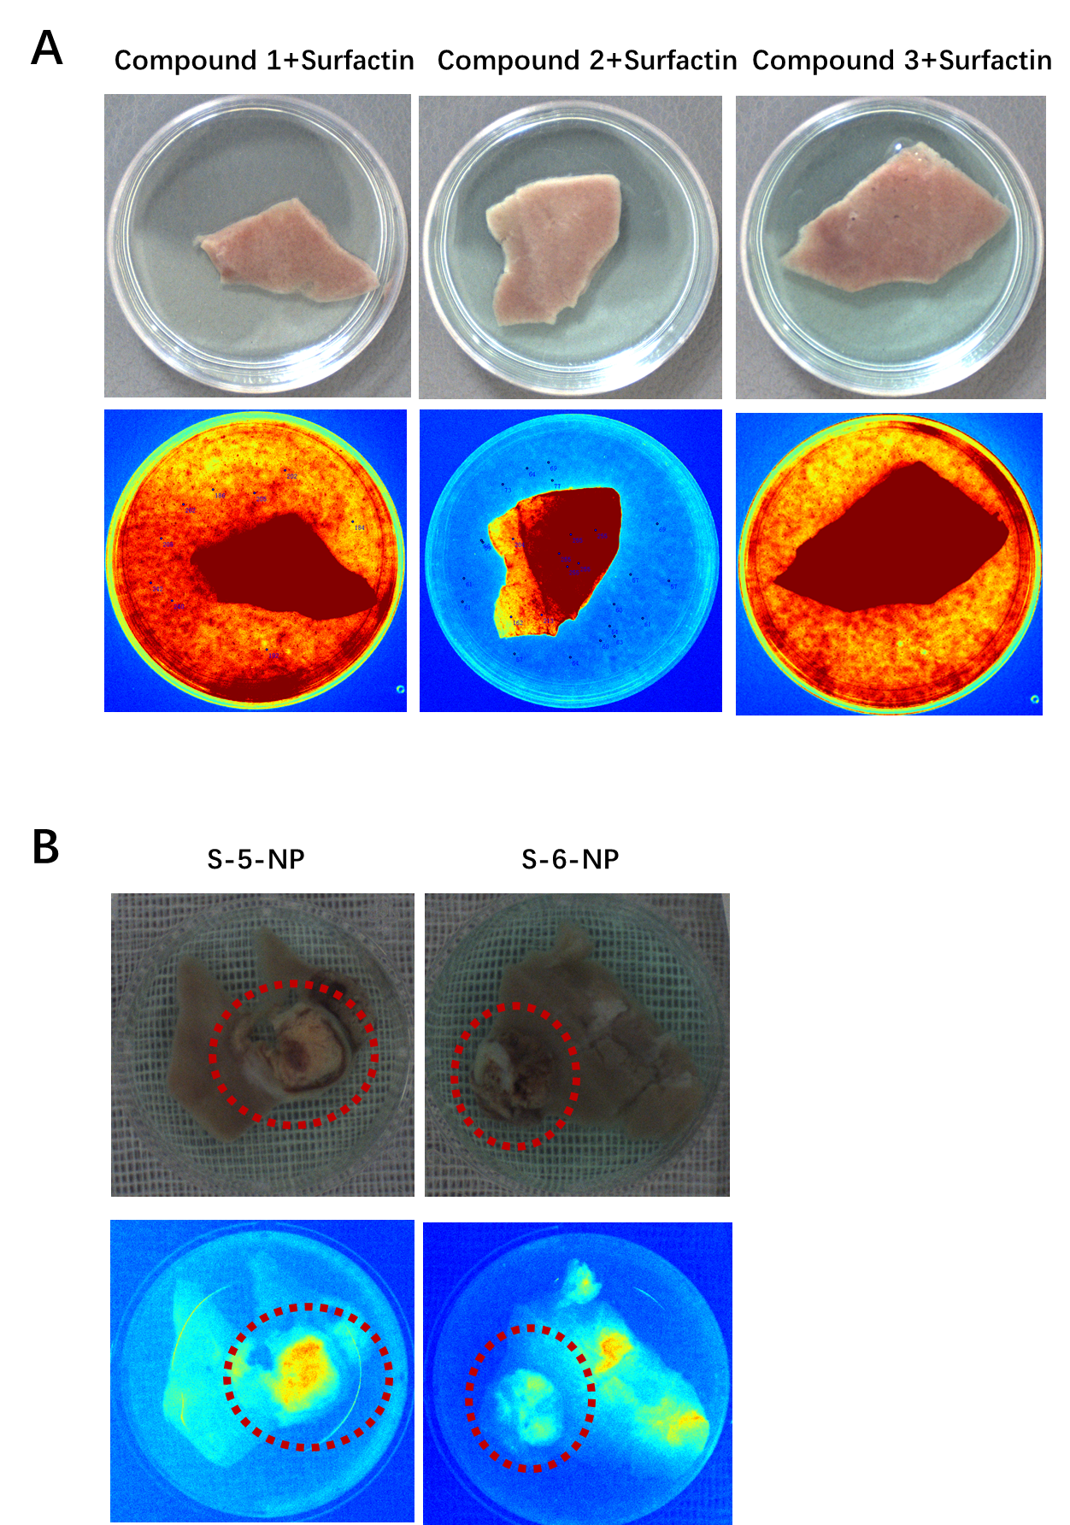
Figure S8. (A) Representative pseudocolor image of transection section of normal kidney tissue for dyes and Surfactin in 1 minute. (B) Representative pseudocolor image of transection section of tumor tissue for dyes and Surfactin in 6 minutes (red circle indicates the tumor).

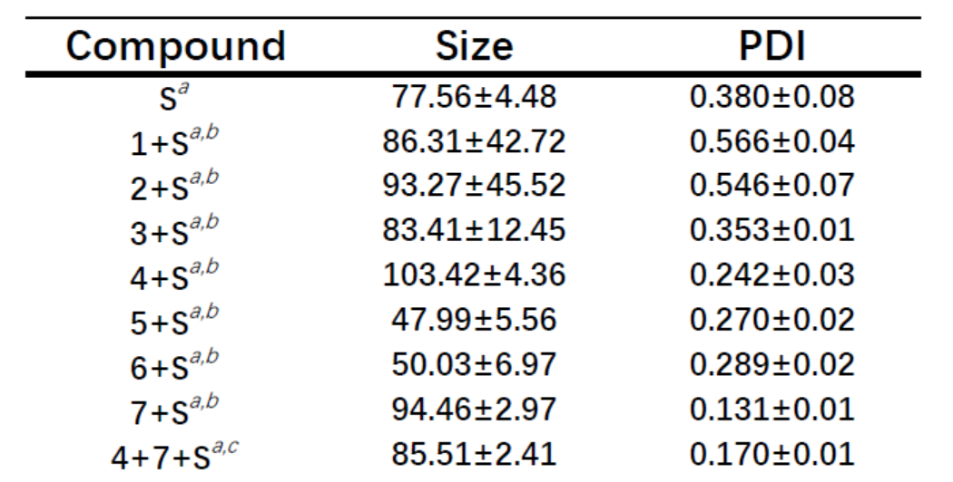

Table S1. Characterization of dyes with Surfactin as determined by dynamic light scattering (DLS). ª The concentration of Surfactin was 100 μM. ^{b} The molar ratio was 1:5 (compound vs. Surfactin). ^{c} The molar ratio was 0.5:0.5:5 (compound 4 vs. compound 7 vs. Surfactin).

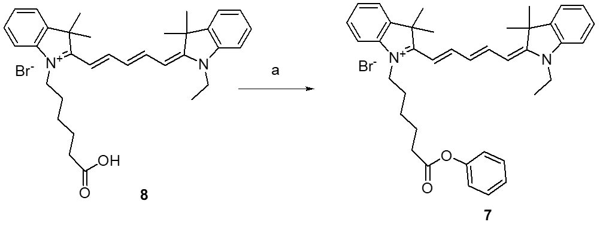
Scheme S1. Synthesis of Er-Cy5. Reagents: (a) phenol, EDC, DMAP, CH₂Cl₂.

