Secretagogin regulates asynchronous and spontaneous glutamate release in hippocampal neurons through interaction with Doc2α

Yingfeng Tu^{1,2,‡}, Jiao Qin^{1,3,‡}, Qiao-Ming Zhang^{2,‡}, Tie-Shan Tang⁴, Lifang Wang⁵, Jun Yao²

¹ Key Laboratory of Birth Defects and Related Diseases of Women and Children, Department of Paediatrics, West China Second University Hospital, State Key Laboratory of Biotherapy, Sichuan University, Chengdu 610041, China.
² State Key Laboratory of Membrane Biology, Tsinghua-Peking Center for Life Sciences, IDG/McGovern Institute for Brain Research, School of Life Sciences, Tsinghua University, Beijing 100084, China.
³ Present address: Human Sperm Bank, Key Laboratory of Birth Defects and Related Diseases of Women and Children, West China Second University Hospital, Sichuan University, Chengdu 610041, China.
⁴ State Key Laboratory of Membrane Biology, Institute of Zoology, Chinese Academy of Sciences, Beijing Institute for Stem Cell and Regenerative Medicine, University of Chinese Academy of Sciences, Beijing 100049, China.
⁵ Peking University Institute of Mental Health, NHC Key Laboratory of Mental Health, National Clinical Research Center for Mental Disorders, Peking University Sixth Hospital, Beijing 100191, China.

‡These authors contributed equally to this work.

Correspondence: tuyingfeng2haha@sina.com (Y.T.), jyao@mail.tsinghua.edu.cn (J.Y.)

This PDF file includes:

Figure S1 to S5.
Table S1 and S2.

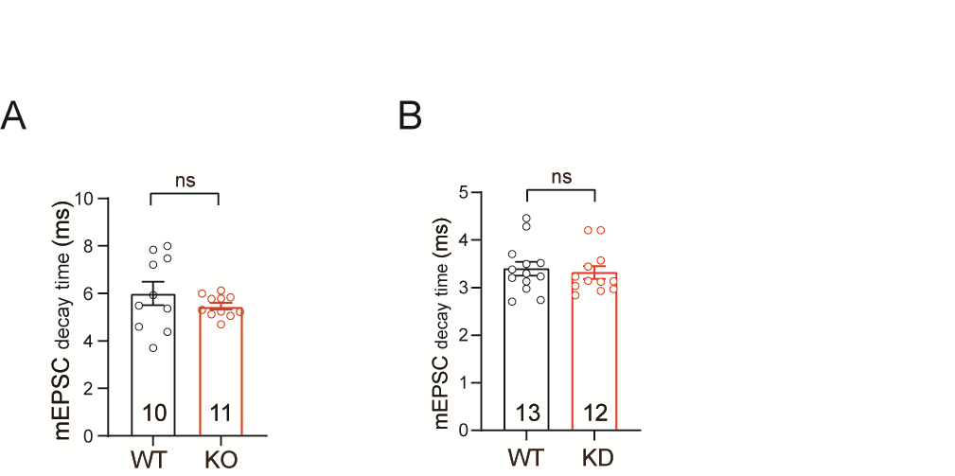

Figure S1. SCGN deficiency does not significantly change the kinetic characters of AMPARs. (A) Quantitative analysis indicating that the decay time of mEPSCs in the SCGN KO neurons were comparable to the WT neurons. (B) Quantification of mEPSC decay time in the WT scrambled control and SCGN KD neurons. Data are presented as mean ± SEM. ns, not significant, P>0.05.

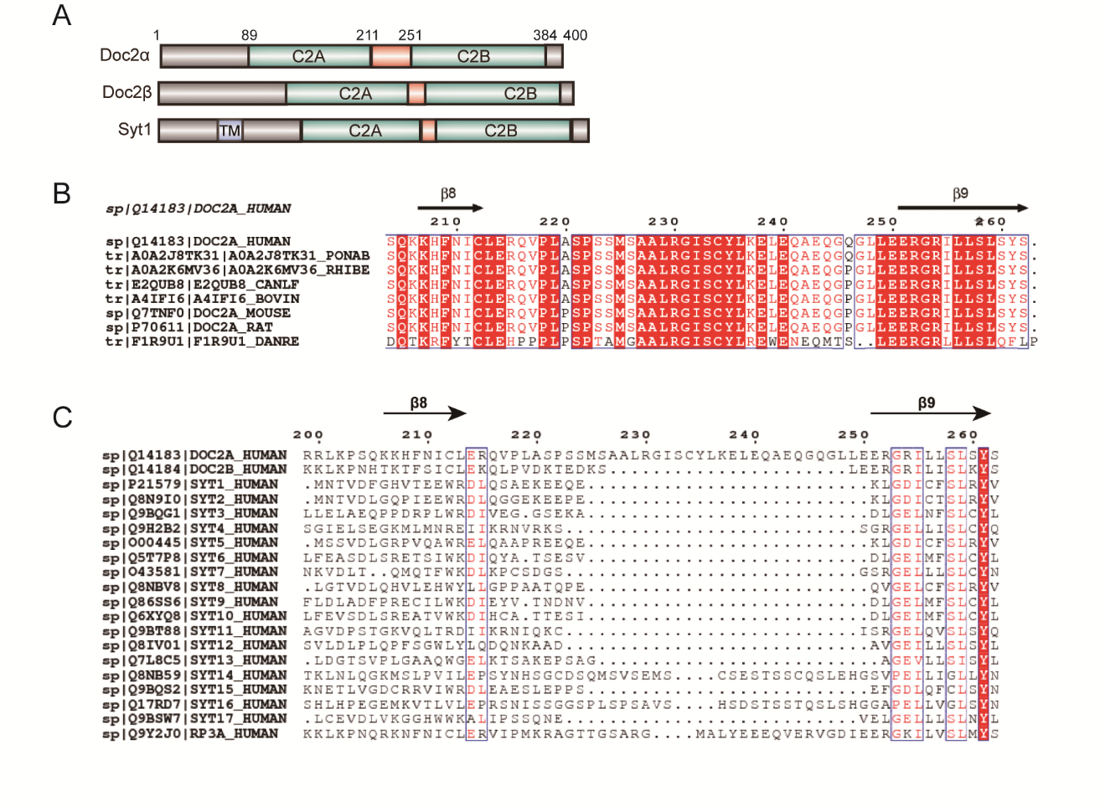

Figure S2. DOC2α linker is unique among the DOC2/Synaptotagmin family. (A) Domain structures of Doc2α, Doc2β and Syt1. TM, transmembrane region. (B) Sequence alignment of linker region in Doc2α homologs. Amino acid sequences are aligned with Homo sapiens (Human), Pongo abelii (PONAB), Rhinopithecus bieti (RHIBE), Canis lupus familiaris (CANLF), Bos taurus (BOVIN), Mus musculus (Mouse), Rattus norvegicus (Rat) and Danio rerio (DANRE) by ClustalW. Amino acids sharing 100% identity in all the species are highlighted with red. Positions of β sheets in Doc2α are marked with arrows. (C) Sequence alignment of the linker region in Human Doc2α/β, synaptotagmin isoforms and rabphilin3A by ClustalW.

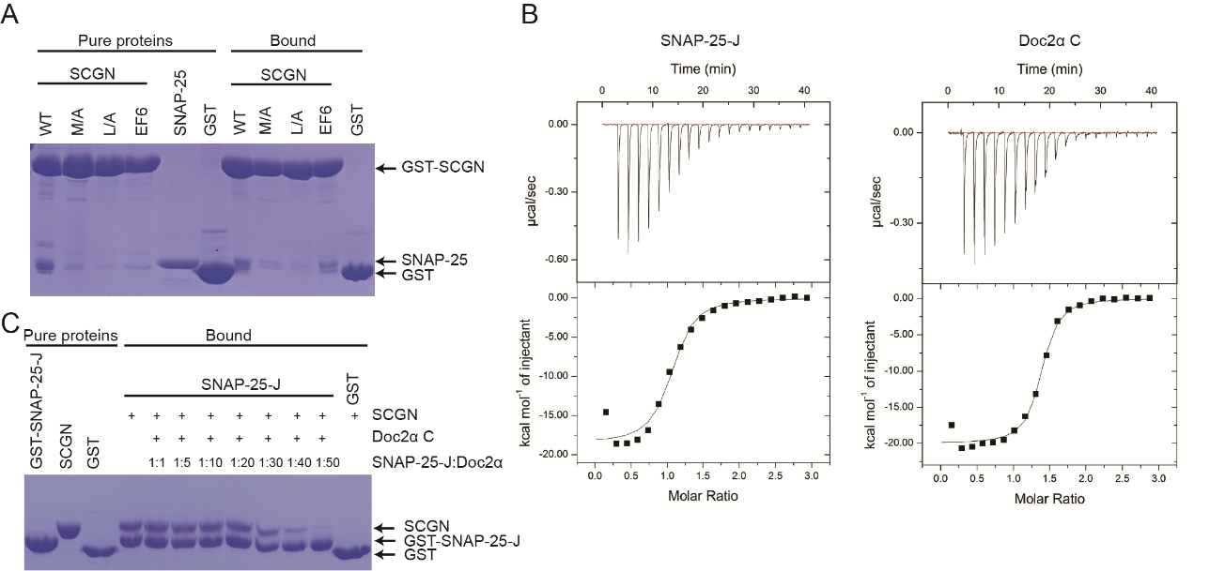

Figure S3. Doc2α and SNAP-25 share binding sites on SCGN. (A) GST pull-down assays performed with GST-human SCGN WT or mutants, or GST, and purified SNAP-25 protein, in the presence of 2 mM CaCl₂. The resin-bound proteins were subjected to SDS-PAGE and Coomassie blue staining. (B) Isothermal titration calorimetry of SNAP-25-J fragment (amino acids 143 to 170) or Doc2α C fragment titrated into human SCGN in a buffer containing 2 mM CaCl₂ at 25°C. Top and bottom panels show raw and integrated heat from injections, respectively. The black curve in the bottom panel represents a fit of the integrated data to a single-site binding model. (C) GST pull-down assays performed with GST-SNAP-25-J, or GST, and purified SCGN in the presence or absence of competing Doc2α C. Proteins were mixed with the resin and incubated at 4°C for 1 hour. The resin was then washed, and resin-bound proteins were subjected to SDS-PAGE and Coomassie blue staining.
.

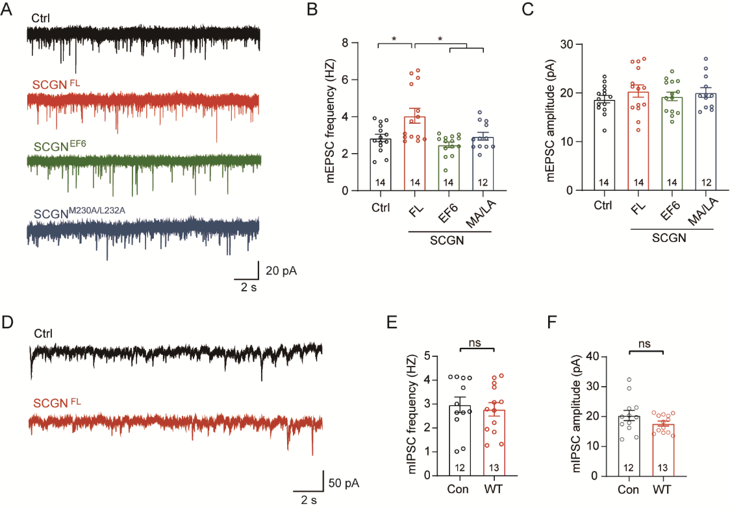

Figure S4. SCGN regulates excitatory spontaneous neurotransmission through its Doc2α/SNAP-25 binding motif. (A) Sample traces of mEPSCs in WT neurons and neurons overexpressing SCGN^{FL} or mutants. (B and C) Summary of the frequency (B) and amplitude (C) of mEPSCs. (D) Sample traces of mIPSCs in WT neurons and neurons over-expressing SCGN^{FL}. (E and F) Summary of the frequency (E) and amplitude (F) of mIPSCs. *P < 0.05; **P < 0.001; error bars, s.e.m.

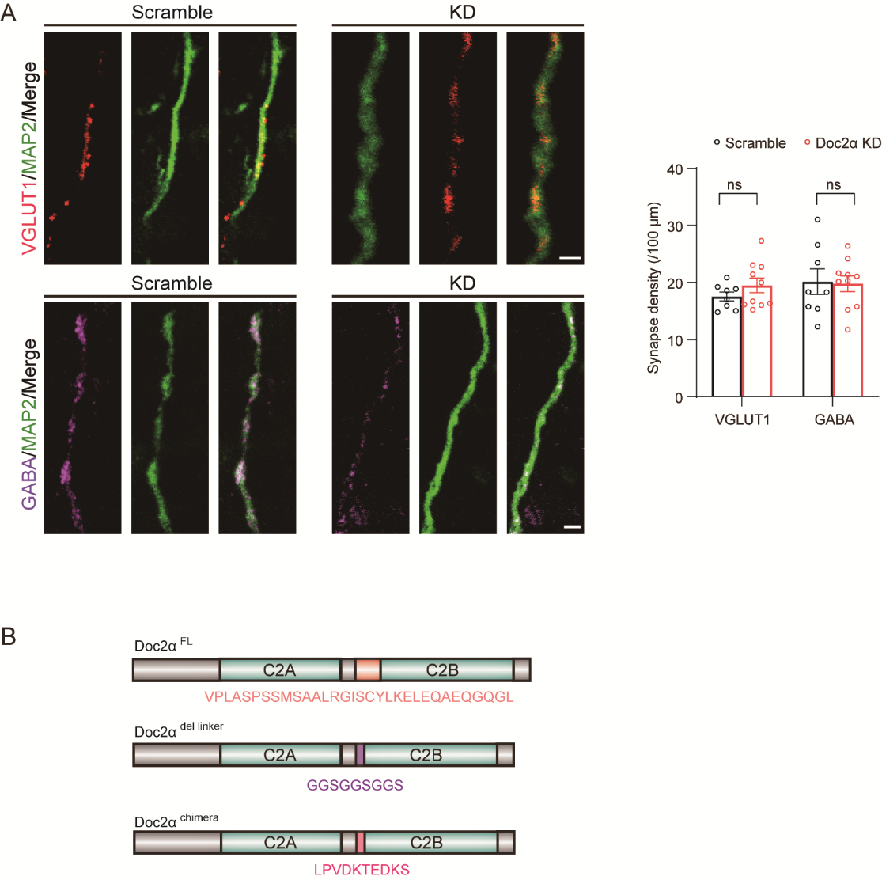

Figure S5. Doc2α regulates excitatory spontaneous neurotransmission through interacting with SCGN. (A) Sample immunostaining images of glutamatergic synapses and GABAergic synapses of WT neurons and Doc2α KD neurons. Scale bar: 2 μm. (B) A schematic diagram of Doc2α WT and its mutants. The linker region of DOC2α was substituted with either a nine-residue linker (GGSGGSGGS) (termed Doc2α^{del linker}) or the linker region of Doc2β (Doc2α^{chimera}). Two-way ANOVA. Data are presented as mean ± SEM. ns, not significant, P>0.05.

Table S1. Statistical data for all experiments.

Fig. 1
Fig.1A | Con | VGLUT1 |  | 16.99 ± 1.15, n = 8
Fig.1A | Con | GABA |  | 18.33 ± 2.32, n = 8
Fig.1A | KO | VGLUT1 |  | 20.03 ± 1.33, n = 10
Fig.1A | KO | GABA |  | 20.74 ± 1.06, n = 10
Fig. 1C | WT |  |  | 941.73 ± 27.29 pA, n = 22
Fig. 1C | KO |  |  | 889.32 ± 27.46 pA, n = 27; p > 0.1, compared to WT
Fig. 1D | WT |  |  | 36.54 ± 1.32 pC, n = 22
Fig. 1D | KO |  |  | 28.35 ± 1.41 pC, n = 27; p < 0.001, compared to WT
Fig. 1E | WT |  |  | 36.97 ± 1.45 ms, n = 22
Fig. 1E | KO |  |  | 30.4 ± 1.85 ms, n = 27; p < 0.01, compared to WT
Fig. 1I | WT |  |  | 148.43 ± 19.46 pC, n = 8
Fig. 1I | KO |  |  | 112.31 ± 16.11 pC, n = 8; p > 0.1, compared to WT
Fig. 1J | Amplitude |  | WT | 1565 ± 198 pA, n = 17
Fig. 1J |  |  | KO | 1686 ± 239.1 pA, n = 19; p > 0.7, compared to WT
Fig. 1J | charge |  | WT | 148.3 ± 20.41 pC, n = 17
Fig. 1J |  |  | KO | 193.9 ± 25.6 pC, n=19; p > 0.1, compared to WT
Fig. 2
Fig. 2B | Control |  |  | 873.38 ± 40.93 pA, n = 18
Fig. 2B | KD |  |  | 911.66 ± 30.07 pA, n = 30; p > 0.4, compared to Control
Fig. 2C | Control |  |  | 44.90 ± 3.46 pC, n = 18
Fig. 2C | KD |  |  | 30.15 ± 1.92 pC, n = 30; p < 0.001, compared to Control
Fig. 2D | Control |  |  | 39.59 ± 4.06 ms, n = 18
Fig. 2D | KD |  |  | 30.83±1.58 ms, n = 30; p < 0.05, compared to Control
Fig. 2H | Control |  |  | 144.23±13.98 pC, n = 12
Fig. 2H | KD |  |  | 112.56±13.40 pC, n = 15; p > 0.1, compared to Control
Fig. 2J | Amplitude |  | Ctrl | 1509 ± 197.3 pA, n = 20
Fig. 2J |  |  | KD | 1526 ± 113.3 pA, n = 21; p > 0.9, compared to Control
Fig. 2J | Charge |  | Ctrl | 167.7 ± 24.71 pC, n = 20
Fig. 2J |  |  | KD | 163.5 ± 19.96 pC, n = 21; p > 0.8, compared to Control
Fig. 3
Fig. 3B | WT |  |  | 1.35 ± 0.16 Hz, n = 10
Fig. 3B | KO |  |  | 0.53 ± 0.04 Hz, n = 11; p < 0.001, compared to WT
Fig. 3C | WT |  |  | 13.68 ± 0.49 pA, n = 10
Fig. 3C | KO |  |  | 14.42 ± 0.61 pA, n = 11; p = 0.36, compared to WT
Fig. 3E | WT |  |  | 2.09 ± 0.25 Hz, n = 16
Fig. 3E | KO |  |  | 2.24 ± 0.22 Hz, n = 14; p = 0.67, compared to WT
Fig. 3F | WT |  |  | 32.66 ± 0.91 pA, n = 16
Fig. 3F | KO |  |  | 36.15 ± 1.54 pA, n = 14; p = 0.055, compared to WT
Fig. 3H | Control |  |  | 1.29 ± 0.11 Hz, n = 13
Fig. 3H | KD |  |  | 0.72 ± 0.08 Hz, n = 12; p < 0.001, compared to Control
Fig. 3I | Control |  |  | 14.21 ± 0.76 pA, n = 13
Fig. 3I | KD |  |  | 16.26 ± 1.11 pA, n = 12; p = 0.13, compared to Control
Fig. 3K | Control |  |  | 2.73 ± 0.05 Hz, n = 12;
Fig. 3K | KD |  |  | 2.39±0.14 Hz, n = 13; p = 0.051, compared to Control
Fig. 3L | Control |  |  | 36.5±1.33 pA, n = 12
 | KD |  |  | 36.74±1.52 pA, n = 13; p = 0.41, compared to Control
Fig. 5
Fig. 5C | WT |  |  | 1041.15 ± 52.78 pA, n = 16
Fig. 5C | KO |  |  | 966.63 ± 20.27 pA, n = 26; p = 0.13, compared to WT
Fig. 5C | SCGN^{FL} |  |  | 1031.78 ± 29.17 pA, n = 25; p = 0.07, compared to KO
Fig. 5C | SCGN^{EF6} |  |  | 1107.68 ± 36.05 pA, n = 17; p = 0.11, compared to SCGN^{FL}
Fig. 5C | SCGN^{M230AL232A} |  |  | 1020.78 ± 36.27 pA, n = 27; p = 0.82, compared to SCGN^{FL}
Fig. 5D | WT |  |  | 55.64 ± 3.44 pC, n = 16
Fig. 5D | KO |  |  | 43.03 ± 1.33 pC, n = 26; p < 0.001, compared to WT
Fig. 5D | SCGN^{FL} |  |  | 74.01 ± 3.65 pC, n = 25; p < 0.001, compared to KO
Fig. 5D | SCGN^{EF6} |  |  | 43.54 ± 1.89 pC, n = 17; p < 0.001, compared to SCGN^{FL}
Fig. 5D | SCGN^{M230AL232A} |  |  | 40.40 ± 3.04 pC, n = 27; p < 0.001, compared to SCGN^{FL}
Fig. 5H | WT |  |  | 1.02 ± 0.07 Hz, n = 13
Fig. 5H | KO |  |  | 0.29 ± 0.05 Hz, n = 11; p < 0.001, compared to WT
Fig. 5H | SCGN^{FL} |  |  | 1.71 ± 0.13 Hz, n = 12; p < 0.001, compared to KO
Fig. 5H | SCGN^{EF6} |  |  | 0.65 ± 0.04 Hz, n = 11; p < 0.001, compared to SCGN^{FL}
Fig. 5H | SCGN^{M230AL232A} |  |  | 0.5 ± 0.08 Hz, n = 11; p < 0.001, compared to SCGN^{FL}
Fig. 5I | WT |  |  | 15.57 ± 0.4 pA, n = 13
Fig. 5I | KO |  |  | 14.47 ± 0.52pA, n = 11; p = 0.1, compared to WT
Fig. 5I | SCGN^{FL} |  |  | 15.46 ± 0.6 pA, n = 12; p = 0.23, compared to KO
Fig. 5I | SCGN^{EF6} |  |  | 17.44 ± 0.76 pA, n = 11; p =0 .052, compared to SCGN^{FL}
Fig. 5I | SCGN^{M230AL232A} |  |  | 19.66 ± 2.05 pA, n = 11; p = 0.055, compared to SCGN^{FL}
Fig. 6
Fig. 6B | CRISPRi scramble |  |  | 1123.78 ± 53.34 pA, n = 26
Fig. 6B | DOC2α KD |  |  | 1036.44 ± 35.17 pA, n = 23; p = 0.19, compared to scramble
Fig. 6B | DOC2α^{FL} |  |  | 1053.5 ± 32.75 pA, n = 26; p = 0.72, compared to KD
Fig. 6B | DOC2α^{del linker} |  |  | 1182.81 ± 81.18 pA, n = 20; p = 0.11, compared to DOC2α^{FL}
Fig. 6B | DOC2α^{chimera} |  |  | 1151.45 ± 51.5 pA, n = 15; p = 0.1, compared to DOC2α^{FL}
Fig. 6C | CRISPRi scramble |  |  | 78.15 ± 4.79 pC, n = 26
Fig. 6C | DOC2α KD |  |  | 52.51 ± 3.62 pC, n = 23; p < 0.001, compared to scramble
Fig. 6C | DOC2α^{FL} |  |  | 72.19 ± 5.01 pC, n = 26; p < 0.01, compared to DOC2α KD
Fig. 6C | DOC2α^{del linker} |  |  | 55.17±3.07 pC, n = 20; p < 0.01, compared to DOC2α^{FL}
Fig. 6C | DOC2α^{chimera} |  |  | 50.77 ± 2.74 pC, n = 15; p < 0.01, compared to DOC2α^{FL}
Fig. 6G | crispri scramble |  |  | 1.62 ± 0.15 Hz, n = 21
Fig. 6G | DOC2α KD |  |  | 0.80 ± 0.05 Hz, n = 39; p < 0.001, compared to scramble
Fig. 6G | DOC2α^{FL} |  |  | 1.65 ± 0.12 Hz, n = 20; p < 0.001, compared to DOC2α KD
Fig. 6G | DOC2α^{del linker} |  |  | 1.05 ± 0.11 Hz, n = 20; p < 0.01, compared to DOC2α^{FL}
Fig. 6G | DOC2α^{chimera} |  |  | 0.79 ± 0.10 Hz, n = 13; p < 0.001, compared to DOC2α^{FL}
Fig. 6H | crispri scramble |  |  | 16.26 ± 0.81 pA, n = 21
Fig. 6H | DOC2α KD |  |  | 16.87 ± 0.54 pA, n = 39, p = 0.56, compared to scramble
Fig. 6H | DOC2α^{FL} |  |  | 17.05 ± 0.82 pA, n =2 0; p = 0.85, compared to DOC2α KD
Fig. 6H | DOC2α^{del linker} |  |  | 15.62 ± 0.59 pA, n = 20; p = 0.15, compared to DOC2α^{FL}
Fig. 6H | DOC2α^{chimera} |  |  | 18.74 ± 0.59 pA, n = 13; p = 0.14, compared to DOC2α^{FL}
Fig.S1
S1A | WT |  |  | 6.00 ± 0.49 ms, n = 10
S1A | KO |  |  | 5.47 ± 0.14 ms, n = 11; p = 0.29, compared to WT
S1B | WT |  |  | 3.40 ± 0.1 Control 4 ms, n = 13
S1B | KD |  |  | 3.32 ± 0.13 ms, n = 12; p = 0.70, compared to WT Control
Fig.S4
S3B | Control |  |  | 2.85 ± 0.2Hz, n = 14
S3B | SCGN^{FL} |  |  | 4.05 ± 0.4 Hz, n = 14; p < 0.05, compared to Control
S3B | SCGN^{EF6} |  |  | 2.48 ± 0.15 Hz, n = 14; p < 0.01, compared to SCGN^{FL}
S3B | SCGN^{M230AL232A} |  |  | 2.94 ± 0.21 Hz, n = 12; p < 0.05, compared to SCGN^{FL}
S3C | Control |  |  | 18.72 ± 0.77 pA, n = 14
S3C | SCGN^{FL} |  |  | 20.4 ± 1.26 pA, n = 14; p = 0.27, compared to Control
S3C | SCGN^{EF6} |  |  | 19.29 ± 0.88 pA, n = 14; p = 0.48, compared to SCGN^{FL}
S3C | SCGN^{M230AL232A} |  |  | 20.09 ± 1.01 pA, n = 12; p = 0.85, compared to SCGN^{FL}
S3E | Control |  |  | 2.97 ± 0.32Hz, n = 12
S3E | SCGN^{FL} |  |  | 2.78 ± 0.28Hz, n = 13; p = 0.66, compared to Control
S3F | Control |  |  | 20.41 ± 1.71pA, n = 12
S3F | SCGN^{FL} |  |  | 17.68 ± 0.82 pA, n = 13; p = 0.15, compared to Control
Fig.S5
S4A | crispri scramble |  |  | VGUT1 | 17.56 ± 0.77, n = 8
S4A |  |  |  | GABA | 20.16 ± 2.24, n = 8
S4A | DOC2α KD |  |  | VGUT1 | 19.52 ± 1.28, n = 10
S4A |  |  |  | GABA | 19.80 ± 1.55, n = 10

Table S2. Key resources table

REAGENT or RESOURCE | SOURCE | IDENTIFIER
Antibodies
Guinea pig polyclonal vGLUT1 | Synaptic Systems | Cat#135 304  RRID:AB_887878
Rabbit polyclonal anti-GABA | Calbiochem | Cat#PC213L  RRID:AB_2232326
mouse monoclonal anti-MAP2 | Sigma-Aldrich | Cat#M1406
Mouse monoclonal anti-SCGN | Santa caruz | Cat# sc374355  RRID:AB_10989370
Mouse monoclonal anti-tubulin | Sigma-Aldrich | Cat# T5076  RRID:AB_532291
Recombinant DNA
Lenti-Scr-GFP | (Zheng et al., 2018) | N/A
Lenti- Doc2α sgRNA-GFP |  | N/A
pLOX-SCGN
pLOX-SCGN^{M230AL232A}
pLOX-SCGN^{EF6}
pLOX-Flag-SCGN
pLOX-Doc2α
pLOX-Doc2α^{del linker}
pLOX-Doc2α^{chimera}
pLOX-HA-Doc2α
Chemicals
tetrodotoxin | Tocris | 1069
picrotoxin | abcam | Ab120315
CNQX | Sigma-Aldrich | C-127
QX314 | Tocris | 2313
DMEM/F12 | Life Technologies | 11330-032
PEI | Polysciences,Inc. | 87001-912
Opti-MEM | Life Technologies | 31985088
B-27 Supplement with VitaminA | Life Technologies | 17504-044
MgATP (507.2) | Sigma, | A9187
Phosphocreatine di(tris) salt (453.4) | Sigma, | P1937
Phosphocreatine disodium salt hydrate | Sigma, | P7936
Creatine Phosphokinase from rabbit muscle, | Sigma, | C3755
Na2GTP | Chemreagents | 56001-37-7
Potassium D-gluconate | Sigma | G4500
EGTA | Tocris | 2807
CNQX | Sigma | C-127
D-AP5 | Tocris | 0106
QX-314 | Tocris | 2313
Neurobasal-A | Life Technologies | 10888-022
Penicillin Streptomycin | Life Technologies | 15140-122
GlutaMax-I | Life Technologies | 35050-061
PDL | Life Technologies | A3890401
HEPES | Life Technologies | 15630106
FBS(fetal bovine serum) | Life Technologies | 1009141
Paraformaldehyde | Sangon | A500684
Tissue-tek OCT medium | Sakura | 458
NaCl | Sigma-Aldrich | 746398
D-(+)-Glucose | Sigma-Aldrich | V900392
Hepes | Sigma-Aldrich | V900477
KCl | Sigma-Aldrich | 746436
CaCl2 | Sigma-Aldrich | 793639
MgCl2 | Sigma-Aldrich | 449172
Gel Extraction Kit | CWBIO | CW2302M
EndoFree Plasmid Midi Kit | CWBIO | CW2105S
T4 Ligase | Thermo | EL0011
Taq PCR Mix | BBI | B639297
Hieff® qPCR SYBR Green Master Mix (No Rox) | YEASEN | 11201ES08
5X All-In-One RT MasterMix | ABM | G492
Trizol | Life Technologies | 15596018
Isopropyl alcohol | MACKLIN | I811925
Ethanol | MACKLIN | E809061
RNA Extraction Buffer | Solarbio | P1011
Software and Algorithms
Fiji/ImageJ | https://fiji.sc/ | N/A
NIS-Elements AR | Nikon | N/A
MATLAB software | MathWorks | N/A
EthoVision XT 11.5 | Noldus | N/A
Other
Nikon A1 | Nikon | N/A
SD-9 stimulator | Grass Technologies | N/A
Hitachi H-7650B transmission electron microscope. | Hitachi | N/A

