Supplementary Information

Nestin prevents mesenchymal stromal cells from apoptosis in LPS-induced lung injury via inhibition of unfolded protein response sensor IRE1α
Hongmiao Wang^{1#}, Chenhao Jiang^{1#}, Jianye Cai^{2,3#}, Qiying Lu^{1#}, Yuan Qiu¹, Yi Wang⁴, Yinong Huang⁵, Yong Xiao¹, Boyan Wang¹, Xiaoyue Wei¹, Jiahao Shi¹, Xingqiang Lai¹, Tao Wang¹, Jiancheng Wang^{1,6,}*, Andy Peng Xiang^{1,}*

¹Centre for Stem Cell Biology and Tissue Engineering, Key Laboratory for Stem Cells and Tissue Engineering, Ministry of Education, Sun Yat-sen University, Guangzhou 510080, China
²Department of Hepatic Surgery and Liver Transplantation Centre, The Third Affiliated Hospital, Sun Yat-sen University, Guangzhou 510630, China
³Guangdong Key Laboratory of Liver Disease Research, Guangdong Engineering Laboratory for Transplantation, The Third Affiliated Hospital, Sun Yat-sen University, Guangzhou 510630, China
⁴Guangdong Institute for Drug Control, NMPA Key Laboratory for Quality Control of Blood Products, Guangdong Drug Administration Key Laboratory of Quality Control and Research of Blood Products, Guangzhou, China
⁵Department of Endocrinology, The First Affiliated Hospital of Sun Yat-Sen University, Guangzhou 510080, China
⁶Scientific Research Centre, The Seventh Affiliated Hospital, Sun Yat-sen University, Shenzhen, China

#The authors contributed equally to this study.

*Correspondence should be addressed to:
Dr. Jiancheng Wang, Scientific Research Centre, The Seventh Affiliated Hospital, Sun Yat-sen University, Shenzhen 518000, China. Phone: 86-20-87335822, Fax: 86-20-87335858, E-mail: wangjch38@mail.sysu.edu.cn
Dr. Andy Peng Xiang, Centre of Stem Cell Biology and Tissue Engineering, Sun Yat-sen University, 74# Zhongshan 2nd Road, Guangzhou 510080, China. Phone: 86-20-87335822, Fax: 86-20-87335858, E-mail: xiangp@mail.sysu.edu.cn

Supplementary Figures
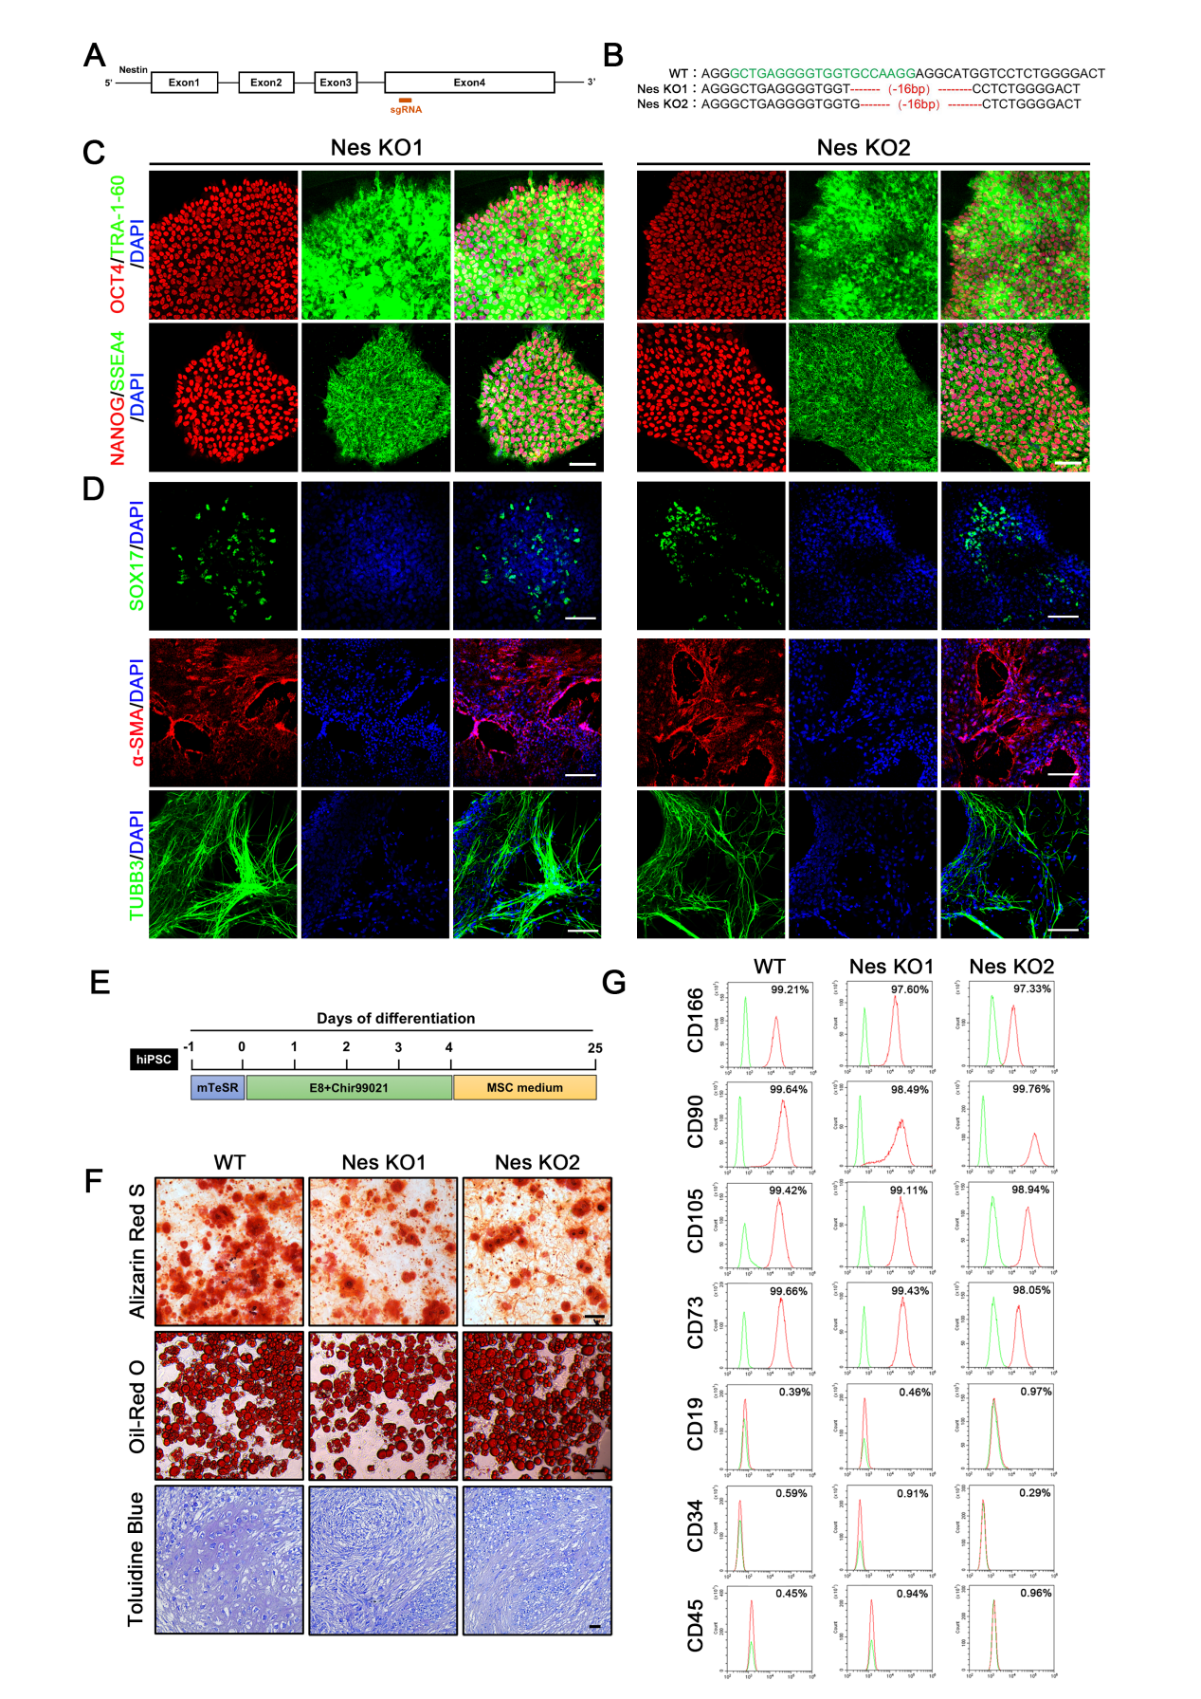
Figure S1. Establishment of Nestin-knockout iPSCs with CRISPR/Cas9 technology and induction towards MSCs.
- Diagram showing the targets of Nestin-knockout sgRNA. (B) Genome sequencing results of Nestin-knockout cell lines. (C) Immunofluorescence staining of the pluripotency stem cell-specific markers, OCT4, TRA-1-60, NANOG and SSEA4 in Nestin-knockout hiPSCs. Scale bar: 100 μm. (D) Immunofluorescence staining of the germ layer specific markers: Endoderm (SOX17), mesoderm (α-SMA) and ectoderm (TUBB3) in Nestin-knockout hiPSCs. Scale bar: 100 μm. (E) Strategy for MSC lineage induction from hiPSC-NMP. (F) The osteogenic, adipogenic, and chondrogenic differentiation potentials of MSCs were verified by Alizarin Red S staining, oil red O staining, and toluidine blue staining, respectively. Scale bar: 100 μm. (G) FACS analysis of typical MSC surface markers in hiPSC-derived MSCs.

Figure S2. Nestin deficiency in murine-derived MSCs hampers the therapeutic effect in LPS-induced lung injury model.
(A) Nestin was silenced in murine-derived MSCs (shNES#1, shNES#2), level of Nestin was analyzed using western blot. (B) IL-1β, TNF-α, IFN-γ and IL-6 in the BALF were detected by ELISA (n = 4). (C) Total cell count, neutrophils and macrophages in BALF were measured. (D-E) Representative images of lung sections with H&E staining. Lung injury scores were calculated. Scale bar: 100 μm. (F-G) Representative images of the lungs stained with Evans blue dye by alveolar leakage. Scale bar: 5 mm. Quantitative spectro-photometric analysis of Evans blue-labelled albumin extravasation. (H-I) Nestin-knockout MSCs administration increased alveolar neutrophil counts, revealed by myeloperoxidase (MPO) staining. Scale bar:100 μm. The data are presented as the means ± SD. *P < 0.05, **P < 0.01, and ***P < 0.001, Student’s t test.

Figure S3. Nestin knockout induced a higher apoptotic rate in MSCs under stress.
- B) Immunofluorescence staining was used to evaluate MSC^{RFP} colonization level in the lungs after 24 h following intravenous MSC infusion (n = 4). (C) TUNEL staining was performed on lung sections of mice transplanted with wild-type MSCs or Nestin-knockout MSCs. TUNEL-positive cells were counted from 4 random HPF per section. (D) Wild-type MSCs and Nestin-knockout MSCs were incubated with H₂O₂ (400 μM) for 6 h. Cell viability was analyzed by CCK8 assay after H₂O₂ treatment (n = 3). (E-F) Cells were treated with 400 μM H₂O₂ for 6 h, before using CellROX staining to evaluate ROS levels in each group (n = 3). Cellular fluorescence intensities were quantified. (G) Quantifications of cell apoptosis level as detected by Annexin V/propidium iodide (PI) flow cytometric analysis. The data are presented as the means ± SD. *P < 0.05, **P < 0.01, and ***P < 0.001, Student’s t test.
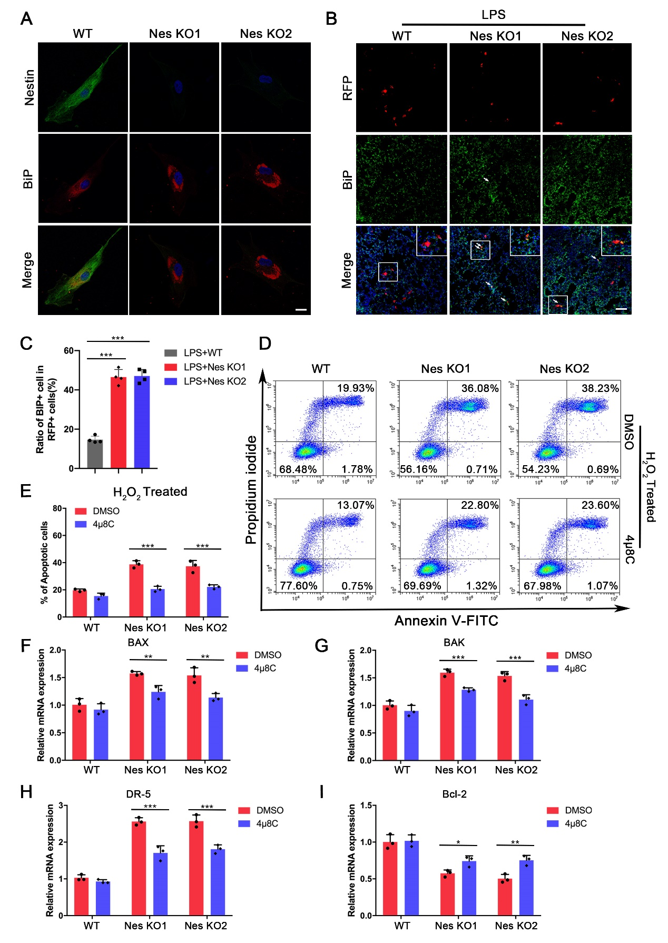
Figure S4. Nestin knockout induced a higher UPR level under stress.
- Immunofluorescence staining was used to detect the morphological change of BiP aggregation in each group. (B-C) Immunofluorescence staining was used to detect the expression level of BiP in wild-type MSCs and Nestin-knockout MSCs in vivo (n = 4), Scale bar: 20 μm. (D-E) Cells were treated with 400 μM H₂O₂ for 6 h. Flow cytometry using Annexin V-FITC and PI was performed to detect apoptosis. Statistical analysis of the total apoptotic rate in MSCs (n = 3). (F-I) Relative mRNA fold change of pro-apoptotic genes BAX, BAK, DR-5, and anti-apoptotic gene Bcl-2. The data are presented as the means ± SD. *P < 0.05, **P < 0.01, and ***P < 0.001, Student’s t test.

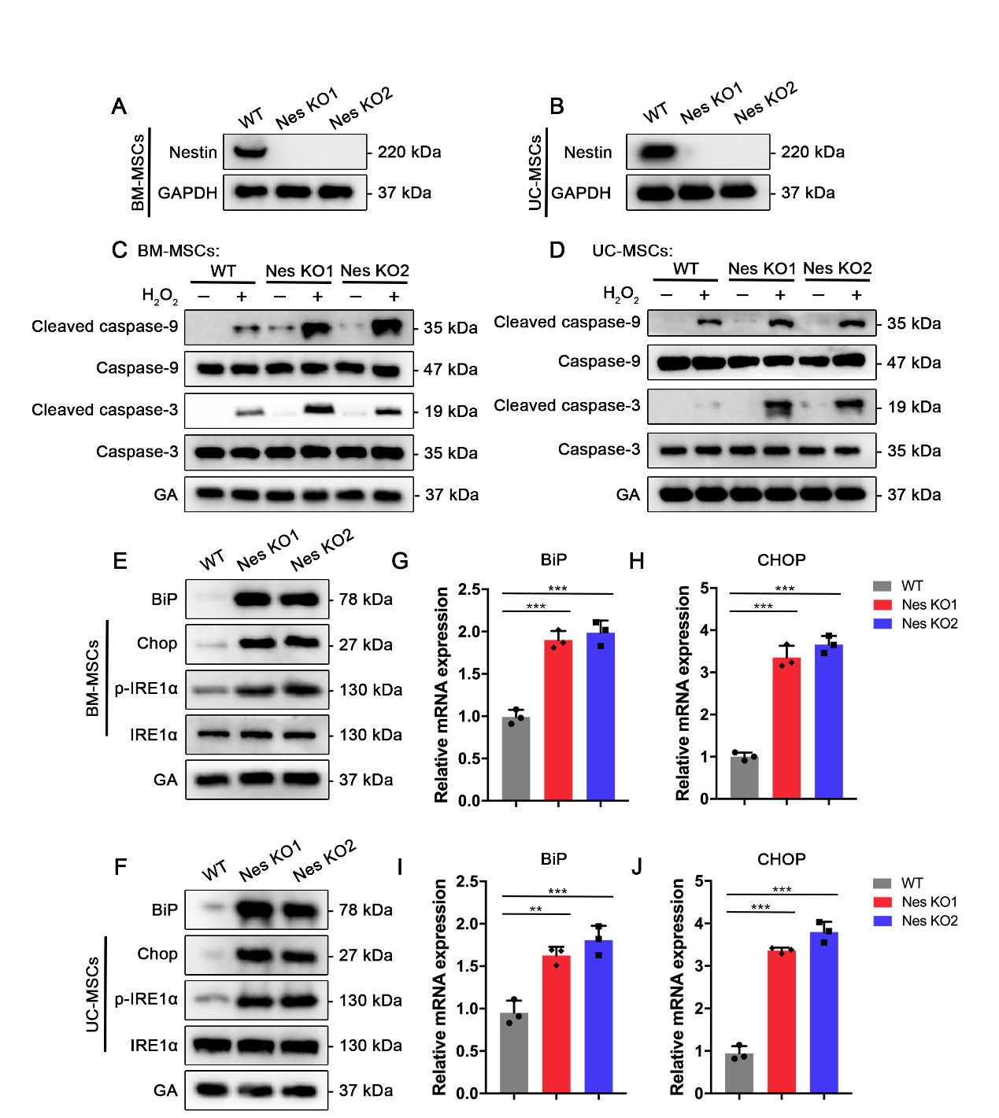
Figure S5. Nestin knockout elevated ER stress-induced apoptosis level in BM-MSCs and UC-MSCs.
(A-B) Nestin was knocked out using CRISPR/Cas9 (Nes KO1 and Nes KO2) in bone marrow-derived MSCs (BM-MSCs) and umbilical cord-derived MSCs (UC-MSCs), Nestin expression level was analyzed using western blot. (C-D) Caspase activation was evaluating using western blot in each group under H₂O₂ stimulation. (E-F) Western blot was used to detect the levels of BiP and CHOP after Nestin knockout. (G-J) Relative mRNA fold change of BiP and CHOP in BM-MSCs and UC-MSCs after Nestin knockout (n = 3). The data are presented as the means ± SD. *P < 0.05, **P < 0.01, and ***P < 0.001, Student’s t test.

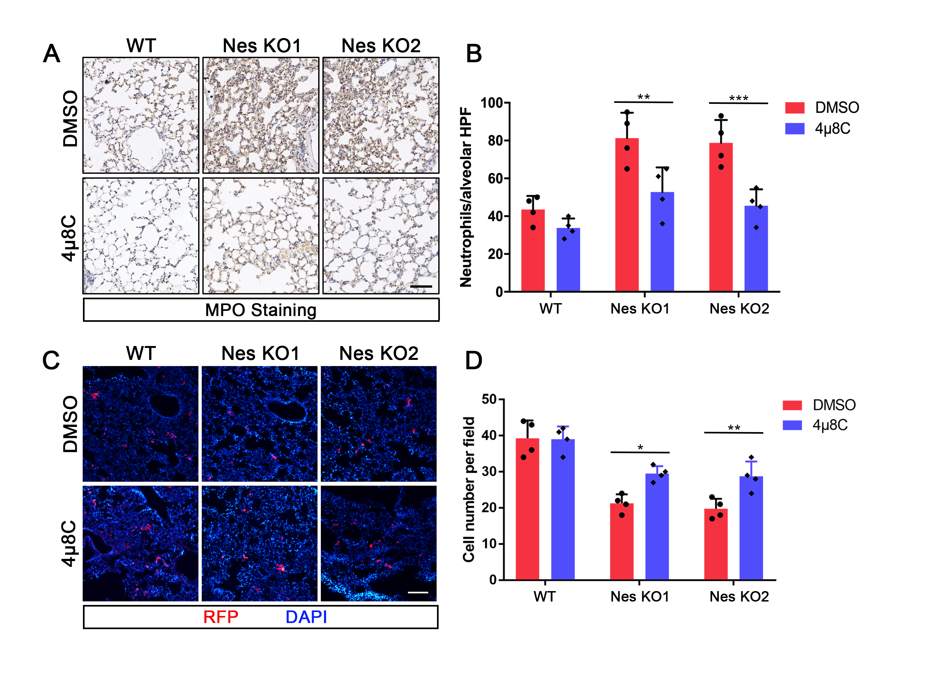
Figure S6. 4μ8C pretreatment in MSCs sustained MSC survival and enhanced therapeutic efficacy.
(A-B) MPO immuno-histochemical staining was used to detect the level of neutrophil infiltration (n = 4). Scale bar:100 μm. (C-D) Immunofluorescence staining was used to evaluate MSC^{RFP} colonization level in the lungs after 24 h following intravenous MSC infusion (n = 4). The data are presented as the means ± SD. *P < 0.05, **P < 0.01, and ***P < 0.001, Student’s t test.

Table S1. Antibodies
Antibody | Sources (Catalogue Number)
Western blot
BiP Rabbit mAb | CST (3177)
CHOP Mouse mAb | CST (2895)
IRE1α Rabbit mAb | CST (3294)
Phospho-IRE1α (phospho S724) Rabbit mAb | Abcam (ab48187)
JNK Rabbit mAb | CST (9252)
Phospho-JNK (Thr183/Tyr185) Mouse mAb | CST (9255)
ATF6 Rabbit mAb | CST (65880)
ATF4 Rabbit mAb | CST (11815)
eIF2α Rabbit mAb | CST (9722)
Phospho-eIF2α (Ser51) Rabbit mAb | CST (3597)
VEGF Receptor 2 Rabbit mAb | CST (2479)
XBP1s Rabbit mAb | CST (40435)
Nestin mouse IgG (Western blot) | BD (611658)
Caspase-3 Rabbit mAb | CST (9662)
Cleaved caspase-3 Rabbit mAb | CST (9661)
Caspase-9 Rabbit mAb | CST (9504)
Cleaved Caspase-9 Rabbit mAb | CST (9509)
GAPDH Rabbit mAb | CST (2118)
Anti-mouse IgG HRP-linked Ab | CST (7076)
Anti-rabbit IgG HRP-linked Ab | CST (7074)
DYKDDDDK Tag Rabbit mAb | CST (14793)
Immunofluorescence
Nestin Rabbit mAb | Millipore (ABD69)
Nestin Mouse mAb | Millipore (MAB5326)
IRE1α Mouse mAb | Santa Cruz (sc-390960)
BiP Rabbit mAb | Abcam (ab21685)
goat anti-mouse IgG Alexa 488 | Invitrogen (A11001)
goat anti-mouse IgG Alexa 555 | Invitrogen (A21422)
goat anti-rabbit IgG Alexa 488 | Invitrogen (A11008)
goat anti-rabbit IgG Alexa 555 | Invitrogen (A21428)
Immunohistochemistry
Myeloperoxidase Rabbit mAb | Abcam (ab208670)

Table S2. Primers used for qPCR
Name | Forward primer sequence | Reverse primer sequence
Nestin | 5’-CTGCTACCCTTGAGACACCTG-3’ | 5’-GGGCTCTGATCTCTGCATCTAC-3’
GAPDH | 5’-CATCCTGGGCTACACTGAGC-3’ | 5’-AAAGTGGTCGTTGAGGGCAA-3’
BAX | 5’-CCCGAGAGGTCTTTTTCCGAG-3’ | 5’-CCAGCCCATGATGGTTCTGAT-3’
BAK | 5’-ATGGTCACCTTACCTCTGCAA-3’ | 5’-TCATAGCGTCGGTTGATGTCG-3’
DR-5 | 5’-GCCCCACAACAAAAGAGGTC-3’ | 5’-AGGTCATTCCAGTGAGTGCTA-3’
Bcl-2 | 5’-GGTGGGGTCATGTGTGTGG-3’ | 5’-CGGTTCAGGTACTCAGTCATCC-3’
BiP | 5’-GACGGGCAAAGATGTCAGGA-3’ | 5’-GCCCGTTTGGCCTTTTCTAC-3’
CHOP | 5’-AGAACCAGGAAACGGAAACAGA-3’ | 5’-TCTCCTTCATGCGCTGCTTT-3’
ATF6 | 5′-GCTTTACATTCCTCCACCTCCTTG-3′ | 5′-ATTTGAGCCCTGTTCCAGAGCAC-3′
ATF4 | 5’-GCTAAGGCGGGCTCCTCCGA-3’ | 5’-ACCCAACAGGGCATCCAAGTCG-3’
XBP1s (qPCR) | 5’-CTGAGTCCGAATCAGGTGCAG-3’ | 5’-ATCCATGGGGAGATGTTCTGG-3’
XBP1 (PCR) | 5’-TTACGAGAGAAAACTCATGGCC-3’ | 5’-GGGTCCAAGTTGTCCAGAATGC-3’
DNAJB9 | 5′-GGAAGGAGGAGCGCTAGGTC-3′ | 5′-ATCCTGCACCCTCCGACTAC-3′
Hrd1 | 5′-AGCTACTTCAGTGAACCCCACT-3′ | 5′-CTCCTCTACAATGCCCACTGAC-3′
BLOS1 | 5′-CAAGGAGCTGCAGGAGAAGA-3′ | 5′-GCCTGGTTGAAGTTCTCCAC-3′
DGAT2 | 5′-GCTGGTGCCCTACTCCAAG-3′ | 5′-CCAGCTTGGGGATGGTGA-3′
CD59 | 5’-TAACCCAACTGCTGACTGCAA-3’ | 5’-TTTGGTAATGAGACACGCATCAA-3’

Table S3. Reagents
Reagent | Sources (Catalogue Number)
TM (Tunicamycin) | Sigma (654380)
CHX (Cycloheximide) | Sigma (C7698)
4μ8C | Selleck (S7272)
LPS (Lipopolysaccharide) | Sigma (L4524)
D-Luciferin | Goldbio (LUCK)
Annexin V-FITC/PI apoptosis kit | MultiSciences (70-AT101-100)
DSS (disuccinimidyl suberate) | Thermo (A39267)
CellROX Deep Red Reagent | Molecular Probes (C10422)
Mouse IL-1β ELISA Kit | Neobioscience (EMC001b)
Mouse TNF-α ELISA Kit | Neobioscience (EMC102a)
Mouse IFN-γ ELISA Kit | Neobioscience (EMC101g)
Mouse IL-6 ELISA Kit | Neobioscience (EMC004)
Evans blue dye | Sigma (E2129)

