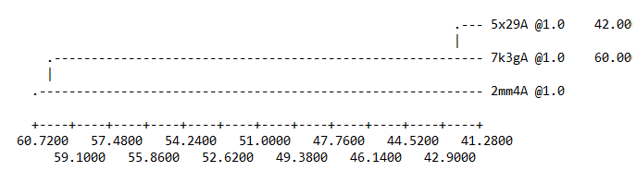A
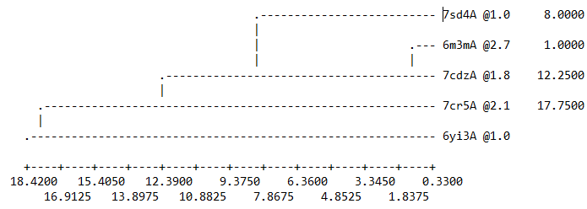B
Figure S1. Dendrogram (A) E protein and (B) N protein of SARS-coronavirus-2 generated by MODELLER
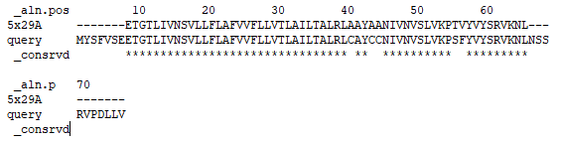 A
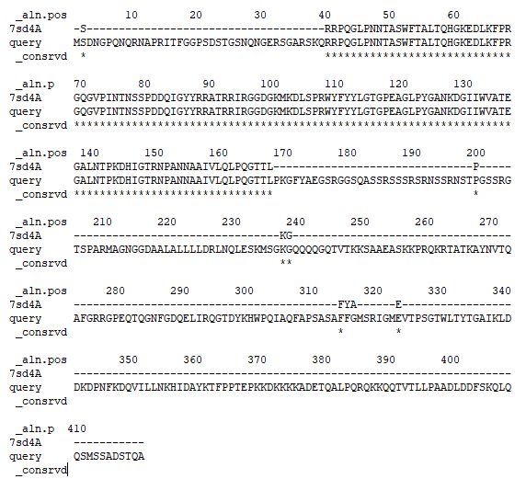 B
Figure S2. The query and template sequence alignment are based on the ALIGN2D command in MODELLER. The symbol (*) refers to identical amino acids.

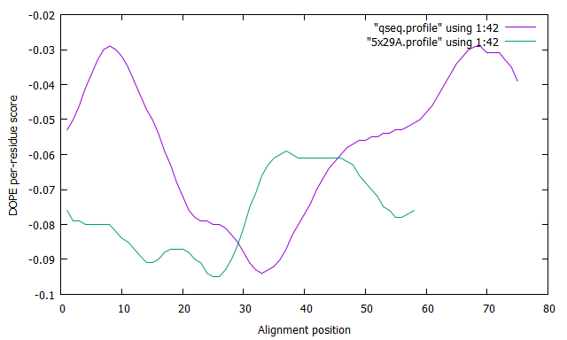A
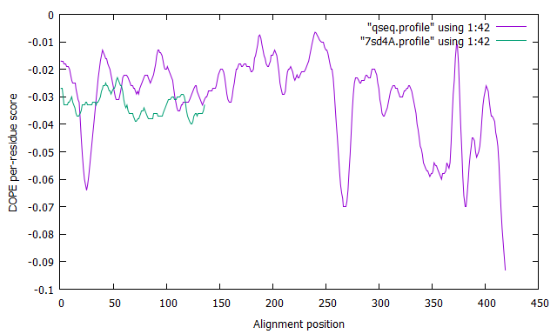B
Figure S3. The DOPE score visibility of (A) Envelope protein Query ID QNH88662 and (B) Nucleocapsid protein Query ID sp|P0DTC9| of SARS-CoV-2 incurred from Modeller software

Table. SI. Basic physiochemical properties of compound 36 and ritonavir drug evaluated by Lipinski, Pfizer, GSK, and Golden Triangle rules.
Parameters | Compound 36 | Ritonavir | Comment
Basic physicochemical property
Molecular Weight | 495.16 | 720.31 | Contain hydrogen atoms. Optimal:100~600
nHA | 6 | 11 | Number of hydrogen bond acceptors. Optimal:0 ~12
nHD | 3 | 4 | Number of hydrogen bond donors. Optimal:0 ~7
TPSA | 94.19 | 145.78 | Topological Polar Surface Area. Optimal:0 ~140
LogS | -6.325 | -4.677 | Log of the aqueous solubility. Optimal: -4~0.5 log mol/L
LogD | 3.731 | 4.592 | logP at physiological pH 7.4. Optimal: 1~3
LogP | 5.029 | 4.5 | Log of the octanol/water partition coefficient. Optimal: 0 ~3
SAscore | 3.166 |  | Synthetic accessibility score ≥ 6, difficult to synthesize; SAscore < 6, easy to synthesize
Absorption
Pgp-inh | 0.998 | 0.991 | Category 1: Inhibitor; Category 0: Non-inhibitor; The output value is the probability of being Pgp-inhibitor
MDCK  Permeability | 7 × 10⁻⁶ | 0.000104 | 1. low permeability: < 2 × 10⁻⁶ cm/s  2. medium permeability: 2–20 × 10⁻⁶ cm/s  3. high passive permeability: > 20 × 10⁻⁶ cm/s
Pgp-sub | 0.966 | 0.684 | Category 1: substrate; Category 0: Non-substrate; The output value is the probability of being Pgp-substrate
HIA | 0.034 | 0.961 | Human Intestinal Absorption  Category 1: HIA+( HIA < 30%); Category 0: HIA-(HIA < 30%); The output value is the probability of being HIA+
Caco-2 | -5.361 | -5.228 | Optimal: higher than -5.15 Log unit
Distribution
BBB | 0.477 | 0.019 | Blood-Brain Barrier Penetration  Category 1: BBB+; Category 0: BBB-; The output value is the probability of being BBB+
VDss | 0.432 | 0.985 | Volume Distribution  Optimal: 0.04-20L/kg
PPB | 99.74% | 97.37% | Plasma Protein Binding  Optimal: < 90%. Drugs with high protein-bound may have a low therapeutic index.
Fu | 0.496% | 0.740% | The fraction unbound in plasma  Low: <5%; Middle: 5~20%; High: > 20%
Metabolism: Category 1: Inhibitor; Category 0: Non-inhibitor/ Category 1: Substrate; Category 0: Non-substrate;
CYP1A2-inh/CYP1A2-sub | 0.142/ 0.275 | 0.274/0.589 | The output value is the probability of being inhibitor/of being substrate.
CYP2C19-inh/CYP2C19-sub | 0.801/0.113 | 0.958/0.318 | The output value is the probability of being inhibitor/of being substrate.
CYP2C9-inh/CYP2C9-sub | 0.874/0.824 | 0.975/0.179 | The output value is the probability of being inhibitor/of being substrate.
CYP2D6-inh/CYP2D6-sub | 0.535/0.672 | 0.969/0.734 | The output value is the probability of being inhibitor/of being substrate.
CYP3A4-inh/CYP3A4-sub | 0.861/0.848 | 0.985/0.917 | The output value is the probability of being inhibitor/of being substrate.
Toxicity
hERG/ Ames | 0.285/ 0.426 | 0.708/0.023 | Category 1: active; Category 0: inactive. The output value is the probability of being active. / Category 1: Ames positive (+); Category 0: Ames  negative (-).
Medicinal Chemistry
Lipinski | Accepted | Rejected | MW ≤ 500; logP ≤ 5; Hacc≤10; Hdon ≤ 5. If two properties are out of range, a poor  absorption or permeability is possible, one is acceptable.
Pfizer | Accepted | Accepted | logP > 3; TPSA < 75. Compounds with a high log P (>3) and low TPSA (<75) are likely to be toxic.
GSK | Rejected | Rejected | MW ≤ 400; logP ≤ 4. Compounds satisfying the GSK rule may have a more favorable ADMET profile.
GoldenTriangle | Accepted | Rejected | 200 ≤ MW ≤ 50; -2 ≤ logD ≤ 5. Compounds satisfying the Golden Triangle rule may have a more favorable ADMET profile.

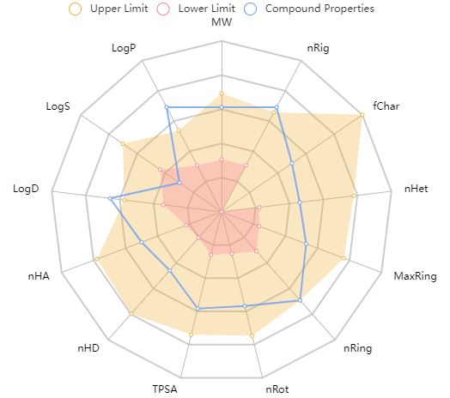Compound 36
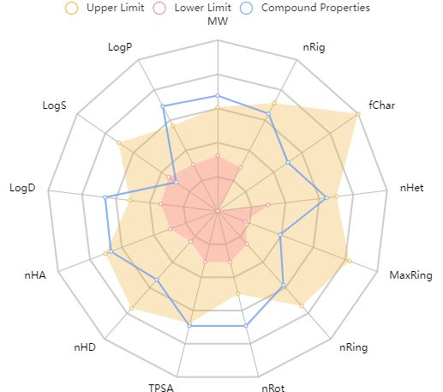Ritonavir
Figure S4. Radar graph showing upper, lower, and predicted values of various physicochemical and molecular properties of the selected molecules (Abbreviations: MW = Molecular weight, nRig = Number of rigid bonds, fChar = Formal charge, nHet = Number of heteroatoms, MaxRing = Number of atoms in the biggest ring, nRing = Number of rings, nRot = Number of rotatable bonds, TPSA = Topological polar surface area, nHD = Number of hydrogen bond donors, nHA = Number of hydrogen bond acceptors, LogP = Log of the octanol/water partition coefficient, LogS = Log of the aqueous solubility, LogD = Log at physiological pH 7.4.

