Appendices for:
Investigation of the working mechanism of a quasi-floating hierarchically sacrificial seismic system for small and mid-span girder bridges
Guo LI, Lei YAN*, Fenglei HAN, Wenbing YU, Xisheng LIN, Cruz Y. LI, Daniel Ziyue PENG
Institute of Future Civil Engineering Science and Technology, Chongqing Jiaotong University, Chongqing 400074, China
State Key Laboratory of Mountain Bridge and Tunnel Engineering, Chongqing Jiaotong University, Chongqing 400074, China
School of Civil Engineering, Chongqing Jiaotong University, Chongqing 400074, China
School of Civil Engineering, Chongqing Three Gorges University, Chongqing 404100, China
Department of Civil and Environmental Engineering, The Hong Kong University of Science and Technology, Hong Kong 999077, China
School of Civil Engineering, Chongqing University, Chongqing 400045, China
*Corresponding author. E-mail: yanlei1988413@163.com

Contents
Contents 1
Appendix A. Table of relative displacement between piers and beams 2
Appendix B. Table of Peak Strain 2
Appendix C. Comparative graph of the response time history of strain at the bottom of the piers 3

Appendix A. Table of relative displacement between piers and beams

Table A1 Relative displacement between piers and beams for load cases A and B (unit: mm)
Load case | Main beam | Top of pier | Middle of pier | Relative displacement between piers and beams | Load case | Main beam | Top of piers | Middle of piers | Relative displacement between piers and beams
A1 | 3.86 | 4.14 | 4.12 | 0.28 | B1 | 3.87 | 4.14 | 4.12 | 0.27
A2 | 3.76 | 4.24 | 4.05 | 0.48 | B2 | 4.06 | 4.57 | 4.53 | 0.51
A3 | 4.95 | 4.77 | 4.74 | 0.17 | B3 | 4.92 | 4.78 | 4.75 | 0.14
A4 | 8.98 | 9.61 | 9.48 | 0.62 | B4 | 8.96 | 9.62 | 9.47 | 0.66
A5 | 9.61 | 11.30 | 11.24 | 1.70 | B5 | 9.56 | 11.06 | 10.88 | 1.50
A6 | 7.85 | 8.36 | 8.15 | 0.51 | B6 | 8.05 | 8.55 | 8.53 | 0.50
A7 | 27.27 | 29.25 | 28.29 | 1.98 | B7 | 26.31 | 27.85 | 27.24 | 1.54
A8 | 39.23 | 44.09 | 43.88 | 4.86 | B8 | 40.77 | 43.73 | 42.62 | 2.96
A9 | 17.28 | 20.37 | 20.27 | 3.09 | B9 | 18.89 | 20.61 | 18.76 | 1.72
A10 | 45.70 | 42.29 | 41.94 | 3.41 | B10 | 44.38 | 41.57 | 40.38 | 2.81
A11 | 84.69 | 72.77 | 70.95 | 11.91 | B11 | 77.25 | 72.11 | 70.90 | 5.14
A12 | 31.60 | 24.54 | 23.76 | 7.07 | B12 | 28.92 | 24.39 | 21.63 | 4.53
A13 | 69.20 | 59.25 | 57.51 | 9.94 | B13 | 65.88 | 60.77 | 59.33 | 5.11
A14 | 124.68 | 84.06 | 82.75 | 40.62 | B14 | 88.97 | 83.62 | 82.12 | 5.35
A15 | 68.60 | 33.75 | 32.92 | 34.86 | B15 | 39.34 | 34.15 | 33.18 | 5.19

Appendix B. Table of Peak Strain

Table B1 Peak strain at each measurement point under load case A (unit: με)
Load case | Left end of  the beam |  | Right end of the beam |  | Middle of the beam |  | Middle of the left pier |  | Middle of the right pier |  | Bottom of the  left pier |  |  | Bottom of the right pier
Load case | T | C | T | C | T | C | T | C | T | C | T | C | T |  | C
A1 | 1.62 | 2.02 | 1.28 | 1.41 | 3.08 | 3.92 | 65.79 | 60.77 | 19.73 | 22.08 | 157.95 | 138.33 | 200.57 |  | 171.41
A2 | 3.43 | 6.17 | 4.83 | 1.35 | 4.79 | 8.57 | 149.15 | 148.52 | 71.36 | 54.17 | 346.05 | 293.91 | 448.57 |  | 374.24
A3 | 7.91 | 11.30 | 3.61 | 1.71 | 5.37 | 5.85 | 92.52 | 152.35 | 49.90 | 37.60 | 230.79 | 345.91 | 292.62 |  | 424.26
A4 | 5.54 | 5.88 | 5.58 | 2.37 | 2.94 | 4.30 | 117.87 | 123.38 | 37.80 | 35.35 | 252.94 | 285.36 | 334.47 |  | 352.92
A5 | 5.75 | 9.57 | 3.40 | 12.67 | 5.10 | 9.36 | 222.49 | 286.66 | 114.49 | 79.65 | 483.89 | 606.66 | 636.20 |  | 748.26
A6 | 11.06 | 16.41 | 13.80 | 3.82 | 7.90 | 4.57 | 249.34 | 258.37 | 93.18 | 96.57 | 489.86 | 576.25 | 645.51 |  | 710.37
A7 | 7.13 | 9.06 | 8.14 | 2.51 | 4.89 | 10.62 | 161.01 | 183.27 | 69.06 | 60.18 | 383.58 | 371.09 | 498.42 |  | 456.97
A8 | 26.12 | 8.22 | 5.50 | 6.92 | 9.42 | 10.51 | 323.67 | 373.58 | 154.50 | 117.08 | 660.84 | 798.33 | 874.86 |  | 966.94
A9 | 23.99 | 19.31 | 20.71 | 1.09 | 13.06 | 13.72 | 376.17 | 390.39 | 151.56 | 135.14 | 793.29 | 848.43 | 1048.41 |  | 1033.49
A10 | 16.56 | 12.64 | 7.85 | 8.20 | 7.46 | 9.13 | 230.99 | 307.20 | 116.79 | 85.74 | 528.57 | 623.98 | 687.33 |  | 754.15
A11 | 62.67 | 23.41 | 12.15 | 81.04 | 8.18 | 17.13 | 674.97 | 642.87 | 265.62 | 250.45 | 1361.15 | 1364.69 | 1845.35 |  | 1630.26
A12 | 16.37 | 21.59 | 14.29 | 3.59 | 17.26 | 17.49 | 389.83 | 424.18 | 173.48 | 138.93 | 891.61 | 940.61 | 1136.77 |  | 1122.89
A13 | 9.34 | 18.62 | 6.61 | 13.33 | 6.06 | 9.51 | 308.48 | 372.03 | 162.35 | 99.15 | 672.08 | 785.77 | 880.96 |  | 931.99
A14 | 49.30 | 26.19 | 15.54 | 18.90 | 14.75 | 25.78 | 561.88 | 793.70 | 327.23 | 197.52 | 1159.96 | 1672.29 | 1498.95 |  | 1995.19
A15 | 23.26 | 5.73 | 12.05 | 18.95 | 19.98 | 8.28 | 512.99 | 700.61 | 297.98 | 189.96 | 1017.50 | 1517.99 | 1305.69 |  | 1801.74

Table B2 Peak strain at each measurement point under load case B (unit: με)
Load case | Left end of the beam |  | Right end of the beam |  | Middle of the beam |  | Middle of the left pier |  | Middle of the right pier |  | Bottom of the  left pier |  |  | Bottom of the right pier
Load case | T | C | T | C | T | C | T | C | T | C | T | C | T |  | C
B1 | 1.62 | 2.25 | 1.18 | 1.30 | 1.50 | 2.21 | 81.27 | 65.29 | 22.08 | 27.46 | 183.20 | 153.77 | 241.34 |  | 191.24
B2 | 11.37 | 2.39 | 0.98 | 5.93 | 5.92 | 4.56 | 160.02 | 171.67 | 71.79 | 57.18 | 366.89 | 363.68 | 472.98 |  | 471.81
B3 | 3.53 | 3.86 | 1.81 | 4.22 | 1.15 | 5.81 | 97.05 | 141.21 | 45.26 | 34.05 | 230.40 | 326.65 | 302.00 |  | 406.18
B4 | 6.63 | 3.58 | 1.33 | 1.87 | 3.79 | 3.13 | 147.69 | 121.29 | 42.38 | 48.58 | 332.87 | 282.56 | 438.39 |  | 353.42
B5 | 17.32 | 19.32 | 13.52 | 31.59 | 3.58 | 3.82 | 206.16 | 234.31 | 90.15 | 87.98 | 437.90 | 511.64 | 580.48 |  | 610.02
B6 | 12.67 | 2.93 | 9.80 | 7.12 | 7.29 | 1.95 | 155.08 | 254.72 | 95.42 | 59.68 | 338.94 | 563.82 | 463.57 |  | 696.27
B7 | 10.05 | 4.84 | 3.57 | 4.00 | 7.72 | 8.42 | 148.75 | 137.76 | 57.18 | 56.41 | 331.13 | 309.57 | 431.96 |  | 378.76
B8 | 23.59 | 19.35 | 7.47 | 61.60 | 11.34 | 19.41 | 283.47 | 341.26 | 136.42 | 105.03 | 574.77 | 700.72 | 786.11 |  | 837.79
B9 | 21.14 | 2.90 | 5.39 | 42.33 | 2.41 | 9.84 | 307.06 | 395.86 | 152.54 | 119.23 | 649.43 | 869.42 | 877.28 |  | 1039.69
B10 | 16.83 | 8.05 | 2.49 | 16.74 | 8.22 | 8.24 | 272.24 | 197.16 | 82.15 | 92.05 | 594.58 | 388.24 | 790.72 |  | 475.42
B11 | 46.04 | 27.51 | 38.51 | 117.10 | 29.44 | 18.89 | 632.07 | 705.90 | 246.78 | 214.87 | 1587.02 | 1579.66 | 2013.42 |  | 1847.06
B12 | 24.17 | 3.60 | 35.58 | 90.20 | 42.31 | 13.62 | 473.23 | 587.24 | 249.24 | 198.44 | 887.28 | 1157.27 | 1261.81 |  | 1442.32
B13 | 21.30 | 6.67 | 6.84 | 38.56 | 11.10 | 23.76 | 356.69 | 354.01 | 106.97 | 126.42 | 804.45 | 799.32 | 1048.98 |  | 957.70
B14 | 53.75 | 28.32 | 105.57 | 75.15 | 38.98 | 14.43 | 874.17 | 956.22 | 388.89 | 334.45 | 2017.36 | 2086.42 | 2560.93 |  | 2488.15
B15 | 42.62 | 7.75 | 45.60 | 126.68 | 23.96 | 12.60 | 637.31 | 955.43 | 415.59 | 236.38 | 1218.43 | 1979.66 | 1688.76 |  | 2320.56

Appendix C. Comparative graph of the response time history of strain at the bottom of the piers

Figures C1-C15 are Comparative graphs of the response time history of strain at the bottom of the piers.
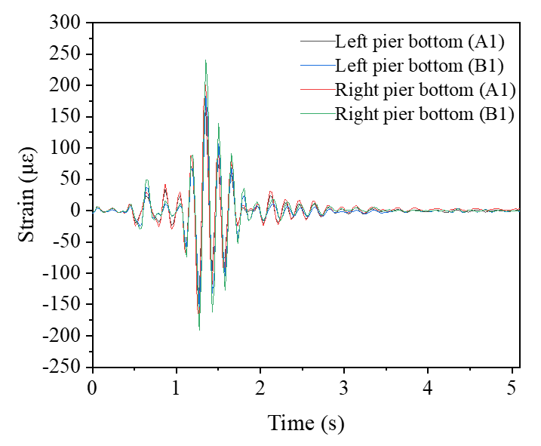

Fig. C1 Response time history of strain at the bottom of the piers in load case A1 and B1.
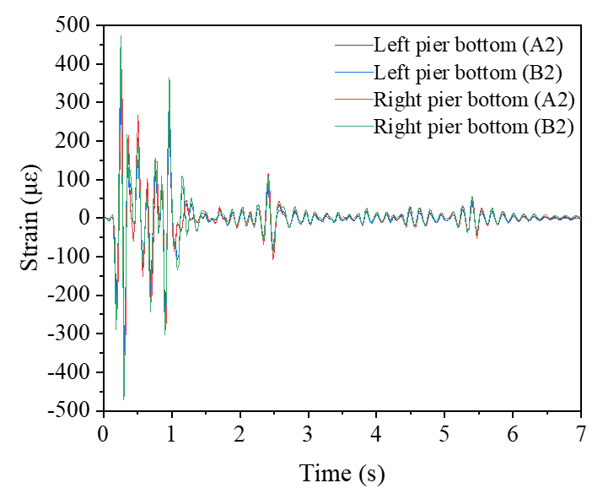

Fig. C2 Response time history of strain at the bottom of the piers in load case A2 and B2.
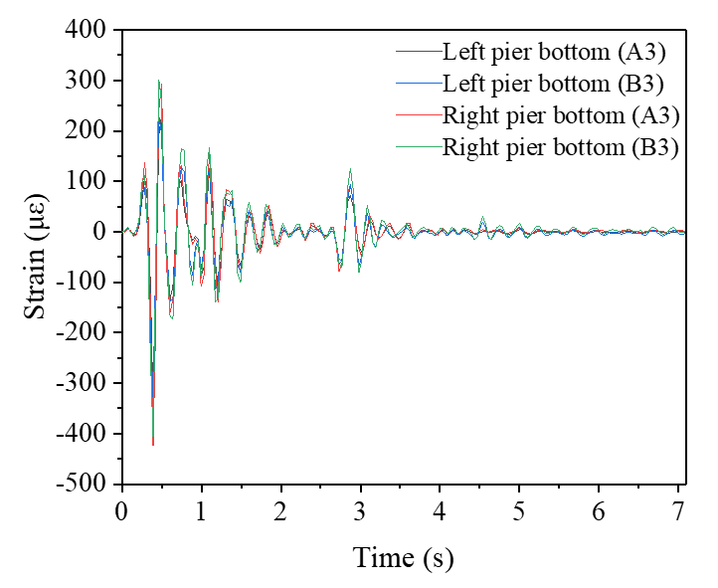

Fig. C3 Response time history of strain at the bottom of the piers in load case A3 and B3.
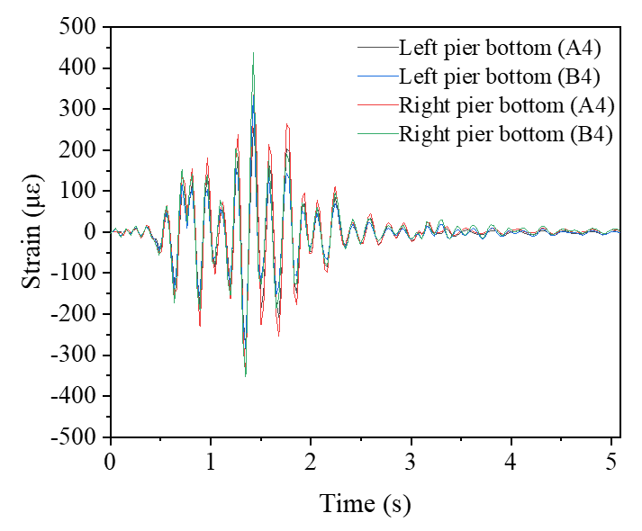

Fig. C4 Response time history of strain at the bottom of the piers in load case A4 and B4.
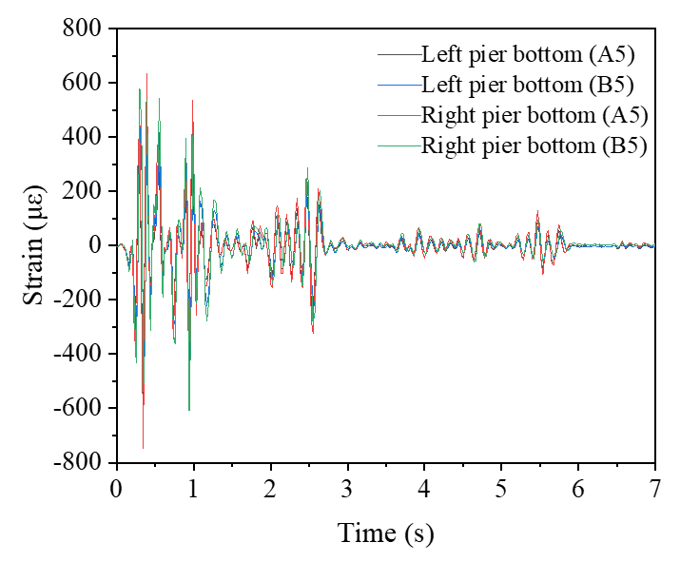

Fig. C5 Response time history of strain at the bottom of the piers in load case A5 and B5.
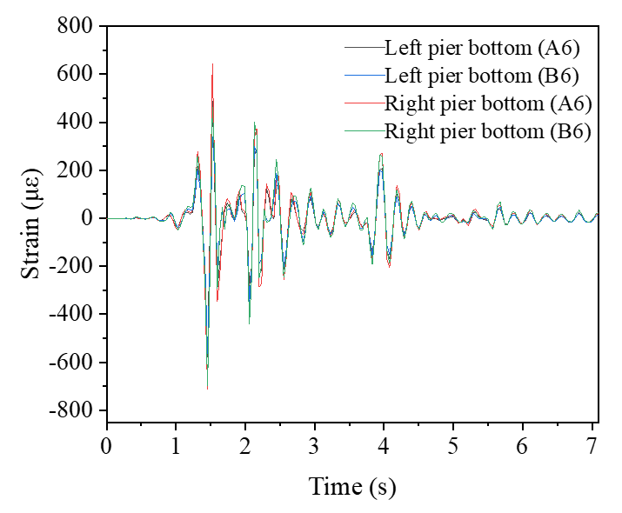

Fig. C6 Response time history of strain at the bottom of the piers in load case A6 and B6.
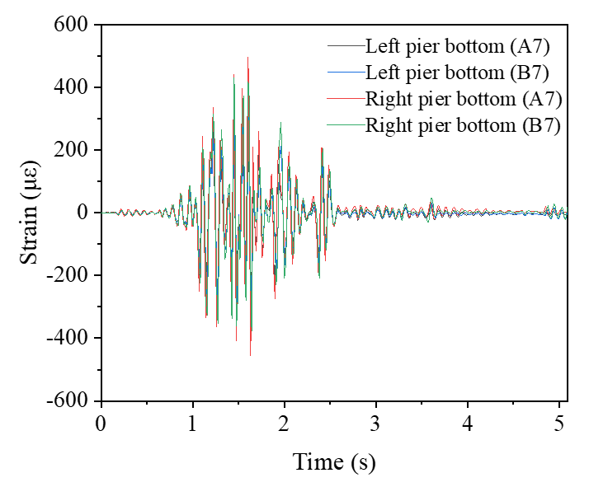

Fig. C7 Response time history of strain at the bottom of the piers in load case A7 and B7.
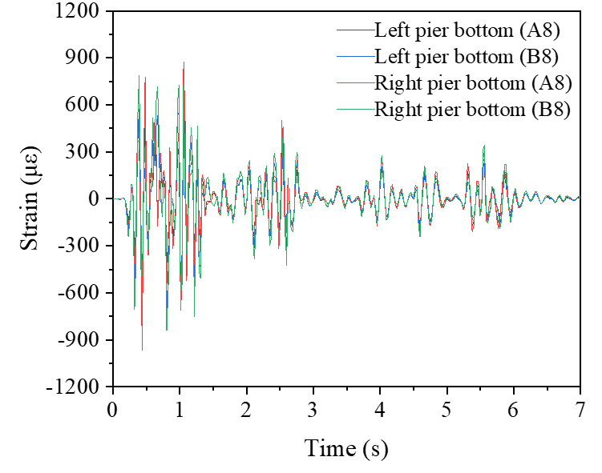

Fig. C8 Response time history of strain at the bottom of the piers in load case A8 and B8.
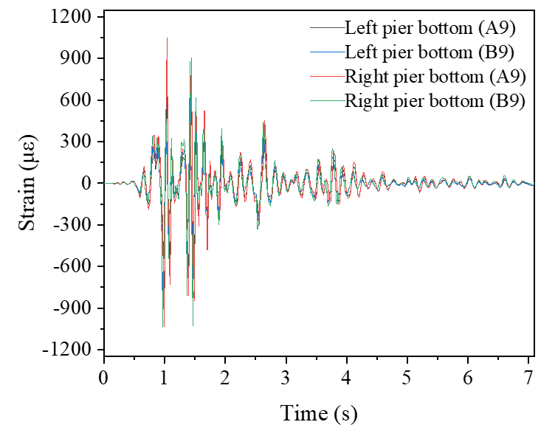

Fig. C9 Response time history of strain at the bottom of the piers in load case A9 and B9.
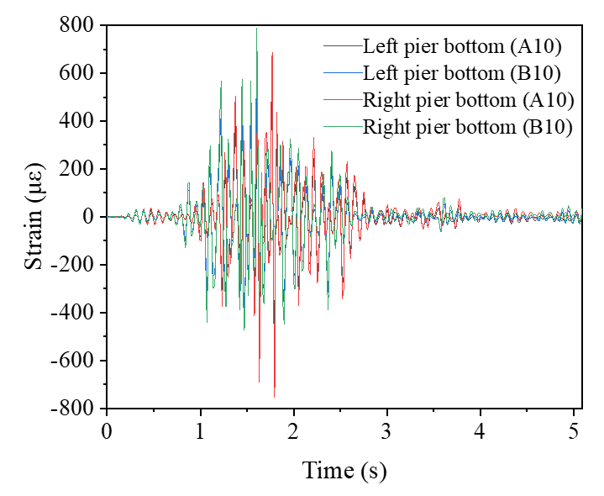

Fig. C10 Response time history of strain at the bottom of the piers in load case A10 and B10.
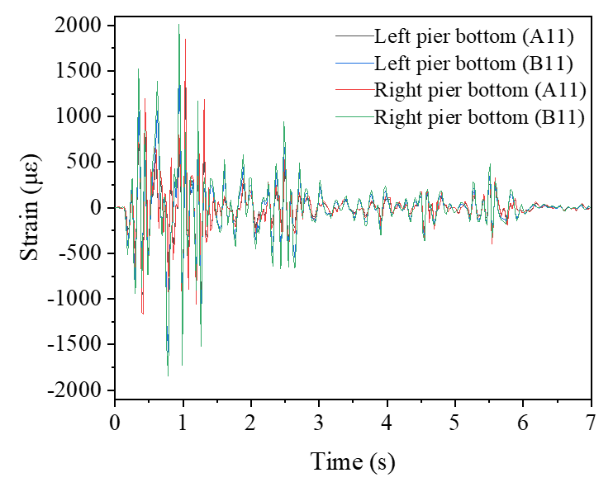

Fig. C11 Response time history of strain at the bottom of the piers in load case A11 and B11.
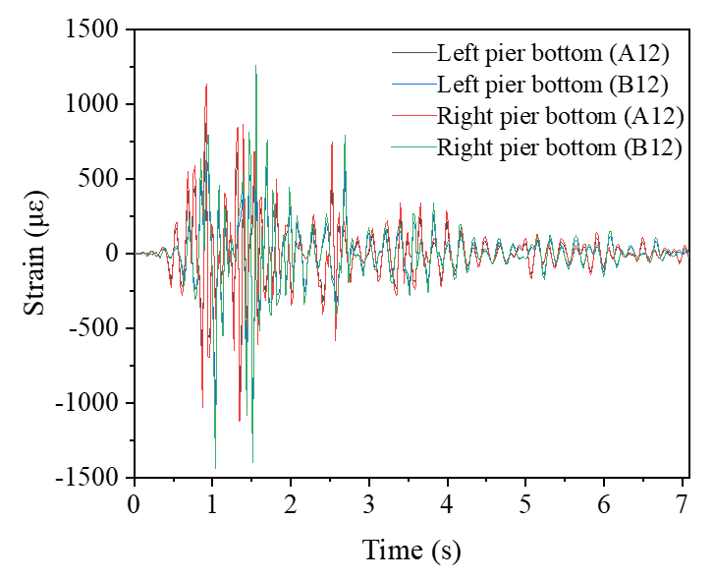

Fig. C12 Response time history of strain at the bottom of the piers in load case A12 and B12.
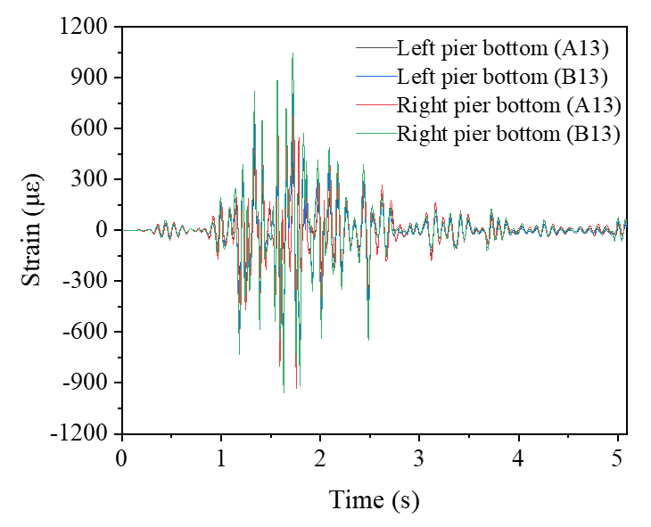

Fig. C13 Response time history of strain at the bottom of the piers in load case A13 and B13.
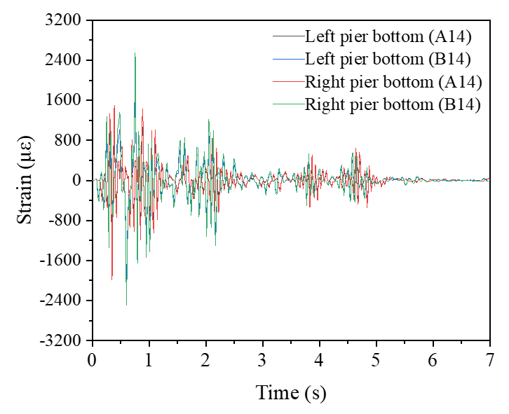

Fig. C14 Response time history of strain at the bottom of the piers in load case A14 and B14.
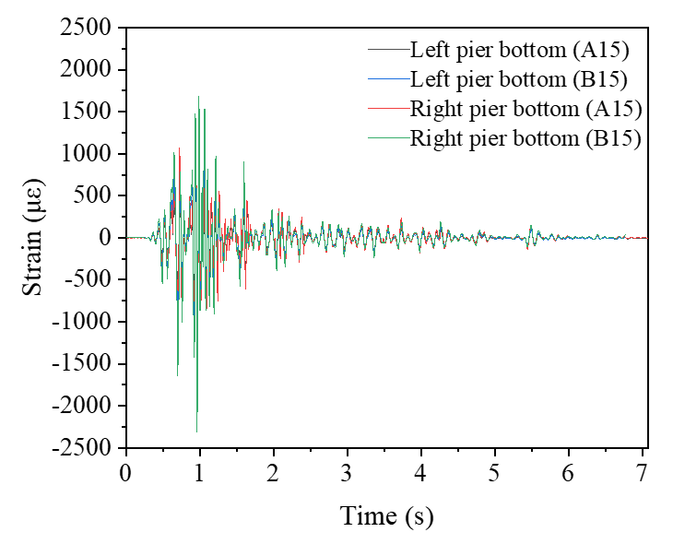

Fig. C15 Response time history of strain at the bottom of the piers in load case A15 and B15.

