Appendices for:
How to optimize large language model performance for human-centric post-occupancy evaluation of underground public space: From model selection to model tuning

Chen-Xiao MA, Fang-Le PENG*, Zi-Jian LI, Yong-Kang QIAO
Research Center for Underground Space & Department of Geotechnical Engineering, Tongji University, Shanghai 200092, China

*Corresponding author. E-mail: pengfangle@tongji.edu.cn

Appendix A Prompts for Task 1
Note (The prompts are written in standard Chinese, which are translated into English here):
Red: Contexts (V1)
Pink: Contexts (V2)
Blue: Questions
Purple: Definitions
Orange: Few-shots
Green: Constraints

A1 P1: Contexts (V1), Questions, Constraints
You are a helpful assistant.
Annotate the reviews by the following labels and then split the entire reviews into multiple segments according to your annotated labels:[Microclimate; Landscape; Lighting; Acoustics; Cleanliness; Spatial form and wayfinding; Connectivity; Accessibility; Spatial scale; Retail; Catering; Culture and entertainment; Commuting; Leisure; Sports and body care; Atmosphere perception; Signage; Restroom and nursing room; Rest seats; Wireless and wired network signals; Escalators, elevators and barrier-free facilities; Parking; Other public facilities; Safety; Operation; Marketing promotion; Commerce formats; Staff service].
If the review involves the labels mentioned above, output them, separated by semicolons for each label. If the review does not involve the labels mentioned above, annotate it as ‘Other’. Do not output any explanation.
The specific review is as follows: {comment}
Do not output any explanation.

A2 P2: Contexts (V2), Questions, Constraints
You are a professional expert in urban underground space planning, with a rich understanding of the planning of underground public space.
Annotate the reviews by the following labels and then split the entire reviews into multiple segments according to your annotated labels:[Microclimate; Landscape; Lighting; Acoustics; Cleanliness; Spatial form and wayfinding; Connectivity; Accessibility; Spatial scale; Retail; Catering; Culture and entertainment; Commuting; Leisure; Sports and body care; Atmosphere perception; Signage; Restroom and nursing room; Rest seats; Wireless and wired network signals; Escalators, elevators and barrier-free facilities; Parking; Other public facilities; Safety; Operation; Marketing promotion; Commerce formats; Staff service].
If the review involves the labels mentioned above, output them, separated by semicolons for each label. If the review does not involve the labels mentioned above, annotate it as ‘Other’. Do not output any explanation.
The specific review is as follows: {comment}
Do not output any explanation.

A3 P3: Contexts (V1), Questions, Definitions, Constraints
You are a helpful assistant.
Annotate the reviews by the following labels and their definitions, then split the entire reviews into multiple segments according to your annotated labels.
Detailed definitions as follows:
Microclimate: Ventilation conditions, air purification effectiveness, temperature and humidity control.
Landscape: Interior design style, natural landscape, landscape sketch, sculpture, decoration, art installations, condition of decoration (new or old).
Lighting: Luminosity, lighting design, natural light.
Acoustics: Noise, music, noisy, quiet.
Cleanliness: Cleanliness and hygiene of the environment.
Spatial form and wayfinding: Architecture design (e.g., sunken plaza, long corridor type, semi-open, open space), spatial layout, sense of direction, ease of getting lost.
Connectivity: Interconnectivity to metro stations, parking lots, underground passages or other underground space.
Accessibility: Location, transportation convenience, accessibility to or from metro stations, bus stops, parking garages, entrances and exits, entrance configuration.
Spatial scale: Floor height, passage width, passage length, space area.
Retail: Shopping activities, experience, variety of goods.
Catering: Types of cuisine, food quality, catering activities.
Culture and entertainment: Cosplay, exhibitions, movies, shows, music, amusement, AR or VR experiences, singing, dancing, claw machines, photo booths, script-based murder mysteries.
Commuting: Passing through, walking through, crossing due to weather, taking public transportation, heading to a destination.
Leisure: Resting, strolling, wandering, taking photos, chatting, gathering, dating, communicating, meeting up, participating in family activities, making new friends, participating in events, spectating, socializing, sharing photos, participating in flash mobs, walking dogs, petting dogs, walking children, exchanging goods, visiting markets.
Sports and body care: Fitness, boxing, yoga, physical exercise, aerobics, skateboarding, darts, beauty and hair care.
Atmosphere perception: Subjective feelings such as desolate, vibrant, prosperous, crowded, deserted, depressed, horrible.
Signage: Layout, direction recognition of public signs.
Restroom and nursing room: Layout, configuration and maintenance of facilities.
Rest seats: Layout, configuration, comfort and maintenance of seating.
Wireless and wired network signals: Coverage of mobile signal and Wi-Fi.
Escalators, elevators and barrier-free facilities: Availability, layout, configuration and maintenance of facilities.
Parking: Availability, convenience and cost of parking.
Other public facilities: Layout, configuration, maintenance and availability of other public facilities such as charging stations, children’s play areas, pet facilities.
Safety: Gate control, space security, epidemic prevention, security patrol, maintenance and configuration of warning systems (e.g., fire alarm).
Operation: Operation status, operating hours, leasing status, other management suggestions.
Marketing promotion: Providing e-marketing, group-buy, free parking, discount to attract more customers.
Commerce formats: Overall description of the business types in the underground space such as a pet-friendly mall, a high end shopping mall, a ‘one-stop eat, drink, and play’ center.
Staff service: Service attitude and service quality of security, cleaning and sales staffs.
If the review involves the labels mentioned above, output them, separated by semicolons for each label. If the review does not involve the labels mentioned above, annotate it as ‘Other’. Do not output any explanation.
The specific review is as follows: {comment}
Do not output any explanation.

A4 P4: Contexts (V1), Questions, Few-shots, Constraints
You are a helpful assistant.
Annotate the reviews by the following labels and their examples, then split the entire reviews into multiple segments according to your annotated labels.
Detailed examples as follows:
Microclimate: The air here is not stuffy, and breathing is very comfortable.
Landscape: Today’s theme is Disney princesses, which is very atmospheric.
Lighting: The lighting is very soft and not glaring.
Acoustics: There are a lot of people here chattering away, it's so noisy.
Cleanliness: There are many crumbs and trash in the corners of the mall.
Spatial form and wayfinding: The long passages inside are well connected, making it easy to lose direction.
Connectivity: The metro station is directly connected to the underground street.
Accessibility: It’s very convenient to come directly from Exit 5 of the metro.
Spatial scale: The corridors are wide and high, and there is no feeling of oppression at all.
Retail: I came to buy some clothes.
Catering: There are many delicious food options.
Culture and entertainment: I came alone to watch a movie because I was bored.
Commuting: I pass through here every day for work. It’s very convenient and I don’t have to worry about the weather.
Leisure: I made a special trip here today to take some photos.
Sports and body care: The gym has closed down again.
Atmosphere perception: There are not many people inside now, it feels very desolate.
Signage: You can see the signposts right after exiting.
Restroom and nursing room: The hygiene of the toilets is really hard to talk about.
Rest seats: It’s nice to have a place to sit when I’m tired from walking around.
Wireless and wired network signals: It’s basically impossible to watch videos.
Escalators, elevators and barrier-free facilities: Fortunately, there are elevators available.
Parking: You can park for free with a purchase of over 300 yuan.
Other public facilities: My phone was about to die, but fortunately, there are shared power banks available.
Safety: The security guards are very strict about checking the health code.
Operation: Many shops have changed.
Marketing promotion: There are often promotional activities during holidays, and you can park for free.
Commerce formats: This is truly the best pet-friendly mall in Shanghai.
Staff service: The staff are very enthusiastic and will patiently help solve any problems.
If the review involves the labels mentioned above, output them, separated by semicolons for each label. If the review does not involve the labels mentioned above, annotate it as ‘Other’. Do not output any explanation.
The specific review is as follows: {comment}
Do not output any explanation.

A5 P5: Contexts (V1), Questions, Definitions, Few-shots, Constraints
You are a helpful assistant.
Annotate the reviews by the following labels and their definitions & examples, then split the entire reviews into multiple segments according to your annotated labels.
Detailed definitions and examples as follows:
Microclimate: Ventilation conditions, air purification effectiveness, temperature and humidity control. (Example: The air here is not stuffy, and breathing is very comfortable.)
Landscape: Interior design style, natural landscape, landscape sketch, sculpture, decoration, art installations, condition of decoration (new or old). (Example: Today’s theme is Disney princesses, which is very atmospheric.)
Lighting: Luminosity, lighting design, natural light. (Example: The lighting is very soft and not glaring.)
Acoustics: Noise, music, noisy, quiet. (Example: There are a lot of people here chattering away, it's so noisy.)
Cleanliness: Cleanliness and hygiene of the environment. (Example: There are many crumbs and trash in the corners of the mall.)
Spatial form and wayfinding: Architecture design (e.g., sunken plaza, long corridor type, semi-open, open space), spatial layout, sense of direction, ease of getting lost. (Example: The long passages inside are well connected, making it easy to lose direction.)
Connectivity: Interconnectivity to metro stations, parking lots, underground passages or other underground space. (Example: The metro station is directly connected to the underground street.)
Accessibility: Location, transportation convenience, accessibility to or from metro stations, bus stops, parking garages, entrances and exits, entrance configuration. (Example: It’s very convenient to come directly from Exit 5 of the metro.)
Spatial scale: Floor height, passage width, passage length, space area. (Example: The corridors are wide and high, and there is no feeling of oppression at all.)
Retail: Shopping activities, experience, variety of goods. (Example: I came to buy some clothes.)
Catering: Types of cuisine, food quality, catering activities. (Example: There are many delicious food options.)
Culture and entertainment: Cosplay, exhibitions, movies, shows, music, amusement, AR or VR experiences, singing, dancing, claw machines, photo booths, script-based murder mysteries. (Example: I came alone to watch a movie because I was bored.)
Commuting: Passing through, walking through, crossing due to weather, taking public transportation, heading to a destination. (Example: I pass through here every day for work. It’s very convenient and I don’t have to worry about the weather.)
Leisure: Resting, strolling, wandering, taking photos, chatting, gathering, dating, communicating, meeting up, participating in family activities, making new friends, participating in events, spectating, socializing, sharing photos, participating in flash mobs, walking dogs, petting dogs, walking children, exchanging goods, visiting markets. (Example: I made a special trip here today to take some photos.)
Sports and body care: Fitness, boxing, yoga, physical exercise, aerobics, skateboarding, darts, beauty and hair care. (Example: The gym has closed down again.)
Atmosphere perception: Subjective feelings such as desolate, vibrant, prosperous, crowded, deserted, depressed, horrible. (Example: There are not many people inside now, it feels very desolate.)
Signage: Layout, direction recognition of public signs. (Example: You can see the signposts right after exiting.)
Restroom and nursing room: Layout, configuration and maintenance of facilities. (Example: The hygiene of the toilets is really hard to talk about.)
Rest seats: Layout, configuration, comfort and maintenance of seating. (Example: It’s nice to have a place to sit when I’m tired from walking around.)
Wireless and wired network signals: Coverage of mobile signal and Wi-Fi. (Example: It’s basically impossible to watch videos.)
Escalators, elevators and barrier-free facilities: Availability, layout, configuration and maintenance of facilities. (Example: Fortunately, there are elevators available.)
Parking: Availability, convenience and cost of parking. (Example: You can park for free with a purchase of over 300 yuan.)
Other public facilities: Layout, configuration, maintenance and availability of other public facilities such as charging stations, children’s play areas, pet facilities. (Example: My phone was about to die, but fortunately, there are shared power banks available.)
Safety: Gate control, space security, epidemic prevention, security patrol, maintenance and configuration of warning systems (e.g., fire alarm). (Example: The security guards are very strict about checking the health code.)
Operation: Operation status, operating hours, leasing status, other management suggestions. (Example: Many shops have changed.)
Marketing promotion: Providing e-marketing, group-buy, free parking, discount to attract more customers. (Example: There are often promotional activities during holidays, and you can park for free.)
Commerce formats: Overall description of the business types in the underground space such as a pet-friendly mall, a high end shopping mall, a ‘one-stop eat, drink, and play’ center. (Example: This is truly the best pet-friendly mall in Shanghai.)
Staff service: Service attitude and service quality of security, cleaning and sales staffs. (Example: The staff are very enthusiastic and will patiently help solve any problems.)
If the review involves the labels mentioned above, output them, separated by semicolons for each label. If the review does not involve the labels mentioned above, annotate it as ‘Other’. Do not output any explanation.
The specific review is as follows: {comment}
Do not output any explanation.

Appendix B Prompts for Task 2
Note (The prompts are written in standard Chinese, which are translated into English here):
Red: Contexts (V1)
Blue: Questions
Purple: Definitions
Orange: Few-shots
Green: Constraints

B1 P1: Contexts (V1), Questions, Constraints
You are a helpful assistant.
Conduct sentiment analysis and return strictly one of ‘positive’, ‘negative’ or ‘neutral’.
Do not output any explanation.

B2 P3: Contexts (V1), Questions, Definitions, Constraints
You are a helpful assistant.
Conduct sentiment analysis based on the following definitions and return strictly one of ‘positive’, ‘negative’ or ‘neutral’.
Detailed definitions as follows:
Positive: Expressing a positive, favorable, optimistic or anticipatory attitude, or having a predominantly positive sentiment overall.
Neutral: Containing both positive and negative attitudes to an equal degree, or having no clear emotional inclination.
Negative: Expressing a negative, pessimistic or adverse attitude, or having a predominantly negative sentiment overall.
Do not output any explanation.

B3 P4: Contexts (V1), Questions, Few-shots, Constraints
You are a helpful assistant.
Conduct sentiment analysis based on the following examples and return strictly one of ‘positive’, ‘negative’ or ‘neutral’.
Detailed examples as follows:
The air is very good (Positive)
Go straight and turn right to get there (Neutral)
The attitude is really bad (Negative)
Do not output any explanation.

B4 P5: Contexts (V1), Questions, Definitions, Few-shots, Constraints
You are a helpful assistant.
Conduct sentiment analysis based on the following definitions and examples and return strictly one of ‘positive’, ‘negative’ or ‘neutral’.
Detailed definitions and examples as follows:
Positive: Expressing a positive, favorable, optimistic or anticipatory attitude, or having a predominantly positive sentiment overall (Example: The air is very good)
Neutral: Containing both positive and negative attitudes to an equal degree, or having no clear emotional inclination. (Example: Go straight and turn right to get there)
Negative: Expressing a negative, pessimistic or adverse attitude, or having a predominantly negative sentiment overall. (Example: The attitude is really bad)
Do not output any explanation.

Appendix C Supplemented tables

Table C1 Basic information of collected reviews
No. | City | UPS | Type¹⁾ | Review number | Review time | Average length | Gender (%)²⁾ |  |  | Belonging place (%)³⁾
 |  |  |  |  |  |  | M | F | UK | L | NL | UK
B1 | Beijing | KALCITY | M | 790 | 2020-2024 | 116 | 18.2% | 58.2% | 23.5% | 82.7% | 5.6% | 11.8%
B2 | Beijing | Xin'ao Shopping Center | M | 5955 | 2010-2024 | 98 | 19.2% | 62.9% | 18.0% | 78.2% | 12.7% | 9.1%
B3 | Beijing | Tianyuan Plaza | M | 147 | 2021-2024 | 134 | 16.3% | 77.6% | 6.1% | 91.8% | 3.4% | 4.8%
B4 | Beijing | Xidan The New | M | 4366 | 2010-2024 | 125 | 15.8% | 69.5% | 14.7% | 83.2% | 8.6% | 8.1%
B5 | Beijing | Haidianwuluju Underground Street | S | 30 | 2019-2024 | 105 | 23.3% | 60.0% | 16.7% | 83.3% | 13.3% | 3.3%
B6 | Beijing | Digua Community | P | 76 | 2016-2023 | 128 | 18.4% | 61.8% | 19.7% | 72.4% | 18.4% | 9.2%
S1 | Shanghai | D-Mall | M | 3943 | 2006-2024 | 110 | 12.0% | 79.8% | 8.2% | 91.4% | 5.7% | 2.9%
S2 | Shanghai | Shanghai South Railway Station Outlets | M | 2103 | 2011-2024 | 97 | 16.2% | 64.2% | 19.6% | 82.3% | 8.0% | 9.7%
S3 | Shanghai | Mix Club | M | 8783 | 2022-2024 | 114 | 16.5% | 67.0% | 16.5% | 84.7% | 5.3% | 10.0%
S4 | Shanghai | Tower Shadow Space | P | 1863 | 2023-2024 | 127 | 11.2% | 75.7% | 13.2% | 86.8% | 5.2% | 8.0%
S5 | Shanghai | Pacific Fresh City Underground Street | S | 3189 | 2017-2024 | 109 | 17.3% | 69.2% | 13.5% | 87.3% | 5.0% | 7.7%
S6 | Shanghai | Hong Kong Underground Street | S | 1290 | 2006-2024 | 103 | 12.8% | 82.2% | 5.0% | 94.9% | 4.7% | 0.4%
S7 | Shanghai | Re Mention Underground Street | S | 883 | 2008-2024 | 107 | 13.6% | 81.0% | 5.4% | 92.0% | 6.6% | 1.5%
S8 | Shanghai | My Block Underground Street | S | 469 | 2013-2024 | 104 | 13.4% | 69.9% | 16.6% | 87.2% | 5.3% | 7.5%
S9 | Shanghai | Huasheng Underground Street | S | 517 | 2008-2024 | 107 | 13.9% | 80.5% | 5.6% | 92.1% | 5.0% | 2.9%
S10 | Shanghai | Xujiahui Underground Street | S | 97 | 2017-2024 | 131 | 29.9% | 63.9% | 6.2% | 83.5% | 14.4% | 2.1%
G1 | Guangzhou | Yuehai Animation Star City | M | 1826 | 2007-2024 | 106 | 19.2% | 62.7% | 18.1% | 63.7% | 28.3% | 8.1%
G2 | Guangzhou | PO PARK | M | 4484 | 2009-2024 | 115 | 16.6% | 67.0% | 16.5% | 72.0% | 19.6% | 8.4%
G3 | Guangzhou | Mall of the World | M | 3023 | 2012-2024 | 112 | 22.5% | 65.2% | 12.2% | 69.4% | 24.2% | 6.3%
G4 | Guangzhou | Fashion Tianhe | M | 6029 | 2012-2024 | 123 | 16.8% | 66.8% | 16.4% | 67.7% | 24.5% | 7.8%
G5 | Guangzhou | Fangcun Underground Street | S | 341 | 2010-2024 | 114 | 22.3% | 67.7% | 10.0% | 85.3% | 9.1% | 5.6%
G6 | Guangzhou | JNSUNDAY Underground Street | S | 922 | 2009-2024 | 109 | 17.1% | 72.9% | 10.0% | 83.8% | 11.1% | 5.1%
G7 | Guangzhou | Tiyuxilu Underground Street | S | 95 | 2011-2023 | 116 | 25.3% | 62.1% | 12.6% | 78.9% | 13.7% | 7.4%
G8 | Guangzhou | Dynasty Plaza | M | 1458 | 2006-2024 | 107 | 17.1% | 72.9% | 10.0% | 84.8% | 11.7% | 3.5%
G9 | Guangzhou | Future City | M | 1070 | 2006-2024 | 73 | 10.3% | 44.2% | 45.5% | 49.7% | 8.2% | 42.1%
Z1 | Shenzhen | X-Space Underground Street | S | 60 | 2022-2024 | 106 | 21.7% | 40.0% | 38.3% | 58.3% | 6.7% | 35.0%
Z2 | Shenzhen | Fengshengting Underground Street | S | 734 | 2011-2024 | 115 | 24.4% | 61.6% | 14.0% | 74.1% | 18.5% | 7.4%
Z3 | Shenzhen | Futian Linkcity Underground Street | S | 1546 | 2012-2024 | 116 | 26.3% | 65.4% | 8.3% | 78.7% | 16.9% | 4.4%
Z4 | Shenzhen | City Hub Underground Street | S | 581 | 2022-2024 | 97 | 23.6% | 44.8% | 31.7% | 52.3% | 28.7% | 18.9%
Z5 | Shenzhen | Huaqiang North Underground Street | S | 488 | 2012-2024 | 112 | 25.2% | 60.5% | 14.3% | 77.5% | 15.0% | 7.6%
Z6 | Shenzhen | Shangmeilin Linkcity Underground Street | S | 99 | 2019-2024 | 112 | 21.2% | 59.6% | 19.2% | 74.7% | 11.1% | 14.1%
Z7 | Shenzhen | Huangbeiling Underground Street | S | 74 | 2018-2024 | 119 | 27.0% | 64.9% | 8.1% | 79.7% | 16.2% | 4.1%
Z8 | Shenzhen | CITIC Metro Square | S | 60 | 2009-2024 | 126 | 31.7% | 60.0% | 8.3% | 86.7% | 10.0% | 3.3%
Z9 | Shenzhen | Lemon Street Plaza | M | 38 | 2018-2024 | 113 | 26.3% | 57.9% | 15.8% | 57.9% | 28.9% | 13.2%
Notes: 1) S: Underground street, M: Underground mall, P: Underground service space; 2) M: Male, F: Female, UK: Unknown; 3) L: Local, NL: Non-local, UK: Unknown.

Table C2 User perception factors of UPS
Aspect | Factor | Definition | Ref.
Environment (A1) | microclimate (A11) | ventilation conditions, air purification effectiveness, temperature and humidity control | [1–4]
Environment (A1) | landscape (A12) | Interior design style, natural landscape, landscape sketch, sculpture, decoration, art installations, condition of decoration (new or old) | [1,2,5–8]
Environment (A1) | lighting (A13) | luminosity, lighting design, natural light | [2,3,6,7,9]
Environment (A1) | acoustics (A14) | noise, music, noisy, quiet | [2,3,6,10]
Environment (A1) | cleanliness (A15) | cleanliness and hygiene of the environment | [6,11]
Design  (A2) | spatial form and wayfinding (A21) | architecture design (e.g., sunken plaza, long corridor type, semi-open, open space), spatial layout, sense of direction, ease of getting lost | [2,7,10,12]
Design  (A2) | connectivity (A22) | interconnectivity to metro stations, parking lots, underground passages or other underground space | [2,3,4,6,9]
Design  (A2) | accessibility (A23) | location, transportation convenience, accessibility to or from metro stations, bus stops, parking garages, entrances and exits, entrance configuration | [2,3,9,13]
Design  (A2) | spatial scale (A24) | floor height, passage width, passage length, space area | [1,2,4,5,11,12]
Function  (A3) | retail (A31) | shopping activities, experience, variety of goods | [2,3,6]
Function  (A3) | catering (A32) | types of cuisine, food quality, catering activities | [2,3,6]
Function  (A3) | culture and entertainment (A33) | cosplay, exhibitions, movies, shows, music, amusement, AR or VR experiences, singing, dancing, claw machines, photo booths, script-based murder mysteries | [2,3,6]
Function  (A3) | commuting (A34) | passing through, walking through, crossing due to weather, taking public transportation, heading to a destination | [2,3,6]
Function  (A3) | leisure (A35) | resting, strolling, wandering, taking photos, chatting, gathering, dating, communicating, meeting up, participating in family activities, making new friends, participating in events, spectating, socializing, sharing photos, participating in flash mobs, walking dogs, petting dogs, walking children, exchanging goods, visiting markets | [2,3,6]
Function  (A3) | sports and body care (A36) | fitness, boxing, yoga, physical exercise, aerobics, skateboarding, darts, beauty and hair care | [2,3,6]
Atmosphere (A4) | atmosphere perceptions (A41) | subjective feelings such as desolate, vibrant, prosperous, crowded, deserted, depressed, horrible | [3,10,11]
Facility (A5) | signage (A51) | layout, direction recognition of public signs | [1,7,12]
Facility (A5) | restroom and nursing room (A52) | layout, configuration and maintenance of facilities | [1,3]
Facility (A5) | rest seats (A53) | layout, configuration, comfort and maintenance of seating | [6,12]
Facility (A5) | wireless and wired network signals (A54) | coverage of mobile signal and Wi-Fi | [3,6,14]
Facility (A5) | escalators, elevators and barrier-free facilities (A55) | availability, layout, configuration and maintenance of facilities | [6,10,12]
Facility (A5) | parking (A56) | availability, convenience and cost of parking | [2]
Facility (A5) | other public facilities (A57) | layout, configuration, maintenance and availability of other public facilities such as charging stations, children’s play areas, pet facilities | [12]
Management  (A6) | safety (A61) | gate control, space security, epidemic prevention, security patrol, maintenance and configuration of warning systems (e.g., fire alarm) | [3]
Management  (A6) | operation (A62) | operation status, operating hours, leasing status, other management suggestions | [12]
Management  (A6) | marketing promotion (A63) | providing e-marketing, group-buy, free parking, discount to attract more customers | [2]
Management  (A6) | commerce formats (A64) | overall description of the business types in the underground space such as a pet-friendly mall, a high end shopping mall, a ‘one-stop eat, drink, and play’ center | [2,3]
Management  (A6) | staff service (A65) | service attitude and service quality of security, cleaning and sales staffs | [2]

References
- Fan L, Cui X. Analysis of the factors influencing the comfort of different behaviors in underground commercial space: A case study of track connection to underground space. Iranian Journal of Science and Technology, Transactions of Civil Engineering, 2023, 47(4): 2485–2495
- Ma J X, Shen Z W, Liang P P, Pan L Y. Spatial element perception measurement and optimization of urban underground complex based on Kano model: A case study of Chengdu SKP. New Architecture, 2024, (5): 80–86 (in Chinese)
- WangX, Shen L Z, Shi S Y. Evaluation of underground space perception: A user-perspective investigation. Tunnelling and Underground Space Technology, 2023, 131: 104822
- Zacharias J, Wang B. Willingness to walk in underground space-evidence from Singapore. IOP Conference Series: Earth and Environmental Science, 2021, 703(1): 012002
- Liu M, Zhang K, Zhu J H, Hao Z W. Post-occupancy evaluation of underground urban link space based on semantic differential method: A case study of Shanghai Wujiaochang. New Architecture, 2019, (6): 15–20 (in Chinese)
- Zhang Y B, Xie Z Q, Zhao X Q, Pu J W, Wang Y N, Xiong B. UPUCS: Spatial evaluation of user-perceived comfort in underground commercial space. Tunnelling and Underground Space Technology, 2025, 155: 106169
- Zhao X X, Guo D J, Chen Y L, Wu Y H, Zhu X P, Du C H, Chen Z L. Sustainable comfort design in underground shopping malls: A user-centric analysis of spatial features. Sustainability, 2025, 17(6): 2717
- Zhou B, Gui Y B, Xie X Y, Li W S, Li Q. A multi-category intelligent method for the evaluation of visual comfort in underground space. Tunnelling and Underground Space Technology, 2022, 124: 104488
- Soh C K, Christopoulos G, Robert A, Lee E H. Human-centered development of underground work spaces. Procedia Engineering, 2016, 165: 242–250
- Jasińska K, Kłosek-Kozłowska D. Passengers’ experience in underground non-transfer metro stations: The impact of spatial characteristics. Tunnelling and Underground Space Technology, 2024, 143: 105482
- Zeng R S, Shen Z W, Luo J. Post-occupancy evaluation of user satisfaction: Case studies of 10 urban underground complexes in China. Tunnelling and Underground Space Technology, 2024, 143: 105500
- Swamidurai S. Evaluation of people’s willingness to use underground space using structural equation modeling–case of Phoenix market city mall in Chennai city, India. Tunnelling and Underground Space Technology, 2019, 91: 103012
- Chan I Y S, Dong Z, Chen H. Impacts of connections to the outside on underground space occupants’ psychophysiological health: A virtual reality-based experimental approach. Tunnelling and Underground Space Technology, 2024, 147: 105675
14. Cui J Q, Allan A, Lin D. SWOT analysis and development strategies for underground pedestrian systems. Tunnelling and Underground Space Technology, 2019, 87: 127–133

Table C3 Basic information of LLMs
Model | Type¹⁾ | Company | Model size²⁾ | Issued time | Invocation method³⁾ | Price (CNY/ 1 million tokens) |  | Default parameters⁴⁾ |  | Parameter adjustment | Testing task⁵⁾
 |  |  |  |  |  |  |  |  |  |  | Task 1 | Task 2
 |  |  |  |  |  | Input | Output | Temperature | Top-p | Parameter adjustment | Task 1 | Task 2
Deepseek-r1 | R,O | Deepseek  (China) | 671 B | 2025.1 | API | 4.0 | 16.0 | 1.0 | 1.0 | No | MS/PT | MS/PT
Deepseek-v3 | G,O | Deepseek  (China) | 671 B | 2024.12 | API | 2.0 | 8.0 | 0.6 | 0.7 | Yes | MS/PS/PT | MS/PT
Ernie-x1-turbo-32k | R,C | Baidu AI Cloud  (China) | UC | 2025.4 | API | 1.0 | 4.0 | UC | UC | No | MS/PT | MS/PT
Ernie-4.5-turbo-128k | G,C | Baidu AI Cloud  (China) | UC | 2025.4 | API | 0.8 | 3.2 | 0.8 | 1.0 | Yes | MS/PS/PT | MS/PT
Qwq-plus | R,C | Alibaba Cloud  (China) | UC | 2025.3 | API | 1.6 | 4.0 | 0.7 | 0.8 | Yes | MS/PS/PT | MS/PT
Qwen-plus | G,C | Alibaba Cloud  (China) | UC | 2024.5 | API | 0.8 | 2.0 | 0.7 | 0.8 | Yes | MS/PS/PT | MS/PT
Qwen2.5-0.5b | G,O | Alibaba Cloud  (China) | 0.5 B | 2024.9 | LD | 0 | 0 | [0,2) | (0,1] | Yes | – | MS/PT/FT
Qwen2.5-1.5b | G,O | Alibaba Cloud  (China) | 1.5 B | 2024.9 | LD | 0 | 0 | [0,2) | (0,1] | Yes | – | MS/PT/FT
Qwen2.5-3b | G,O | Alibaba Cloud  (China) | 3 B | 2024.9 | LD | 0 | 0 | [0,2) | (0,1] | Yes | – | MS/PT/FT
Qwen2.5-7b | G,O | Alibaba Cloud  (China) | 7 B | 2024.9 | LD | 0 | 0 | [0,2) | (0,1] | Yes | – | MS/PT/FT
Qwen2.5-14b | G,O | Alibaba Cloud  (China) | 14 B | 2024.9 | LD | 0 | 0 | [0,2) | (0,1] | Yes | – | MS/PT/FT
Qwen2.5-32b | G,O | Alibaba Cloud  (China) | 32 B | 2024.9 | LD | 0 | 0 | [0,2) | (0,1] | Yes | – | MS/PT/FT
o4-mini | R,C | OpenAI  (USA) | UC | 2025.4 | API | 7.87 | 31.48 | 1.0 | UD | No | MS/PT | MS/PT
Gemini-2.5-flash | R,C | Google  (USA) | UC | 2025.4 | API | 2.15 | 17.89 | 1.0 | 0.5 | No | MS/PT | MS/PT
Notes: 1) G: General purpose models, R: Reasoning-focused models, O: Open source models, C: Closed source models; 2) B: Billion, UC: Undisclosed; 3) API: Application programming interface, LD: Local deployment; 4) UC: Undisclosed; 5) MS: Model selection, PS: Parameter setting, PT: Prompt tuning, FT: Fine-tuning.

Appendix D Supplemented figures
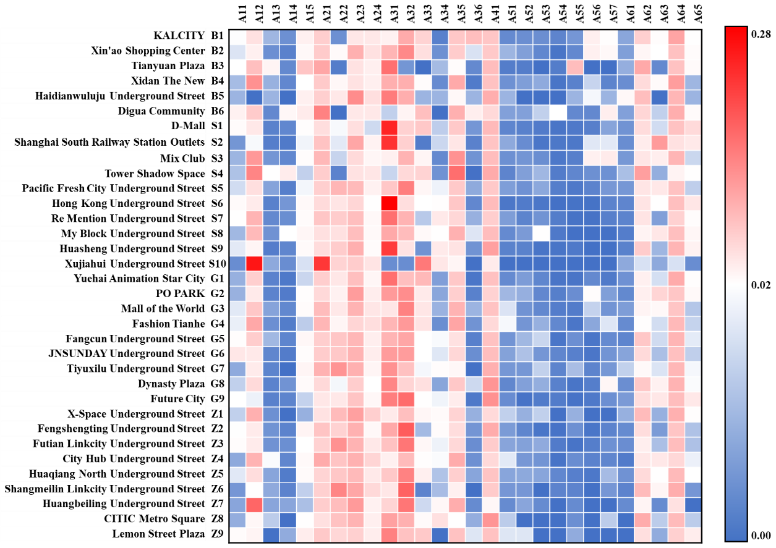

Fig. D1 Relative frequencies of perception factors for each UPS.
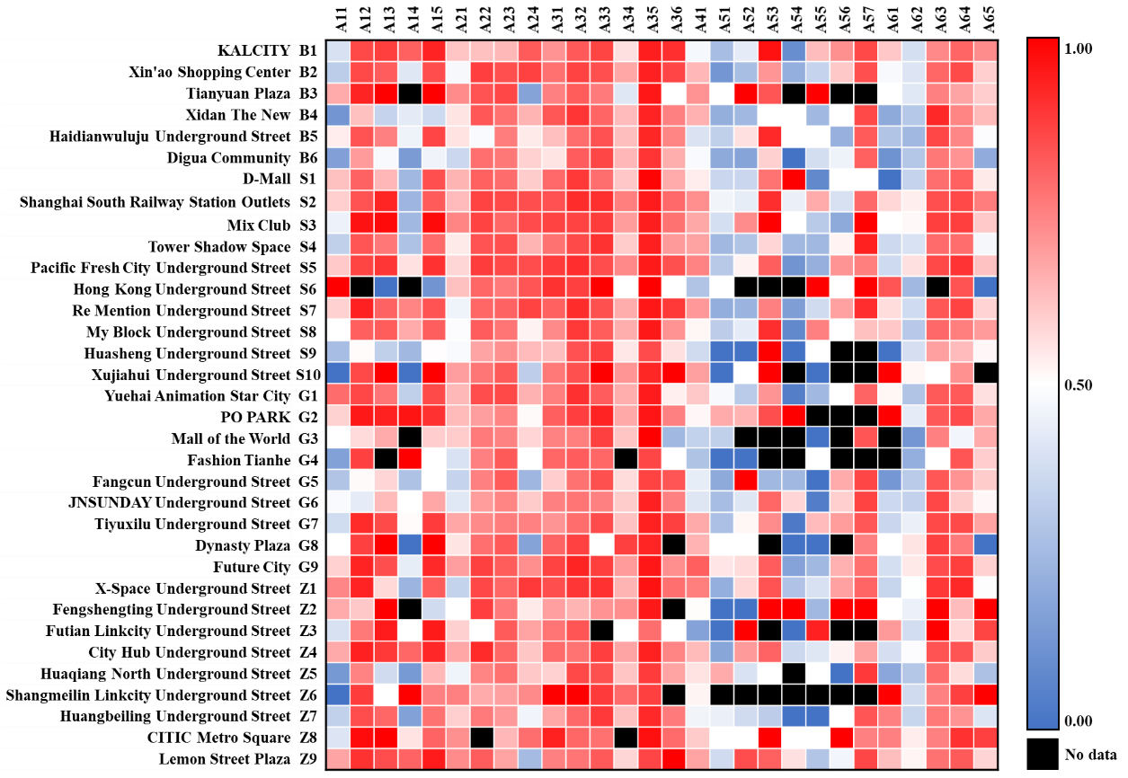

Fig. D2 Sentimental scores of perception factors for each UPS.
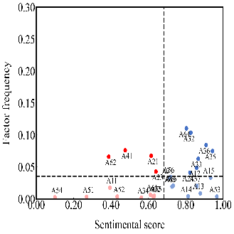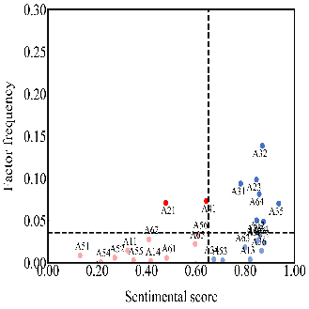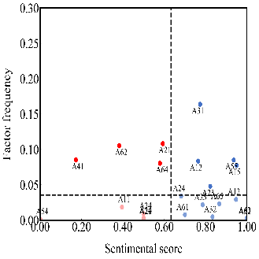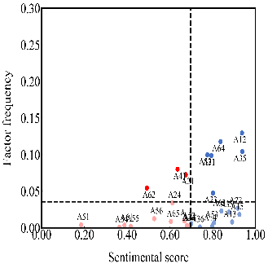
(a) (b) (c) (d)
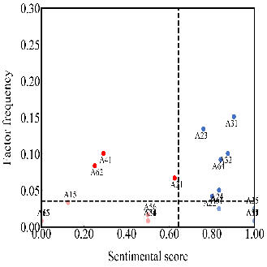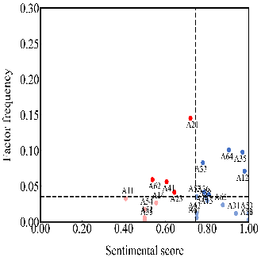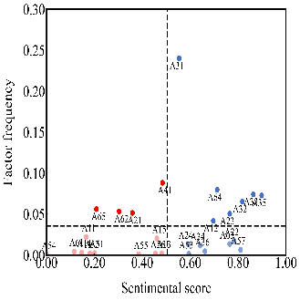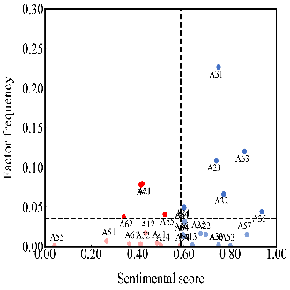
(e) (f) (g) (h)
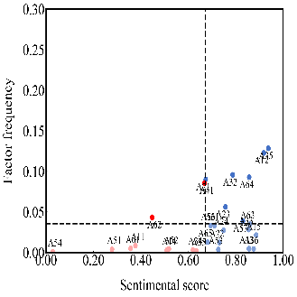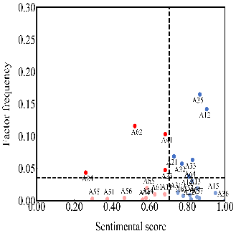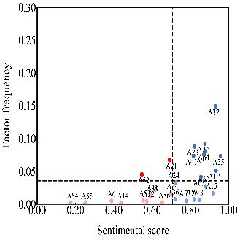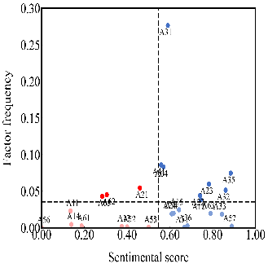
(i) (j) (k) (l)
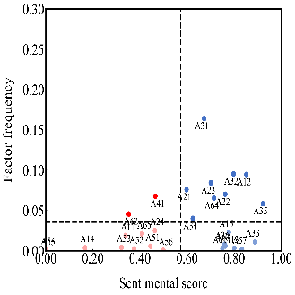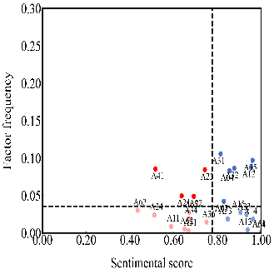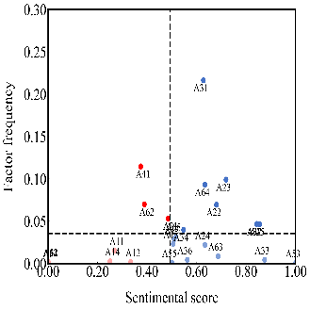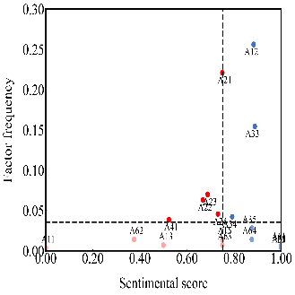
(m) (n) (o) (p)
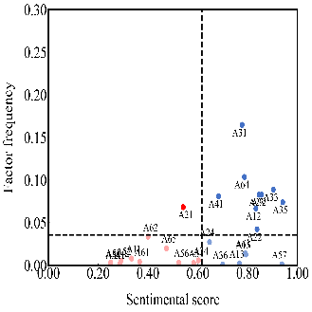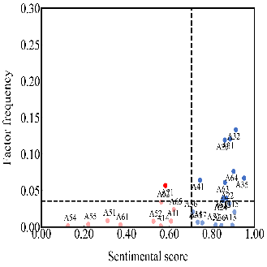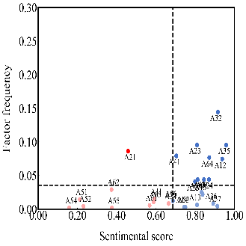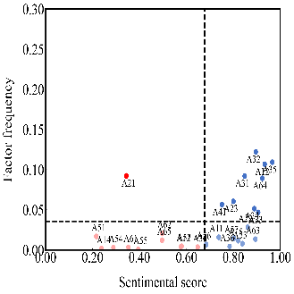
(q) (r) (s) (t)
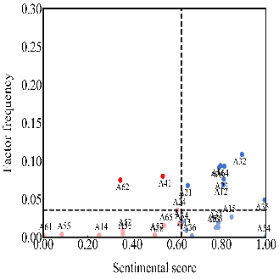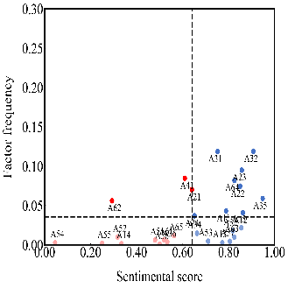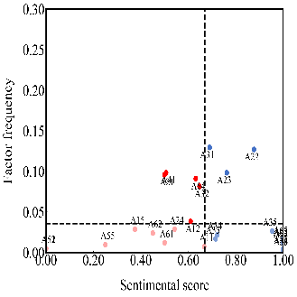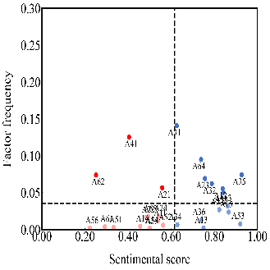
(u) (v) (w) (x)
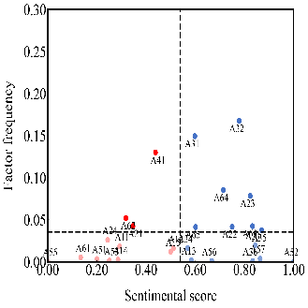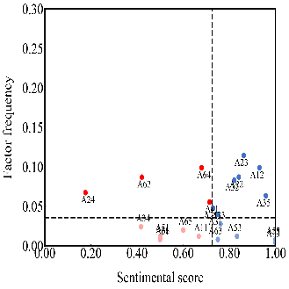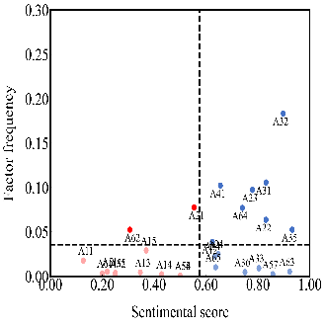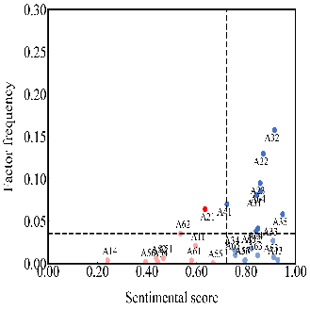
(y) (z) (aa) (ab)
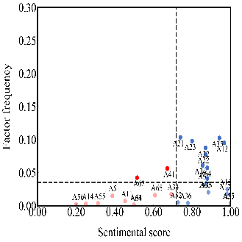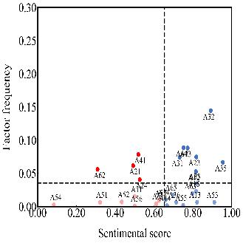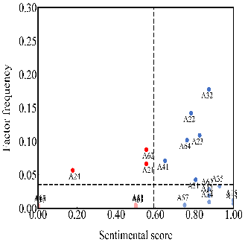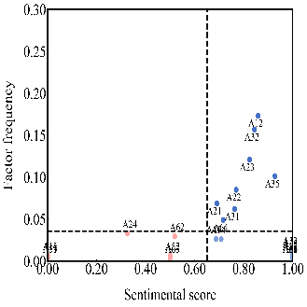
(ac) (ad) (ae) (af)
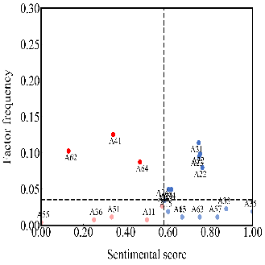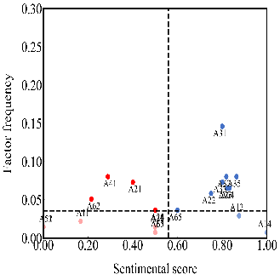
(ag) (ah)

Fig. D3 IPA results for each UPS: (a) KALCITY; (b) Xin’ao Shopping Center; (c) Tianyuan Plaza; (d) Xidan The New; (e) Haidianwuluju Underground Street; (f) Digua Community; (g) D-Mall; (h) Shanghai South Railway Station Outlets; (i) Mix Club; (j) Tower Shadow Space; (k) Pacific Fresh City Underground Street; (l) Hong Kong Underground Street; (m) Re Mention Underground Street; (n) My Block Underground Street; (o) Huasheng Underground Street; (p) Xujiahui Underground Street; (q) Yuehai Animation Star City; (r) PO PARK; (s) Mall of the World; (t) Fashion Tianhe; (u) Fangcun Underground Street; (v) JNSUNDAY Underground Street; (w) Tiyuxilu Underground Street; (x) Dynasty Plaza; (y) Future City; (z) X-Space Underground Street; (aa) Fengshengting Underground Street; (ab) Futian Linkcity Underground Street; (ac) City Hub Underground Street; (ad) Huaqiang North Underground Street; (ae) Shangmeilin Linkcity Underground Street; (af) Huangbeiling Underground Street; (ag) CITIC Metro Square; (ah) Lemon Street Plaza.

