Appendices for:
Numerical simulation and shear strength research of reinforced concrete beam based on peridynamics

Zhongwen GONG, Ergang XIONG*, Shang WANG, Yao ZHANG, Yupeng XIE
School of Civil Engineering, Chang’an University, Xi’an 710061, China
*Corresponding author. Email: xerg@chd.edu.cn

Appendix A. Specimen size details

Table A1 Specimen size details
Specimen number | Section height (mm) | Section width (mm) | Effective height (mm) | Flange width (mm) | Flange height (mm) | Length (mm) | Shear span (mm) | Shear span ratio | Reinfor-cement ratio (%)
R-700-125-1 | 250 | 125 | 218 | – | – | 2100 | 700 | 3.21 | 1.13
T-700-250-1 | 250 | 125 | 218 | 250 | 70 | 2100 | 700 | 3.21 | 1.13
T-700-375-1 | 250 | 125 | 218 | 375 | 70 | 2100 | 700 | 3.21 | 1.13
T-700-500-1 | 250 | 125 | 218 | 500 | 70 | 2100 | 700 | 3.21 | 1.13
R-700-125-2 | 250 | 125 | 218 | – | – | 2100 | 700 | 3.21 | 1.42
T-700-250-2 | 250 | 125 | 218 | 250 | 70 | 2100 | 700 | 3.21 | 1.42
T-700-375-2 | 250 | 125 | 218 | 375 | 70 | 2100 | 700 | 3.21 | 1.42
T-700-500-2 | 250 | 125 | 218 | 500 | 70 | 2100 | 700 | 3.21 | 1.42
R-700-125-3 | 250 | 125 | 201 | – | – | 2100 | 700 | 3.48 | 1.85
T-700-250-3 | 250 | 125 | 201 | 250 | 70 | 2100 | 700 | 3.48 | 1.85
T-700-375-3 | 250 | 125 | 201 | 375 | 70 | 2100 | 700 | 3.48 | 1.85
T-700-500-3 | 250 | 125 | 201 | 500 | 70 | 2100 | 700 | 3.48 | 1.85
R-575-125-1 | 250 | 125 | 218 | – | – | 1850 | 575 | 2.64 | 1.13
T-575-250-1 | 250 | 125 | 218 | 250 | 70 | 1850 | 575 | 2.64 | 1.13
T-575-375-1 | 250 | 125 | 218 | 375 | 70 | 1850 | 575 | 2.64 | 1.13
T-575-500-1 | 250 | 125 | 218 | 500 | 70 | 1850 | 575 | 2.64 | 1.13
R-575-125-2 | 250 | 125 | 218 | – | – | 1850 | 575 | 2.64 | 1.42
T-575-250-2 | 250 | 125 | 218 | 250 | 70 | 1850 | 575 | 2.64 | 1.42
T-575-375-2 | 250 | 125 | 218 | 375 | 70 | 1850 | 575 | 2.64 | 1.42
T-575-500-2 | 250 | 125 | 218 | 500 | 70 | 1850 | 575 | 2.64 | 1.42
R-575-125-3 | 250 | 125 | 201 | – | – | 1850 | 575 | 2.86 | 1.85
T-575-250-3 | 250 | 125 | 201 | 250 | 70 | 1850 | 575 | 2.86 | 1.85
T-575-375-3 | 250 | 125 | 201 | 375 | 70 | 1850 | 575 | 2.86 | 1.85
T-575-500-3 | 250 | 125 | 201 | 500 | 70 | 1850 | 575 | 2.86 | 1.85
R-400-125-1 | 250 | 125 | 218 | – | – | 1500 | 400 | 1.83 | 1.13
T-400-250-1 | 250 | 125 | 218 | 250 | 70 | 1500 | 400 | 1.83 | 1.13
T-400-375-1 | 250 | 125 | 218 | 375 | 70 | 1500 | 400 | 1.83 | 1.13
T-400-500-1 | 250 | 125 | 218 | 500 | 70 | 1500 | 400 | 1.83 | 1.13
R-400-125-2 | 250 | 125 | 218 | – | – | 1500 | 400 | 1.83 | 1.42
T-400-250-2 | 250 | 125 | 218 | 250 | 70 | 1500 | 400 | 1.83 | 1.42
T-400-375-2 | 250 | 125 | 218 | 375 | 70 | 1500 | 400 | 1.83 | 1.42
T-400-500-2 | 250 | 125 | 218 | 500 | 70 | 1500 | 400 | 1.83 | 1.42
R-400-125-3 | 250 | 125 | 201 | – | – | 1500 | 400 | 1.99 | 1.85
T-400-250-3 | 250 | 125 | 201 | 250 | 70 | 1500 | 400 | 1.99 | 1.85
T-400-375-3 | 250 | 125 | 201 | 375 | 70 | 1500 | 400 | 1.99 | 1.85
T-400-500-3 | 250 | 125 | 201 | 500 | 70 | 1500 | 400 | 1.99 | 1.85

Appendix B. Comparison of test results and simulation results (left: test results; right: simulation results)
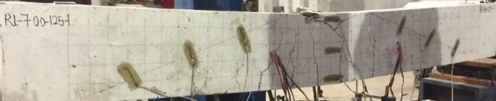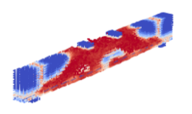
(a)
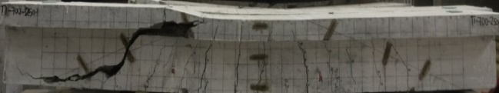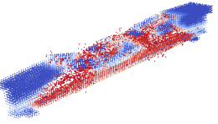
(b)
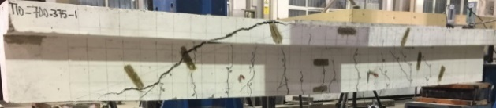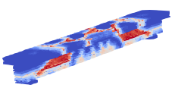
(c)
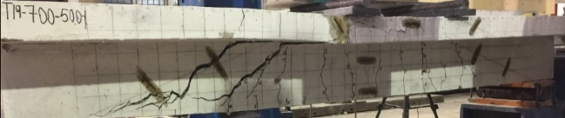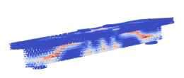
(d)
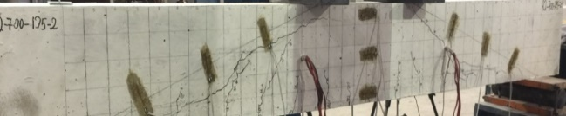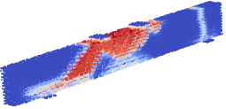
(e)
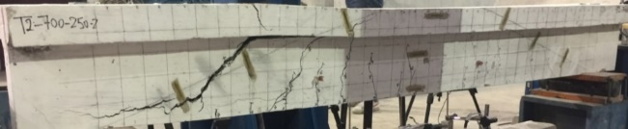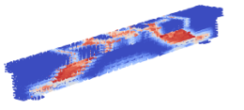
(f)
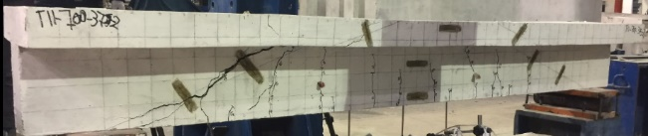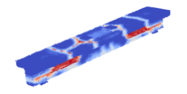
(g)
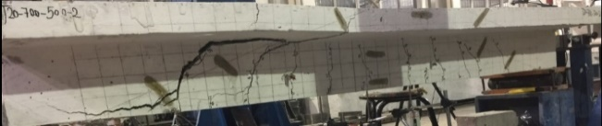
(h)
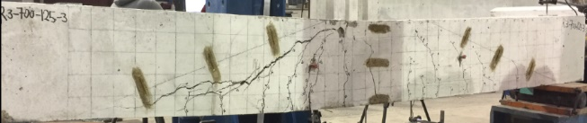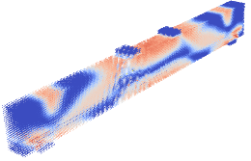
(i)
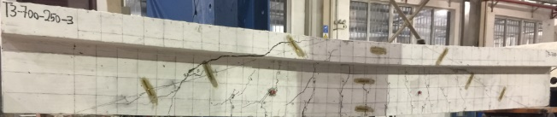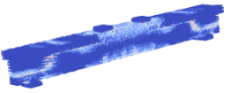
(j)
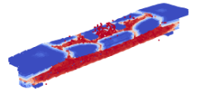
(k)
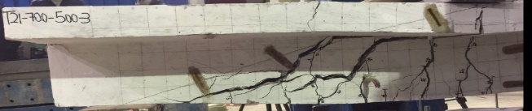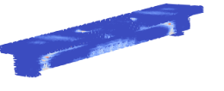
(l)
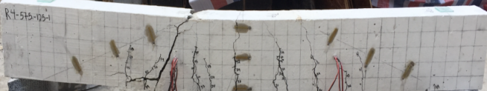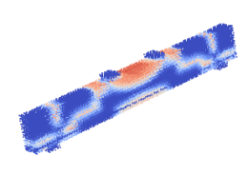
(m)
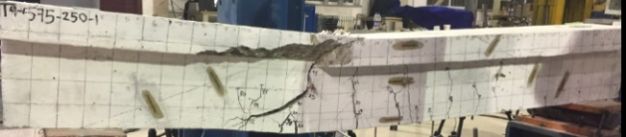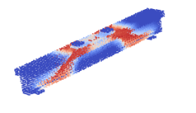
(n)
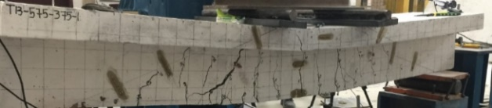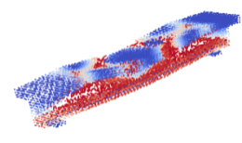
(o)
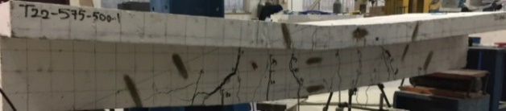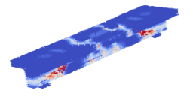
(p)
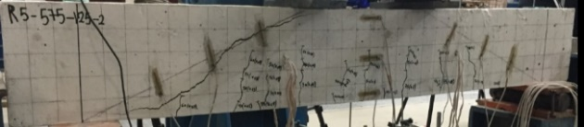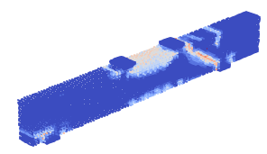
(q)
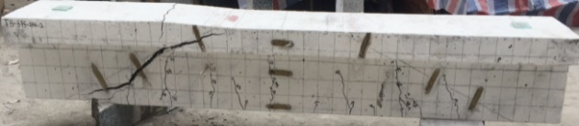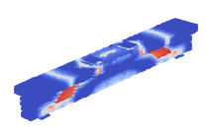
(r)
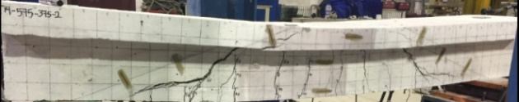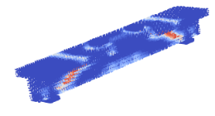
(s)
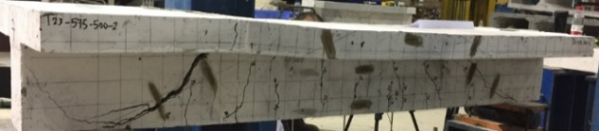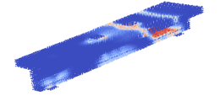
(t)
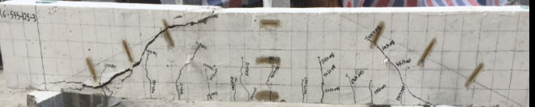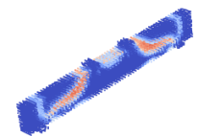
(u)
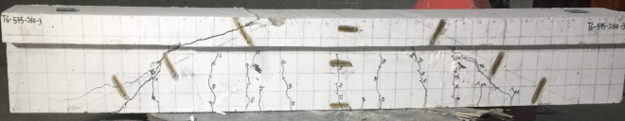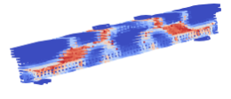
(v)
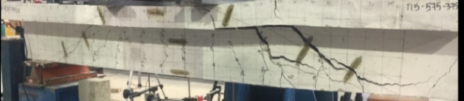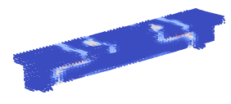
(w)
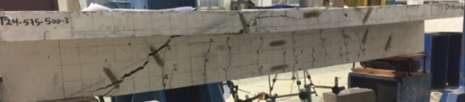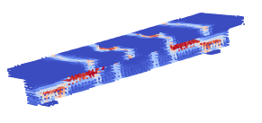
(x)
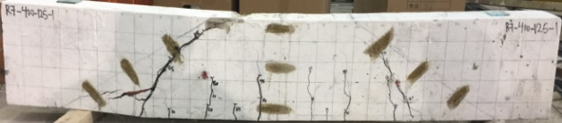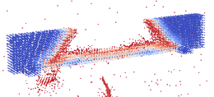
(y)
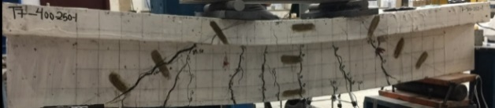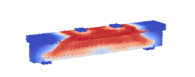
(z)
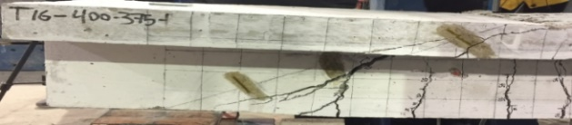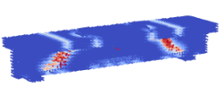
(aa)
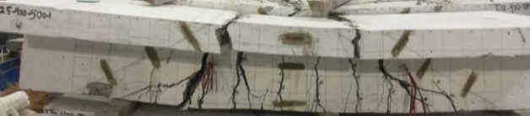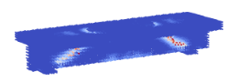
(ab)
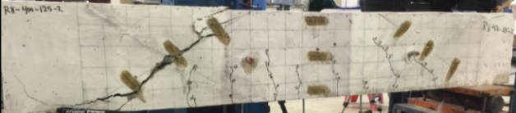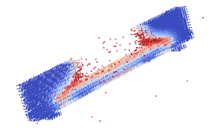
(ac)
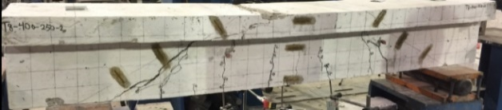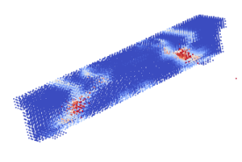
(ad)
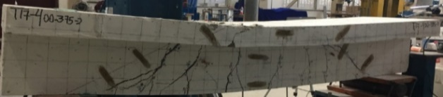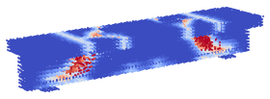
(ae)
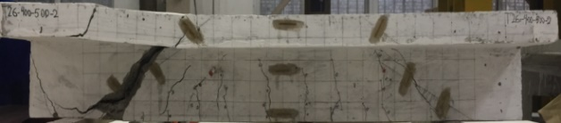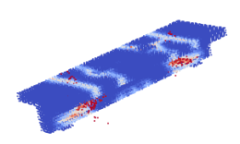
(af)
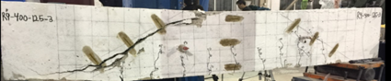
(ag)
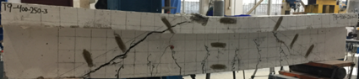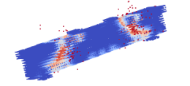
(ah)
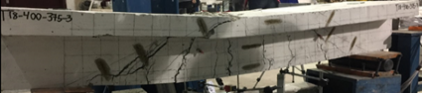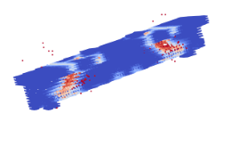
(ai)
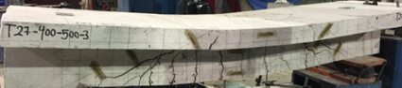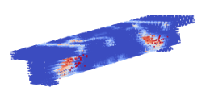
(aj)

Fig. B1 Comparison of test results and simulation results (left: test results; right: simulation results): (a) R-700-125-1; (b) T-700-250-1; (c) T-700-375-1; (d) T-700-500-1; (e) R-700-125-2; (f) T-700-250-2; (g) T-700-375-2; (h) T-700-500-2; (i) R-700-125-3; (j) T-700-250-3; (k) T-700-375-3; (l) T-700-500-3; (m) R-575-125-1; (n) T-575-250-1; (o) T-575-375-1; (p) T-575-500-1; (q) R-575-125-2; (r) T-575-250-2; (s) T-575-375-2; (t) T-575-500-2; (u) R-575-125-3; (v) T-575-250-3; (w) T-575-375-3; (x) T-575-500-3; (y) R-400-125-1; (z) T-400-250-1; (aa) T-400-375-1; (ab) T-400-500-1; (ac) R-400-125-2; (ad) T-400-250-2; (ae) T-400-375-2; (af) T-400-500-2; (ag) R-400-125-3; (ah) T-400-250-3; (ai) T-400-375-3; (aj) T-400-500-3.

