Appendices for:
Vulnerability assessment of sustainable seismic retrofit solutions for reinforced concrete structures: A multi-faceted approach

Hafiz Asfandyar AHMED, Yaohan LI*
Department of Construction and Quality Management, Hong Kong Metropolitan University, Hong Kong 00000, China
*Corresponding author. E-mail: engrasfandyar2009@gmail.com

Contents
Contents 1
Appendix A 2
Appendix B 3

Appendix A
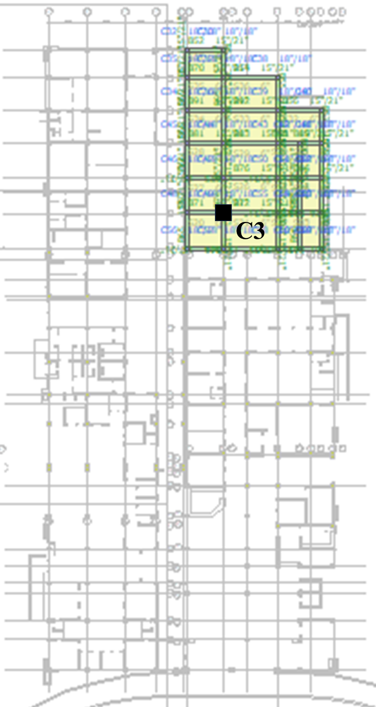
Fig. A1 Plan of the complete building with highlighted block considered in this study.
Dimensions of considered block: 60’ x 87.5’
Floor area of considered block: 5250 sft
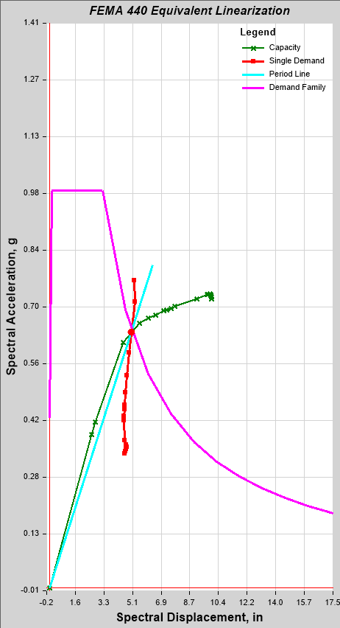
Fig. A2 Equivalent linearization of capacity curve using FEMA 440 along with demand response spectrum and other parameters to determine the performance points e.g., F*_{max.}

Appendix B
B1 - Carbon Emission Factors of Rebar and Structural Steel
Pig iron (BF-BOF) – 100% Virgin (2.09 kgCO₂-e/kg),
Direct-reduced iron (EAF) – 100% Virgin (1.54 kgCO₂-e/kg),
Direct-reduced iron (EAF) – 100% Recycled (0.39 kgCO₂-e/kg)
Finished steel material – Rebar (0.16 kgCO₂-e/kg),
Finished steel material – Structural steel (0.21 kgCO₂-e/kg).
The emission factors for the EAF process rebar are calculated based on the percentage of recycled scrap used.
For example, the emission factor for the EAF process rebar with 21% recycled content can be calculated as: 1.54 x (1-21%) + 0.39 x 21% +0.16 = 1.459 kg CO₂-e/kg.
According to the World Steel Association (WSA, 2011), the emission factor for BF-BOF rebar (13% scrap) is equal to: 2.09–13% × 1.41 + 0.16 = 2.07 kg CO₂-e/kg; the emission factor for BF-BOF structural steel (10% scrap) is equal to: 2.09–10% × 1.41 + 0.21 = 2.16 kg CO₂-e/kg.

B2 – Data used in Green Concrete LCA tool
Table B1 List of materials
User Input data | Type of Material
Ordinary Portland cement (OPC) | ASTM Type-I
Admixture | superplasticizer
Electricity grid station | location
Cement supply | Cherat, Pak
Fine aggregate supply | Larunspur, Pak
Coarse aggregate supply | Taxila, Pak
RCP | Warsak, Pak

Table B2 Transportation of raw materials
Transportation detail | Mode | Distance (km)
Cement raw materials to cement plant | truck class 8b | 15
Gypsum to cement plant | truck class 8b | 275
Cement to concrete plant | truck class 8b | 225
Fine aggregate to concrete plant | truck class 8b | 190
Coarse aggregates to concrete plant | truck class 8b | 150
Admixture to concrete plant | truck class 2 | 270

Table B3 Details of processes and technologies selected
Technology options for | Type of technology selected
Cement raw materials pre-homogenization | Dry, raw storing, pre-blending
Cement raw materials grinding | dry, raw storing, tube mill
cement raw meal | Dry, raw meal
blending/homogenization | blending, storage
Clinker pyro processing | Preheater / precalciner kiln with US average kiln fuel mix
Clinker cooling | Reciprocating grate cooler (modern)
cement finish | Tube mill
milling/grinding/blending | Tube mill
Cement PM control technology | ESP
Conveying within the cement plant | Screw pump
Concrete batching plant loading/mixing | Mixer loading (central mix)
Concrete batching plant PM control | Fabric filter

Table B4 Electricity grid mix percentage for Pakistan [100]
User input data | National grid (%)
Coal | 12
Natural gas | 29
Fuel oil | 20
Pet coke | –
Nuclear | 2.5
Hydropower | 34
Biomass | 0.5
Geothermal | –
Solar | 1
Wind | 1

