Appendices for:
Longitudinal shaking of culvert-frame combined underground structure

Yong YUAN^{a,b}, Xuzhao LAN^{a*}
ª Department of Geotechnical Engineering, Tongji University, Shanghai 200092, China
^{b} State Key Laboratory for Disaster Reduction in Civil Engineering, Tongji University, Shanghai 200092, China
*Corresponding author. E-mail: 1810768@tongji.edu.cn

Contents
Contents 1
Appendix A. Joint extensions in SEM-0.1g which change over the time of the input motion 2
Appendix B. Joint extension differences in SEM-0.1g which change over the time of the input motion 3

Appendix A. Joint extensions in SEM-0.1g which change over the time of the input motion

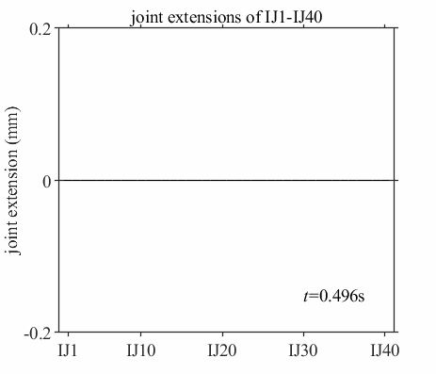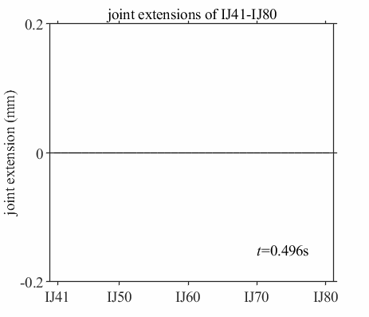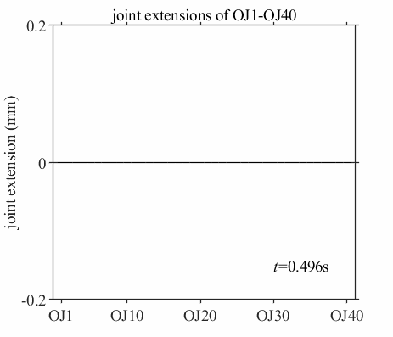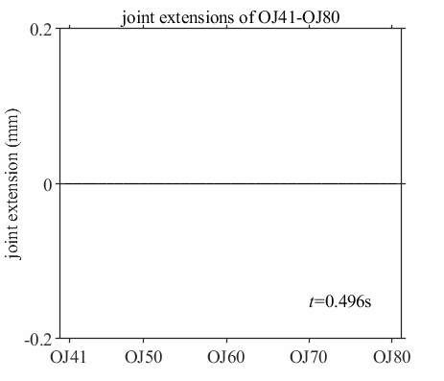

Appendix B. Joint extension differences in SEM-0.1g which change over the time of the input motion



