Supplementary-Table 1. The baseline risk factors between treated and untreated groups
 | LMWH-treated（N=20） | LMWH-untreated（N=15） | P value
Age | 34.75±3.51 | 32.30±3.44 | 0.008*
BMI in early pregnancy | 22.49(19.95,24.28) | 21.94(20.50,24.55) | 0.856
VTE history | 2/20 | 0/15 | 0.319
Family history | 2/20 | 0/15 | 0.319
Poor outcome history | 5/20 | 3/15 | 0.319
IVF-ET | 8/20 | 2/15 | 0.087
GDM in pregnancy | 3/20 | 2/15 | 0.64
Hypertension Preeclampsia in pregnancy | 2/20 | 1/15 | 0.61
Induced abortion history |  |  | 0.214
0 | 18/20 | 15/15
1 | 2/20 | 0/15
Abortion history |  |  | 0.66
<2 | 16/20 | 12/15
≥2 | 4/20 | 3/15
Ectopic pregnancy history |  |  | 0.681
0 | 17/20 | 14/15
1 | 2/20 | 1/15
2 | 1/20 | 0/15
Total number of pregnancies | 2（2,3.25） | 2(1,3) | 0.122

Supplementary Table 2: Current pregnancy outcomes in patients in the LMWH-treated, LMWH-untreated, and control groups
 | LMWH-treated  (N=20) | LMWH-untreated  (N=15) | Control  (N=70)
Primary pregnancy outcome
Live birth | 20* | 8 | 69
Premature labor | 1 | 1 | 5
Twin pregnancy | 1 | 0 | 3
Intrauterine fetal death | 0 | 4 | 0
SA | 0 | 3 | 0
Stillbirth | 0 | 0 | 1
Secondary pregnancy outcome
Thrombosis
Thrombosis during the current pregnancy | 2 | 0 | 0
Varicose veins | 1 | 0 | 0
Other
GDM | 3 | 2 | 19
Hypertension in pregnancy | 1 | 1 | 5
Preeclampsia | 1 | 0 | 7
HELLP syndrome | 0 | 0 | 0
Premature rupture of membranes | 6 | 2 | 15
Oligohydramnios | 1 | 0 | 6
Placental implantation with hemorrhage | 0 | 0 | 0
Placental adhesions with/without hemorrhage | 2 | 0 | 2
Placenta previa with/without hemorrhage | 1 | 0 | 1
Racket-shaped Placenta | 1 | 0 | 2
Low-lying placenta | 0 | 1 | 0
Persistent transverse occipital position | 0 | 0 | 2
Breech presentation | 0 | 0 | 5
Bleeding volume
Intraoperative hemorrhage, Median [IQR], ml | 200(150,250) | 300(150,375) | 250(200,300)
Postoperative hemorrhage at 2 h, Median [IQR], ml | 320(240,405) | 420(287.5,745) | 340(262.5,440)
Postoperative hemorrhage at 24 h, Median [IQR], ml | 390(300,457.5) | 480(337.5,725) | 400(300,595)
SA: Spontaneous abortion; GDM: Gestational diabetes mellitus
*：LMWH-treated vs. LMWH-untreated, P=0.001

Supplementary Table 3. Adjusted Odds Ratios (aOR) with 95% Confidence Intervals using Firth’s penalized-likelihood logistic regression
 | Variable | aOR  CI low | aOR  CI high | P value
LMWH Treatment  (Treated vs Untreated) | 31.0978 | 1.9284 | 13766.1536 | 0.0098
Age | 0.8692 | 0.5703 | 1.184 | 0.3828
VTE Score | 1.5426 | 0.5913 | 5.2798 | 0.3898
IVF-ET Used (vs No IVF-ET) | 0.1457 | 0.001 | 1.9785 | 0.1586
Aspirin Used (vs No Aspirin) | 1.7008 | 0.0488 | 276.8785 | 0.7646

Supplementary Figure 1. Forest plot for Firth’s penalized-likelihood logistic regression
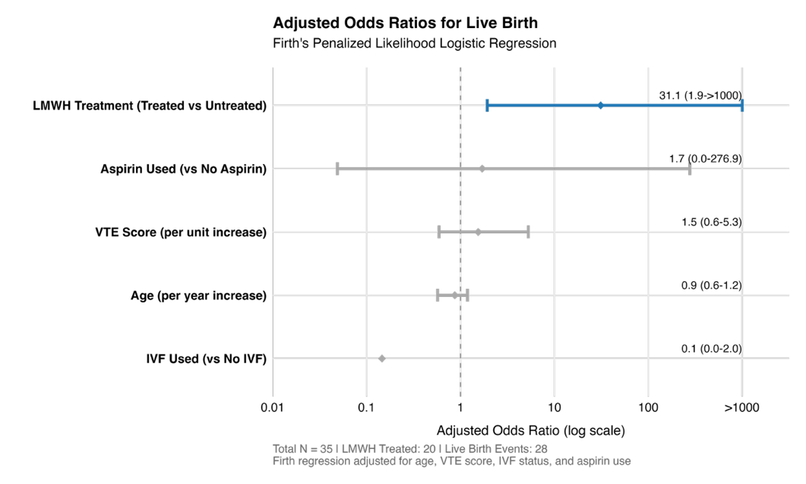
We conducted Firth’s penalized-likelihood logistic regression to assess the association between LMWH treatment and live birth, adjusting for clinically relevant confounding factors including maternal age, VTE risk score, method of conception, and aspirin use. After comprehensive adjustment, LMWH treatment exhibited a statistically significant association with live birth.
Supplementary Table 4. Sensitivity Analysis of LMWH Treatment Effect on Live Birth
Model | aOR | 95% CI | P value | EPV
Full Adjusted | 31.10 | [1.93, 13766.15] | 0.010 | 5.6
Core Adjusted | 67.82 | [3.80, 26203.83] | 0.001 | 7.0
Grouped Vars | 23.07 | [1.57, 9179.71] | 0.018 | 5.6
Unadjusted | 36.18 | [3.71, 4895.21] | <0.001 | 28.0
No IVF Subgroup | 8.26 | [0.82, 972.49] | 0.076 | 5.0
No Aspirin Subgroup | 28.55 | [1.83, 13017.39] | 0.011 | 4.8

