Supplementary Material 1. Search Key

PubMed
(pregnan* OR "expectant mother" OR gestation* OR "in-utero" OR "prenatal" OR "antenatal") AND ((“Risk” AND Factor*) OR (“Maternal” AND Exposure*)) AND ((("Congenital" AND "Heart") AND (Defect* OR Disease*)) OR ((Malformation* OR Abnormal*) AND Heart*) OR ((("Cardiac" AND "Birth") OR ("Heart" AND Sept* AND "Ventricular") OR ("Heart" AND Sept* AND "Atrial") OR ("Atrioventricular" AND "Septal") OR ("Atrio-ventricular" AND "Septal") OR "Canal" OR "AVC") AND Defect*) OR ("Persistent" AND "Ostium" AND "Primum") OR ("Ductus" AND Arteriosus* AND Paten*) OR ("Tetralogy" AND Fallot*) OR (Stenos* AND Pulmonar* AND Arter*) OR (Aort* AND Coarctation*) OR (Pulmonar* AND "Atresia") OR (Valv* AND "Atresia") OR (Transposition* AND ("Great Arteries" OR "Great Vessels")) OR (("Dextro" OR "Levo") AND "TGA") OR (Hypoplas* AND "Left" AND "Heart" AND "Syndrome") OR "AVSD")

CENTRAL
(pregnan* OR "expectant mother" OR gestation* OR "in-utero" OR "prenatal" OR "antenatal") AND (("Risk" AND Factor*) OR ("Maternal" AND Exposure*)) AND ((("Congenital" AND "Heart") AND (Defect* OR Disease*)) OR ((Malformation* OR Abnormal*) AND Heart*) OR ((("Cardiac" AND "Birth") OR ("Heart" AND Sept* AND "Ventricular") OR ("Heart" AND Sept* AND "Atrial") OR ("Atrioventricular" AND "Septal") OR ("Atrio-ventricular" AND "Septal") OR "Canal" OR "AVC") AND Defect*) OR ("Persistent" AND "Ostium" AND "Primum") OR ("Ductus" AND Arteriosus* AND Paten*) OR ("Tetralogy" AND Fallot*) OR (Stenos* AND Pulmonar* AND Arter*) OR (Aort* AND Coarctation*) OR (Pulmonar* AND "Atresia") OR (Valv* AND "Atresia") OR (Transposition* AND ("Great Arteries" OR "Great Vessels")) OR (("Dextro" OR "Levo") AND "TGA") OR (Hypoplas* AND "Left" AND "Heart" AND "Syndrome") OR "AVSD")

Embase (title, abstract, keywords filters were used)
(pregnan* OR 'expectant mother' OR gestation* OR 'in-utero' OR prenatal OR antenatal):ab,kw,ti AND ((Risk AND Factor*) OR (Maternal AND Exposure*)):ab,kw,ti AND (((Congenital AND Heart) AND (Defect* OR Disease*)) OR ((Malformation* OR Abnormal*) AND Heart*) OR (((Cardiac AND Birth) OR (Heart AND Sept* AND Ventricular) OR (Heart AND Sept* AND Atrial) OR (Atrioventricular AND Septal) OR (Atrio-ventricular AND Septal) OR Canal OR AVC) AND Defect*) OR ("Persistent" AND "Ostium" AND "Primum") OR ("Ductus" AND Arteriosus* AND Paten*) OR (Tetralogy AND Fallot*) OR (Stenos* AND Pulmonar* AND Arter*) OR (Aort* AND Coarctation*) OR (Pulmonar* AND Atresia) OR (Valv* AND Atresia) OR (Transposition* AND ('Great Arteries' OR 'Great Vessels')) OR ((Dextro OR Levo) AND TGA) OR (Hypoplas* AND Left AND Heart AND Syndrome) OR AVSD):ab,kw,ti

Table S1. Definitions of maternal factors
Maternal factor |  | Definition
Maternal diabetes | Pre-pregnancy diabetes |  | Diabetes that is first diagnosed before pregnancy (most commonly type 1 or type 2 diabetes)
Maternal obesity* | Overall obesity |  | Women with a pre-pregnancy BMI of larger than 30.0 kg/m² are considered obese (international standard)
Maternal obesity* | Class I obesity |  | 30.0≤BMI<35.0 kg/m²
Maternal obesity* | Cass II obesity |  | 35.0≤BMI<40.0 kg/m²
Maternal obesity* | Class III obesity |  | BMI≥40.0 kg/m²
Maternal underweight* | Women who are underweight before pregnancy. Women with a pre-pregnancy BMI of less than 18.5 kg/m² are considered underweight.
Maternal smoking | The exposure of pregnant women to smoking within the first trimester of pregnancy, including both active smoking and passive smoking
Maternal alcohol consumption | The exposure of pregnant women to alcohol during the first trimester of pregnancy, primarily through drinking.
Maternal hypertension | Chronic hypertension |  | High blood pressure diagnosed before pregnancy
* BMI thresholds are based on WHO recommendation

Table S2. Definitions of phenotypes of congenital heart defects
Congenital heart defect phenotype | Abbreviation | ICD-9 | ICD-10 | Definition*
Ventricular septal defect | VSD | 745.4 | Q21.0 | An incomplete development of the ventricular septum
Atrial septal defect | ASD | 745.5 | Q21.1 | An incomplete development of the atrial septum
Patent ductus arteriosus | PDA | 747.0 | Q25.0 | Failure to close the ductus arteriosus after birth
Tetralogy of Fallot | ToF | 745.2 | Q21.3 | A combination of four heart defects: ventricular septal defect, pulmonary stenosis, overriding aorta, and right ventricular hypertrophy
Pulmonary artery stenosis | PAS | 747.3 | Q25.6 | Narrowing of the pulmonary artery
Coarctation of the aorta | CoA | 747.10 | Q25.1 | Narrowing of aorta
Pulmonary atresia | PA | 746.01 | Q22.0 | Complete closure of the pulmonary valve
Transposition of the great arteries | TGA | 745.10 | Q20.3 | The aorta and pulmonary artery are reversed
Hypoplastic left heart syndrome | HLHS | 746.7 | Q23.4 | A severe underdevelopment of the left side of the heart
Atrioventricular septal defect | AVSD | 745.69 | Q21.2 | Deficiency in the septum between the atria and ventricles, resulting in connections between two atria, as well as between the two ventricles
* Definition sourced from the American Heart Association: https://www.heart.org/en/health-topics/congenital-heart-defects/about-congenital-heart-defects

Supplementary Material 2. QUIPS tool
The QUIPS tool comprises six potential bias domains: Study Participation, Study Attrition, Prognostic Factor Measurement, Outcome Measurement, Study Confounding, and Statistical Analysis and Reporting.

The risk of bias for each domain is categorized as low, intermediate, or high, and the overall risk of bias in the study is determined by aggregating the risk of bias levels across all domains. The assessment of bias risk was performed strictly according to the prompting items and considerations suggested by Hayden et al. If an article failed to meet 2 considerations in a domain, it was considered to have a moderate risk of bias; if more than two considerations were not met, it was considered to have a high risk of bias. In the overall assessment, if no more than one domain is considered to have a moderate risk of bias, then the overall evaluation should be considered low risk of bias. If more than one but no more than two domains are considered to have a moderate risk of bias, then the overall evaluation should be considered moderate risk of bias. If more than two domains are considered to have a moderate risk of bias, or if at least one domain is considered to have a high risk of bias, then the overall evaluation should be considered a high risk of bias.

Studies with low risk of bias commonly considered and adjusted the following important confounding factors: maternal age, education level, race, marital status, residence (urban or rural), socioeconomic status, fetal birth year, place and gender, pre-pregnancy BMI, medication use (such as folic acid, vitamins, and other drugs), maternal diseases (such as obesity, diabetes, hypertension), and maternal risk behaviors during pregnancy (such as smoking and alcohol consumption).

Table S3. Basic characteristics of studies included in the systematic review and meta-analysis
Index | Author and Year of Publication | Country/  Regions | Study Period | Study Design | CHD/Non-CHD | Maternal Factors | Outcomes | Adjustment Variables | Effect  Measurement
1 | Dong and Hao (2024) [1] | China | 2016-2021 | Case-control | 125/125 | Pre-pregnancy diabetes | CHD | NA (univariate model) | Odds ratio (OR)
2 | Turunen et al. (2024)  [2] | Finland | 2006-2016 | Cohort | 10,254/610,497 | Obesity  Underweight  Pre-pregnancy diabetes | CHD; TGA; VSD; ASD | Maternal smoking, maternal age, childbirth year, first parity, and highest parental education level | Odds ratio (OR)
3 | Amini-Rarani et al. (2023)  [3] | Iran | 2020 | Case-control | 200/400 | Smoking  Alcohol consumption | CHD | Mother's age, child's age, child's gender and city of residence | Odds ratio (OR)
4 | Kawai et al. (2023)  [4] | Japan | 2011-2014 | Cohort | 1,264/90,400 | Obesity  Underweight  Alcohol consumption  Pre-pregnancy diabetes  Smoking | CHD | Maternal BMI, maternal history of diabetes, smoking, alcohol consumption, and dietary intake of retinol and folic acid | Odds ratio (OR)
5 | Lemaitre et al. (2023)  [5] | France | 2012-2020 | Cohort | 48,707/6,027,544 | Pre-pregnancy diabetes | CHD; VSD; ASD; AVSD; ToF; HLHS; PDA; CoA; PAS | NA (Univariate model) | Odds ratio (OR)
6 | Bolin et al. (2022)  [6] | United States | 1997-2011 | Case-control | 8,339/11,020 | Smoking | VSD; ASD; AVSD; HLHS; CoA; ToF; TGA | Infant sex, maternal age at delivery, race/ethnicity, category of pre-pregnancy body mass index, periconceptional alcohol consumption, folic acid intake from one month prior to conception to two months after conception, energy adjusted dietary folate intake, periconceptional caffeine intake, family history of CHDs, and site | Odds ratio (OR)
7 | Mezzasalma et al. (2022)  [7] | Italy | 2005-2017 | Case-control | 1,853/39,542 | Underweight | CHD | Maternal age, geographic origin, maternal education level, and maternal smoking | Odds ratio (OR)
8 | Wang et al. (2022)  [8] | China | 2013-2019 | Cohort | 564/43,484 | Alcohol Consumption | CHD; ASD; VSD; PDA; ToF | Maternal age, ethnicity, educational level, history of adverse pregnancy outcomes, smoking in 3 months before pregnancy, alcohol consumption in 3 months before pregnancy, and smoking in early pregnancy | Relative risk (RR)
9 | Wang et al. (2022)  [9] | China | 2013-2019 | Cohort | 538/44,048 | Smoking | CHD; ASD; VSD; PDA; ToF; PAS; AVSD; TGA | Maternal age, ethnicity, educational level, model of conception, parity, history of adverse pregnancy outcomes, pre-pregnancy BMI, active smoking in 3 months before pregnancy, passive smoking in 3 months before pregnancy, and alcohol consumption in 3 months before pregnancy | Relative risk (RR)
10 | Wu et al. (2022)  ^{[10]} | China | 2017-2019 | Cohort | 372/53,336 | Obesity  Underweight  Pre-pregnancy diabetes | CHD; ToF; VSD | Maternal age, maternal education level, mode of conception, parity, maternal gestational diabetes, and offspring sex | Odds ratio (OR)
11 | Diao et al. (2021)  [11] | China | 2017-2020 | Case-control | 654/666 | Smoking | CHD; ASD; VSD; AVSD; PDA | Maternal education level, income, residence, abnormal pregnancy history, family history of inbreeding and congenital malformations, personal medical history before or during this pregnancy, personal lifestyle and habit before this pregnancy and exposure history to environmental hazardous substance as well as spouse’s education level, and smoking and drinking history | Odds ratio (OR)
12 | Jin et al. (2021)  [12] | China | 2018-2019 | Cohort | 602/64,161 | Underweight | CHD | NA (univariate model) | Odds ratio (OR)
13 | Kurita et al. (2021)  [13] | Japan | 2011-2014 | Cohort | 799/72,796 | Alcohol consumption | CHD | Maternal age, BMI before pregnancy, maternal smoking habit, means of pregnancy, and complications during pregnancy (including diabetes mellitus/gestational diabetes mellitus, and hypertensive disorder of pregnancy, and intrauterine fetal infection | Odds ratio (OR)
14 | Luo et al. (2021)  [14] | China | 2017-2019 | Case-control | 464/504 | Pre-pregnancy diabetes | CHD | Maternal age, education level, family annual income, residence location, family history of birth defects, family history of consanguineous marriages, folate supplementation status in this pregnancy, cold and fever history, history of active and passive smoking, drinking history, history of drinking tea, history of drinking coffee, frequency of cosmetics use, environmentally harmful substance and noise pollution exposures, pet feeding experiences, perming or dying hair experiences and dietary habits (including the intake frequency of barbecued or fried foods, fish and shrimp, fresh eggs, fresh fruits, soy foods, and milk products) as well as spouse’s education level, and smoking and drinking histories. | Odds ratio (OR)
15 | Rutkowski et al. (2021)  [15] | United States | 2005-2016 | Cohort | 4,763/2,337,813 | Obesity  Underweight | HLHS; PA; ToF; TGA; CoA | Maternal education, parity, maternal marital status, maternal nativity, maternal race/ethnicity, and maternal age | Odds ratio (OR)
16 | Saad et al. (2021)  [16] | United Kingdom | 2010-2014 | Cohort | 1,162/92,905 | Obesity  Underweight  Smoking  Alcohol consumption | CHD | Gestational age at frst booking, urban/rural residency, deprivation using NIMDM, parity, woman’s age at frst booking, unplanned pregnancy, history of CHD or congenital abnormalities and syndromes, woman’s BMI, woman’s smoking, alcohol consumption, woman’s self-reported usage of medication, preterm baby, multiple birth, prescription and redemption of medication, history of abortion, SGA, LBW, and gender | Odds ratio (OR)
17 | Tinker et al. (2021)  [17] | United States | 1997-2011 | Case-control | 8,823/31,811 | Obesity  Pre-pregnancy diabetes | ToF; TGA; ASD; VSD; AVSD; HLHS; CoA; PA | NA (univariate model) | Odds ratio (OR)
18 | Taylor et al. (2021)  [18] | United Kingdom | 1991-2016 | Case-control | 2,469/229,921 | Obesity  Underweight  Smoking | CHD | Obesity & Underweight: Maternal age, parity, maternal ethnicity, socioeconomic position, smoking, alcohol use, offspring sex  Smoking:  Maternal age, maternal education, maternal ethnicity, alcohol consumption, maternal parity, and offspring sex | Odds ratio (OR)
19 | Ahmadi et al. (2020)  [19] | Iran | 2014-2016 | Case-control | 474/436 | Obesity | CHD | NA (univariate model) | Odds ratio (OR)
20 | Dolk et al. (2020)  [20] | United Kingdom | NA | Case-control | 242/966 | Obesity  Underweight  Pre-pregnancy diabetes | CHD | Maternal age, previous pregnancy, maternal education, socioeconomic deprivation of area of residence, dietary class (except for analysis of individual food types), BMI category, self-reported folic acid supplementation (except when analysing preconceptional folic acid reported to midwife), smoking (except when analysing smoking reported to midwife), antidepressant prescription in first trimester, pregnancy stress, multiple stressors | Odds ratio (OR)
21 | Giraldo-Grueso et al. (2020)  [21] | Columbia | 2006-2013 | Case-control | 277/234,091 | Obesity  Underweight  Pre-pregnancy diabetes | CHD | NA (univariate model) | Odds ratio (OR)
22 | Li et al. (2020)  [22] | China | 2014-2016 | Case-control | 695/1,564 | Smoking | CHD | Mother's age, mother's domicile, mother's education, father's education, mother's reproductive history, history of miscarriage, family history of CHD, abnormal prenatal checkups, periconceptional infections, periconceptional folic acid use, periconceptional exposure to hazardous substances, and periconceptional exposure to adverse environments | Odds ratio (OR)
23 | Luo et al. (2020)  [23] | China | 2018-2019 | Case-control | 464/504 | Pre-pregnancy diabetes | CHD | Maternal education level, annual household income, place of residence, history of birth defects in family members, history of three-generation consanguineous marriages in the family, folic acid supplementation in the first three months of pregnancy and in early pregnancy, colds and fevers in early pregnancy, active smoking, exposure to secondhand smoke, consumption of alcohol, tea, and coffee, and emission of harmful pollutants from the environment in the vicinity of the place of residence | Odds ratio (OR)
24 | Tanghöj et al. (2020)  [24] | Sweden | 2010-2015 | Case-control | 978/8866 | Obesity  Underweight | ASD | Maternal smoking, maternal diabetes mellitus, maternal weight-classes, gestational subclasses, small for gestational age, persistent ductus arteriosus and congenital heart defect | Odds ratio (OR)
25 | Yuan et al. (2020)  [25] | China | 2010-2015 | Case-control | 1,206/1,112 | Underweight | CHD; VSD | Residence type, maternal age, maternal education, maternal smoking, paternal smoking, maternal drinking, parity, maternal folic acid supplementation | Odds ratio (OR)
26 | Zhao et al. (2020)  [26] | China | 2017-2019 | Case-control | 620/620 | Pre-pregnancy diabetes | CHD | Maternal age, Education level, Family’s annual income, Residence location, Induced abortion or labor, Fetal death or stillbirth, Premature delivery, Low birth weight, etc. | Odds ratio (OR)
27 | Perry et al. (2019)  [27] | United States | 2006-2015 | Cohort | 972/1,443,044 | Smoking | CHD | Maternal age, maternal ethnicity, maternal pregestational diabetes, and Medicaid | Relative risk (RR)
28 | Persson et al. (2019)  [28] | Sweden | 1992-2012 | Cohort | 28,628/2,021,863 | Obesity  Underweight  Smoking  Pre-pregnancy diabetes | CHD | NA (univariate model) | Relative risk (RR)
29 | Robinson et al. (2019)  [29] | Israel | 1991-2011 | Cohort | 6,078/236,783 | Pre-pregnancy diabetes | CHD | Newborn sex and birth number | Odds ratio (OR)
30 | Feng et al. (2018)  [30] | China | 2011-2017 | Case-control | 2,458/2,458 | Smoking | CHD; VSD; ASD; PDA; ToF | Maternal age, parity, gravidity, and education status | Odds ratio (OR)
31 | Helle et al. (2018)  [31] | United States | 2009-2015 | Cohort | 811/18,296 | Pre-pregnancy diabetes | CHD | OGTT, maternal pre-pregnancy BMI, maternal age | Odds ratio (OR)
32 | Kovalenko et al. (2018)  [32] | Russia | 2006-2011 | Cohort | 233/49,230 | Underweight  Pre-pregnancy diabetes | VSD | Birth weight, Sex, Age at delivery, Gestational age, BMI, Smoking during pregnancy, Alcohol abuse during pregnancy, Drug abuse during pregnancy, Folic acid intake during pregnancy, Multivitamins intake during pregnancy | Odds ratio (OR)
33 | Persson et al. (2017)  [33] | Sweden | 2001-2014 | Cohort | 20,074/1,223,883 | Obesity  Underweight | CHD | Maternal age, height, parity, early pregnancy smoking status, educational level, maternal country of birth, family situation, and sex of offspring | Relative risk (RR)
34 | Chou et al. (2016)  [34] | Taiwan | 2004-2010 | Cohort | 23,483/1,364,167 | Pre-pregnancy diabetes  Chronic hypertension | CHD | Maternal nationality, parental age, level of parental education, birth order, single v. multiple births, sex of the infant, infant’s year of birth, urbanization of the birth site, and maternal smoking and alcohol consumption | Odds ratio (OR)
35 | Hoyt et al. (2016)  [35] | United States | 1997-2009 | Case-control | 4,848/21,661 | Smoking | ToF; TGA; AVSD; HLHS; CoA; PA; VSD; ASD | Maternal age, education, race, body mass index in kg/m2, nativity, alcohol intake one month prior to conception through the first trimester, folic acid intake in multivitamins or alone, dietary folate equivalent, previous live births, pregnancy intention, household income divided by no. of people supported by this income, study center, and time to interview | Odds ratio (OR)
36 | Øyen et al. (2016)  [36] | Denmark | 1978-2011 | Cohort | 16,325/2,009,402 | Pre-pregnancy diabetes | CHD; TGA; ToF; AVSD; CoA; VSD; ASD | Birth year, maternal age, and birth order | Relative risk (RR)
37 | Bateman et al. (2015)  [37] | United States | 2000-2007 | Cohort | NA | Chronic hypertension | CHD; VSD; ASD | Maternal demographic characteristics, comorbid medical conditions, obstetric characteristics/conditions, maternal medication exposures, and measures of healthcare utilization | Odds ratio (OR)
38 | Sullivan et al. (2015)  [38] | United States | 1989-2011 | Case-control | 14,128/60,938 | Smoking | CHD; TGA; ToF; AVSD; CoA; HLHS; ASD; VSD; PDA | Sex and maternal age, race, marital status, weight, diabetes, and timing of prenatal care | Odds ratio (OR)
39 | Van Gelder et al. (2015)  [39] | United States and Canada | 1998-2010 | Case-control | NA | Chronic hypertension | CHD; VSD; ASD | Study centre, age at conception, race/ethnicity, parity, and pre-pregnancy BMI | Odds ratio (OR)
40 | Zhu et al. (2015)  [40] | United States | 1997-2007 | Case-control | 7,076/7,972 | Alcohol consumption | ToF; TGA; ASD; CoA; HLHS | Periconceptional smoking (ToF);  Maternal Pre-pregnancy BMI (TGA);  Maternal ethnicity, maternal education, periconceptional smoking, and study site (ASD);  Maternal age, maternal education, and periconceptional smoking (CoA);  Maternal pre-pregnancy BMI and study site (HLHS) | Odds ratio (OR)
41 | Brite et al. (2014)  [41] | United States | 2002-2008 | Cohort | 1,388/120,427 | Obesity  Underweight | CHD; VSD; ASD | Study site, maternal age, maternal ethnicity, maternal insurance, maternal smoking | Odds ratio (OR)
42 | Ghaderian et al.  (2014)  [42] | Iran | 2011-2012 | Case-control | 164/158 | Obesity  Underweight | CHD | NA (Univariate model) | Odds ratio (OR)
43 | Leite et al. (2014)  [43] | Denmark | 1997-2010 | Cohort | 17,002/821,263 | Smoking | CHD | Maternal age, year of birth and maternal marital status | Odds ratio (OR)
44 | Vereczkey et al. (2014)  [44] | Hungary | NA | Case-control | 3,562/38,151 | Pre-pregnancy diabetes  Chronic Hypertension | VSD; ASD; AVSD; PDA; TGA; HLHS; ToF; CoA | Maternal age, Birth order, Low SES | Odds ratio (OR)
45 | Block et al. (2013)  [45] | United States | 2004-2009 | Case-control | 8,953/1,115,417 | Obesity  Underweight | CoA; HLHS; PA; ToF; TGA; VSD | Maternal ethnicity, maternal education level, maternal smoking, maternal marital status, maternal nativity, and maternal age | Odds ratio (OR)
46 | Csáky-Szunyogh et al. (2013)  [46] | Hungary | NA | Case-control | 1,661/38,151 | Pre-pregnancy diabetes  Chronic hypertension | VSD | Maternal age, birth order (parity), employment status of mothers as indicator of socio-economic status and folic acid/multivitamin supplements | Odds ratio (OR)
47 | Fung et al. (2013)  [47] | Canada | 2008-2011 | Case-control | 2,339/199 | Pre-pregnancy diabetes  Smoking  Alcohol consumption  Chronic hypertension | CHD; PDA; TGA | NA (univariate model) | Odds ratio (OR)
48 | Liu et al. (2013)  [48] | Canada | 2002-2010 | Cohort | 26,488/2,252,350 | Obesity  Pre-pregnancy diabetes  Chronic hypertension | CHD; AVSD | Maternal age, infant sex, parity, rural residence, and region and year of birth | Odds ratio (OR)
49 | Nie et al. (2013)  [49] | China | 2004-2011 | Case-control | 2,568/2,568 | Pre-pregnancy diabetes | CHD | NA (univariate model) | Odds ratio (OR)
50 | Taksande et al. (2013)  [50] | India | 2004-2007 | Case-control | 209/11,539 | Pre-pregnancy diabetes | CHD | NA (univariate model) | Odds ratio (OR)
51 | Baardman et al. (2012)  [51] | Netherland | 1997-2008 | Case-control | 797/322 | Smoking | CHD | Maternal age, maternal education level, maternal folic acid use, and periconceptional alcohol consumption | Odds ratio (OR)
52 | Balaha et al. (2012)  [52] | Saudi Arabia | 2006-2010 | Case-control | 26/37,142 | Obesity | CHD | NA (univariate model) | Odds ratio (OR)
53 | Garne et al. (2012)  [53] | Europe | 1990-2005 | Cohort | 26,551/3,702,679 | Pre-pregnancy diabetes | CHD; TGA; VSD; ASD; AVSD; ToF; HLHS; CoA | Maternal age, year and registry | Odds ratio (OR)
54 | Madsen et al. (2012)  [54] | United States | 1992-2007 | Case-control | 11,263/140,470 | Obesity  Underweight | CHD; ASD; VSD; CoA; HLHS; PA; PAS; TGA; ToF; PDA | Maternal gestational diabetes | Odds ratio (OR)
55 | Mateja et al. (2012)  [55] | United States | 1996-2005 | Case-control | 237/948 | Obesity  Underweight  Chronic hypertension | CHD | NA (univariate model) | Odds ratio (OR)
56 | Alverson et al. (2011)  [56] | United States | 1981-1989 | Case-control | 2,525/3,435 | Smoking | CHD; TGA; ToF; AVSD; HLHS; CoA; VSD; ASD; PDA | Family history of CHD, infant gender, infant race, maternal age, and maternal BMI | Odds ratio (OR)
57 | Karatza et al. (2011)  [57] | Greece | 2006-2009 | Case-control | 157/208 | Pre-pregnancy diabetes  Smoking | CHD | Maternal age, therapeutic drug exposure, influenza-like illness, pregestational diabetes, parity, paternal smoking, family history of congenital heart disease, gender, prematurity | Odds ratio (OR)
58 | Zen et al. (2011)  [58] | Brazil | 2005-2007 | Case-control | 250/303 | Alcohol consumption | CHD | NA (univariable model) | Odds ratio (OR)
59 | Bánhidy et al. (2010)  [59] | Hungary | 1980-1996 | Case-control | 22,843/38,151 | Pre-pregnancy diabetes | CHD | Maternal age, employment status, birth order, and maternal hypertension | Odds ratio (OR)
60 | Blomberg et al. (2010)  [60] | Sweden | 1995-2007 | Cohort | 11,163/1,038,419 | Obesity  Underweight | CHD; ToF; TGA; HLHS | Maternal age, parity, maternal smoking, and year of birth | Odds ratio (OR)
61 | Gilboa et al. (2010)  [61] | United States | 1997-2004 | Case-control | 6,440/5,673 | Obesity  Underweight  Smoking  Chronic hypertension | CHD; ToF; TGA; AVSD; HLHS; CoA; PA; VSD; ASD | Maternal age, race-ethnicity, education, hypertension, parity, smoking in the month prior to conception or the first month of pregnancy, and folic acid supplement use in the month prior to conception or the first month of pregnancy by conditional logistic regression grouping on study center | Odds ratio (OR)
62 | Kuciene et al. (2010)  [62] | Lithuania | 1995-2005 | Case-control | 261/1,122 | Smoking | SD | NA (univariate model) | Odds ratio (OR)
63 | Mills et al. (2010)  [63] | United States | 1993-2003 | Case-control | 7,392/56,304 | Obesity  Underweight | CHD; TGA; ToF; ASD; VSD; HLHS; CoA; AVSD | Maternal age, education, race, smoking, and payment method for health care | Odds ratio (OR)
64 | Rankin et al. (2010)  [64] | United Kingdom | 2003-2005 | Cohort | 272/40,670 | Obesity  Underweight | CHD; TGA; VSD; ASD; ToF; CoA | Maternal age, maternal ethnicity, maternal BMI, maternal pre-gestational diabetes, maternal cigarette smoking status, and maternal index of multiple deprivation | Odds ratio (OR)
65 | Grewal et al. (2008)  [65] | United States | 1999-2003 | Case-control | 323/1,738 | Smoking | TGA; ToF | NA (univariate model) | Odds ratio (OR)
66 | Malik et al. (2008)  [66] | United States | 1997-2002 | Case-control | 3,067/3,947 | Obesity  Underweight  Alcohol consumption  Smoking | CHD; ToF; TGA; HLHS; CoA; VSD; ASD; AVSD | Infant gender, maternal age, race, BMI, drinking from 1 month before through 3 months after conception, folic acid intake from 1 month before through 2 months after conception, dietary folate intake in dietary folate equivalents (energy adjusted), caffeine intake, family history of heart defect, and residence of mothers. | Odds ratio (OR)
67 | Waller et al. (2007)  [67] | United States | 1997-2002 | Case-control | 4,128/10,186 | Obesity  Underweight | CHD | Maternal ethnicity, age, parity, smoking, and any intake of vitamins | Odds ratio (OR)
68 | Williams et al. (2004)  [68] | United States | 1968-1980 | Case-control | 122/3029 | Smoking  Alcohol consumption | VSD | NA (Univariate model) | Odds ratio (OR)
69 | Cedergren et al. (2002)  [69] | Sweden | 1982-1996 | Case-control | 269/524 | Smoking  Alcohol consumption | CHD | NA (univariate model) | Odds ratio (OR)
70 | Loffredo et al. (2001)  [70] | United States | 1981-1989 | Case-control | 1069/3568 | Pre-pregnancy diabetes | CHD; TGA; AVSD; VSD | NA (univariate model) | Odds ratio (OR)
71 | Watkins et al. (2001)  [71] | United States | 1968-1980 | Case-control | 851/2767 | Obesity  Underweight | CHD; ToF; TGA; VSD; ASD | Maternal race, education, age, smoking, alcohol use, chronic illness, periconceptional multivitamin use, and child’s period of birth. | Odds ratio (OR)
72 | Källén et al. (1999)  [72] | Sweden | 1983-1996 | Case-control | 3,384/1,413,811 | Smoking | CHD; VSD; ASD; AVSD; ToF; TGA; HLHS; CoA; PDA | Year of birth, maternal age, parity, and educational level | Odds ratio (OR)
73 | Janssen et al. (1996)  [73] | United States | 1984-1991 | Cohort | 86/19,219 | Pre-pregnancy diabetes | CHD | Mother's age, race, smoking status and year of child's birth | Odds ratio (OR)
74 | Pradat (1992)  [74] | Sweden | 1981-1986 | Case-control | 1,324/2,648 | Smoking | CHD | NA (univariate model) | Odds ratio (OR)
75 | Tikkanen et al. (1991)  [75] | Finland | 1982-1983 | Case-control | 150/756 | Alcohol consumption | VSD | NA (univariate model) | Relative risk (RR)
76 | Tikkanen et al. (1991)  [76] | Finland | 1982-1984 | Case-control | 573/1055 | Alcohol consumption | CHD | Maternal age | Relative risk (RR)
77 | Tikkanen et al. (1990)  [77] | Finland | 1982-1983 | Case-control | 408/756 | Alcohol consumption  Chronic Hypertension | CHD; VSD; ASD | Maternal age, Birth order, Low SES | Odds ratio (OR)
78 | Stoll et al. (1989)  [78] | France | 1979-1986 | Case-control | 801/104,573 | Pre-pregnancy diabetes  Smoking  Chronic hypertension | CHD; VSD; ASD | NA (univariate model) | Odds ratio (OR)
BMI, body mass index; CHD, congenital heart defect; VSD, ventricular septal defect; ASD, atrial septal defect; PDA, patent ductus arteriosus; ToF, Tetralogy of Fallot; PAS, pulmonary artery stenosis; CoA, coarctation of the aorta; PA, pulmonary atresia; TGA, transposition of the great arteries; HLHS, hypoplastic left heart syndrome; AVSD, atrioventricular septal defect; SES, socioeconomic status; SGA, small for gestational age; LBW, low birth weight; OGTT, oral glucose tolerance; NA, non-applicable.
Table S4. Distribution of maternal factors and congenital heart defect phenotypes

A. The distribution of maternal factors

Maternal factor | Number of studies (%)
Maternal diabetes | 29 (37.2)
Maternal obesity | 27 (34.6)
Maternal underweight | 27 (34.6)
Maternal smoking | 27 (34.6)
Maternal alcohol consumption | 14 (17.9)
Maternal hypertension | 11 (14.1)

CHD phenotype | Number of studies (%)
Overall CHD | 63 (80.8)
VSD | 34 (43.6)
ASD | 28 (35.9)
PDA | 11 (14.1)
ToF | 25 (32.1)
PAS | 3 (3.8)
CoA | 18 (23.1)
PA | 6 (7.7)
TGA | 24 (30.8)
HLHS | 17 (21.8)
AVSD | 17 (21.8)
B. The distribution of congenital heart defect phenotypes

CHD, congenital heart defect; VSD, ventricular septal defect; ASD, atrial septal defect; PDA, patent ductus arteriosus; ToF, Tetralogy of Fallot; PAS, pulmonary artery stenosis; CoA, coarctation of the aorta; PA, pulmonary atresia; TGA, transposition of the great arteries; HLHS, hypoplastic left heart syndrome; AVSD, atrioventricular septal defect

Table S5. Systematic review and results not included in the meta-analysis

1. Maternal Diabetes
Author and Year of Publication | Country/Regions | Maternal Factors | Outcomes | OR (95%CI)
Tinker et al. (2021) | United States | Obesity + Pre-pregnancy diabetes | ToF | 8.10 (4.80-13.60)*
Tinker et al. (2021) | United States | Obesity + Pre-pregnancy diabetes | TGA | 1.80 (0.60-5.20)
Tinker et al. (2021) | United States | Obesity + Pre-pregnancy diabetes | AVSD | 12.40 (6.50-23.90)*
Tinker et al. (2021) | United States | Obesity + Pre-pregnancy diabetes | HLHS | 2.90 (1.10-7.40)*
Tinker et al. (2021) | United States | Obesity + Pre-pregnancy diabetes | CoA | 4.00 (2.10-7.70)*
Tinker et al. (2021) | United States | Obesity + Pre-pregnancy diabetes | VSD | 5.60 (3.30-9.40)*
Tinker et al. (2021) | United States | Obesity + Pre-pregnancy diabetes | ASD | 9.00 (5.60-13.60)*
Vereczkey et al. (2014) | Hungary | Pre-pregnancy diabetes | PDA | 1.91 (0.31-6.05)
Lemaitre et al. (2023) | France | Type-1 diabetes | VSD | 0.83 (0.70-0.98)*
Lemaitre et al. (2023) | France | Type-1 diabetes | ASD | 1.06 (0.89-1.25)
Lemaitre et al. (2023) | France | Type-1 diabetes | AVSD | 1.17 (0.78-1.74)
Lemaitre et al. (2023) | France | Type-1 diabetes | ToF | 0.91 (0.59-1.39)
Lemaitre et al. (2023) | France | Type-1 diabetes | HLHS | 1.15 (0.63-2.09)
Lemaitre et al. (2023) | France | Type-1 diabetes | PDA | 0.81 (0.68-0.97)*
Lemaitre et al. (2023) | France | Type-1 diabetes | CoA | 0.74 (0.51-1.10)
Lemaitre et al. (2023) | France | Type-1 diabetes | PAS | 0.77 (0.45-1.31)
Turunen et al. (2024) | Finland | Type-1 diabetes | VSD | 3.50 (2.91-4.21)*
Turunen et al. (2024) | Finland | Type-1 diabetes | ASD | 5.03 (3.21-7.87)*
Turunen et al. (2024) | Finland | Type-1 diabetes | TGA | 7.39 (3.00-18.21)*
Liu et al. (2013) | Canada | Type-1 diabetes | AVSD | 4.90 (2.52-9.52)*
Lemaitre et al. (2023) | France | Type-2 diabetes | VSD | 0.90 (0.72-1.11)
Lemaitre et al. (2023) | France | Type-2 diabetes | ASD | 1.24 (1.00-1.54)*
Lemaitre et al. (2023) | France | Type-2 diabetes | AVSD | 1.21 (0.72-2.04)
Lemaitre et al. (2023) | France | Type-2 diabetes | ToF | 1.38 (0.87-2.19)
Lemaitre et al. (2023) | France | Type-2 diabetes | PDA | 1.16 (0.94-1.44)
Lemaitre et al. (2023) | France | Type-2 diabetes | PAS | 1.56 (0.94-2.57)
Turunen et al. (2024) | Finland | Type-2 diabetes | VSD | 1.46 (0.86-2.48)
Turunen et al. (2024) | Finland | Type-2 diabetes | ASD | 1.54 (0.38-6.23)
Liu et al. (2013) | Canada | Type-2 diabetes | AVSD | 2.73 (1.34-5.56)*
*Statistically significant OR at p < 0.05.

2. Maternal obesity
Author and Year of Publication | Country/Regions | Maternal Factors | Outcomes | OR (95%CI)
Madsen et al. (2012) | United States | Obesity | PDA | 1.44 (1.27-1.64)*
Madsen et al. (2012) | United States | Obesity | PA | 1.46 (1.13-1.87)*
Madsen et al. (2012) | United States | Obesity | PAS | 1.39 (1.08-1.79)*
Block et al. (2013) | United States | Obesity | PA | 1.36 (1.17-1.58)*
Rutkowski et al. (2021) | United States | Class I obesity | HLHS | 1.16 (0.86-1.55)
Rutkowski et al. (2021) | United States | Class I obesity | PA | 1.07 (0.66-1.74)
Rutkowski et al. (2021) | United States | Class I obesity | ToF | 1.19 (0.94-1.51)
Rutkowski et al. (2021) | United States | Class I obesity | TGA | 1.22 (0.87-1.71)
Rutkowski et al. (2021) | United States | Class I obesity | CoA | 1.24 (1.01-1.52)*
Gilboa et al. (2010) | United States | Class I obesity | HLHS | 1.51 (1.03-2.22)*
Gilboa et al. (2010) | United States | Class I obesity | PA | 1.56 (0.77-3.19)
Gilboa et al. (2010) | United States | Class I obesity | ToF | 1.18 (0.85-1.65)
Gilboa et al. (2010) | United States | Class I obesity | TGA | 1.20 (0.82-1.76)
Gilboa et al. (2010) | United States | Class I obesity | CoA | 1.27 (0.85-1.92)
Gilboa et al. (2010) | United States | Class I obesity | VSD | 0.85 (0.64-1.13)
Gilboa et al. (2010) | United States | Class I obesity | ASD | 1.16 (0.87-1.55)
Gilboa et al. (2010) | United States | Class I obesity | AVSD | 0.58 (0.23-1.49)
Rutkowski et al. (2021) | United States | Class II obesity | HLHS | 1.18 (0.78-1.76)
Rutkowski et al. (2021) | United States | Class II obesity | PA | 1.89 (1.10-3.24)*
Rutkowski et al. (2021) | United States | Class II obesity | ToF | 1.34 (0.98-1.83)
Rutkowski et al. (2021) | United States | Class II obesity | TGA | 1.55 (1.01-2.38)*
Rutkowski et al. (2021) | United States | Class II obesity | CoA | 1.38 (1.01-1.76)*
Gilboa et al. (2010) | United States | Class II obesity | HLHS | 1.21 (0.72-2.06)
Gilboa et al. (2010) | United States | Class II obesity | PA | 1.15 (0.40-3.28)
Gilboa et al. (2010) | United States | Class II obesity | ToF | 1.68 (1.16-2.43)*
Gilboa et al. (2010) | United States | Class II obesity | TGA | 0.82 (0.46-1.47)
Gilboa et al. (2010) | United States | Class II obesity | CoA | 0.84 (0.45-1.59)
Gilboa et al. (2010) | United States | Class II obesity | VSD | 1.23 (0.89-1.71)
Gilboa et al. (2010) | United States | Class II obesity | ASD | 1.51 (1.09-2.11)*
Gilboa et al. (2010) | United States | Class II obesity | AVSD | 1.42 (0.62-3.23)
Rutkowski et al. (2021) | United States | Class III obesity | HLHS | 1.45 (0.93-2.27)
Rutkowski et al. (2021) | United States | Class III obesity | PA | 1.79 (0.92-3.48)
Rutkowski et al. (2021) | United States | Class III obesity | ToF | 1.42 (0.99-2.06)
Rutkowski et al. (2021) | United States | Class III obesity | TGA | 0.92 (0.47-1.78)
Rutkowski et al. (2021) | United States | Class III obesity | CoA | 1.68 (1.23-2.28)*
*Statistically significant OR at p < 0.05.

Madsen et al. indicated that maternal obesity significantly increased the risk of offspring developing PDA, PA, and PAS phenotypes, a finding consistent with Block et al. regarding the PA phenotype. In addition, Rutkowski et al. and Gilboa et al. reported on the effects of obesity classes on various CHD phenotypes.

3. Maternal underweight
Author and Year of Publication | Country/Regions | Maternal Factors | Outcomes | OR (95%CI)
Mills et al. (2010) | United States | Underweight | AVSD | 0.77 (0.35-1.70)
Gilboa et al. (2010) | United States | Underweight | AVSD | 0.59 (0.18-1.93)
*Statistically significant OR at p < 0.05.

4. Maternal smoking
Author and Year of Publication | Country/Regions | Maternal Factors | Outcomes | OR (95%CI)
Wang et al. (2022) | China | Active smoking | PAS | 3.61 (0.82-15.81)
Malik et al. (2008) | United States | Light Smoking | ToF | 1.03 (0.71-1.48)
Malik et al. (2008) | United States | Light Smoking | TGA | 1.08 (0.73-1.58)
Malik et al. (2008) | United States | Light Smoking | HLHS | 1.09 (0.69-1.72)
Malik et al. (2008) | United States | Light Smoking | CoA | 1.03 (0.67-1.57)
Malik et al. (2008) | United States | Light Smoking | VSD | 1.30 (1.00-1.69)*
Malik et al. (2008) | United States | Light Smoking | ASD | 2.02 (1.47-2.77)*
Malik et al. (2008) | United States | Light Smoking | AVSD | 1.02 (0.53-1.97)
Malik et al. (2008) | United States | Medium Smoking | ToF | 0.62 (0.31-1.26)
Malik et al. (2008) | United States | Medium Smoking | TGA | 0.79 (0.42-1.48)
Malik et al. (2008) | United States | Medium Smoking | HLHS | 0.94 (0.45-1.94)
Malik et al. (2008) | United States | Medium Smoking | CoA | 0.69 (0.33-1.47)
Malik et al. (2008) | United States | Medium Smoking | VSD | 1.33 (0.89-2.00)
Malik et al. (2008) | United States | Medium Smoking | ASD | 1.78 (1.05-3.01)*
Malik et al. (2008) | United States | Medium Smoking | AVSD | 2.18 (1.04-4.55)*
Malik et al. (2008) | United States | Heavy Smoking | ToF | 1.01 (0.30-3.38)
Malik et al. (2008) | United States | Heavy Smoking | TGA | 1.19 (0.41-3.49)
Malik et al. (2008) | United States | Heavy Smoking | HLHS | 1.57 (0.46-5.40)
Malik et al. (2008) | United States | Heavy Smoking | CoA | 0.41 (0.06-3.09)
Malik et al. (2008) | United States | Heavy Smoking | VSD | 1.68 (0.82-3.47)
Malik et al. (2008) | United States | Heavy Smoking | ASD | 2.35 (0.92-6.00)
Malik et al. (2008) | United States | Heavy Smoking | AVSD | 2.01 (0.44-9.12)
Wang et al. (2022) | China | Passive smoking | PDA | 1.80 (0.94-3.45)
Wang et al. (2022) | China | Passive smoking | ToF | 3.04 (1.23-7.51)*
Wang et al. (2022) | China | Passive smoking | PAS | 2.35 (0.98-5.59)
Wang et al. (2022) | China | Passive smoking | TGA | 4.10 (1.72-9.80)*
Hoyt et al. (2016) | United States | Passive smoking | ToF | 1.21 (0.95-1.54)
Hoyt et al. (2016) | United States | Passive smoking | TGA | 1.08 (0.79-1.50)
Hoyt et al. (2016) | United States | Passive smoking | HLHS | 1.19 (0.86-1.64)
Hoyt et al. (2016) | United States | Passive smoking | CoA | 1.00 (0.70-1.43)
Hoyt et al. (2016) | United States | Passive smoking | PA | 1.23 (0.69-2.18)
Diao et al. (2021) | China | Passive smoking | PDA | 3.67 (2.44-5.51)*
*Statistically significant OR at p < 0.05.
Light smoking: 1 to 14 cigarettes per day; Medium smoking: 15 to 24 cigarettes per day; Heavy smoking: ≥25 cigarettes per day.

Interestingly, Malik et al. categorized smoking into light, medium, and heavy smoking based on the number of cigarettes smoked per day and investigated the impact of different smoking levels on CHD phenotypes in their offspring. The effects of active and passive smoking on other phenotypes that could not be pooled are shown in this supplementary table.

5. Maternal alcohol consumption
Author and Year of Publication | Country/Regions | Maternal Factors | Outcomes | OR (95%CI)
Zhu et al. (2015) | United States | Alcohol consumption | ToF | 1.20 (1.00-1.40)*
Zhu et al. (2015) | United States | Alcohol consumption | TGA | 1.00 (0.80-1.30)
Zhu et al. (2015) | United States | Alcohol consumption | CoA | 0.80 (0.70-1.10)
Zhu et al. (2015) | United States | Alcohol consumption | HLHS | 0.90 (0.70-1.20)
Wang et al. (2022) | China | Alcohol consumption | PDA | 5.87 (2.37-14.55)*
Wang et al. (2022) | China | Alcohol consumption | ToF | 0.63 (0.09-4.52)
*Statistically significant OR at p < 0.05.

6. Maternal hypertension
Author and Year of Publication | Country/Regions | Maternal Factors | Outcomes | OR (95%CI)
Vereczkey et al. (2014) | Hungary | Chronic hypertension | AVSD | 2.47 (1.19-4.60)*
Vereczkey et al. (2014) | Hungary | Chronic hypertension | PDA | 1.66 (0.95-2.69)
Vereczkey et al. (2014) | Hungary | Chronic hypertension | TGA | 0.84 (0.48-1.36)
Vereczkey et al. (2014) | Hungary | Chronic hypertension | ToF | 1.20 (0.68-1.96)
Vereczkey et al. (2014) | Hungary | Chronic hypertension | HLHS | 1.39 (0.54-2.95)
Vereczkey et al. (2014) | Hungary | Chronic hypertension | CoA | 0.92 (0.36-1.93)
Liu et al. (2013) | Canada | Chronic hypertension | AVSD | 1.97 (1.07-3.64)*
*Statistically significant OR at p < 0.05.

Vereczkey et al. and Liu et al. both reported a significant association between maternal chronic hypertension and an increased risk of AVSD in the fetus.
Figure S1. Forest plot of ORs for maternal type 1 and type 2 diabetes and risk of CHD

Type 1 diabetes

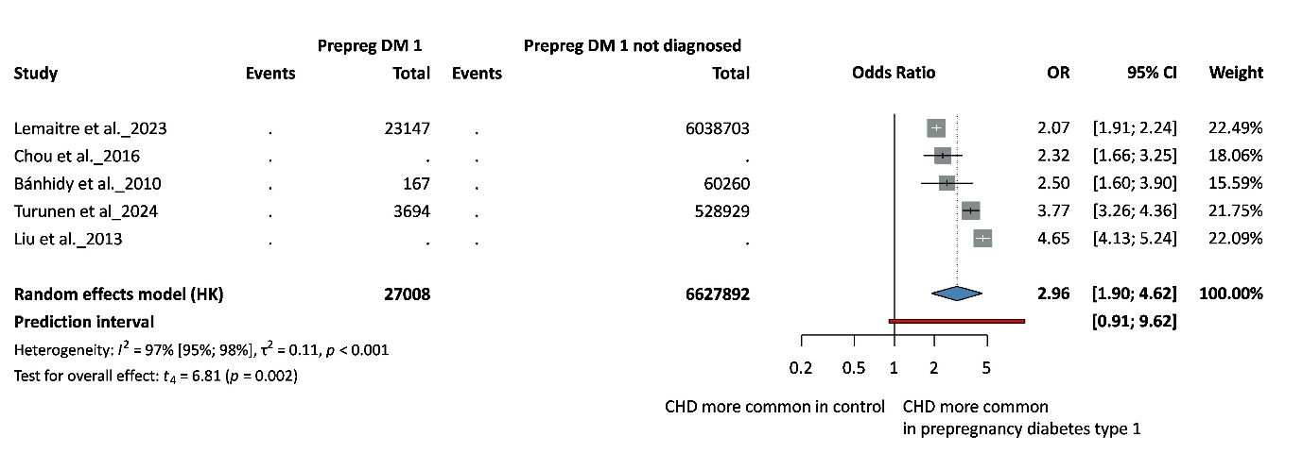

Type 2 diabetes

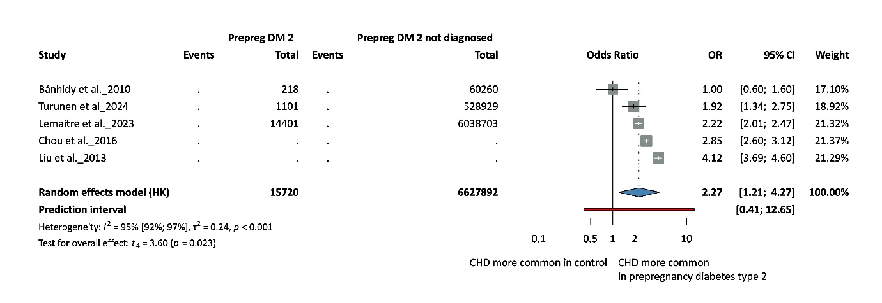

Figure S2. Forest plots of the ORs for maternal diabetes and the risk of specific CHD phenotypes and funnel plots

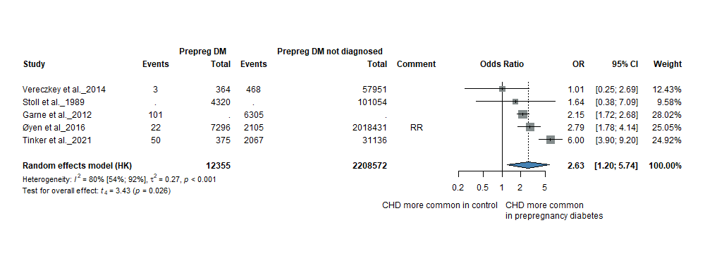
ASD – Forest plot

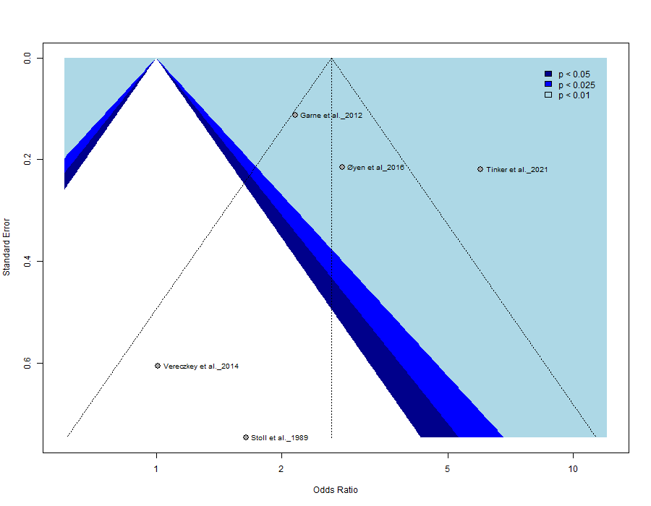
ASD – Funnel plot (Egger’s test: not applicable)

VSD – Forest plot
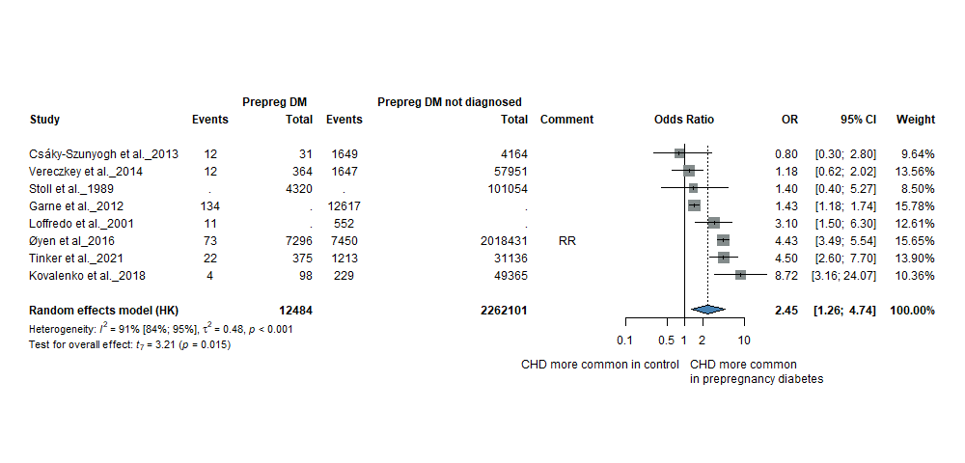

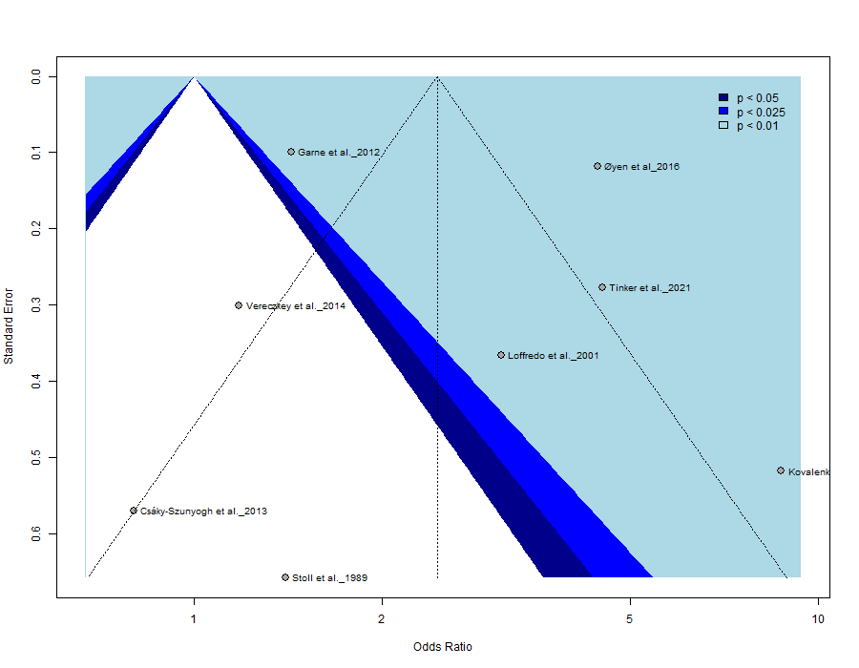
VSD – Funnel plot (Egger’s test: not applicable)

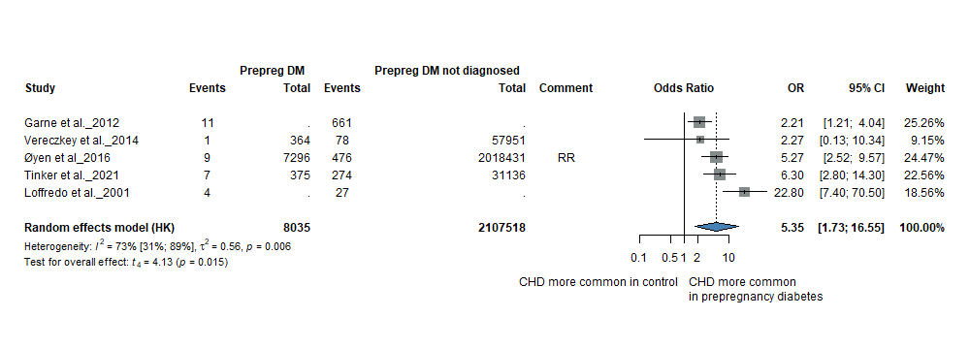
AVSD – Forest plot

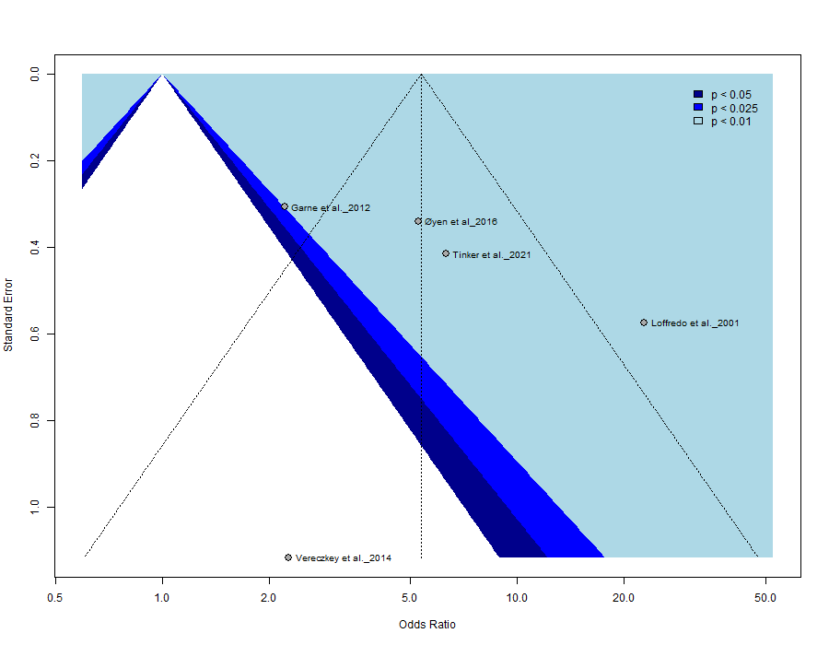
AVSD – Funnel plot (Egger’s test: not applicable)

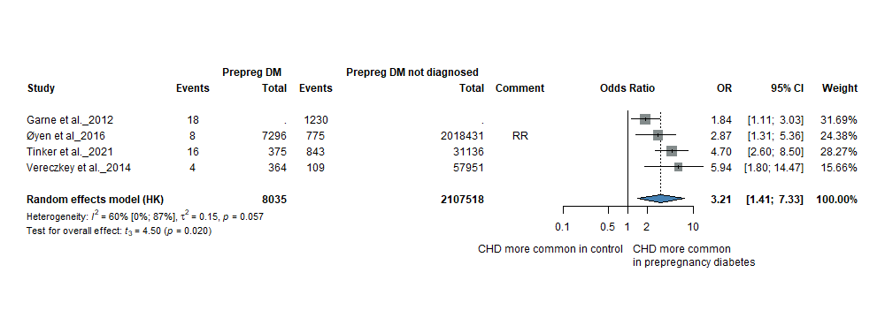
CoA – Forest plot

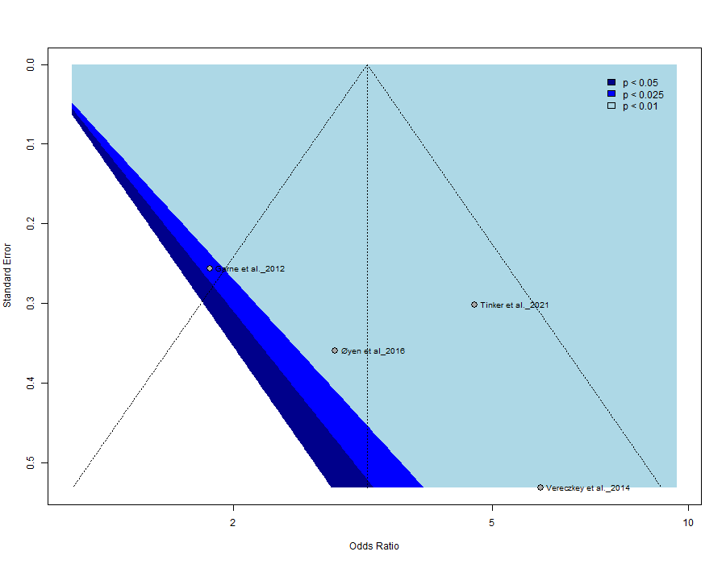
CoA – Funnel plot (Egger’s test: not applicable)

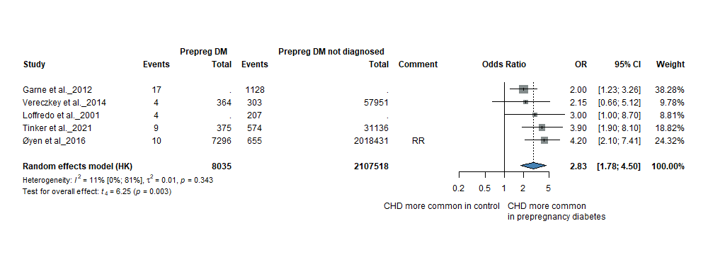
TGA – Forest plot

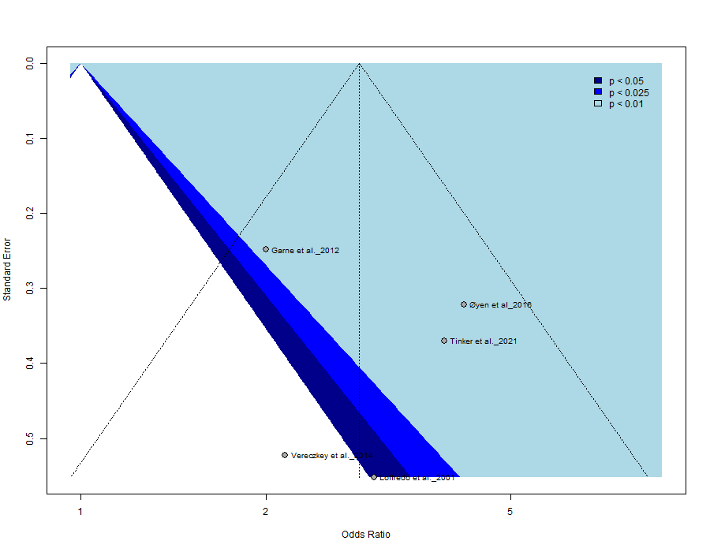
TGA – Funnel plot (Egger’s test: not applicable)

HLHS – Forest plot

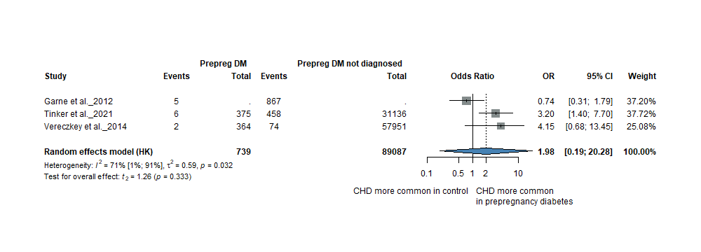

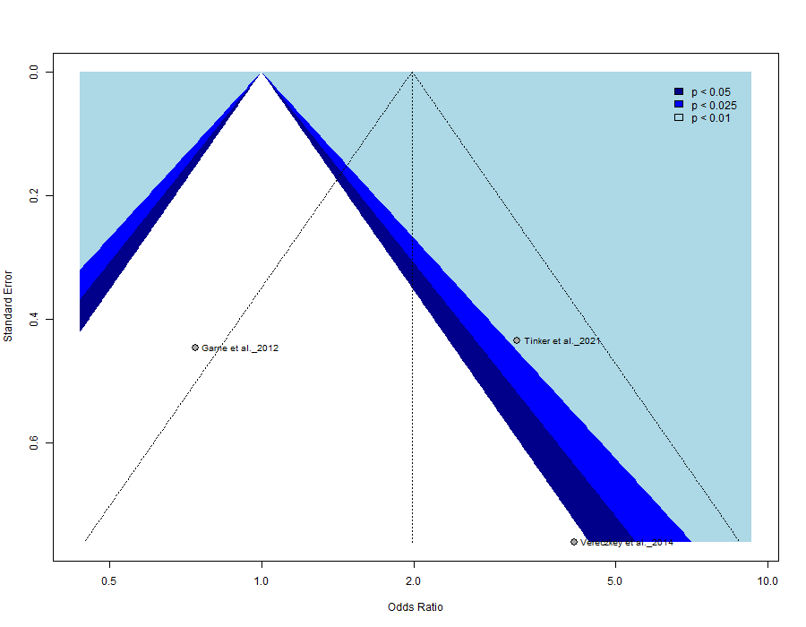
HLHS – Funnel plot (Egger’s test: not applicable)

ToF – Forest plot
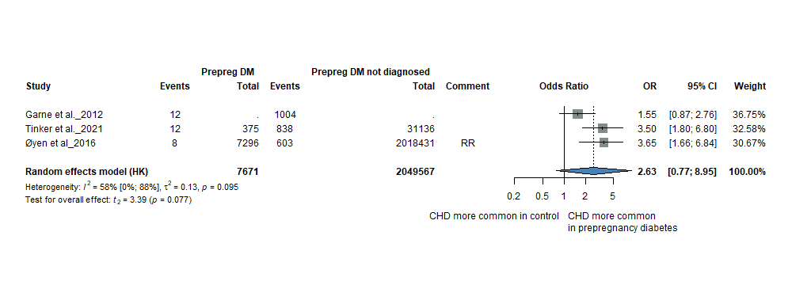

ToF – Funnel plot (Egger’s test: not applicable)

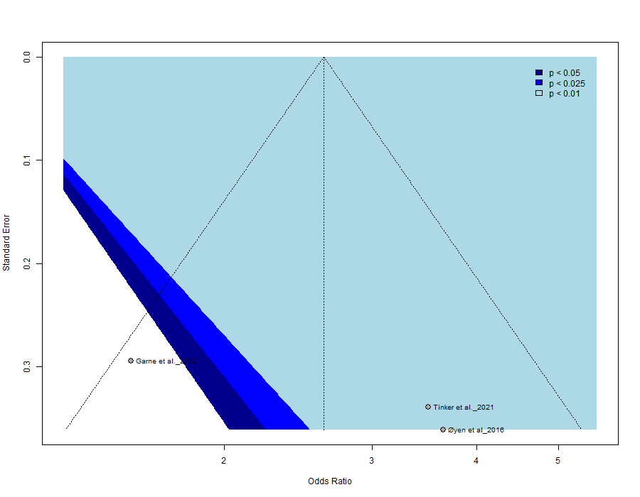

Figure S3. Forest plots of the ORs for maternal obesity and the risk of specific CHD phenotypes and funnel plots

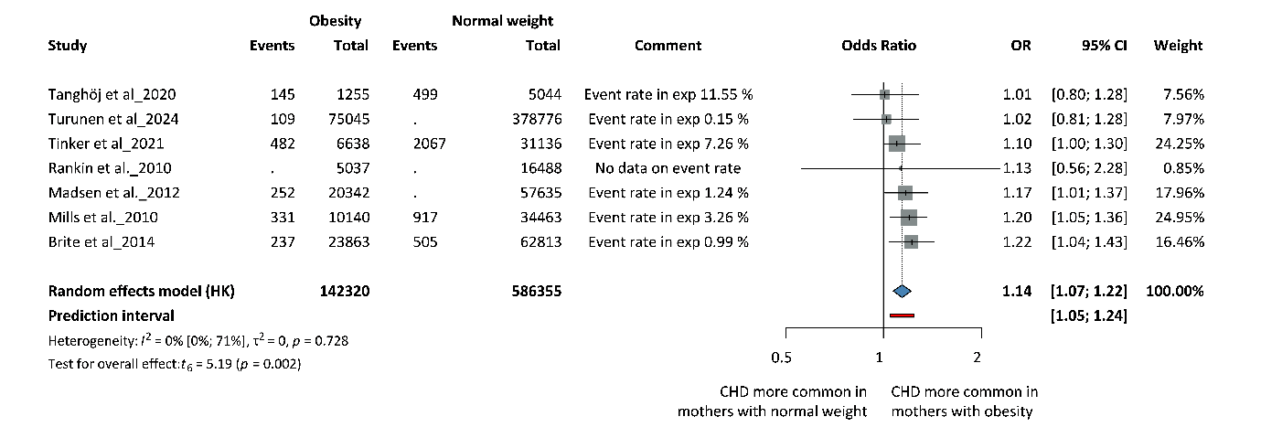
ASD – Forest plot

ASD – Funnel plot (Egger’s test: not applicable)
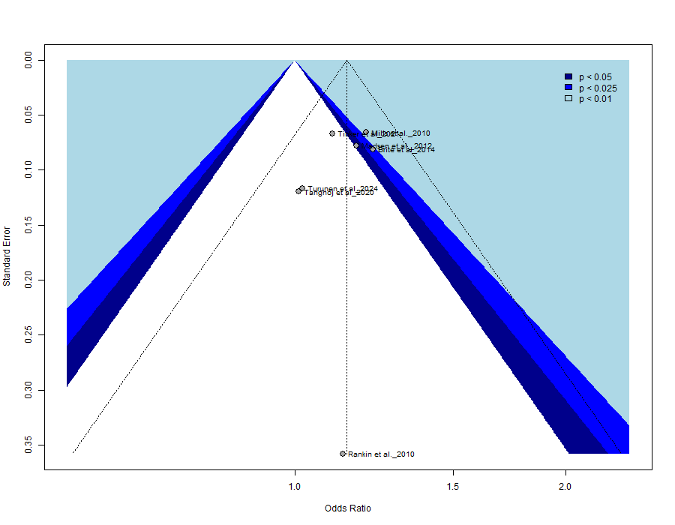

ToF – Forest plot

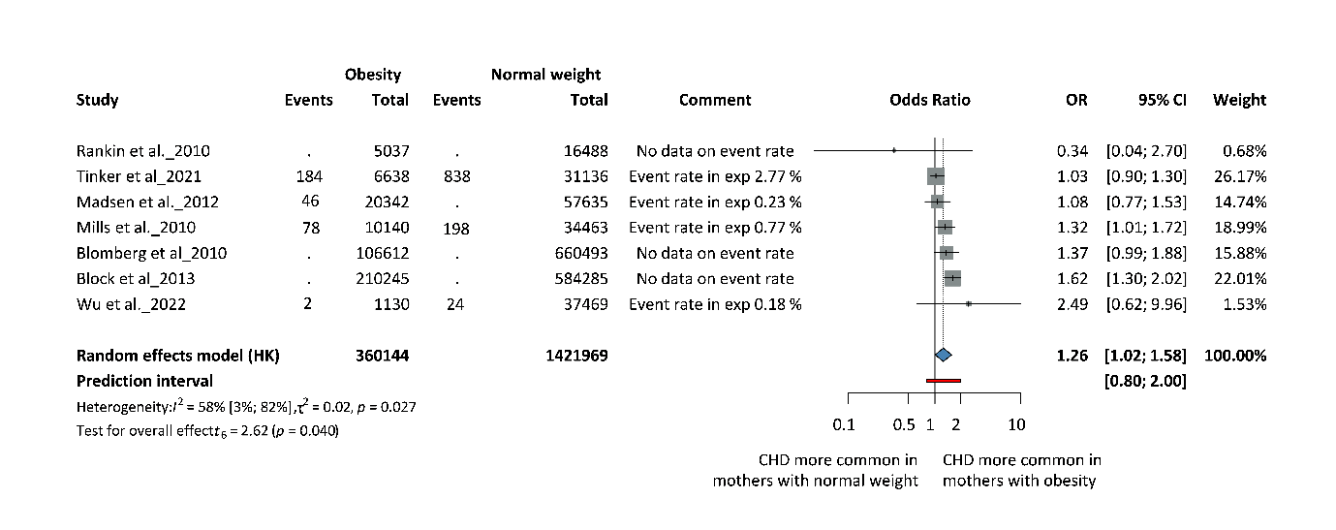

ToF – Funnel plot (Egger’s test: not applicable)
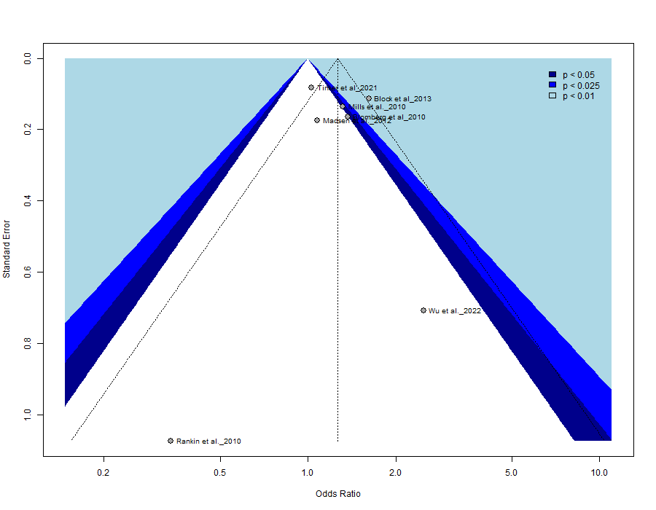

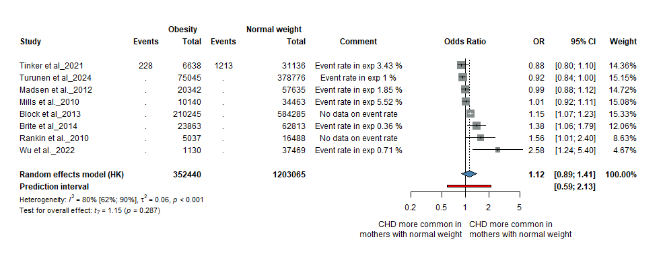
VSD – Forest plot

VSD – Funnel plot (Egger’s test: not applicable)
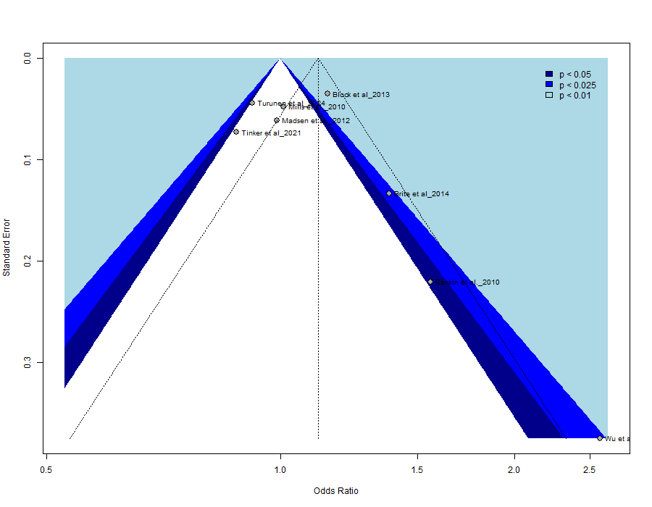

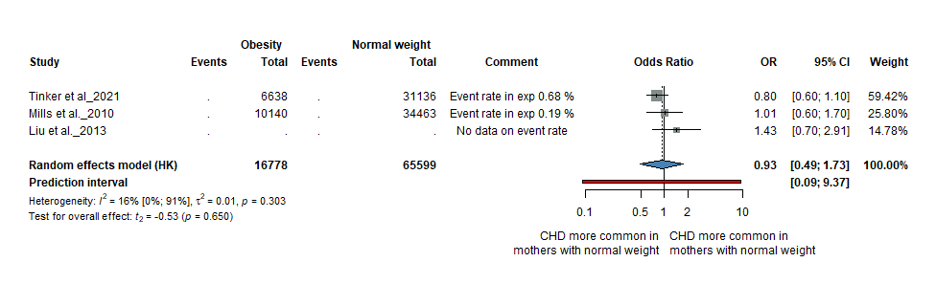
AVSD – Forest plot

AVSD – Funnel plot (Egger’s test: not applicable)
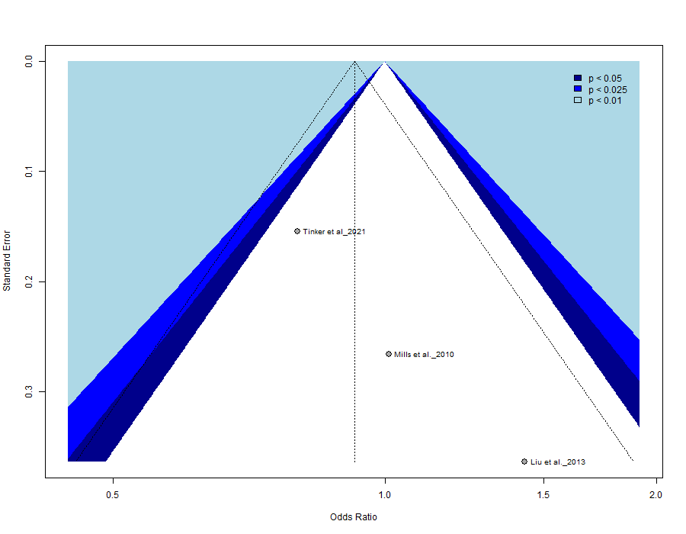

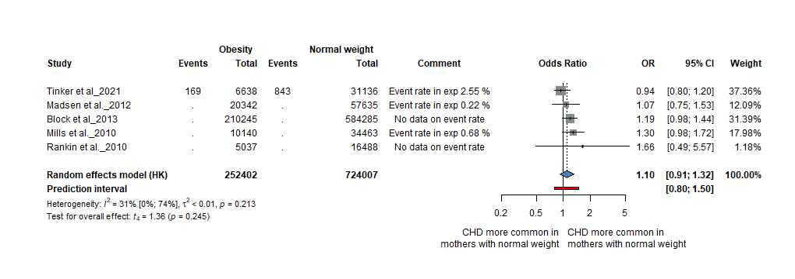
CoA – Forest plot

CoA – Funnel plot (Egger’s test: not applicable)
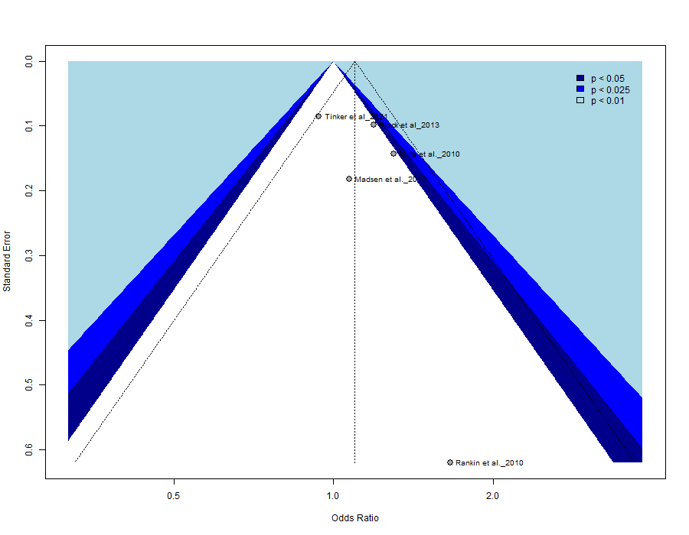

HLHS – Forest plot
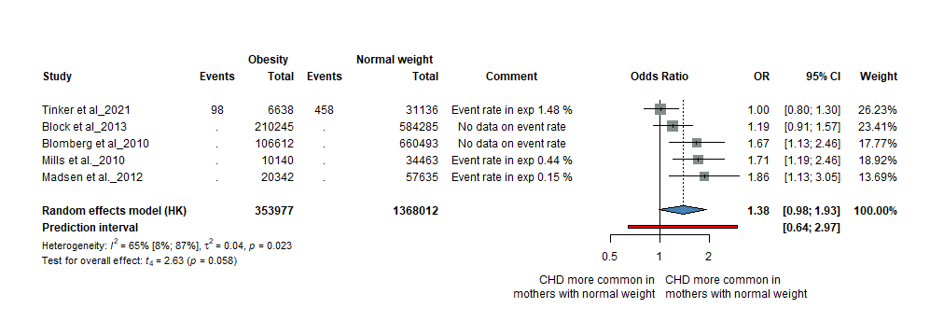

HLHS – Funnel plot (Egger’s test: not applicable)
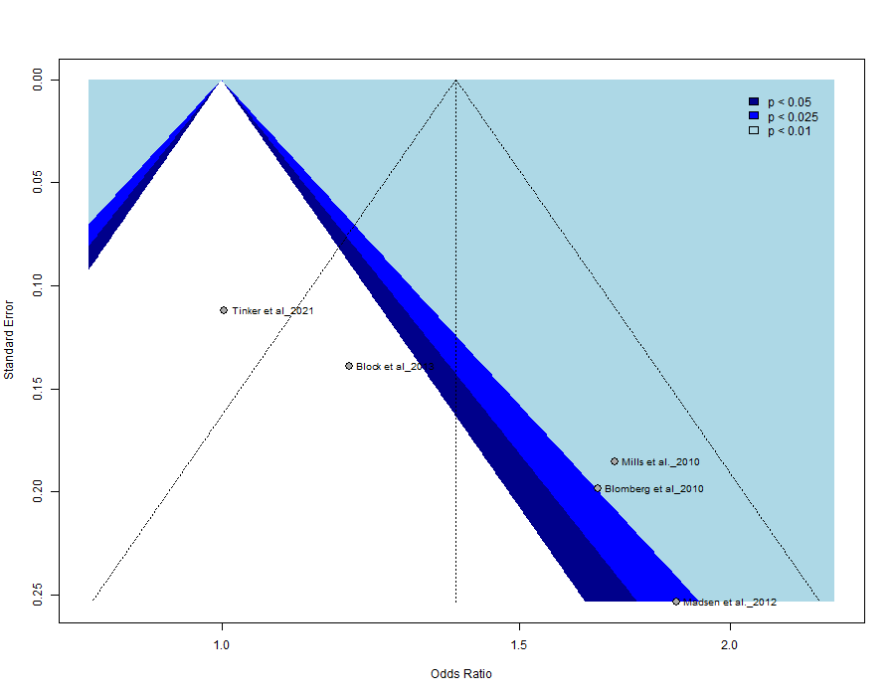

TGA – Forest plot
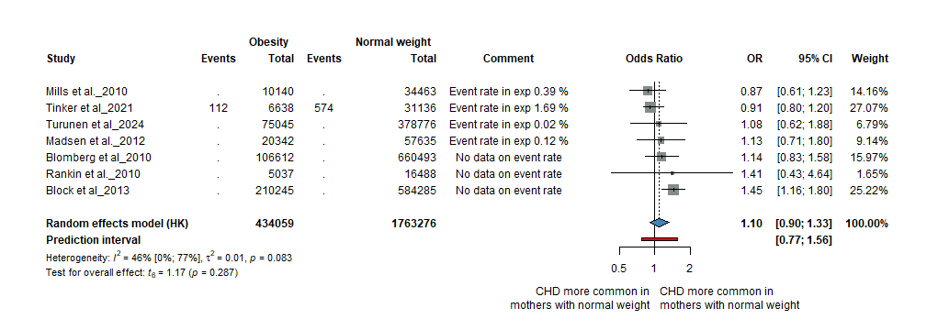

TGA – Funnel plot (Egger’s test: not applicable)
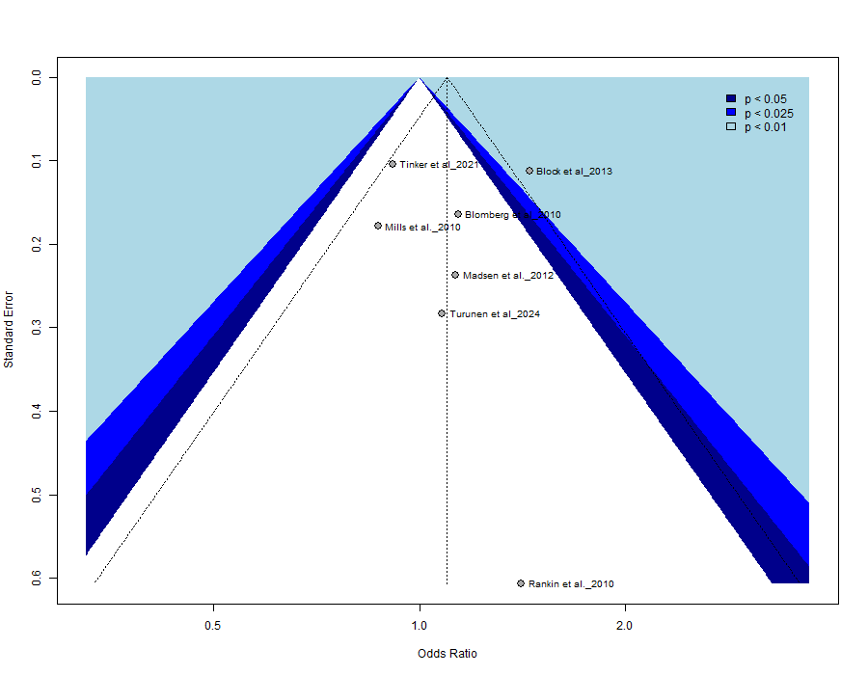

Figure S4. Forest plot of ORs for classified maternal obesity and risk of CHD

Class I obesity (30.0≤BMI<35.0 kg/m²)
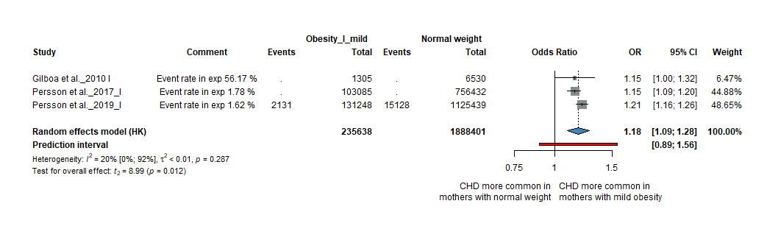
Class II obesity (35.0≤BMI<40.0 kg/m²)
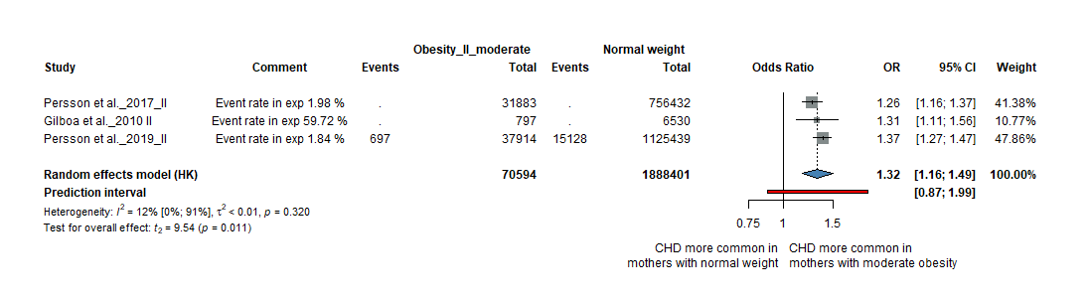
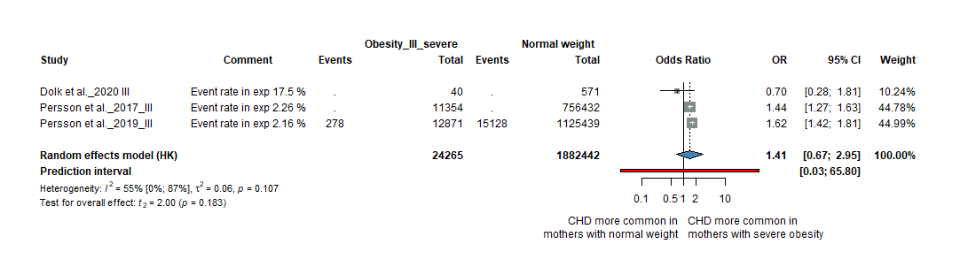
Class III obesity (BMI≥40.0 kg/m²)

Figure S5. Forest plots of the ORs for maternal underweight and the risk of specific CHD phenotypes and funnel plots

VSD – Forest plot
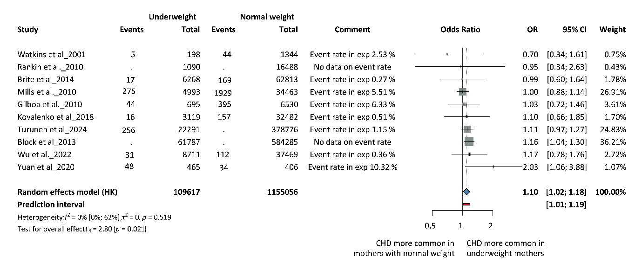
VSD – Funnel plot (Egger’s test: -0.032)

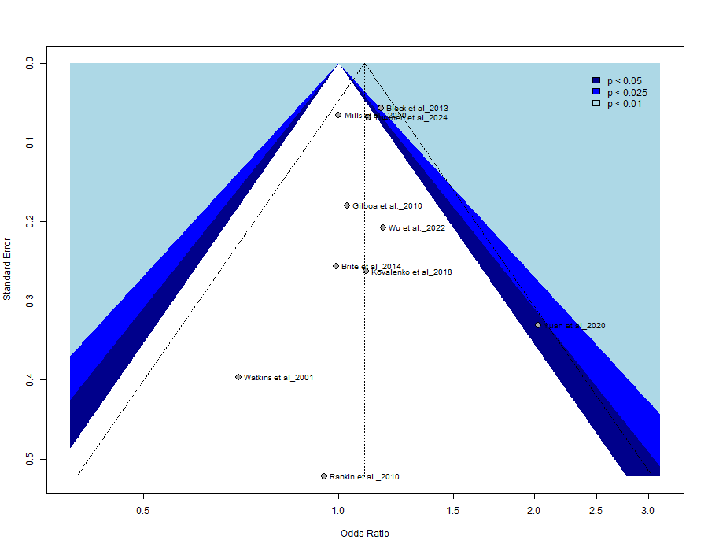

ASD – Forest plot
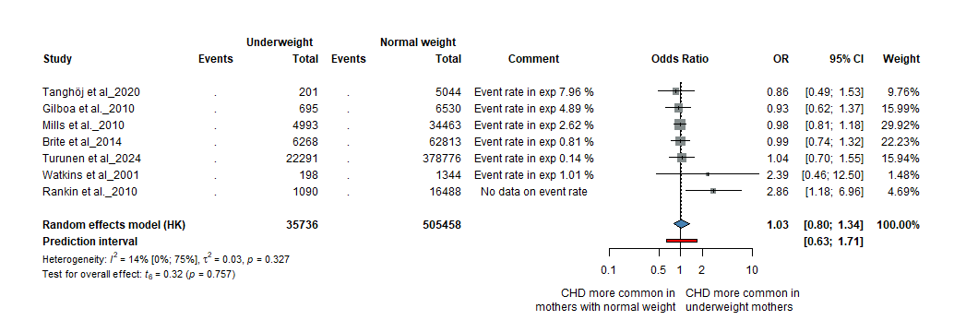

ASD – Funnel plot (Egger’s test: not applicable)
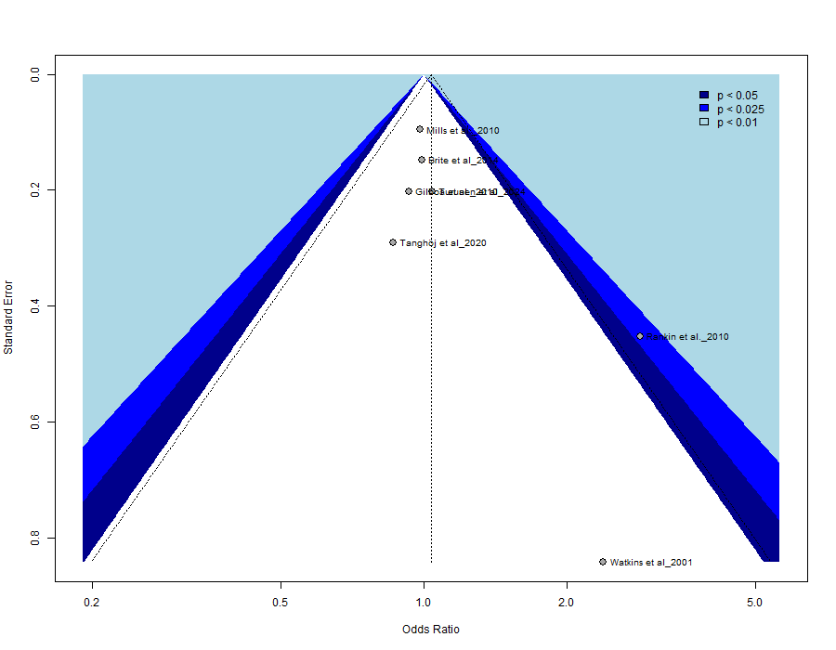

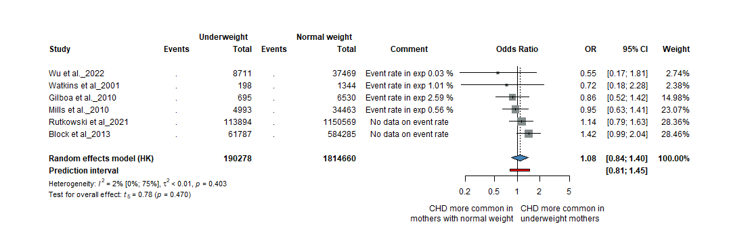
ToF – Forest plot

ToF – Funnel plot (Egger’s test: not applicable)
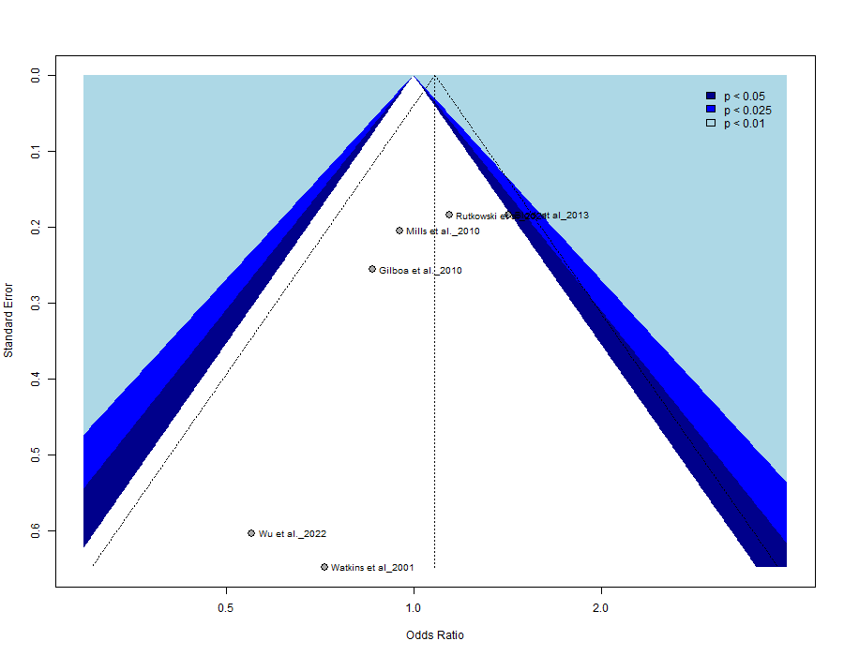

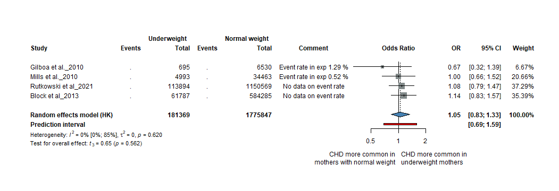
CoA – Forest plot

CoA – Funnel plot (Egger’s test: not applicable)
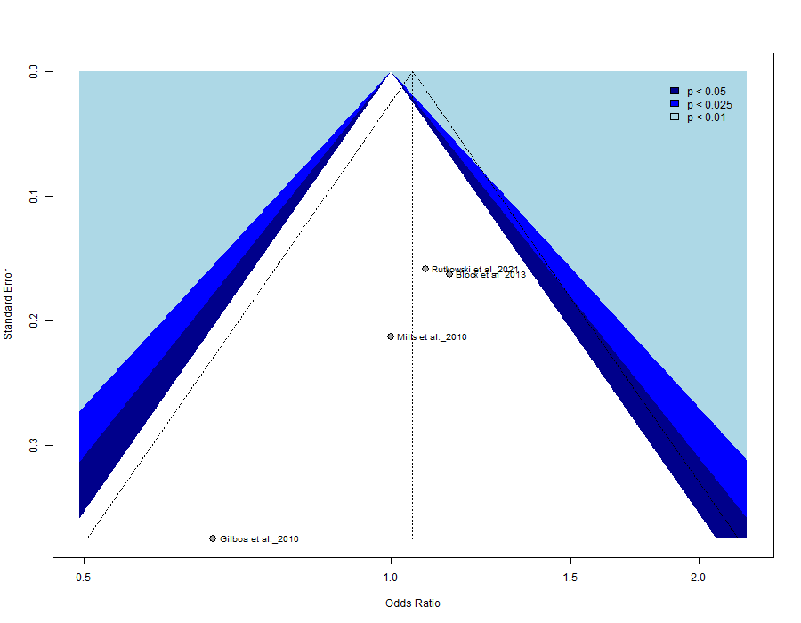

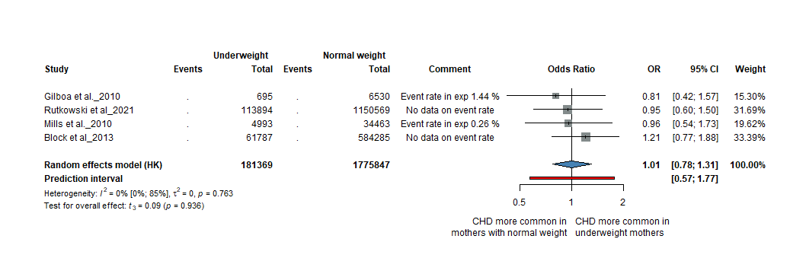
HLHS – Forest plot

HLHS – Funnel plot (Egger’s test: not applicable)
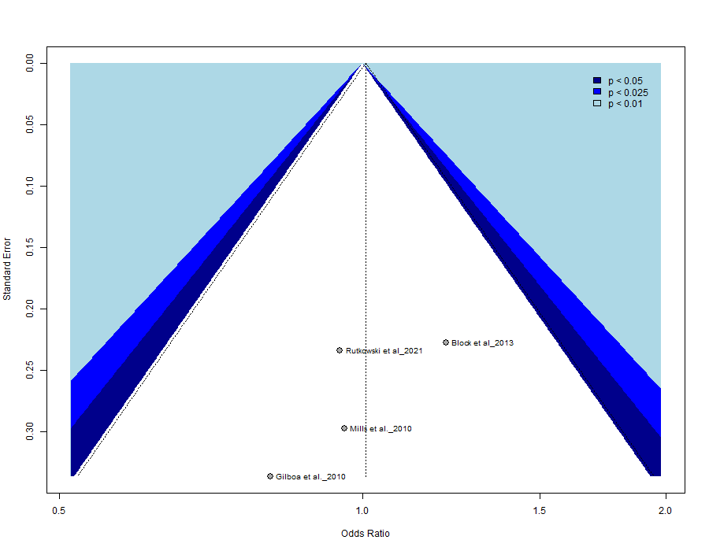

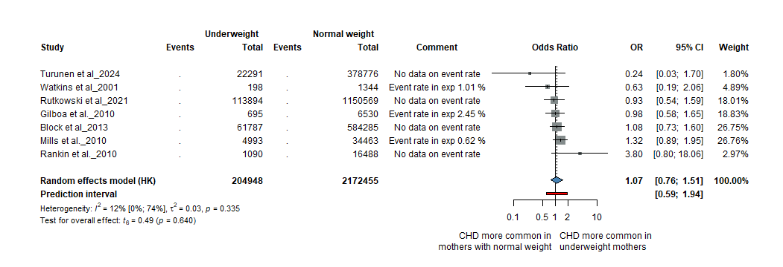
TGA – Forest plot

TGA – Funnel plot (Egger’s test: not applicable)
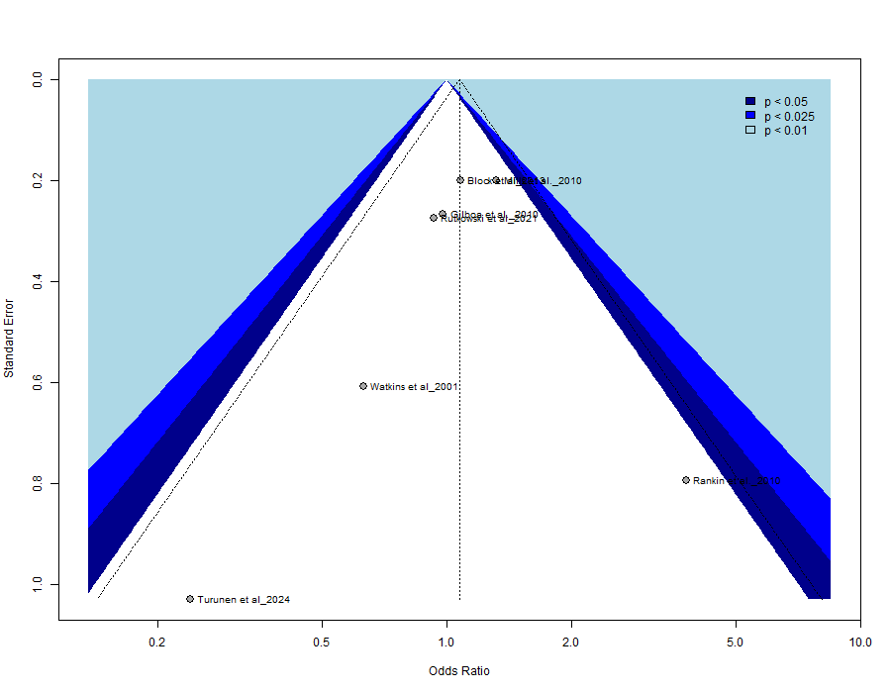

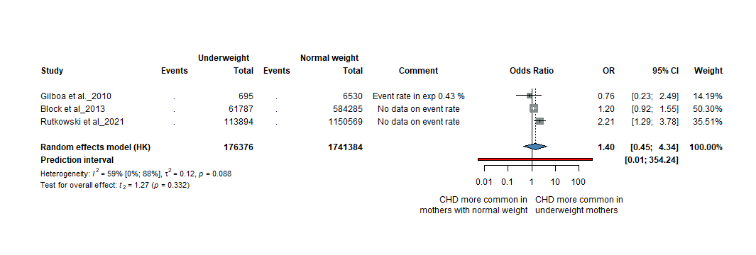
PA – Forest plot

PA – Funnel plot (Egger’s test: not applicable)
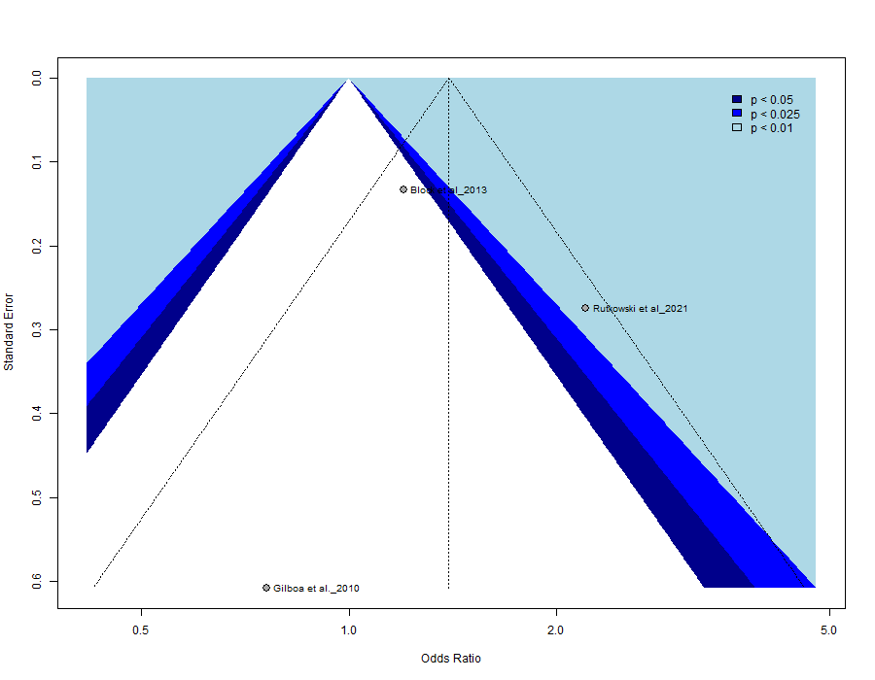

Figure S6. Forest plots of the ORs for maternal smoking and the risk of specific CHD phenotypes and funnel plots

(A). Active smoking

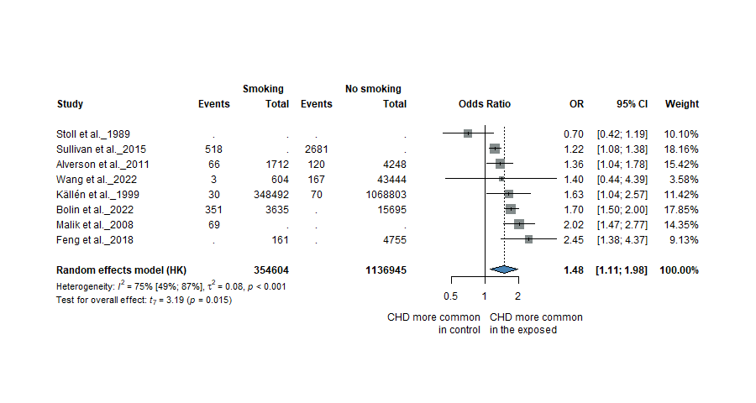
ASD – Forest plot

ASD – Funnel plot (Egger’s test: not applicable)
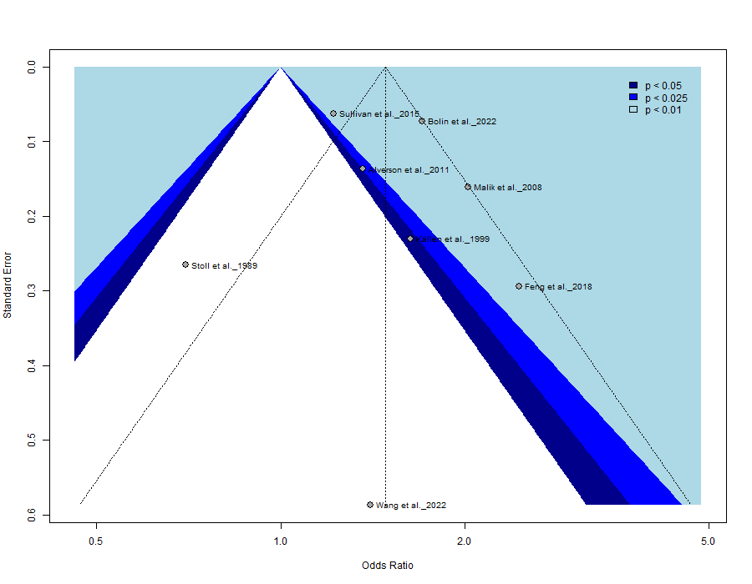
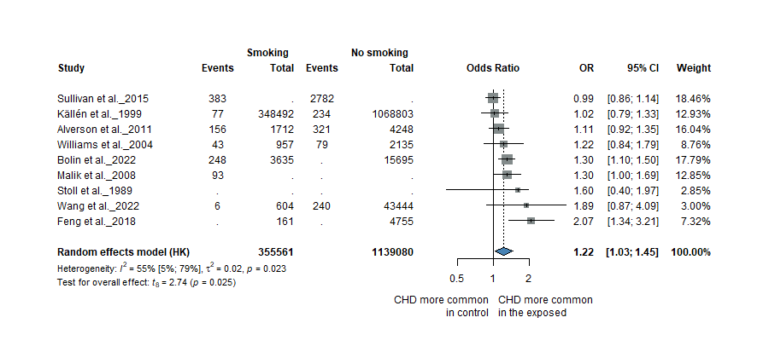
VSD – Forest plot

VSD – Funnel plot (Egger’s test: not applicable)
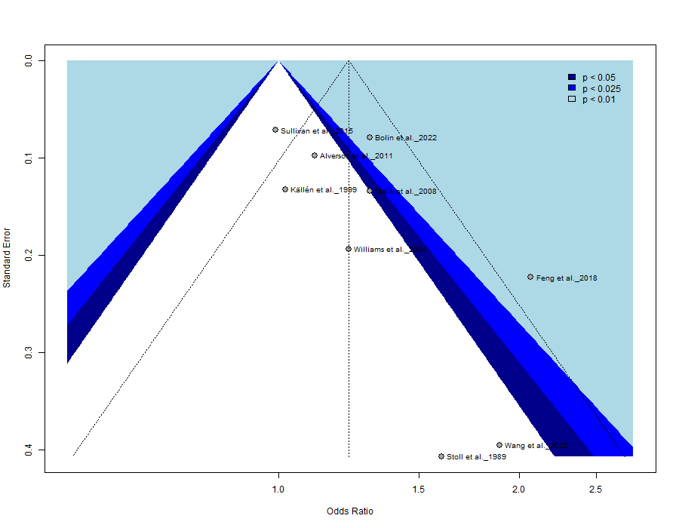

AVSD – Forest plot
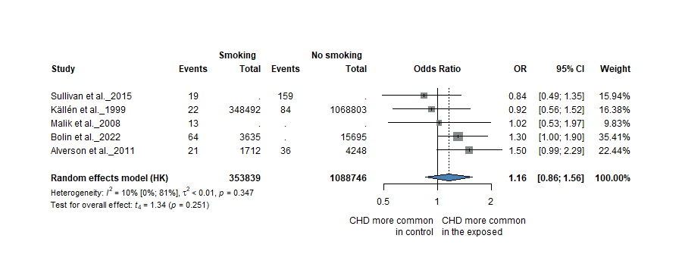

AVSD – Funnel plot (Egger’s test: not applicable)
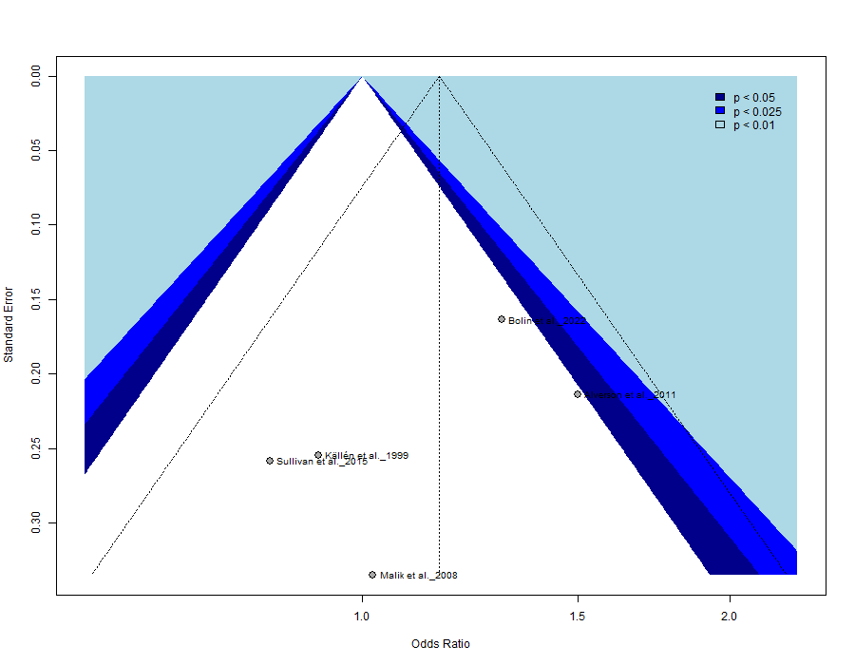

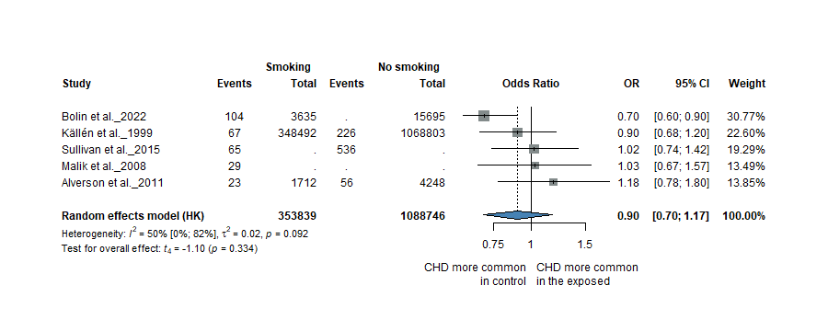
CoA – Forest plot

CoA – Funnel plot (Egger’s test: not applicable)
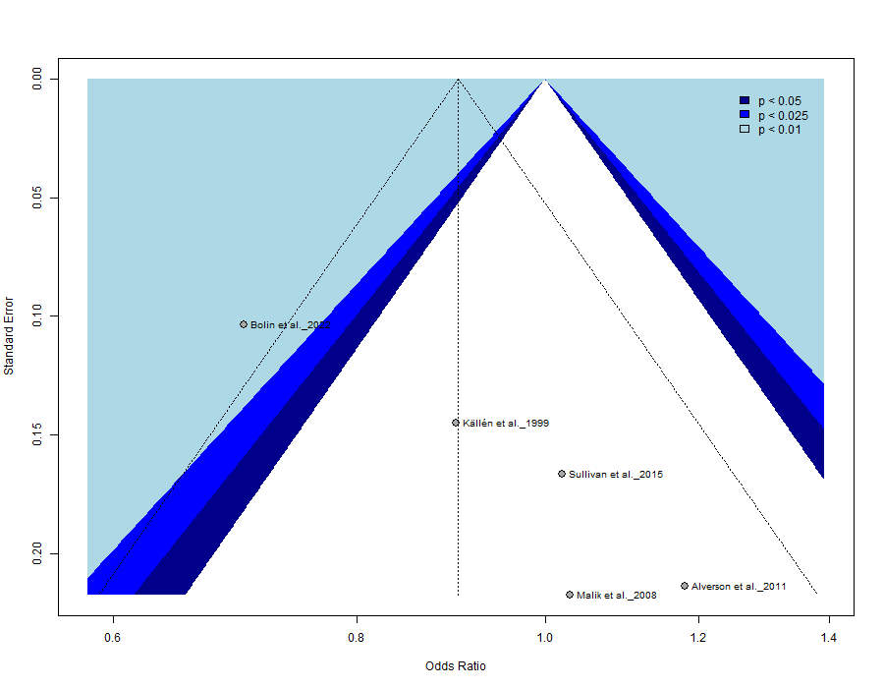

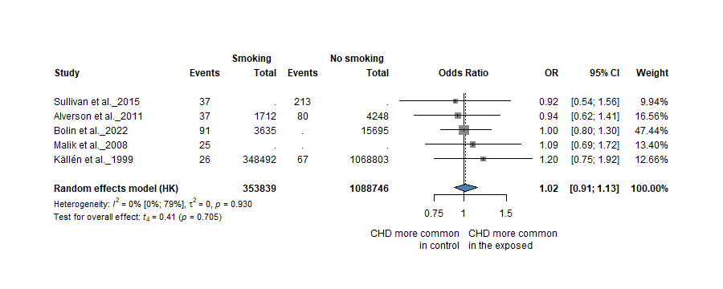
HLHS – Forest plot

HLHS – Funnel plot (Egger’s test: not applicable)
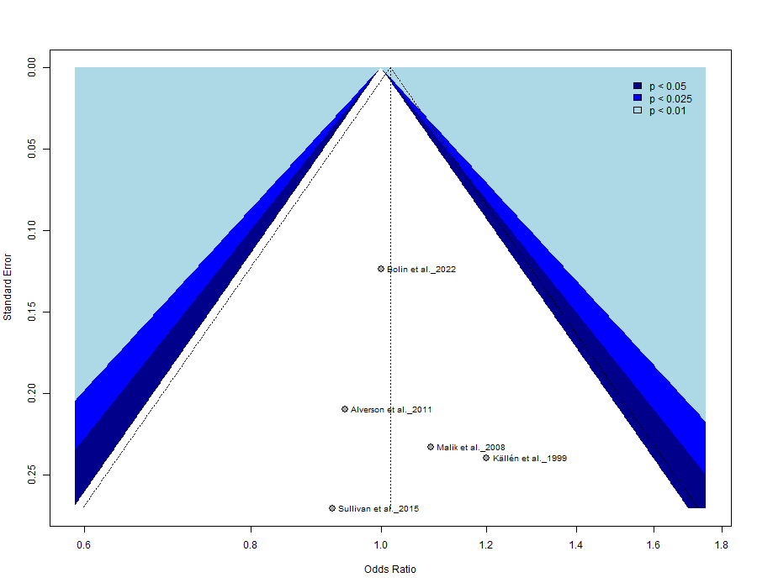

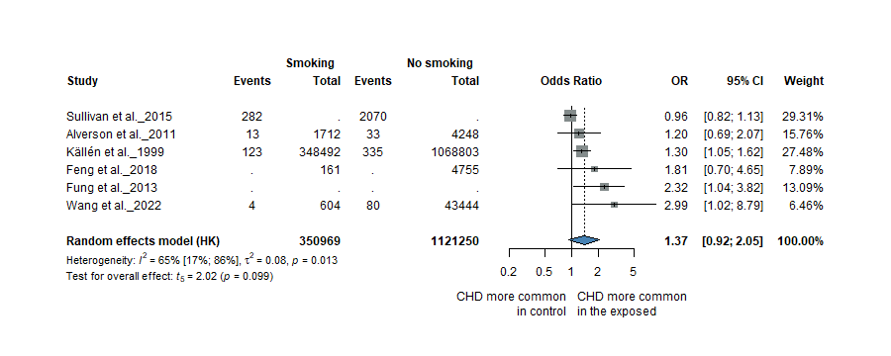
PDA – Forest plot

PDA – Funnel plot (Egger’s test: not applicable)
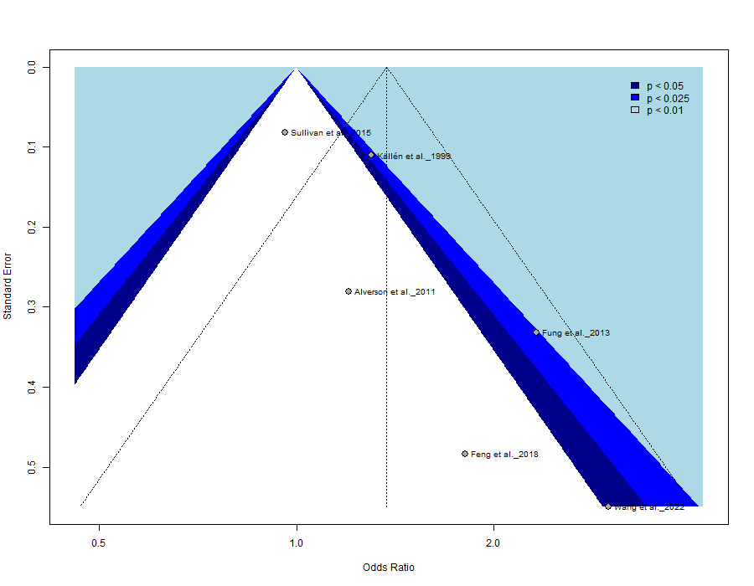

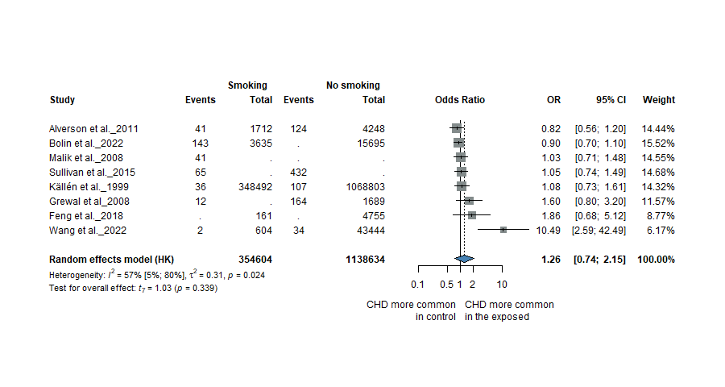
ToF – Forest plot

ToF – Funnel plot (Egger’s test: not applicable)
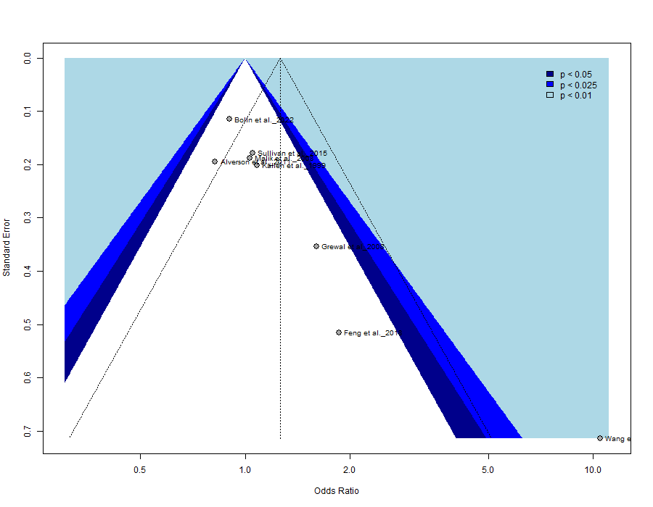

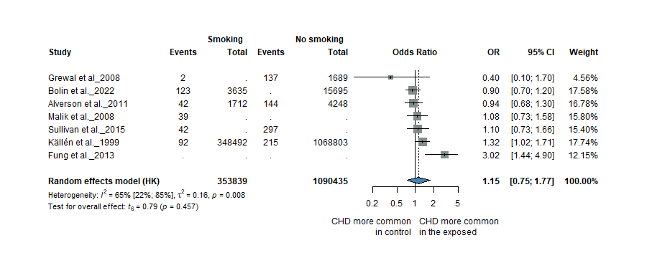
TGA – Forest plot

TGA – Funnel plot (Egger’s test: not applicable)
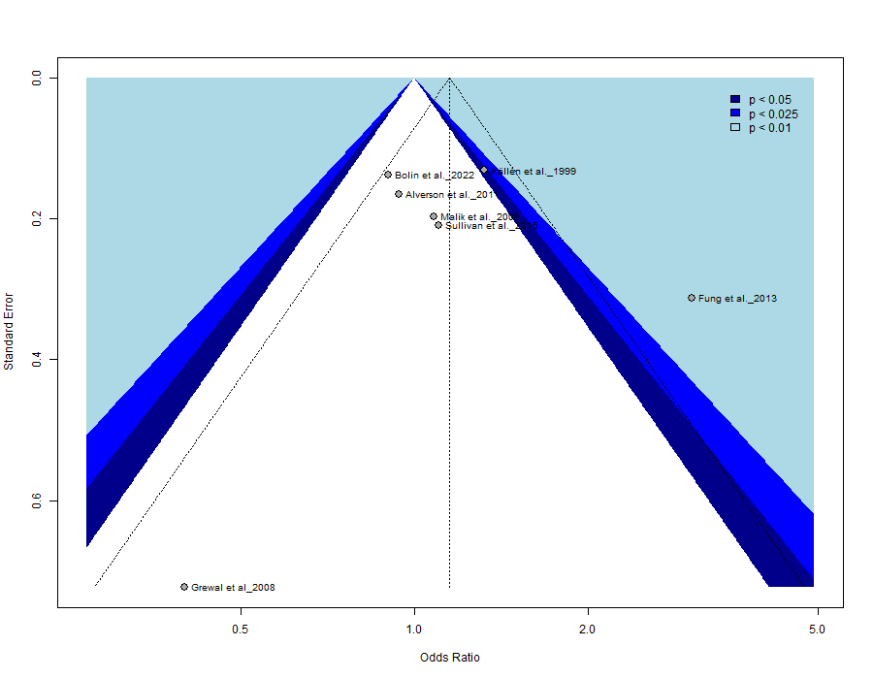

(B). Passive smoking

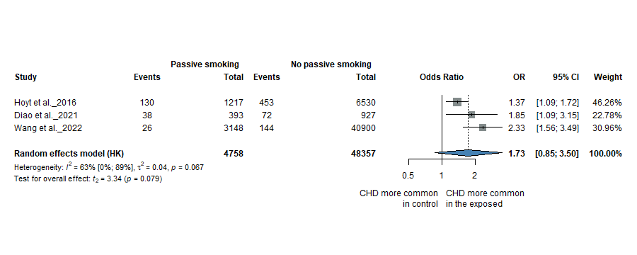
ASD – Forest plot

ASD – Funnel plot (Egger’s test: not applicable)
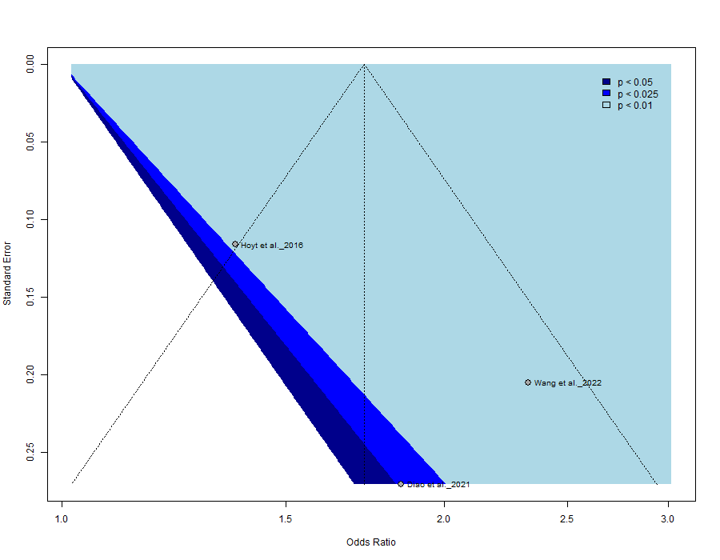

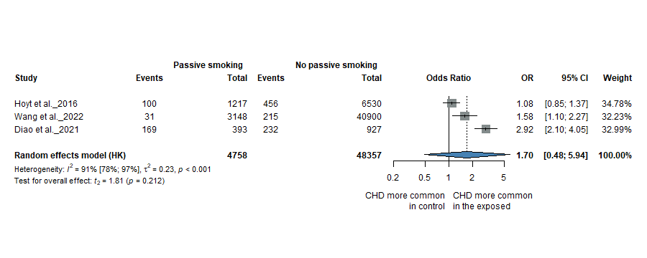
VSD – Forest plot

VSD – Funnel plot (Egger’s test: not applicable)
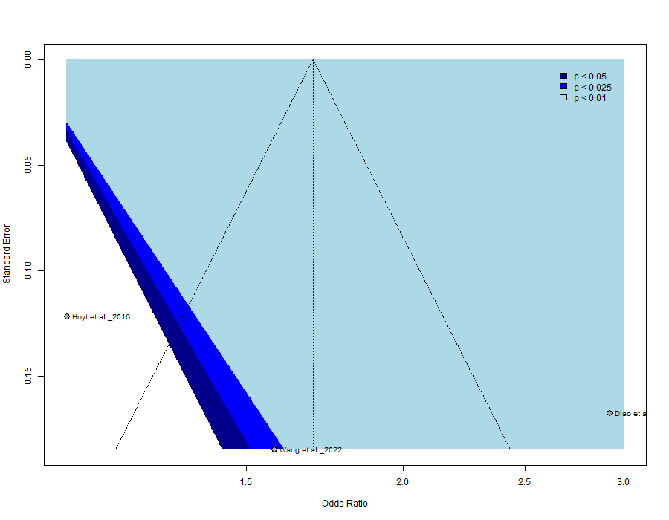

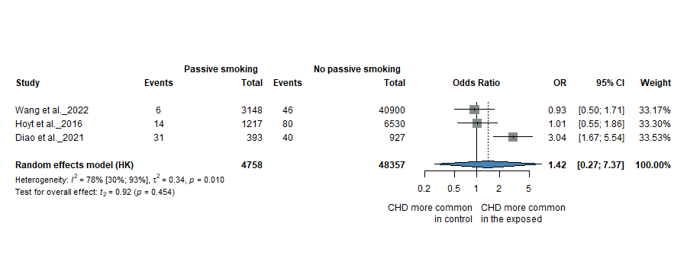
AVSD – Forest plot

AVSD – Funnel plot (Egger’s test: not applicable)

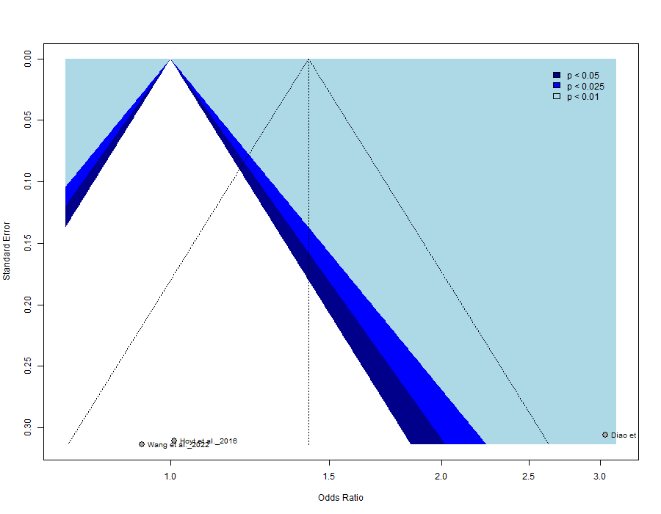

Figure S7. Forest plots of the ORs for maternal alcohol consumption and the risk of specific CHD phenotypes and funnel plots

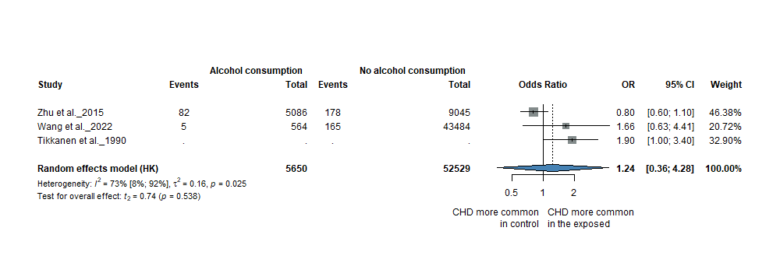
ASD – Forest plot

ASD – Funnel plot (Egger’s test: not applicable)
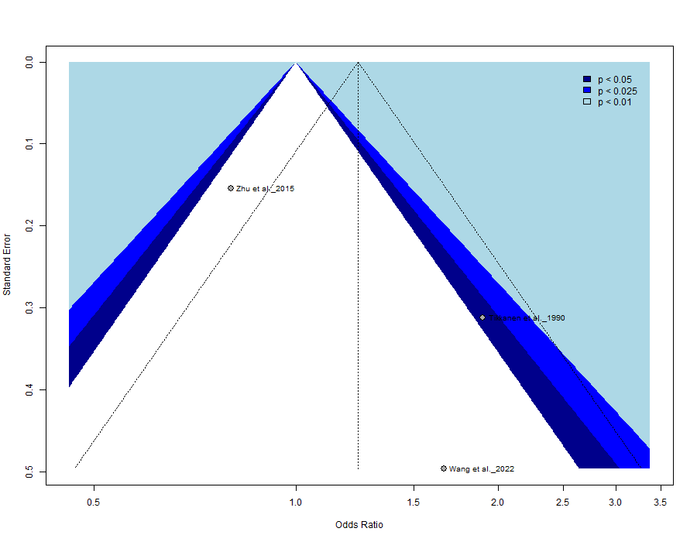

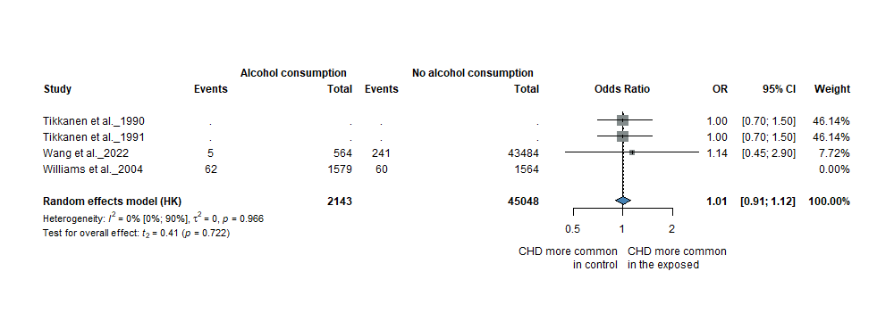
VSD – Forest plot

VSD – Funnel plot (Egger’s test: not applicable)
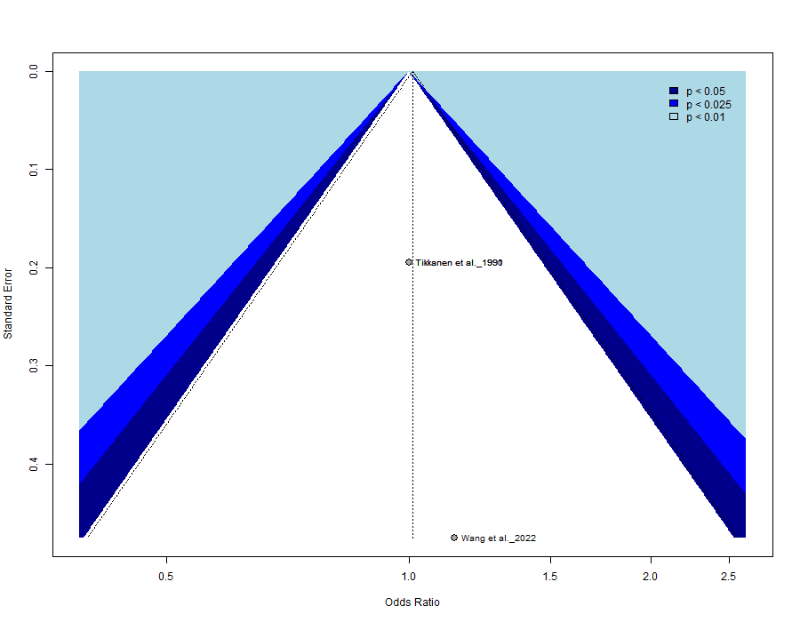

Figure S8. Forest plots of the ORs for maternal chronic hypertension and the risk of specific CHD phenotypes and funnel plots

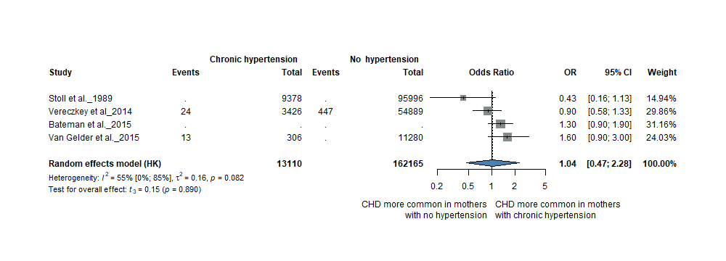
ASD – Forest plot

ASD – Funnel plot (Egger’s test: not applicable)
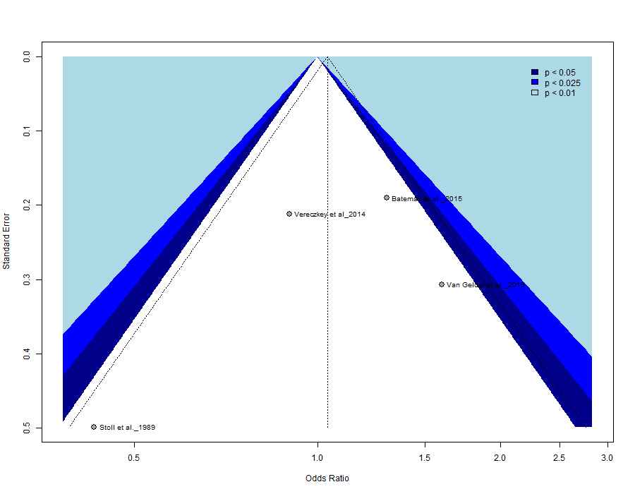

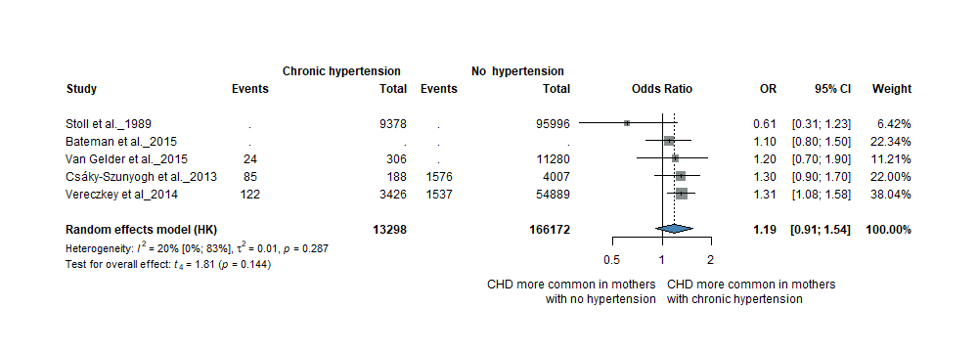
VSD – Forest plot

VSD – Funnel plot (Egger’s test: not applicable)
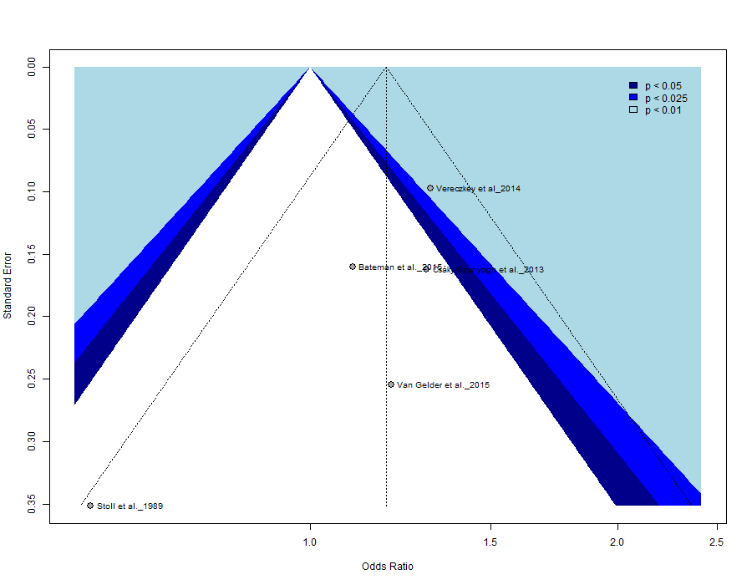

Table S6. RoB assessments

Index | Study | Study Participation (D1) | Study Attrition (D2) | Obesity (D3.1) | Diabetes (D3.2) | Smoking (D3.3) | Alcohol Consumption (D3.4) | Underweight (D3.5) | Hypertension (D3.6) | Outcome measurement (D4) | Study confounding (D5) | Statistical analysis reporting (D6) | Overall risk of bias
1 | Dong and Hao (2024) | + | + |  | + |  |  |  |  | + | - | + | -
2 | Turunen et al. (2024) | + | NA | + | + |  |  | + |  | + | + | + | +
3 | Amini-Rarani et al. (2023) | + | NA |  |  | ? | ? |  |  | + | + | ? | ?
4 | Kawai et al. (2023) | + | ? | + | + | + | + | + |  | + | + | + | +
5 | Lemaitre et al. (2023) | + | NA |  | ? |  |  |  |  | + | ? | + | ?
6 | Bolin et al. (2022) | + | NA |  |  | + |  |  |  | + | + | + | +
7 | Mezzasalma et al. (2022) | + | + |  |  |  |  | + |  | ? | + | + | +
8 | Wang et al. (2022) | + | ? |  |  |  | + |  |  | + | + | + | +
9 | Wang et al. (2022) | + | ? |  |  | + |  |  |  | + | + | + | +
10 | Wu et al. (2022) | + | NA | + | ? |  |  | + |  | + | + | + | +
11 | Diao et al. (2021) | + | NA |  |  | + |  |  |  | ? | + | + | +
12 | Jin et al. (2021) | + | ? |  |  |  |  | + |  | + | - | + | -
13 | Kurita et al. (2021) | + | + |  |  |  | + |  |  | + | + | + | +
14 | Luo et al. (2021) | + | ? |  | + |  |  |  |  | + | + | + | +
15 | Rutkowski et al. (2021) | + | NA | + |  |  |  | + |  | + | + | + | +
16 | Saad et al. (2021) | + | + | ? |  | ? | ? | ? |  | + | + | + | +
17 | Tinker et al. (2021) | + | + | + | + |  |  |  |  | ? | - | + | -
18 | Taylor et al. (2021) | + | ? | ? |  | + |  | ? |  | ? | + | + | ?
19 | Ahmadi et al. (2020) | ? | NA | ? |  |  |  |  |  | + | - | + | -
20 | Dolk et al. (2020) | + | NA | + | ? |  |  | + |  | ? | + | + | ?
21 | Giraldo-Grueso et al. (2020) | + | NA | - | - |  |  | - |  | ? | - | ? | -
22 | Li et al. (2020) | + | ? |  |  | + |  |  |  | + | + | + | +
23 | Luo et al. (2020) | ? | NA |  | + |  |  |  |  | + | + | + | +
24 | Tanghöj et al. (2020) | ? | NA | + |  |  |  | + |  | ? | + | + | ?
25 | Yuan et al. (2020) | + | + |  |  |  |  | ? |  | + | + | + | +
26 | Zhao et al. (2020) | ? | NA |  | + |  |  |  |  | + | ? | + | ?
27 | Perry et al. (2019) | + | NA |  |  | + |  |  |  | ? | + | + | +
28 | Persson et al. (2019) | + | + | + | + | + |  | + |  | + | + | + | +
29 | Robinson et al. (2019) | + | NA |  | ? |  |  |  |  | + | + | + | +
30 | Feng et al. (2018) | + | ? |  |  | + |  |  |  | + | ? | + | ?
31 | Helle et al. (2018) | + | NA |  | ? |  |  |  |  | ? | + | + | ?
32 | Kovalenko et al. (2018) | + | + |  | ? |  |  | + |  | ? | + | + | ?
33 | Persson et al. (2017) | + | + | + |  |  |  | + |  | + | + | + | +
34 | Chou et al. (2016) | ? | NA |  | ? |  |  |  | ? | ? | + | + | ?
35 | Hoyt et al. (2016) | + | NA |  |  | + |  |  |  | + | ? | + | +
36 | Øyen et al. (2016) | + | NA |  | + |  |  |  |  | ? | + | + | +
37 | Bateman et al. (2015) | + | ? |  |  |  |  |  | + | ? | ? | + | ?
38 | Sullivan et al. (2015) | + | NA |  |  | ? |  |  |  | ? | + | + | ?
39 | Van Gelder et al. (2015) | + | + |  |  |  |  |  | + | ? | + | + | +
40 | Zhu et al. (2015) | ? | + |  |  |  | ? |  |  | + | - | + | -
41 | Brite et al. (2014) | + | + | ? |  |  |  | ? |  | + | + | + | +
42 | Ghaderian et al. (2014) | + | + | + |  |  |  | + |  | + | - | ? | -
43 | Leite et al. (2014) | + | NA |  |  | + |  |  |  | + | ? | + | +
44 | Vereczkey et al. (2014) | ? | + |  | + |  |  |  | + | + | + | + | +
45 | Block et al. (2013) | + | ? | + |  |  |  | + |  | ? | + | + | ?
46 | Csáky-Szunyogh et al. (2013) | ? | + |  | ? |  |  |  | ? | + | + | + | ?
47 | Fung et al. (2013) | + | + |  | + | ? | ? |  | + | + | - | ? | -
48 | Liu et al. (2013) | + | NA | ? | + |  |  |  | + | + | + | + | +
49 | Nie et al. (2013) | + | NA |  | ? |  |  |  |  | + | + | + | +
50 | Taksande et al. (2013) | ? | NA |  | + |  |  |  |  | + | - | ? | -
51 | Baardman et al. (2012) | + | ? |  |  | + |  |  |  | ? | + | + | ?
52 | Balaha et al. (2012) | + | ? | ? |  |  |  |  |  | + | - | ? | -
53 | Garne et al. (2012) | ? | NA |  | + |  |  |  |  | ? | ? | + | ?
54 | Madsen et al. (2012) | + | NA | + |  |  |  | + |  | ? | ? | + | ?
55 | Mateja et al. (2012) | + | ? | ? | + |  |  | ? | ? | ? | + | + | -
56 | Alverson et al. (2011) | + | NA |  |  | + |  |  |  | ? | + | + | +
57 | Karatza et al. (2011) | ? | NA |  | ? | + |  |  |  | + | ? | + | -
58 | Zen et al. (2011) | ? | + |  |  |  | + |  |  | + | - | ? | -
59 | Bánhidy et al. (2010) | ? | + |  | + |  |  |  |  | + | + | + | +
60 | Blomberg et al. (2010) | ? | NA | + |  |  |  | + |  | ? | + | + | ?
61 | Gilboa et al. (2010) | + | NA | + |  | + |  | + | + | + | ? | + | ?
62 | Kuciene et al. (2010) | ? | ? |  |  | + |  |  |  | ? | - | + | -
63 | Mills et al. (2010) | + | ? | + |  |  |  | + |  | + | + | + | +
64 | Rankin et al. (2010) | + | ? | + |  |  |  | + |  | + | + | + | +
65 | Grewal et al. (2008) | + | + |  |  | + |  |  |  | ? | + | + | +
66 | Malik et al. (2008) | + | ? | + |  | + | + | + |  | + | + | + | +
67 | Waller et al. (2007) | + | ? | + |  |  |  | + |  | ? | + | + | +
68 | Williams et al. (2004) | ? | ? |  |  | + | + |  |  | ? | + | + | ?
69 | Cedergren et al. (2002) | + | NA |  |  | + | + |  |  | ? | - | + | -
70 | Loffredo et al. (2001) | + | ? |  | ? |  |  |  |  | + | + | + | ?
71 | Watkins et al. (2001) | + | ? | + |  |  |  | + |  | + | + | + | +
72 | Källén et al. (1999) | ? | NA |  |  | + |  |  |  | + | ? | + | ?
73 | Janssen et al. (1996) | + | NA |  | ? |  |  |  |  | ? | + | + | ?
74 | Pradat (1992) | ? | ? |  |  | + |  |  |  | + | - | + | -
75 | Tikkanen et al. (1991) | + | ? |  |  |  | + |  |  | + | + | + | +
76 | Tikkanen et al. (1991) | + | ? |  |  |  | + |  |  | + | + | + | +
77 | Tikkanen et al. (1990) | ? | ? |  |  |  | + |  | + | + | + | + | ?
78 | Stoll et al. (1989) | ? | ? |  | ? | + |  |  | ? | + | - | + | -
Green (+) = Low risk; Orange (?) = Moderate risk; Red (−) = High risk; Grey (NA) = Not applicable
Figure S9. Funnel plots for overall CHD

(A). Maternal pre-pregnancy diabetes (Egger’s test = -0.112)
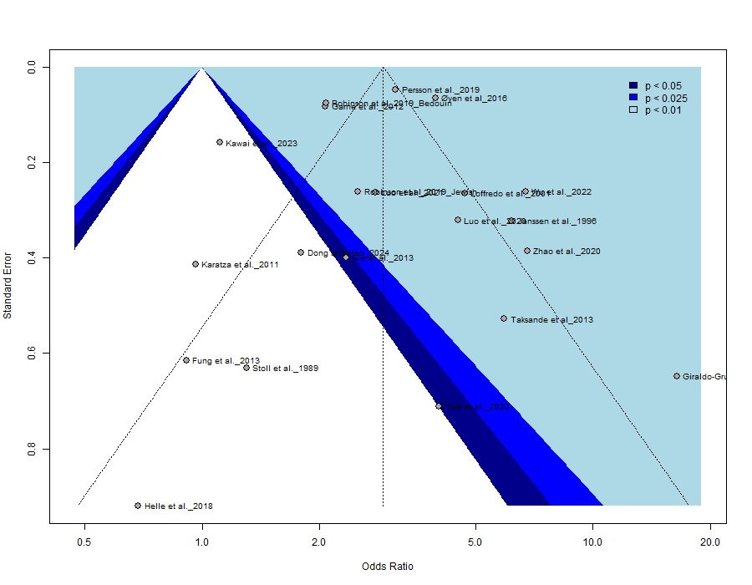

(B). Maternal type 1 diabetes (Egger’s test: not applicable) 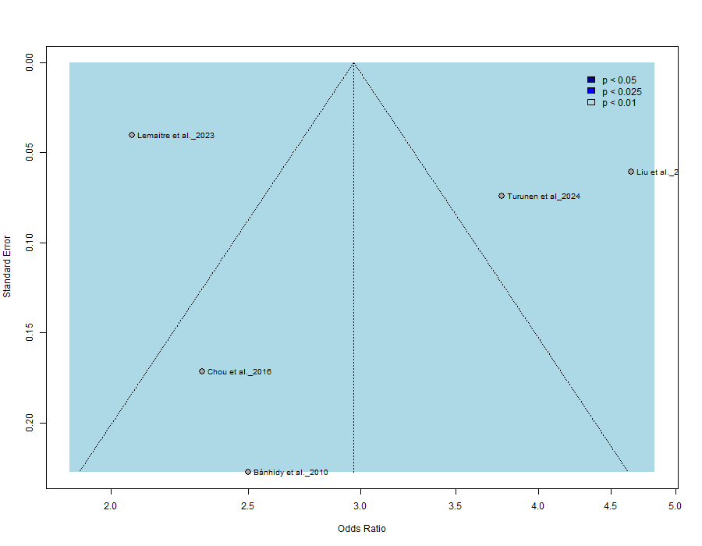
(C). Maternal type 2 diabetes (Egger’s test: not applicable) 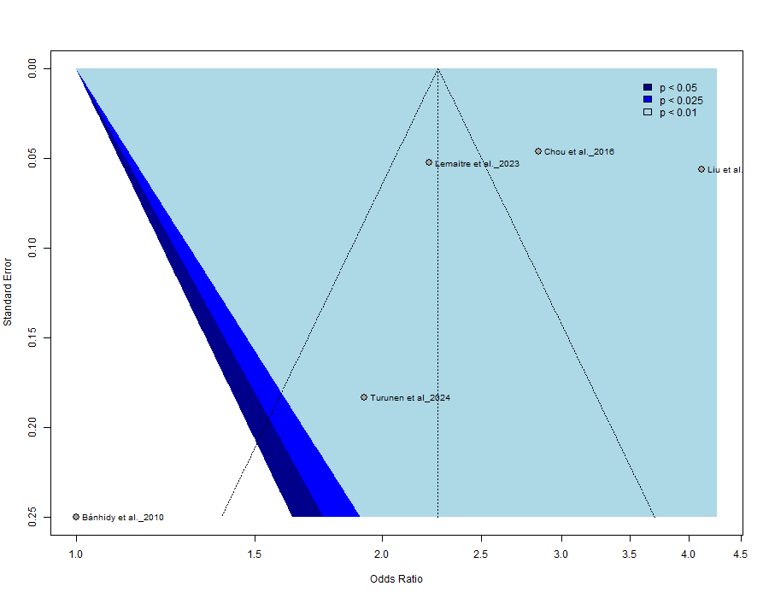

(D). Maternal overall obesity (Egger’s test = 0.850)
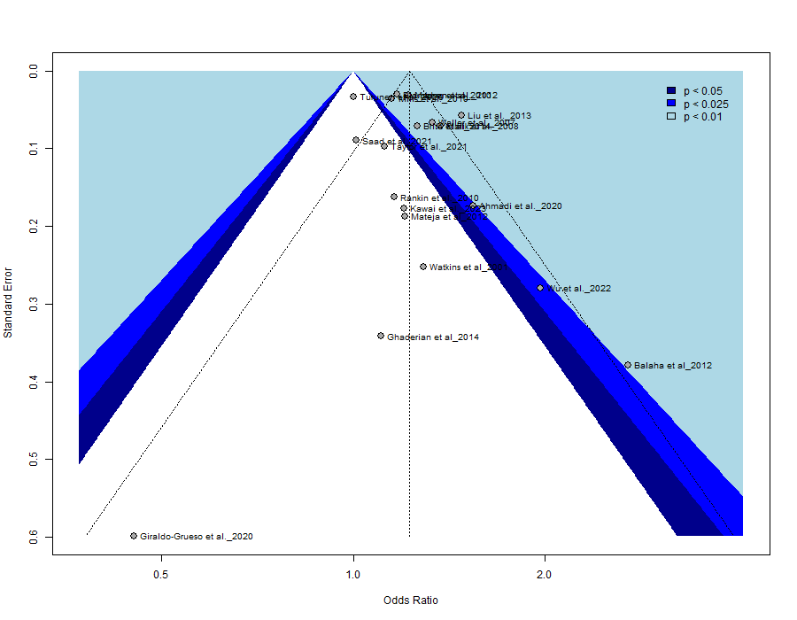
(E). Maternal class I obesity (Egger’s test: not applicable)
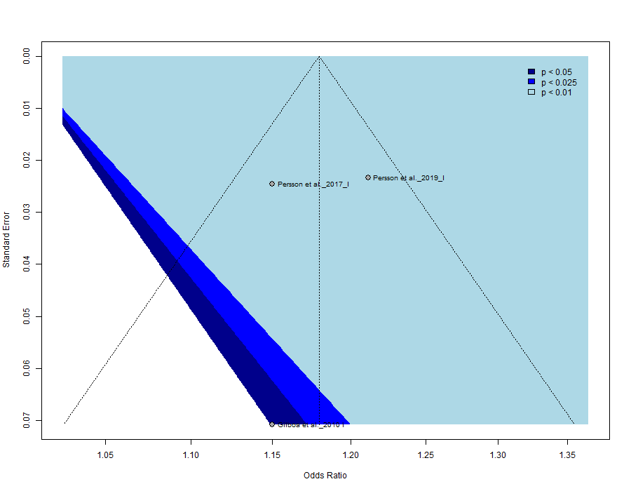
(F). Maternal class II obesity (Egger’s test: not applicable)
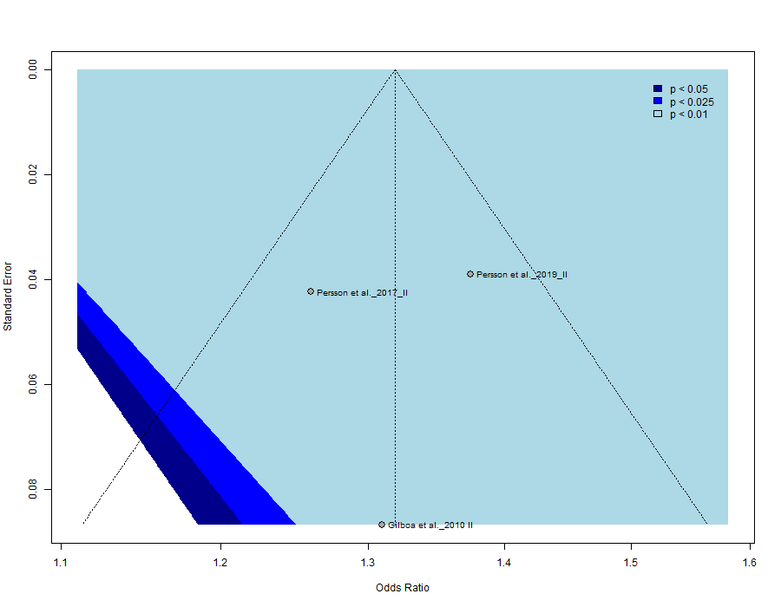

(G). Maternal class III obesity (Egger’s test: not applicable)
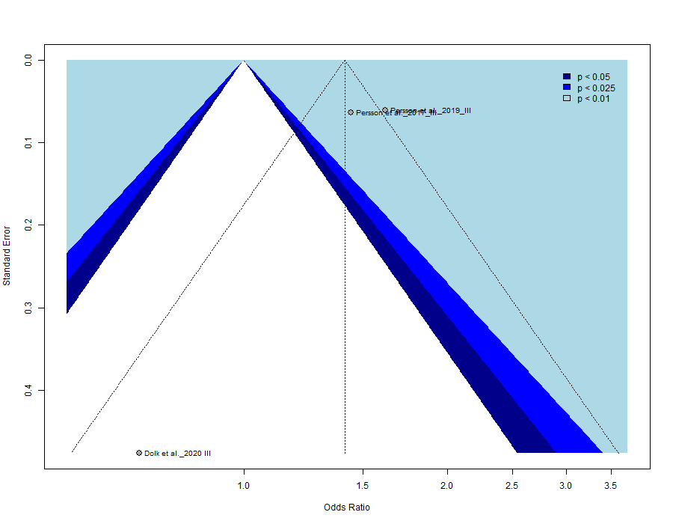
(H). Maternal underweight (Egger’s test = 0.376) 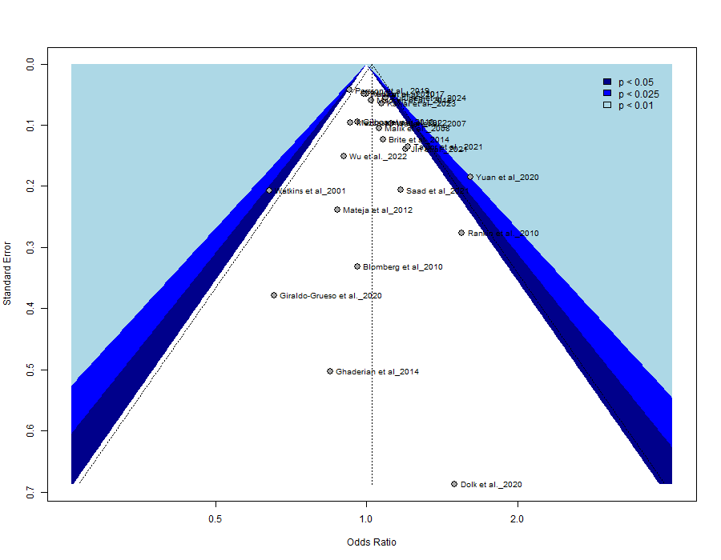
(I). Maternal active smoking (Egger’s test = 2.479)
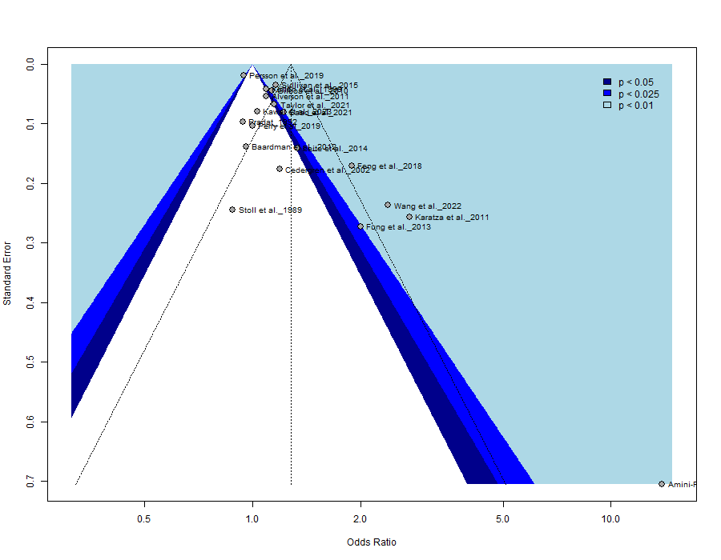
(J). Maternal passive smoking (Egger’s test: not applicable)
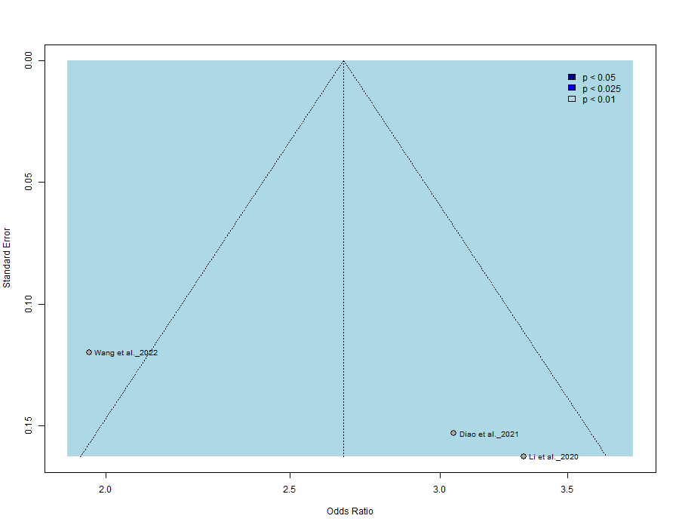
(K). Maternal alcohol consumption (Egger’s test = 1.570)
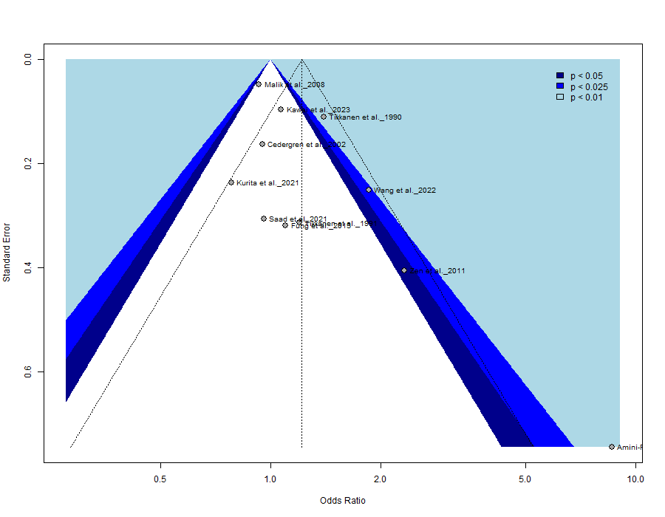
(L). Maternal chronic hypertension (Egger’s test: not applicable)
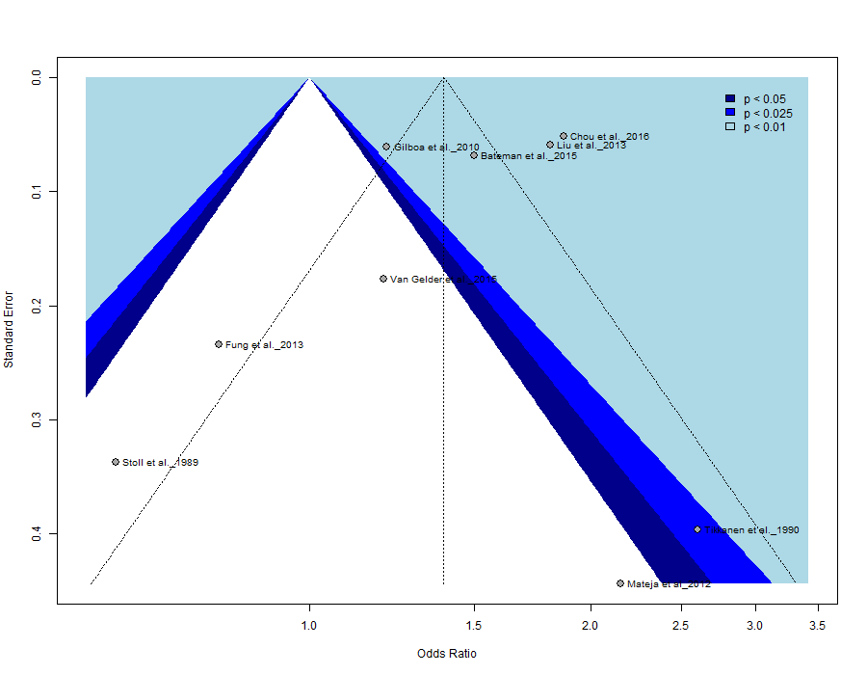

Figure S10. Forest plots of ORs for overall CHD from subgroup analysis of eligible risk factors based on RoB levels

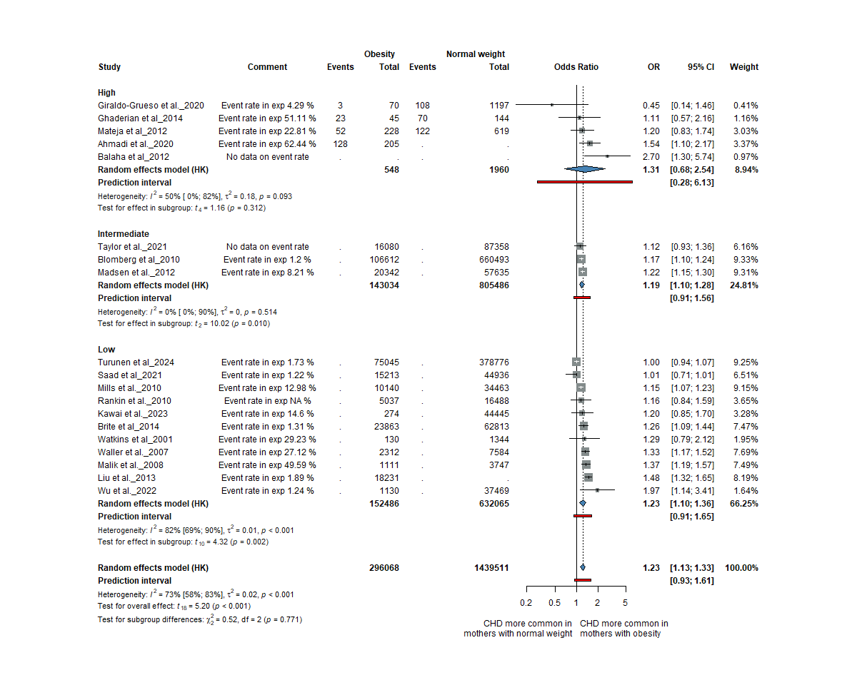
(A) Maternal obesity

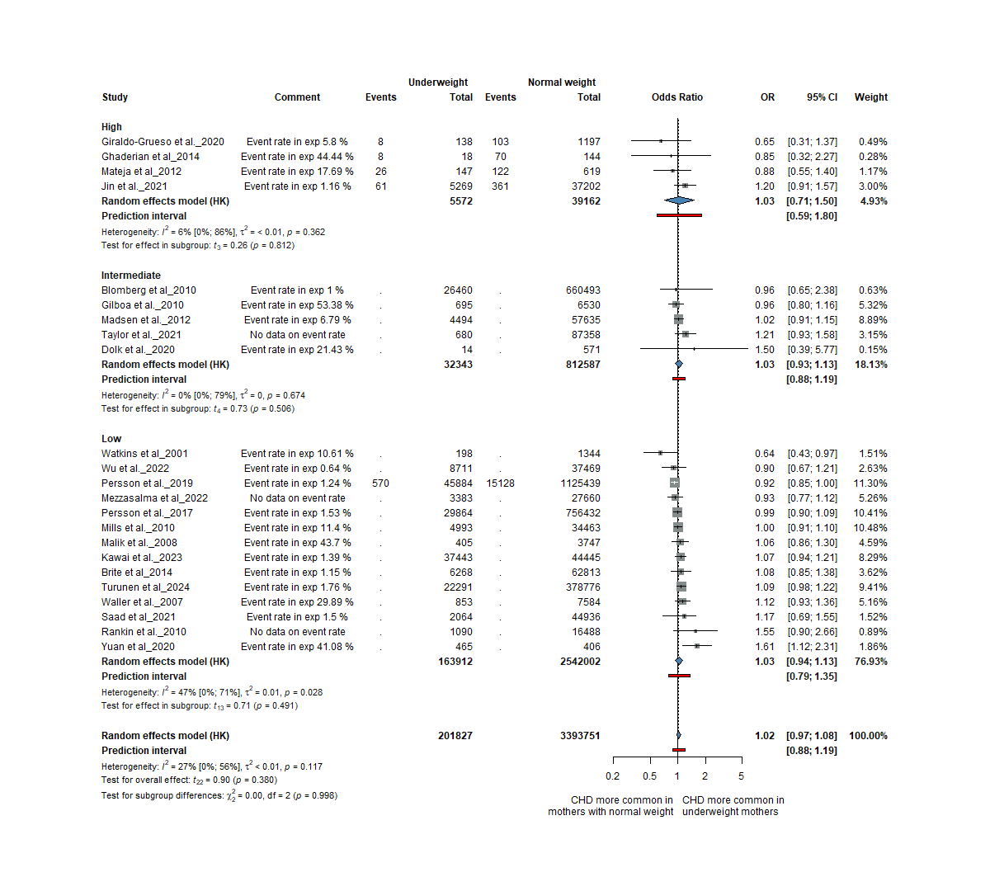
(B) Maternal underweight

(C) Maternal pre-pregnancy diabetes
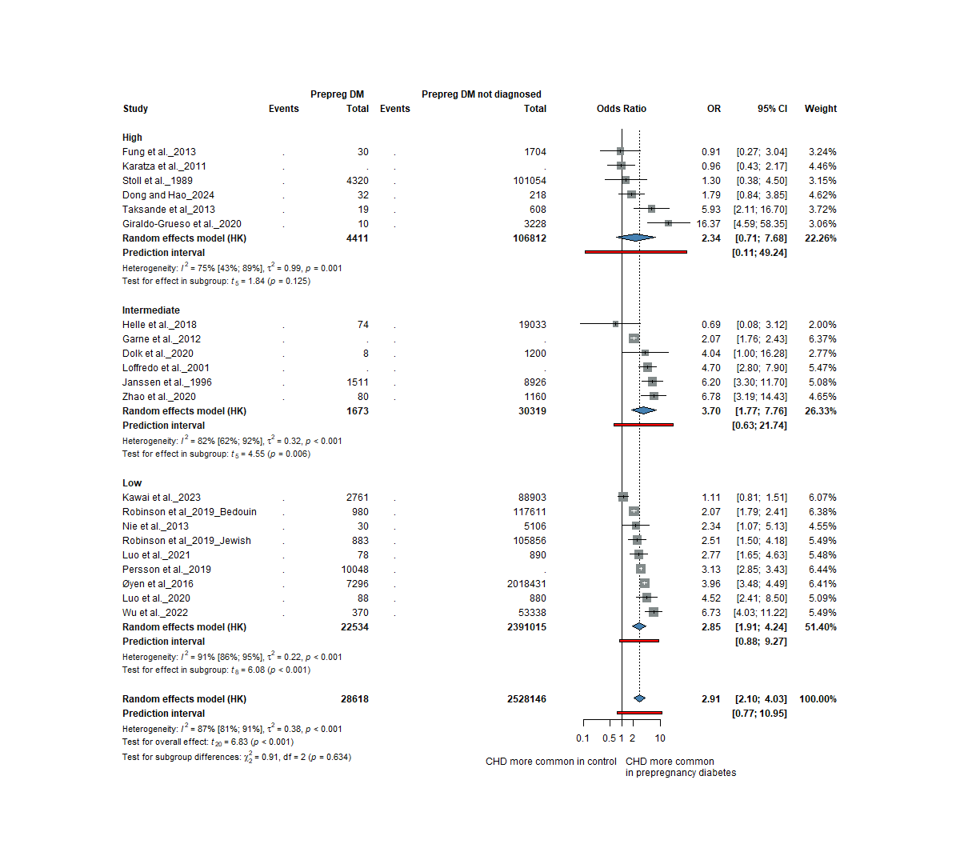
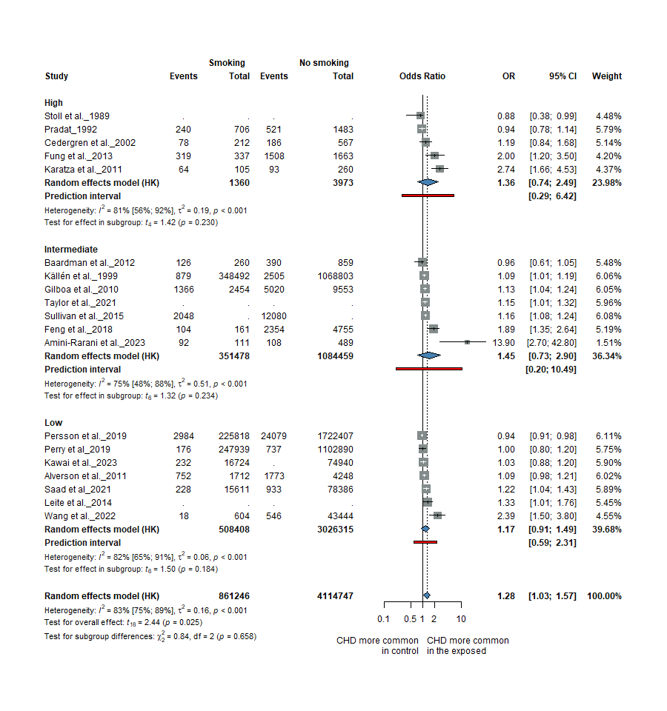
(D) Maternal active smoking
Reference
1. Dong J, Hao T. Association of maternal and paternal risk factors with risk of congenital heart disease in infants: a case-control study. Ir J Med Sci 2024; 193(1): 95-99
2. Turunen R, Pulakka A, Metsälä J, Vahlberg T, Ojala T, Gissler M, Kajantie E, Helle E. Maternal Diabetes and Overweight and Congenital Heart Defects in Offspring. JAMA Network Open 2024; 7(1): e2350579-e2350579
3. Amini-Rarani M, Karimi SE, SoleimanvandiAzar N, Nosratabadi M. Risk and protective factors related to having a child with congenital heart diseases (CHD): a case-control study in Iran. Front Pediatr 2023; 11: 1170743
4. Kawai S, Pak K, Iwamoto S, Kawakami C, Inuzuka R, Maeda J, Furutani Y, Kamisago M, Takatsuki S, Uyeda T, Yamagishi H, Ito S, Kobayashi T. Association Between Maternal Factors in Early Pregnancy and Congenital Heart Defects in Offspring: The Japan Environment and Children's Study. Journal of the American Heart Association 2023; 12(17): e029268
5. Lemaitre M, Bourdon G, Bruandet A, Lenne X, Subtil D, Rakza T, Vambergue A. Pre-gestational diabetes and the risk of congenital heart defects in the offspring: A French nationwide study. Diabetes Metab 2023; 49(4): 101446
6. Bolin EH, Gokun Y, Romitti PA, Tinker SC, Summers AD, Roberson PK, Hobbs CA, Malik S, Botto LD, Nembhard WN. Maternal Smoking and Congenital Heart Defects, National Birth Defects Prevention Study, 1997-2011. J Pediatr 2022; 240: 79-86.e71
7. Mezzasalma L, Santoro M, Coi A, Pierini A. Association between maternal body mass index and congenital anomalies: A case-control study in Tuscany (Italy). Birth Defects Res 2022; 114(3-4): 116-123
8. Wang T, Li Q, Chen L, Ni B, Sheng X, Huang P, Zhang S, Chen L, Qin J. Effect of maternal alcohol consumption during the pre-pregnancy/early-pregnancy period on congenital heart disease: A prospective cohort study in Central China. Prev Med 2022; 155: 106963
9. Wang T, Chen L, Ni B, Sheng X, Huang P, Zhang S, Qin J. Maternal pre-pregnancy/early-pregnancy smoking and risk of congenital heart diseases in offspring: A prospective cohort study in Central China. J Glob Health 2022; 12: 11009
10. Wu X-X, Ge R-X, Huang L, Tian F-Y, Chen Y-X, Wu L-L, Niu J-M. Pregestational diabetes mediates the association between maternal obesity and the risk of congenital heart defects. Journal of Diabetes Investigation 2022; 13(2): 367-374
11. Diao J, Zhao L, Luo L, Li J, Li Y, Zhang S, Wang T, Chen L, Huang P, Qin J. Associations and interaction effects of maternal smoking and genetic polymorphisms of cytochrome P450 genes with risk of congenital heart disease in offspring: A case-control study. Medicine (Baltimore) 2021; 100(23): e26268
12. Jin X, Ni W, Wang G, Wu Q, Zhang J, Li G, Jiao N, Chen W, Liu Q, Gao L, Xing Q. Incidence and risk factors of congenital heart disease in Qingdao: a prospective cohort study. BMC Public Health 2021; 21(1): 1044
13. Kurita H, Motoki N, Inaba Y, Misawa Y, Ohira S, Kanai M, Tsukahara T, Nomiyama T. Maternal alcohol consumption and risk of offspring with congenital malformation: the Japan Environment and Children's Study. Pediatr Res 2021; 90(2): 479-486
14. Luo L, Zhang S, Wang T, Diao J, Li J, Li Y, Zhao L, Chen L, Ye Z, Huang P, Qin J. Associations of maternal diabetes mellitus and adiponectin gene polymorphisms with congenital heart disease in offspring: A case-control study. Medicine (Baltimore) 2021; 100(9): e24672
15. Rutkowski RE, Tanner JP, Anjohrin SB, Kirby RS, Salemi JL. Proportion of critical congenital heart defects attributable to unhealthy prepregnancy body mass index among women with live births in Florida, 2005-2016. Birth Defects Res 2021; 113(18): 1285-1298
16. Saad H, Sinclair M, Bunting B. Maternal sociodemographic characteristics, early pregnancy behaviours, and livebirth outcomes as congenital heart defects risk factors - Northern Ireland 2010-2014. BMC Pregnancy Childbirth 2021; 21(1): 759
17. Tinker SC, Gilboa SM, Moore CA, Waller DK, Simeone RM, Kim SY, Jamieson DJ, Botto LD, Fisher SC, Reefhuis J, the National Birth Defects Prevention S. Modification of the association between diabetes and birth defects by obesity, National Birth Defects Prevention Study, 1997–2011. Birth Defects Research 2021; 113(14): 1084-1097
18. Taylor K, Elhakeem A, Thorbjørnsrud Nader JL, Yang TC, Isaevska E, Richiardi L, Vrijkotte T, Pinot de Moira A, Murray DM, Finn D, Mason D, Wright J, Oddie S, Roeleveld N, Harris JR, Andersen AMN, Caputo M, Lawlor DA. Effect of Maternal Prepregnancy/Early‐Pregnancy Body Mass Index and Pregnancy Smoking and Alcohol on Congenital Heart Diseases: A Parental Negative Control Study. Journal of the American Heart Association 2021; 10(11): e020051
19. Ahmadi A, Gharipour M, Navabi ZS, Heydari H. Risk factors of congenital heart diseases: A hospital-based case-control study in Isfahan, Iran. ARYA Atheroscler 2020; 16(1): 1-6
20. Dolk H, McCullough N, Callaghan S, Casey F, Craig B, Given J, Loane M, Lagan BM, Bunting B, Boyle B, Dabir T. Risk factors for congenital heart disease: The Baby Hearts Study, a population-based case-control study. PLOS ONE 2020; 15(2): e0227908
21. Giraldo-Grueso M, Zarante I, Mejía-Grueso A, Gracia G. Risk factors for congenital heart disease: A case-control study. Revista Colombiana de Cardiología 2020; 27(4): 324-329
22. Li J, Du YJ, Wang HL, Du JY, Qu PF, Zhang R, Guo LQ, Yan H, Dang SN. [Association between maternal passive smoking during perinatal period and congenital heart disease in their offspring-based on a case-control study]. Zhonghua Liu Xing Bing Xue Za Zhi 2020; 41(6): 884-889
23. Luo L, Huang P, Wang TT, Zhao LJ, Ye ZW, Zhang SM, Chen LT, Diao JY, Li JQ, Li YH, Qin JB. [Association of maternal diabetes mellitus and UCP2 gene polymorphisms with congenital heart disease in offspring: a case-control study]. Zhongguo Dang Dai Er Ke Za Zhi 2020; 22(10): 1092-1099
24. Tanghöj G, Lindam A, Liuba P, Sjöberg G, Naumburg E. Atrial septal defect in children: The incidence and risk factors for diagnosis. Congenital Heart Disease 2020; 15(5): 287-299
25. Yuan X, Liu Z, Zhu J, Yu P, Deng Y, Chen X, Li N, Li S, Yang S, Li J, Liu H, Li X. Association between prepregnancy body mass index and risk of congenital heart defects in offspring: an ambispective observational study in China. BMC Pregnancy and Childbirth 2020; 20(1): 444
26. Zhao M, Diao J, Huang P, Li J, Li Y, Yang Y, Luo L, Zhang S, Chen L, Wang T, Zhu P, Qin J. Association of Maternal Diabetes Mellitus and Polymorphisms of the NKX2.5 Gene in Children with Congenital Heart Disease: A Single Centre-Based Case-Control Study. J Diabetes Res 2020; 2020: 3854630
27. Perry MF, Mulcahy H, DeFranco EA. Influence of periconception smoking behavior on birth defect risk. Am J Obstet Gynecol 2019; 220(6): 588.e581-588.e587
28. Persson M, Razaz N, Edstedt Bonamy AK, Villamor E, Cnattingius S. Maternal Overweight and Obesity and Risk of Congenital Heart Defects. J Am Coll Cardiol 2019; 73(1): 44-53
29. Robinson R, Stavsky M, Yitshak Sade M, Krymko H, Slanovic L, Novack V, Atar Vardi M, Broides A, Levitas A. Risk factors for congenital heart defects in two populations residing in the same geographic area: a long-term population-based study, Southern Israel. Cardiol Young 2019; 29(8): 1040-1044
30. Feng Y, Cai J, Tong X, Chen R, Zhu Y, Xu B, Mo X. Non-inheritable risk factors during pregnancy for congenital heart defects in offspring: A matched case-control study. Int J Cardiol 2018; 264: 45-52
31. Helle EIT, Biegley P, Knowles JW, Leader JB, Pendergrass S, Yang W, Reaven GR, Shaw GM, Ritchie M, Priest JR. First Trimester Plasma Glucose Values in Women without Diabetes are Associated with Risk for Congenital Heart Disease in Offspring. J Pediatr 2018; 195: 275-278
32. Kovalenko AA, Anda EE, Odland JØ, Nieboer E, Brenn T, Krettek A. Risk Factors for Ventricular Septal Defects in Murmansk County, Russia: A Registry-Based Study. International Journal of Environmental Research and Public Health 2018; 15(7): 1320
33. Persson M, Cnattingius S, Villamor E, Söderling J, Pasternak B, Stephansson O, Neovius M. Risk of major congenital malformations in relation to maternal overweight and obesity severity: cohort study of 1.2 million singletons. BMJ 2017; 357: j2563
34. Chou HH, Chiou MJ, Liang FW, Chen LH, Lu TH, Li CY. Association of maternal chronic disease with risk of congenital heart disease in offspring. Cmaj 2016; 188(17-18): E438-e446
35. Hoyt AT, Canfield MA, Romitti PA, Botto LD, Anderka MT, Krikov SV, Tarpey MK, Feldkamp ML. Associations between maternal periconceptional exposure to secondhand tobacco smoke and major birth defects. Am J Obstet Gynecol 2016; 215(5): 613.e611-613.e611
36. Øyen N, Diaz LJ, Leirgul E, Boyd HA, Priest J, Mathiesen ER, Quertermous T, Wohlfahrt J, Melbye M. Prepregnancy Diabetes and Offspring Risk of Congenital Heart Disease: A Nationwide Cohort Study. Circulation 2016; 133(23): 2243-2253
37. Bateman BT, Huybrechts KF, Fischer MA, Seely EW, Ecker JL, Oberg AS, Franklin JM, Mogun H, Hernandez-Diaz S. Chronic hypertension in pregnancy and the risk of congenital malformations: a cohort study. Am J Obstet Gynecol 2015; 212(3): 337.e331-314
38. Sullivan PM, Dervan LA, Reiger S, Buddhe S, Schwartz SM. Risk of congenital heart defects in the offspring of smoking mothers: a population-based study. J Pediatr 2015; 166(4): 978-984.e972
39. Van Gelder MMHJ, Van Bennekom CM, Louik C, Werler MM, Roeleveld N, Mitchell AA. Maternal hypertensive disorders, antihypertensive medication use, and the risk of birth defects: A case-control study. BJOG: An International Journal of Obstetrics and Gynaecology 2015; 122(7): 1002-1009
40. Zhu Y, Romitti PA, Caspers Conway KM, Shen DH, Sun L, Browne ML, Botto LD, Lin AE, Druschel CM. Maternal periconceptional alcohol consumption and congenital heart defects. Birth Defects Res A Clin Mol Teratol 2015; 103(7): 617-629
41. Brite J, Laughon SK, Troendle J, Mills J. Maternal overweight and obesity and risk of congenital heart defects in offspring. Int J Obes (Lond) 2014; 38(6): 878-882
42. Ghaderian M, Emami-Moghadam AR, Khalilian MR, Riahi K, Ghaedi F. Prepregnancy Maternal Weight and Body Mass Index of Children with and without Congenital Heart Disease. Iran J Pediatr 2014; 24(3): 313-318
43. Leite M, Albieri V, Kjaer SK, Jensen A. Maternal smoking in pregnancy and risk for congenital malformations: results of a Danish register-based cohort study. Acta Obstet Gynecol Scand 2014; 93(8): 825-834
44. Vereczkey A, Gerencsér B, Czeizel AE, Szabó I. Association of certain chronic maternal diseases with the risk of specific congenital heart defects: a population-based study. Eur J Obstet Gynecol Reprod Biol 2014; 182: 1-6
45. Block SR, Watkins SM, Salemi JL, Rutkowski R, Tanner JP, Correia JA, Kirby RS. Maternal pre-pregnancy body mass index and risk of selected birth defects: evidence of a dose-response relationship. Paediatr Perinat Epidemiol 2013; 27(6): 521-531
46. Csáky-Szunyogh M, Vereczkey A, Kósa Z, Urbán R, Czeizel AE. Association of maternal diseases during pregnancy with the risk of single ventricular septal defects in the offspring--a population-based case-control study. J Matern Fetal Neonatal Med 2013; 26(8): 738-747
47. Fung A, Manlhiot C, Naik S, Rosenberg H, Smythe J, Lougheed J, Mondal T, Chitayat D, McCrindle BW, Mital S. Impact of Prenatal Risk Factors on Congenital Heart Disease in the Current Era. Journal of the American Heart Association; 2(3): e000064
48. Liu S, Joseph KS, Lisonkova S, Rouleau J, Van den Hof M, Sauve R, Kramer MS. Association between maternal chronic conditions and congenital heart defects: a population-based cohort study. Circulation 2013; 128(6): 583-589
49. Nie ZQ, Ou YQ, Chen JM, Liu XQ, Mai JZ, Gao XM, Wu Y, Zhuang J. [Risk factors of congenital heart defects in fetal and infants born from 2004 to 2011 in Guangdong]. Zhonghua Xin Xue Guan Bing Za Zhi 2013; 41(8): 704-708
50. Taksande A, Vilhekar K. Study of Risk Factor for Congenital Heart Diseases in Children at Rural Hospital of Central India. Journal of Nepal Paediatric Society 2013; 33:
51. Baardman ME, Kerstjens-Frederikse WS, Corpeleijn E, de Walle HE, Hofstra RM, Berger RM, Bakker MK. Combined adverse effects of maternal smoking and high body mass index on heart development in offspring: evidence for interaction? Heart 2012; 98(6): 474-479
52. Balaha MH, Ali WH, Al Aswad LH, Al Moghannum MS, Hashim I. Maternal obesity predict isolated birth defects in live births in Eastern Province of Saudi Arabia. J Matern Fetal Neonatal Med 2012; 25(7): 924-929
53. Garne E, Loane M, Dolk H, Barisic I, Addor MC, Arriola L, Bakker M, Calzolari E, Matias Dias C, Doray B, Gatt M, Melve KK, Nelen V, O'Mahony M, Pierini A, Randrianaivo-Ranjatoelina H, Rankin J, Rissmann A, Tucker D, Verellun-Dumoulin C, Wiesel A. Spectrum of congenital anomalies in pregnancies with pregestational diabetes. Birth Defects Res A Clin Mol Teratol 2012; 94(3): 134-140
54. Madsen NL, Schwartz SM, Lewin MB, Mueller BA. Prepregnancy Body Mass Index and Congenital Heart Defects among Offspring: A Population-based Study. Congenital Heart Disease 2013; 8(2): 131-141
55. Mateja WA, Nelson DB, Kroelinger CD, Ruzek S, Segal J. The association between maternal alcohol use and smoking in early pregnancy and congenital cardiac defects. J Womens Health (Larchmt) 2012; 21(1): 26-34
56. Alverson CJ, Strickland MJ, Gilboa SM, Correa A. Maternal smoking and congenital heart defects in the Baltimore-Washington Infant Study. Pediatrics 2011; 127(3): e647-653
57. Karatza AA, Giannakopoulos I, Dassios TG, Belavgenis G, Mantagos SP, Varvarigou AA. Periconceptional tobacco smoking and isolated congenital heart defects in the neonatal period. Int J Cardiol 2011; 148(3): 295-299
58. Zen TD, Rosa RFM, Zen PRG, Trevisan P, Da Silva AP, Ricachinevsky CP, Paskulin GA. Gestational and family risk factors for carriers of congenital heart defects in southern Brazil. Pediatrics International 2011; 53(4): 551-557
59. Bánhidy F, Acs N, Puhó EH, Czeizel AE. Congenital abnormalities in the offspring of pregnant women with type 1, type 2 and gestational diabetes mellitus: a population-based case-control study. Congenit Anom (Kyoto) 2010; 50(2): 115-121
60. Blomberg MI, Källén B. Maternal obesity and morbid obesity: the risk for birth defects in the offspring. Birth Defects Res A Clin Mol Teratol 2010; 88(1): 35-40
61. Gilboa SM, Correa A, Botto LD, Rasmussen SA, Waller DK, Hobbs CA, Cleves MA, Riehle-Colarusso TJ. Association between prepregnancy body mass index and congenital heart defects. Am J Obstet Gynecol 2010; 202(1): 51.e51-51.e10
62. Kuciene R, Dulskiene V. Parental cigarette smoking and the risk of congenital heart septal defects. Medicina (Kaunas) 2010; 46(9): 635-641
63. Mills JL, Troendle J, Conley MR, Carter T, Druschel CM. Maternal obesity and congenital heart defects: a population-based study. Am J Clin Nutr 2010; 91(6): 1543-1549
64. Rankin J, Tennant PWG, Stothard KJ, Bythell M, Summerbell C, Bell R. Maternal body mass index and congenital anomaly risk: a cohort study. International journal of obesity (2005) 2010; 34(9): 1371-1380
65. Grewal J, Carmichael SL, Ma C, Lammer EJ, Shaw GM. Maternal periconceptional smoking and alcohol consumption and risk for select congenital anomalies. Birth Defects Res A Clin Mol Teratol 2008; 82(7): 519-526
66. Malik S, Cleves MA, Honein MA, Romitti PA, Botto LD, Yang S, Hobbs CA, Study atNBDP. Maternal Smoking and Congenital Heart Defects. Pediatrics 2008; 121(4): e810-e816
67. Waller DK, Shaw GM, Rasmussen SA, Hobbs CA, Canfield MA, Siega-Riz A-M, Gallaway MS, Correa A, for the National Birth Defects Prevention S. Prepregnancy Obesity as a Risk Factor for Structural Birth Defects. Archives of Pediatrics & Adolescent Medicine 2007; 161(8): 745-750
68. Williams LJ, Correa A, Rasmussen S. Maternal lifestyle factors and risk for ventricular septal defects. Birth Defects Res A Clin Mol Teratol 2004; 70(2): 59-64
69. Cedergren MI, Selbing AJ, Källén BA. Risk factors for cardiovascular malformation--a study based on prospectively collected data. Scand J Work Environ Health 2002; 28(1): 12-17
70. Loffredo CA, Wilson PD, Ferencz C. Maternal diabetes: an independent risk factor for major cardiovascular malformations with increased mortality of affected infants. Teratology 2001; 64(2): 98-106
71. Watkins ML, Botto LD. Maternal Prepregnancy Weight and Congenital Heart Defects in the Offspring. Epidemiology 2001; 12(4):
72. Källén K. Maternal smoking and congenital heart defects. Eur J Epidemiol 1999; 15(8): 731-737
73. Janssen PA, Rothman I, Schwartz SM. Congenital malformations in newborns of women with established and gestational diabetes in Washington State, 1984-91. Paediatr Perinat Epidemiol 1996; 10(1): 52-63
74. Pradat P. A case-control study of major congenital heart defects in Sweden--1981-1986. Eur J Epidemiol 1992; 8(6): 789-796
75. Tikkanen J, Heinonen OP. Risk factors for ventricular septal defect in Finland. Public Health 1991; 105(2): 99-112
76. Tikkanen J, Heinonen OP. Maternal exposure to chemical and physical factors during pregnancy and cardiovascular malformations in the offspring. Teratology 1991; 43(6): 591-600
77. Tikkanen J, Heinonen OP. Risk factors for cardiovascular malformations in Finland. Eur J Epidemiol 1990; 6(4): 348-356
78. Stoll C, Alembik Y, Roth MP, Dott B, De Geeter B. Risk factors in congenital heart disease. Eur J Epidemiol 1989; 5(3): 382-391

