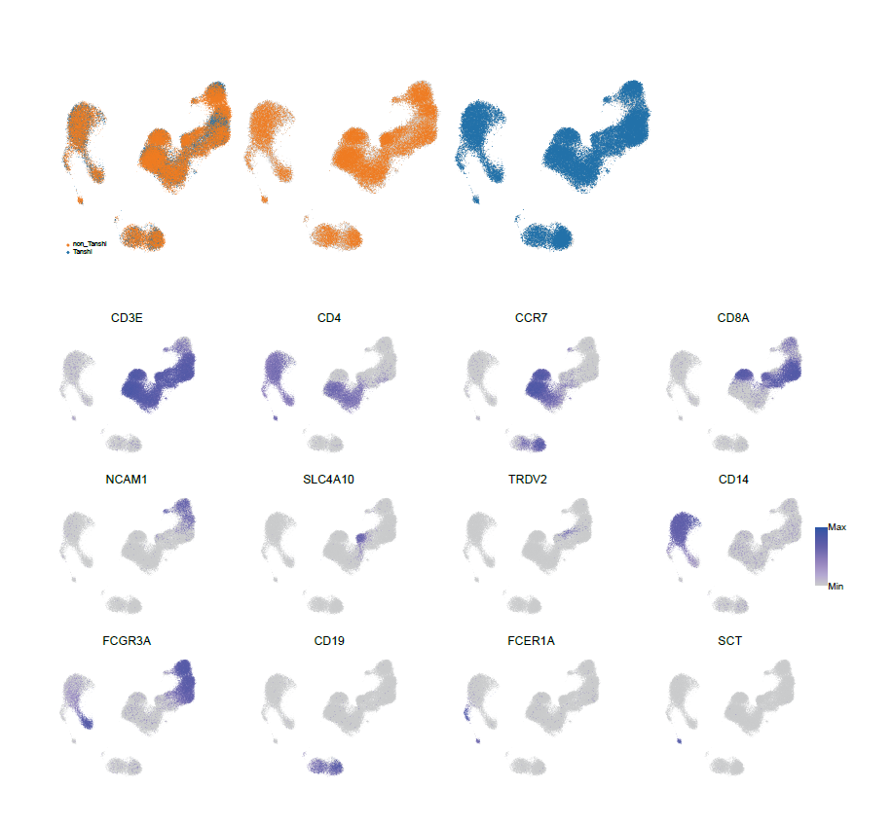
Supplementary Figure 1. UMAP plots show cell-type-specific gene expression in merged scRNA-seq data of Tanshi and non-Tanshi PBMCs. The gray dots represent all cells, including both the Tanshi and non-Tanshi groups. In the upper panel, orange dots highlight the non-Tanshi group, while blue dots highlight the Tanshi group. The lower panels illustrate the expression levels of 12 marker genes, with gradient blue colors indicating the gene expression levels.
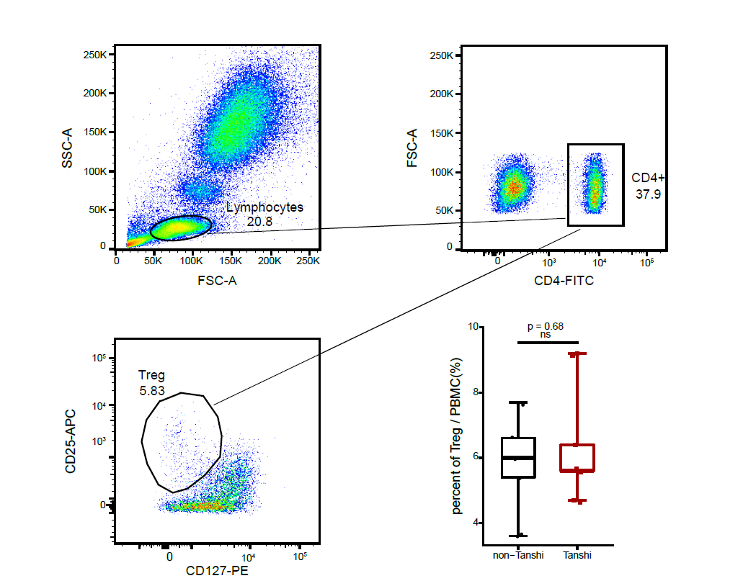
Supplementary Figure 2. The percentages of CD4 positive T-regs were not significantly different between Tanshi and non-Tanshi individuals. The figure shows the flow cytometry gating strategy and the percentage of CD4 positive T-regs.

