Online only Supplemental Materials
Supplemental Figures (SF):
SF. 1 Representative single-fiber recording from aortic depressor nerve and related computer-control fluid pressure ramp protocol. (A) Representative single-fiber recording of myelinated A-type afferent in the presence of 100 nM Capsaicin and 100 nM Sodium nitroprusside to block unmyelinated C-type fiber activity and possible vascular responses. (B) The pressure ramp generated by computer-control fluid device. c. The plot of instantaneous firing frequency (IFF, Hz) over the function of pressure (mmHg).
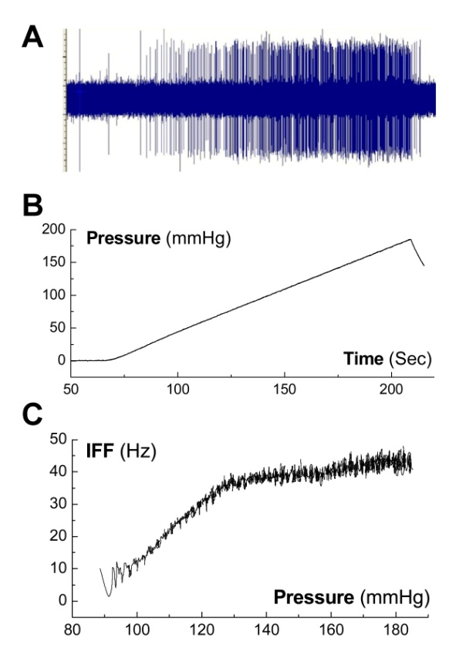
SF. 2 Representative myelinated A-type of action potential evoked by the vagal stimulation and the current derivative plotted as the function of membrane voltage. (A) vagal stimulation (blue arrowhead) elicited action potential; (B) Phase plot. Red dash-dot line: an estimated kick-in time for tetrodotoxin-sensitive/Nav1.7 Na⁺ currents expressed only in this particular type of NG neurons during the depolarization.
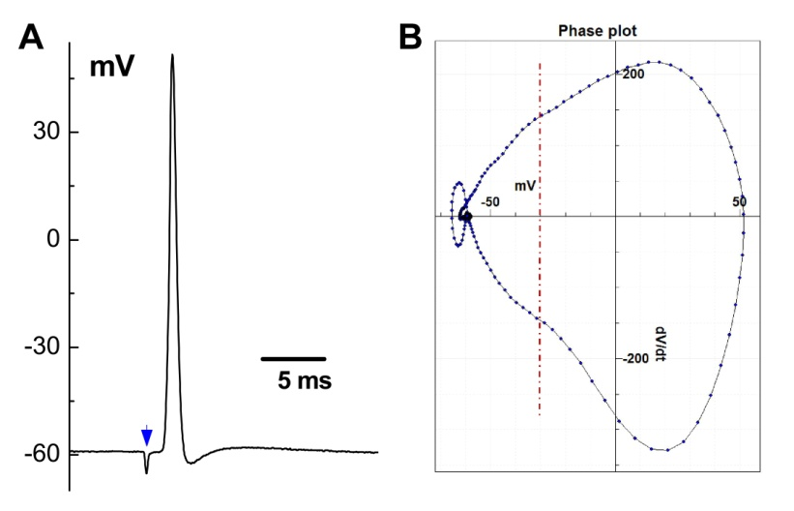
SF. 3 Representative recordings of action potential from identified myelinated A-type nodose neurons isolated from adult male rats. (A) The single action potential (AP) evoked by a brief pulse was used to analyze to the waveform characters including AP firing threshold (APFT, < -40 mV), maximal up- (UV_{MAX}> 250 mV/ms) and down-stroke velocity (DV_{MAM}> 100 mV/ms), and AP duration (APD₅₀< 1.0 ms). (B) Instantaneous change (dV/dt) of membrane currents plotted over the function of membrane voltage (mV) is termed as the phase plot that is the most sensitive way to identify the hump over the time course of repolarization (positive portion, DV representing total outward currents), the typical feature/behaviors for unmyelinated C-type nodose neurons. (C) The phase plots generated from all tested myelinated A-type nodose neurons (n = 23).
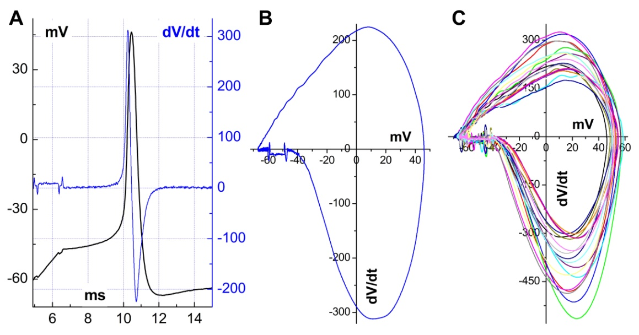
SF. 4 Expended tracings of spontaneous discharges shown in the Fig. 1a. to demonstrating more details depolarization events. (A) Expended tracing from the 1storange box from the left; (B) Expended tracing from the 2ndorange box; (C) Expended tracing from the 3rdorange box. Blue arrowheads: major sub-threshold depolarizations (Ma-STPs) beyond red dash-dot line; black arrowheads: minor sub-threshold depolarizations (Mi-STPs) below red dash-dot line; orange circles: APs developed based on the Ma-STPs that may superimposed by several Mi-STPs.
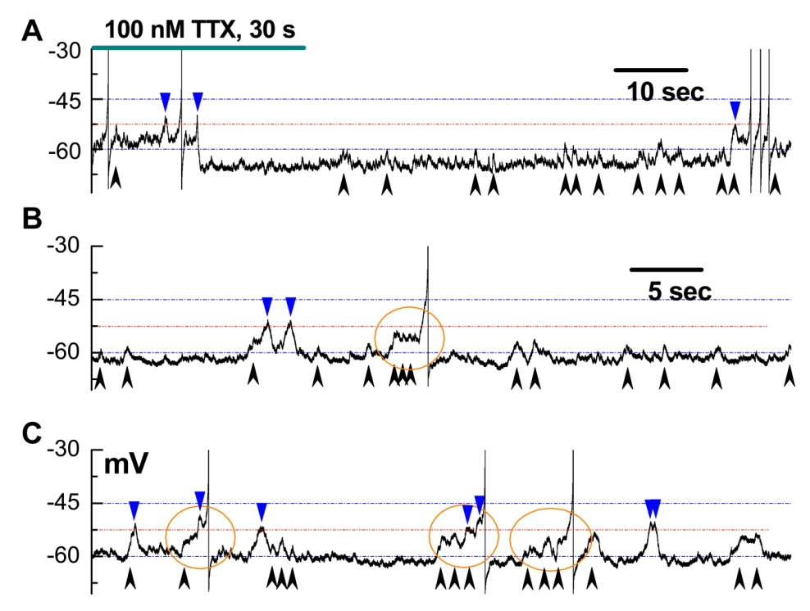
SF. 5 Equivalent of current derivative of depolarization shown by the phase plots shown in the SF. 3C to the peaks of spontaneous inward currents recorded by gap-free voltage-clamp shown in the Fig. 5. Phase plots were generated from identified A-type NG neurons (n = 23) and spontaneous inward currents were recorded from 3 complete recordings with total 122 inward events. Unpaired student-t test showed no significant difference between groups.
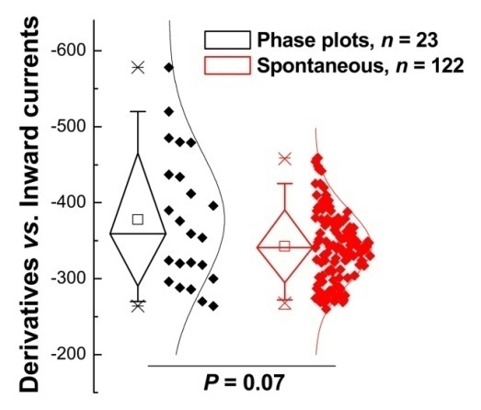
SF. 6 Representative of membrane charging as capacitance evoked by a brief pulse evoked AP (black) with its derivatives (blue). A single AP (black) was elicited by a brief pulse (500 μs) leading to the membrane slowly charging as a capacitance to firing threshold and fire the AP/membrane discharge. The current derivative was plotted as the function of membrane voltage (phase plot, blue). Red circle: charging/black and brief pulse/blue.
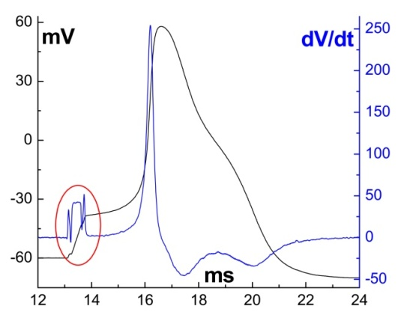
SF. 7 Piezo1 activation mediates membrane depolarizations. (A) Spontaneous depolarization activities were not detected in 90% of tested identified A-type NG neurons under gap-free current-clamp recordings; (B) Grouped/superimposed major sub-threshold depolarizations (Ma-STPs, orange circled) with one AP were observed in the presence of 1 μM Yoda1; (C) Aforementioned grouped/superimposed Ma-STPs were replaced by repetitive discharge of APs with possible Ma-STP (blue arrowhead) in the presence of 3 μM Yoda1; (D) Yoda1-mediated Ma-STPs and discharged APs were blocked by 3 μM GsMTx4 almost completely. All recordings were completed from the same patch, and the horizontal scale bar shown in (a) is applied for all.
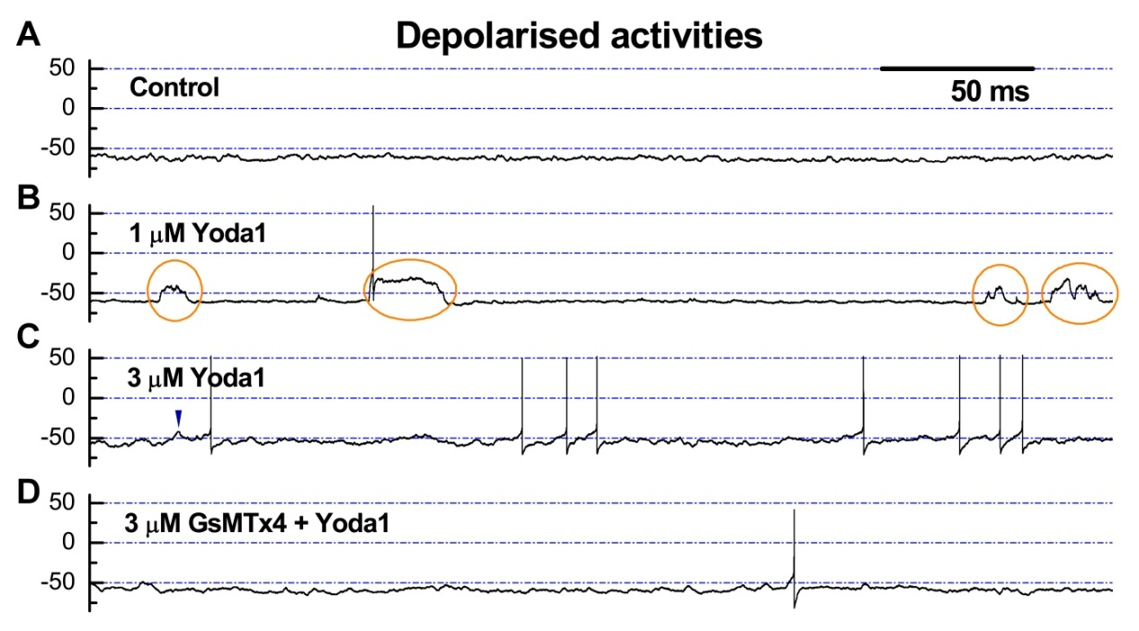
SF. 8 Molecular verification of Piezo1 and TRPM4 channel distribution in the nodose ganglion of adult male rats. Results of RT-PCR on TRPM4 and Piezo1 in the NG of control groups rats (male), n = 6. Each group is provided with a sub-hole. Averaged data were presented by mean ± SD.
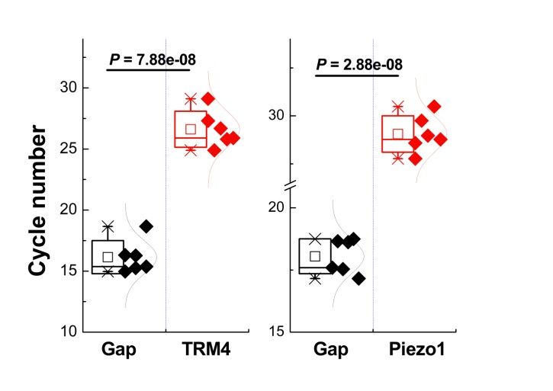
SF. 9 Bioinformatics data showed a positive correlation between the expressions of PIEZO1 and TRPM4. (A) The single-cell sequencing data of Medulla oblongata-anterior cerebellar nucleus-inferior olive nucleus. (B) Single-cell sequencing data from neuronal cells showed consistency in the expression distribution of PIEZO1 and TRPM4. (C-D) Linear correlation pattern shown a positive relationship between the expression of PIEZO1 and TRPM4 based on GSE233732 and GSE43490.


