FMD-25046-CSJ-Supplementary Figs

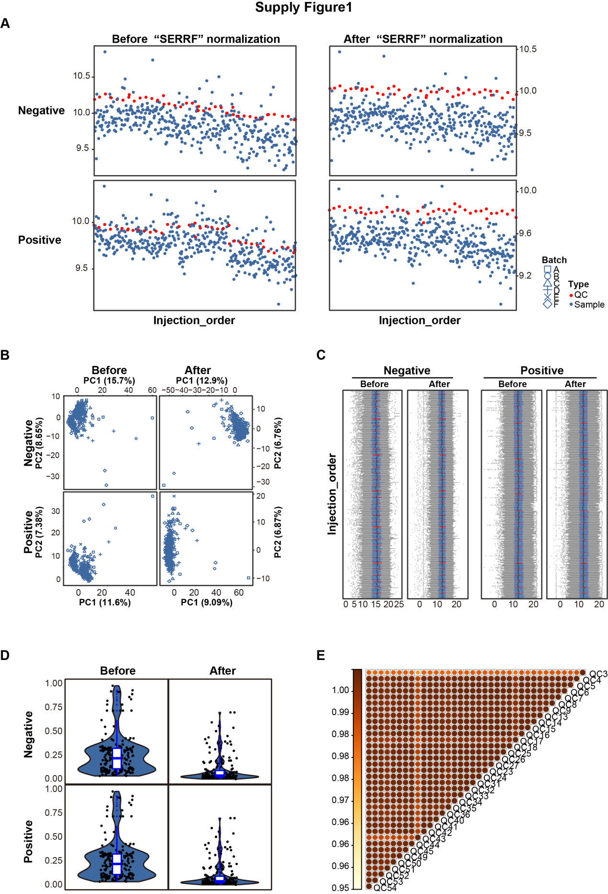

Fig. S1 Quality controls for data generation and serum collection protocol, and molecular changes in response to CAR-T therapy, related to Fig. 1. (A) Scatter plot showing the median abundance of all metabolites across injection order, before and after normalization. (B) Principal component analysis plot after normalization using the “SERRF” R package. (C) Boxplots and (D) violin plots illustrating metabolite distributions before and after normalization with the “SERRR” R package. (E) Correlation heatmap of quality control samples after normalization with the “SERRF” R package.
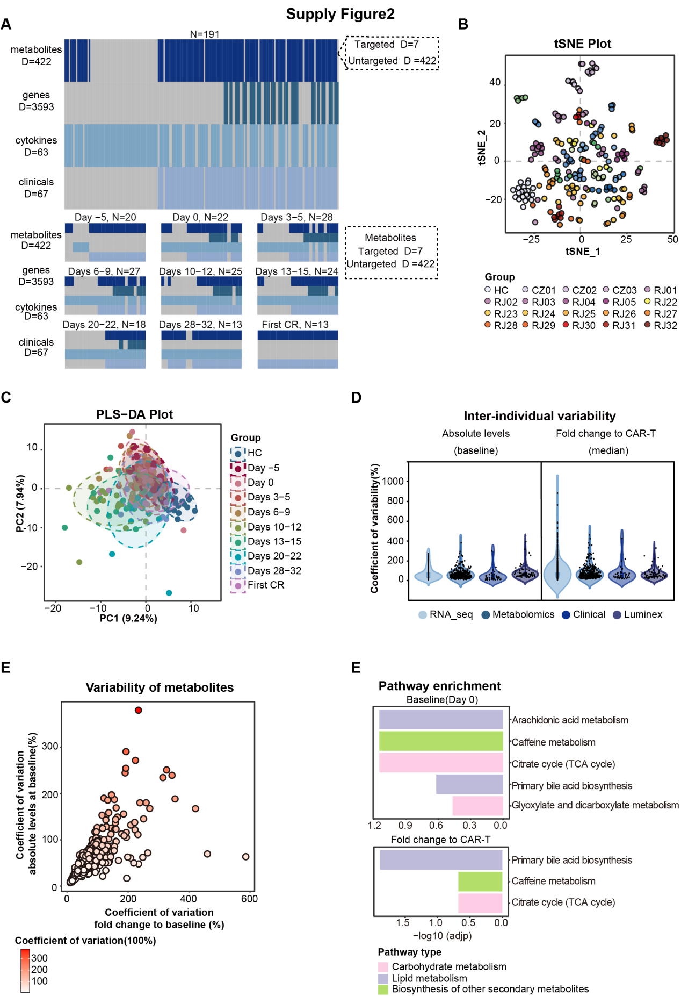
Fig. S2 Analysis of differential abundance and multi-omics variability in response to CAR-T therapy. (A) Overview of the multi-omics dataset; gray indicates missing data. (B) Two-dimensional visualization of all multi-omics analytes using t-distributed stochastic neighbor embedding (t-SNE). Each point represents a sample colored by participant. (C) Partial least squares-discriminant analysis (PLS-DA) of metabolomic data across different time points. Each point represents a sample colored by time slot. (D) Intra-individual variability at baseline (absolute levels) and in response to CAR-T therapy (median fold change relative to baseline) across molecular types. (E) Inter-individual variability of metabolites at baseline and in response to CAR-T therapy. (F) Pathway enrichment analysis for metabolites at baseline (left) and median fold change in response to CAR-T therapy (right).
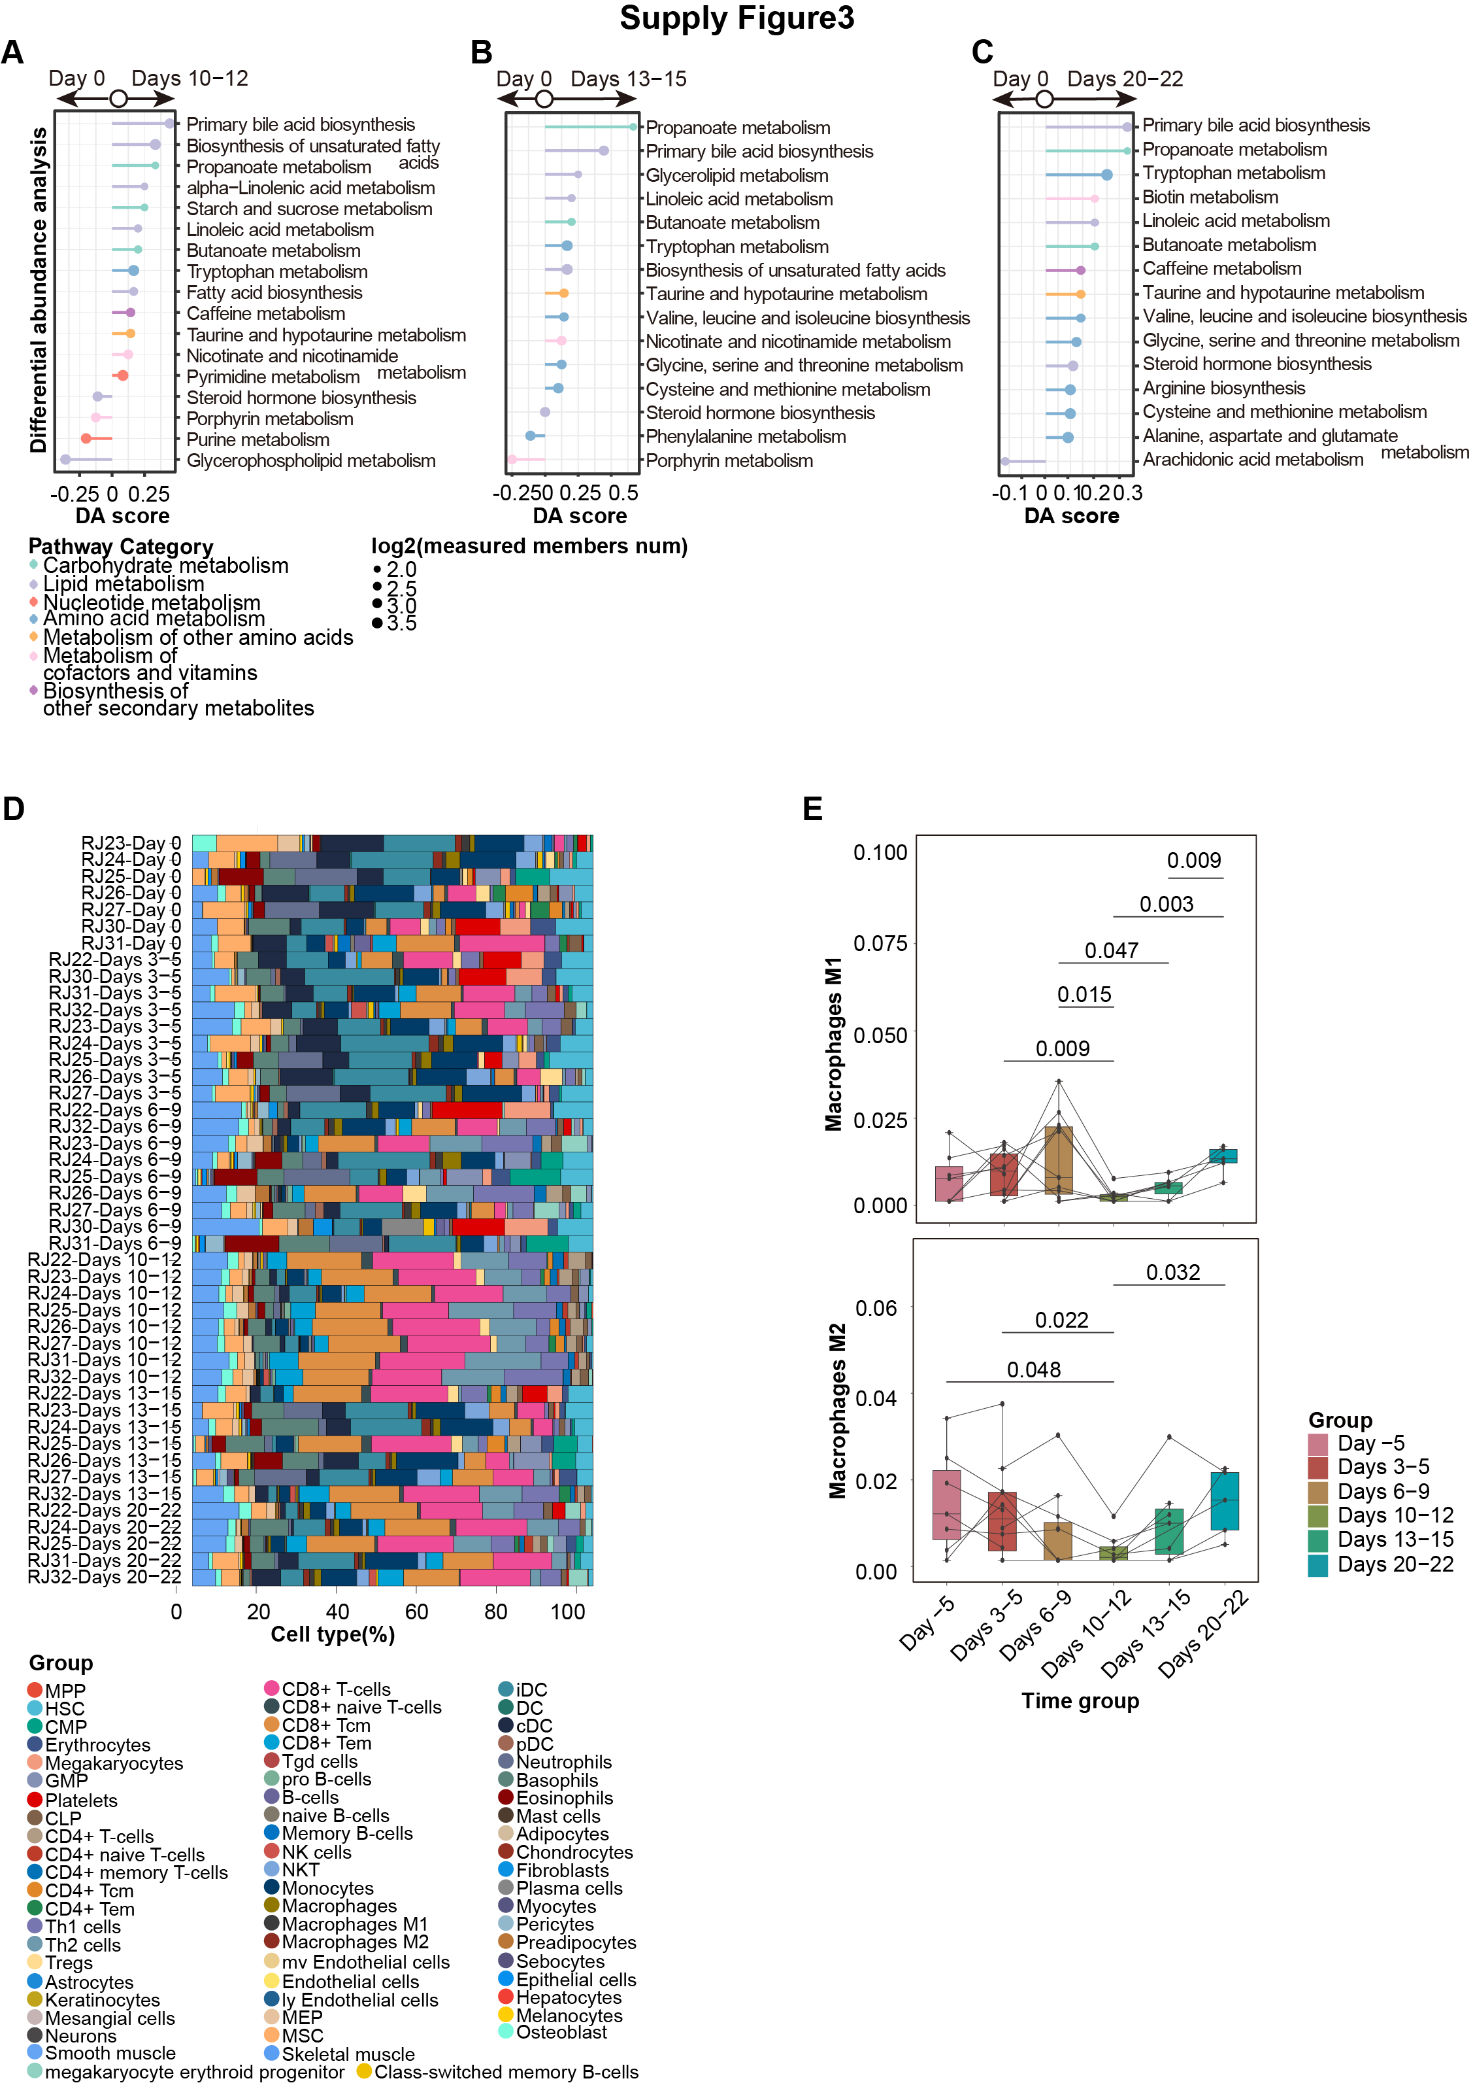
Fig. S3 Differential abundance scores across different time points and immune cell type analysis using “xCell”. (A–C) Differential abundance (DA) scores representing the overall tendency of metabolites in a pathway to be increased or decreased relative to baseline, at three different time slots. (D) Overview of the proportions of 64 cell types across time points. (E) Proportions of macrophage M1 and M2 cell types across time points.
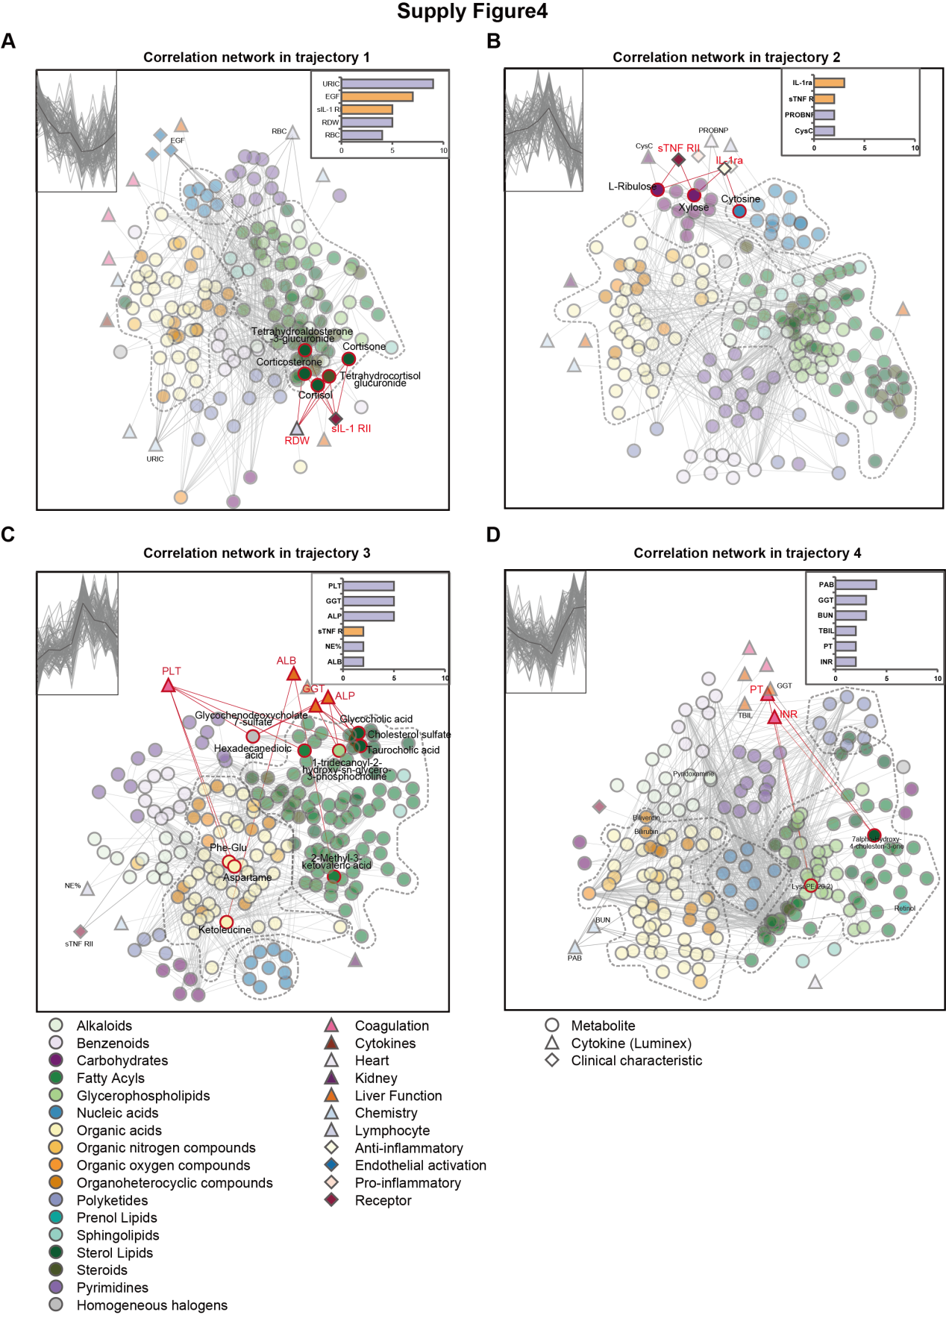
Fig. S4 Integrative multi-omics correlation analysis. (A−D) Pairwise Spearman correlation networks of multi-omics measures grouped by the trajectories defined in Figure 2D. Nodes are colored by molecule type and shaped by dataset. The top five proteins with the highest number of first-order connections in each network are highlighted. (|r| > 0.6, P value < 0.05).

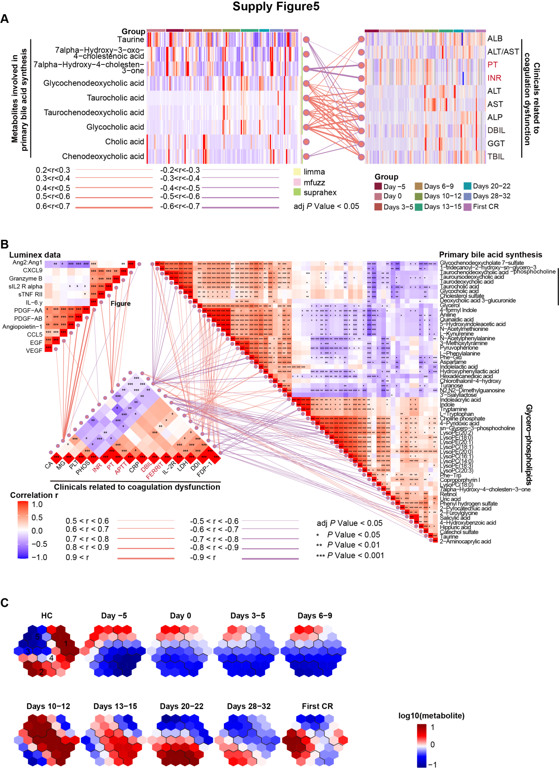
Fig. S5 Correlation analysis among metabolites, clinical characteristics, and cytokines. (A) Correlation between metabolites involved in primary bile acid synthesis and clinical characteristics of liver dysfunction. Left: differential abundance metabolites identified by the "limma" (yellow), "mfuzz" (pink), and "supraHex" (green) methods. Right: heatmap of clinical characteristics related to liver impairment. (B) Correlation analysis of coagulation-related clinical characteristics, cytokines, and metabolites. Left: correlation network among selected cytokines (|r| > 0.5, adjusted P value < 0.05). Middle: correlation among coagulation-related clinical characteristics (|r| > 0.5, adjusted P value < 0.05). Right: correlation network among selected metabolites (|r| > 0.5, adjusted P value < 0.05). Line width represents the absolute correlation coefficient (|r|); orange and purple lines indicate positive and negative correlations, respectively. (C) Five expression dynamic trajectories identified using the “supraHex” R package (see Supplementary Table S6 for details).
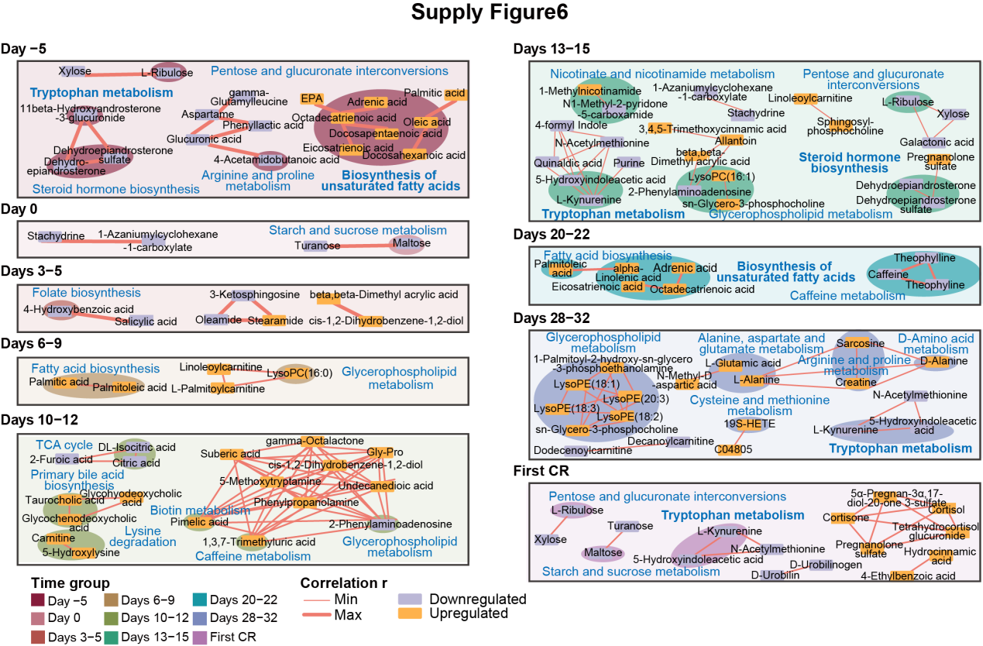
Fig. S6 Correlation of differential metabolites between the severe and mild CRS groups. Shown are correlation patterns of differential abundance metabolites across nine time points. KEGG pathways with significant enrichment are highlighted with darker background colors. Each square represents one metabolite. Line width corresponds to the absolute correlation coefficient (|r|); orange and purple indicate up- and down-regulation in the severe group, respectively. Pathway enrichment criteria: adjusted P value < 0.1, |r| > 0.6, fold change > 1.5, and P value < 0.05.
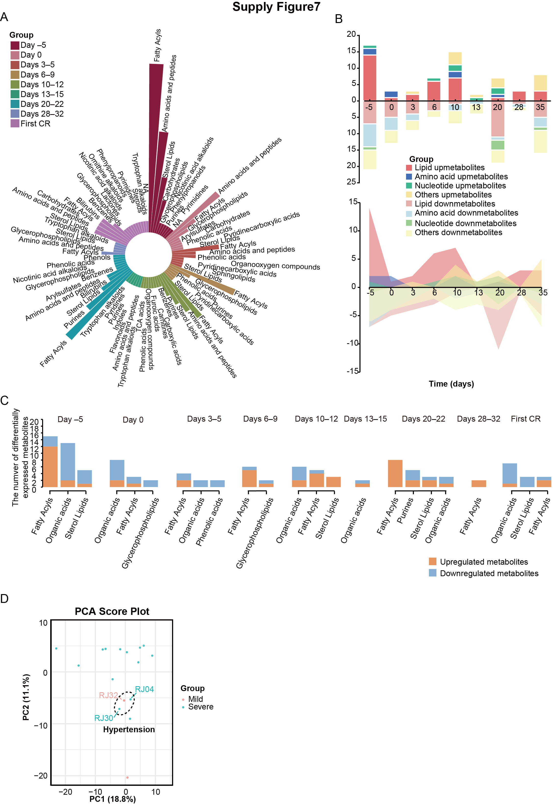
Fig. S7 Dynamic metabolomics profiling of severe versus mild CRS groups. (A) Subclassification of differentially expressed metabolites between severe and mild CRS groups. Sector length represents the number of metabolites in each subclass; only subclasses containing more than one metabolite are labeled. (B) Stream graph and histogram showing differential metabolites categorized as lipids, amino acids, nucleotides, or others. Positive and negative values indicate upregulation and downregulation in the severe group, respectively (|log₂FC| > 0.25, Welch’s t-test P value < 0.05). (C) Histogram of the top four dysregulated metabolites. (D) PCA plot of the severe and mild cohorts at Day –5, highlighting patients with hypertension.

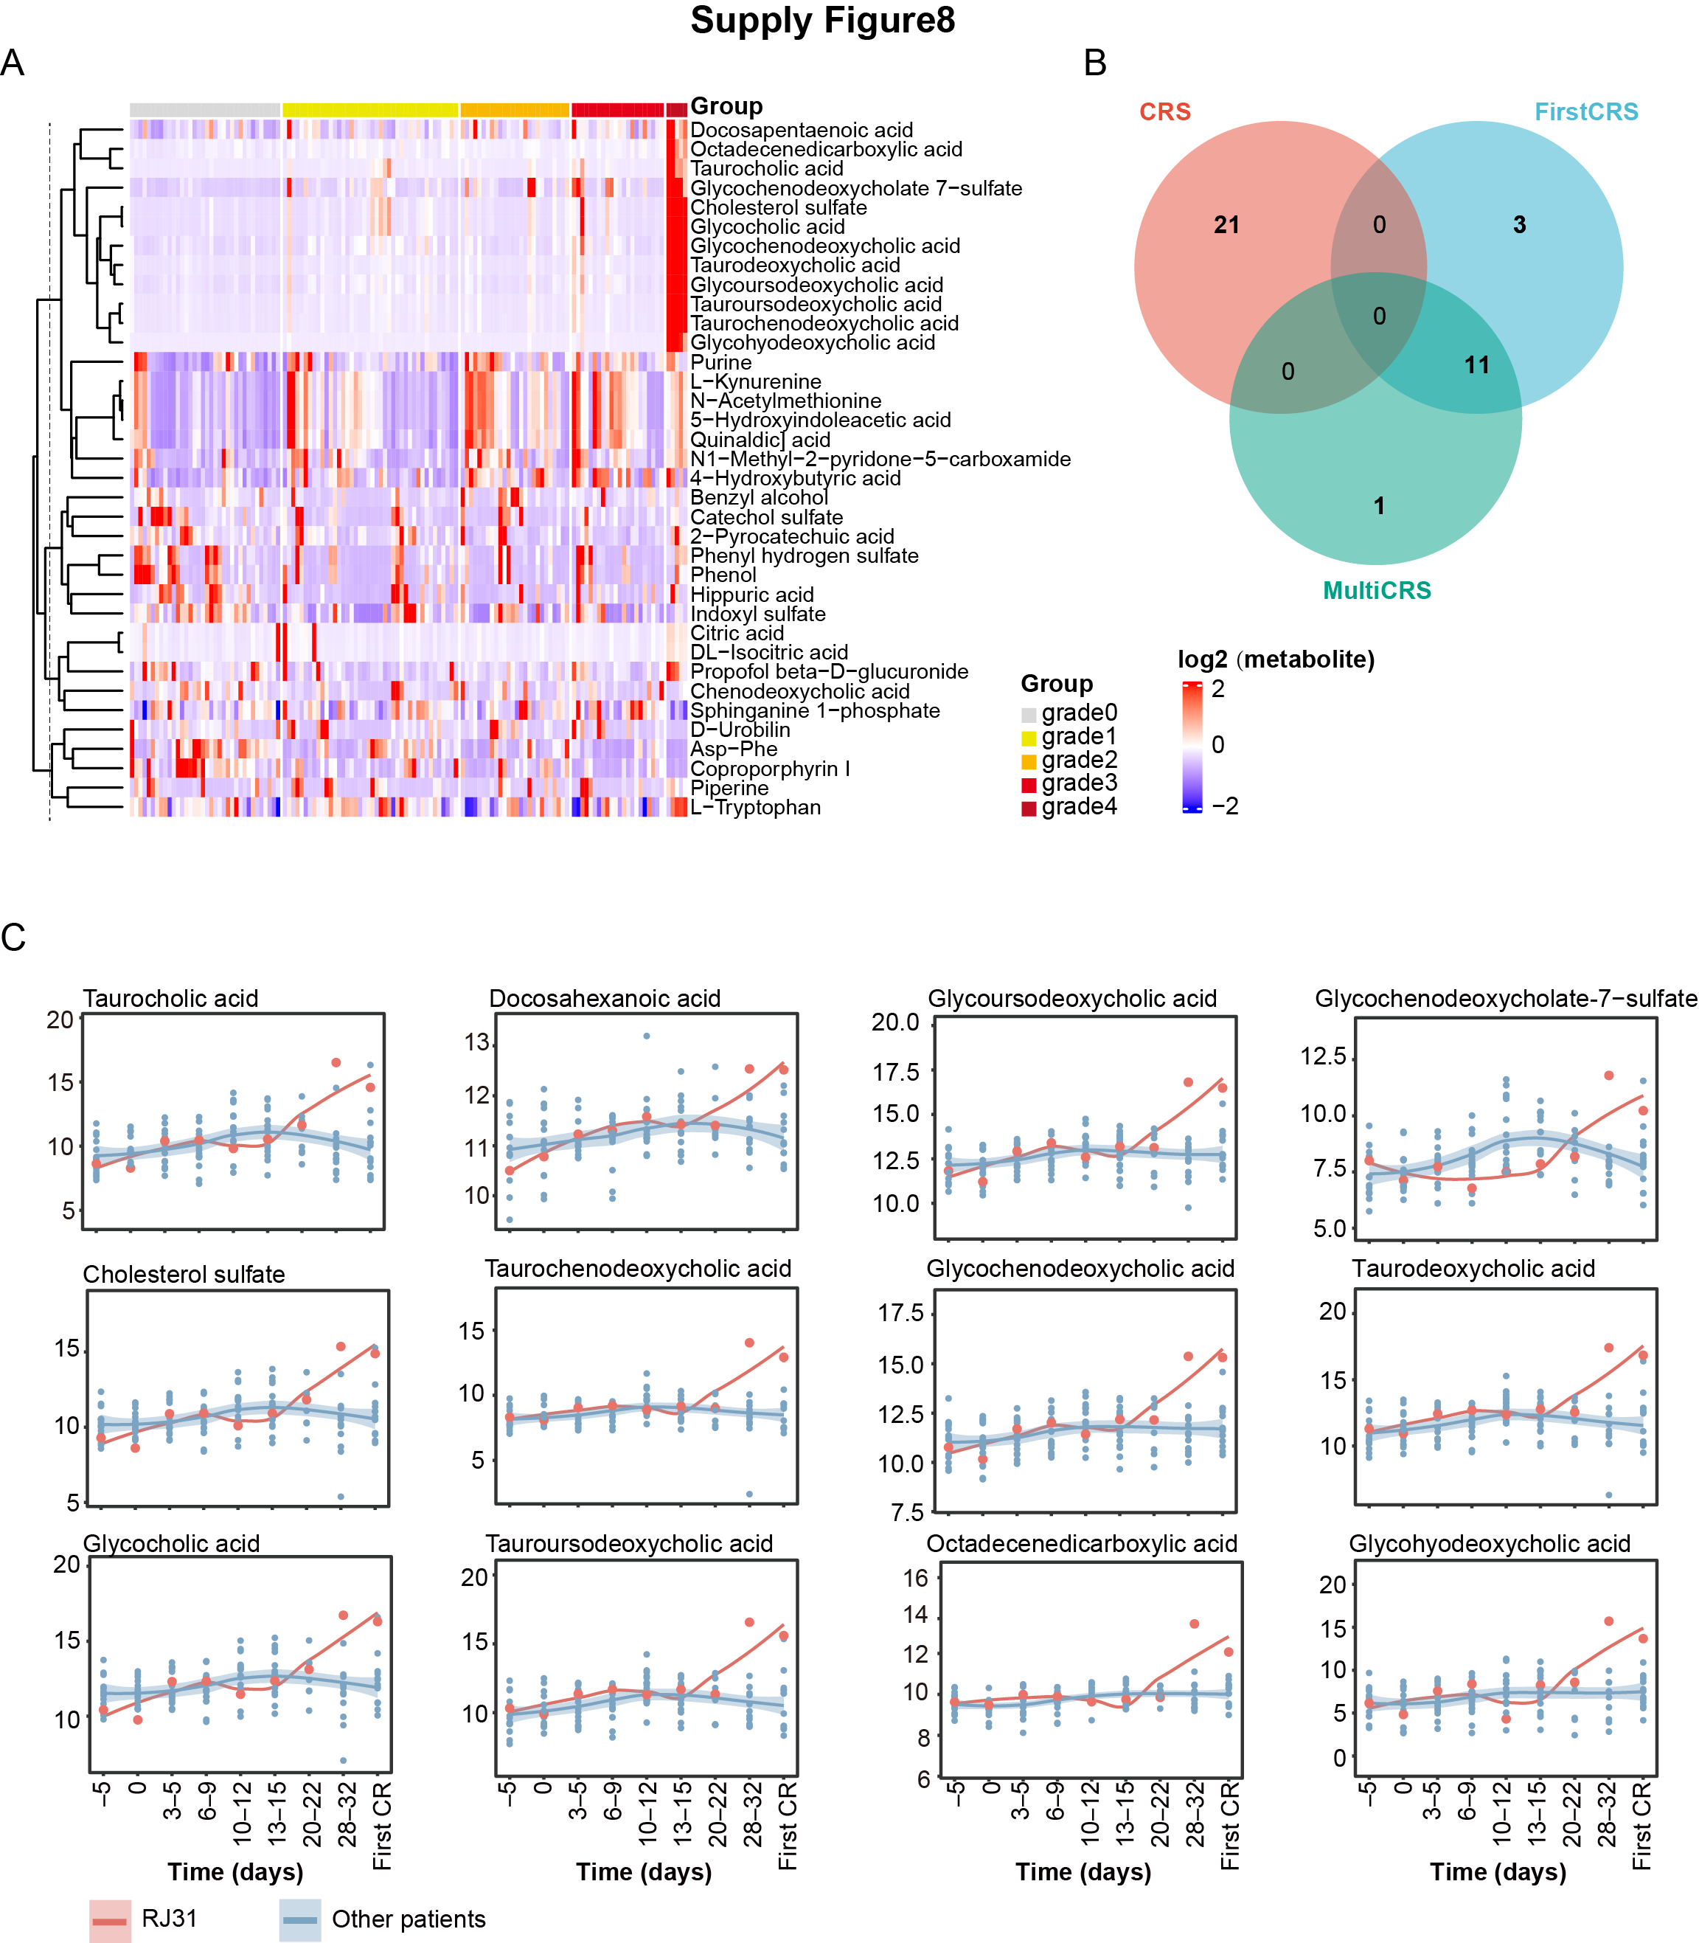
Fig. S8 Metabolites associated with CRS grade. (A) Heatmap of differential abundance metabolites across CRS grades. (B) Venn diagram showing the number of differential abundance metabolites identified by different classification methods. (C) River plot of differential metabolites within the top cluster from (A).
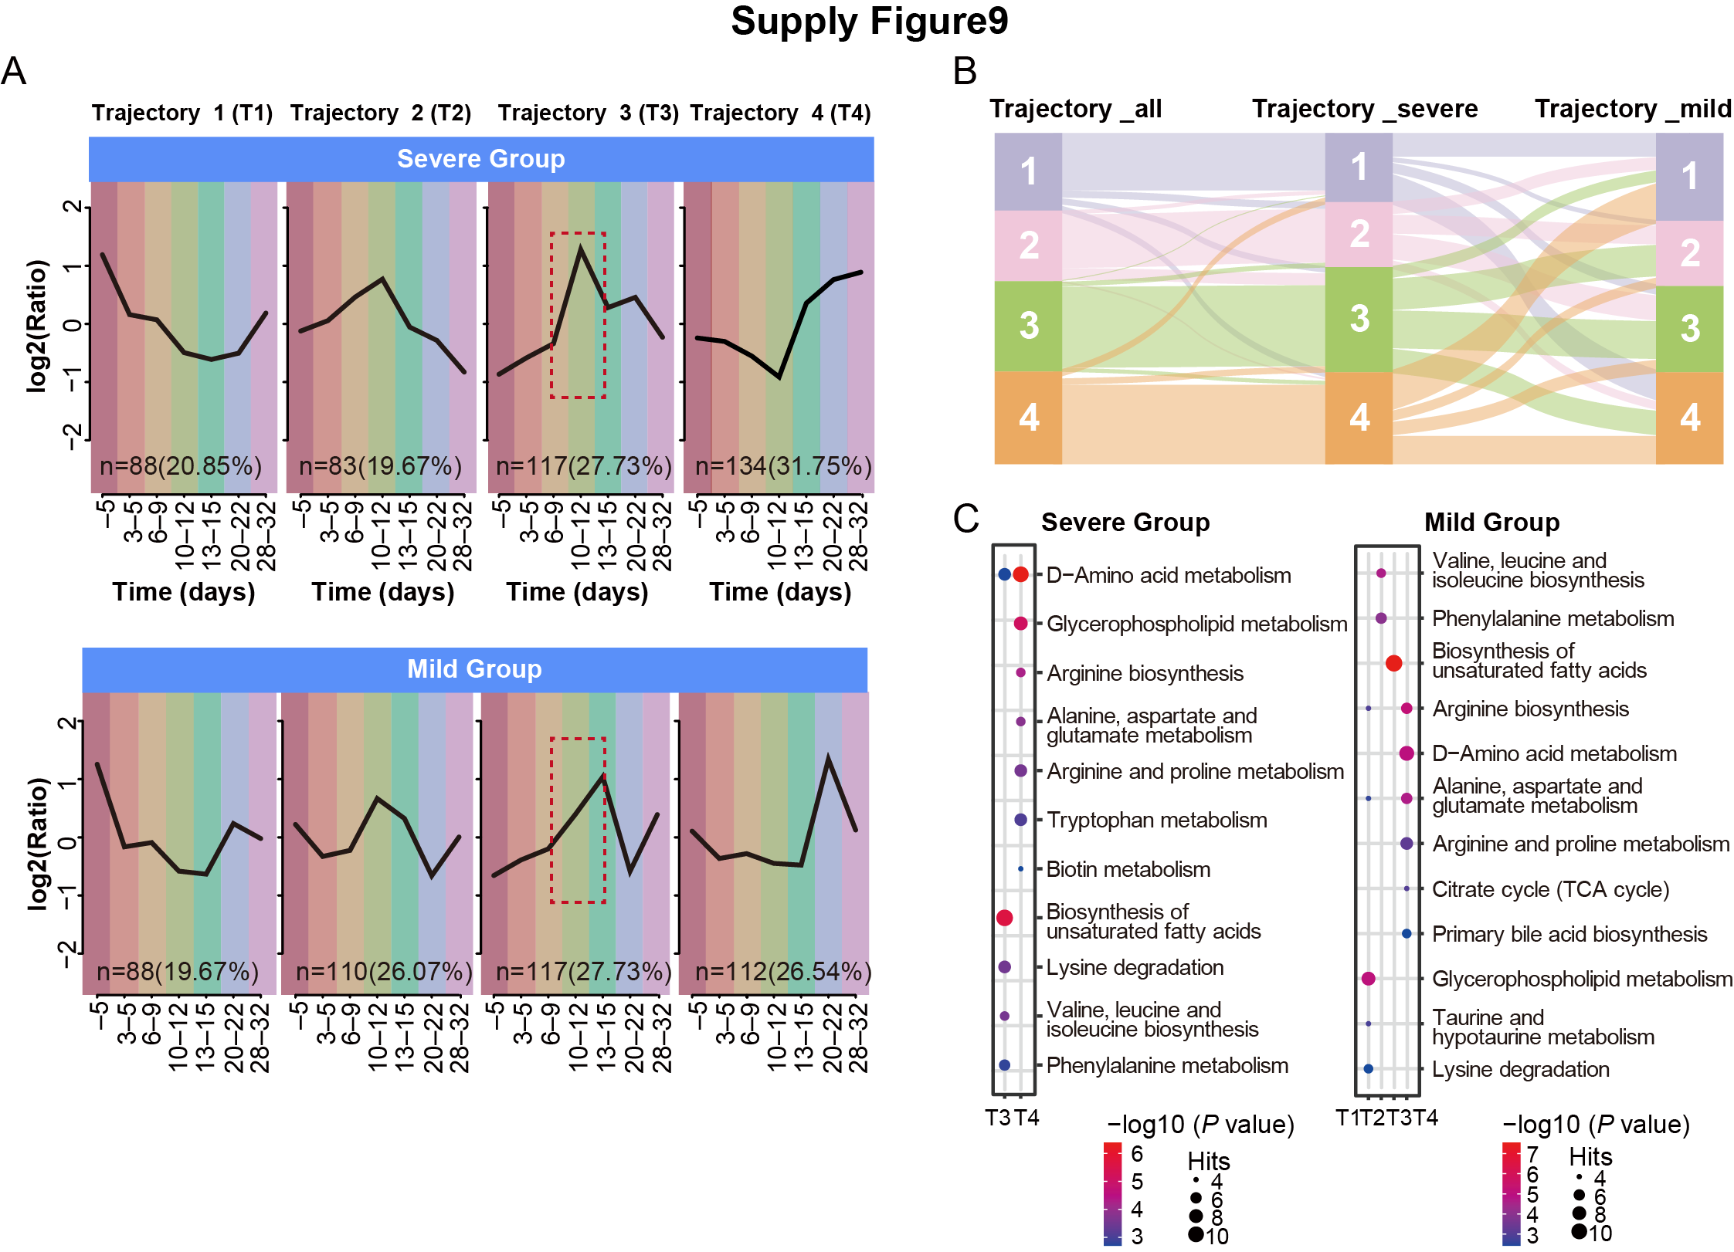
Fig. S9 Dynamic metabolite profiles of severe versus mild CRS groups, related to Fig. 2D. (A) Four distinct metabolite expression trajectories in severe and mild groups, identified by “Mfuzz” analysis. (B) Sankey diagram showing metabolites associated with differential trajectories across three patient groups. (C) Pathway enrichment analysis for metabolites within the four trajectories across the three groups.
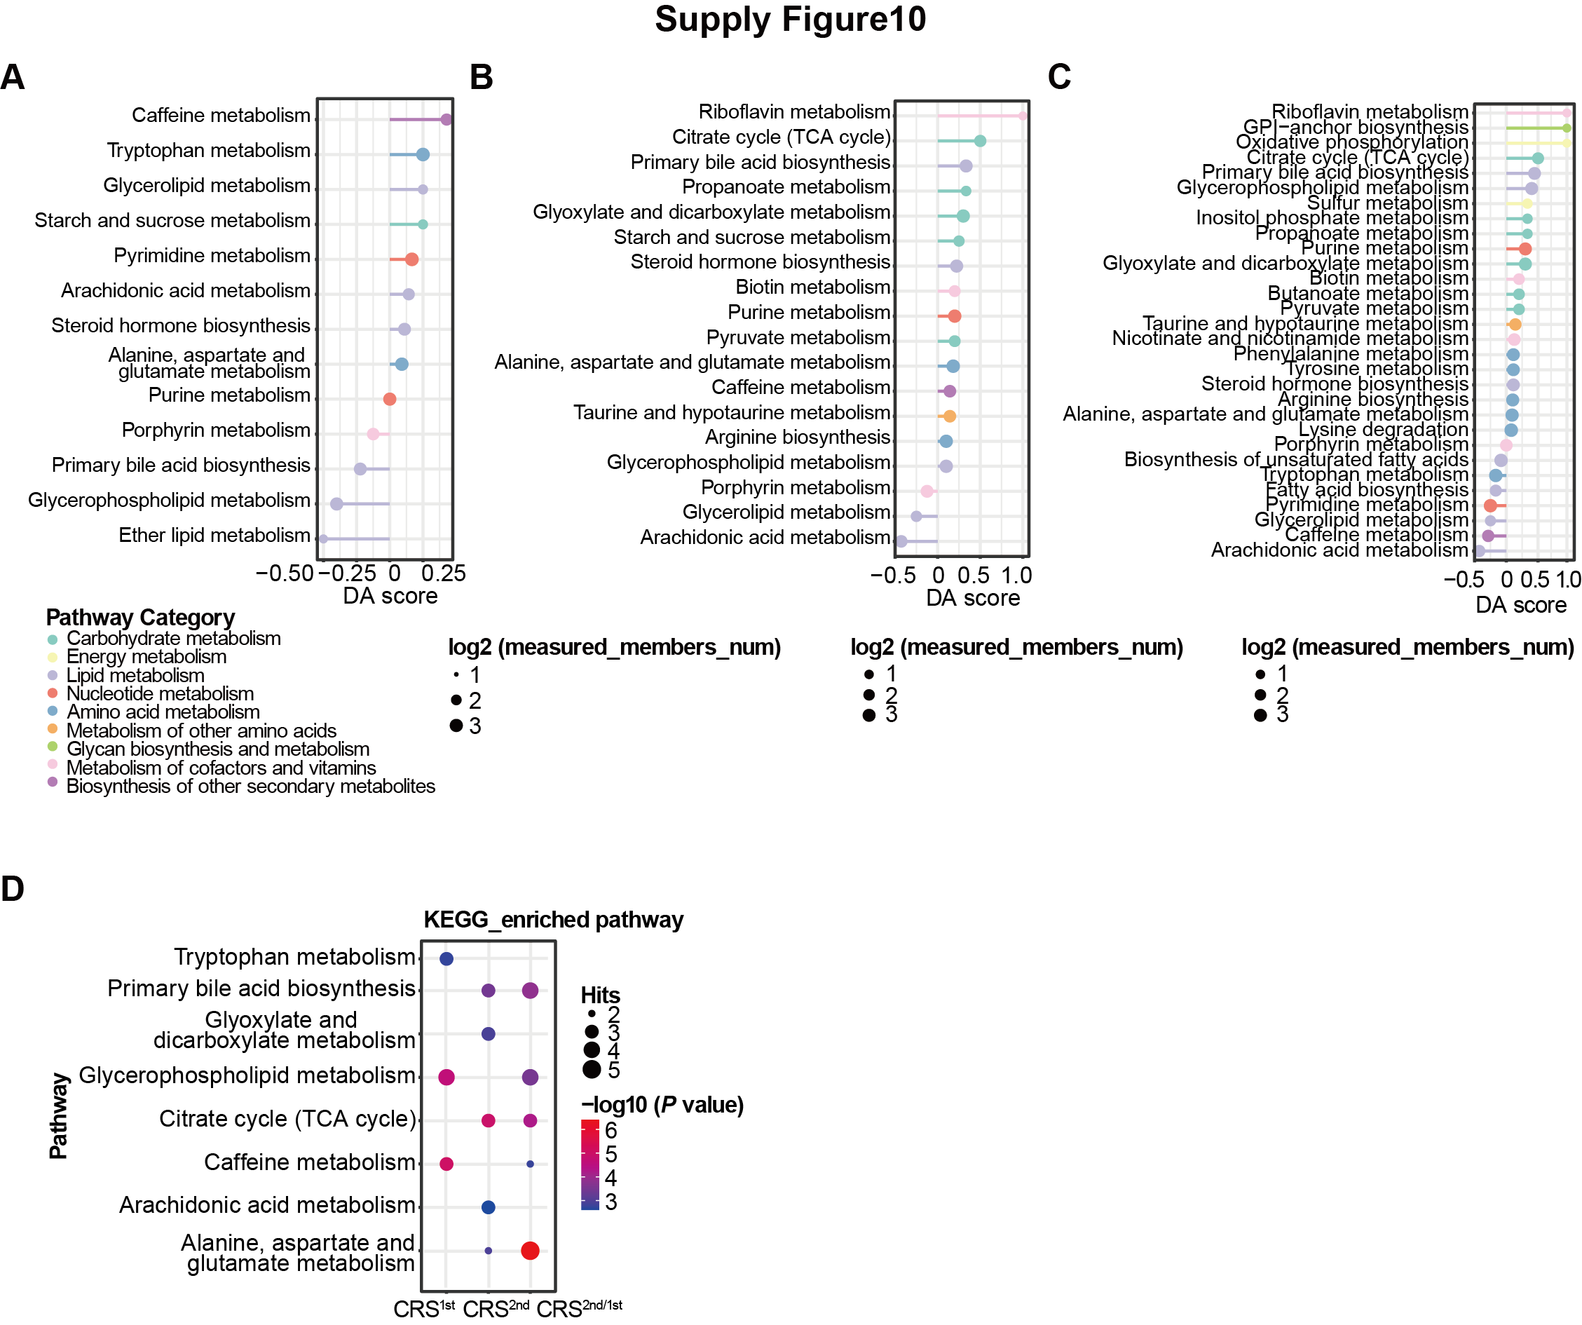
Fig. S10 Differential Abundance (DA) scores and pathway enrichment between two CRS episodes in patient RJ31. (A–C) Differential Abundance scores (DA scores) representing the overall increase or decrease of metabolites within pathways during the first CRS episode (A), the second CRS episode (B), and between both episodes (C) in patient RJ31. (D) Pathway enrichment analysis of differential metabolites during the first CRS, the second CRS, and between both episodes.

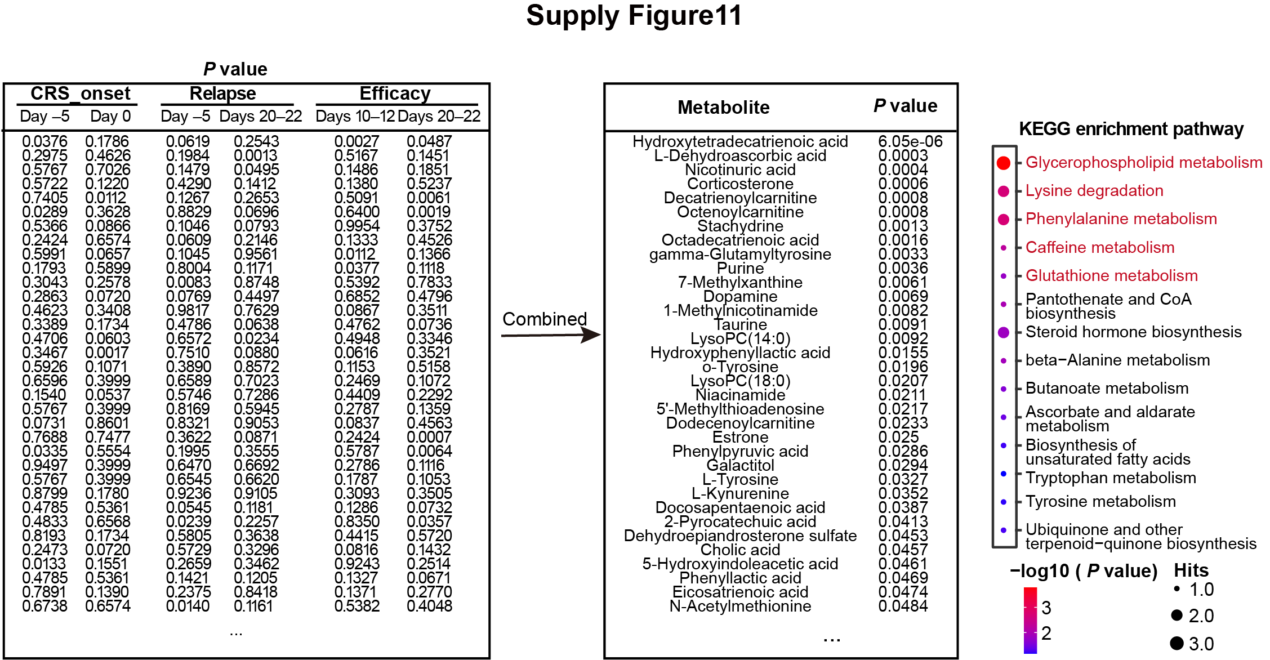
Fig. S11 Flowchart illustrating the calculation process for combined P values using Fisher’s method. The approach integrates P values from analyses of metabolites associated with CRS onset time, one-year relapse status, and CAR-T cell therapy efficacy to identify key metabolites significantly affecting multiple aspects of CAR-T treatment.
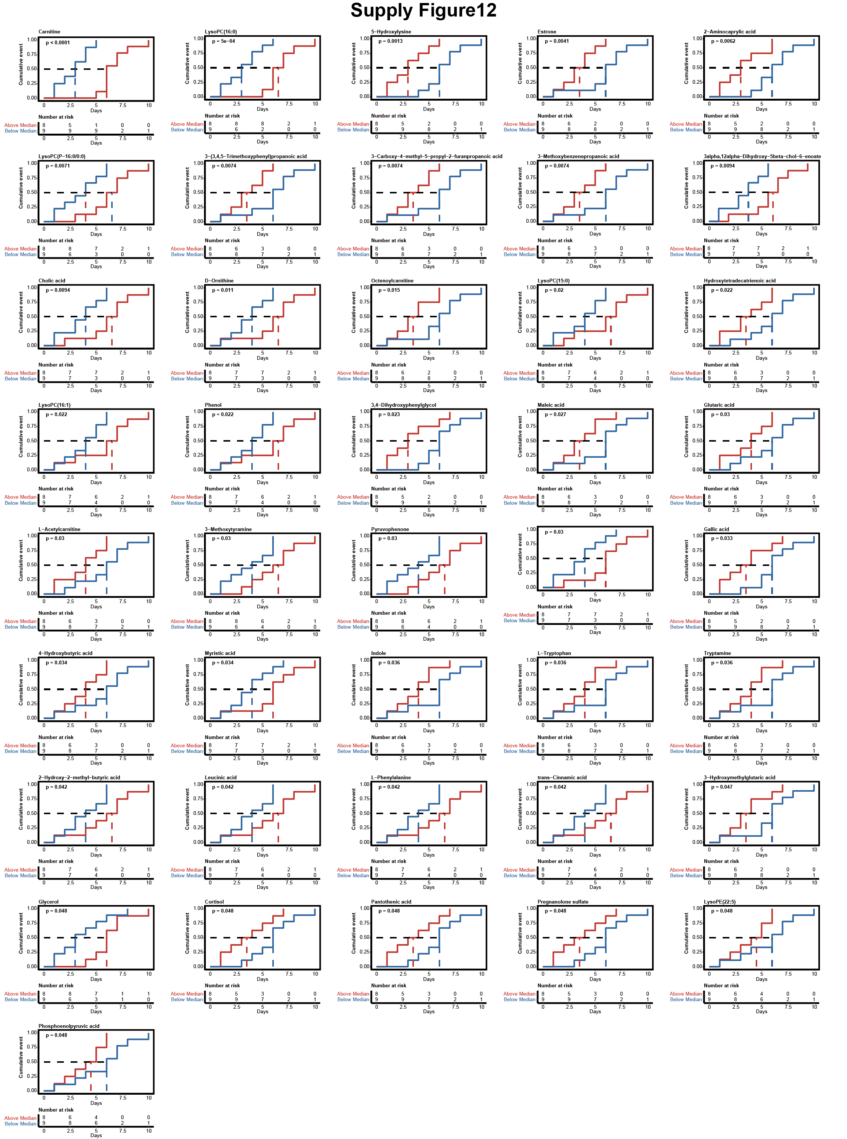
Fig. S12 Association between metabolite levels at Day –5 and time to CRS onset. Kaplan–Meier curves for the 41 significant metabolites, stratified by median abundance at Day –5. Red and blue dotted lines indicate median time to CRS onset for the high- and low-abundance groups, respectively.
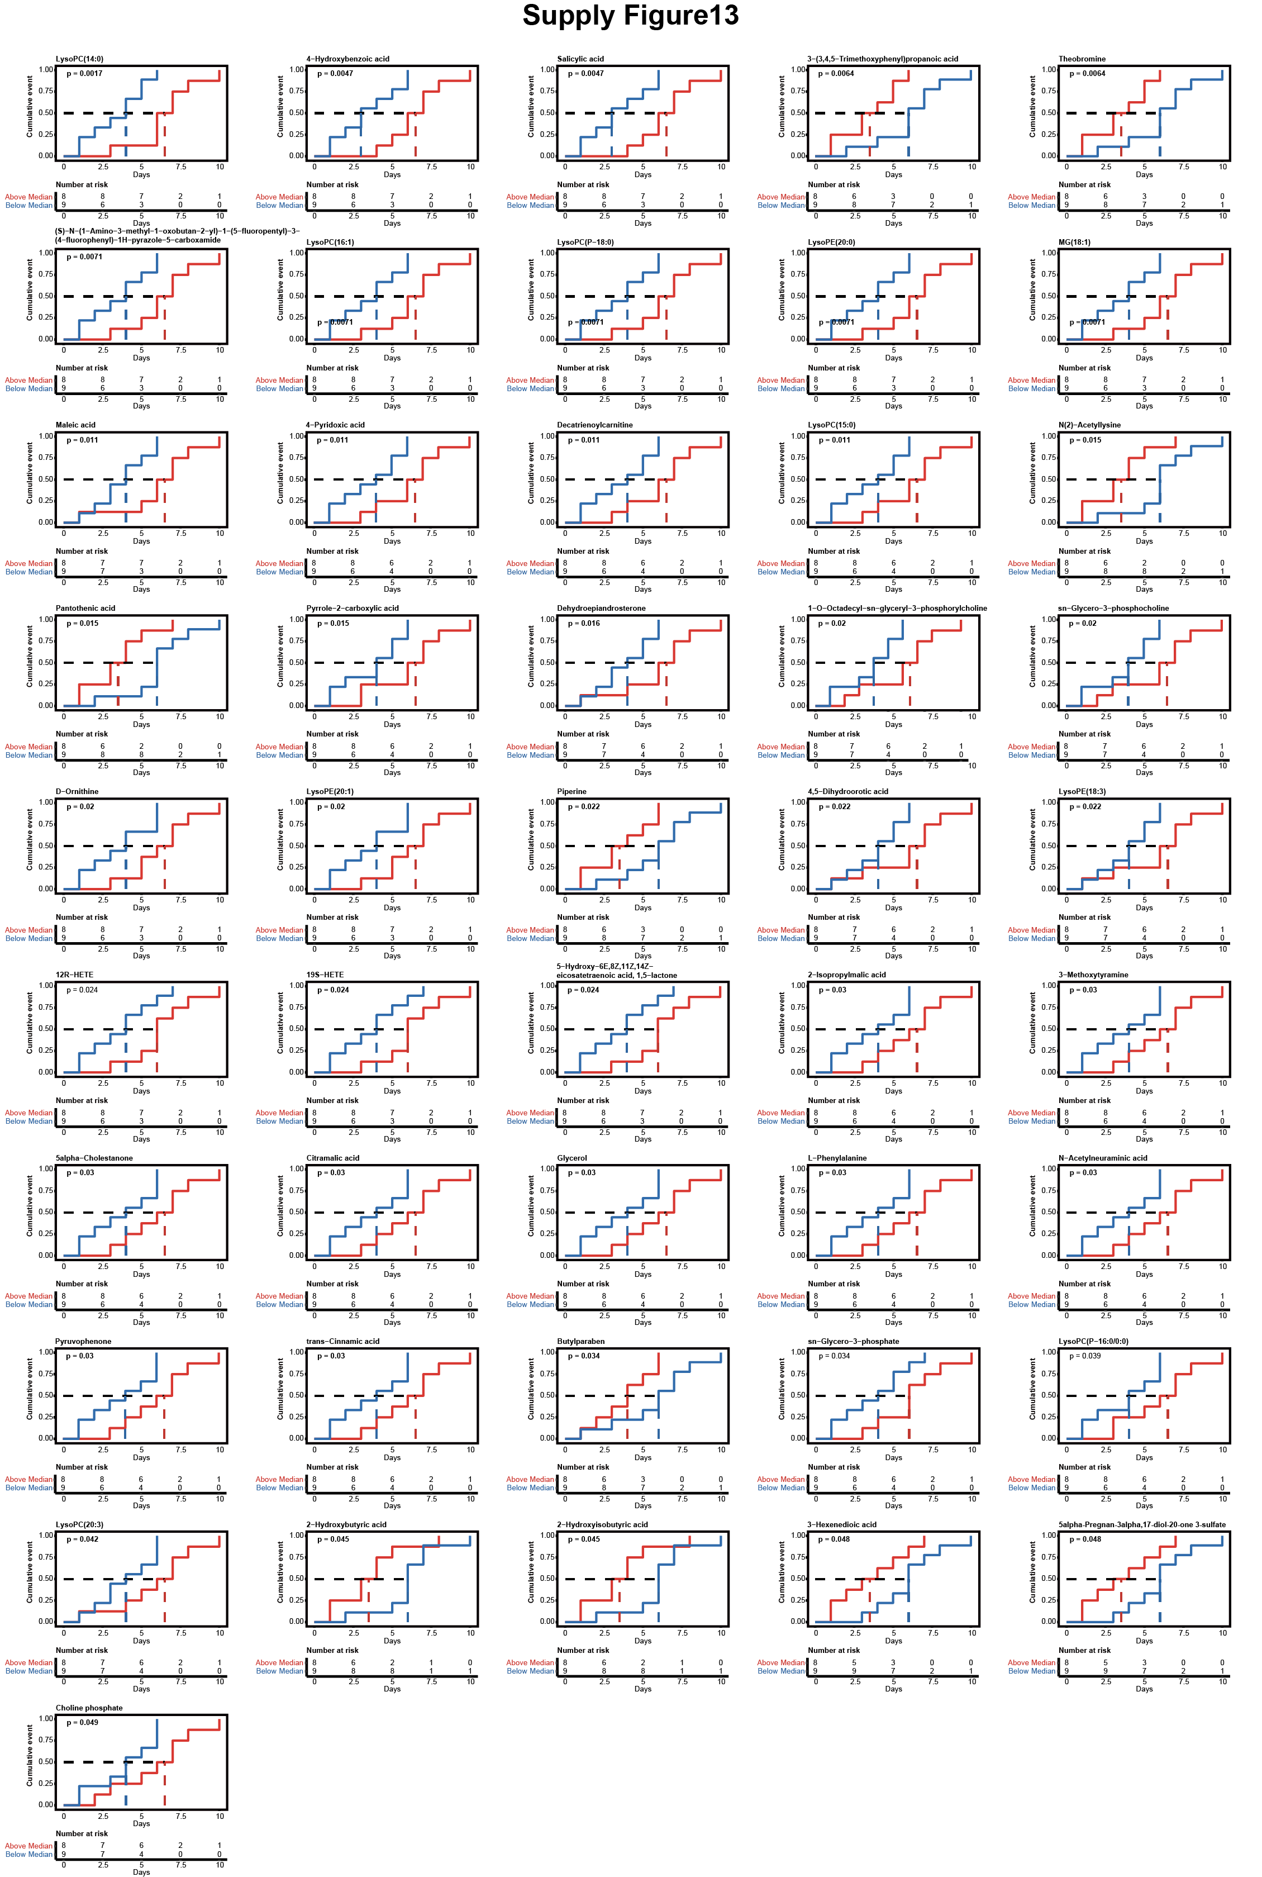
Fig. S13 Association between metabolite levels at Day 0 and time to CRS onset. Kaplan–Meier curves for the 46 significant metabolites, stratified by median abundance at Day 0. Red and blue dotted lines indicate median time to CRS onset for the high- and low-abundance groups, respectively.

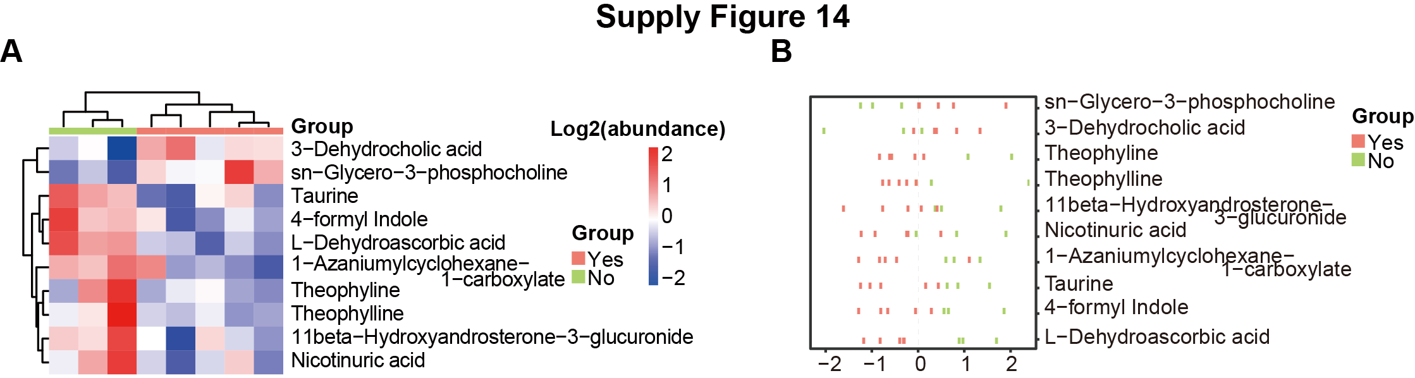
Fig. S14 Differential abundance metabolites between patients with and without one-year relapse. (A) Heatmap of metabolites that are differentially abundant at Days 20–22 between relapse and non-relapse groups. (B) Z-scores of the metabolites shown in (A).
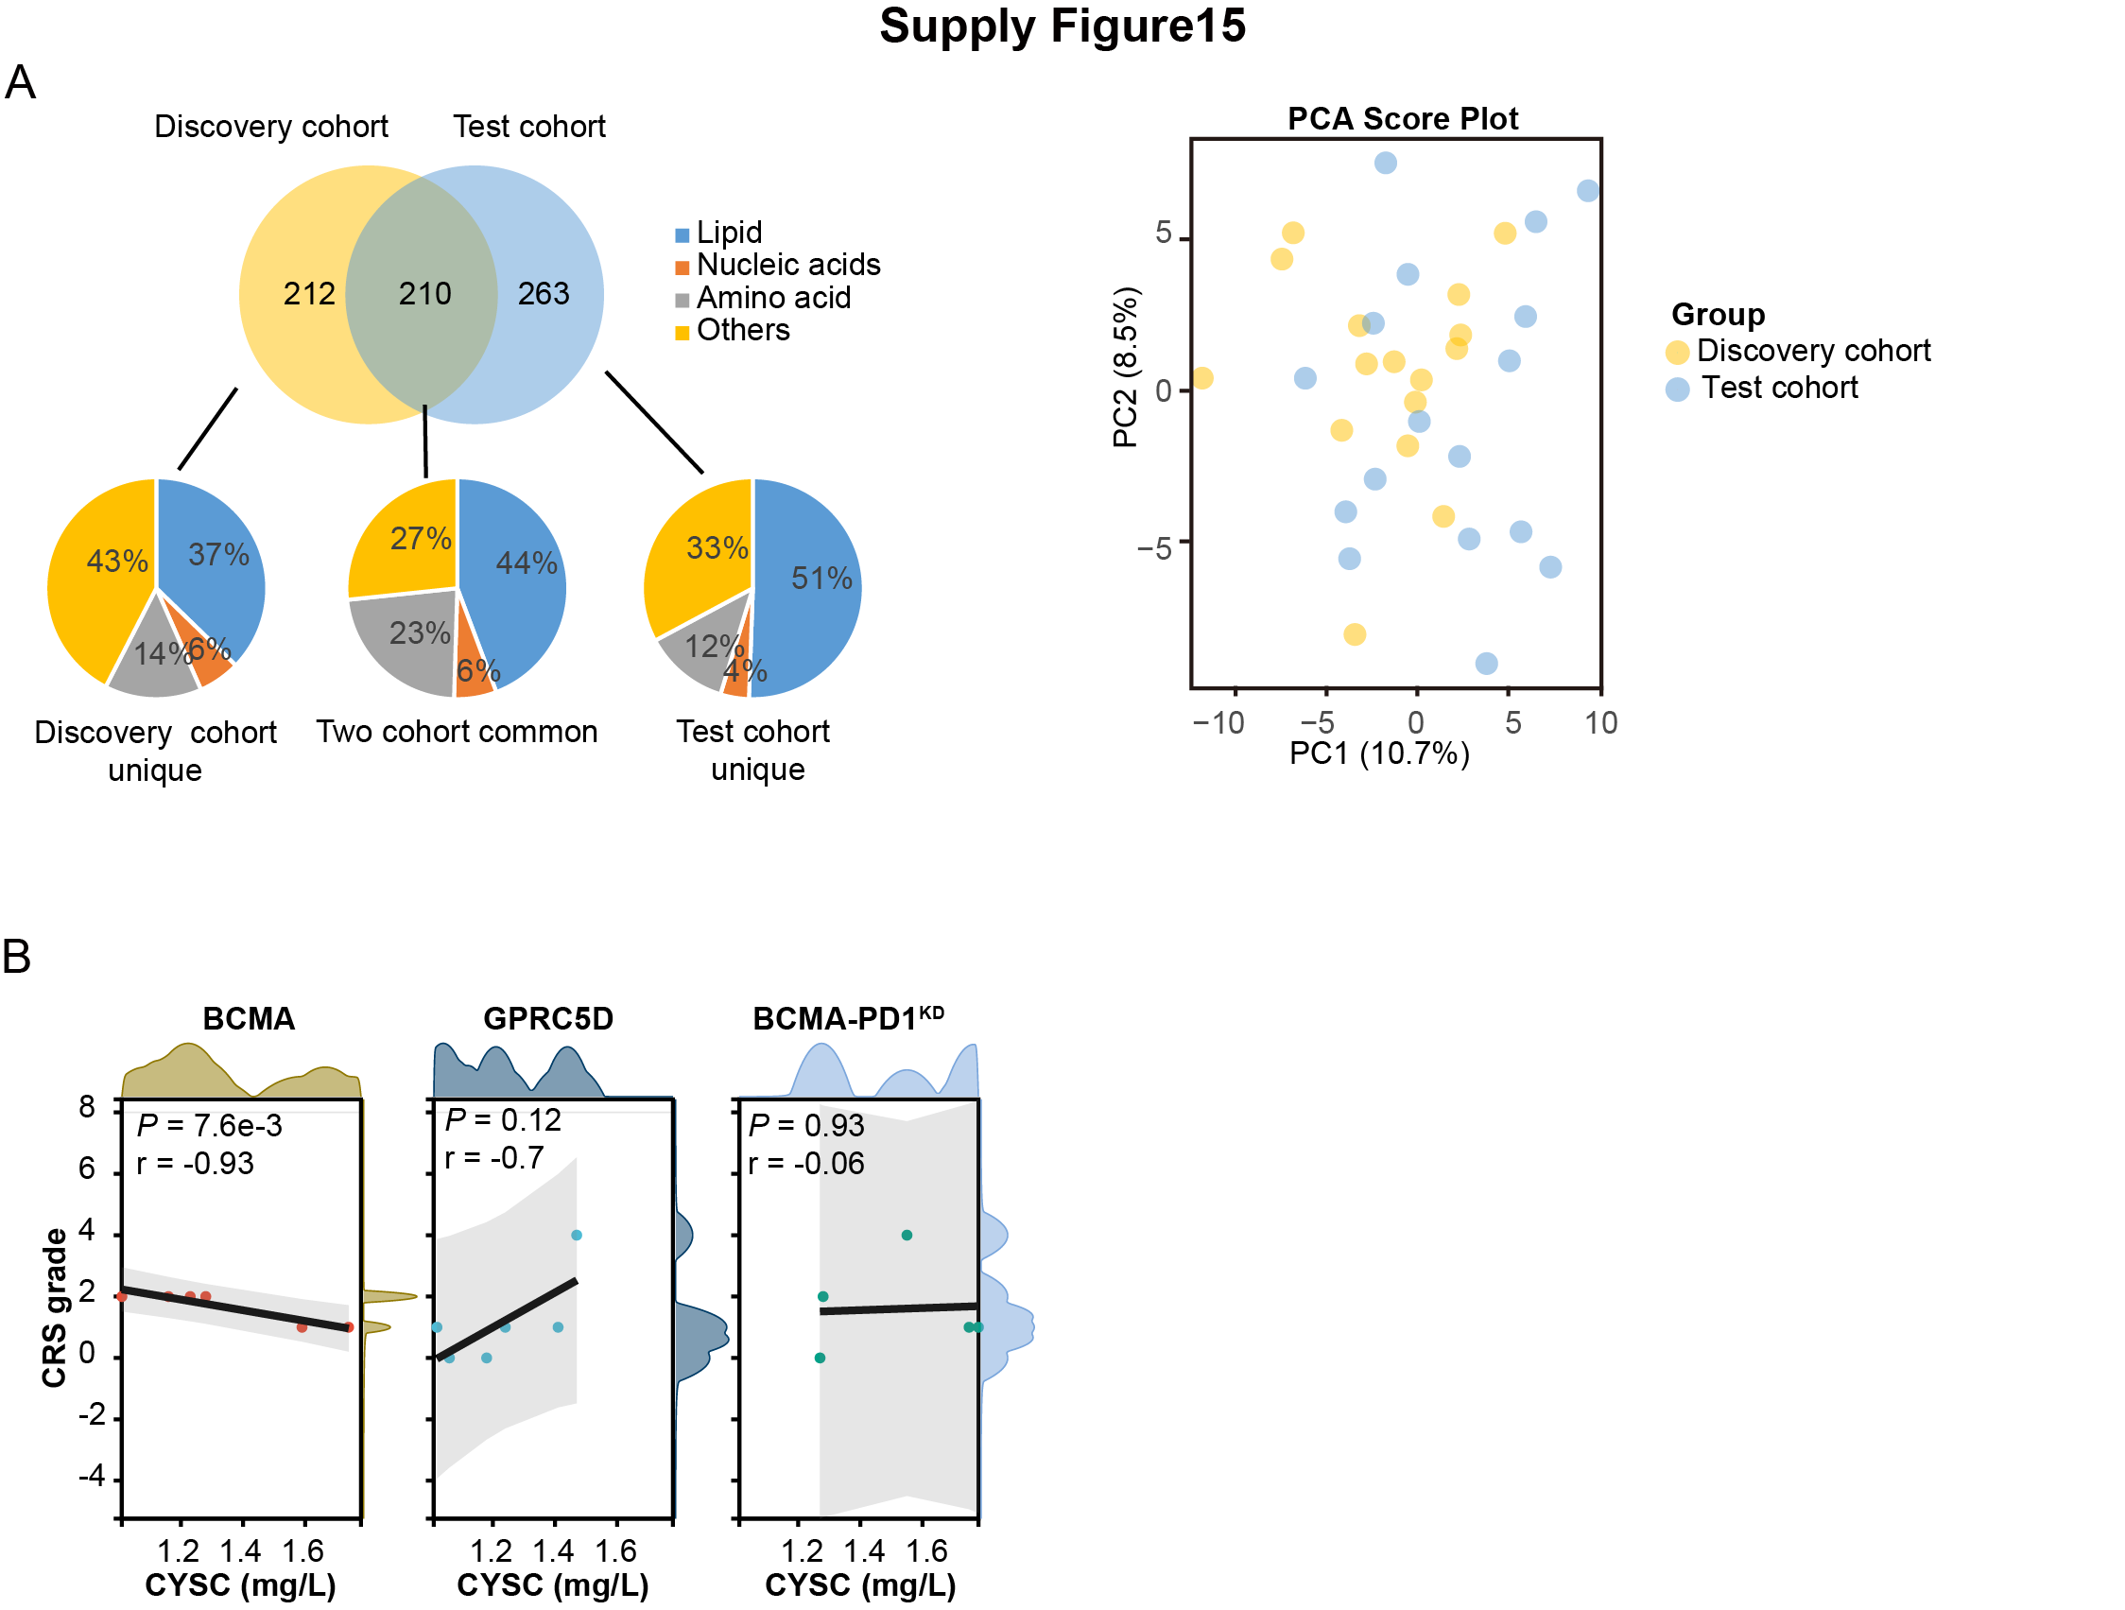
Fig. S15 Machine learning model for predicting CRS onset. (A) Left: Venn diagram showing the overlap of metabolite subtypes between the discovery and validation cohorts; Right: PCA plot of both cohorts at Day –5. (B) Correlation between serum CYSC levels and CRS grade in the validation cohort, stratified by different CAR-T products.

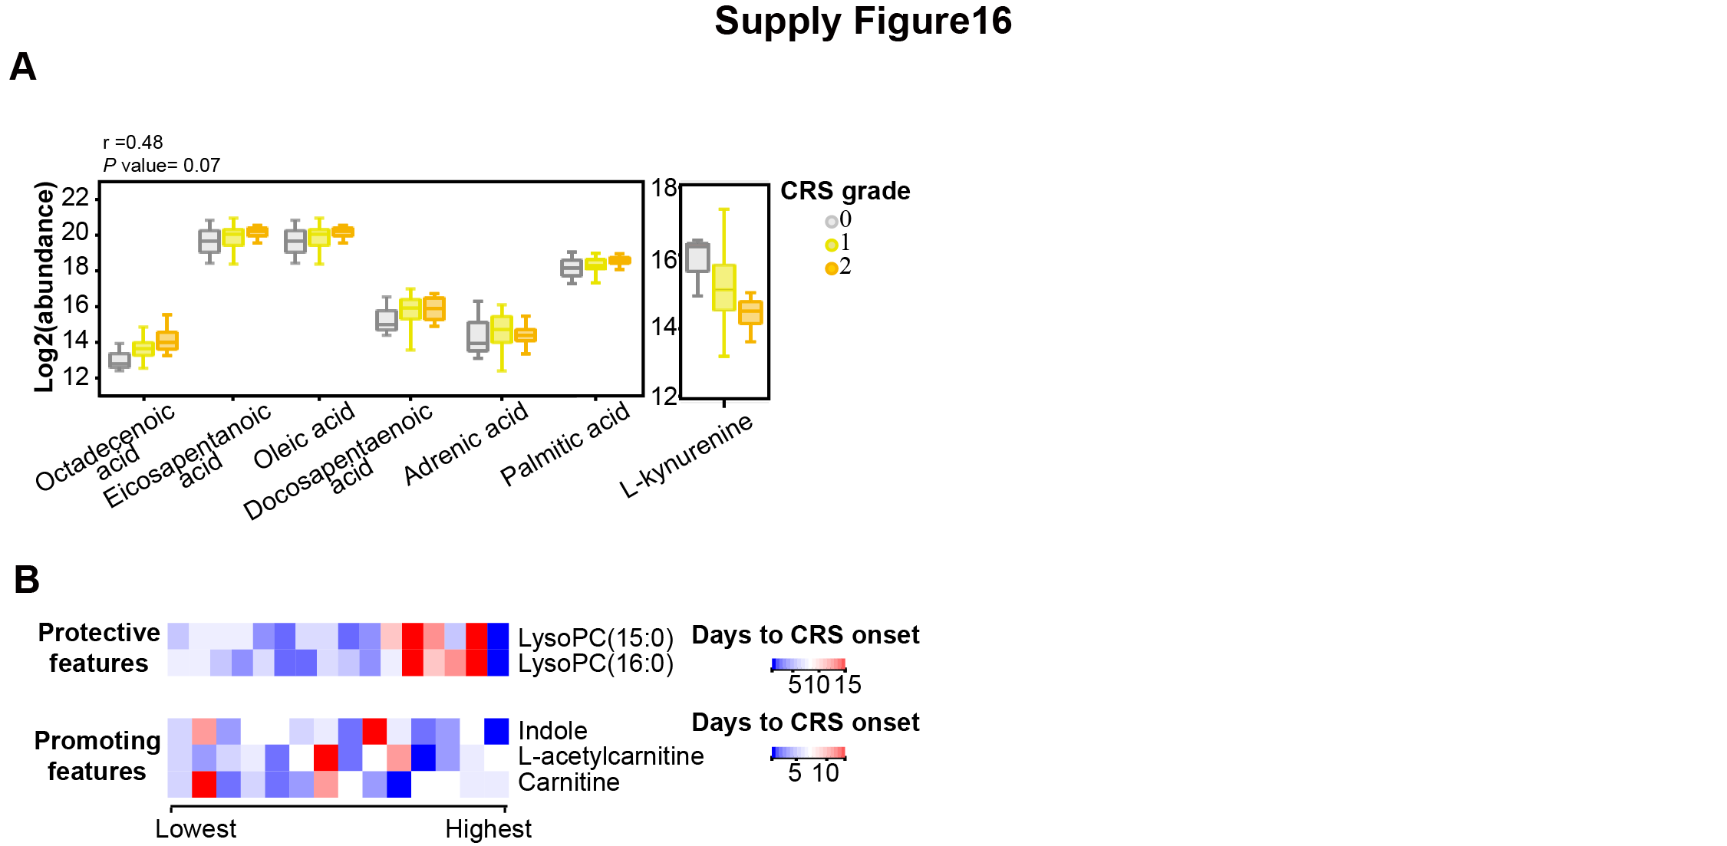
Fig. S16 Expression levels of CRS severity- and onset-related metabolites in the validation cohort. (A) Expression levels of CRS severity-associated unsaturated fatty acids and tryptophan-kynurenine pathway metabolites in the validation cohort. (B) Expression levels of CRS onset-associated metabolites in the validation cohort.

