Supplementary Figure 1
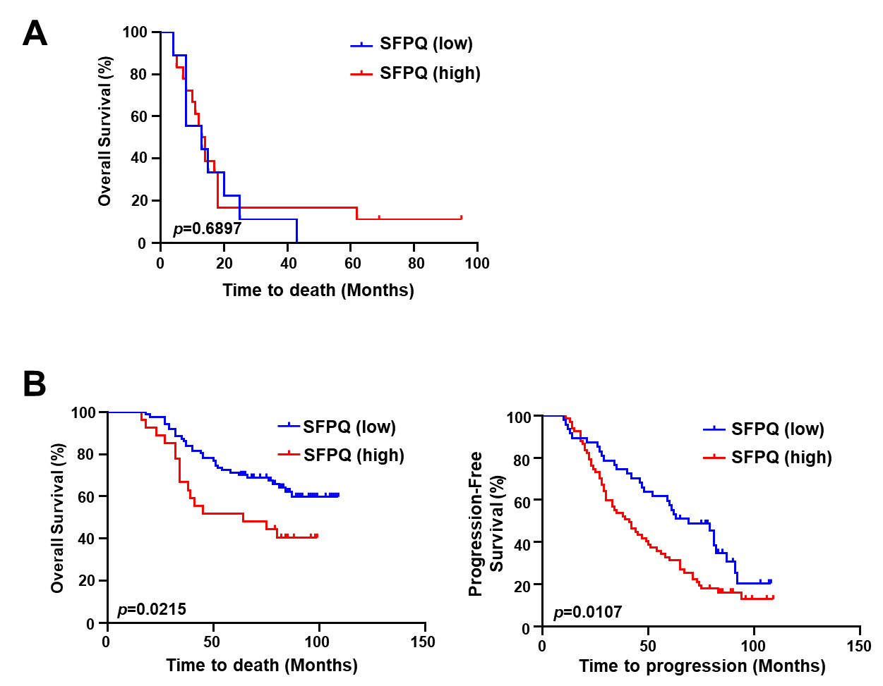
Supplementary Figure 1 SFPQ is correlated with poor prognosis in ovarian cancer patients.
(A) Kaplan–Meier analysis of the overall of platinum-resistant ovarian cancer patients with high (red) or low (blue) SFPQ expression. The cut-off value between high and low groups was determined by the receiver operating characteristic (ROC) curve. p Values were determined by log-rank test.
(B) Kaplan–Meier analysis of the overall survival (left panel) and progression-free survival (right panel) of platinum-sensitive ovarian cancer patients with high (red) or low (blue) SFPQ expression. The cut-off value between high and low groups was determined by the receiver operating characteristic (ROC) curve. p Values were determined by log-rank test.
Supplementary Figure 2
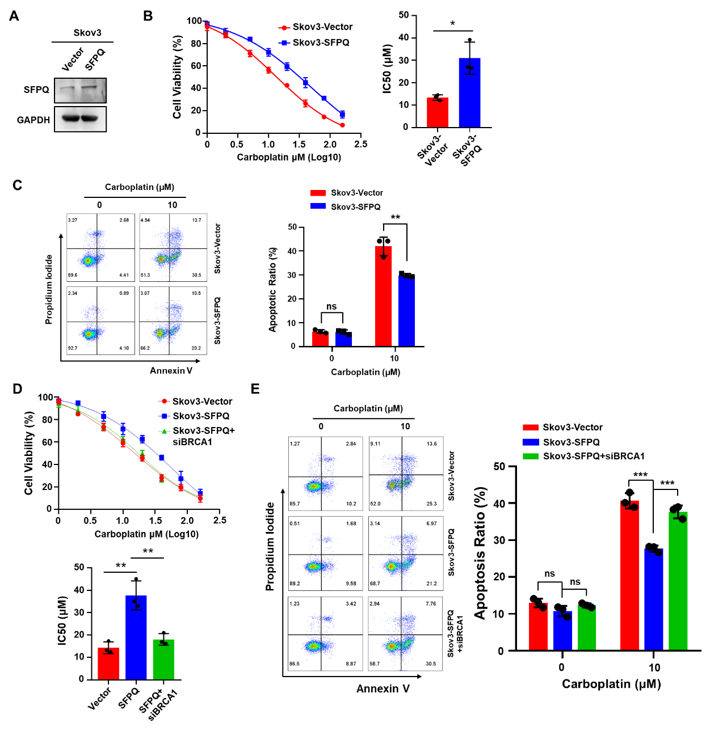
Supplementary Figure 2 High expression of SFPQ promotes platinum resistance in ovarian cancer cell.
(A) Western blot analysis of the protein level of SFPQ in Skov3 cell transfected with vector or SFPQ plasmids. n = 3 biologically independent experiments.
(B) CCK8 assays of Skov3 cell transfected with vector (red) or SFPQ (blue) plasmids. Cells were treated with carboplatin under a range of concentrations as indicated (left panel). IC50 values for carboplatin were calculated using nonlinear regression and shown as mean ± SD (right panel). p Values were determined by Student’s t-test. n = 3 biologically independent experiments.
(C) Skov3-Vector and Skov3-SFPQ cells were treated with various concentrations of carboplatin for 24 hours. Cell apoptosis was determined via flow cytometry using an Annexin-V/PI dual staining assay (left panel). Columns (right panel) represented the average percentage of Annexin V-positive cells from three independent experiments, shown as the mean ± SD. p Values were determined by Student’s t-test. n = 3 biologically independent experiments.
(D) CCK8 assays of Skov3 cell transfected with vector (red) , or SFPQ (blue) plasmids, or SFPQ plasmid and siBRCA1 (green). Cells were treated with carboplatin under a range of concentrations as indicated (top panel). IC50 values for carboplatin were calculated using nonlinear regression and shown as mean ± SD (bottom panel). p Values were determined by Student’s t-test. n = 3 biologically independent experiments.
(E) Skov3 cell transfected with vector, or SFPQ plasmids, or SFPQ plasmid and siBRCA1 were treated with various concentrations of carboplatin for 24 hours. Cell apoptosis was determined via flow cytometry using an Annexin-V/PI dual staining assay (left panel). Columns (right panel) represented the average percentage of Annexin V-positive cells from three independent experiments, shown as the mean ± SD. p Values were determined by Student’s t-test. n = 3 biologically independent experiments.
Supplementary Figure 3
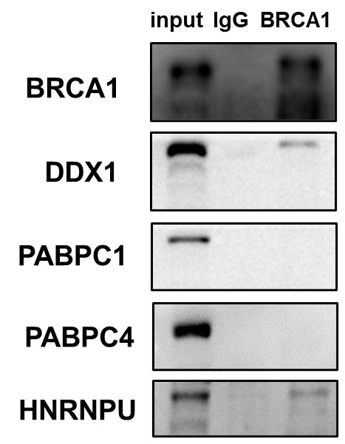
Supplementary Figure 3 Coimmunoprecipitation assay showing the absence of the combination between BRCA1 and DDX1, PABPC1, PABPC4 or HNRNPU.
Supplementary Figure 4
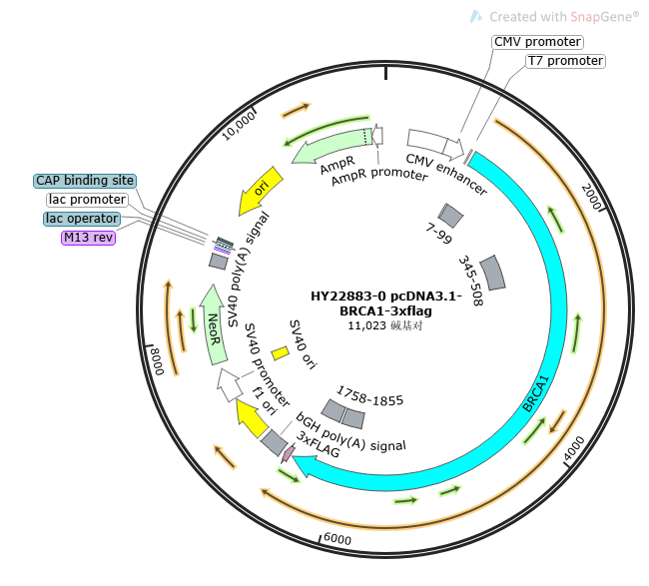
Supplementary Figure 4 Plasmid map of the truncated BRCA1 plasmid.
Supplementary Figure 5
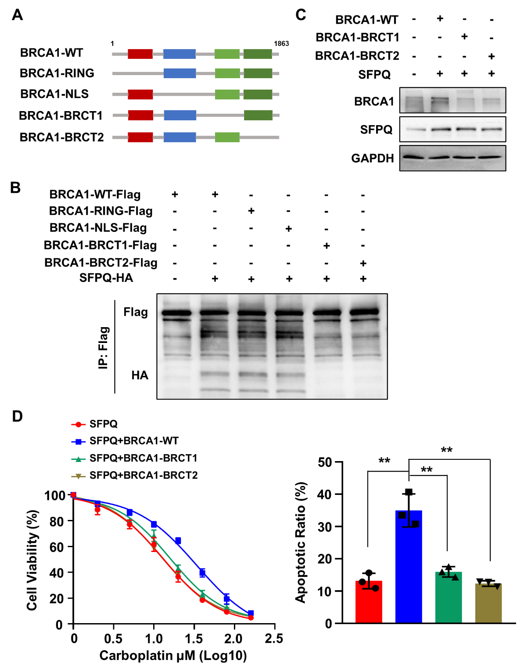
Supplementary Figure 5 SFPQ combines to the BRCT domain of BRCA1.
(A) Schematic Diagram of four BRCA1 Truncated Plasmids.
(B) Coimmunoprecipitation assay showing the presence of a complex containing SFPQ and BRCA1. Flag antibody coprecipitating HA. n = 3 biologically independent experiments.
(C) Western blot analysis of the protein levels of BRCA1 and SFPQ in A2780 cell transfected with SFPQ plasmid and different BRCA1 truncated plasmids (BRCA1-WT, BRCA1-BRCT1, BRCA1-BRCT2). n = 3 biologically independent experiments.
(D) CCK8 assays of A2780 cell transfected with SFPQ plasmid and different BRCA1 truncated plasmids (BRCA1-WT, BRCA1-BRCT1, BRCA1-BRCT2). Cells were treated with carboplatin under a range of concentrations as indicated (left panel). IC50 values for carboplatin were calculated using nonlinear regression and shown as mean ± SD (right panel). p Values were determined by Student’s t-test. n = 3 biologically independent experiments.
Supplementary Figure 6
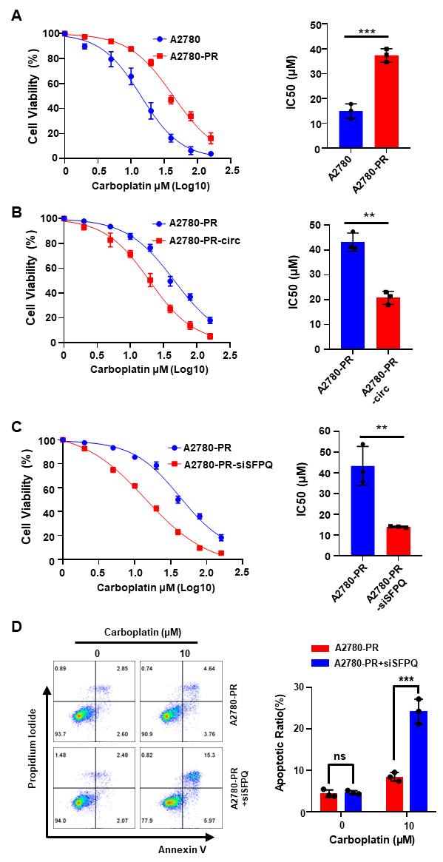
Supplementary Figure 6 SFPQ participates in platinum resistance in platinum-resistant ovarian cancer cells.
(A) CCK8 assays of A2780 cell (blue) and its platinum-resistant cells (A2780-PR) (red). Cells were treated with carboplatin under a range of concentrations as indicated (left panel). IC50 values for carboplatin were calculated using nonlinear regression and shown as mean ± SD (right panel). p Values were determined by Student’s t-test. n = 3 biologically independent experiments.
(B) CCK8 assays of A2780-PR cell transfected with vector (blue) or circSFPQ_008 (red) plasmids. Cells were treated with carboplatin under a range of concentrations as indicated (left panel). IC50 values for carboplatin were calculated using nonlinear regression and shown as mean ± SD (right panel). p Values were determined by Student’s t-test. n = 3 biologically independent experiments.
(C) CCK8 assays of A2780-PR cell transfected with siNC (blue) or SFPQ siRNA (red). Cells were treated with carboplatin under a range of concentrations as indicated (left panel). IC50 values for carboplatin were calculated using nonlinear regression and shown as mean ± SD (right panel). p Values were determined by Student’s t-test. n = 3 biologically independent experiments.
(D) A2780-PR and A2780-siSFPQ cells were treated with various concentrations of carboplatin for 24 hours. Cell apoptosis was determined via flow cytometry using an Annexin-V/PI dual staining assay (left panel). Columns (right panel) represented the average percentage of Annexin V-positive cells from three independent experiments, shown as the mean ± SD. p Values were determined by Student’s t-test. n = 3 biologically independent experiments.
Supplementary Table 1 Clinicopathological characteristics in patients with OC.
Characteristics | Case (%)
Age (years) ª | 50.72±10.95
< 60 | 109 (77.30)
≥ 60 | 32 (22.70)
FIGO stage
I/II | 44 (31.21)
III/IV | 97 (68.79)
Pathological Grade
Well/Moderate | 27 (19.15)
Poor | 101 (71.63)
Missing data | 13 (9.22)
PFI (months) ^{b}
≤ 6 | 27 (19.15)
> 6 | 114 (80.85)
SFPQ expression ^{c}
Low | 58 (41.13)
High | 83 (58.87)
Recurrence status
No | 26 (18.44)
Yes | 115 (81.56)
Survival status
Alive | 68 (48.23)
Death | 73 (51.77)
Progression-free survival (months) | 43.43±31.68
Overall survival (months) | 59.40±31.89
ª These values were presented as mean with standard deviation (SD).
^{b} PFI, platinum-free interval.
^{c} The SFPQ expressions were examined in 141 OC patients by immunohistochemistry and the cut-off value was determined using ROC curve.
Supplementary Table 2 Correlations between SFPQ expression and clinicopathological features of patients with OC.
Clinical variables | SFPQ expression ª |  | p value ^{b}
Clinical variables | High (%) n = 83 | Low (%) n = 58 | p value ^{b}
Age (years) |  |  | 0.947
< 60 | 64 (77.11) | 45 (77.59)
≥ 60 | 19 (22.89) | 13 (22.41)
FIGO stage |  |  | 0.109
I-II | 21 (25.30) | 22 (37.93)
III-IV | 62 (74.70) | 36 (62.07)
Differentiation |  |  | 0.034
Well/Moderate | 11 (13.25) | 16 (27.59)
Poor | 64 (77.11) | 37 (63.79)
Missing data | 8 (9.64) | 5 (8.62)
Recurrence |  |  | 0.019
No | 10 (12.05) | 16 (27.59)
Yes | 73 (87.95) | 42 (72.41)
Vital status |  |  | 0.168
Alive | 36 (43.37) | 32 (55.17)
Death | 47 (56.63) | 26 (44.83)
ª The SFPQ expressions were examined in 141 OC patients by immunohistochemistry and the cut-off value was determined using ROC curve.
^{b} The p values were calculated by chi-squared (χ²) test. The p values in bold indicated significance (p < 0.05).
Supplementary Table 3 Univariate and multivariate analyses of prognostic parameters in patients with OC.
Clinical variables | Subset | HR (95% CI) ª | p value ^{b}
Overall survival
Univariate analysis
Age (years) | < 60 vs ≥ 60 | 2.055(1.230-3.433) | 0.006
FIGO stage | I-II vs III-IV | 4.273(1.770-10.319) | 0.001
Expression of SFPQ ^{c} | Low vs High | 2.349(1.421-3.885) | 0.001
Differentiation | Well/Moderate versus Poor | 1.252(0.520-3.015) | 0.617
Multivariate analysis
FIGO stage | I-II vs III-IV | 4.872(2.333-10.174) | <0.001
Expression of SFPQ | Low vs High | 1.897(1.161-3.101) | 0.011
Progression-free survival
Univariate analysis
Age (years) | < 60 vs ≥ 60 | 1.781(1.145-2.772) | 0.01
FIGO stage | I-II vs III-IV | 2.461(1.314-4.609) | 0.005
Expression of SFPQ ^{c} | Low vs High | 1.364(0.908-2.048) | 0.135
Differentiation | Well/Moderate versus Poor | 1.115(0.562-2.211) | 0.756
Multivariate analysis
Age (years) | < 60 vs ≥ 60 | 1.603(1.055-2.436) | 0.027
FIGO stage | I-II vs III-IV | 2.821(1.750-4.548) | <0.001
ª HR (Hazard Ratio) and p values were calculated using univariate or multivariate Cox proportional hazards regression. 95% CI, 95% confidence interval. HR > 1 indicated that the clinical variable is a risk factor.
^{b} The p values in bold indicated significance (p < 0.05).
^{c} The SFPQ expressions were examined in 141 OC patients by immunohistochemistry and the cut-off value was determined using ROC curve.
Supplementary Table 4 Sequences of siRNAs
siRNA | Sequences
siSFPQ-1 | CCAGAAATTTCCACCTCTA
siSFPQ-2 | GGATGATCGTGGAAGATCT
siSFPQ-3 | GGAGGAACGACGTAGAAGA
siBRCA1 | CCACACGATTTGACGGAAA
siHDAC1-1 | GCGACTGTTTGAGAACCTT
siHDAC1-2 | GGGATCGGTTAGGTTGCTT
siHDAC1-3 | AGGCGGTGGTTACACCATT
si-hsa_circSFPQ_008 | GGAAGTGACATGGCAAGAG

Supplementary Table 5 Primers for real-time PCR
Genes | Forward | Reverse
BRCA1 | ACCTTGGAACTGTGAGAACTCT | TCTTGATCTCCCACACTGCAATA
SFPQ | AGCGATGTCGGTTGTTTGTTG | AGCGAACTCGAAGCTGTCTAC
hsa_circSFPQ_008 | TGACATGGCAAGAGGAG | CCATTCGGCTGTAACTT
GAPDH | GAGTCAACGGATTTGGTCGT | GACAAGCTTCCCGTTCTCAG
U6 | CGCTTCGGCAGCACATATAC | AAATATGGAACGCTTCACGA

Supplementary Table 6 Antibodies for IHC, WB and IP
Target protein | IHC | WB | IP
SFPQ | 1:100, Proteintech #15585-1-AP | 1:1000, Proteintech #15585-1-AP | Proteintech #15585-1-AP
BRCA1 | 1:100, Proteintech #22362-1-AP | 1:1000, Proteintech #22362-1-AP | Proteintech #22362-1-AP
HDAC1 |  | 1:1000, Proteintech #10197-1-AP | Proteintech #10197-1-AP
H3K27Ac |  | 1:1000, PTM Bio #PTM-116RM
Flag |  | 1:1000, Proteintech #20543-1-AP
His |  | 1:1000, Proteintech #66005-1-Ig
GAPDH |  | 1:5000, Proteintech #10494-1-AP
IgG |  |  | Proteintech #98136-1-RR

