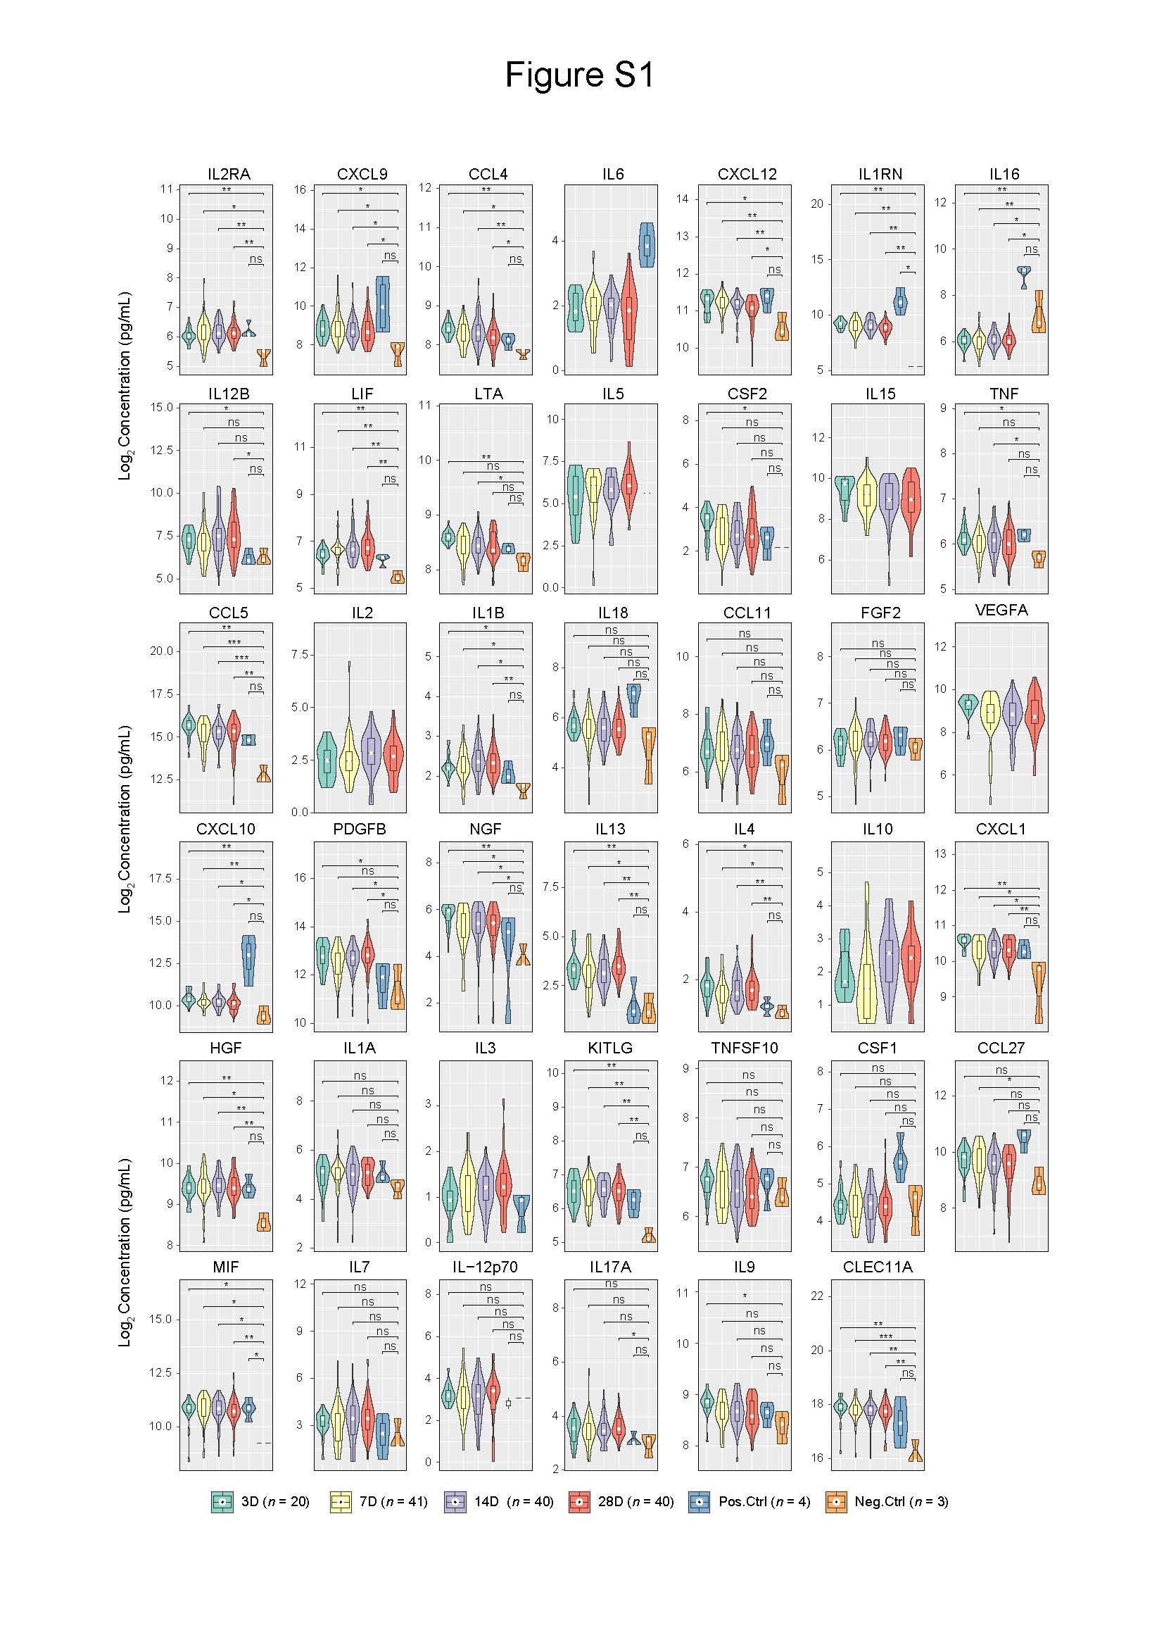

Figure S1. Responses of cytokines and chemokines to a third dose of BBIBP-CorV. Related to Figure 2.
Violin plots of representative cytokines/chemokines induced by the third dose of BBIBP-CorV. P values of Wilcoxon tests are shown on each plot. * P_{adj} < 0.05, ** P_{adj} < 0.01, *** P_{adj} < 0.001, **** P_{adj} < 0.0001; ns, not significant.
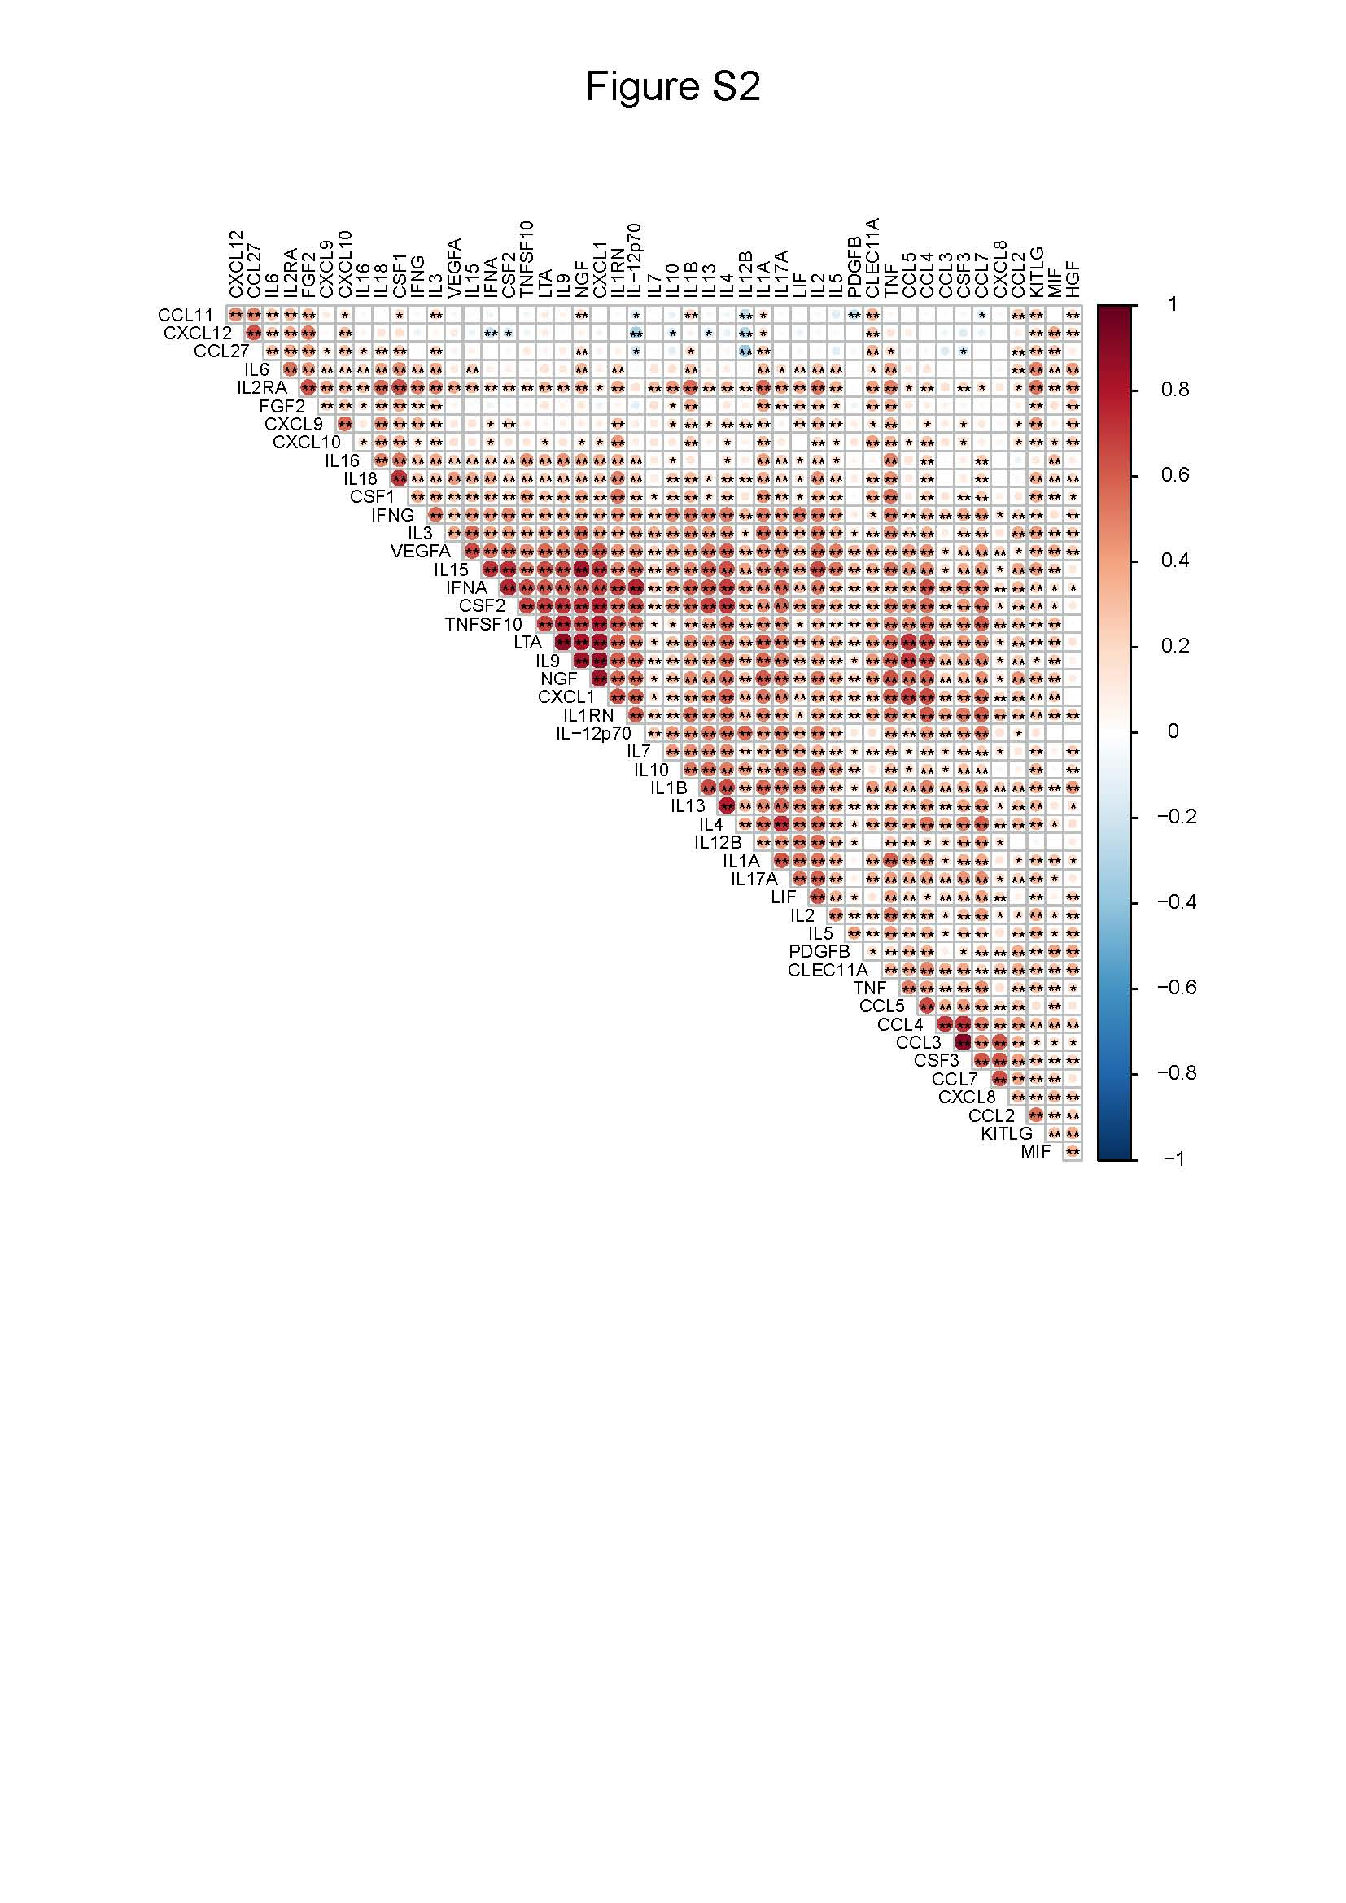
Figure S2. Correlation between 48 cytokines/chemokines in response to a third dose of BBIBP-CorV. Related to Figure 2.

