Table S1. Frequency of KMT2A rearrangements in BCP-ALL under 1 y.o., pediatric AML and adult AL during period from 1.01.2023 to 31.12.2024 classified by Meyer 2023 et. Al.
Diagnosis, age group |  | BCP-ALL under 1 y.o. |  | AML 0-18 y.o. |  | AML adults
 |  | n | % | n | % | n | %
total number of investigated patients |  | 49 | 100% | 239 | 100% | 183 | 100,00%
KMT2A+ cases | total | 34 | 69,40% | 76 | 31,80% | 24
KMT2A+ cases | KMT2A::AFF1 | 17 | 50,0 | - | - | 10
KMT2A+ cases | KMT2A::MLLT3 | 5 | 14,7 | 26 | 34,2 | 9
KMT2A+ cases | KMT2A::MLLT1 | 8 | 23,5 | 4 | 5,3 | 2
KMT2A+ cases | KMT2A::MLLT10 | 1 | 2,9 | 25 | 32,9 | - | -
KMT2A+ cases | KMT2A::AFDN | - | - | 4 | 5,3 | 3
KMT2A+ cases | KMT2A::ELL | - | - | 8 | 10,5 | - | -
KMT2A+ cases | KMT2A::EPS15 | 1 | 2,9 | - | - | - | -
KMT2A+ cases | KMT2A::MLLT11 | - | - | 3 | 3,9 | - | -
KMT2A+ cases | other | 1 | 2,9 | 3 | 3,9 | - | -
novel KMT2A+ cases | KMT2A::MRFTB | 1 | 2,9 | - | - | - | -
novel KMT2A+ cases | KMT2A::SORBS1 | - | - | 1 | 1,3 | - | -
novel KMT2A+ cases | KMT2A::SSC5D | - | - | - | - | 1 | -

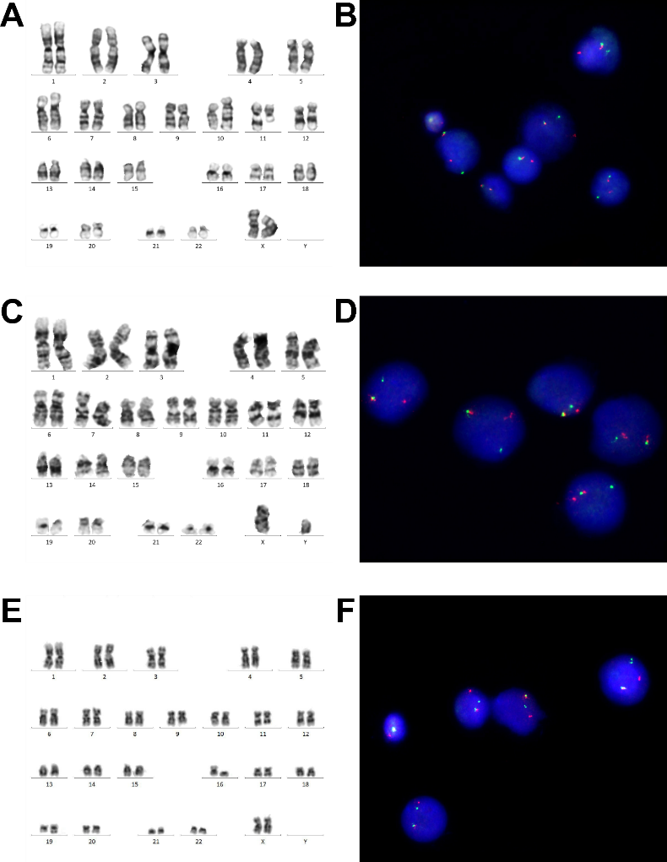
Figure supplementary 1. Cytogenetic and FISH assessment of novel KMT2A rearrangements: conventional GTG-banded karyotyping (A, C, E); FISH with 11q23.3 break-apart probe (B, D, F)

