Supplementary Materials
THP-1 cells proliferation
Cells expressing GFP, CAS9, and either control gRNA (gRNA control) or ADA2 specific gRNA (gRNA ADA2) were procured from Ubigene and cultured in 96-well plates in 200 μl of complete RPMI medium at a starting cell density of 0.13x10⁶ cells/ml. The cell density in seven independent wells was monitored daily by counting the cells using a cell counter and flow cytometry. In another experiment, ADA2 knock-out cells (0.15x10⁶ cells/ml) were incubated with increasing concentrations of ADA2, and the cell number was determined on day 4 of culture.
Western blot analysis of 293T cells expressing ADA2 mutants
To introduce the mutation in ADA2: ADA2-M109 (A109D), ADA2-M169 (R169Q), ADA2-M453 (Y453C), ADA2-M47 (G47A), and ADA2-M112 (H112Q) ¹⁶, sets of primers containing the mutation of interest were synthesized (Supplementary Table 2), and the cloning strategy was used as described previously ²⁰. The 293FT cells were transfected with lentiviruses expressing the desired genes and cultured in DMEM medium (Invitrogen) with 10% fetal bovine serum (FBS), 100 U/ml of penicillin, and 100 mg/ml of Streptomycin at 37˚C. ²⁰. The cells were lysed in denaturing buffer (50 mM Tris (pH 7.5), 0.5 mM EDTA, 1% SDS, and 1 mM DTT). The cell extracts were centrifugated for 10 minutes at 4˚C at 15,000 g. Protein gels were run and blotted using the Mini-PROTEAN Tetra Electrophoresis system (Biorad). Western blot analysis was carried out by detecting purified or associated protein using chemiluminescence (PerkinElmer) and the ADA2 ⁸ and GFP (Cell Signaling Technology) antibodies.

Immunostainings of 293T cells expressing ADA2 mutants
The cells were treated with either 10% formaldehyde or 4% PFA for 10 minutes. They were then washed three times with PBS and permeabilized for 5 minutes in PBS-T, which is PBS supplemented with 0.3% Triton X-100. After three more washes with PBS, the cells were incubated overnight at 4°C in a primary antibody diluted in PBS containing 1% BSA. Next, they were washed three times with PBS and incubated with a secondary antibody in PBS containing 1% BSA for 30 minutes at room temperature. After three further washes, the cells were mounted in 80% glycerol. The antibody dilutions for B4GALT1, LAMP2 (both from Sino Biological), and ADA2 were 1:200. Finally, fluorescent stains were captured on the Leica sp8 confocal microscope.
TNF-α secretion by monocyte subsets
Pan monocytes were isolated from PBMCs by negative selection (Miltenyi Biotech). CD16+ monocyte subset was depleted using CD16+ magnetic beads (Miltenyi Biotech). Total monocytes and monocytes lacking CD16+ subset (0.4 ml, 0.5 x10⁶ cells/ml) were incubated with 50 ng/ml LPS in the complete RPMI medium for 24 hours in 5 ml Falcon tubes (BD). The amount of TNF-α was determined in the cell culture medium by ELISA (Biolegend). The difference between TNF-α produced by total monocytes and monocytes lacking CD16+ subset was attributed to CD16+ monocytes. The amount of TNF-α produced by 1 x10⁶ cells/ml CD16+ monocytes and CD16- monocytes was calculated based on the percentage of CD16+ cells obtained by the flow cytometry analysis (Supplementary Figure 8 A).

Supplementary Table 1. Analysis of the cytokines and ADA2 concentration in BAL samples of pneumonia patients.
Lab ID | Lab aquisition date | Gender | Age (Month) | Administration date | Antibiotics | Macrolide | Corticosterioids | IL1β_BAL
LGB_0009 | 2016-09-27 | Male | 50 | 2016-09-17 | 1 | 1 | 1 | 5.26
LGB_0011 | 2016-09-29 | Female | 49 | 2016-09-27 | 1 | 0 | 0 | 24.32
LGB_0020 | 2016-11-01 | Female | 16 | 2016-10-25 | 1 | 1 | 1 | 7.83
LGB_0021 | 2016-11-01 | Female | 7 | 2016-10-31 | 1 | 1 | 1 | 221.55
LGB_0027 | 2016-11-10 | Male | 12 | 2016-11-06 | 1 | 1 | 1 | 8.52
LGB_0046 | 2016-11-21 | Male | 12 | 2016-11-20 | 1 | 0 | 0 | 48.87
LGP_0052 | 2016-11-22 | Male | 72 | 2016-11-11 | 1 | 1 | 0 | 330.71
LGP_0053 | 2016-11-22 | Female | 72 | 2016-11-13 | 1 | 1 | 0 | 34.99
LGB_0056 | 2016-11-24 | Male | 60 | 2016-11-22 | 1 | 0 | 0 | 213.81
LGP_0057 | 2016-11-24 | Female | 48 | 2016-11-19 | 1 | 1 | 0 | 199.56
LGP_0065 | 2016-12-01 | Male | 60 | 2016-11-22 | 1 | 1 | 0 | 39.94
LGP_0066 | 2016-12-01 | Female | 48 | 2016-11-19 | 1 | 1 | 0 | 272.08
LGP_0070 | 2016-12-08 | Male | 108 | 2016-12-03 | 1 | 1 | 0 | 338.52
LGB_0076 | 2016-12-19 | Female | 55 | 2016-12-13 | 1 | 0 | 0 | 1.97
LGP_0080 | 2016-12-22 | Male | 3 | 2016-12-15 | 1 | 0 | 0 | 139.17
LGB_0081 | 2016-12-22 | Male | 16 | 2016-12-21 | 1 | 1 | 0 | 892.17
LGP_0085 | 2016-12-27 | Male | 86 | 2016-12-13 | 1 | 0 | 0 | 2.88
LGP_0086 | 2016-12-27 | Male | 60 | 2016-12-24 | 1 | 1 | 0 | 67.95
LGB_0088 | 2016-12-29 | Male | 72 | 2016-12-26 | 1 | 0 | 0 | 156.76
LGP_0090 | 2017-01-03 | Male | 36 | 2016-12-29 | 1 | 0 | 0 | 16.78
LGB_0092 | 2017-01-04 | Male | 13 | 2017-01-04 | 0 | 0 | 0 | 1.02
LGB_0093 | 2017-01-04 | Female | 48 | 2017-01-04 | 0 | 0 | 0 | 207.44
LGB_0094 | 2017-01-05 | Male | 72 | 2016-12-26 | 1 | 0 | 0 | 3.63
LGB_0095 | 2017-01-05 | Male | 26 | 2017-01-02 | 0 | 0 | 0 | 3.82
LGB_0100 | 2017-01-18 | Male | 29 | 2017-01-17 | 1 | 0 | 0 | 11.32
LGB_0101 | 2017-01-18 | Male | 30 | 2017-01-11 | 1 | 1 | 1 | 19.38
LGB_0102 | 2017-01-18 | Male | 125 | 2017-01-16 | 1 | 0 | 0 | 231.06
LGB_0103 | 2017-01-19 | Male | 78 | 2017-01-13 | 1 | 1 | 0 | 31.71
LGB_0104 | 2017-01-19 | Male | 15 | 2017-01-14 | 1 | 0 | 0 | 4.8
LGB_0105 | 2017-01-24 | Male | 10 | 2017-01-21 | 1 | 0 | 0 | 52.94
LGB_0106 | 2017-01-24 | Male | 66 | 2017-01-19 | 1 | 0 | 0 | 92.18
LGB_0107 | 2017-01-24 | Male | 41 | 2017-01-18 | 1 | 1 | 0 | 8.18
LGB_0112 | 2017-03-08 | Male | 33 | 2017-03-08 | 1 | 0 | 0 | 2.74
LGB_0113 | 2017-03-08 | Female | 48 | 2017-03-08 | 1 | 0 | 0 | 2705.28
LGB_0120 | 2017-03-17 | Male | 15 | 2017-03-15 | 1 | 0 | 1 | 19.76
LGB_0121 | 2017-03-20 | Female | 29 | 2017-03-10 | 1 | 0 | 1 | 5.45
LGB_0122 | 2017-03-20 | Female | 70 | 2017-03-12 | 1 | 1 | 0 | 2.42
LGB_0123 | 2017-03-20 | Male | 5 | 2017-03-20 | 0 | 0 | 0 | 0.71
LGB_0124 | 2017-03-22 | Male | 16 | 2017-03-21 | 1 | 0 | 0 | 38.09
LGB_0126 | 2017-03-27 | Male | 18 | 2017-03-27 |  | 0 |  | 21.37
LGB_0128 | 2017-03-29 | Male | 69 | 2017-03-28 | 1 | 0 | 0 | 0.98
LGB_0134 | 2017-04-07 | Female | 24 | 2017-04-03 | 1 | 1 | 0 | 17.15
LGB_0136 | 2017-04-14 | Female | 36 | 2017-04-12 | 1 | 1 | 0 | 6.83
LGB_0137 | 2017-04-19 | Female | 36 | 2017-04-12 | 1 | 1 | 0 | 128.34
LGB_0138 | 2017-04-21 | Male | 36 | 2017-04-02 | 0 | 0 | 0 | 256.05
LGB_0139 | 2017-04-24 | Male | 4 | 2017-03-02 | 1 | 0 | 1 | 10.53
LGP_0140 | 2017-04-26 | Male | 24 | 2017-04-21 | 1 | 1 | 1 | 301.12
LGB_0142 | 2017-05-10 | Female | 12 | 2017-05-04 | 1 | 0 | 1 | 19.68
LGB_0143 | 2017-05-10 | Male | 24 | 2017-04-21 | 1 | 1 | 1 | 4.85
LGB_0145 | 2017-05-16 | Male | 26 | 2017-05-11 | 1 | 0 | 0 | 465.32
LGB_0146 | 2017-05-18 | Male | 12 | 2017-05-12 | 1 | 0 | 0 | 5.26
LGB_0147 | 2017-05-20 | Male | 8 | 2017-05-09 | 1 | 0 | 0 | 2.81
LGB_0148 | 2017-05-26 | Male | 12 | 2017-05-16 | 1 | 0 | 0 | 15.44
LGB_0150 | 2017-05-26 | Female | 12 | 2017-05-09 | 1 | 1 | 1 | 12.26
LGP_0151 | 2017-05-26 | Female | 12 | 2017-05-09 | 1 | 1 | 0 | 7.23
LGB_0152 | 2017-05-31 | Male | 9 | 2017-05-31 |  | 0 |  | 0.3
LGP_0156 | 2017-06-09 | Female | 24 | 2017-06-06 | 1 | 0 | 0 | 458.69
LGB_0163 | 2017-06-21 | Male | 64 | 2017-06-21 | 0 | 0 | 0 | 12.09
LGB_0164 | 2017-06-21 | Male | 45 | 2017-06-21 | 0 | 0 | 0 | 634.32
LGP_0165 | 2017-06-21 | Male | 9 | 2017-05-14 | 1 | 1 | 1 | 33.14
LGB_0166 | 2017-06-23 | Female | 73 | 2017-06-23 | 0 | 0 | 0 | 74.75
LGB_0167 | 2017-06-23 | Female | 2 | 2017-06-22 | 1 | 1 | 0 | 18.79
LGB_0168 | 2017-07-05 | Male | 7 | 2017-07-05 | 1 | 1 | 0 | 2.91
LGB_0171 | 2017-07-13 | Female | 113 | 2017-07-13 | 1 | 1 | 0 | 3.86
LGB_0172 | 2017-07-28 | Male | 9 | 2017-07-24 | 1 | 0 | 0 | 41.35
LGB_0173 | 2017-07-28 | Male | 96 | 2017-07-27 | 1 | 0 | 0 | 658.83
LGB_0174 | 2017-07-28 | Female | 60 | 2017-07-24 | 1 | 1 | 0 | 33.75
LGB_0175 | 2017-07-28 | Female | 74 | 2017-07-28 | 1 | 1 | 0 | 1.71
LGB_0177 | 2017-07-31 | Female | 10 | 2017-07-31 | 1 | 0 | 0 | 868.96
LGB_0180 | 2017-08-02 | Male | 8 | 2017-07-24 | 1 | 0 | 0 | 42.27
LGB_0182 | 2017-08-04 | Female | 60 | 2017-07-24 | 1 | 1 | 0 | 111.03
LGB_0183 | 2017-08-04 | Male | 48 | 2017-08-04 | 0 | 0 | 0 | 28.82
LGB_0185 | 2017-08-07 | Male | 118 | 2017-08-07 | 0 | 0 | 0 | 4.12
LGB_0186 | 2017-08-16 | Female | 32 | 2017-08-11 | 1 | 1 | 1 | 5.7
LGB_0187 | 2017-08-16 | Male | 6 | 2017-08-16 | 0 | 0 | 0 | 0.73
LGB_0188 | 2017-08-16 | Female | 21 | 2017-08-16 | 0 | 0 | 0 | 11.27
LGB_0189 | 2017-08-16 | Male | 72 | 2017-08-12 | 1 | 1 | 0 | 1.5

Lab ID | IL-1ra_BAL | IL-2_BAL | IL-4_BAL | IL-5_BAL | IL-6_BAL | IL-7_BAL | IL-8_BAL | IL-9_BAL
LGB_0009 | 3300.64 | 1.05 | 2.35 | 3.24 | 453.59 | 1.26 | 191.93 | 43.13
LGB_0011 | 4725.15 | 1.11 | 1.07 | 0.73 | 90.42 | 1.98 | 229.02 | 50.28
LGB_0020 | 873.03 | 1.11 | 0.22 | 0.17 | 0.91 | 0.12 | 70.45 | 16.33
LGB_0021 | 7279.91 | 1.11 | 1.19 | 1.52 | 16.49 | 4.88 | 865.9 | 24.86
LGB_0027 | 542.65 | 1.11 | 0.04 | 0.17 | 0.91 | 0.12 | 115.38 | 3.79
LGB_0046 | 3799.31 | 1.05 | 1.55 | 6.68 | 17.85 | 5 | 461.52 | 10.16
LGP_0052 | 3505.92 | 1.05 | 2.27 | 0.86 | 63.37 | 0.55 | 1116.82 | 28.41
LGP_0053 | 2903.01 | 1.05 | 2.19 | 1.96 | 13.74 | 4.41 | 1101.16 | 59.86
LGB_0056 | 8472.73 | 1.05 | 4.43 | 3.8 | 1198.15 | 0.55 | 1280.91 | 83.06
LGP_0057 | 1276.12 | 1.05 | 1.88 | 3.24 | 48.34 | 1.6 | 1546.75 | 73.3
LGP_0065 | 2592.45 | 1.05 | 1.2 | 1.96 | 1.02 | 0.91 | 738.97 | 24.93
LGP_0066 | 1424.08 | 1.05 | 1.71 | 1.96 | 9.41 | 2.57 | 1545.95 | 35.78
LGP_0070 | 3596.05 | 1.05 | 3.97 | 3.8 | 54.86 | 0.55 | 852.09 | 69.47
LGB_0076 | 2003.32 | 1.11 | 0.18 | 0.17 | 16.95 | 0.12 | 80.48 | 22.77
LGP_0080 | 4860.25 | 1.05 | 1.71 | 3.24 | 13.01 | 2.57 | 1383.2 | 80.32
LGB_0081 | 8417.57 | 1.11 | 1.22 | 0.17 | 54.63 | 4.88 | 2785.49 | 71.87
LGP_0085 | 1236.65 | 1.05 | 0.91 | 2.63 | 8.56 | 1.93 | 107.9 | 2.46
LGP_0086 | 3255.37 | 1.05 | 3.22 | 0.86 | 370.61 | 3.81 | 1062.82 | 61.86
LGB_0088 | 3353.38 | 1.11 | 1.69 | 2.77 | 8.55 | 15.2 | 1011.17 | 55.86
LGP_0090 | 4325.5 | 1.05 | 2.57 | 4.33 | 11.99 | 3.2 | 638.97 | 36.64
LGB_0092 | 1325.24 | 1.11 | 0.14 | 0.17 | 0.66 | 0.12 | 38.42 | 6.43
LGB_0093 | 2293.68 | 1.11 | 0.51 | 0.17 | 3.77 | 0.12 | 420.55 | 57.8
LGB_0094 | 1871.2 | 1.11 | 0.14 | 0.17 | 0.91 | 1.14 | 72.76 | 21.16
LGB_0095 | 1146.8 | 1.11 | 0.14 | 0.17 | 0.91 | 2.38 | 101.83 | 23.51
LGB_0100 | 6939.26 | 1.11 | 0.7 | 0.17 | 54.15 | 6.19 | 413.35 | 77.96
LGB_0101 | 7512.25 | 1.11 | 1.25 | 1.52 | 22.78 | 3.49 | 277.07 | 99.99
LGB_0102 | 2652.32 | 1.11 | 0.22 | 0.17 | 1.65 | 0.12 | 402.74 | 15.83
LGB_0103 | 3828.61 | 1.11 | 0.51 | 0.17 | 4.28 | 8.38 | 720.06 | 59.25
LGB_0104 | 1970.82 | 1.11 | 0.3 | 0.17 | 5.49 | 2.76 | 162.25 | 14.83
LGB_0105 | 3655.99 | 1.11 | 0.7 | 0.17 | 7.58 | 3.49 | 383.93 | 40.58
LGB_0106 | 3071.64 | 1.11 | 0.86 | 2.18 | 11.65 | 6.19 | 563.03 | 41.8
LGB_0107 | 2403.83 | 1.11 | 0.67 | 0.17 | 22.5 | 1.57 | 242.82 | 18.57
LGB_0112 | 844.24 | 1.11 | 0.3 | 0.17 | 1.9 | 4.2 | 32.65 | 0.44
LGB_0113 | 8783.7 | 1.11 | 1.41 | 0.73 | 4.89 | 1.98 | 1308.07 | 49.32
LGB_0120 | 1169.51 | 1.11 | 0.22 | 0.17 | 4.63 | 0.12 | 133.86 | 42.89
LGB_0121 | 837.13 | 0.22 | 0.22 | 0.78 | 0.13 | 3.23 | 180.66 | 9.66
LGB_0122 | 2503.95 | 0.22 | 0.16 | 0.78 | 3.56 | 0.42 | 30.09 | 1.34
LGB_0123 | 1490.65 | 0.22 | 0.09 | 0.78 | 0.13 | 1.26 | 16.01 | 3.59
LGB_0124 | 2272.78 | 0.22 | 0.92 | 0.78 | 15.75 | 1.97 | 427.11 | 54.04
LGB_0126 | 2370.19 | 1.11 | 0.33 | 0.17 | 6.88 | 1.14 | 130.04 | 33.78
LGB_0128 | 733.66 | 0.22 | 0.09 | 0.78 | 77.07 | 0.86 | 280.03 | 7.69
LGB_0134 | 2411.4 | 1.11 | 0.44 | 0.17 | 10.05 | 2.76 | 564.93 | 88.45
LGB_0136 | 4537.94 | 9.01 | 1.01 | 1.52 | 616.29 | 1.14 | 202.25 | 71.87
LGB_0137 | 1904.48 | 0.22 | 0.54 | 0.78 | 0.13 | 2.62 | 616.86 | 21.81
LGB_0138 | 3360.9 | 0.22 | 0.34 | 1.89 | 0.56 | 0.42 | 422.6 | 47.43
LGB_0139 | 621 | 0.22 | 0.09 | 0.78 | 4.55 | 0.42 | 202.38 | 5.68
LGP_0140 | 2683.56 | 1.05 | 2.04 | 6.24 | 24.75 | 1.26 | 1171.83 | 44.11
LGB_0142 | 1174.42 | 0.22 | 0.4 | 0.78 | 3.65 | 1.26 | 1253.1 | 36.16
LGB_0143 | 1243.53 | 0.22 | 0.22 | 0.78 | 2.55 | 0.86 | 124.95 | 13.25
LGB_0145 | 5016.29 | 0.22 | 0.82 | 1.1 | 0.46 | 3.82 | 843.98 | 45.11
LGB_0146 | 3620.31 | 0.22 | 0.26 | 0.41 | 18.53 | 1.26 | 315.04 | 23.62
LGB_0147 | 1699.09 | 0.22 | 0.09 | 0.41 | 1.68 | 0.42 | 49.85 | 16.29
LGB_0148 | 1439.27 | 0.22 | 0.34 | 0.41 | 0.76 | 0.42 | 363.41 | 20.89
LGB_0150 | 1775.96 | 0.22 | 0.46 | 0.41 | 0.13 | 0.42 | 133.91 | 21.69
LGP_0151 | 1017.39 | 1.05 | 0.81 | 3.24 | 4.95 | 0.55 | 77.61 | 15.4
LGB_0152 | 230.16 | 0.22 | 0.16 | 0.41 | 3.56 | 0.42 | 62.42 | 2.77
LGP_0156 | 5075.41 | 1.05 | 3.36 | 4.33 | 25.81 | 1.26 | 1484.84 | 83.28
LGB_0163 | 2196.75 | 0.22 | 0.57 | 0.41 | 8.04 | 2.93 | 282.77 | 27.68
LGB_0164 | 6725.1 | 0.22 | 0.67 | 1.1 | 1.5 | 0.42 | 498.67 | 36.38
LGP_0165 | 3724.81 | 1.05 | 1.37 | 1.96 | 8.28 | 1.26 | 881.13 | 64.76
LGB_0166 | 5239.46 | 0.22 | 0.92 | 2.36 | 7.1 | 1.97 | 648.76 | 39.59
LGB_0167 | 3751.19 | 0.22 | 0.34 | 0.41 | 6.31 | 0.42 | 504.48 | 15.36
LGB_0168 | 2505.49 | 0.22 | 0.09 | 4.33 | 4.14 | 0.42 | 62.23 | 39.7
LGB_0171 | 606.99 | 0.22 | 0.57 | 0.41 | 5.03 | 2.62 | 103.39 | 5.68
LGB_0172 | 4219.32 | 0.22 | 0.57 | 1.1 | 180.32 | 1.62 | 438.63 | 70.12
LGB_0173 | 3637.65 | 0.22 | 0.51 | 1.38 | 2.03 | 2.62 | 136.34 | 2.5
LGB_0174 | 6626.36 | 1.32 | 0.64 | 0.41 | 79.19 | 1.97 | 396.89 | 72.11
LGB_0175 | 480.59 | 0.22 | 0.46 | 0.41 | 1.5 | 1.97 | 62.61 | 5.68
LGB_0177 | 13931.35 | 0.2 | 1.6 | 1.89 | 28.62 | 3.23 | 982.96 | 95.87
LGB_0180 | 5893.27 | 0.22 | 0.72 | 0.41 | 5.99 | 3.23 | 656.98 | 73.43
LGB_0182 | 5438.86 | 0.22 | 0.57 | 0.78 | 13.26 | 2.62 | 784.44 | 101.36
LGB_0183 | 2467.29 | 1.11 | 0.22 | 0.17 | 4.11 | 4.2 | 594.32 | 22.52
LGB_0185 | 1574.63 | 1.11 | 0.22 | 0.73 | 1.32 | 1.98 | 27.9 | 8.11
LGB_0186 | 3008.46 | 1.11 | 0.77 | 0.17 | 13.35 | 0.12 | 203.35 | 41.31
LGB_0187 | 530.11 | 1.11 | 0.09 | 0.17 | 0.75 | 0.12 | 7.28 | 3.79
LGB_0188 | 1548.25 | 1.11 | 0.57 | 0.17 | 8.28 | 1.14 | 259.23 | 41.19
LGB_0189 | 2691.87 | 1.11 | 0.26 | 0.17 | 2.92 | 1.57 | 72.34 | 9.78

Lab ID | IL-10_BAL | IL-12(p70)_BAL | IL-13_BAL | IL-15_BAL | IL-17_BAL | Eotaxin_BAL | FGF basic_BAL | G-CSF_BAL
LGB_0009 | 6.55 | 5.13 | 1.4 | 2.36 | 10.5 | 55.49 | 12.96 | 231.54
LGB_0011 | 12.65 | 17.57 | 1.36 | 1.57 | 48.29 | 14.56 | 13.19 | 389.13
LGB_0020 | 0.46 | 21.78 | 0.13 | 1.57 | 12.16 | 1.55 | 0.68 | 144.1
LGB_0021 | 3.81 | 0.07 | 0.47 | 1.57 | 16.83 | 12.46 | 4.43 | 1969.3
LGB_0027 | 1.75 | 16.08 | 0.13 | 1.57 | 0.68 | 0.2 | 12.27 | 40.4
LGB_0046 | 3.32 | 7.98 | 4.45 | 2.36 | 0.2 | 13.8 | 16.48 | 2121.14
LGP_0052 | 2.42 | 5.71 | 1.67 | 2.36 | 7.54 | 48.16 | 21.41 | 859.54
LGP_0053 | 2.72 | 19.82 | 2.39 | 2.36 | 28.49 | 12.85 | 15.12 | 415.52
LGB_0056 | 48.43 | 4.57 | 6.24 | 2.36 | 46.39 | 44.74 | 26.06 | 946.59
LGP_0057 | 2.23 | 10.08 | 2.39 | 2.36 | 22.62 | 10.56 | 13.7 | 248.77
LGP_0065 | 4.04 | 3.24 | 1.12 | 2.36 | 13.49 | 12.85 | 0.51 | 188.17
LGP_0066 | 3.42 | 7.2 | 0.48 | 2.36 | 14.69 | 8.47 | 18.41 | 210.25
LGP_0070 | 18.09 | 41.52 | 1.4 | 2.36 | 31.92 | 19.16 | 21.41 | 3363.99
LGB_0076 | 1.09 | 7.83 | 0.58 | 1.57 | 1.9 | 5.01 | 17.35 | 196.66
LGP_0080 | 3.63 | 35.21 | 1.4 | 2.36 | 30.67 | 27.29 | 13.33 | 1022.83
LGB_0081 | 10.75 | 28.46 | 0.78 | 1.57 | 42.19 | 11.66 | 21.66 | 5240.98
LGP_0085 | 1.13 | 10.75 | 1.4 | 2.36 | 0.2 | 11.23 | 0.51 | 128.22
LGP_0086 | 3.12 | 13.16 | 0.82 | 2.36 | 9.6 | 82.99 | 6.33 | 1.81
LGB_0088 | 4.52 | 31.84 | 2.1 | 1.57 | 35.31 | 11.39 | 44.38 | 542.06
LGP_0090 | 3.22 | 14.58 | 3.26 | 2.36 | 20.16 | 13.17 | 17.77 | 332.68
LGB_0092 | 2.43 | 22.38 | 0.36 | 1.57 | 3.51 | 0.2 | 8.01 | 129.82
LGB_0093 | 1.09 | 19.37 | 0.13 | 1.57 | 24.56 | 0.2 | 16.57 | 179.44
LGB_0094 | 0.17 | 6.37 | 0.13 | 1.57 | 3.9 | 3.03 | 8.01 | 151.79
LGB_0095 | 0.31 | 5.21 | 0.13 | 1.57 | 5.1 | 5.01 | 24.58 | 115.26
LGB_0100 | 3.46 | 41.78 | 0.58 | 1.57 | 39.14 | 7.45 | 13.64 | 277.17
LGB_0101 | 5.95 | 6.95 | 0.68 | 1.57 | 53.62 | 21.52 | 22.66 | 144.1
LGB_0102 | 5.23 | 4.06 | 0.13 | 1.57 | 0.68 | 3.03 | 10.27 | 6.35
LGB_0103 | 3.46 | 22.68 | 2.89 | 1.57 | 17.61 | 7.45 | 14.94 | 306.89
LGB_0104 | 1.09 | 33.38 | 0.36 | 1.57 | 1.09 | 2.31 | 0.68 | 315.94
LGB_0105 | 2.43 | 14 | 0.36 | 1.57 | 12.55 | 7.45 | 10.27 | 400.02
LGB_0106 | 4.52 | 29.08 | 0.98 | 1.57 | 19.16 | 14.3 | 26.41 | 3483.97
LGB_0107 | 1.42 | 14 | 0.58 | 1.57 | 11.38 | 17.1 | 15.77 | 432.41
LGB_0112 | 3.81 | 36.48 | 0.58 | 1.57 | 0.68 | 0.2 | 0.68 | 128.51
LGB_0113 | 2.09 | 23.29 | 0.58 | 1.57 | 21.47 | 10.29 | 18.85 | 6001.44
LGB_0120 | 0.77 | 19.97 | 0.36 | 1.57 | 12.16 | 0.2 | 0.68 | 274.87
LGB_0121 | 2.48 | 12.01 | 0.86 | 9.58 | 0.52 | 3.44 | 16.23 | 325.92
LGB_0122 | 2.34 | 10.25 | 0.25 | 9.58 | 0.52 | 2.03 | 0.54 | 305.79
LGB_0123 | 2.75 | 15.54 | 0.57 | 9.58 | 0.52 | 0.5 | 5.85 | 90.64
LGB_0124 | 2.75 | 6.13 | 1.05 | 9.58 | 33.77 | 10.43 | 20.73 | 1311.45
LGB_0126 | 2.09 | 16.38 | 0.36 | 1.57 | 10.6 | 2.31 | 5.26 | 535.83
LGB_0128 | 0.22 | 0.25 | 0.25 | 9.58 | 3.19 | 5.58 | 7.45 | 156.58
LGB_0134 | 1.42 | 18.17 | 0.58 | 1.57 | 30.33 | 2.31 | 20.98 | 710.78
LGB_0136 | 9.63 | 42.09 | 0.78 | 29.17 | 39.14 | 55.3 | 19.21 | 417.34
LGB_0137 | 2.21 | 28.75 | 0.86 | 9.58 | 15.9 | 10.43 | 15.33 | 2039.22
LGB_0138 | 3.58 | 41.34 | 1.24 | 9.58 | 12.98 | 6.79 | 16.23 | 1539.29
LGB_0139 | 2.07 | 8.08 | 0.25 | 9.58 | 1.39 | 3.02 | 7.45 | 257.3
LGP_0140 | 2.82 | 8.14 | 3.87 | 2.36 | 14.09 | 15.64 | 12.96 | 357
LGB_0142 | 1.68 | 13.33 | 0.67 | 9.58 | 17.53 | 5.58 | 8.84 | 239.91
LGB_0143 | 1.81 | 7.86 | 0.25 | 9.58 | 7.87 | 3.02 | 0.54 | 306.98
LGB_0145 | 2.75 | 24.59 | 0.47 | 9.58 | 24.77 | 12.72 | 17.95 | 4395.78
LGB_0146 | 0.56 | 10.25 | 0.86 | 9.58 | 8.5 | 8.17 | 12.37 | 247.39
LGB_0147 | 0.12 | 0.71 | 0.25 | 9.58 | 0.52 | 0.5 | 0.54 | 256.07
LGB_0148 | 2.21 | 7.21 | 0.25 | 9.58 | 2.89 | 3.44 | 12.37 | 117.32
LGB_0150 | 0.67 | 8.73 | 0.25 | 9.58 | 3.5 | 5.58 | 11.27 | 201.72
LGP_0151 | 2.82 | 16.41 | 1.4 | 2.36 | 3.49 | 4.56 | 0.51 | 119.51
LGB_0152 | 0.92 | 8.08 | 0.25 | 9.58 | 0.52 | 1.41 | 10.7 | 204.31
LGP_0156 | 4.68 | 6.75 | 3.67 | 2.36 | 38.81 | 20.29 | 23.1 | 825.38
LGB_0163 | 1.55 | 25.05 | 0.86 | 9.58 | 11.69 | 2.03 | 5.85 | 1904.95
LGB_0164 | 3.3 | 10.25 | 0.36 | 9.58 | 5.98 | 7.07 | 11.27 | 264.68
LGP_0165 | 2.42 | 9.1 | 0.82 | 2.36 | 37.55 | 9.88 | 14.42 | 758.1
LGB_0166 | 1.17 | 15.77 | 0.86 | 9.58 | 16.87 | 7.36 | 39.1 | 4902.2
LGB_0167 | 0.09 | 12.01 | 0.25 | 9.58 | 12.98 | 6.79 | 0.54 | 579.12
LGB_0168 | 0.09 | 3.33 | 0.57 | 9.58 | 11.69 | 4.22 | 0.54 | 123.08
LGB_0171 | 1.68 | 5.91 | 1.24 | 9.58 | 5.35 | 1.41 | 13.4 | 496.98
LGB_0172 | 0.22 | 1.82 | 0.77 | 9.58 | 26.76 | 11.82 | 21.11 | 414.33
LGB_0173 | 3.86 | 0.25 | 0.36 | 9.58 | 0.52 | 1.41 | 0.54 | 1097.19
LGB_0174 | 12.04 | 13.99 | 0.57 | 9.58 | 29.42 | 14.23 | 18.37 | 232.37
LGB_0175 | 2.21 | 4.41 | 0.96 | 9.58 | 0.52 | 4.22 | 0.54 | 465.36
LGB_0177 | 27.01 | 18 | 1.24 | 22.33 | 54.44 | 21.13 | 32.12 | 789.21
LGB_0180 | 1.42 | 9.82 | 1.24 | 9.58 | 40.84 | 8.43 | 23.29 | 140.03
LGB_0182 | 2.61 | 16.44 | 2.13 | 9.58 | 34.44 | 11.82 | 16.23 | 610.52
LGB_0183 | 1.58 | 22.99 | 0.13 | 1.57 | 6.68 | 9.17 | 10.27 | 166.97
LGB_0185 | 1.75 | 27.85 | 0.13 | 1.57 | 11.38 | 0.2 | 12.27 | 73.7
LGB_0186 | 3.81 | 2.91 | 0.13 | 1.57 | 16.83 | 14.56 | 10.27 | 112.58
LGB_0187 | 0.46 | 16.38 | 0.13 | 1.57 | 0.68 | 0.2 | 0.68 | 60.48
LGB_0188 | 3.46 | 0.07 | 1.74 | 1.57 | 9.04 | 6.25 | 14.08 | 519.17
LGB_0189 | 0.03 | 2.91 | 0.13 | 1.57 | 2.71 | 5.95 | 8.01 | 76.58

Lab ID | GM-CSF_BAL | IFN-γ_BAL | IP-10_BAL | MCP-1(MCAF)_BAL | MIP-1α_BAL | PDGF-bb_BAL | MIP-1β_BAL
LGB_0009 | 32.86 | 108.23 | 8866.22 | 84.82 | 3.1 | 20.15 | 144.46
LGB_0011 | 104.6 | 39.27 | 19090.15 | 144.19 | 7.08 | 22.79 | 408.77
LGB_0020 | 184.39 | 2.1 | 919.08 | 27.14 | 0.81 | 3.47 | 54.68
LGB_0021 | 78.24 | 45.24 | 1938.78 | 59.49 | 29.71 | 17.29 | 261.19
LGB_0027 | 131.31 | 2.1 | 119.02 | 22.79 | 0.62 | 0.22 | 12.89
LGB_0046 | 32.86 | 65.45 | 13277.97 | 69.01 | 5.67 | 11.7 | 56.17
LGP_0052 | 48.18 | 87.96 | 5839.1 | 12 | 15.68 | 27.74 | 29.63
LGP_0053 | 53.22 | 94.92 | 3417.86 | 24.04 | 13.8 | 15.47 | 272.08
LGB_0056 | 36.22 | 192.89 | 30623.68 | 195.17 | 59.29 | 73.66 | 654.74
LGP_0057 | 31.52 | 73.28 | 5272.93 | 8.76 | 10.16 | 0.86 | 138.87
LGP_0065 | 5.55 | 48.4 | 422.36 | 7.68 | 20.1 | 0.86 | 42.49
LGP_0066 | 48.74 | 94.92 | 1954.51 | 9.84 | 9.21 | 17.85 | 115.84
LGP_0070 | 29.73 | 126.98 | 19849.4 | 78.78 | 18.65 | 52.49 | 423.68
LGB_0076 | 4.3 | 2.1 | 6266.09 | 47.4 | 0.87 | 4.52 | 88.37
LGP_0080 | 44.04 | 94.92 | 5046.41 | 42.5 | 32.58 | 4.46 | 450.24
LGB_0081 | 149.67 | 53.84 | 21473.14 | 165.05 | 6.13 | 18.3 | 311.77
LGP_0085 | 27.05 | 48.4 | 4331.51 | 1.93 | 1.16 | 0.86 | 13.81
LGP_0086 | 0.61 | 108.23 | 9887.43 | 41.38 | 28.74 | 44.35 | 249
LGB_0088 | 137.07 | 60.74 | 188.81 | 92.76 | 6.5 | 38.1 | 74.76
LGP_0090 | 39.12 | 87.96 | 34351.14 | 96.54 | 4.3 | 11.7 | 148.62
LGB_0092 | 135.42 | 2.1 | 1733.91 | 17.44 | 0.56 | 3.47 | 18.71
LGB_0093 | 174.42 | 4.95 | 2518.43 | 53.66 | 5.54 | 5.57 | 279.49
LGB_0094 | 61.98 | 4.95 | 351.81 | 47.4 | 0.99 | 0.22 | 70.59
LGB_0095 | 98.52 | 24.82 | 2388.81 | 17.44 | 0.93 | 3.47 | 60.5
LGB_0100 | 140.36 | 24.82 | 3596.61 | 78.42 | 7.71 | 34.67 | 422.5
LGB_0101 | 75.44 | 55.24 | 21176.3 | 282.77 | 7.33 | 37.61 | 1082.95
LGB_0102 | 167.73 | 2.1 | 2.61 | 25.05 | 2.29 | 0.22 | 134.68
LGB_0103 | 129.66 | 9.66 | 6950.45 | 235.26 | 1.7 | 11.73 | 195.97
LGB_0104 | 108.33 | 9.66 | 825.67 | 40.54 | 1.04 | 0.22 | 60.78
LGB_0105 | 134.46 | 24.82 | 2459.84 | 39.07 | 1.2 | 11.73 | 184.63
LGB_0106 | 88.82 | 26.51 | 15634.84 | 49.96 | 1.26 | 19.8 | 164.08
LGB_0107 | 111.78 | 34.63 | 19467.66 | 251.9 | 1.84 | 81.16 | 69.02
LGB_0112 | 92.15 | 2.1 | 1669.79 | 17.44 | 0.62 | 3.47 | 11.52
LGB_0113 | 156.79 | 49.59 | 8168.91 | 58.92 | 12.93 | 18.3 | 356.32
LGB_0120 | 128.97 | 2.1 | 185.45 | 17.44 | 2.76 | 0.22 | 157
LGB_0121 | 97.64 | 2.23 | 3069.91 | 28.12 | 2.44 | 1.09 | 44.76
LGB_0122 | 164.26 | 2.23 | 402.74 | 18.1 | 0.02 | 0.68 | 10.6
LGB_0123 | 120.35 | 2.23 | 230.2 | 20.5 | 0.19 | 3.17 | 27.31
LGB_0124 | 90.71 | 23.98 | 5438.14 | 51.94 | 23.66 | 21.5 | 295.46
LGB_0126 | 129.11 | 4.95 | 14522.79 | 39.07 | 2.12 | 4.52 | 146.06
LGB_0128 | 109.82 | 2.23 | 7576.28 | 150.24 | 1.69 | 0.68 | 44.7
LGB_0134 | 79.35 | 19.52 | 3768.46 | 48.69 | 1.31 | 5.57 | 473.13
LGB_0136 | 60.57 | 81.63 | 14448.49 | 309.06 | 14.97 | 23.79 | 594.63
LGB_0137 | 106.92 | 11.01 | 8967.77 | 70 | 28.94 | 15.25 | 521.73
LGB_0138 | 103.45 | 2.23 | 6599.72 | 22.19 | 25.1 | 12.33 | 371.09
LGB_0139 | 102.62 | 2.23 | 1546.18 | 20.16 | 1.53 | 10.67 | 103.06
LGP_0140 | 25.48 | 108.23 | 10795.08 | 22.21 | 42.24 | 24.57 | 145.69
LGB_0142 | 117.86 | 5.61 | 405.01 | 26.17 | 22.96 | 5.67 | 225.38
LGB_0143 | 210.09 | 2.23 | 4764.2 | 52.24 | 1.26 | 2.34 | 70.7
LGB_0145 | 130.32 | 17.86 | 1983.17 | 51.04 | 10.97 | 4.84 | 268.97
LGB_0146 | 42.32 | 29.67 | 16201.08 | 65 | 3.67 | 20.66 | 140.13
LGB_0147 | 1.6 | 2.23 | 652.49 | 17.4 | 1.76 | 0.68 | 42.11
LGB_0148 | 163.01 | 2.23 | 116.09 | 25.51 | 1.95 | 1.93 | 75.64
LGB_0150 | 174.94 | 2.23 | 1649.95 | 14.56 | 2.53 | 4 | 77.95
LGP_0151 | 28.5 | 1.06 | 452.48 | 10.56 | 2.44 | 0.86 | 31.5
LGB_0152 | 148.32 | 2.23 | 348.18 | 12.74 | 0.99 | 1.09 | 27.07
LGP_0156 | 37.33 | 155.88 | 28161.46 | 145.44 | 24.8 | 46.19 | 372.78
LGB_0163 | 12.45 | 5.61 | 3456 | 18.1 | 0.92 | 4 | 95.65
LGB_0164 | 147.35 | 2.23 | 511.89 | 70.58 | 10.31 | 5.67 | 201.82
LGP_0165 | 35.55 | 57.19 | 1184.28 | 39.16 | 10.01 | 12.99 | 249.46
LGB_0166 | 64.34 | 22 | 15670.46 | 15.64 | 7.27 | 10.67 | 106.12
LGB_0167 | 180.49 | 2.23 | 4009.1 | 14.56 | 3.83 | 0.68 | 196.09
LGB_0168 | 176.6 | 2.23 | 2984.14 | 12.36 | 1.97 | 1.93 | 215.38
LGB_0171 | 44.14 | 2.23 | 1506.21 | 13.84 | 0.66 | 4.42 | 27.38
LGB_0172 | 106.78 | 35.04 | 12348.17 | 114.55 | 16.4 | 14.41 | 510
LGB_0173 | 38.69 | 15.68 | 36.96 | 13.47 | 1.1 | 0.68 | 23.28
LGB_0174 | 70.73 | 27.81 | 16640 | 107.26 | 12.33 | 9.83 | 665.88
LGB_0175 | 181.88 | 2.23 | 1461.28 | 19.82 | 0.37 | 1.93 | 30.77
LGB_0177 | 154.14 | 70.74 | 28352.28 | 146.96 | 424.56 | 65.7 | 1053.88
LGB_0180 | 117.86 | 29.67 | 18467.59 | 67.65 | 37.73 | 19 | 520.69
LGB_0182 | 106.78 | 15.68 | 3048.43 | 75.84 | 36.75 | 17.75 | 360.17
LGB_0183 | 100.46 | 2.1 | 1970.65 | 47.4 | 1.26 | 3.47 | 86.47
LGB_0185 | 129.66 | 2.1 | 1175.82 | 17.44 | 0.62 | 0.22 | 25.16
LGB_0186 | 77.96 | 4.95 | 16335.9 | 287.18 | 1.23 | 29.74 | 152.2
LGB_0187 | 111.92 | 2.1 | 106.89 | 17.44 | 0.62 | 0.78 | 15.04
LGB_0188 | 82.98 | 15.78 | 37.17 | 66.63 | 2.25 | 7.64 | 144.56
LGB_0189 | 51.08 | 4.95 | 7511.01 | 27.14 | 0.81 | 0.22 | 50.38

Lab ID | RANTES_BAL | TNF-α_BAL | VEGF_BAL | Clinical score | ADA2 (ng/ml)
LGB_0009 | 11.06 | 34.83 | 23.08 | severe | 3.800
LGB_0011 | 348.92 | 22.63 | 39.59 | severe | 25.100
LGB_0020 | 96.59 | 0.06 | 171.9 | mild/moderate | 3.800
LGB_0021 | 307.95 | 16.19 | 36.14 | severe | 3.800
LGB_0027 | 6.51 | 0.06 | 189.8 | Severe | 3.800
LGB_0046 | 27.53 | 34.83 | 206.97 | severe | 9.500
LGP_0052 | 168.31 | 50.65 | 146.76 | Severe | 10.300
LGP_0053 | 705.8 | 32.38 | 117.54 | Severe | 6.200
LGB_0056 | 260.59 | 303.73 | 24.4 | Severe | 297.100
LGP_0057 | 1.63 | 32.38 | 31.93 | Severe | 9.700
LGP_0065 | 142.69 | 25 | 26.16 | Severe | 5.300
LGP_0066 | 148.93 | 39.72 | 81.18 | Severe | 14.400
LGP_0070 | 130.09 | 242.55 | 375.91 | mild/moderate | 25.100
LGB_0076 | 230.31 | 11.81 | 113.8 | mild/moderate | 17.400
LGP_0080 | 332.66 | 42.15 | 346.38 | mild/moderate | 6.600
LGB_0081 | 271.06 | 110.38 | 514.97 | mild/moderate | 5.500
LGP_0085 | 1.63 | 10.01 | 94.64 | severe | 3.800
LGP_0086 | 244.05 | 78.31 | 71.19 | Severe | 35.700
LGB_0088 | 393.67 | 107.49 | 415.92 | Severe | 11.400
LGP_0090 | 101.56 | 34.83 | 139.78 | mild/moderate | 7.200
LGB_0092 | 74.53 | 0.06 | 146.27 | Severe | 3.800
LGB_0093 | 110.97 | 5.02 | 165.05 | mild/moderate | 3.800
LGB_0094 | 85.18 | 2.64 | 73.46 | Severe | 3.800
LGB_0095 | 244.14 | 6.18 | 84.33 | mild/moderate | 3.800
LGB_0100 | 497.15 | 45.42 | 132.51 | Severe | 193.700
LGB_0101 | 1100.85 | 35.18 | 69.86 | mild/moderate | 32.700
LGB_0102 | 4.37 | 67.49 | 534.3 | Severe | 25.300
LGB_0103 | 343.78 | 20.49 | 190.35 | mild/moderate | 6.900
LGB_0104 | 401.02 | 5.02 | 236.68 | mild/moderate | 7.400
LGB_0105 | 1052.76 | 16.19 | 181.24 | mild/moderate | 4.200
LGB_0106 | 397.61 | 28.95 | 386.84 | mild/moderate | 3.800
LGB_0107 | 790.13 | 14.01 | 196.99 | Severe | 10.200
LGB_0112 | 36.23 | 0.06 | 424.27 | mild/moderate | 3.800
LGB_0113 | 145.48 | 53.51 | 810.12 | Severe | 16.500
LGB_0120 | 4.37 | 0.06 | 156.32 | severe | 3.800
LGB_0121 | 131.31 | 0.77 | 150.1 | mild/moderate | 3.800
LGB_0122 | 31.77 | 0.77 | 106.73 | mild/moderate | 3.800
LGB_0123 | 123.19 | 4.26 | 225.06 | mild/moderate | 3.800
LGB_0124 | 154.94 | 12.91 | 114.97 | Severe | 17.400
LGB_0126 | 142.82 | 0.06 | 180.97 | mild/moderate | 3.800
LGB_0128 | 57.18 | 11.18 | 29.85 | severe | 13.100
LGB_0134 | 276.99 | 14.01 | 269.55 | Severe | 9.800
LGB_0136 | 174.08 | 49.48 | 379.75 | severe | 221.400
LGB_0137 | 646.04 | 68.49 | 176.43 | severe | 47.300
LGB_0138 | 276.92 | 12.91 | 303.22 | Severe | 45.200
LGB_0139 | 42.18 | 4.26 | 112.8 | severe | 3.800
LGP_0140 | 48.15 | 156.36 | 109.95 | severe | 60.400
LGB_0142 | 159.8 | 9.46 | 136.85 | severe | 3.800
LGB_0143 | 98.16 | 4.26 | 165.9 | severe | 5.000
LGB_0145 | 165.72 | 23.23 | 318.99 | Severe | 7.300
LGB_0146 | 385.69 | 16.35 | 95.51 | severe | 52.100
LGB_0147 | 6.91 | 1.64 | 40.29 | Severe | 3.800
LGB_0148 | 80.91 | 0.77 | 297.98 | severe | 3.800
LGB_0150 | 157.34 | 2.52 | 68.25 | severe | 8.500
LGP_0151 | 1.63 | 4.9 | 190.12 | severe | 3.800
LGB_0152 | 15.87 | 1.64 | 176.88 | mild/moderate | 3.800
LGP_0156 | 297.28 | 85.47 | 110.44 | severe | 5.600
LGB_0163 | 223.23 | 8.59 | 221.39 | Severe | 3.800
LGB_0164 | 90.63 | 14.63 | 289.92 | mild/moderate | 11.200
LGP_0165 | 97.33 | 25 | 115.09 | severe | 6.700
LGB_0166 | 200.75 | 36.93 | 387.62 | mild/moderate | 14.500
LGB_0167 | 280.53 | 2.52 | 167.47 | severe | 3.800
LGB_0168 | 107.17 | 3.39 | 51.68 | mild/moderate | 4.700
LGB_0171 | 96.16 | 6.86 | 138.17 | mild/moderate | 3.800
LGB_0172 | 168.64 | 23.23 | 27.41 | severe | 3.800
LGB_0173 | 53 | 64.23 | 144.79 | severe | 5.700
LGB_0174 | 406.15 | 40.35 | 110.63 | severe | 107.500
LGB_0175 | 72.96 | 0.77 | 88.22 | mild/moderate | 3.800
LGB_0177 | 616.05 | 63.38 | 165.68 | severe | 25.200
LGB_0180 | 411.85 | 23.23 | 113.02 | severe | 3.800
LGB_0182 | 231.93 | 30.08 | 264.97 | severe | 31.800
LGB_0183 | 66.24 | 2.64 | 246.84 | Severe | 9.100
LGB_0185 | 81.58 | 0.06 | 190.07 | Severe | 3.800
LGB_0186 | 201.54 | 11.81 | 46.04 | severe | 89.600
LGB_0187 | 4.37 | 0.06 | 137.36 | mild/moderate | 3.800
LGB_0188 | 156.05 | 16.19 | 167.79 | mild/moderate | 8.000
LGB_0189 | 188.91 | 0.06 | 52.81 | mild/moderate | 7.600

Supplementary Table 2. Primers design for ADA2wt mutagenesis.
Mutation introduced | Forward primer containing the mutation (5'-3') | Reverse primer containing the mutation (5'-3')
ADA2-M109 (A109D) | GATGATGCCAAAAGGGGATGCCTTGCACCTCCATGAC | GTCATGGAGGTGCAAGGCATCCCCTTTTGGCATCATC
ADA2-M169 (R169Q) | TTCTGCTGGAGGATTATCAGAAGCGGGTGCAGAACGTC | GACGTTCTGCACCCGCTTCTGATAATCCTCCAGCAGAA
ADA2-M453 (Y453C) | GGTGCCAAAGGCTTGTCCTGTGATTTCTATGAGGTCTTC | GAAGACCTCATAGAAATCACAGGACAAGCCTTTGGCACC
ADA2-M47 (G47A) | GAAAAGATGATGCGGCTGGCGGGGCGGCTGGTGCTGAAT | ATTCAGCACCAGCCGCCCCGCCAGCCGCATCATCTTTTC
ADA2-M112 (H112Q) | AAAGGGGCTGCCTTGCAGCTCCATGACATTGGCAT | ATGCCAATGTCATGGAGCTGCAAGGCAGCCCCTTT

A | 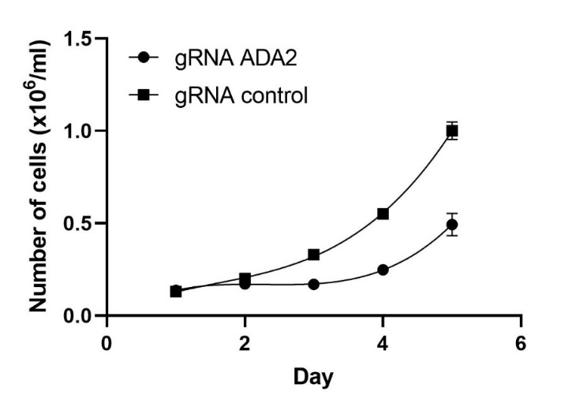 | B | 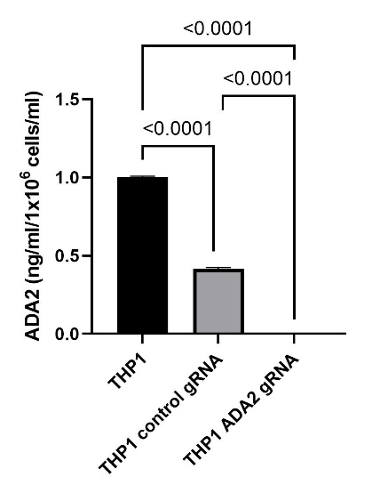
C | 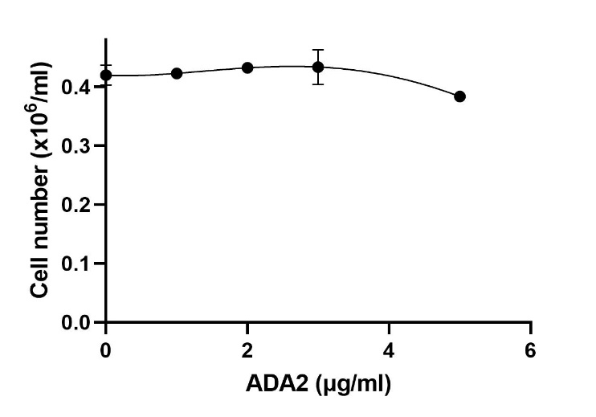

Supplementary Figure 1. (A) Knock-out of the ADA2 gene in THP1 cells slows down cell proliferation. The number of cells was assessed using flow cytometry. No apoptotic cells were detected in either case. Each dot represents a mean value of six independent experiments. The difference in cell numbers between Days four and five was significantly different (p<0.001) as calculated using an unpaired Student’s t-test. (B) The concentration of ADA2 in the cell culture medium of wild-type THP1 cells and the cells expressing Cas9 were transfected with control and ADA2-specific gRNA. (C) Analysis of the number of ADA2 knock-out cells was performed after culturing for 4 days in the presence of increasing concentrations of recombinant ADA2 added to the culture medium. Each dot represents a mean value of three independent measurements.

A | 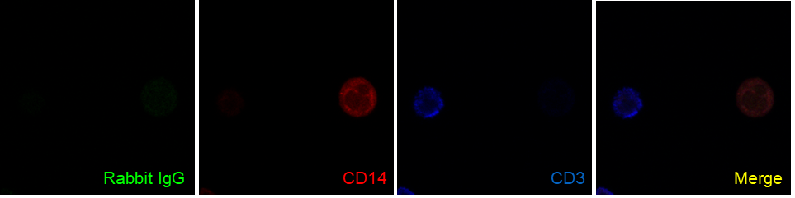
B | 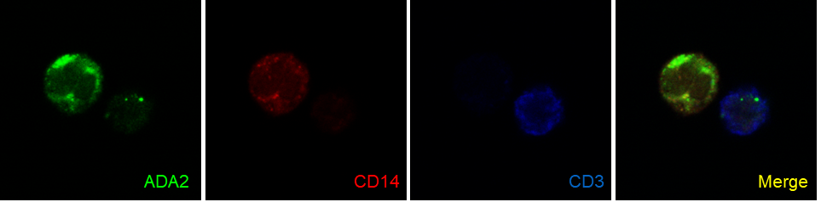

Supplementary Figure 2. ADA2 is highly expressed in Monocytes compared with T cells in PBMCs. (A) PBMCs were stained with anti-CD14 antibodies (monocytes), anti-CD3 antibodies (T-cells), and either rabbit polyclonal (A) or rabbit anti-ADA2 antibodies (B).

A | 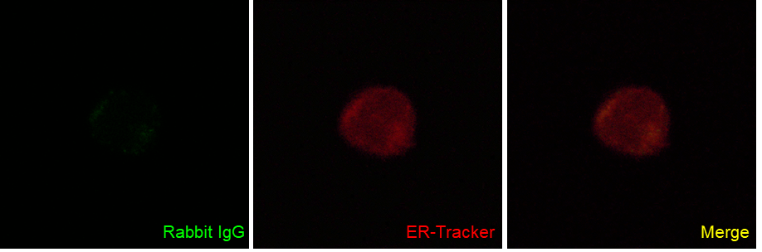
B | 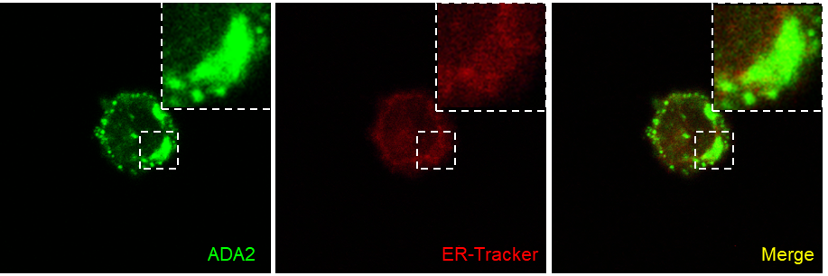
C | 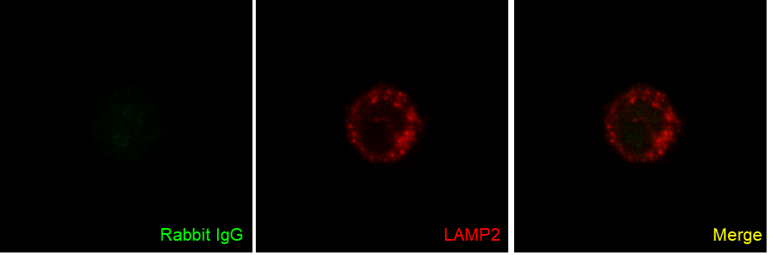
D | 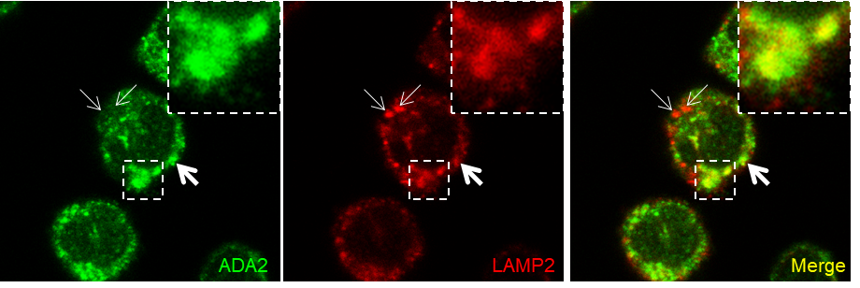

Supplementary Figure 3. ADA2 is partially localized in ER and lysosome in monocytes.
(A-B) ADA2 is co-localized with endosomal reticulum (ER) in monocytes. Monocytes were stained with the ER-Tracker and either rabbit polyclonal (A) or anti-ADA2 antibodies (B). (C-D) ADA2 is co-localized with lysosomes in monocytes. Monocytes were stained with the lysosomal marker LAMP2 and either rabbit polyclonal (C) or anti-ADA2 antibodies (D). Note that ADA2 is partially co-localized with lysosome.

A | 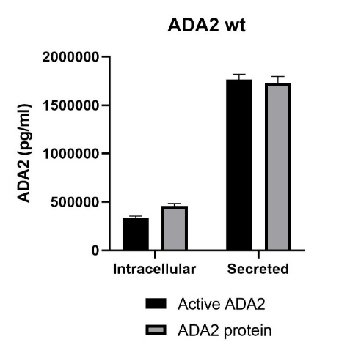 | B | 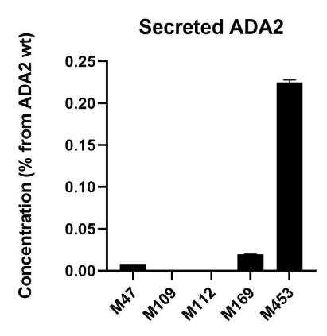
C | 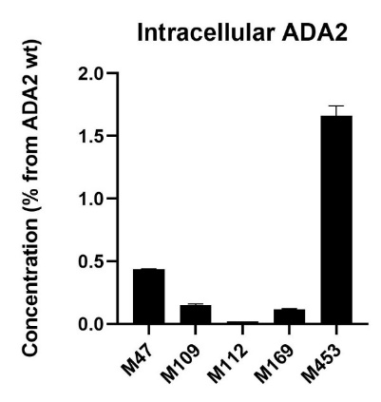 | D | 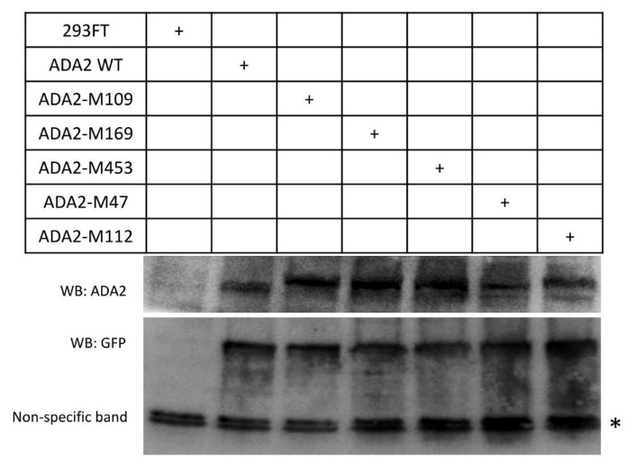

Supplementary Figure 4. ADA2 and its mutant forms expressed in 293FT cells.
(A) Analysis of the active and total protein concentration of ADA2 in the cell culture medium and the cell lysates. 293T cells (0.3x10⁶) expressing ADA2 ²⁰ were grown in 6-well plates for 2 Days, and the concentration of active ADA2 total protein in the cell culture and cell lysates (2x10⁶ cells/ml) was analyzed by ELISA ⁸. (B) Analysis of the active and total protein concentration of ADA2 in the cell culture medium and the cell lysates. 293T cells (0.3x10⁶) expressing ADA2 mutants were grown in 6-well plates for 2 Days, and the concentration of active ADA2 total protein was in the cell culture and cell lysate. The result of three independent measurements and the corresponding standard deviations are shown on all plots. (D) ADA2 expression in the 293T cells analyzed by Western blot. 293FT cells and 293T GFP cells expressing ADA2 WT, ADA2-M109, ADA2-M169, ADA2-M453, ADA2-M47, and ADA2-M112 were lysed with and the cell lysates were analyzed by Western blot with the indicated antibodies.

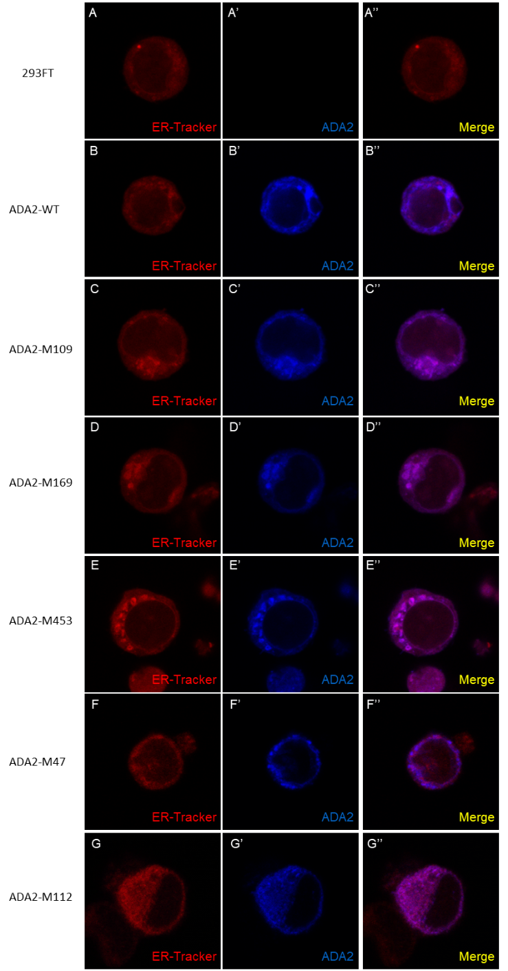

Figure 5. A part of ADA2 localized in ER.
(A-G’’) ADA2 co-localized with ER (labeled by ER-Tracker) in cultured 293FT cells. 293FT cells that expressed ADA2 WT, ADA2-M109, ADA2-M169，ADA2-M453，ADA2-M47，ADA2-M112 were stained by the indicated antibodies. Note that ADA2 WT and its mutant forms co-localized with ER in cytoplasm.

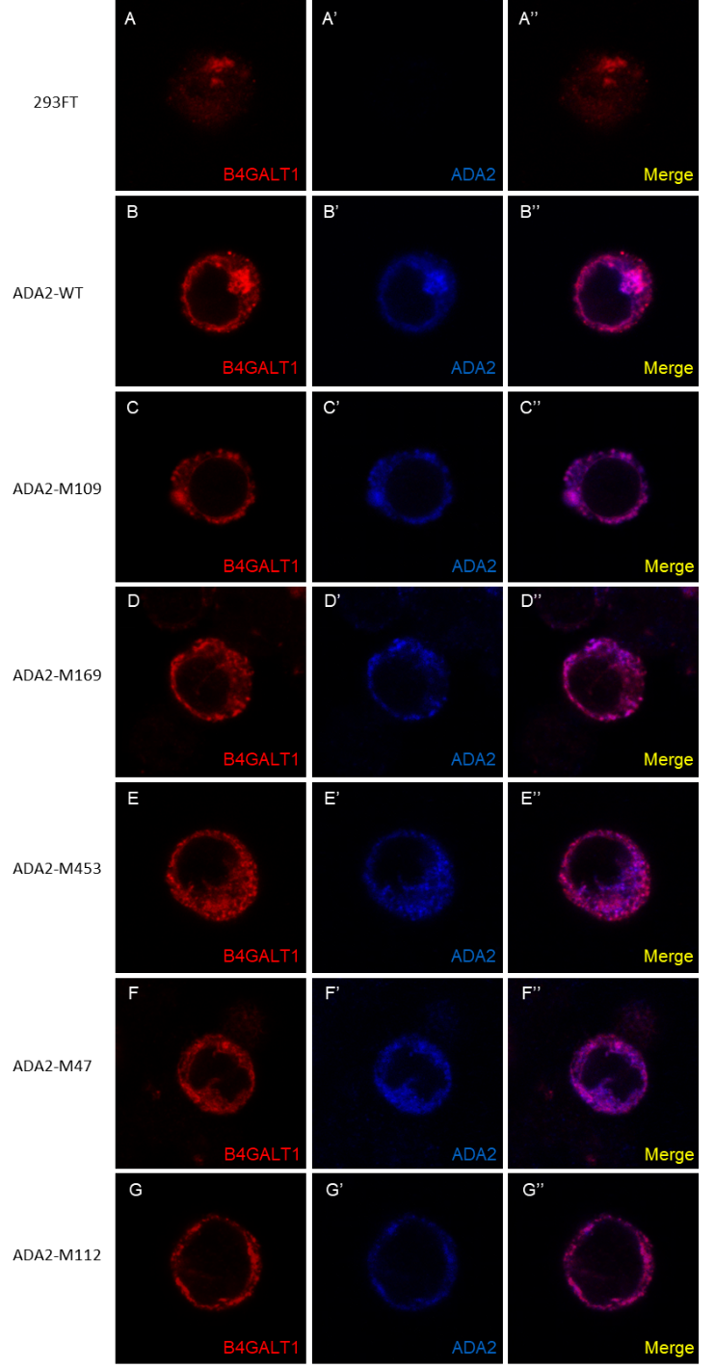
Figure 6. A part of ADA2 localized in the Golgi apparatus.
(A-G’’) ADA2 co-localized with the Golgi apparatus (labeled by B4GALT1) in cultured 293FT cells. 293FT cells that expressed ADA2 WT, ADA2-M109, ADA2-M169，ADA2-M453，ADA2-M47，ADA2-M112 were stained by the indicated antibodies. Note that ADA2 WT and its mutant forms co-localized with the Golgi apparatus in the cytoplasm.

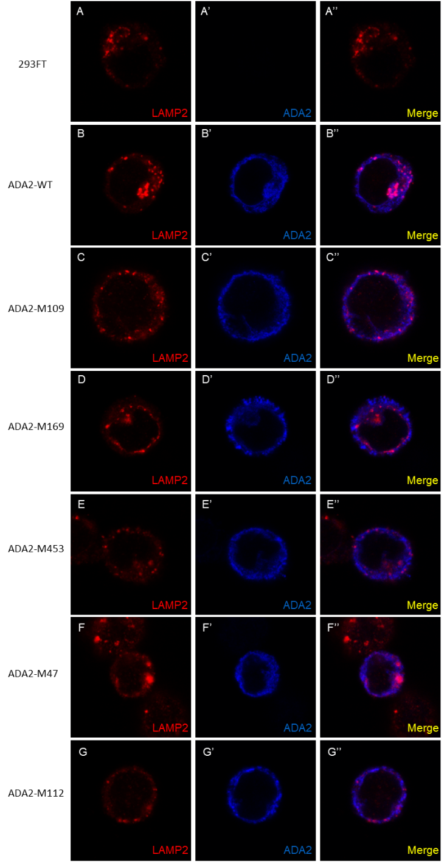
Figure 7. A little part of ADA2 localized in lysosome.
(A-G’’) little amount of ADA2 co-localized with lysosome (labeled by LAMP2) in cultured 293FT cells. 293FT cells that expressed ADA2 WT, ADA2-M109, ADA2-M169, ADA2-M453，ADA2-M47，ADA2-M112. Our study has shown that ADA2 is present in endolysosomes, and its concentration decreases in cells that secrete TNF-α, specifically the CD16+ subset of monocytes and GM-CSF differentiated macrophages. This suggests a new mechanism where the expression level of ADA2 within cells can affect the cells' sensitivity to activation signals. Therefore, inhibiting ADA2 activity in the endolysosome could be a promising therapeutic strategy for controlling monocyte differentiation and macrophage polarization in cases of inflammation or cancer.

A | 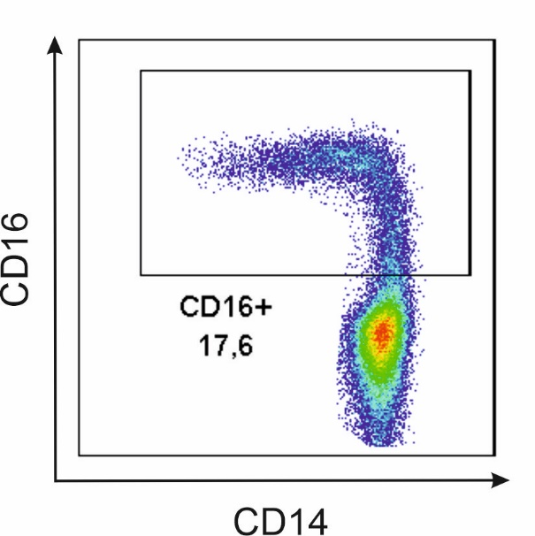 | B | 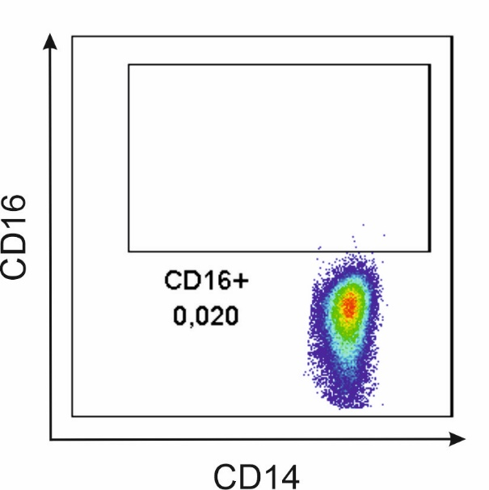
C | 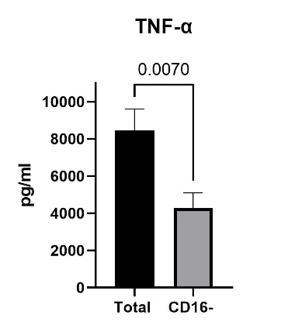 | D | 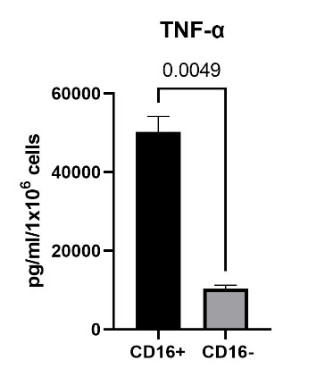

Supplementary Figure 8. Analysis of TNF-alpha secretion by total monocytes and monocytes lacking CD16+ subset. Flow cytometry analysis of blood monocytes before (A) and after (B) depletion of CD16 positive monocyte subset. (C) The concentration of TNF-α released in the cell culture medium by total monocytes (A) and monocytes lacking CD16+ subset stimulated with 50 ng/ml of LPS (B). (D) The amount of TNF-α produced by CD16+ and CD16- monocytes was calculated for 1x10⁶ cells. The error bars represent the standard deviation, and the results were obtained from four independent measurements. The data was analyzed using an unpaired t-test.

A | 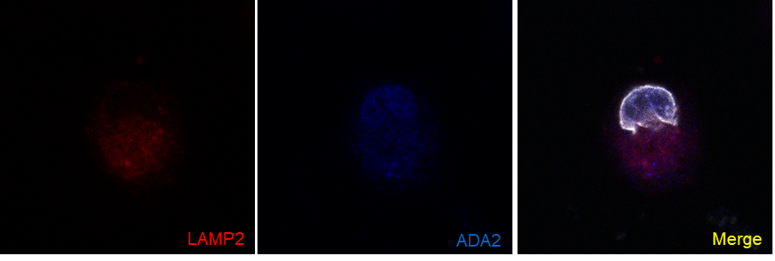
B | 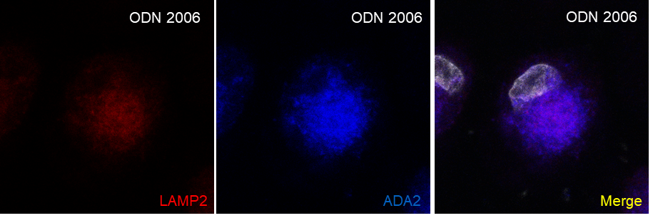
C | 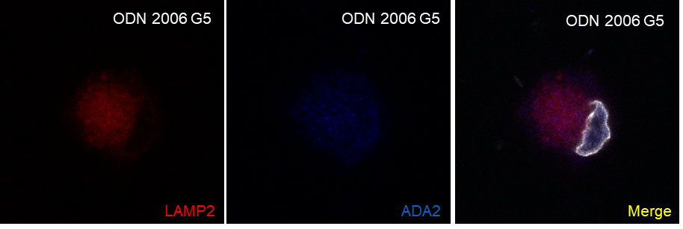
Supplementary Figure 9. Localization of ADA2 in the lysosomes of GM-CSF differentiated monocytes on Day 4. Monocytes (0.4 x 10⁶ cells/ml) were isolated from PBMCs and differentiated into macrophages for 3 days with 40 ng/ml GM-CSF. Macrophages were either left untreated (A) or treated with 0.5 μM CpG ODN 2006 PTO (B) or CpG ODN 2006 G5 PD (C) and fixed after 24 hours. The stained cells were analyzed for ADA2 (blue) and lysosomal marker LAMP2 (red). An increase in ADA2 density and co-localization of ADA2 with LAMP2 was observed in macrophages treated with CpG ODN 2006 PTO (B).

A | 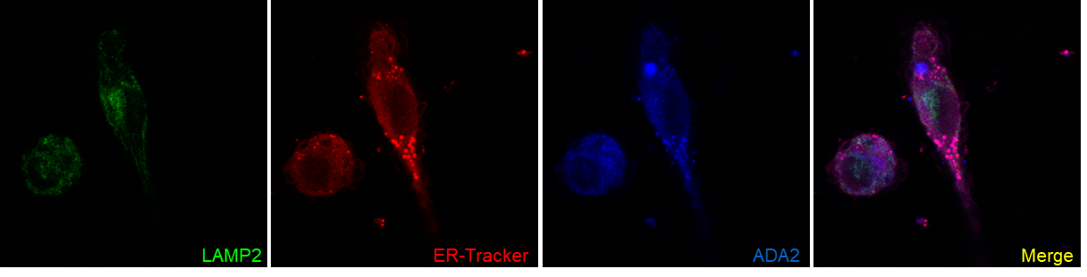
B | 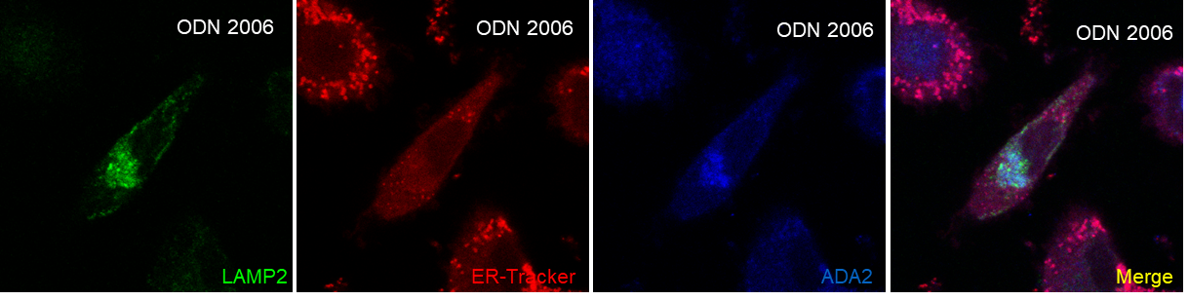
C | 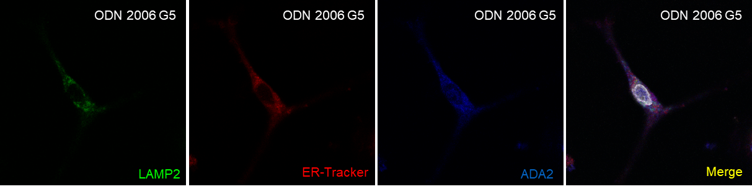

Supplementary Figure 10. Localization of ADA2 in the lysosomes of M-CSF differentiated monocytes on Day 4. Monocytes (0.4 x 10⁶ cells/ml) were isolated from PBMCs and differentiated into macrophages for 3 days with 20 ng/ml M-CSF. Macrophages were either left untreated (A) or treated with 0.5 μM CpG ODN 2006 PTO (B) or CpG ODN 2006 G5 PD (C) and fixed after 24 hours. The stained cells were analyzed for ADA2 (blue) and lysosomal marker LAMP2 (red). An increase in ADA2 density and co-localization of ADA2 with LAMP2 was observed in macrophages treated with CpG ODN 2006 PTO (B).

A | 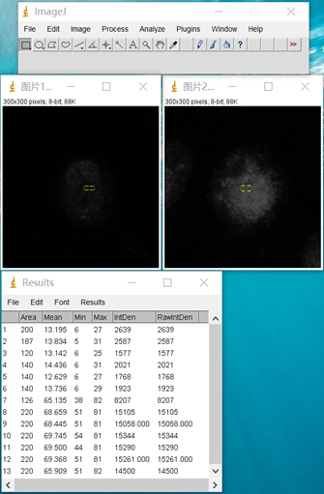 | B | 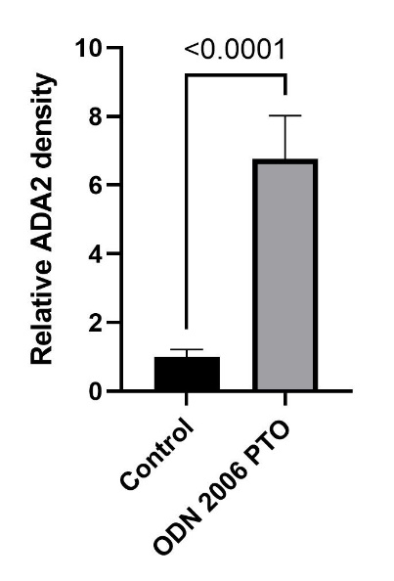

Supplementary Figure 11. The effect of ODN 2006 PTO incubation on ADA2 density inside lysosomes of macrophages differentiated for 4 days in the presence of GM-CSF. The fluorescence images from Figure 9A and B were analyzed using the IntDen tool of Image J Software (A). The analysis demonstrates an increase (p<0.0001) in ADA2 density inside macrophages treated with ODN 2006 PTO compared to the control group. The error bars represent the standard deviation, and the results were obtained from six independent measurements. The data was analyzed using an unpaired t-test.

A | 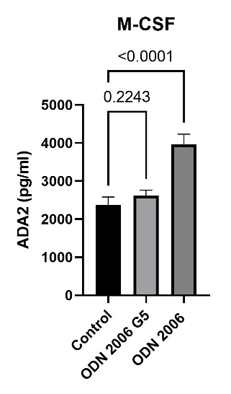 | B | 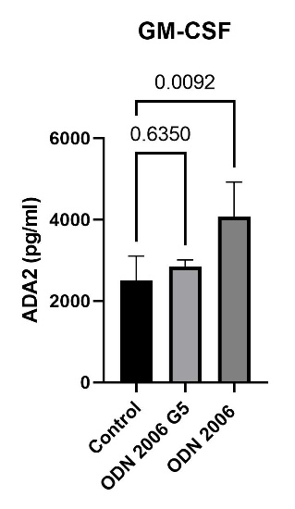

Supplementary Figure 12. The intracellular concentration of ADA2 in M-CSF and GM-CSF differentiated monocytes. Monocytes (0.15 x 10⁶ cells/ml) were isolated from PBMCs and differentiated into macrophages for five days using 20 ng/ml M-CSF or 40 ng/ml GM-CSF. Afterward, the cells were washed and treated with 2 μM CpG ODN 2006 PTO or CpG ODN 2006 G5 PD for 24 hours or left untreated. The concentration of ADA2 in the cell lysates was then analyzed using ELISA. The error bars represent the standard deviation, and the results were obtained from four independent measurements. The data was analyzed using one-way ANOVA.

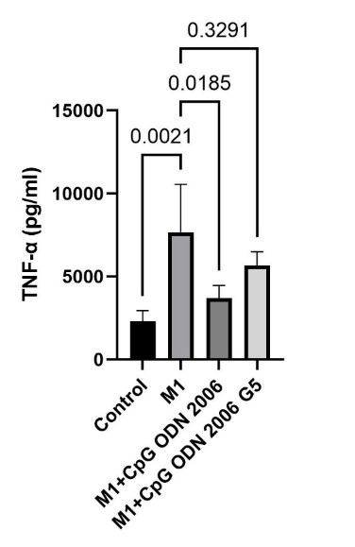
Supplementary Figure 13. CpG 2006 ODN PTO inhibits TNF-α secretion from GM-CSF differentiated monocytes. Monocytes (0.25 x 10⁶ cells/ml) were isolated from PBMCs and differentiated into macrophages for 5 days with 40 ng/ml GM-CSF. The cells were washed with the fresh medium and either left untreated or treated with 2 μM CpG ODN 2006 PTO or CpG ODN 2006 G5 PD for 24 hours. After, the cells were activated with 10 ng/ml IFN-γ and 100 ng/ml LPS for additional 24 hours. The concentration of TNF-α in the cell culture medium was analyzed with ELISA. The error bars represent the standard deviation, and the results were obtained from four independent measurements. The data was analyzed using one-way ANOVA.

A | 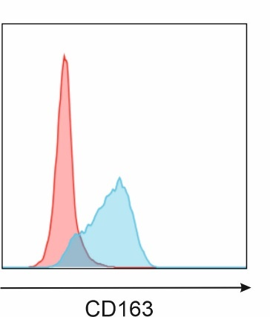 | B | 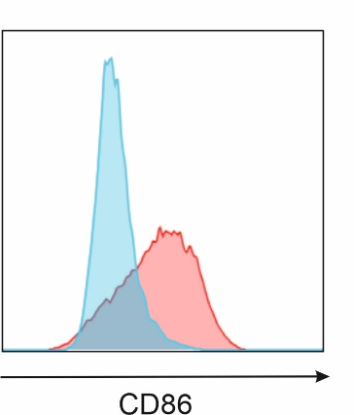

Supplementary Figure 14. Flow cytometry analysis of blood monocytes after 8 days of differentiation into macrophages in the presence of GM-CSF (red) and M-CSF (blue). The cells were stained for CD163 and CD86 (BioLegend), characteristic markers of M2 and M1 macrophages, respectively.

A | 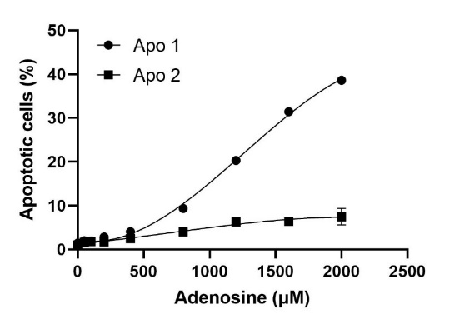 | B | 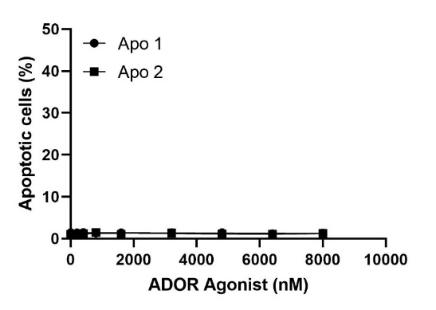
C | 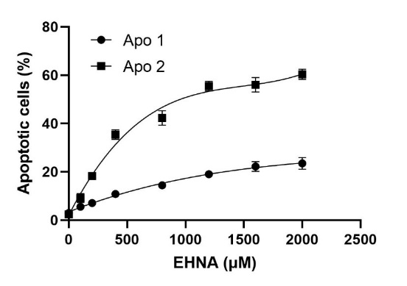 | D | 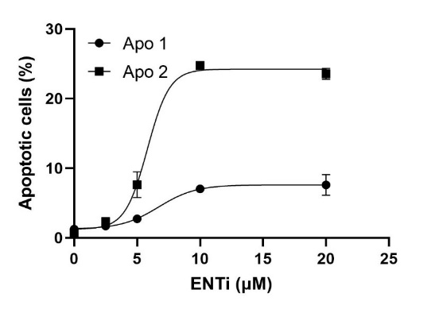
E | 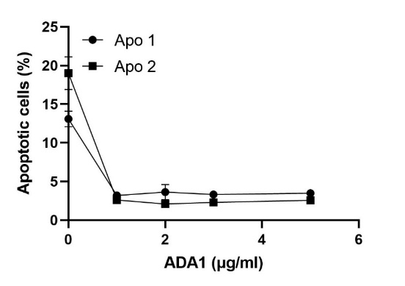 | F | 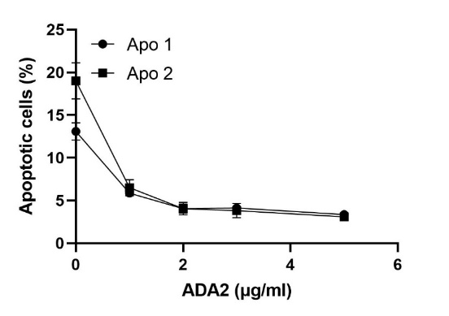

Supplementary Figure 15. Adenosine deaminases reduce apoptosis of THP1 cells by high concentrations of extracellular adenosine. Analysis of the percentage of apoptotic cells (Apo 1 and Apo 2, see Figure 7) after incubation of THP cells (0.4x10⁶ cells/ml) for 72 hours with increasing concentrations of (A) adenosine, (B) ADOR agonist NECA (Tocris), (C) ADA1 inhibitor EHNA (Tocris), (D) ENT1 inhibitor Nitrobenzylthioinosine (Tocris) (E) recombinant hADA1 in the presence of 2 mM adenosine, (F) recombinant hADA2 in the presence of 2 mM adenosine. The mean value of two replicates is represented by each dot.

