Supporting Information

Dual Modulation of Fe-N-C Catalysts via Axial and In-Plane Heteroatoms for Oxygen Reduction: A Combined DFT and Machine Learning Study

Note S1: Performance Metrics
In assessing the performance of machine learning models, we employ 2 key performance metrics, including the coefficient of determination (R ²) and root mean squared error (RMSE). These metrics serve as valuable indicators of the model’s predictive accuracy and provide quantitative measures of the variance explained, the average magnitude of errors, and the overall deviation between predicted and actual values.
R ² represents a numerical characteristic of the relationship between a random variable and multiple random variables, serving as a statistical indicator to reflect the reliability of the dependent variable's variation explained by the regression model. It is calculated using the formula:
$$R^{2}=1−\frac{{SS}_{res}}{{SS}_{tot}}$$
Here, SS_{res} represents the residual sum of squares: ${SS}_{res}=\sum_{i=1}^{n}{{(y_{i}−y_{i}^{'})}^{2}}$, and SS_{tot} denotes the total sum of squares: ${SS}_{tot}=\sum_{i=1}^{n}{{(y_{i}−\overline{y})}^{2}}$. In these formulas, n represents the total number of data points in the dataset, y_{i} corresponds to the true value, y_{i}'​ represents the predicted value of the sample i of the target variable, and $\overline{y}$ signifies the mean of the true data. The R² value, ranging from 0 to 1, serves as a measure of the fitting of a regression model. A value of zero indicates that the model does not explain any of the variance in the data, while a value of one indicates that the model captures all the observed variance.
The RMSE (Root Mean Squared Error) is the square root of the ratio of the square of the deviation between the predicted value and the true value to the number of observations n. It measures the deviation between the predicted value and the true value. It is calculated using the formula:
$$RMSE=\sqrt{\frac{1}{n}\sum_{i}^{n}{{(y_{i}−y_{i}^{'})}^{2}}}$$
RMSE measures the square root of the average squared difference between the predicted values (y_{i}') and the actual values (y_{i}).

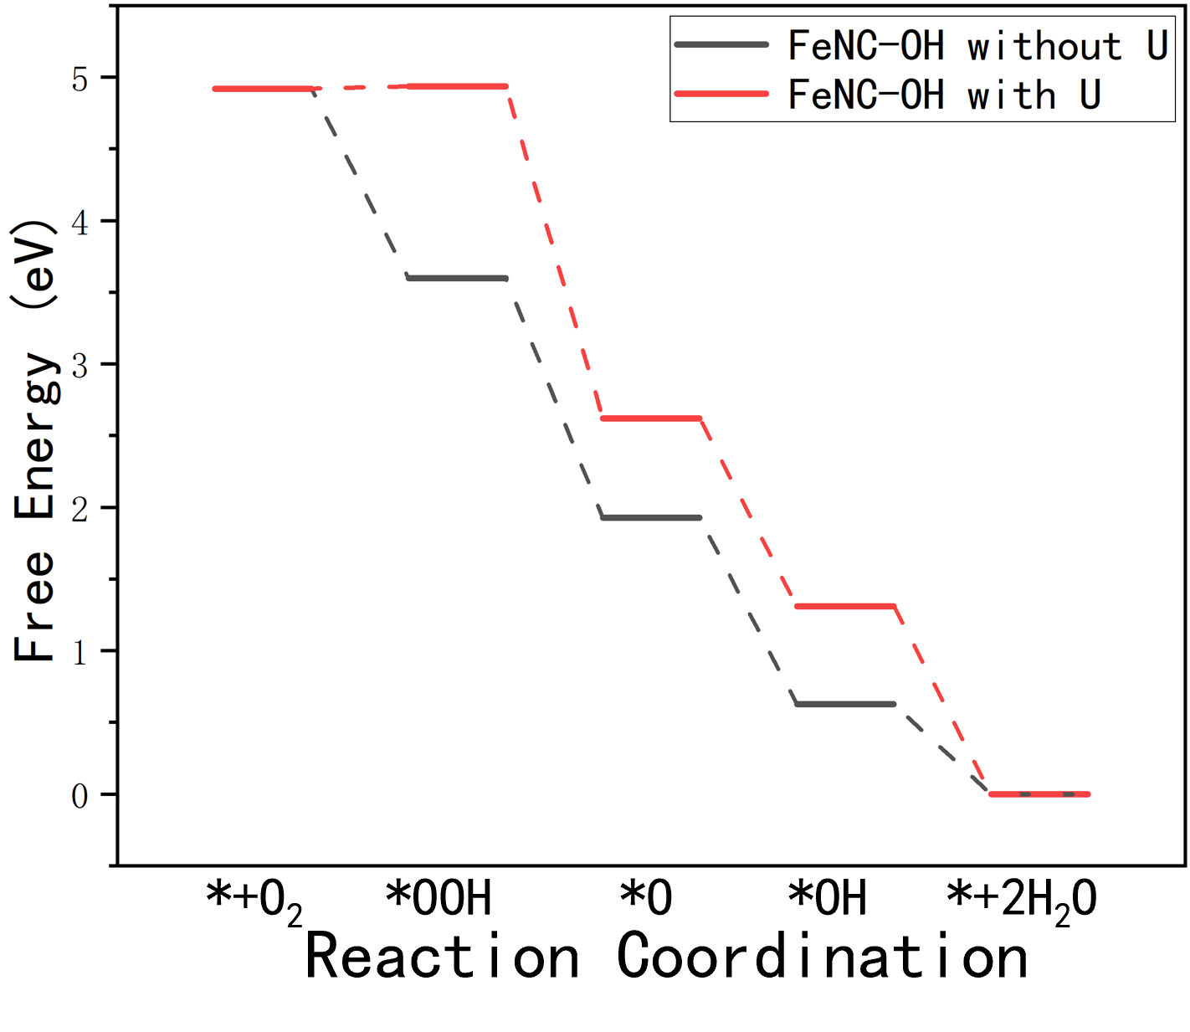
Figure S1. Comparison of oxygen reduction reaction (ORR) pathways on the FeNC-OH single-atom catalyst with and without Hubbard U correction.

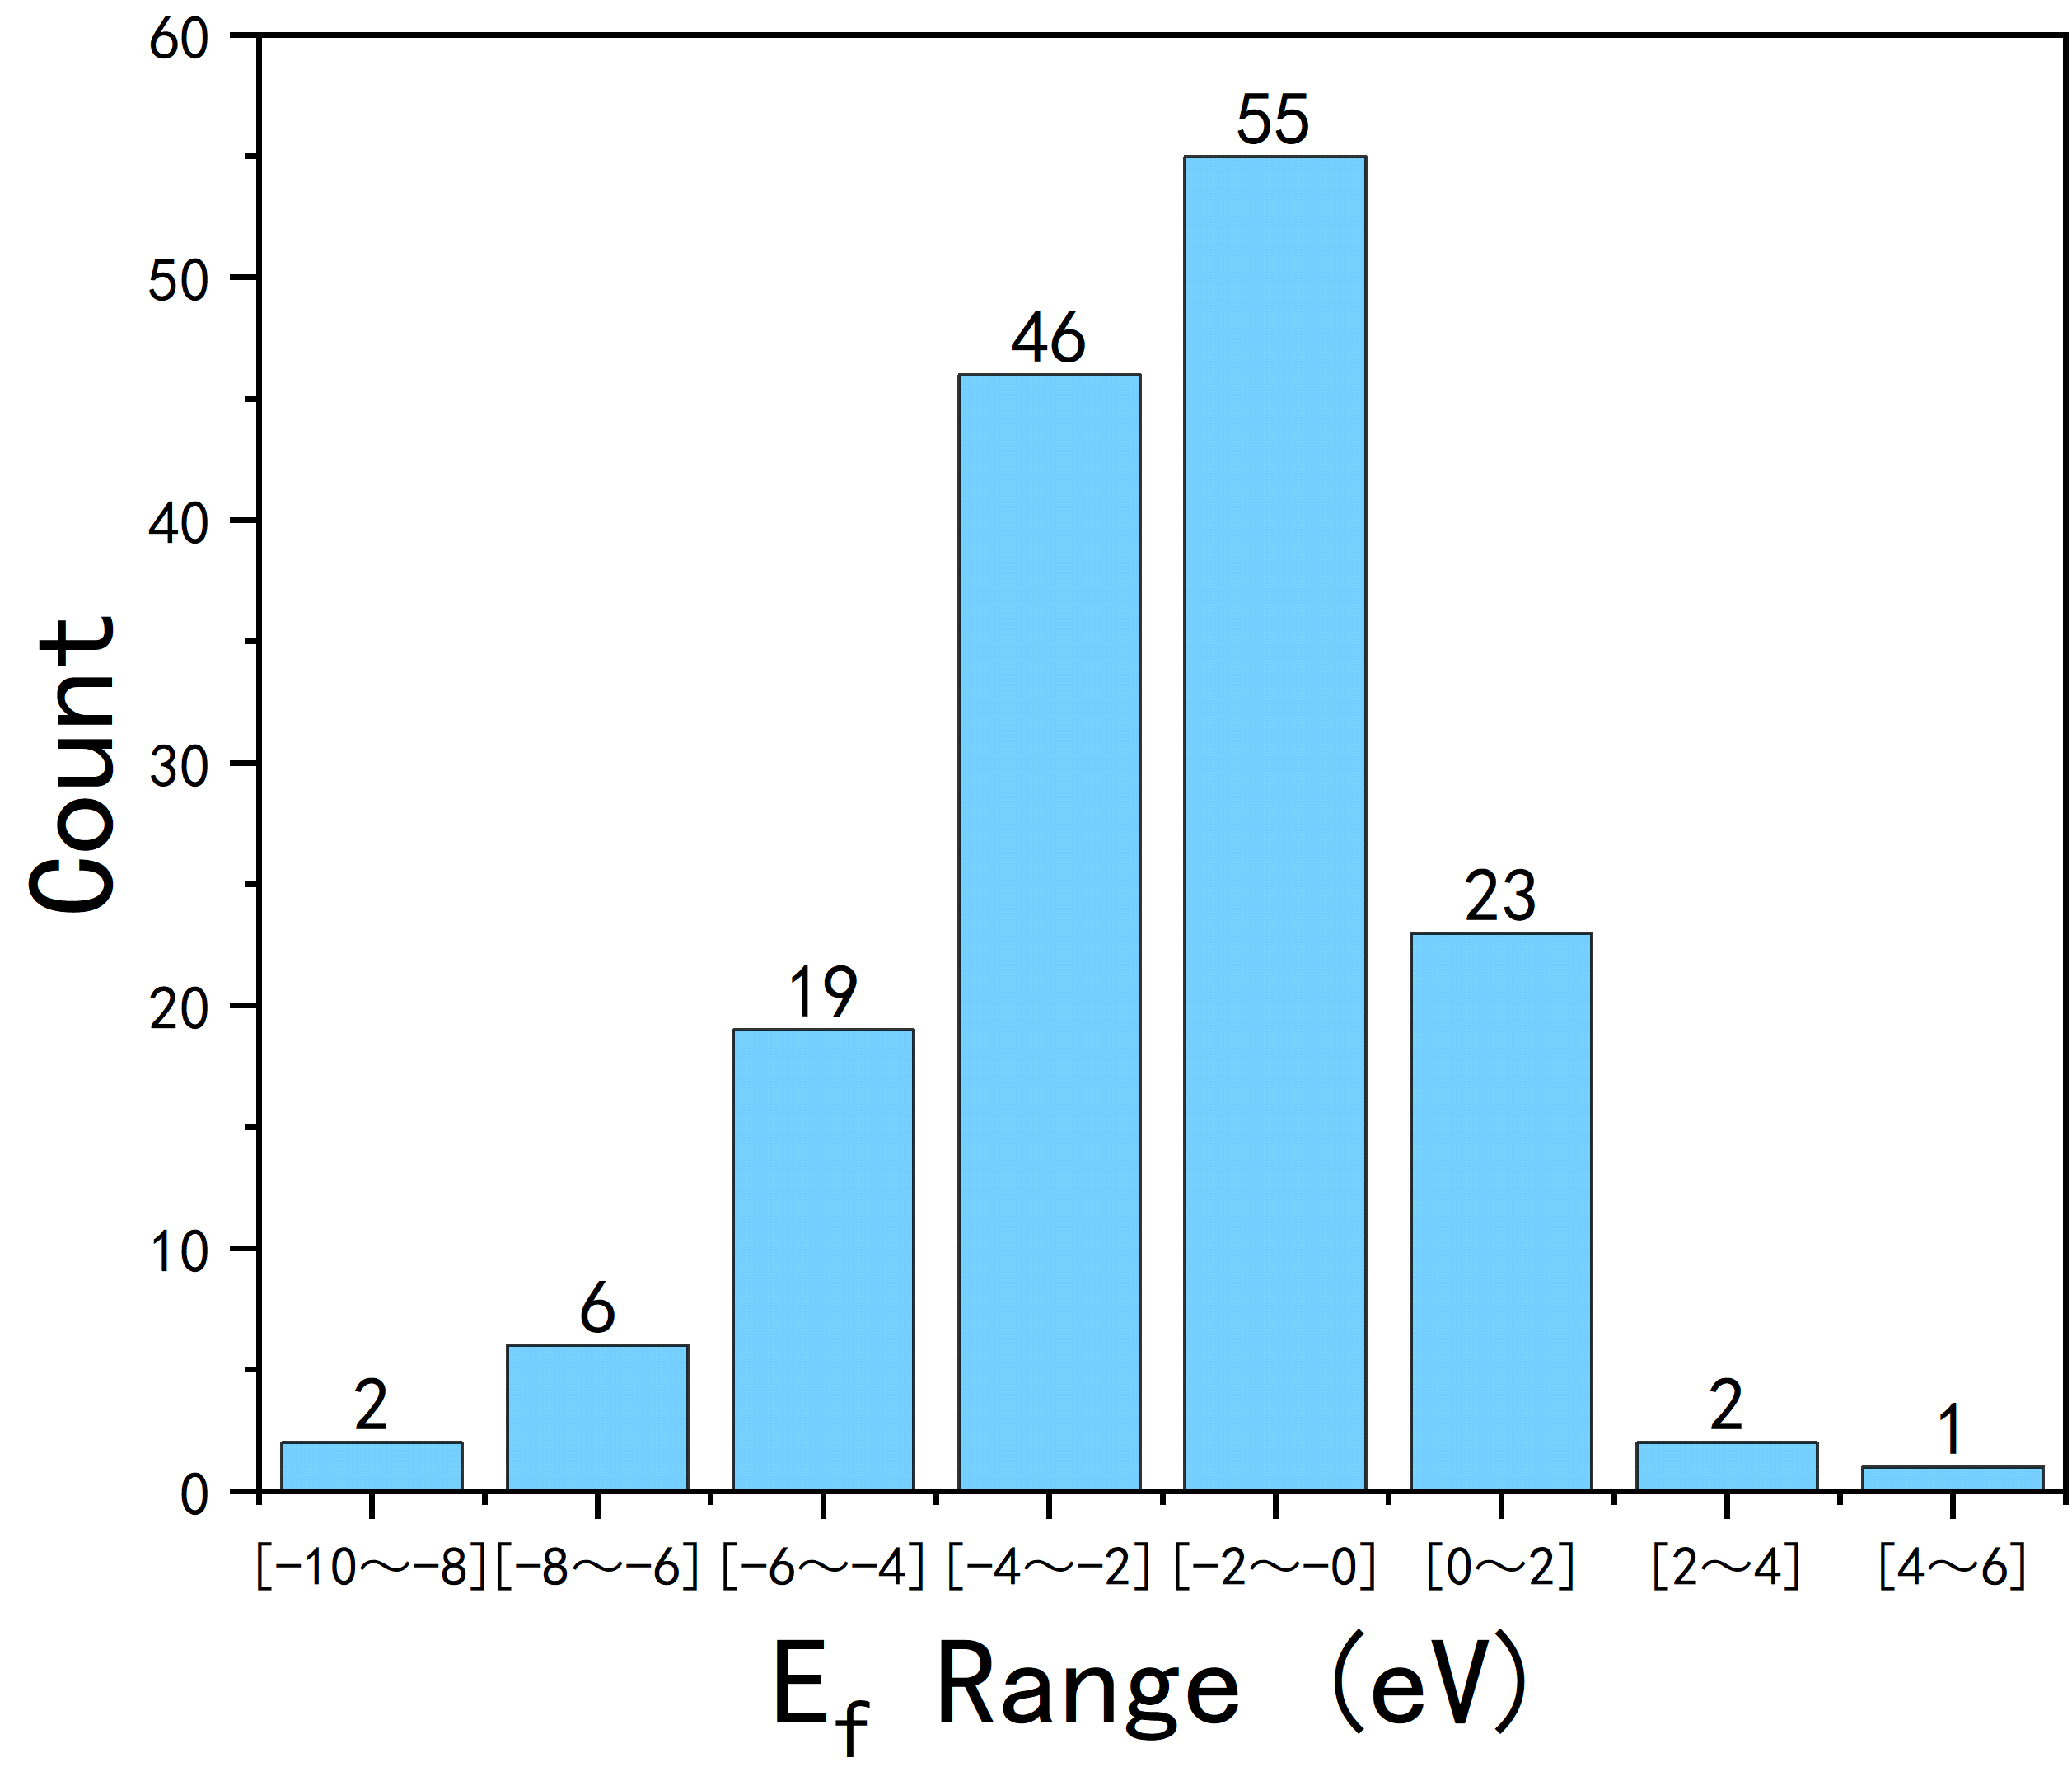
Figure S2. Distribution of formation energy E_{f} values.

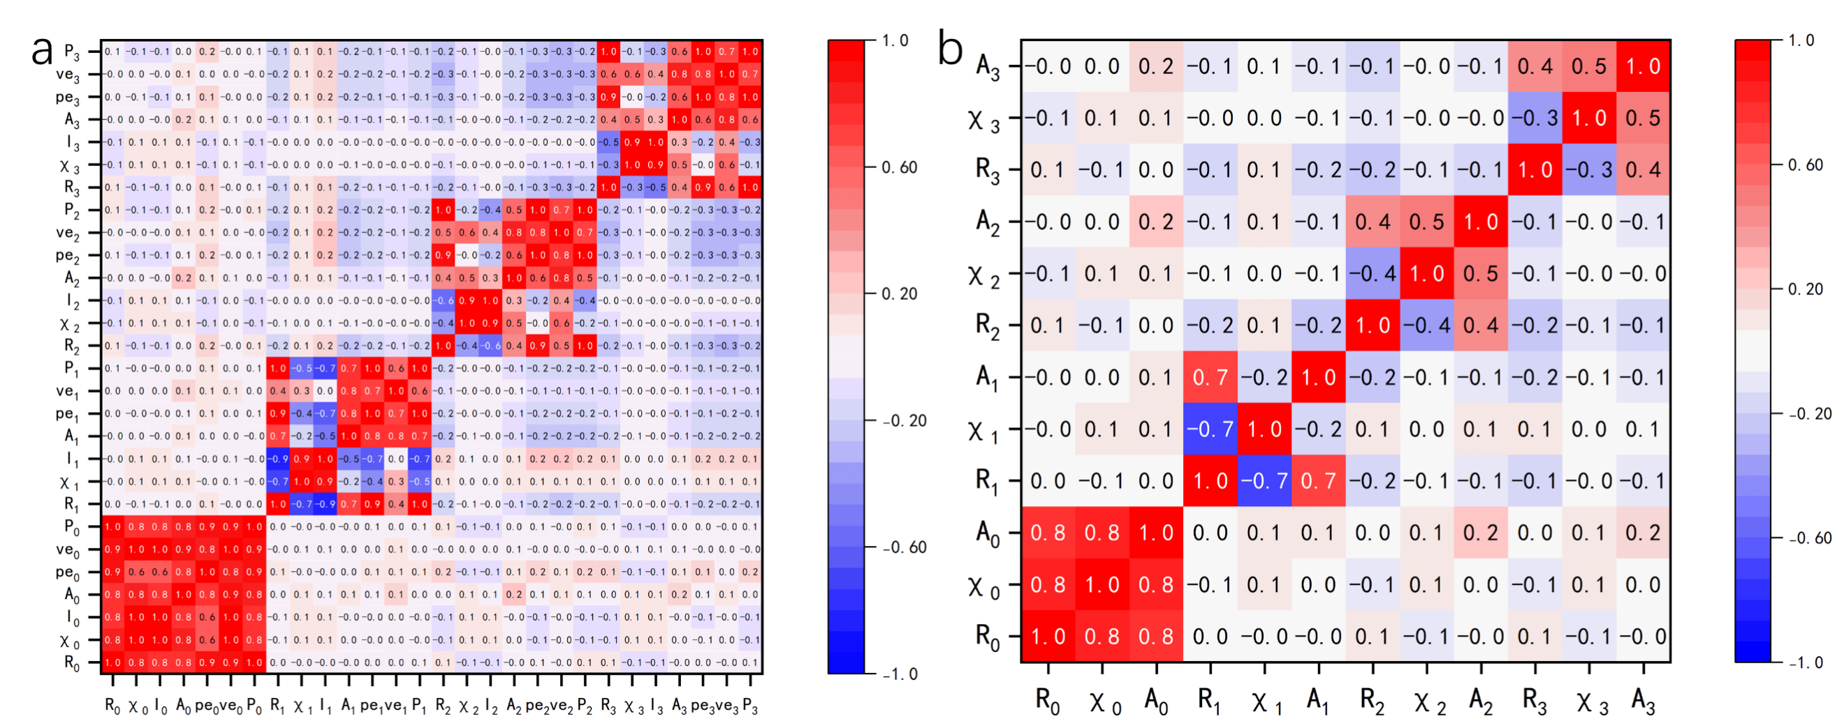
Figure S3. a, b) Heatmaps of Pearson correlation coefficients for features of stability model before and after correlation-based filtering. The color scale (red: strong positive, blue: strong negative) is consistent across both subfigures.

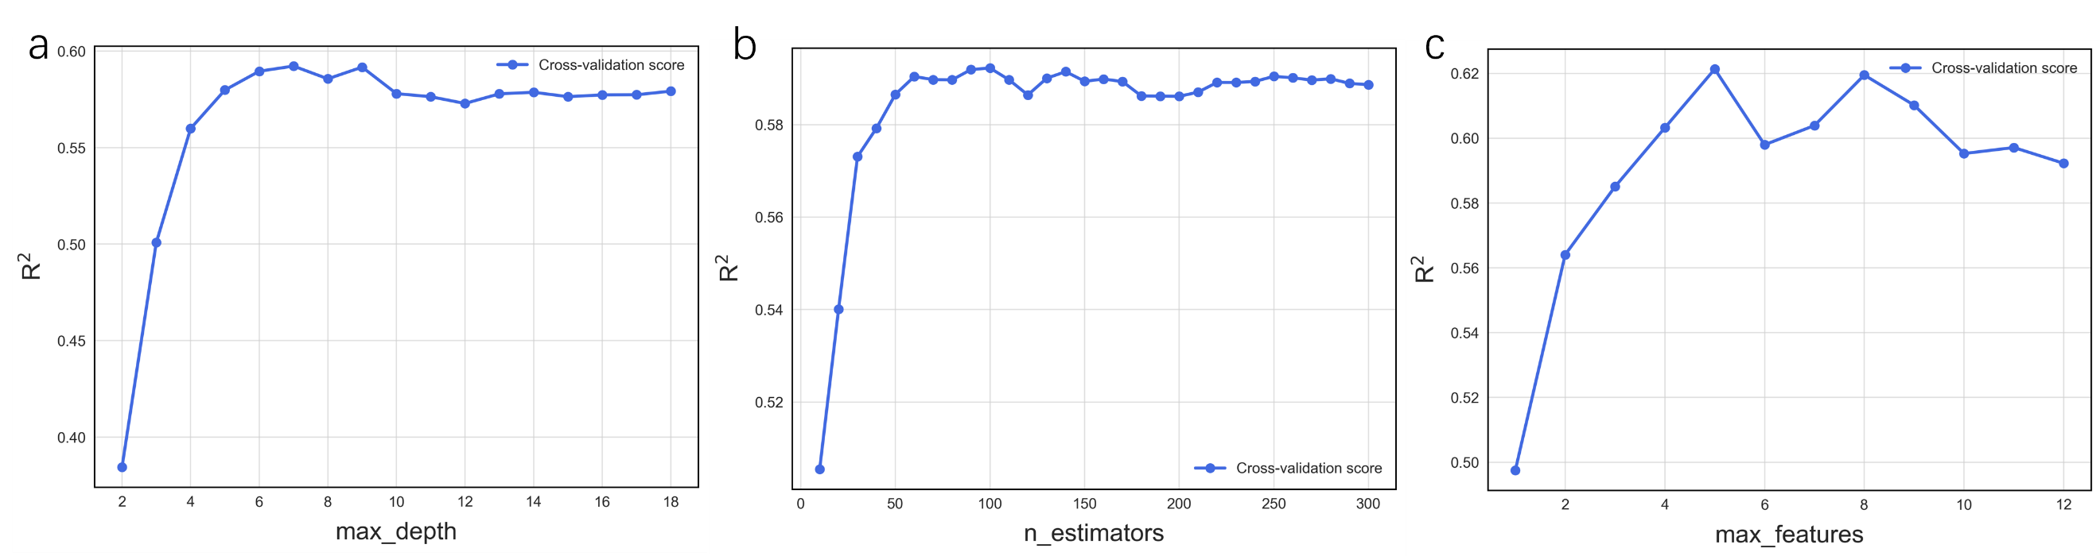
Figure S4. Learning curves of the stability RF model for different hyperparameters: (a) max_depth, (b) n_estimators, and (c) max_features.

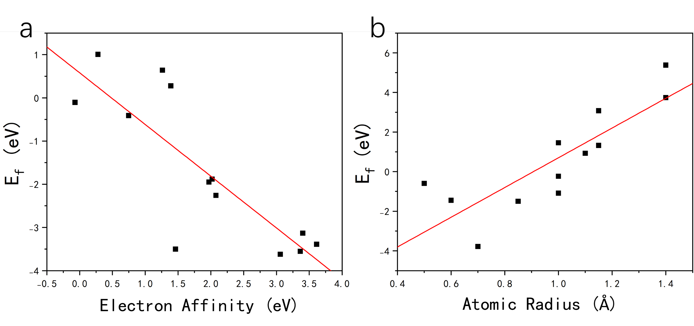
Figure S5. The formation energy E_{f} versus (a) electron affinity of the axial atom for structures without in-plane doping and (b) atomic radius of the site1 dopant atom for site1-doped structures without axial ligands.

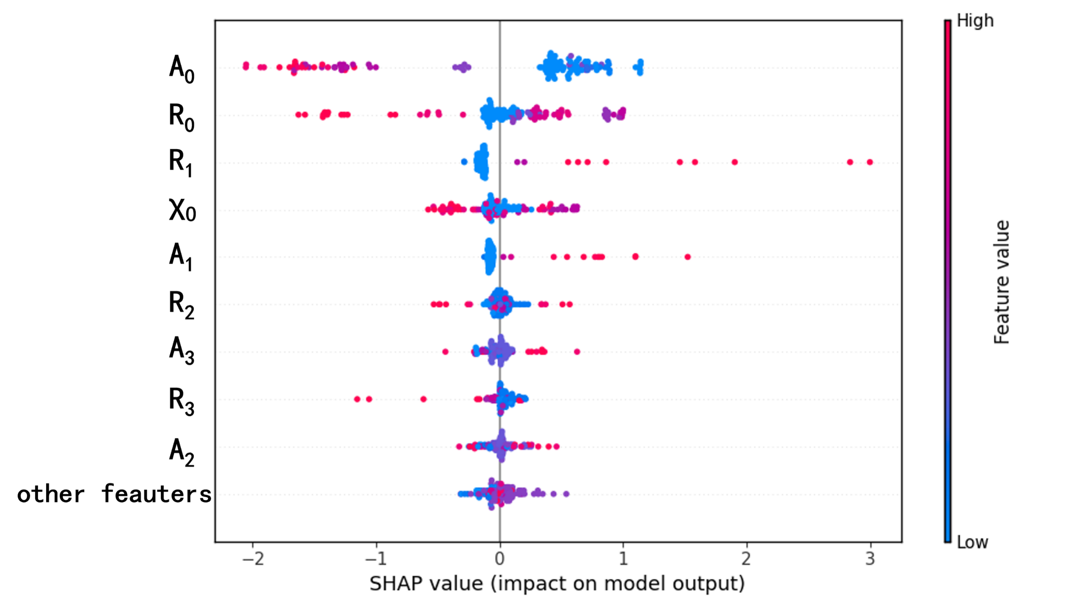
Figure S6. SHAP analysis for the RF stability model. The color of the dots represents values of the corresponding features. The positive/negative sign of a SHAP value implies a direct correlation between the feature and an increase/decrease in E_{f}.

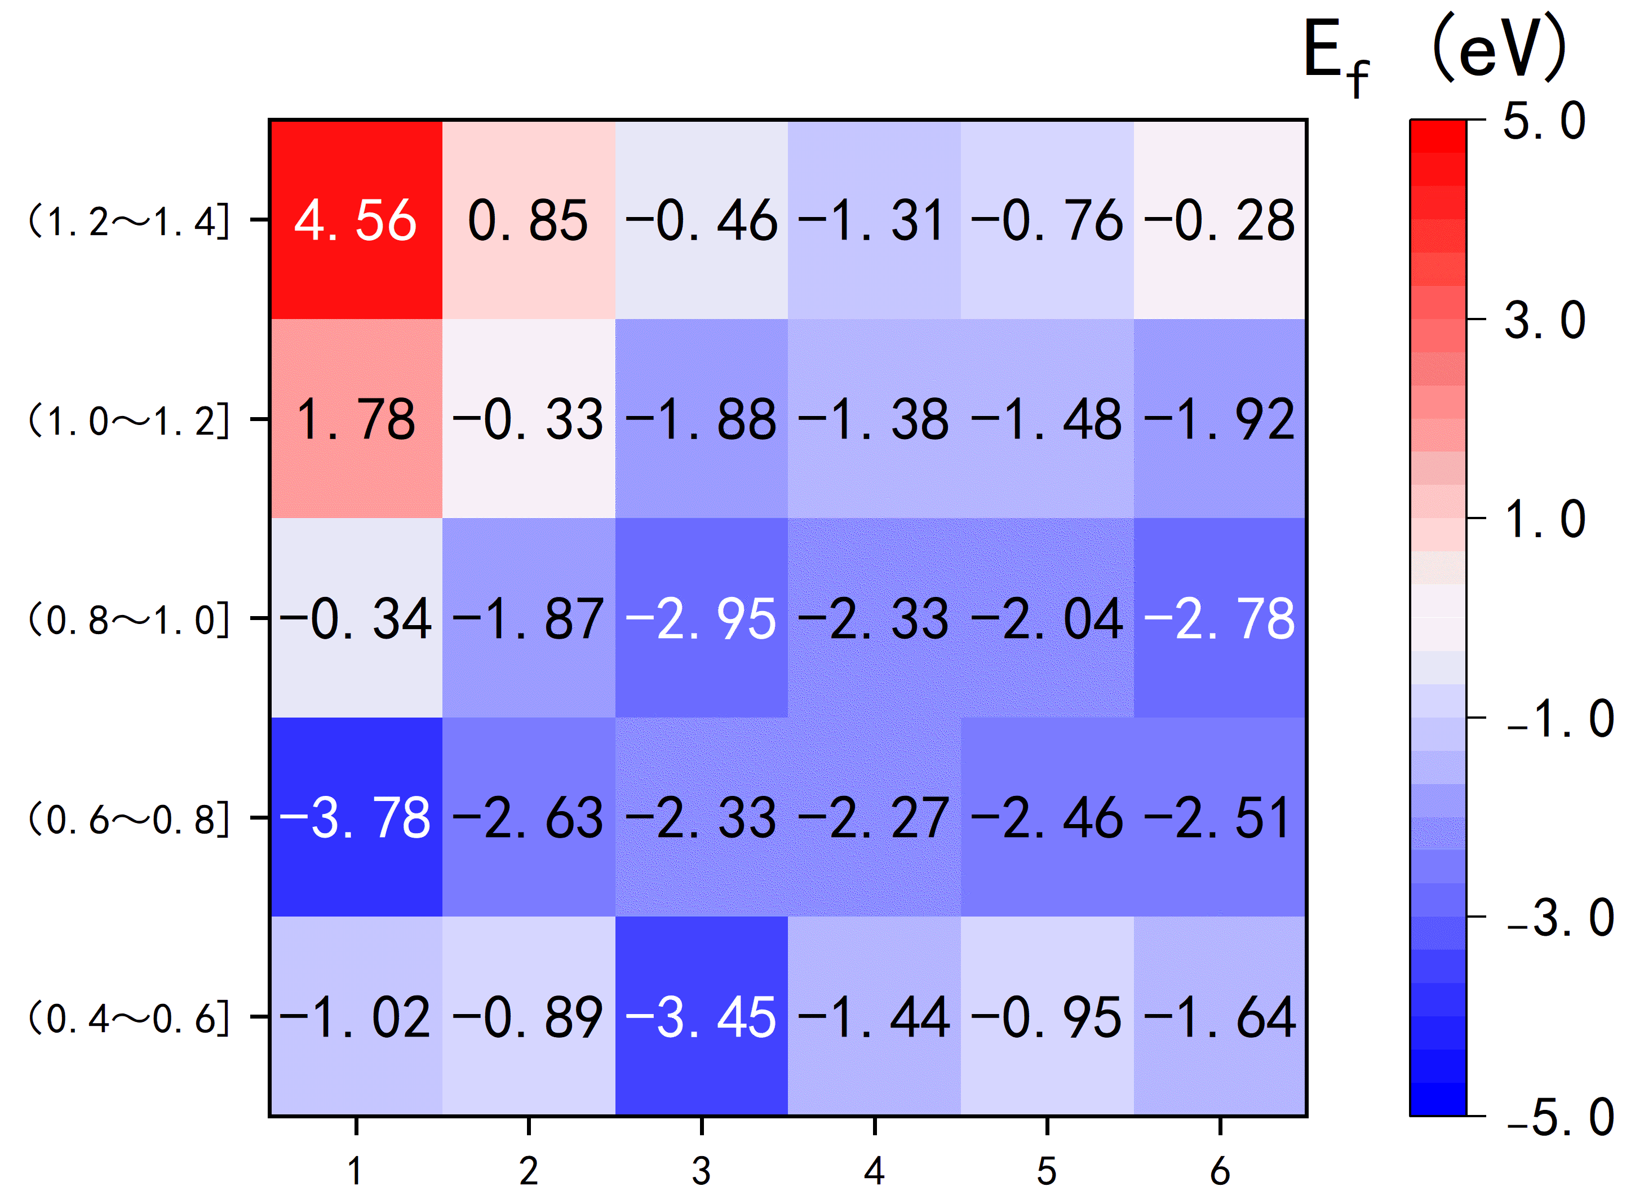
Figure S7. Heatmap of average formation energy E_{f} versus doping site and atomic radius for all structures without axial ligands.

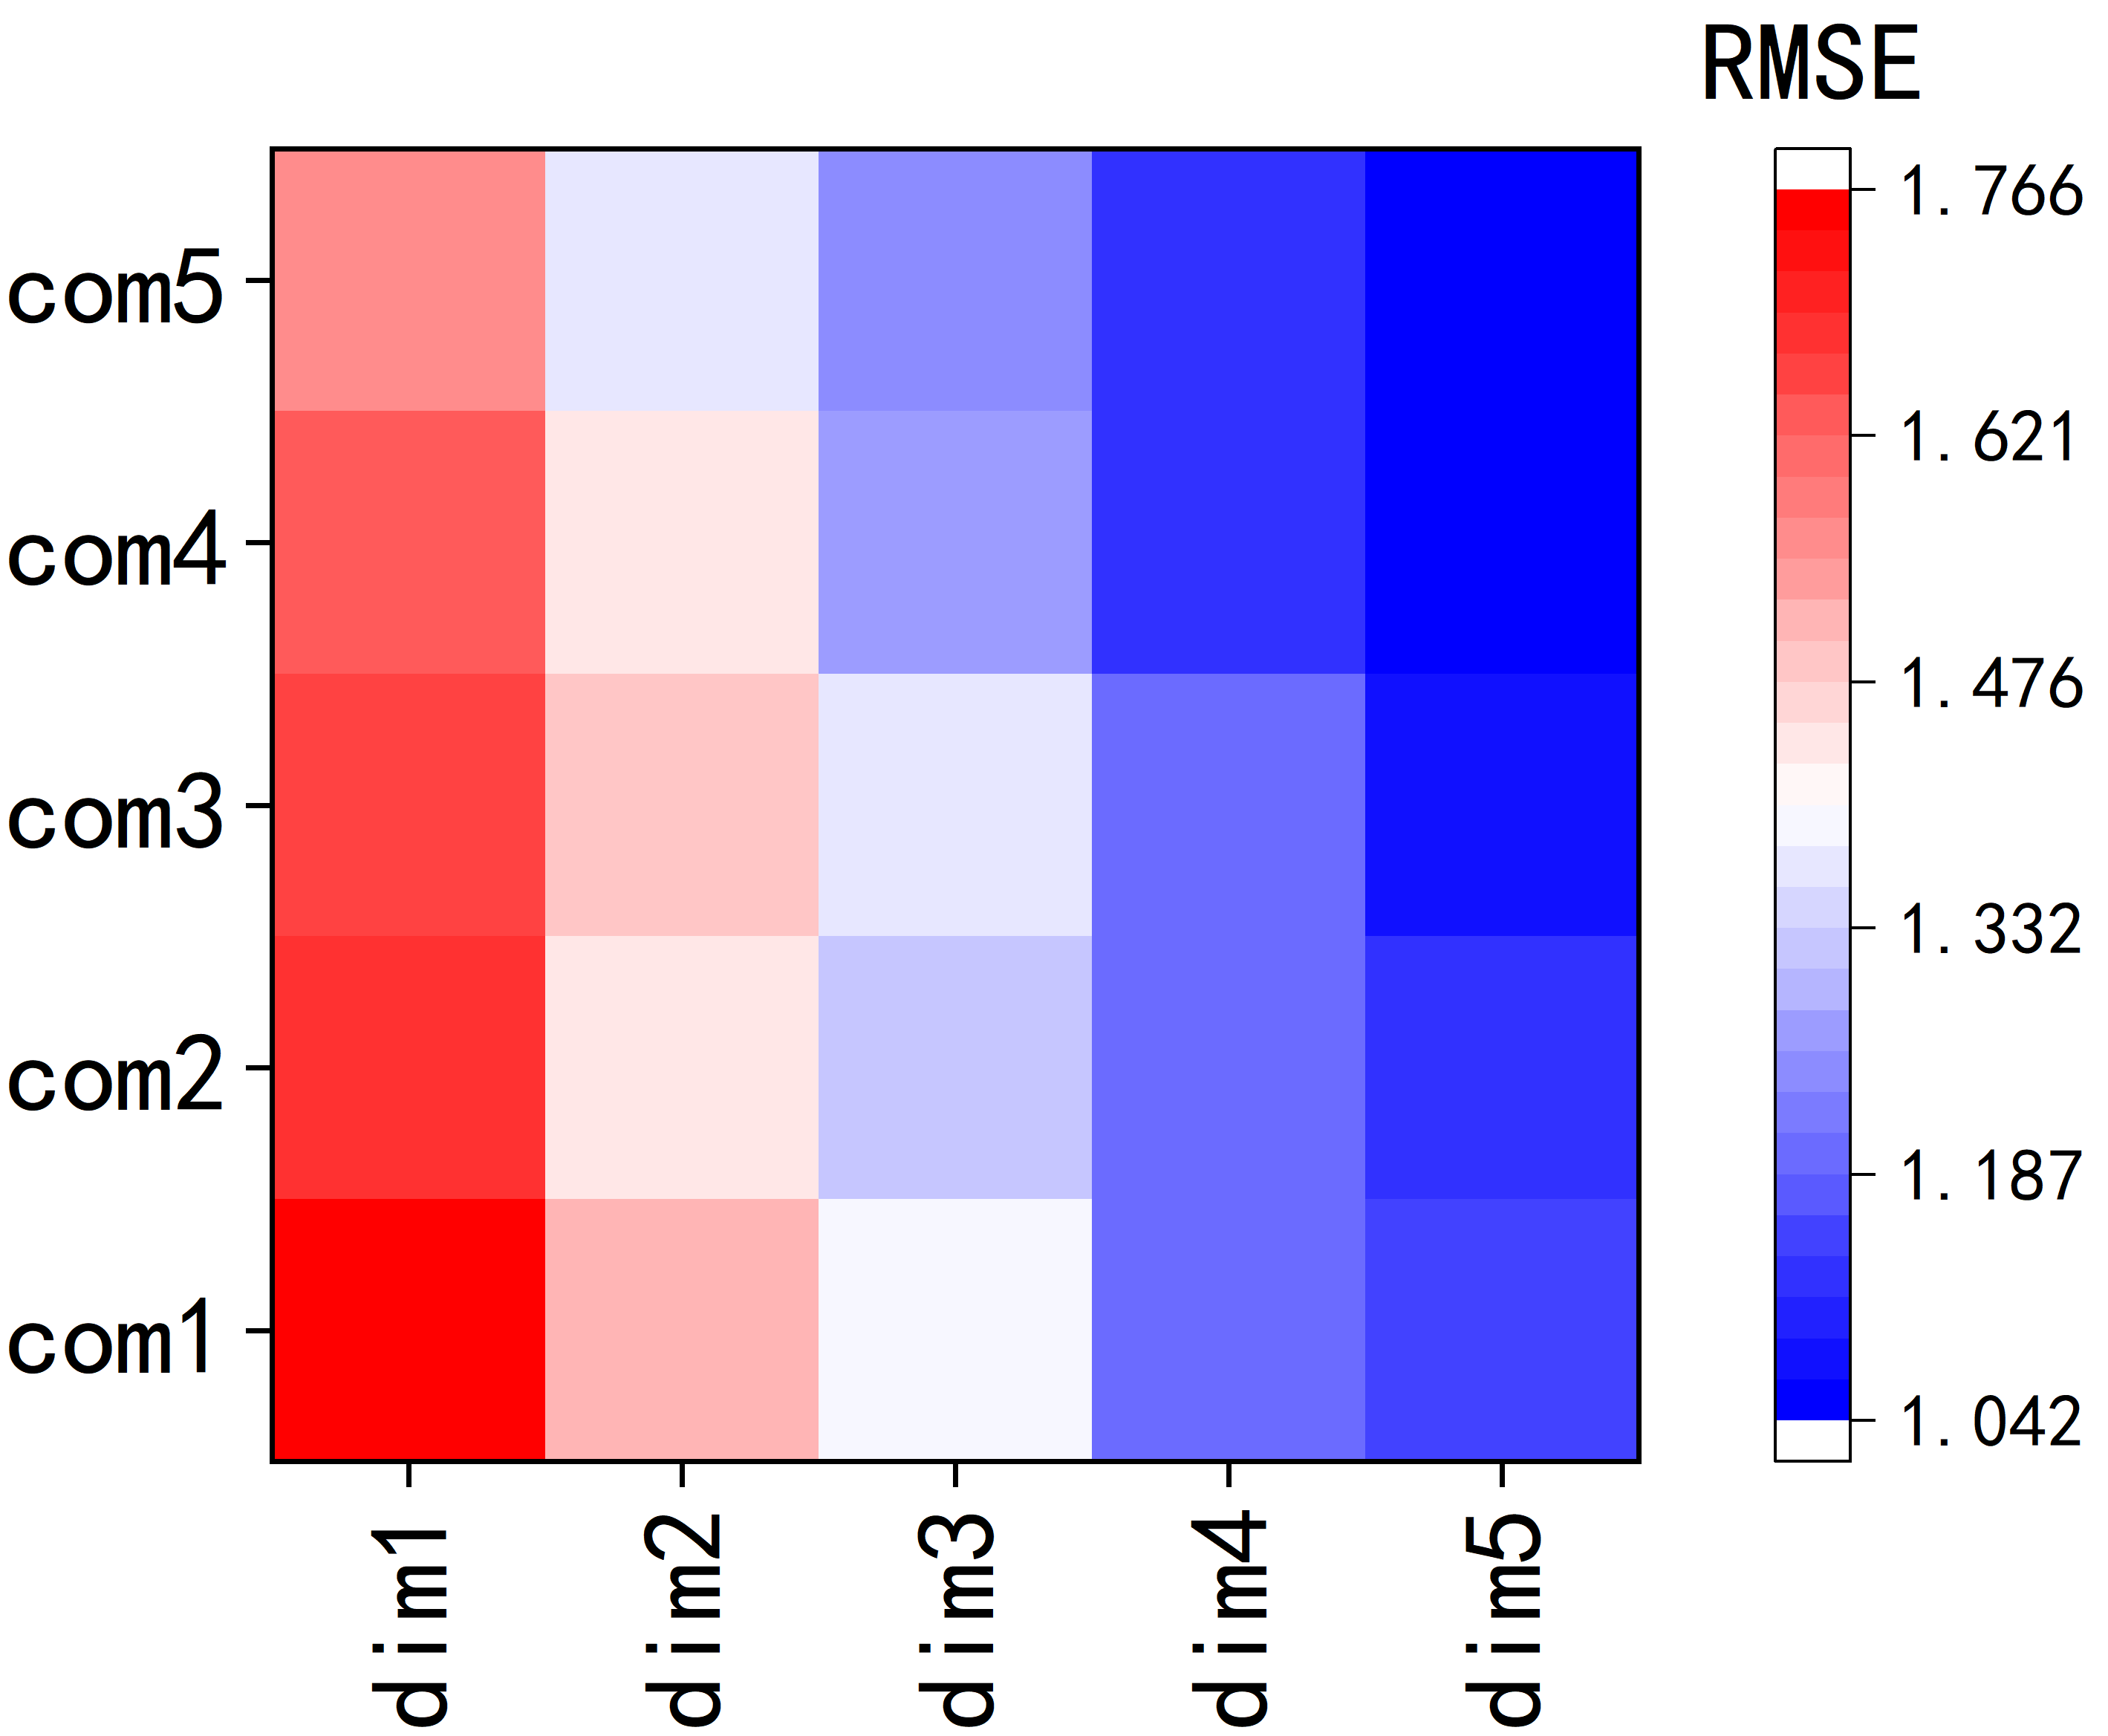
Figure S8. Model accuracy heatmaps across descriptor dimensions (dim1~5) and complexity levels (com1~5) of the accuracy of SISSO analysis of E_{f}.

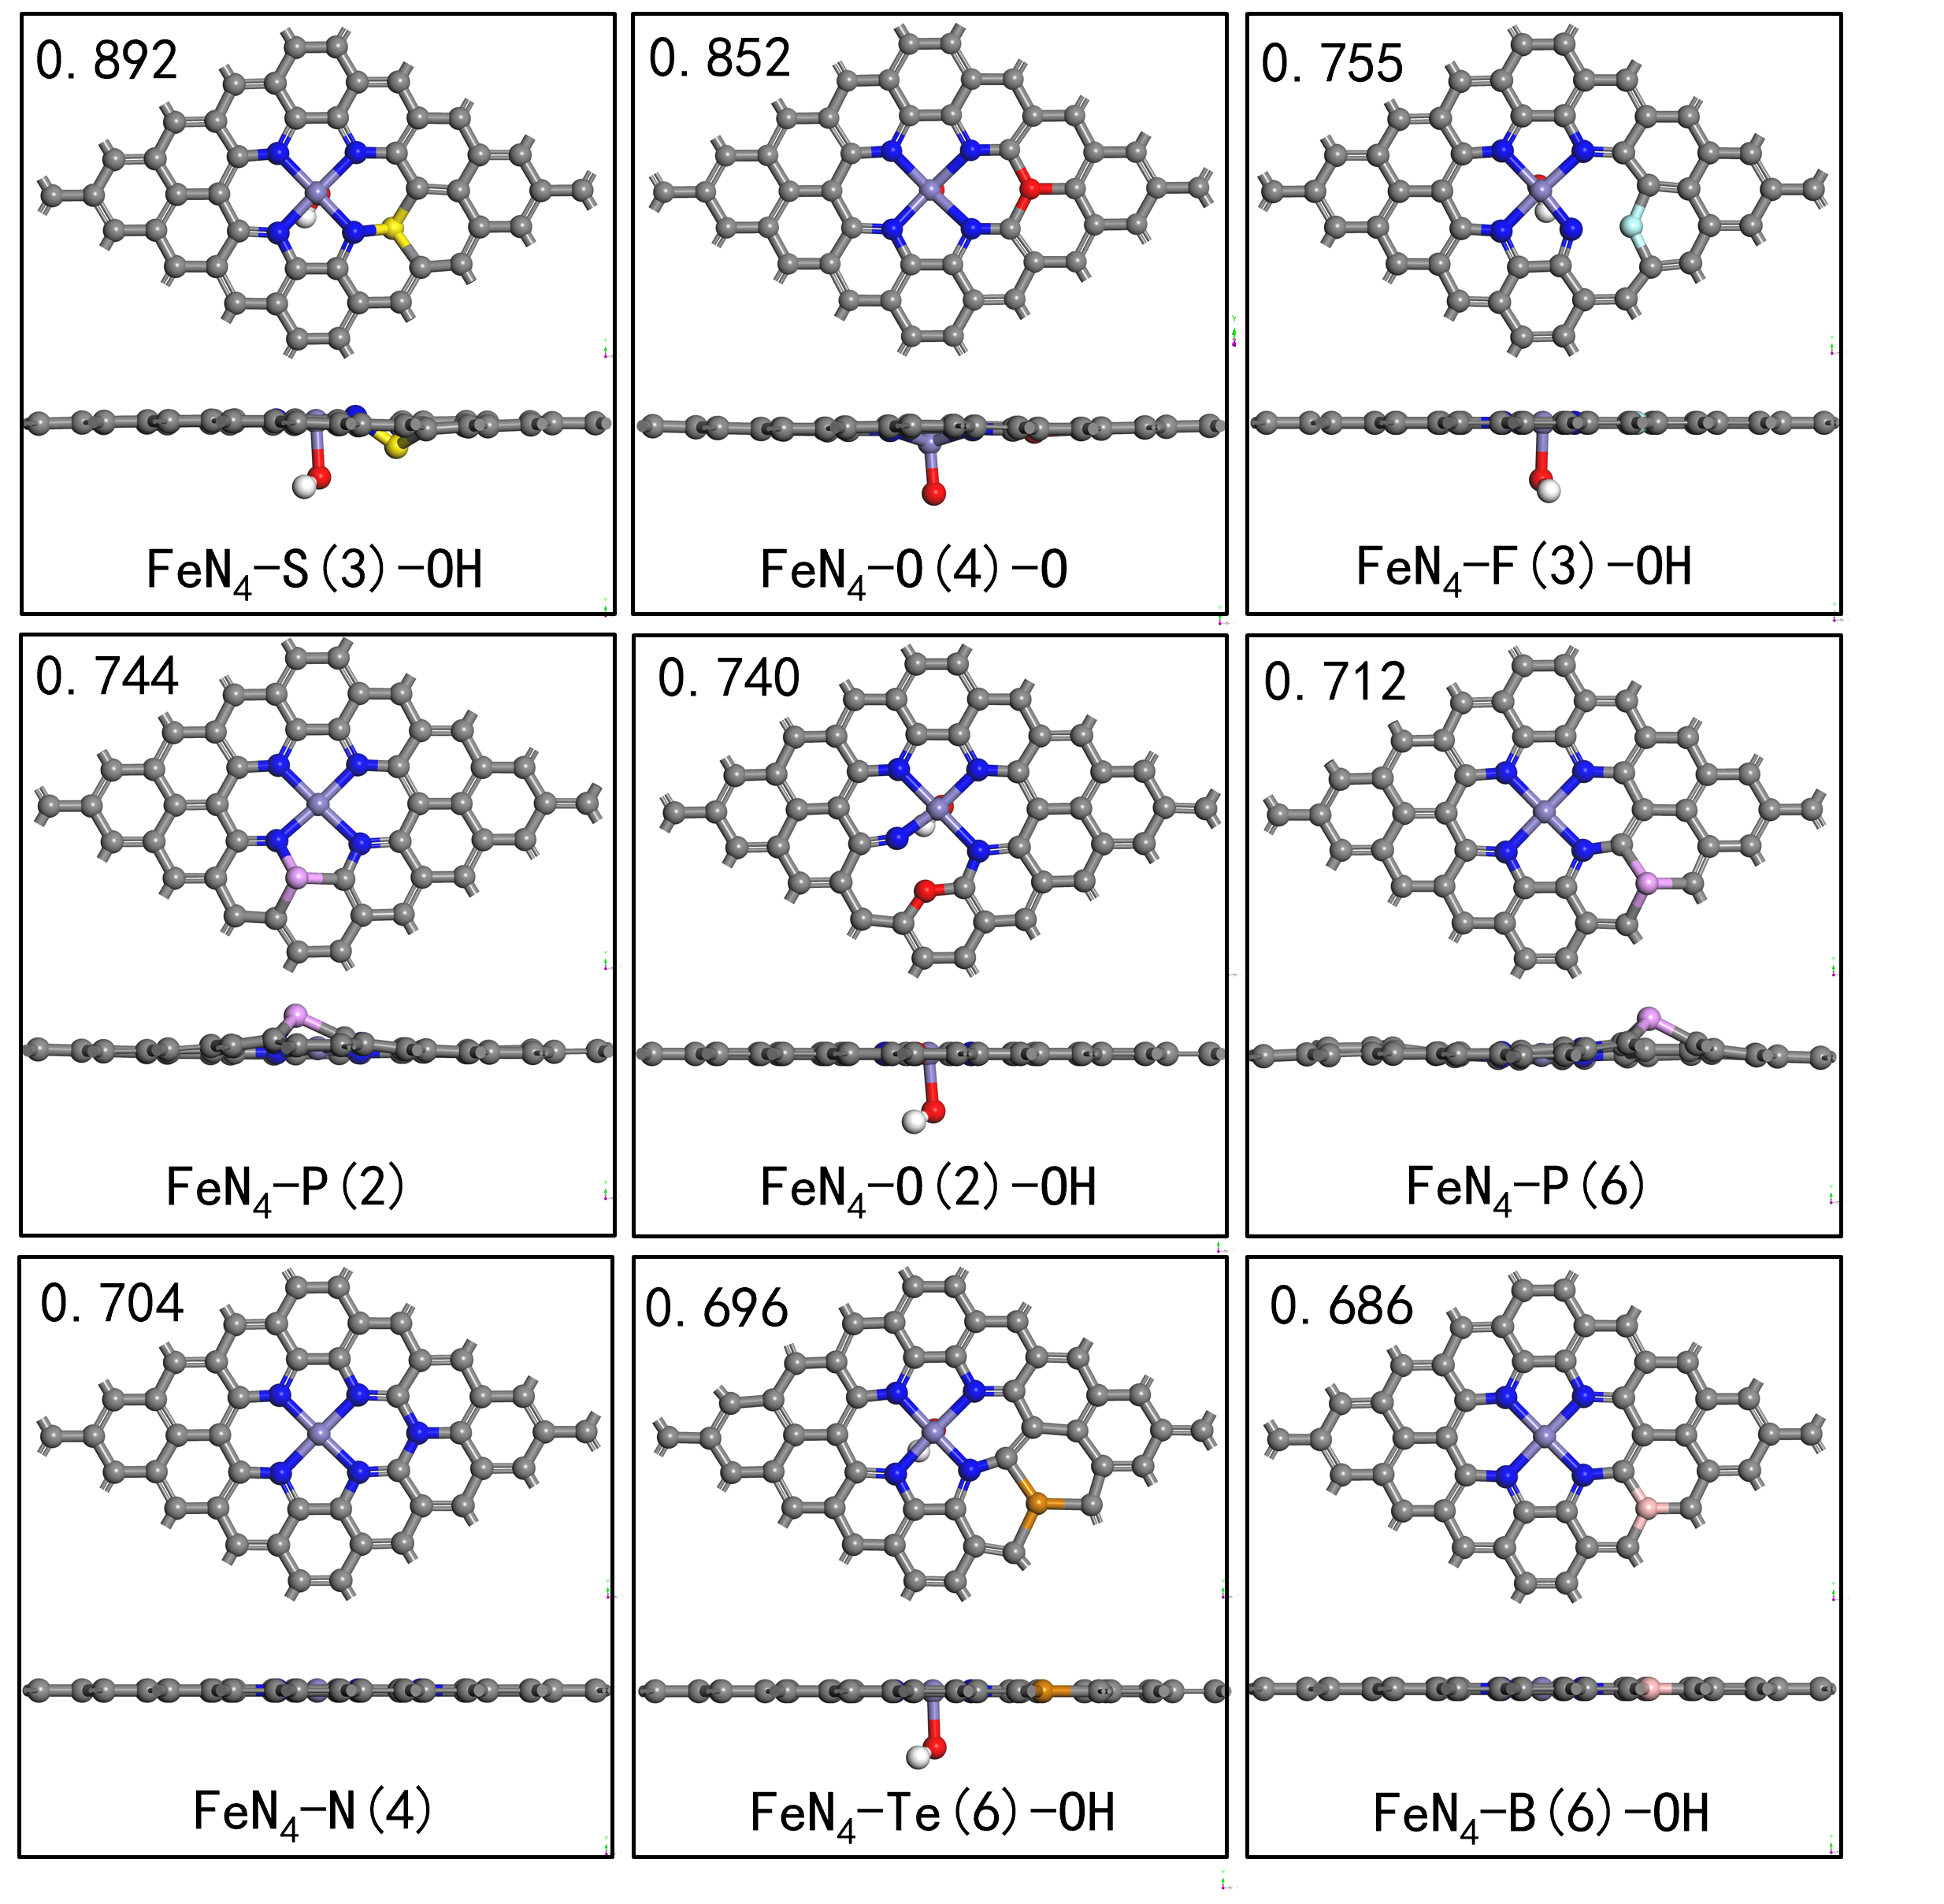
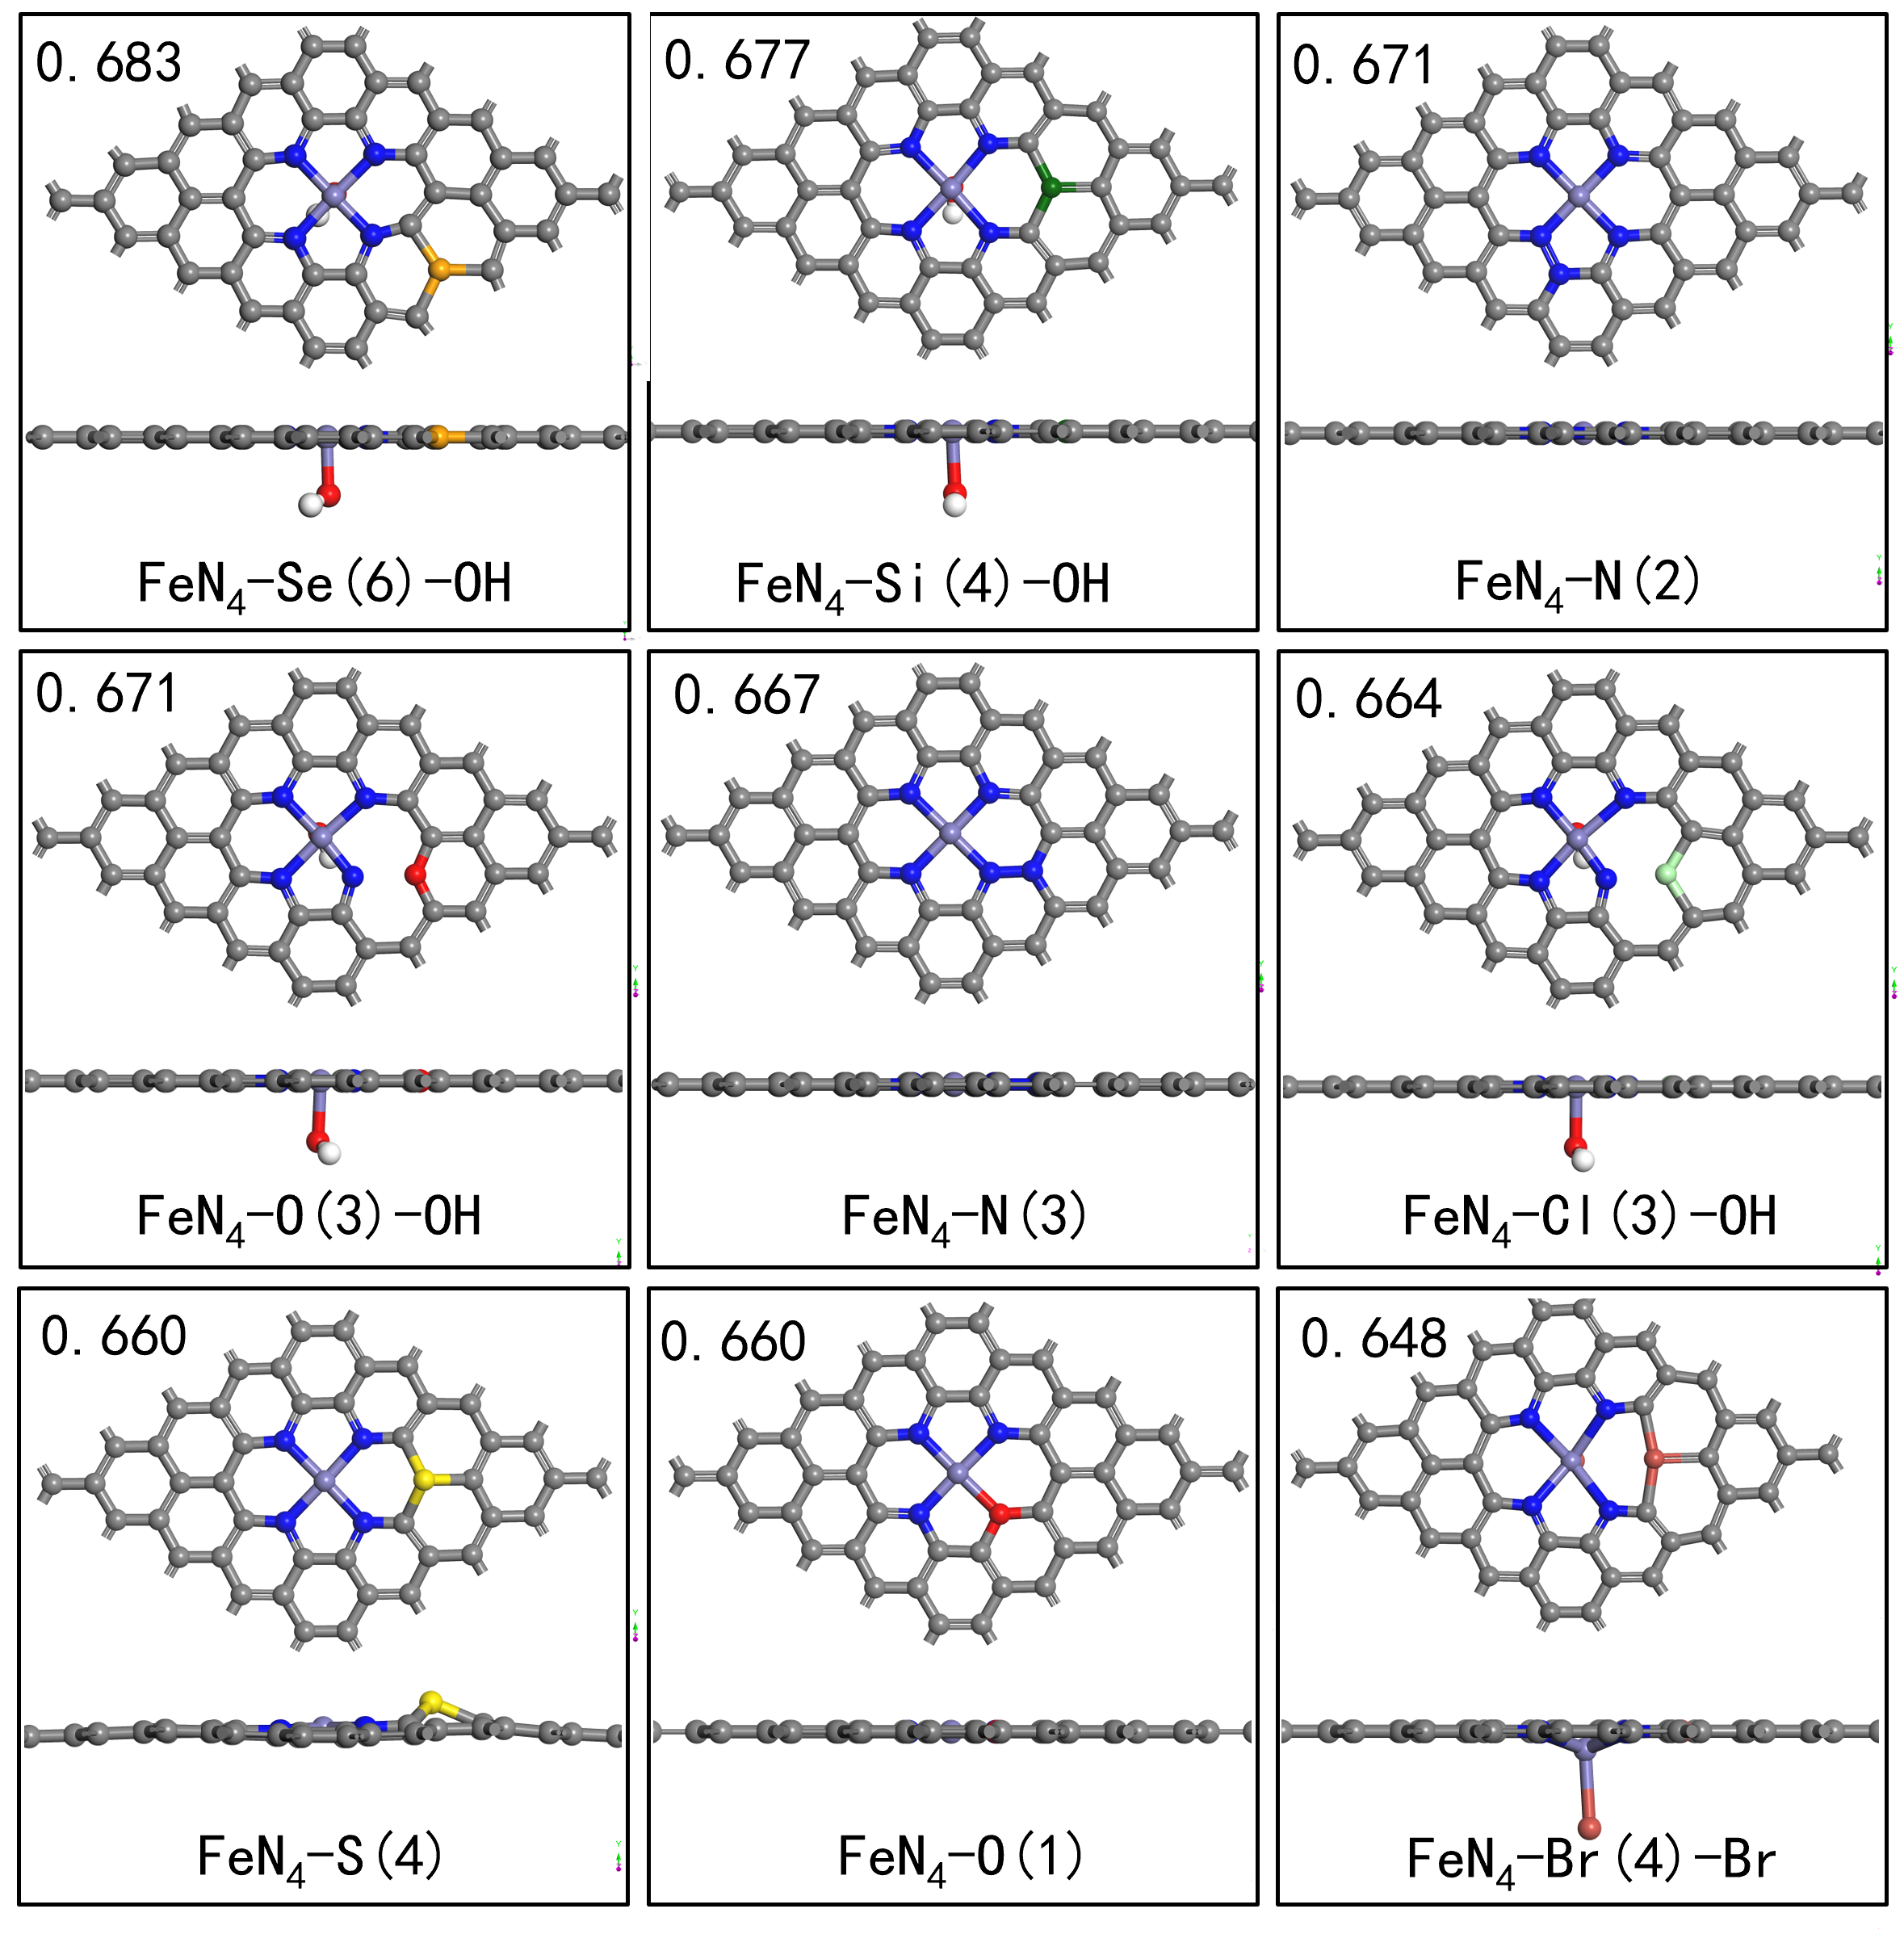
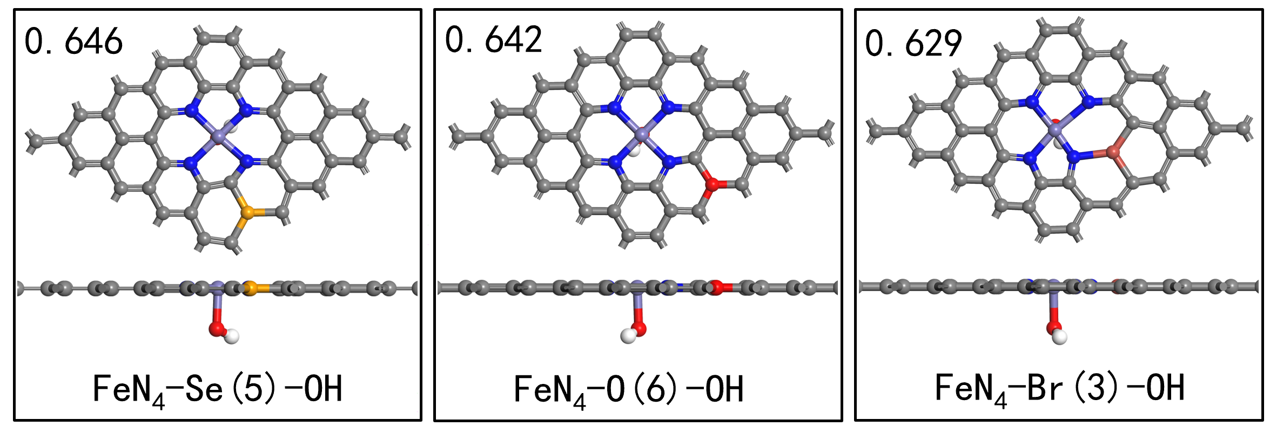
Figure S9. Structural diagrams of modified Fe-N-C catalysts with superior ORR performance from training set DFT calculations (The ORR U_{onset} is marked at the upper left of each structure). Color legend: gray = C, blue = N, purple = Fe, yellow = S, red = O, light blue = F, pink = P, orange = Se, light pink = B, white = H, light green = Cl, brown = Br, dark green = Si.

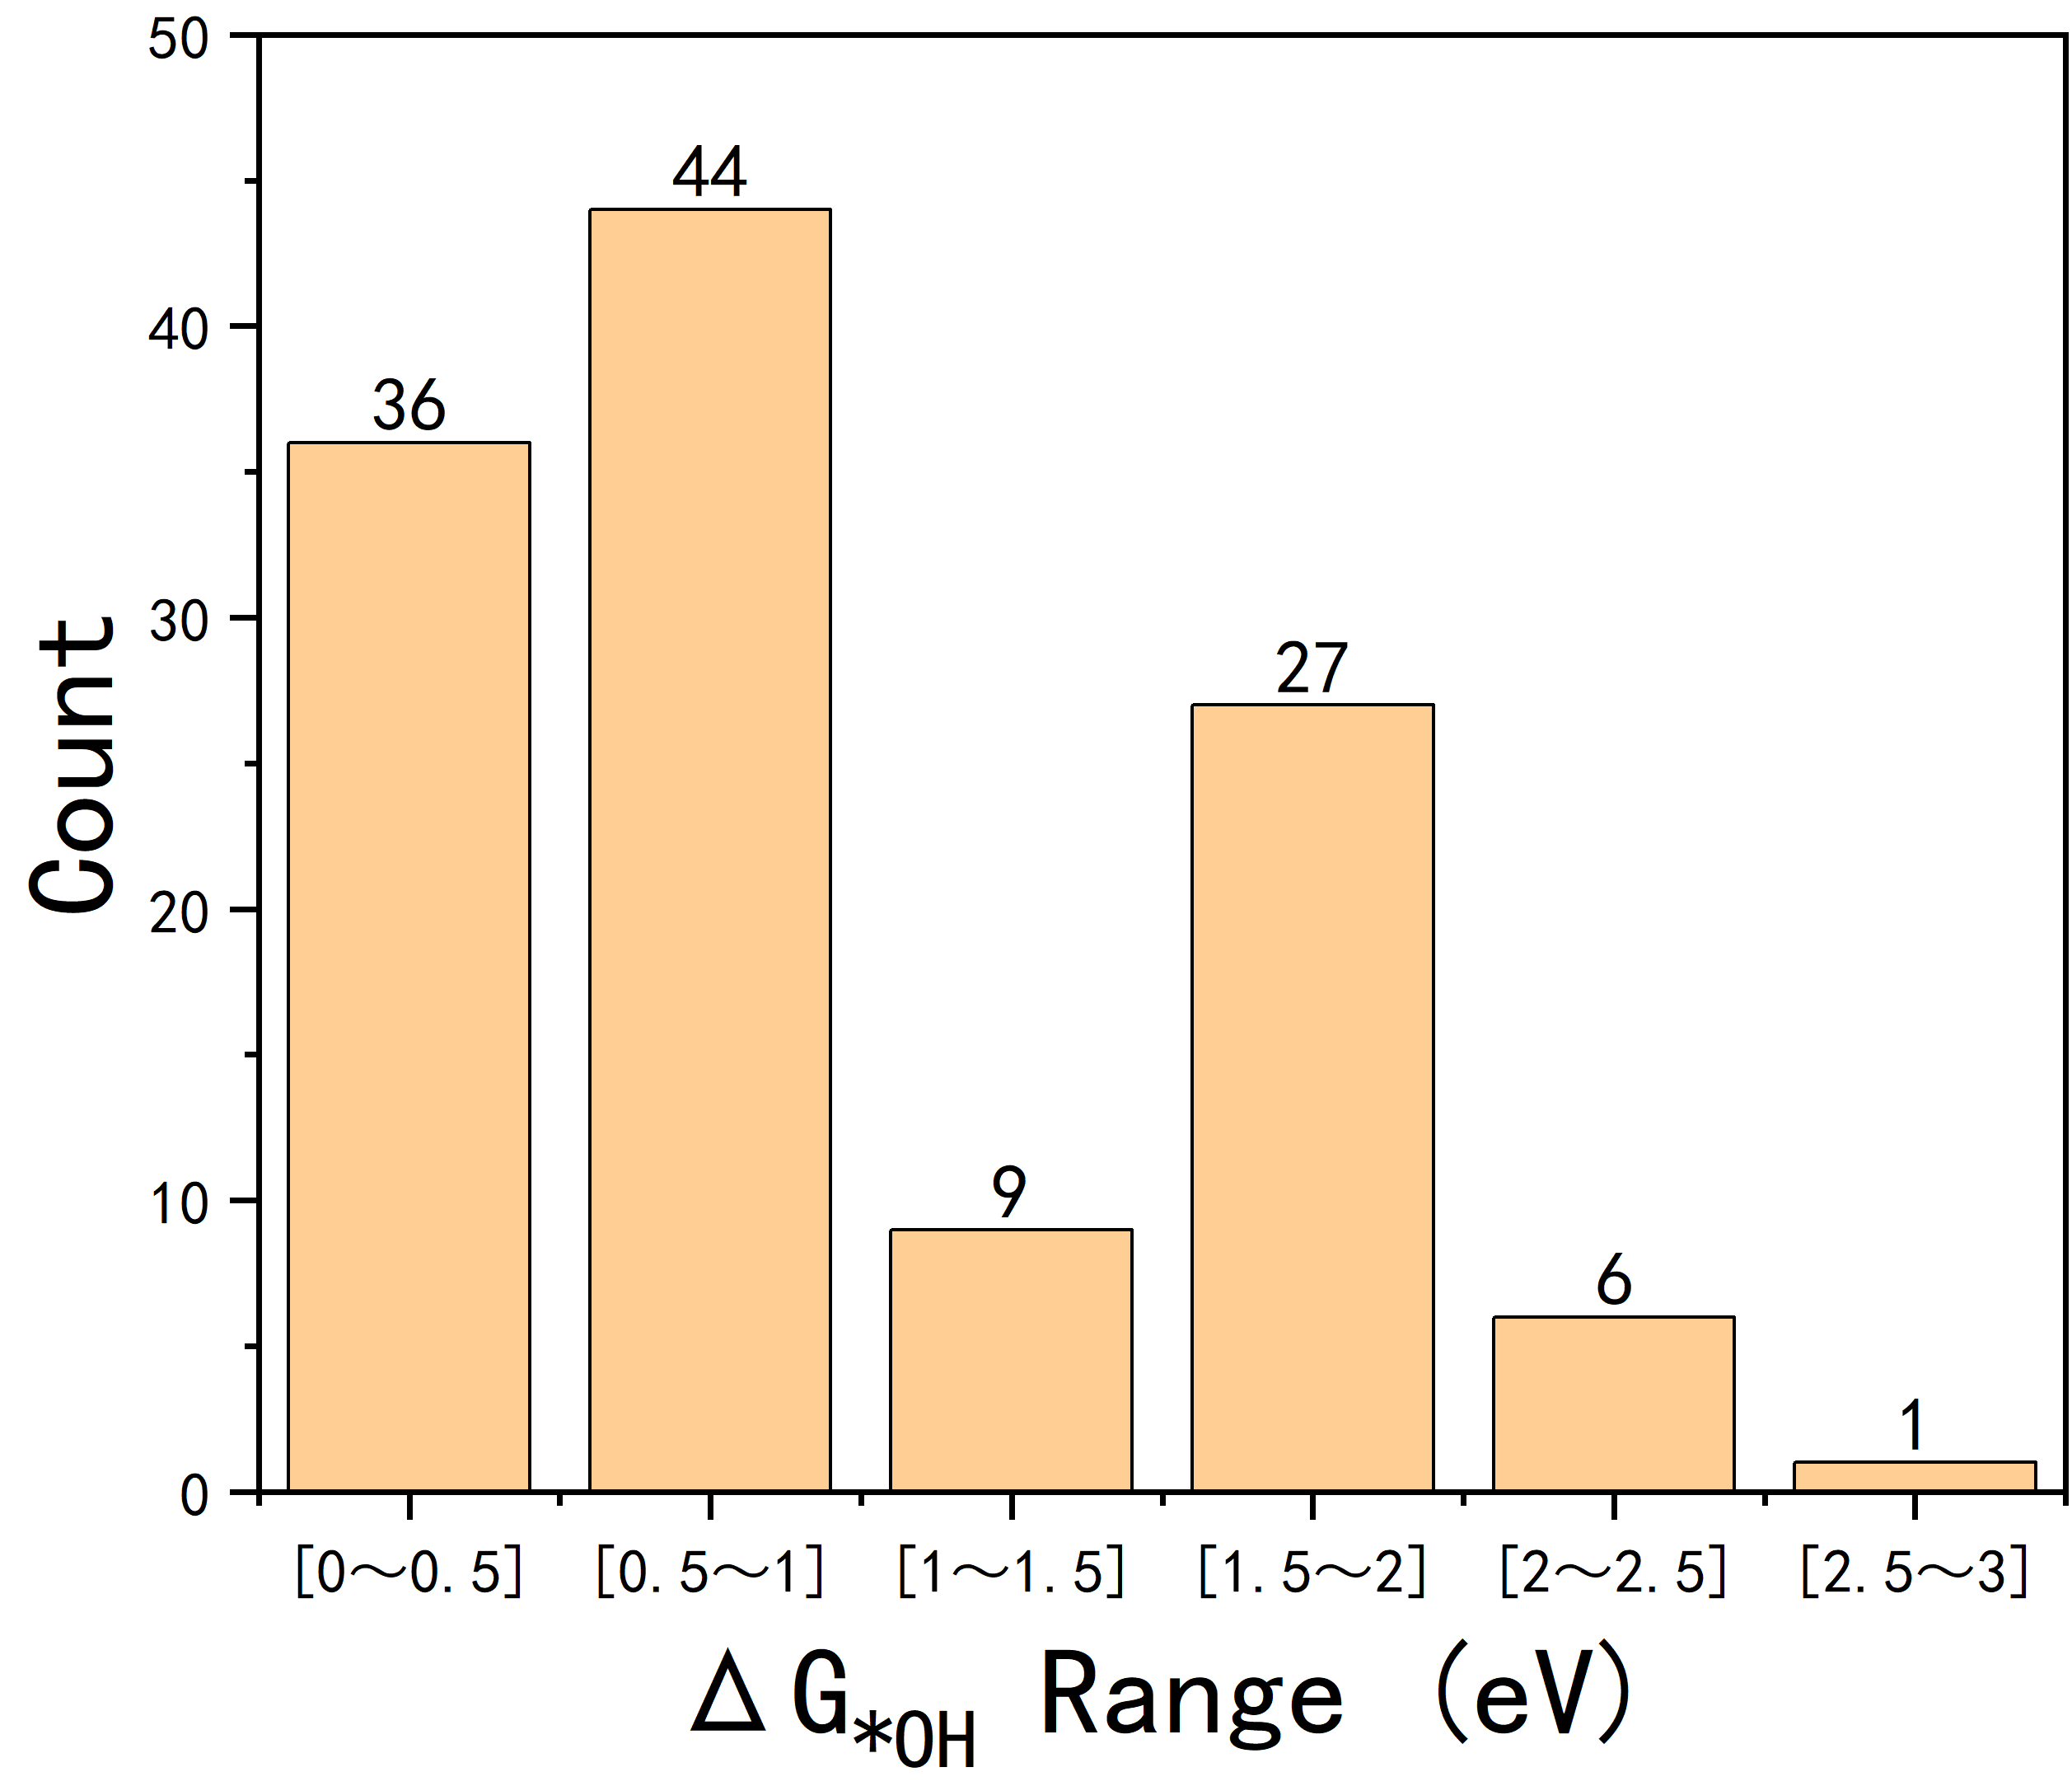
Figure S10. Distribution of G_{*OH} Adsorption Energy Values.

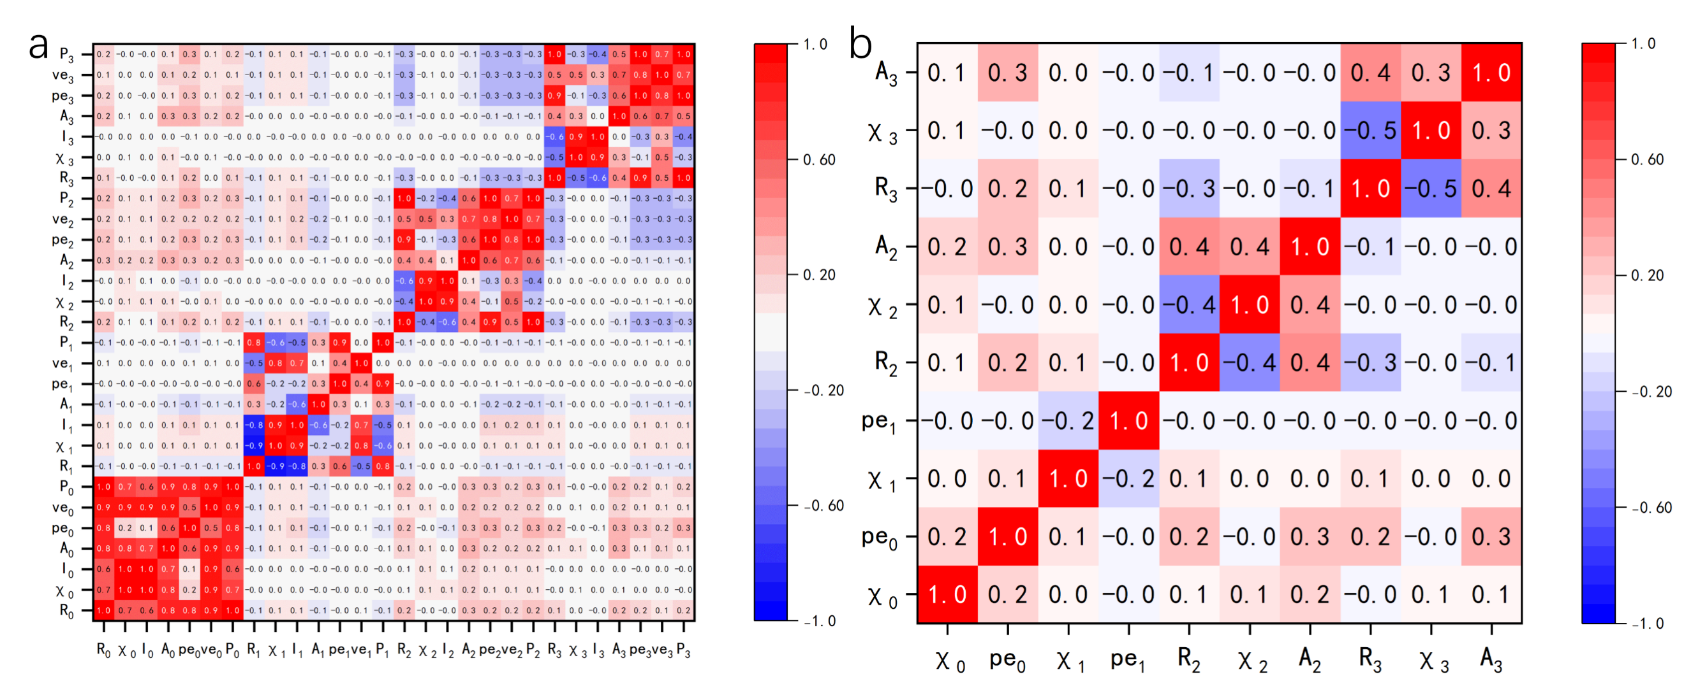
Figure S11. Heatmaps of Pearson correlation coefficients for features of activity model (a) before and (b) after correlation-based filtering. The color scale (red: strong positive, blue: strong negative) is consistent across both (a) and (b).

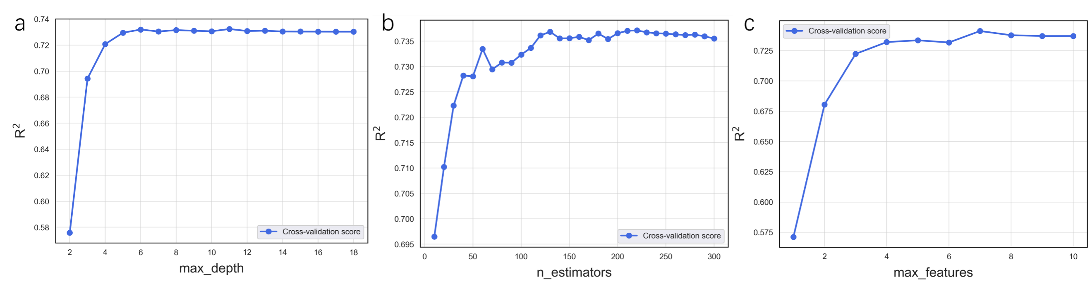
Figure S12. Learning curves of different hyperparameters in the RF model for ΔG_{*OH} prediction: (a) max_depth, (b) n_estimators, and (c) max_features.

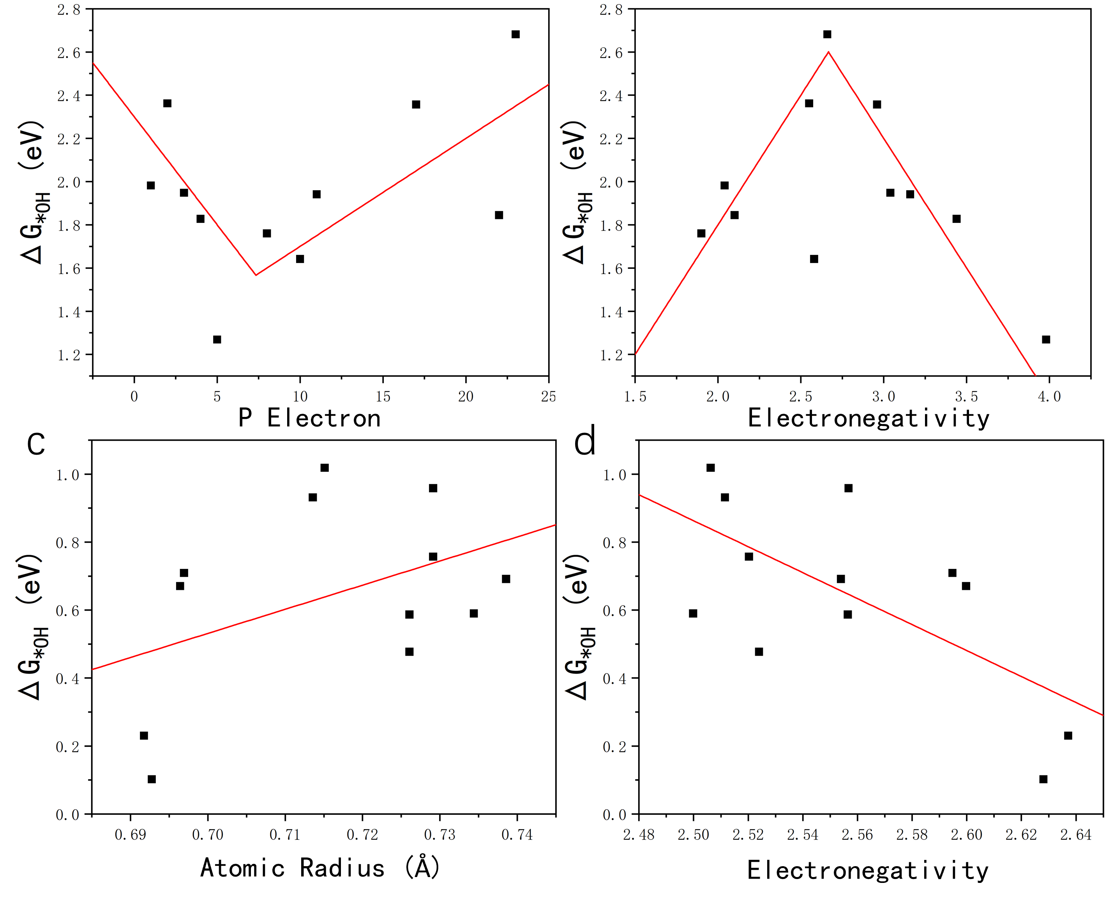
Figure S13. Scatter plots of ΔG_{*OH} versus (a) number of p electron and (b) electronegativity of the axial atom for Fe-N-C structures modified with axial heteroatoms and no in-plane doping atom. Scatter plots of ΔG_{*OH} versus (c) atomic radius and (d) electronegativity of the shell2 dopant atoms for Fe-N-C structures modified with heteroatoms doped in shell2 and axial atom.

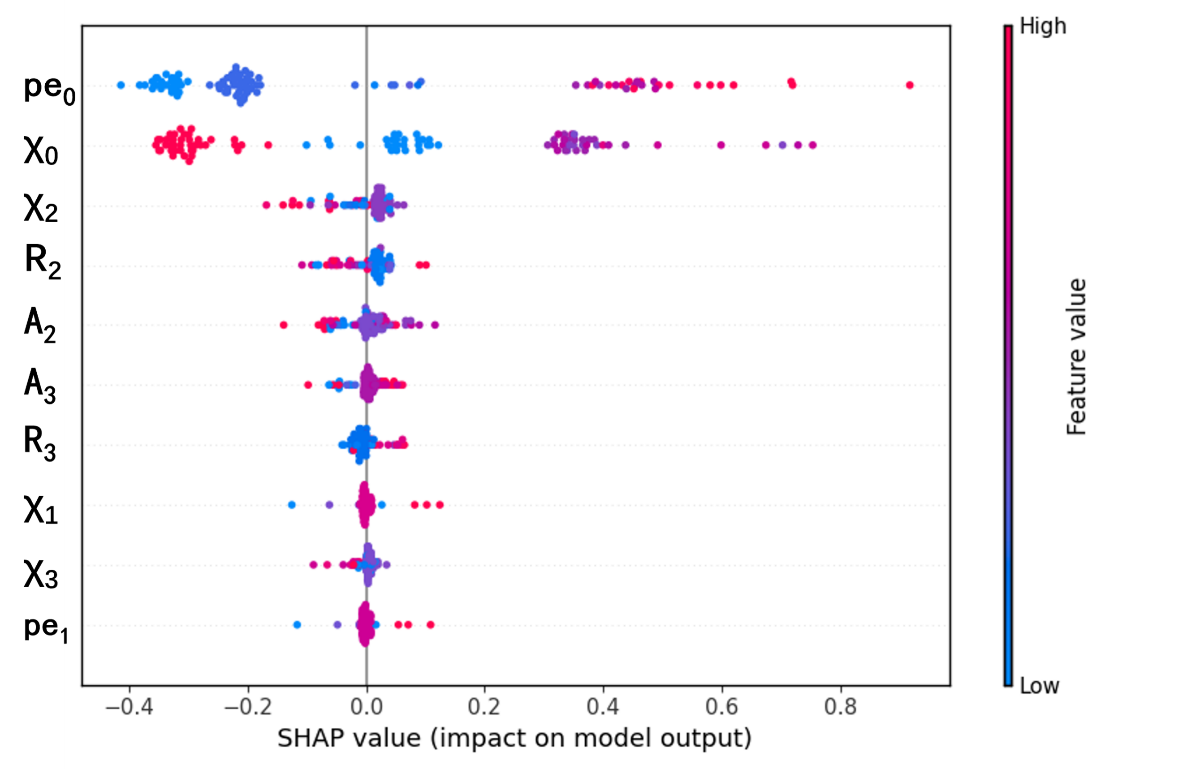
Figure S14. SHAP summary plot for the activity model.

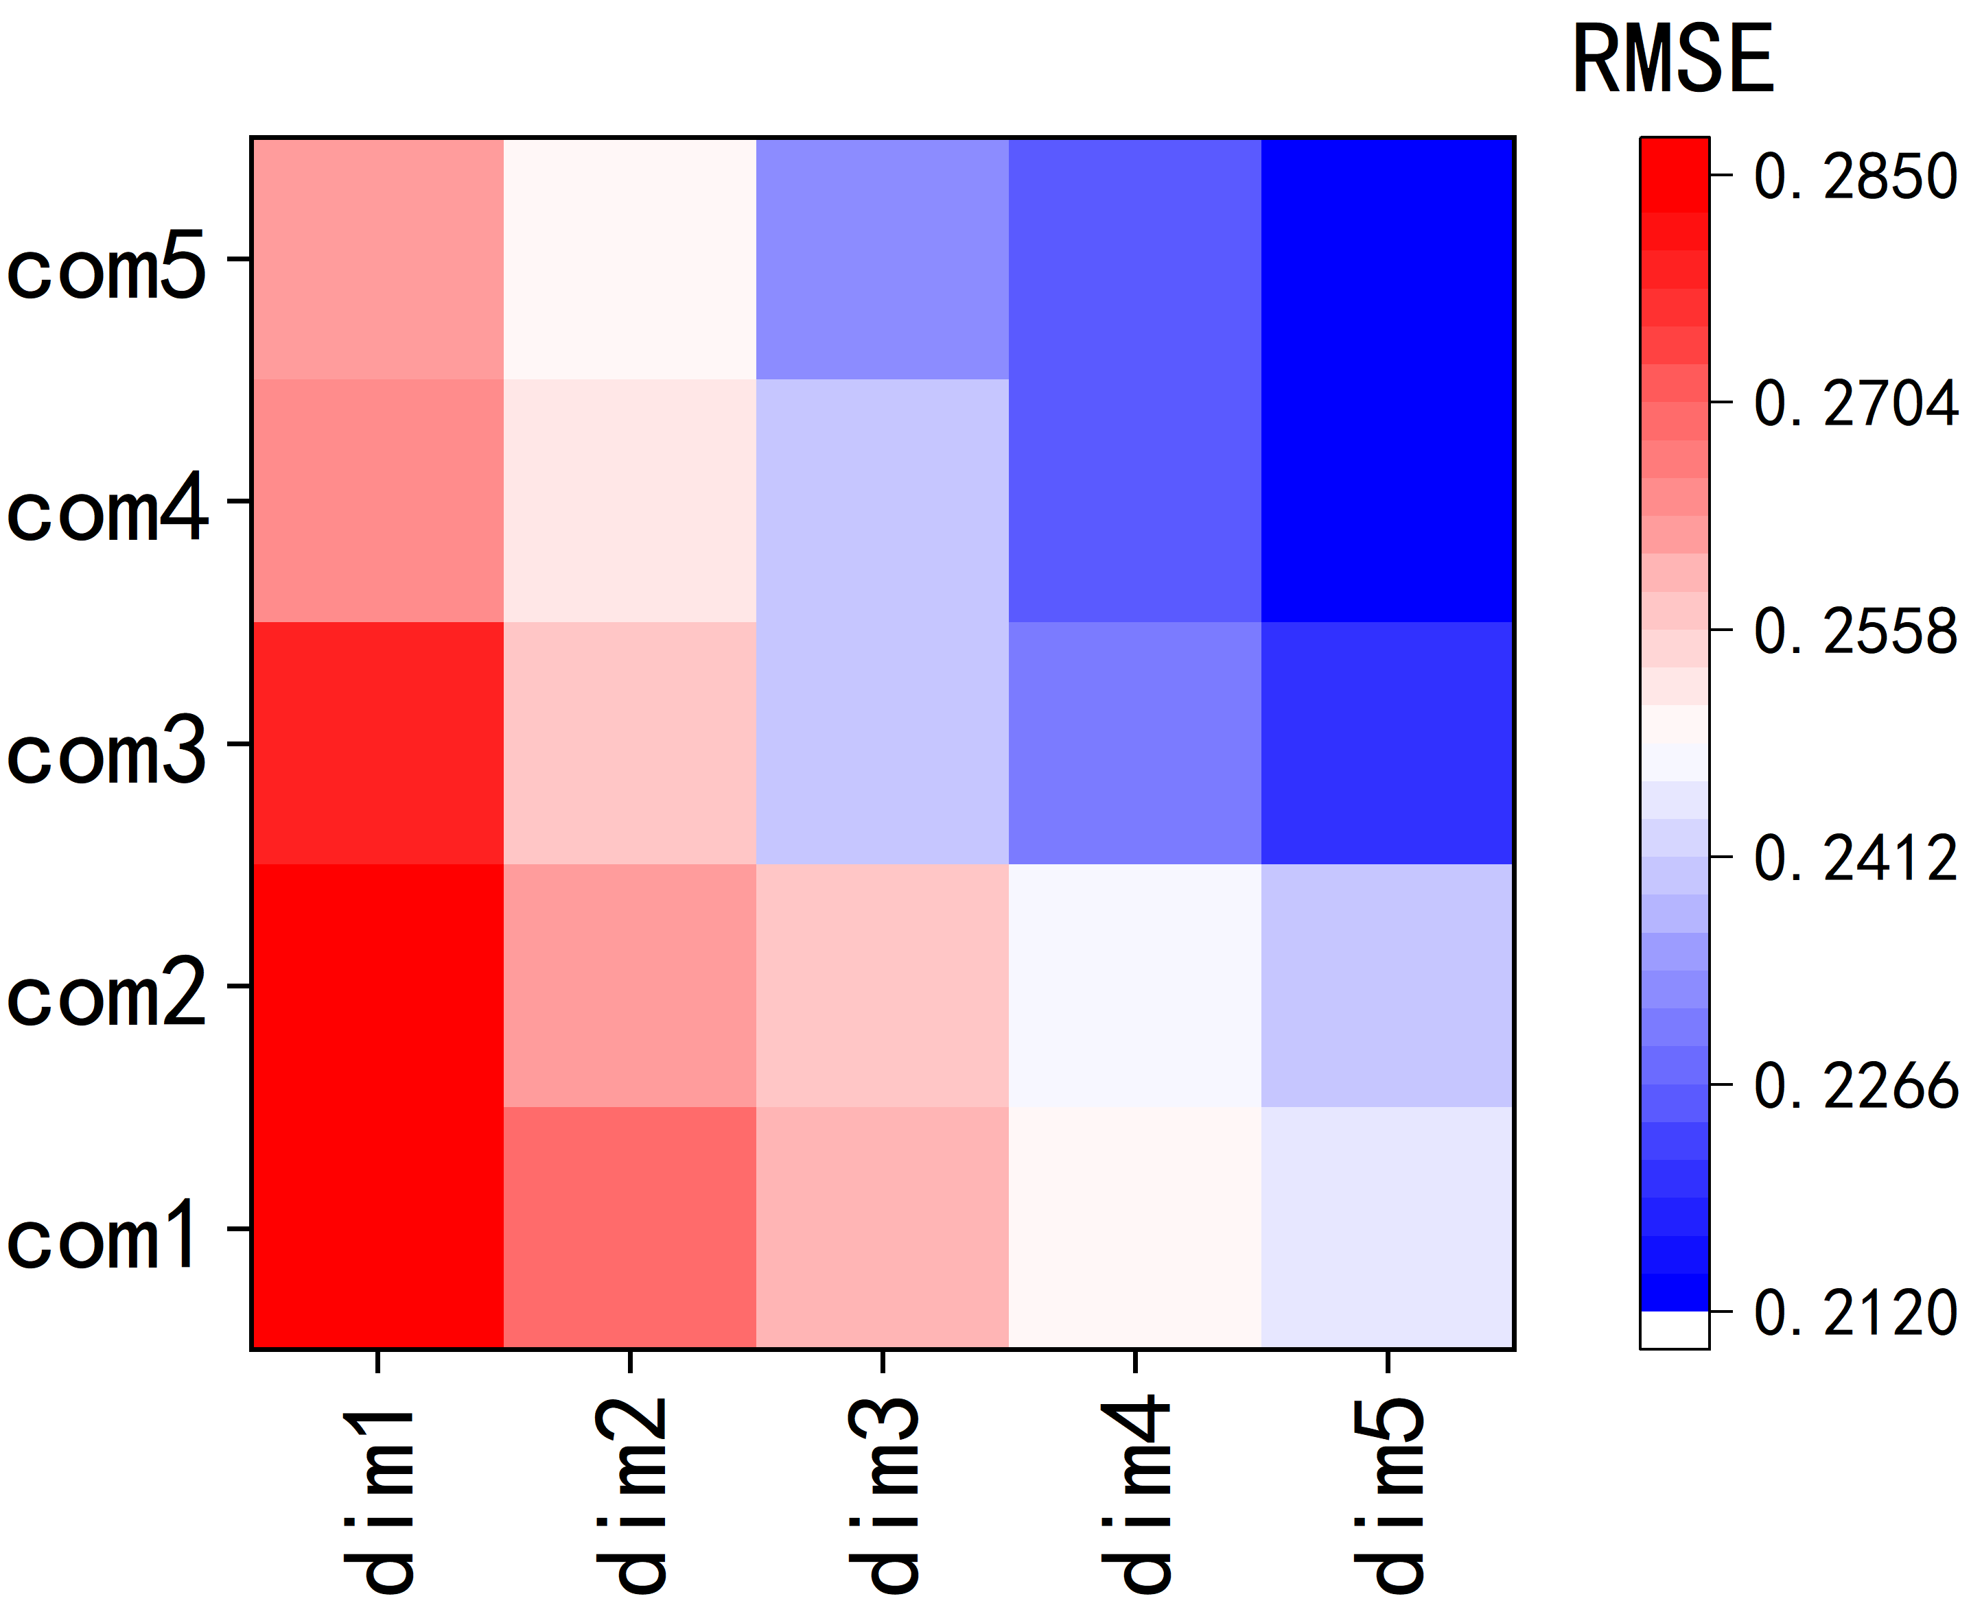
Figure S15. Model accuracy heatmaps across descriptor dimensions and complexity levels of activity model accuracy.

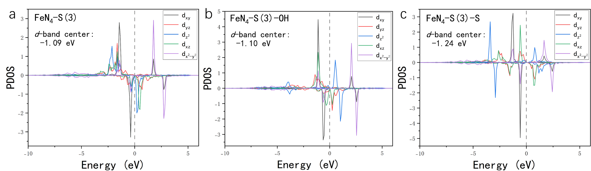
Figure S16. Projected density of state (PDOS) of Fe single atom in a) FeNC-S(3), b) FeNC-S(3)-OH and c) FeNC-S(3)-S.

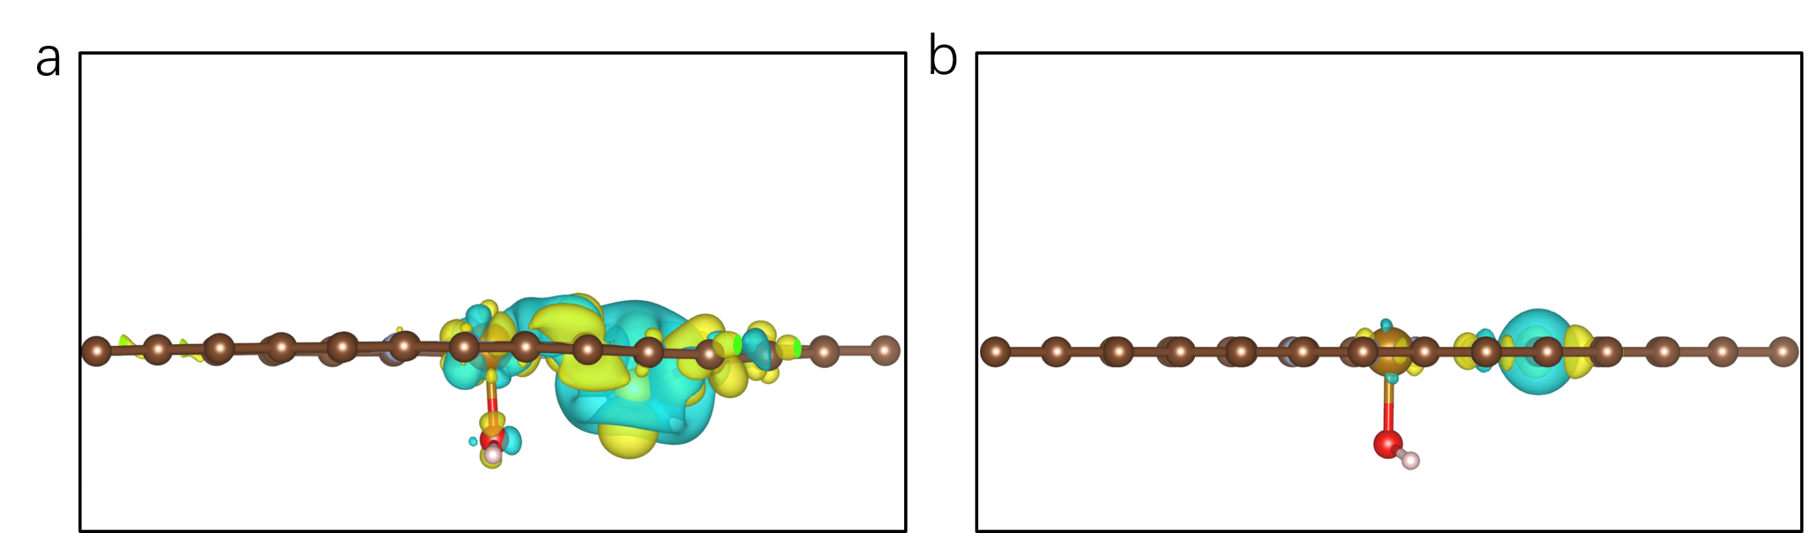
Figure S17. The charge density difference between the site 3 atom and other parts of the catalyst structure in (a) FeNC-S(3)-OH and (b) FeNC-OH.

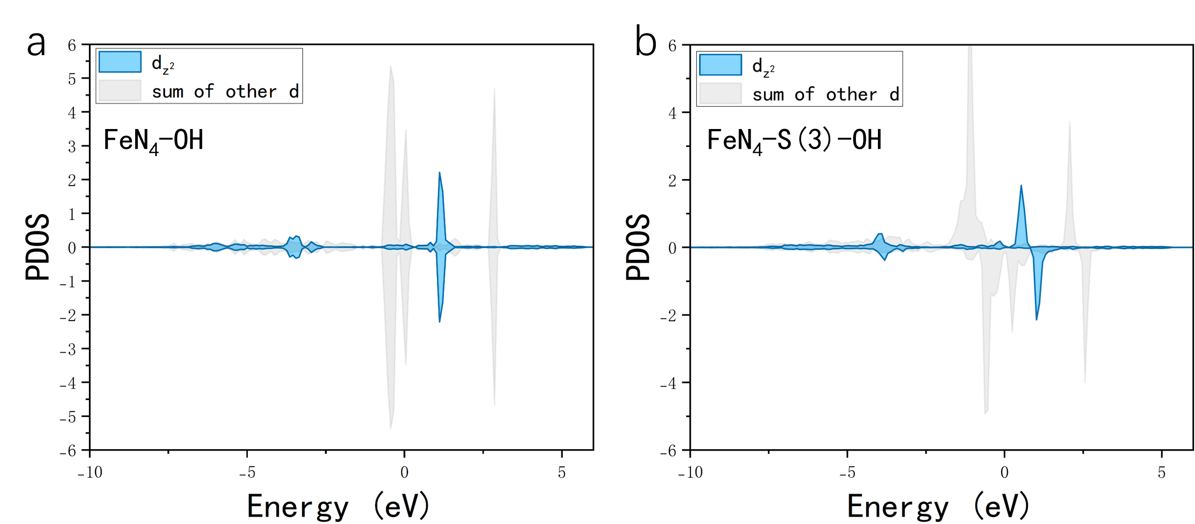
Figure S18. Comparison of Fe-3d PDOS a) FeNC-OH and b) FeNC-S(3)-OH. The blue curve corresponds to the dz² orbital of the central Fe atom, while the gray area represents the sum of other d orbital components.

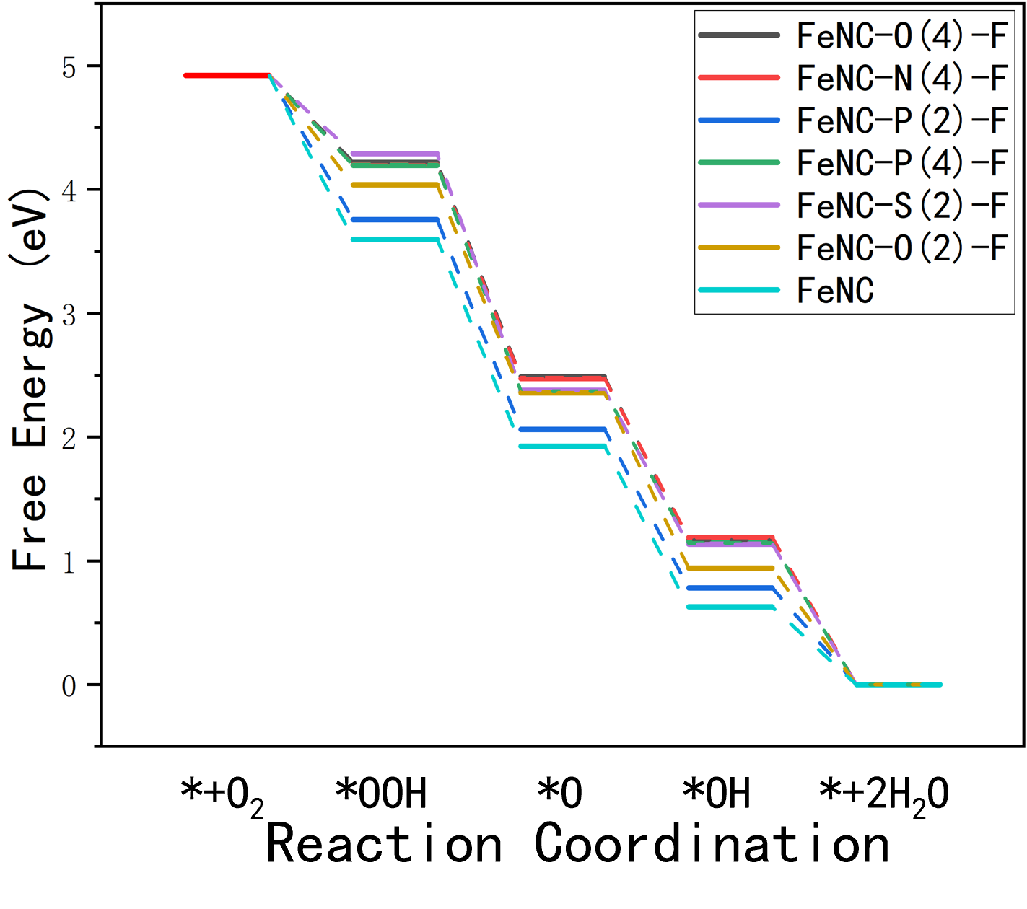
Figure S19. Gibbs free energy diagrams of ORR on FeNC-O(4)-F, FeNC-N(4)-F, FeNC-P(4)-F, FeNC-P(2)-F and FeNC-S(4)-F at 0V.

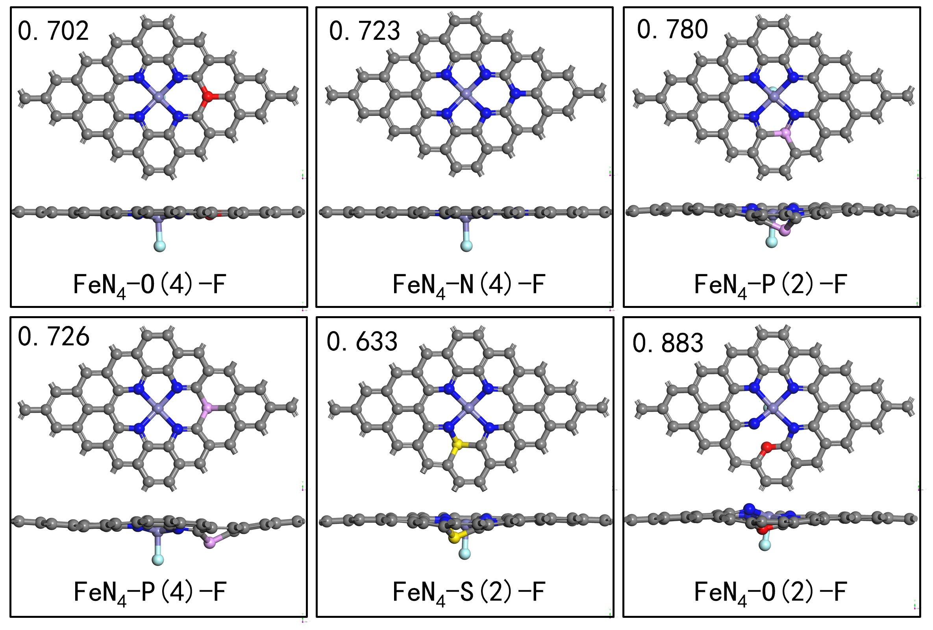
Figure S20. Structural diagrams of predicted modified Fe-N-C catalysts with superior ORR performance verified by DFT calculations (The ORR U_{onset} is marked at the upper left of each structure). Color legend: gray = C, blue = N, purple = Fe, red = O, pink = P, yellow = S, light blue = F.

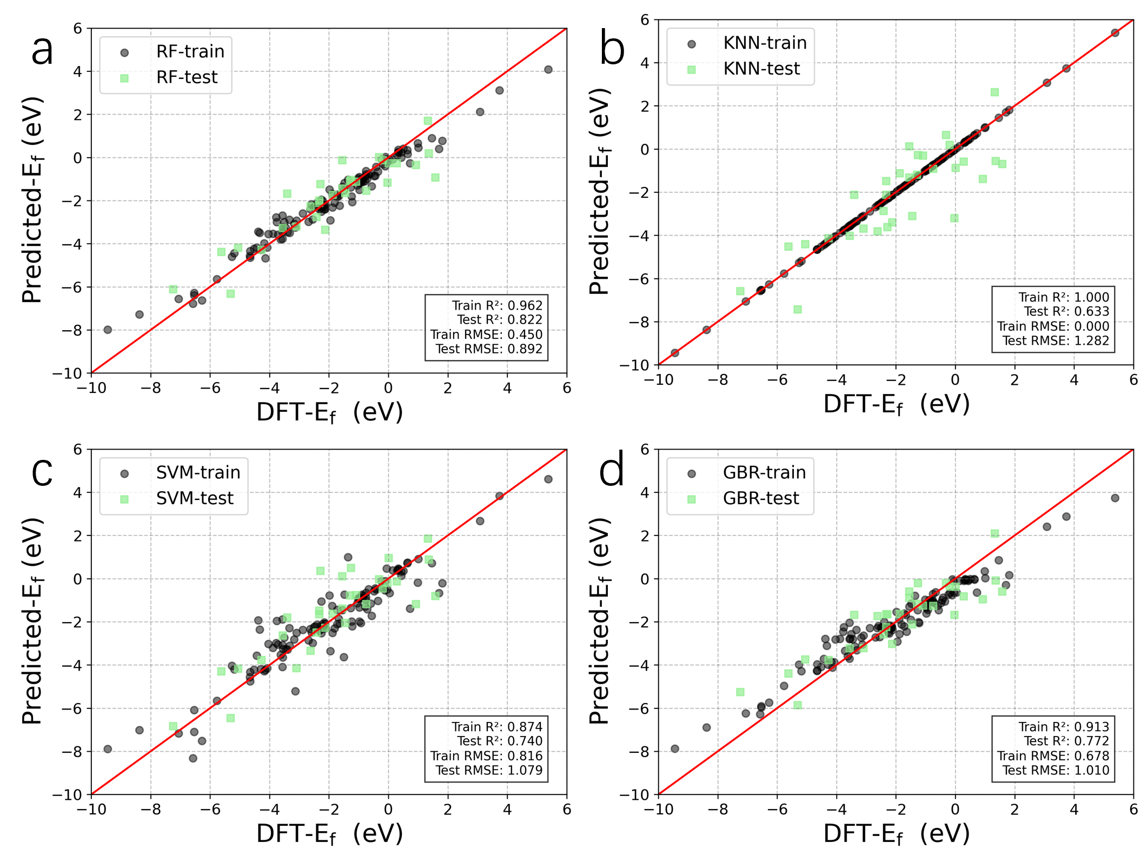
Figure S21. Training and testing results of (a) RF, (b) KNN, (c) SVM and (d) GBR models for E_{f} prediction with full feature set without feature filtering (black dots represent the training set, black dots indicate the test set).

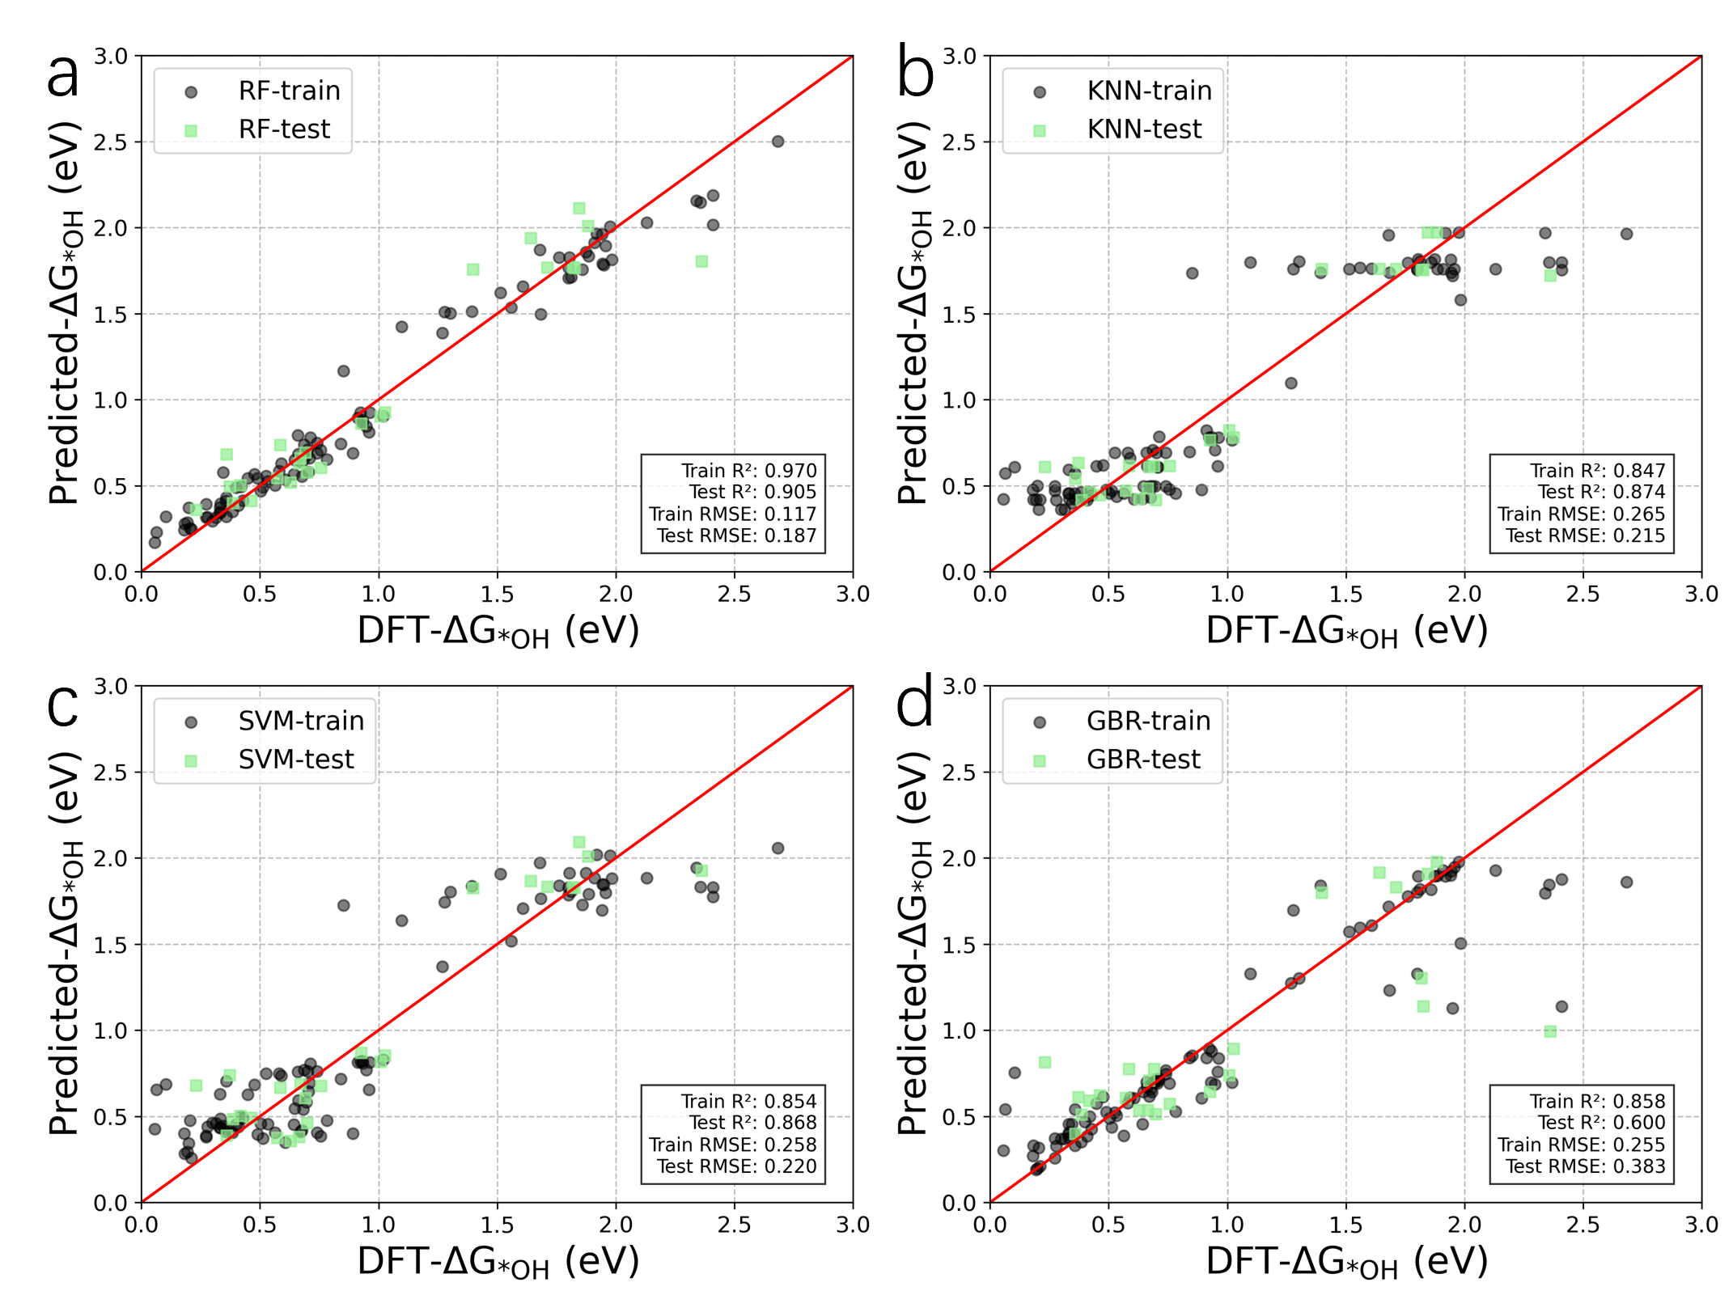
Figure S22. Training and testing results of (a) RF, (b) KNN, (c) SVM and (d) GBR models for ΔG_{*OH} prediction with full feature set without feature filtering (black dots represent the training set, black dots indicate the test set).

Table S1. The original 28 features before feature filtering.
Features
The average atomic radius of the first shell | R₁
The average atomic radius of the second shell  The average atomic radius of the third shell | R₂  R₃
The atomic radius of the axial ligand  The average electronegativity of the first shell  The average electronegativity of the second shell  The average electronegativity of the third shell  The electronegativity of the axial ligand  The average ionization energy of the first shell  The average ionization energy of the second shell  The average ionization energy of the third shell  The ionization energy of the axial ligand  The average electron affinity of the first shell  The average electron affinity of the second shell  The average electron affinity of the third shell  The electron affinity of the axial ligand  The average p electron of the first shell  The average p electron of the second shell  The average p electron of the third shell  The p electron of the axial ligand  The average valence electron of the first shell  The average valence electron of the second shell  The average valence electron of the third shell  The valence electron of the axial ligand  The average period of the first shell  The average period of the second shell  The average period of the third shell  The period of the axial ligand | R₀  χ₁  χ₂  χ₃  χ₀  I₁  I₂  I₃  I₀  A₁  A₂  A₃  A₀  pe₁  pe₂  pe₃  pe₀  ve₁  ve₂  ve₃  ve₀  P₁  P₂  P₃  P₀

Table S2. Intrinsic properties of atoms. The units of R, I, and A are Å, eV, eV, respectively.
Element | R | χ | I | A | pe | ve | P
B | 0.85 | 2.04 | 8.298 | 0.280 | 1 | 3 | 2
Br  Cl  F  I  O  P  S  Se  Si  Te  C  N  H | 1.15  1.00  0.50  1.40  0.60  1.00  1.00  1.15  1.10  1.40  0.70  0.65  0.25 | 2.96  3.16  3.98  2.66  3.44  2.19  2.58  2.55  1.90  2.10  2.55  3.04  2.20 | 11.814  12.968  17.423  10.451  13.618  10.487  10.360  9.752  8.152  9.010  11.260  14.534  13.598 | 3.364  3.613  3.401  3.059  1.461  0.747  2.077  2.021  1.390  1.971  1.262  -0.070  0.755 | 17  11  5  23  4  9  10  16  8  22  2  3  0 | 7  7  7  7  6  5  6  6  4  6  4  5  1 | 4  3  2  5  2  3  3  4  3  5  2  2  1

Table S3. The hyper-parameters of the ML model for predicting E_{f}.
Algorithm | Hyperparameters
RF  KNN  SVR  GBR | max_depth=7, n_estimators=100, max_features=5  n_neighbors=7, weights=’uniform’  C=100, kernel=’rbf’, gamma=0.1  Learning_rate=0.01, max_depth=4, n_estimators=200

Table S4. The hyper-parameters of the ML model for predicting ΔG_{*OH}.
Algorithm | Hyperparameters
RF  KNN  SVR  GBR | max_depth=11, n_estimators=220, max_features=7  n_neighbors=5, weights=’uniform’  C=13, kernel=’rbf’, gamma=’scale’  Learning_rate=0.1, max_depth=4, n_estimators=50

Table S5. Prediction of E_{f} and ΔG_{*OH} with different structures of dopant and axial coordinating atoms.
Structure | Predicted E_{f} (eV) | Predicted ΔG_{*OH} (eV)
site_4_doped_with_F_axial_O | -2.3521 | 1.142124
site_4_doped_with_O_axial_F | -3.19142 | 1.155989
site_4_doped_with_F_axial_B | 0.180919 | 1.166919
site_2_doped_with_F_axial_O | -2.25143 | 1.173836
site_4_doped_with_O_axial_B | 0.352783 | 1.177221
site_2_doped_with_F_axial_B | 0.311268 | 1.182146
site_3_doped_with_F_axial_O | -2.25396 | 1.187937
site_3_doped_with_F_axial_B | 0.281192 | 1.19278
site_4_doped_with_F_axial_N | 0.040332 | 1.257964
site_4_doped_with_F_axial_C | -0.12055 | 1.276395
site_2_doped_with_F_axial_N | 0.181893 | 1.285585
site_4_doped_with_O_axial_N | 0.274694 | 1.292524
site_2_doped_with_F_axial_C | -0.00695 | 1.295008
site_4_doped_with_O_axial_C | 0.098521 | 1.297095
site_3_doped_with_F_axial_N | 0.181893 | 1.299686
site_3_doped_with_F_axial_C | -0.00695 | 1.305642
site_4_doped_with_Cl_axial_F | -3.73615 | 1.332505
site_4_doped_with_Br_axial_F | -4.34606 | 1.337083
site_4_doped_with_N_axial_F | -3.17425 | 1.343054
site_4_doped_with_Br_axial_O | -2.51161 | 1.349998
site_4_doped_with_S_axial_F | -3.44361 | 1.354765
site_4_doped_with_Cl_axial_O | -2.47282 | 1.361433
site_2_doped_with_Cl_axial_F | -3.602 | 1.367939
site_3_doped_with_Cl_axial_F | -3.7277 | 1.370517
site_2_doped_with_P_axial_F | -3.27743 | 1.372332
site_4_doped_with_P_axial_F | -3.53344 | 1.377965
site_2_doped_with_Br_axial_F | -3.86431 | 1.379028
site_3_doped_with_P_axial_F | -3.27743 | 1.379628
site_2_doped_with_B_axial_F | -3.53014 | 1.380607
site_2_doped_with_Se_axial_F | -3.38826 | 1.381422
site_3_doped_with_B_axial_F | -3.51751 | 1.381465
site_4_doped_with_Cl_axial_B | 0.063299 | 1.387001
site_4_doped_with_B_axial_F | -3.50701 | 1.394655
site_3_doped_with_Br_axial_F | -3.80268 | 1.397485
site_4_doped_with_I_axial_F | -4.22879 | 1.398488
site_3_doped_with_Se_axial_F | -3.37953 | 1.399538
site_3_doped_with_O_axial_F | -3.33998 | 1.403335
site_3_doped_with_N_axial_F | -3.24851 | 1.406262
site_3_doped_with_I_axial_F | -4.15481 | 1.408002
site_2_doped_with_S_axial_F | -3.37147 | 1.409351
site_3_doped_with_S_axial_F | -3.37752 | 1.411156
site_4_doped_with_Cl_axial_S | -3.32902 | 1.412109
site_2_doped_with_O_axial_F | -3.22527 | 1.412942
site_2_doped_with_N_axial_F | -3.24851 | 1.414545
site_4_doped_with_Br_axial_B | -0.0965 | 1.419402
site_1_doped_with_B_axial_F | -3.01329 | 1.422554
site_4_doped_with_I_axial_O | -2.42619 | 1.425419
site_4_doped_with_Cl_axial_Se | -4.09897 | 1.429839
site_4_doped_with_S_axial_O | -2.47246 | 1.433888
site_2_doped_with_I_axial_F | -4.39438 | 1.436568
site_2_doped_with_Cl_axial_O | -2.31088 | 1.440248
site_3_doped_with_N_axial_F | -3.42259 | 1.441675
site_3_doped_with_Cl_axial_O | -2.3685 | 1.444598
site_2_doped_with_Br_axial_O | -2.42887 | 1.444802
site_4_doped_with_F_axial_P | -0.8073 | 1.44588
site_3_doped_with_B_axial_F | -3.36063 | 1.44599
site_3_doped_with_P_axial_F | -3.41675 | 1.446011
site_3_doped_with_B_axial_F | -3.36063 | 1.448563
site_4_doped_with_F_axial_Si | -0.58601 | 1.44883
site_4_doped_with_Br_axial_N | -0.19558 | 1.451576
site_1_doped_with_C_axial_F | -2.79514 | 1.452605
site_4_doped_with_Cl_axial_Br | -4.31375 | 1.453486
site_3_doped_with_N_axial_F | -3.40267 | 1.453938
site_4_doped_with_Cl_axial_N | -0.09938 | 1.45456
site_3_doped_with_P_axial_F | -3.41675 | 1.455136
site_3_doped_with_Te_axial_F | -3.89972 | 1.455658
site_4_doped_with_Cl_axial_P | -0.86805 | 1.45596
site_4_doped_with_Cl_axial_Si | -0.6053 | 1.458097
site_4_doped_with_F_axial_S | -3.09048 | 1.46531
site_3_doped_with_Si_axial_F | -3.70811 | 1.466894
site_3_doped_with_Br_axial_F | -3.8657 | 1.469112
site_3_doped_with_S_axial_F | -3.39348 | 1.46921
site_2_doped_with_Si_axial_F | -3.67771 | 1.470699
site_4_doped_with_N_axial_O | -2.51725 | 1.471794
site_3_doped_with_Si_axial_F | -3.42745 | 1.473022
site_3_doped_with_Si_axial_F | -3.42745 | 1.473022
site_3_doped_with_I_axial_O | -2.26618 | 1.473647
site_4_doped_with_S_axial_Se | -3.79261 | 1.474091
site_3_doped_with_Br_axial_F | -3.88712 | 1.474246
site_4_doped_with_S_axial_B | 0.333536 | 1.474317
site_2_doped_with_Br_axial_S | -3.27526 | 1.474919
site_4_doped_with_F_axial_Se | -3.62739 | 1.475387
site_3_doped_with_Cl_axial_F | -3.88248 | 1.478542
site_2_doped_with_I_axial_O | -2.1869 | 1.479473
site_3_doped_with_Br_axial_O | -2.39693 | 1.480389
site_3_doped_with_O_axial_B | 0.355886 | 1.480868
site_3_doped_with_I_axial_F | -4.32778 | 1.481425
site_3_doped_with_I_axial_F | -4.32778 | 1.481425
site_2_doped_with_Br_axial_B | 0.249391 | 1.482232
site_4_doped_with_S_axial_P | -0.7127 | 1.482367
site_4_doped_with_S_axial_Si | -0.40075 | 1.48479
site_3_doped_with_Se_axial_F | -3.43168 | 1.485754
site_3_doped_with_Te_axial_F | -4.18851 | 1.486512
site_3_doped_with_Cl_axial_F | -3.87207 | 1.486602
site_3_doped_with_Te_axial_F | -4.18851 | 1.486684
site_3_doped_with_Se_axial_F | -3.39199 | 1.486928
site_4_doped_with_F_axial_Cl | -3.7155 | 1.487129
site_3_doped_with_Cl_axial_B | 0.230852 | 1.487716
site_4_doped_with_Se_axial_F | -4.07254 | 1.488303
site_4_doped_with_F_axial_Br | -3.98137 | 1.489801
site_4_doped_with_I_axial_B | 0.168931 | 1.490154
site_2_doped_with_Cl_axial_B | 0.159921 | 1.491359
site_2_doped_with_Te_axial_F | -4.17675 | 1.491986
site_3_doped_with_S_axial_F | -3.41271 | 1.492818
site_2_doped_with_F_axial_P | -0.71525 | 1.493522
site_4_doped_with_S_axial_Cl | -3.64341 | 1.493681
site_4_doped_with_Cl_axial_C | -0.22159 | 1.493733
site_3_doped_with_F_axial_P | -0.71525 | 1.494347
site_2_doped_with_F_axial_Si | -0.46127 | 1.496186
site_3_doped_with_O_axial_F | -3.39203 | 1.496894
site_3_doped_with_F_axial_Si | -0.49135 | 1.497011
site_2_doped_with_O_axial_B | 0.355886 | 1.499943
site_3_doped_with_O_axial_F | -3.43307 | 1.499982
site_2_doped_with_Br_axial_Se | -4.15987 | 1.505983
site_2_doped_with_Br_axial_P | -0.70986 | 1.510061
site_3_doped_with_I_axial_B | 0.338659 | 1.510825
site_2_doped_with_Br_axial_Si | -0.39506 | 1.512484
site_4_doped_with_Te_axial_F | -4.3085 | 1.517824
site_4_doped_with_Si_axial_F | -4.00377 | 1.518184
site_4_doped_with_Br_axial_C | -0.38538 | 1.520902
site_4_doped_with_O_axial_Si | -0.49163 | 1.521955
site_4_doped_with_O_axial_P | -0.67696 | 1.522604
site_4_doped_with_S_axial_N | 0.112274 | 1.523663
site_2_doped_with_I_axial_B | 0.309399 | 1.52668
site_2_doped_with_Se_axial_O | -2.54454 | 1.526727
site_3_doped_with_Br_axial_B | 0.283864 | 1.529975
site_2_doped_with_F_axial_S | -3.01893 | 1.531653
site_3_doped_with_F_axial_S | -3.04563 | 1.532479
site_4_doped_with_I_axial_N | -0.00346 | 1.533842
site_2_doped_with_Br_axial_Cl | -4.17304 | 1.535462
site_3_doped_with_Br_axial_Se | -4.41009 | 1.537418
site_2_doped_with_Br_axial_N | 0.085266 | 1.53768
site_4_doped_with_N_axial_B | 0.266503 | 1.540262
site_4_doped_with_Br_axial_Cl | -4.58004 | 1.541305
site_2_doped_with_F_axial_Se | -3.66626 | 1.54185
site_3_doped_with_Br_axial_Cl | -3.99926 | 1.541996
site_3_doped_with_F_axial_Se | -3.70209 | 1.542676
site_2_doped_with_F_axial_Cl | -3.78001 | 1.54561
site_3_doped_with_F_axial_Cl | -3.82717 | 1.546435
site_4_doped_with_Br_axial_S | -4.01898 | 1.547246
site_4_doped_with_P_axial_O | -2.75109 | 1.553214
site_2_doped_with_Se_axial_B | 0.333536 | 1.556105
site_4_doped_with_S_axial_C | -0.00852 | 1.5562
site_2_doped_with_Cl_axial_N | 0.012436 | 1.556287
site_4_doped_with_B_axial_O | -2.74824 | 1.556562
site_3_doped_with_Cl_axial_N | 0.092906 | 1.560637
site_4_doped_with_Br_axial_Se | -4.95697 | 1.561541
site_4_doped_with_Te_axial_O | -2.62766 | 1.561792
site_3_doped_with_Br_axial_P | -0.89623 | 1.565735
site_4_doped_with_S_axial_Br | -4.06227 | 1.567686
site_3_doped_with_I_axial_N | 0.173272 | 1.567983
site_2_doped_with_Br_axial_C | -0.03724 | 1.569108
site_3_doped_with_Br_axial_Si | -0.75924 | 1.569715
site_4_doped_with_Cl_axial_Te | -4.83824 | 1.57031
site_4_doped_with_N_axial_Si | -0.54023 | 1.570508
site_4_doped_with_Br_axial_P | -0.96912 | 1.571746
site_4_doped_with_N_axial_P | -0.69998 | 1.572124
site_4_doped_with_F_axial_Te | -4.37013 | 1.572154
site_2_doped_with_F_axial_Br | -4.09054 | 1.572507
site_3_doped_with_F_axial_Br | -4.17484 | 1.573332
site_2_doped_with_Cl_axial_P | -0.76498 | 1.573358
site_2_doped_with_Cl_axial_Si | -0.44806 | 1.573378
site_3_doped_with_Cl_axial_P | -0.74746 | 1.573396
site_3_doped_with_Cl_axial_Si | -0.42312 | 1.573417
site_2_doped_with_P_axial_O | -2.55484 | 1.573872
site_4_doped_with_Br_axial_Si | -0.69555 | 1.574309
site_4_doped_with_Se_axial_O | -2.37095 | 1.577452
site_2_doped_with_S_axial_O | -2.53635 | 1.580807
site_2_doped_with_I_axial_N | 0.148159 | 1.584001
site_4_doped_with_I_axial_C | -0.15289 | 1.586438
site_2_doped_with_Se_axial_Si | -0.36044 | 1.586725
site_2_doped_with_Se_axial_P | -0.68366 | 1.586768
site_3_doped_with_Cl_axial_C | -0.06996 | 1.587538
site_2_doped_with_B_axial_O | -2.80831 | 1.587672
site_2_doped_with_Cl_axial_C | -0.13331 | 1.587974
site_3_doped_with_B_axial_O | -2.83115 | 1.588922
site_3_doped_with_Br_axial_S | -3.5629 | 1.588967
site_3_doped_with_Se_axial_O | -2.54454 | 1.590261
site_3_doped_with_P_axial_O | -2.56072 | 1.592226
site_4_doped_with_P_axial_B | 0.174136 | 1.59343
site_3_doped_with_N_axial_O | -2.64137 | 1.595837
site_3_doped_with_Br_axial_N | 0.119738 | 1.59729
site_3_doped_with_Te_axial_O | -2.43442 | 1.598425
site_2_doped_with_N_axial_O | -2.64137 | 1.598568
site_2_doped_with_Se_axial_S | -2.83789 | 1.598852
site_2_doped_with_Cl_axial_S | -3.1286 | 1.601848
site_4_doped_with_O_axial_Se | -3.24606 | 1.602421
site_1_doped_with_P_axial_F | -2.16442 | 1.602503
site_1_doped_with_Si_axial_F | -1.94741 | 1.602503
site_1_doped_with_Te_axial_F | -0.69196 | 1.602503
site_3_doped_with_Cl_axial_S | -3.18658 | 1.603307
site_4_doped_with_Te_axial_B | 0.129617 | 1.604344
site_4_doped_with_O_axial_S | -2.67525 | 1.604347
site_3_doped_with_P_axial_B | 0.321064 | 1.605137
site_3_doped_with_I_axial_S | -3.64751 | 1.605419
site_3_doped_with_Cl_axial_Br | -4.42923 | 1.605548
site_2_doped_with_S_axial_B | 0.342958 | 1.606635
site_3_doped_with_F_axial_Se | -4.01918 | 1.60669
site_3_doped_with_S_axial_O | -2.53635 | 1.606853
site_3_doped_with_Cl_axial_Se | -4.16911 | 1.607024
site_4_doped_with_O_axial_Cl | -3.43959 | 1.607075
site_2_doped_with_Cl_axial_Se | -3.91528 | 1.607284
site_3_doped_with_I_axial_C | 0.002185 | 1.608116
site_3_doped_with_Cl_axial_Se | -3.95784 | 1.608168
site_2_doped_with_P_axial_B | 0.239278 | 1.60898
site_2_doped_with_Te_axial_O | -2.58745 | 1.610891
site_3_doped_with_Cl_axial_Br | -4.41882 | 1.613169
site_1_doped_with_I_axial_F | -0.33063 | 1.613301
site_1_doped_with_S_axial_F | -1.49286 | 1.613301
site_1_doped_with_Se_axial_F | -0.93017 | 1.613301
site_3_doped_with_Cl_axial_P | -0.93413 | 1.613949
site_3_doped_with_F_axial_Si | -0.76423 | 1.615129
site_3_doped_with_F_axial_P | -0.94386 | 1.61618
site_2_doped_with_Se_axial_N | 0.097919 | 1.616571
site_3_doped_with_Cl_axial_Se | -4.16332 | 1.616948
site_3_doped_with_Cl_axial_Si | -0.81908 | 1.61717
site_2_doped_with_O_axial_Si | -0.48987 | 1.61785
site_3_doped_with_O_axial_Si | -0.48987 | 1.617976
site_3_doped_with_Se_axial_B | 0.333536 | 1.618222
site_3_doped_with_Te_axial_B | 0.180826 | 1.620137
site_2_doped_with_O_axial_P | -0.67475 | 1.620686
site_3_doped_with_O_axial_P | -0.67475 | 1.620813
site_3_doped_with_S_axial_B | 0.342958 | 1.621892
site_3_doped_with_I_axial_P | -0.6532 | 1.622038
site_3_doped_with_I_axial_Cl | -4.46691 | 1.622064
site_3_doped_with_F_axial_Cl | -4.04911 | 1.622191
site_3_doped_with_I_axial_Si | -0.30998 | 1.624234
site_2_doped_with_N_axial_B | 0.264867 | 1.626764
site_3_doped_with_N_axial_O | -2.54719 | 1.627289
site_3_doped_with_N_axial_Si | -0.41239 | 1.628618
site_3_doped_with_B_axial_P | -0.58075 | 1.628931
site_3_doped_with_B_axial_P | -0.58075 | 1.629166
site_4_doped_with_Se_axial_B | 0.251259 | 1.629372
site_3_doped_with_Br_axial_C | -0.00277 | 1.629419
site_3_doped_with_N_axial_Si | -0.41239 | 1.629727
site_2_doped_with_Se_axial_Cl | -3.5701 | 1.630575
site_2_doped_with_Te_axial_B | 0.099019 | 1.632704
site_3_doped_with_B_axial_Si | -0.41857 | 1.633347
site_3_doped_with_N_axial_P | -0.55935 | 1.633774
site_1_doped_with_Br_axial_F | -0.72427 | 1.633781
site_1_doped_with_Cl_axial_F | -1.40719 | 1.633781
site_3_doped_with_I_axial_Se | -4.79558 | 1.63394
site_4_doped_with_Br_axial_Te | -5.80304 | 1.634231
site_3_doped_with_N_axial_P | -0.55935 | 1.634883
site_3_doped_with_B_axial_Si | -0.41857 | 1.635092
site_3_doped_with_O_axial_C | 0.066375 | 1.635212
site_3_doped_with_I_axial_Br | -5.06335 | 1.635371
site_3_doped_with_Cl_axial_P | -0.93413 | 1.635639
site_3_doped_with_P_axial_Si | -0.51873 | 1.635752
site_2_doped_with_I_axial_C | 0.009811 | 1.63606
site_4_doped_with_N_axial_Se | -2.7654 | 1.636305
site_2_doped_with_Se_axial_C | 0.009108 | 1.636804
site_2_doped_with_Si_axial_O | -2.88315 | 1.636832
site_3_doped_with_Cl_axial_Si | -0.81908 | 1.637361
site_3_doped_with_N_axial_B | 0.342076 | 1.638195
site_2_doped_with_F_axial_Te | -4.42291 | 1.638646
site_3_doped_with_F_axial_Te | -4.47138 | 1.639472
site_1_doped_with_C_axial_B | 0.449251 | 1.639591
site_3_doped_with_Cl_axial_S | -3.539 | 1.641115
site_3_doped_with_N_axial_Si | -0.57491 | 1.641488
site_2_doped_with_O_axial_C | 0.093283 | 1.641979
site_3_doped_with_Cl_axial_Br | -4.29896 | 1.642125
site_2_doped_with_N_axial_Si | -0.57491 | 1.642833
site_2_doped_with_Cl_axial_Br | -4.14918 | 1.642879
site_3_doped_with_N_axial_O | -2.56581 | 1.643034
site_3_doped_with_N_axial_B | 0.259268 | 1.643399
site_4_doped_with_N_axial_S | -2.59968 | 1.643619
site_3_doped_with_Br_axial_Si | -0.34909 | 1.643643
site_3_doped_with_Br_axial_P | -0.67539 | 1.644583
site_3_doped_with_F_axial_B | 0.088523 | 1.644769
site_4_doped_with_Si_axial_O | -2.58233 | 1.64564
site_3_doped_with_F_axial_S | -3.45834 | 1.645884
site_3_doped_with_F_axial_B | 0.100516 | 1.647993
site_4_doped_with_N_axial_C | 0.058467 | 1.648823
site_2_doped_with_Si_axial_B | 0.285582 | 1.652062
site_3_doped_with_F_axial_Br | -4.37418 | 1.652543
site_4_doped_with_Si_axial_B | 0.164011 | 1.65333
site_3_doped_with_N_axial_P | -0.72063 | 1.653476
site_3_doped_with_N_axial_B | 0.342076 | 1.653533
site_3_doped_with_P_axial_Si | -0.51873 | 1.65361
site_2_doped_with_N_axial_P | -0.72063 | 1.654821
site_3_doped_with_F_axial_O | -2.77417 | 1.657117
site_2_doped_with_Br_axial_Te | -4.91103 | 1.658957
site_3_doped_with_Br_axial_O | -2.73332 | 1.659405
site_3_doped_with_F_axial_O | -2.81682 | 1.659421
site_4_doped_with_P_axial_N | 0.095638 | 1.659505
site_3_doped_with_O_axial_N | 0.248661 | 1.659552
site_4_doped_with_N_axial_Cl | -3.36192 | 1.661314
site_2_doped_with_O_axial_N | 0.242172 | 1.662756
site_3_doped_with_Br_axial_S | -3.24084 | 1.666976
site_3_doped_with_Cl_axial_S | -3.53321 | 1.667227
site_3_doped_with_Cl_axial_O | -2.69999 | 1.667452
site_3_doped_with_Cl_axial_O | -2.73763 | 1.67088
site_4_doped_with_B_axial_N | 0.1929 | 1.671455
site_4_doped_with_Te_axial_N | -0.07189 | 1.674334
site_3_doped_with_Si_axial_O | -2.94351 | 1.674631
site_3_doped_with_P_axial_B | 0.219349 | 1.675774
site_3_doped_with_P_axial_O | -2.75894 | 1.676305
site_3_doped_with_Br_axial_B | 0.054128 | 1.676351
site_3_doped_with_B_axial_O | -2.67279 | 1.676712
site_3_doped_with_Si_axial_B | 0.31387 | 1.677925
site_1_doped_with_B_axial_O | -2.25435 | 1.678415
site_3_doped_with_P_axial_O | -2.75894 | 1.678668
site_4_doped_with_S_axial_Te | -4.60322 | 1.679153
site_3_doped_with_B_axial_O | -2.67279 | 1.679341
site_3_doped_with_Br_axial_O | -2.75369 | 1.68265
site_4_doped_with_O_axial_Br | -3.71595 | 1.68286
site_3_doped_with_Cl_axial_B | 0.009428 | 1.68311
site_2_doped_with_S_axial_N | 0.119774 | 1.683846
site_4_doped_with_I_axial_Br | -5.08451 | 1.685897
site_3_doped_with_P_axial_B | 0.219349 | 1.686055
site_3_doped_with_Cl_axial_B | 0.009428 | 1.686599
site_3_doped_with_F_axial_Si | -0.74309 | 1.687388
site_4_doped_with_Se_axial_N | 0.055138 | 1.689875
site_2_doped_with_P_axial_N | 0.114961 | 1.690456
site_4_doped_with_I_axial_Cl | -4.47658 | 1.690528
site_3_doped_with_N_axial_Se | -3.25598 | 1.692658
site_3_doped_with_F_axial_P | -0.93187 | 1.693452
site_3_doped_with_N_axial_Se | -3.25598 | 1.693767
site_2_doped_with_O_axial_Se | -2.91135 | 1.69563
site_3_doped_with_Te_axial_N | 0.022053 | 1.695679
site_3_doped_with_O_axial_Se | -2.95532 | 1.695756
site_3_doped_with_Se_axial_N | 0.097919 | 1.696632
site_4_doped_with_P_axial_C | -0.07473 | 1.698089
site_3_doped_with_Cl_axial_Te | -4.77988 | 1.69812
site_2_doped_with_Cl_axial_Te | -4.74855 | 1.698203
site_3_doped_with_Br_axial_B | 0.062351 | 1.698334
site_3_doped_with_O_axial_B | 0.359705 | 1.698918
site_3_doped_with_Br_axial_Cl | -4.11931 | 1.699539
site_3_doped_with_Br_axial_Se | -4.15525 | 1.69984
site_2_doped_with_S_axial_C | 0.007281 | 1.700375
site_2_doped_with_O_axial_S | -2.67308 | 1.702118
site_3_doped_with_O_axial_S | -2.75485 | 1.702244
site_3_doped_with_F_axial_Cl | -4.05435 | 1.702479
site_3_doped_with_I_axial_O | -2.85207 | 1.702857
site_3_doped_with_I_axial_O | -2.85207 | 1.702857
site_4_doped_with_Cl_axial_I | -5.3465 | 1.703057
site_2_doped_with_B_axial_N | 0.15604 | 1.70306
site_3_doped_with_B_axial_N | 0.171621 | 1.704114
site_1_doped_with_C_axial_O | -2.36014 | 1.705362
site_4_doped_with_I_axial_S | -3.84474 | 1.705562
site_3_doped_with_P_axial_N | 0.179036 | 1.705858
site_4_doped_with_P_axial_Se | -3.4489 | 1.706336
site_3_doped_with_S_axial_N | 0.119774 | 1.708785
site_3_doped_with_O_axial_B | 0.359705 | 1.710309
site_3_doped_with_Te_axial_B | 0.075549 | 1.710924
site_3_doped_with_Si_axial_B | 0.235041 | 1.711049
site_3_doped_with_Si_axial_B | 0.235041 | 1.711246
site_3_doped_with_Te_axial_B | 0.075549 | 1.712072
site_2_doped_with_Te_axial_N | -0.07918 | 1.712686
site_3_doped_with_F_axial_Se | -4.01918 | 1.714399
site_4_doped_with_Br_axial_I | -6.34363 | 1.716979
site_3_doped_with_Te_axial_O | -3.03841 | 1.718735
site_3_doped_with_Si_axial_O | -2.74521 | 1.71876
site_3_doped_with_Si_axial_O | -2.74521 | 1.71876
site_3_doped_with_Te_axial_O | -3.03841 | 1.719078
site_3_doped_with_I_axial_B | 0.053864 | 1.719367
site_3_doped_with_I_axial_B | 0.053864 | 1.719367
site_2_doped_with_O_axial_Cl | -3.50098 | 1.720074
site_3_doped_with_O_axial_Cl | -3.58878 | 1.7202
site_3_doped_with_Se_axial_C | 0.004335 | 1.720213
site_3_doped_with_S_axial_C | 0.007281 | 1.72037
site_2_doped_with_S_axial_Si | -0.34787 | 1.720901
site_4_doped_with_P_axial_Si | -0.54041 | 1.720991
site_2_doped_with_P_axial_C | -0.059 | 1.721207
site_3_doped_with_N_axial_S | -2.83412 | 1.721466
site_3_doped_with_Br_axial_Te | -5.25165 | 1.721553
site_3_doped_with_O_axial_Si | -0.48341 | 1.721625
site_3_doped_with_O_axial_Si | -0.48341 | 1.722155
site_3_doped_with_N_axial_S | -2.83412 | 1.722575
site_3_doped_with_I_axial_Te | -5.62902 | 1.722676
site_4_doped_with_B_axial_C | -0.0000979 | 1.723095
site_4_doped_with_P_axial_Cl | -3.63521 | 1.723259
site_3_doped_with_P_axial_C | 0.017678 | 1.723578
site_3_doped_with_S_axial_O | -2.83842 | 1.72414
site_3_doped_with_N_axial_Cl | -3.54624 | 1.724777
site_3_doped_with_Se_axial_B | 0.215354 | 1.724853
site_3_doped_with_Se_axial_O | -2.7548 | 1.725709
site_3_doped_with_N_axial_Cl | -3.52205 | 1.726888
site_1_doped_with_B_axial_C | 0.317214 | 1.72821
site_3_doped_with_Te_axial_C | -0.10905 | 1.729215
site_4_doped_with_Te_axial_C | -0.18907 | 1.729472
site_4_doped_with_P_axial_S | -2.95054 | 1.729605
site_2_doped_with_S_axial_P | -0.68063 | 1.730672
site_3_doped_with_F_axial_N | -0.10035 | 1.731326
site_3_doped_with_Se_axial_B | 0.224048 | 1.731493
site_3_doped_with_O_axial_P | -0.60844 | 1.733457
site_3_doped_with_F_axial_N | -0.08836 | 1.7335
site_3_doped_with_O_axial_P | -0.60844 | 1.733986
site_4_doped_with_O_axial_Te | -3.86482 | 1.73414
site_3_doped_with_Br_axial_Si | -0.75832 | 1.734206
site_4_doped_with_I_axial_P | -0.78319 | 1.734695
site_3_doped_with_Se_axial_O | -2.80206 | 1.735246
site_4_doped_with_N_axial_Br | -3.33527 | 1.735556
site_3_doped_with_N_axial_Se | -2.8466 | 1.73628
site_3_doped_with_Br_axial_Cl | -3.979 | 1.736508
site_4_doped_with_I_axial_Si | -0.47053 | 1.736996
site_3_doped_with_Br_axial_P | -0.88576 | 1.737479
site_2_doped_with_N_axial_Se | -2.8466 | 1.737625
site_3_doped_with_S_axial_B | 0.193804 | 1.739013
site_2_doped_with_N_axial_C | 0.067586 | 1.740052
site_3_doped_with_S_axial_O | -2.79762 | 1.74045
site_4_doped_with_F_axial_I | -5.01534 | 1.741955
site_2_doped_with_P_axial_Si | -0.5369 | 1.742259
site_3_doped_with_P_axial_Si | -0.50182 | 1.742456
site_3_doped_with_N_axial_S | -2.67307 | 1.743159
site_3_doped_with_Br_axial_N | -0.15708 | 1.743329
site_4_doped_with_Se_axial_C | -0.07336 | 1.743348
site_3_doped_with_F_axial_S | -3.46358 | 1.743807
site_2_doped_with_N_axial_S | -2.67307 | 1.744504
site_2_doped_with_Te_axial_C | -0.20104 | 1.745717
site_4_doped_with_Si_axial_N | 0.0167 | 1.747484
site_3_doped_with_N_axial_C | 0.11345 | 1.748817
site_4_doped_with_I_axial_Se | -4.90487 | 1.749056
site_3_doped_with_Te_axial_Si | -0.7442 | 1.749169
site_3_doped_with_Cl_axial_N | -0.17497 | 1.749208
site_3_doped_with_Te_axial_Si | -0.7442 | 1.749958
site_3_doped_with_F_axial_C | -0.29351 | 1.751579
site_3_doped_with_Cl_axial_N | -0.17497 | 1.751806
site_3_doped_with_B_axial_S | -2.73204 | 1.752369
site_3_doped_with_P_axial_Cl | -3.58185 | 1.753134
site_2_doped_with_I_axial_Cl | -4.6682 | 1.753536
site_3_doped_with_S_axial_B | 0.143894 | 1.753782
site_3_doped_with_F_axial_C | -0.25086 | 1.754802
site_2_doped_with_Si_axial_N | 0.059687 | 1.755572
site_3_doped_with_P_axial_S | -2.91715 | 1.755989
site_3_doped_with_B_axial_S | -2.73204 | 1.756388
site_3_doped_with_N_axial_C | 0.064918 | 1.756688
site_3_doped_with_S_axial_Si | -0.35761 | 1.757585
site_3_doped_with_Te_axial_P | -0.87437 | 1.759682
site_3_doped_with_N_axial_Cl | -3.46803 | 1.760295
site_2_doped_with_B_axial_C | 0.006122 | 1.76094
site_3_doped_with_N_axial_C | 0.11345 | 1.761803
site_3_doped_with_B_axial_C | 0.038556 | 1.762093
site_3_doped_with_Si_axial_P | -0.65254 | 1.76215
site_3_doped_with_Si_axial_P | -0.65149 | 1.76215
site_3_doped_with_B_axial_Cl | -3.49077 | 1.762906
site_3_doped_with_Te_axial_P | -0.87437 | 1.763095
site_3_doped_with_B_axial_Si | -0.46428 | 1.763126
site_2_doped_with_B_axial_Si | -0.47688 | 1.76365
site_3_doped_with_F_axial_Br | -4.37943 | 1.764628
site_3_doped_with_Se_axial_Si | -0.34894 | 1.764926
site_3_doped_with_B_axial_Cl | -3.49077 | 1.765199
site_2_doped_with_N_axial_Cl | -3.46803 | 1.766129
site_2_doped_with_S_axial_Se | -3.66167 | 1.766389
site_4_doped_with_Si_axial_C | -0.0778 | 1.767303
site_3_doped_with_Br_axial_Se | -4.35653 | 1.767373
site_3_doped_with_Se_axial_Si | -0.66251 | 1.767436
site_2_doped_with_Se_axial_Br | -4.03602 | 1.767625
site_3_doped_with_P_axial_Se | -3.24666 | 1.768842
site_3_doped_with_P_axial_N | 0.061896 | 1.770443
site_4_doped_with_N_axial_Te | -3.29574 | 1.771994
site_2_doped_with_I_axial_Br | -5.4061 | 1.772315
site_3_doped_with_P_axial_N | 0.061896 | 1.772805
site_2_doped_with_Si_axial_C | 0.010091 | 1.77311
site_1_doped_with_B_axial_Si | -0.21545 | 1.773496
site_3_doped_with_B_axial_Se | -2.99701 | 1.773999
site_3_doped_with_B_axial_Se | -2.99701 | 1.774234
site_3_doped_with_Se_axial_P | -0.75701 | 1.775444
site_3_doped_with_Br_axial_C | -0.26893 | 1.775803
site_4_doped_with_B_axial_Si | -0.37657 | 1.775973
site_3_doped_with_S_axial_P | -0.69036 | 1.776931
site_1_doped_with_C_axial_Si | -0.42996 | 1.777435
site_1_doped_with_B_axial_N | 0.341764 | 1.777922
site_1_doped_with_P_axial_B | 0.728093 | 1.777964
site_1_doped_with_Si_axial_B | 0.765261 | 1.777964
site_1_doped_with_Te_axial_B | 2.621509 | 1.777964
site_3_doped_with_O_axial_Se | -3.21404 | 1.778674
site_3_doped_with_O_axial_Se | -3.23408 | 1.779203
site_3_doped_with_Br_axial_N | -0.1536 | 1.779347
site_2_doped_with_B_axial_P | -0.79164 | 1.779525
site_3_doped_with_I_axial_Si | -0.7396 | 1.779871
site_3_doped_with_I_axial_Si | -0.7396 | 1.779871
site_3_doped_with_B_axial_P | -0.77134 | 1.780299
site_3_doped_with_Cl_axial_C | -0.30527 | 1.782555
site_2_doped_with_Se_axial_Te | -4.57629 | 1.782729
site_3_doped_with_B_axial_N | 0.174393 | 1.78277
site_2_doped_with_I_axial_S | -3.89811 | 1.783308
site_3_doped_with_P_axial_Se | -3.24666 | 1.783805
site_3_doped_with_Se_axial_P | -0.68843 | 1.784946
site_2_doped_with_I_axial_P | -0.65015 | 1.785285
site_3_doped_with_B_axial_N | 0.174393 | 1.785362
site_3_doped_with_Cl_axial_C | -0.30527 | 1.78565
site_3_doped_with_P_axial_Cl | -3.58185 | 1.786966
site_3_doped_with_Br_axial_Te | -4.94837 | 1.787035
site_3_doped_with_I_axial_Cl | -4.4499 | 1.787243
site_3_doped_with_I_axial_Cl | -4.4499 | 1.787243
site_2_doped_with_I_axial_Si | -0.31291 | 1.787907
site_2_doped_with_Br_axial_I | -5.42636 | 1.788999
site_3_doped_with_I_axial_P | -0.97252 | 1.789463
site_3_doped_with_I_axial_P | -0.97252 | 1.789463
site_4_doped_with_B_axial_P | -0.68615 | 1.790379
site_3_doped_with_P_axial_C | 0.004954 | 1.790981
site_3_doped_with_Si_axial_N | 0.090167 | 1.793133
site_3_doped_with_P_axial_S | -2.91715 | 1.794877
site_2_doped_with_O_axial_Br | -3.52134 | 1.795467
site_3_doped_with_O_axial_Br | -3.56339 | 1.795593
site_3_doped_with_P_axial_C | 0.004954 | 1.79583
site_3_doped_with_F_axial_Te | -4.6967 | 1.795971
site_3_doped_with_Se_axial_Si | -0.66699 | 1.797567
site_3_doped_with_Cl_axial_Te | -4.76234 | 1.798129
site_1_doped_with_B_axial_P | -0.34144 | 1.79837
site_3_doped_with_O_axial_Cl | -3.51706 | 1.799533
site_3_doped_with_O_axial_Cl | -3.51473 | 1.800062
site_3_doped_with_S_axial_Si | -0.67447 | 1.801089
site_3_doped_with_B_axial_C | 0.125979 | 1.80221
site_1_doped_with_C_axial_P | -0.64668 | 1.802309
site_3_doped_with_Br_axial_C | -0.25523 | 1.804023
site_1_doped_with_O_axial_F | -2.65435 | 1.804158
site_3_doped_with_I_axial_N | -0.29475 | 1.80497
site_3_doped_with_I_axial_N | -0.29475 | 1.80497
site_3_doped_with_Cl_axial_Te | -4.76234 | 1.80515
site_3_doped_with_B_axial_C | 0.125979 | 1.808255
site_3_doped_with_Br_axial_S | -3.54827 | 1.80843
site_1_doped_with_I_axial_B | 3.36539 | 1.808654
site_1_doped_with_S_axial_B | 0.766114 | 1.808654
site_1_doped_with_Se_axial_B | 1.755969 | 1.808654
site_3_doped_with_Si_axial_C | 0.01381 | 1.808685
site_3_doped_with_Se_axial_P | -0.74781 | 1.809984
site_2_doped_with_F_axial_I | -5.06078 | 1.811454
site_3_doped_with_O_axial_S | -2.79558 | 1.812148
site_3_doped_with_F_axial_I | -5.14618 | 1.812279
site_3_doped_with_O_axial_S | -2.81562 | 1.812677
site_3_doped_with_Te_axial_Cl | -4.33675 | 1.813356
site_3_doped_with_Te_axial_N | -0.07098 | 1.813443
site_3_doped_with_Te_axial_N | -0.07098 | 1.813786
site_3_doped_with_Si_axial_N | 0.098291 | 1.814527
site_3_doped_with_Si_axial_N | 0.098291 | 1.814527
site_1_doped_with_C_axial_N | 0.175124 | 1.817689
site_3_doped_with_S_axial_P | -0.77058 | 1.818039
site_3_doped_with_O_axial_N | 0.258355 | 1.818586
site_3_doped_with_O_axial_N | 0.235987 | 1.81868
site_3_doped_with_Te_axial_Cl | -4.33675 | 1.819727
site_3_doped_with_O_axial_C | 0.08035 | 1.820416
site_3_doped_with_N_axial_Br | -3.81997 | 1.820417
site_3_doped_with_O_axial_C | 0.08035 | 1.820851
site_2_doped_with_P_axial_Se | -2.87651 | 1.822528
site_3_doped_with_N_axial_Br | -3.81997 | 1.822528
site_3_doped_with_Se_axial_N | 0.0699 | 1.823636
site_3_doped_with_O_axial_Te | -3.43132 | 1.824629
site_2_doped_with_S_axial_Cl | -3.56673 | 1.82589
site_3_doped_with_P_axial_Se | -2.83144 | 1.826304
site_3_doped_with_Se_axial_Cl | -3.58415 | 1.826425
site_2_doped_with_O_axial_Te | -3.38735 | 1.826501
site_3_doped_with_Te_axial_Se | -4.68903 | 1.826691
site_3_doped_with_Si_axial_C | 0.023347 | 1.826748
site_3_doped_with_Si_axial_C | 0.023347 | 1.826945
site_3_doped_with_Te_axial_C | -0.20515 | 1.827249
site_3_doped_with_S_axial_N | 0.035156 | 1.827468
site_2_doped_with_I_axial_Se | -5.16298 | 1.82752
site_4_doped_with_I_axial_Te | -5.7029 | 1.82757
site_3_doped_with_Te_axial_C | -0.20515 | 1.82849
site_3_doped_with_I_axial_C | -0.32833 | 1.829362
site_3_doped_with_I_axial_C | -0.32833 | 1.829362
site_3_doped_with_I_axial_Se | -4.92568 | 1.832501
site_3_doped_with_I_axial_Se | -4.92568 | 1.832501
site_3_doped_with_Se_axial_N | 0.07746 | 1.832682
site_3_doped_with_Te_axial_Se | -4.68903 | 1.834269
site_3_doped_with_Se_axial_C | -0.05547 | 1.835494
site_3_doped_with_Si_axial_P | -0.69474 | 1.838601
site_3_doped_with_Te_axial_S | -3.93352 | 1.839254
site_2_doped_with_P_axial_Cl | -3.38265 | 1.84004
site_3_doped_with_I_axial_Br | -5.11167 | 1.841875
site_3_doped_with_I_axial_Br | -5.11167 | 1.841875
site_2_doped_with_Si_axial_P | -0.69764 | 1.841884
site_3_doped_with_S_axial_Se | -3.62499 | 1.843208
site_3_doped_with_Se_axial_C | -0.04626 | 1.843553
site_3_doped_with_Te_axial_S | -3.93352 | 1.844996
site_3_doped_with_S_axial_N | -0.01475 | 1.845905
site_3_doped_with_P_axial_Cl | -3.38265 | 1.846083
site_1_doped_with_Br_axial_B | 2.010659 | 1.846705
site_1_doped_with_Cl_axial_B | 0.929558 | 1.846705
site_1_doped_with_Br_axial_Si | 1.706754 | 1.848316
site_1_doped_with_Cl_axial_Si | 0.466218 | 1.848316
site_1_doped_with_I_axial_Si | 3.010669 | 1.848316
site_1_doped_with_P_axial_Si | 0.075459 | 1.848316
site_1_doped_with_S_axial_Si | 0.237335 | 1.848316
site_1_doped_with_Se_axial_Si | 1.34742 | 1.848316
site_1_doped_with_Te_axial_Si | 2.232637 | 1.848316
site_3_doped_with_S_axial_C | -0.08805 | 1.849153
site_3_doped_with_Si_axial_Cl | -3.59254 | 1.84974
site_3_doped_with_Si_axial_Cl | -3.59254 | 1.84974
site_4_doped_with_B_axial_Se | -3.25733 | 1.852914
site_3_doped_with_Se_axial_S | -3.13028 | 1.853946
site_2_doped_with_B_axial_Se | -3.25654 | 1.855162
site_3_doped_with_Si_axial_Se | -3.32313 | 1.85598
site_3_doped_with_Si_axial_Se | -3.32313 | 1.85598
site_2_doped_with_P_axial_S | -2.52484 | 1.85652
site_3_doped_with_N_axial_Br | -3.43807 | 1.860205
site_4_doped_with_S_axial_I | -5.17254 | 1.86066
site_3_doped_with_N_axial_Te | -3.4094 | 1.86103
site_2_doped_with_B_axial_Cl | -3.65483 | 1.861395
site_3_doped_with_P_axial_S | -2.52484 | 1.861404
site_3_doped_with_Te_axial_Si | -0.44295 | 1.861461
site_4_doped_with_B_axial_Cl | -3.61044 | 1.861985
site_4_doped_with_P_axial_Br | -3.77075 | 1.862864
site_3_doped_with_B_axial_Cl | -3.6422 | 1.864514
site_2_doped_with_N_axial_Te | -3.4094 | 1.865202
site_3_doped_with_B_axial_Se | -3.15061 | 1.865364
site_3_doped_with_S_axial_C | -0.14098 | 1.865374
site_2_doped_with_N_axial_Br | -3.43807 | 1.866038
site_3_doped_with_Te_axial_P | -0.77704 | 1.867456
site_3_doped_with_I_axial_S | -4.0281 | 1.869442
site_3_doped_with_I_axial_S | -4.0281 | 1.869442
site_3_doped_with_Si_axial_S | -2.91168 | 1.869495
site_3_doped_with_Si_axial_S | -2.91168 | 1.869495
site_3_doped_with_S_axial_Cl | -3.54711 | 1.872174
site_1_doped_with_Br_axial_P | 1.405615 | 1.872585
site_1_doped_with_Cl_axial_P | 0.324912 | 1.872585
site_1_doped_with_I_axial_P | 2.587319 | 1.872585
site_1_doped_with_S_axial_P | 0.008431 | 1.872585
site_1_doped_with_Se_axial_P | 1.01019 | 1.872585
site_1_doped_with_Si_axial_P | -0.01925 | 1.872585
site_1_doped_with_Te_axial_P | 1.885896 | 1.872585
site_3_doped_with_Se_axial_Cl | -3.54562 | 1.873187
site_3_doped_with_S_axial_Si | -0.71346 | 1.873611
site_3_doped_with_Te_axial_Se | -4.48812 | 1.877182
site_2_doped_with_B_axial_S | -2.85368 | 1.881668
site_3_doped_with_B_axial_S | -2.835 | 1.882244
site_4_doped_with_Si_axial_P | -0.72327 | 1.883526
site_4_doped_with_B_axial_S | -2.8382 | 1.884283
site_3_doped_with_S_axial_Cl | -3.57278 | 1.885422
site_3_doped_with_N_axial_Te | -3.88476 | 1.886769
site_3_doped_with_N_axial_Te | -3.88476 | 1.887877
site_3_doped_with_Te_axial_Cl | -4.06368 | 1.888324
site_3_doped_with_S_axial_P | -0.8056 | 1.888994
site_3_doped_with_Se_axial_S | -2.8392 | 1.891668
site_3_doped_with_Se_axial_Cl | -3.56137 | 1.891708
site_3_doped_with_F_axial_Te | -4.6967 | 1.894573
site_3_doped_with_Cl_axial_I | -5.34269 | 1.895033
site_2_doped_with_Cl_axial_I | -5.25352 | 1.89559
site_2_doped_with_I_axial_Te | -5.96107 | 1.895972
site_3_doped_with_O_axial_Br | -3.81109 | 1.896251
site_3_doped_with_O_axial_Br | -3.80876 | 1.89678
site_3_doped_with_Se_axial_S | -3.08504 | 1.897784
site_3_doped_with_S_axial_Se | -3.56485 | 1.898893
site_2_doped_with_S_axial_Te | -4.48323 | 1.901421
site_3_doped_with_Br_axial_Te | -5.23951 | 1.902835
site_1_doped_with_F_axial_Si | -0.35572 | 1.902944
site_1_doped_with_O_axial_Si | -0.48621 | 1.902944
site_3_doped_with_Te_axial_S | -3.40035 | 1.903364
site_4_doped_with_Si_axial_Se | -4.20604 | 1.904854
site_2_doped_with_Si_axial_Se | -3.56418 | 1.908333
site_3_doped_with_P_axial_Br | -3.71978 | 1.908799
site_3_doped_with_Si_axial_Se | -3.5566 | 1.908832
site_4_doped_with_Si_axial_Cl | -4.17687 | 1.917211
site_3_doped_with_Se_axial_Br | -3.92759 | 1.919376
site_3_doped_with_Te_axial_Br | -4.88436 | 1.919715
site_1_doped_with_F_axial_P | -0.49603 | 1.920449
site_1_doped_with_O_axial_P | -0.66777 | 1.920449
site_1_doped_with_P_axial_O | -1.28944 | 1.921178
site_1_doped_with_Si_axial_O | -1.22292 | 1.921178
site_1_doped_with_Te_axial_O | 0.573262 | 1.921178
site_1_doped_with_B_axial_Se | -2.65316 | 1.923613
site_3_doped_with_P_axial_Br | -3.71978 | 1.923762
site_1_doped_with_B_axial_Cl | -3.13018 | 1.924495
site_4_doped_with_P_axial_Te | -4.11907 | 1.926907
site_1_doped_with_C_axial_Se | -2.46399 | 1.927551
site_2_doped_with_Si_axial_S | -3.07497 | 1.927623
site_1_doped_with_F_axial_B | 0.4025 | 1.928254
site_1_doped_with_O_axial_B | 0.428012 | 1.928254
site_3_doped_with_Si_axial_Cl | -3.85219 | 1.929148
site_1_doped_with_C_axial_Cl | -2.88921 | 1.929392
site_3_doped_with_Te_axial_Br | -4.88436 | 1.929515
site_4_doped_with_Si_axial_S | -3.51365 | 1.930005
site_1_doped_with_I_axial_O | 1.18657 | 1.930107
site_1_doped_with_S_axial_O | -0.6582 | 1.930107
site_1_doped_with_Se_axial_O | -0.02949 | 1.930107
site_2_doped_with_Si_axial_Cl | -3.83364 | 1.931508
site_1_doped_with_B_axial_S | -2.23205 | 1.933133
site_1_doped_with_C_axial_S | -2.1354 | 1.937071
site_3_doped_with_Si_axial_S | -3.09071 | 1.937715
site_3_doped_with_B_axial_Br | -3.58919 | 1.946303
site_1_doped_with_P_axial_C | 0.48144 | 1.946767
site_1_doped_with_Si_axial_C | 0.491234 | 1.946767
site_1_doped_with_Te_axial_C | 2.200482 | 1.946767
site_3_doped_with_B_axial_Br | -3.58919 | 1.947794
site_3_doped_with_S_axial_Cl | -3.55524 | 1.95008
site_2_doped_with_S_axial_Br | -3.97819 | 1.950118
site_1_doped_with_Br_axial_O | 0.306215 | 1.95094
site_1_doped_with_Cl_axial_O | -0.55138 | 1.95094
site_3_doped_with_Se_axial_Te | -4.36345 | 1.955413
site_3_doped_with_Br_axial_I | -5.50063 | 1.955608
site_3_doped_with_S_axial_Te | -4.45377 | 1.958055
site_3_doped_with_O_axial_Te | -3.85323 | 1.961284
site_3_doped_with_O_axial_Te | -3.85323 | 1.961813
site_3_doped_with_I_axial_Te | -5.68085 | 1.963937
site_3_doped_with_I_axial_Te | -5.68085 | 1.963937
site_3_doped_with_P_axial_Te | -3.27683 | 1.966167
site_1_doped_with_I_axial_C | 2.804876 | 1.967528
site_1_doped_with_S_axial_C | 0.498191 | 1.967528
site_1_doped_with_Se_axial_C | 1.288543 | 1.967528
site_2_doped_with_P_axial_Te | -3.29868 | 1.967887
site_2_doped_with_Te_axial_Cl | -4.36778 | 1.969076
site_3_doped_with_S_axial_Se | -3.59223 | 1.969416
site_3_doped_with_Si_axial_Br | -3.81527 | 1.975147
site_3_doped_with_Si_axial_Br | -3.81527 | 1.975147
site_3_doped_with_P_axial_Te | -3.72815 | 1.975981
site_3_doped_with_Se_axial_Br | -3.87475 | 1.976208
site_4_doped_with_Se_axial_Cl | -4.255 | 1.979532
site_3_doped_with_Se_axial_Te | -4.56869 | 1.98172
site_3_doped_with_B_axial_Te | -3.62423 | 1.982263
site_3_doped_with_B_axial_Te | -3.62423 | 1.982499
site_3_doped_with_P_axial_Te | -3.72815 | 1.986168
site_4_doped_with_O_axial_I | -4.3477 | 1.986635
site_2_doped_with_Te_axial_Si | -0.49262 | 1.987478
site_2_doped_with_Te_axial_P | -0.86977 | 1.989167
site_3_doped_with_Te_axial_Br | -4.60203 | 1.990197
site_1_doped_with_Br_axial_Se | -1.29927 | 1.995946
site_1_doped_with_Cl_axial_Se | -1.78992 | 1.995946
site_1_doped_with_I_axial_Se | -1.25919 | 1.995946
site_1_doped_with_P_axial_Se | -2.14855 | 1.995946
site_1_doped_with_S_axial_Se | -1.78343 | 1.995946
site_1_doped_with_Si_axial_Se | -1.93567 | 1.995946
site_1_doped_with_Te_axial_Se | -1.56912 | 1.995946
site_3_doped_with_Se_axial_Te | -4.30862 | 1.996439
site_2_doped_with_P_axial_Br | -3.35992 | 1.998668
site_1_doped_with_Br_axial_Cl | -0.83638 | 2.000236
site_1_doped_with_I_axial_Cl | -0.5255 | 2.000236
site_1_doped_with_P_axial_Cl | -2.25777 | 2.000236
site_1_doped_with_S_axial_Cl | -1.58547 | 2.000236
site_1_doped_with_Se_axial_Cl | -1.03717 | 2.000236
site_1_doped_with_Si_axial_Cl | -2.00791 | 2.000236
site_1_doped_with_Te_axial_Cl | -0.8549 | 2.000236
site_1_doped_with_Br_axial_S | -0.31832 | 2.002311
site_1_doped_with_Cl_axial_S | -1.15994 | 2.002311
site_1_doped_with_I_axial_S | 0.050637 | 2.002311
site_1_doped_with_P_axial_S | -1.65317 | 2.002311
site_1_doped_with_Se_axial_S | -0.55815 | 2.002311
site_1_doped_with_Si_axial_S | -1.48387 | 2.002311
site_1_doped_with_Te_axial_S | -0.34669 | 2.002311
site_4_doped_with_B_axial_Te | -3.81863 | 2.002725
site_1_doped_with_Br_axial_C | 1.600072 | 2.00322
site_1_doped_with_Cl_axial_C | 0.710255 | 2.00322
site_3_doped_with_S_axial_Br | -3.78748 | 2.003348
site_3_doped_with_P_axial_Br | -3.3548 | 2.003447
site_1_doped_with_P_axial_N | 0.484264 | 2.006041
site_1_doped_with_Si_axial_N | 0.450902 | 2.006041
site_1_doped_with_Te_axial_N | 2.214849 | 2.006041
site_2_doped_with_B_axial_Te | -3.84012 | 2.006508
site_4_doped_with_B_axial_Br | -3.70915 | 2.013937
site_4_doped_with_N_axial_I | -4.086 | 2.015201
site_3_doped_with_Si_axial_Te | -4.00623 | 2.016537
site_3_doped_with_Si_axial_Te | -4.00623 | 2.016537
site_3_doped_with_B_axial_Te | -3.74494 | 2.01696
site_1_doped_with_I_axial_N | 2.767232 | 2.018611
site_1_doped_with_S_axial_N | 0.471673 | 2.018611
site_1_doped_with_Se_axial_N | 1.305104 | 2.018611
site_4_doped_with_Se_axial_P | -0.73018 | 2.020948
site_4_doped_with_Si_axial_Te | -4.86133 | 2.022113
site_4_doped_with_Si_axial_Br | -4.50623 | 2.022368
site_4_doped_with_Se_axial_Si | -0.38695 | 2.02357
site_3_doped_with_S_axial_Br | -3.97912 | 2.024747
site_2_doped_with_Te_axial_S | -3.7417 | 2.025981
site_2_doped_with_Te_axial_Se | -4.87781 | 2.027195
site_1_doped_with_Br_axial_N | 1.546935 | 2.036025
site_1_doped_with_Cl_axial_N | 0.642573 | 2.036025
site_2_doped_with_B_axial_Br | -3.68718 | 2.037854
site_3_doped_with_S_axial_Te | -3.86208 | 2.037916
site_1_doped_with_F_axial_Se | -2.35551 | 2.041671
site_1_doped_with_O_axial_Se | -2.58612 | 2.041671
site_3_doped_with_Br_axial_I | -5.82998 | 2.04313
site_3_doped_with_S_axial_Br | -3.80139 | 2.04389
site_3_doped_with_Si_axial_Te | -4.15482 | 2.044659
site_4_doped_with_Se_axial_S | -3.54845 | 2.045057
site_1_doped_with_F_axial_Cl | -2.24222 | 2.047568
site_1_doped_with_O_axial_Cl | -2.74744 | 2.047568
site_1_doped_with_F_axial_S | -1.964 | 2.049713
site_1_doped_with_O_axial_S | -2.36869 | 2.049713
site_3_doped_with_B_axial_Br | -3.64666 | 2.051894
site_2_doped_with_Si_axial_Te | -4.19274 | 2.053135
site_4_doped_with_Te_axial_Cl | -4.50401 | 2.05665
site_4_doped_with_Se_axial_Br | -4.97348 | 2.060015
site_3_doped_with_Se_axial_Br | -4.01349 | 2.061682
site_2_doped_with_Te_axial_Br | -4.99155 | 2.065383
site_1_doped_with_B_axial_Te | -3.28141 | 2.080988
site_1_doped_with_F_axial_C | 0.219524 | 2.084006
site_1_doped_with_O_axial_C | 0.173906 | 2.084006
site_1_doped_with_C_axial_Te | -3.13969 | 2.084926
site_3_doped_with_Si_axial_Br | -3.93668 | 2.084937
site_3_doped_with_O_axial_I | -4.13986 | 2.087279
site_2_doped_with_O_axial_I | -4.09781 | 2.089151
site_3_doped_with_S_axial_Te | -3.88946 | 2.09071
site_2_doped_with_Si_axial_Br | -3.94427 | 2.092872
site_3_doped_with_Cl_axial_I | -5.38614 | 2.10502
site_3_doped_with_Cl_axial_I | -5.38614 | 2.112765
site_3_doped_with_N_axial_I | -4.1356 | 2.114442
site_4_doped_with_Te_axial_P | -0.8403 | 2.115176
site_4_doped_with_Te_axial_Br | -5.10851 | 2.119065
site_4_doped_with_Te_axial_Si | -0.47443 | 2.120481
site_2_doped_with_N_axial_I | -4.1356 | 2.121395
site_1_doped_with_B_axial_Br | -3.28363 | 2.127709
site_3_doped_with_F_axial_I | -5.36252 | 2.131298
site_4_doped_with_Te_axial_S | -3.83825 | 2.132199
site_1_doped_with_C_axial_Br | -3.02805 | 2.132606
site_1_doped_with_Br_axial_Te | -1.98988 | 2.135271
site_1_doped_with_Cl_axial_Te | -2.47655 | 2.135271
site_1_doped_with_I_axial_Te | -1.95944 | 2.135271
site_1_doped_with_P_axial_Te | -2.90368 | 2.135271
site_1_doped_with_S_axial_Te | -2.51837 | 2.135271
site_1_doped_with_Se_axial_Te | -2.25378 | 2.135271
site_1_doped_with_Si_axial_Te | -2.56349 | 2.135271
site_2_doped_with_Se_axial_I | -5.01798 | 2.145828
site_4_doped_with_Se_axial_Te | -5.57096 | 2.162953
site_1_doped_with_F_axial_O | -1.85907 | 2.166124
site_4_doped_with_Te_axial_Se | -4.96592 | 2.169271
site_1_doped_with_F_axial_Te | -2.9742 | 2.173471
site_1_doped_with_O_axial_Te | -3.23375 | 2.173471
site_1_doped_with_Cl_axial_Br | -2.08624 | 2.182727
site_1_doped_with_I_axial_Br | -1.64411 | 2.182727
site_1_doped_with_P_axial_Br | -2.53229 | 2.182727
site_1_doped_with_S_axial_Br | -1.98235 | 2.182727
site_1_doped_with_Se_axial_Br | -1.70559 | 2.182727
site_1_doped_with_Si_axial_Br | -2.25628 | 2.182727
site_1_doped_with_Te_axial_Br | -1.8059 | 2.182727
site_1_doped_with_F_axial_N | 0.307376 | 2.195704
site_1_doped_with_O_axial_N | 0.225876 | 2.195704
site_1_doped_with_F_axial_Br | -2.74519 | 2.21272
site_1_doped_with_O_axial_Br | -3.10996 | 2.21272
site_4_doped_with_P_axial_I | -4.48393 | 2.221594
site_3_doped_with_F_axial_I | -5.36252 | 2.222556
site_3_doped_with_Br_axial_I | -5.85241 | 2.223123
site_3_doped_with_N_axial_I | -4.79815 | 2.259402
site_3_doped_with_N_axial_I | -4.79815 | 2.261513
site_3_doped_with_Te_axial_I | -5.51863 | 2.282463
site_2_doped_with_S_axial_I | -4.96591 | 2.293524
site_4_doped_with_Se_axial_I | -6.26954 | 2.31057
site_2_doped_with_Te_axial_I | -5.99262 | 2.314232
site_3_doped_with_Te_axial_I | -5.76304 | 2.317919
site_3_doped_with_Te_axial_I | -5.76304 | 2.318601
site_3_doped_with_Se_axial_I | -4.75649 | 2.322901
site_4_doped_with_Si_axial_I | -5.20194 | 2.323356
site_3_doped_with_O_axial_I | -4.7778 | 2.325651
site_3_doped_with_O_axial_I | -4.7778 | 2.32618
site_2_doped_with_P_axial_I | -3.91288 | 2.332519
site_4_doped_with_B_axial_I | -4.27745 | 2.335092
site_3_doped_with_P_axial_I | -3.90775 | 2.337879
site_3_doped_with_S_axial_I | -4.96079 | 2.345412
site_3_doped_with_P_axial_I | -4.35133 | 2.352473
site_3_doped_with_P_axial_I | -4.35133 | 2.36093
site_2_doped_with_B_axial_I | -4.24446 | 2.362469
site_4_doped_with_Te_axial_I | -6.23073 | 2.36266
site_3_doped_with_Se_axial_I | -4.70365 | 2.364026
site_3_doped_with_Se_axial_I | -5.01798 | 2.365303
site_3_doped_with_B_axial_I | -4.30208 | 2.366633
site_3_doped_with_B_axial_I | -4.30208 | 2.366651
site_3_doped_with_B_axial_I | -4.17821 | 2.370089
site_3_doped_with_S_axial_I | -4.38953 | 2.378076
site_3_doped_with_Si_axial_I | -4.63533 | 2.379355
site_3_doped_with_Si_axial_I | -4.63533 | 2.379355
site_2_doped_with_Si_axial_I | -4.52477 | 2.39199
site_3_doped_with_Si_axial_I | -4.50202 | 2.398559
site_3_doped_with_S_axial_I | -4.39984 | 2.414748
site_1_doped_with_B_axial_I | -4.04464 | 2.464237
site_1_doped_with_C_axial_I | -3.73317 | 2.469134
site_1_doped_with_Br_axial_I | -2.32884 | 2.5084
site_1_doped_with_Cl_axial_I | -2.82961 | 2.5084
site_1_doped_with_P_axial_I | -3.32739 | 2.5084
site_1_doped_with_S_axial_I | -2.68727 | 2.5084
site_1_doped_with_Se_axial_I | -2.44372 | 2.5084
site_1_doped_with_Si_axial_I | -2.88666 | 2.5084
site_1_doped_with_Te_axial_I | -2.61213 | 2.5084
site_1_doped_with_F_axial_I | -3.58099 | 2.534836
site_1_doped_with_O_axial_I | -3.92032 | 2.534836

