Supplementary Material
Modulating reaction pathway for the highly selective light aromatics from CO₂ hydrogenation

Supporting Methods

S1.1 Catalyst characterizations
X-ray diffraction (XRD) analyzer (Rigaku Ultima IV) was used to record the XRD patterns of the samples. The ratio of Si/Al was determined by X-ray fluorescence (XRF) using a Rigaku ZSX Primus II instrument.
Emission scanning electron microscopy (SEM) (ZEISS SUPRRATM55 SAPPHIRE) was used for morphological observation.
N₂ adsorption-desorption was carried out on the specific surface area and pore size analyzer (Micromeritics ASAP 2460). The sample was firstly degassed at 300 °C in a vacuum for 10 h and then moved to the analysis station for adsorption-desorption at −196 °C. The specific surface area was determined based on the Brunauer-Emmett-Teller (BET) method and the pore volume and pore diameter were calculated based on the Barrett-Joyner-Halenda (BJH) model.
NH₃ temperature-programmed desorption (NH₃-TPD) experiments were recorded with a thermal conductivity detector (TCD). Typically, 150 mg sample was pretreated in an Ar flow (30 mL·min^{–1}) at 200 °C for 1 h. After cooling to 100 °C, the sample was saturated with ammonia flow for 0.5 h, and then the Ar flow was introduced as the sweep gas. Finally, NH₃-TPD was presented in the temperature range from 100 to 500 °C at a rate of 10 °C.
H₂ temperature-programmed reduction experiments (H₂-TPR) were characterized by a Micromeritics ChemiSorb 2920 instrument, and the signals were detected by a thermal conductivity detector (TCD). Firstly, 100 mg of sample was loaded into a quartz tube and processed in a 60 mL·min^{–1} Ar atmosphere at 300 °C with the rate of 5 °C·min^{–1} for 1 h. After the temperature was lowered to 50 °C, the sample was cut to a 5% H₂/Ar mixture at a flow rate of 30 mL·min^{–1}, and the test was initiated after the baseline was stable. During the test, the temperature was increased to 700 °C at 5 °C·min^{–1}. H₂-TPD and CO₂-TPD results are normalized based on the same catalyst mass, and all measurements were conducted under identical experimental conditions.
The H₂-D₂ exchange experiments were carried out on the Micromeritics Autochem 2920 connected to MS. Firstly, 100 mg of sample was loaded into a quartz tube and processed in a 30 mL·min^{–1} Ar atmosphere at 310 °C with the rate of 5 °C·min^{–1} for 1 h. After the temperature was lowered to 50 °C, the sample was cut to a H₂/D₂ mixture at a flow rate of 30 mL·min^{–1}, and the test was initiated after the baseline was stable. During the test, the temperature was increased to 750 °C at 10 °C·min^{–1}.
H₂/CO₂ temperature-programmed desorption (H₂/CO₂-TPD) was performed on a Micromeritics Autochem 2920 instrument. The 100 mg catalyst was pretreated in an Ar flow (30 mL·min^{–1}) at 310 °C for 1 h and then cooled to 50 °C. Then, after adsorbing H₂/CO₂ for 30 min, physically adsorbed H₂/CO₂ on the catalyst surface was purged with an Ar flow of 30 mL min⁻¹. After baseline stabilization, the catalyst was heated from 50 to 750 °C at a rate of 10 °C min⁻¹.
Thermogravimetric (TG) analysis of the spent samples was performed on a STA449-QMS thermal analyzer. The spent samples were heated in air (30 mL·min^{–1}) from 40 to 900 °C at a rate of 10 °C·min^{–1}.
In situ Diffuse reflectance infrared Fourier transform spectroscopy (in situ DRIFTS) experiments were tested on a Nicolet 6700 instrument equipped with an MCT detector. In situ absorbance spectra were obtained by collecting 32 scans at 8 cm^{–1} resolution. Before DRIFTS analyses, the catalysts undergone the same pretreatment in the cell at the Ar atmosphere, which was then cooled down to the target temperatures under Ar and the corresponding background spectra were collected for subsequent DRIFTS analyses.
C₃H₆-desorption Diffuse reflectance infrared Fourier transform spectroscopy was recorded using a Nicolet 6700 instrument. As a typical run, the sample was heated to 310 °C and kept for 1 h under Ar with a flow rate of 20 mL/min, and then the temperature was cooled to 30 °C. Then, 20% C₃H₆-10% N₂-70% Ar was introduced into the sample with a flow rate of 20 mL/min for 1 h. The spectrum was collected at 5 min intervals to ensure saturation adsorption of C₃H₆. Then, the gas flow was changed to Ar with a flow rate of 10 mL/min to start the desorption step. The spectrum was collected every 30 s for 20 min.
S1.2 Catalytic performance measurements
CO₂ hydrogenation was carried out on a continuous flow fixed-bed reactor. The calcined ZnZrO_{x}, SAPO-34, and ZSM-5 zeolites were mixed in a specific mass ratio, ground, and sieved through a 40–60 mesh. 0.75 g of bifunctional catalyst was loaded into the middle of a quartz tube, and the top and bottom ends were fixed with quartz wool. Before the reaction, the catalyst was pretreated under the following conditions: Ar atmosphere, 310 °C, 0.1 MPa, 1 h. After the pretreatment, the reaction was switched to reaction gas (H₂/CO₂ = 3), and the products were analyzed online using a Shimadzu GC-2010. The chromatograph is equipped with a thermal conductivity detector (TCD) and a TDX-01 packed column as well as a hydrogen flame ion detector (FID) and a Plot-Q capillary column. CO₂ conversion was calculated using N₂ as an internal standard, and hydrocarbon product distribution was calculated from carbon moles (without considering CO).
The CO₂ conversion is calculated as:
where CO_{2 inlet} and CO_{2 outlet} refer to the molar concentration of CO₂ in the inlet and outlet of the reaction tube, respectively.
The CO selectivity is calculated as:
where CO_{outlet} is the molar concentration of CO at the outlet of the reaction tube.
The distribution of various products in the FID tail gas is calculated as:
where N_{CnHm} is the carbon moles of the product C_{n}H_{m} detected by FID; N_{MeOH} is the carbon moles of the product MeOH detected by FID; and N_{DME} is the carbon moles of the product DME detected by FID.

Supporting figures

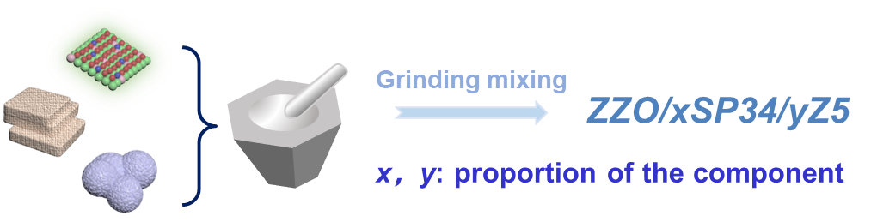
Scheme S1. Schematic diagram of ZZO/xSP34/yZ5 by grinding mixing.

Fig. S1 (a) XRD pattern, (b) SEM image, and (c) NH₃-TPD curve of Z5@S1.

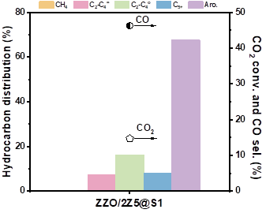
Fig. S2 The catalytic performance over the ZZO/2Z5@S1.

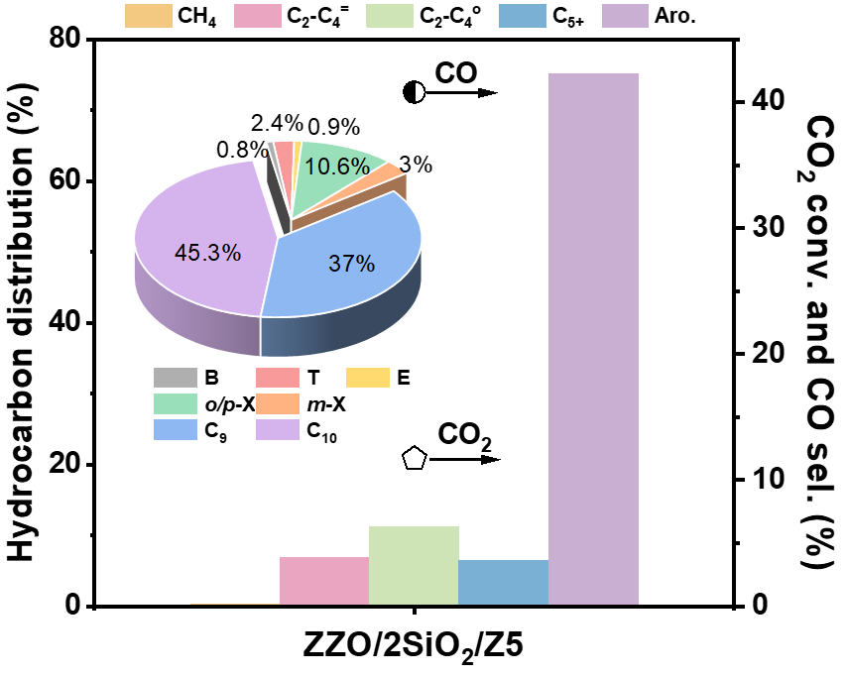
Fig. S3 The catalytic performance and aromatic distribution over the ZZO/2SiO₂/Z5.

Fig. S4 The effect of mixing methods and temperature on the (a, b) catalytic performance and (c, d) aromatic distribution over the ZZO/2SP34/Z5.

Fig. S5 The effect of GHSV and pressure on the (a, b) catalytic performance and (c, d) aromatic distribution over the ZZO/2SP34/Z5.

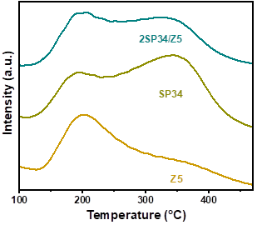
Fig. S6 NH₃-TPD curves of SP34, Z5, and 2SP34/Z5 zeolites.

Fig. S7 (a) H₂-TPR, (b) CO₂-TPD, (c) H₂-TPD, and (d) H₂-D₂ exchange curves of ZZO and zeolites.

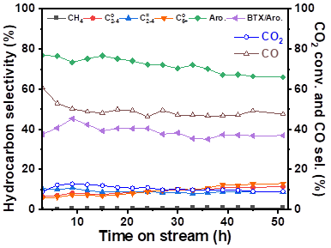
Fig. S8 Stability test of the ZZO/2SP34/Z5 at 320 °C.

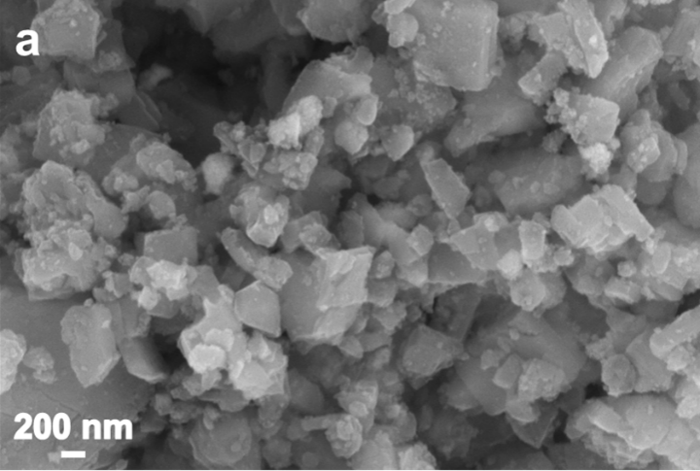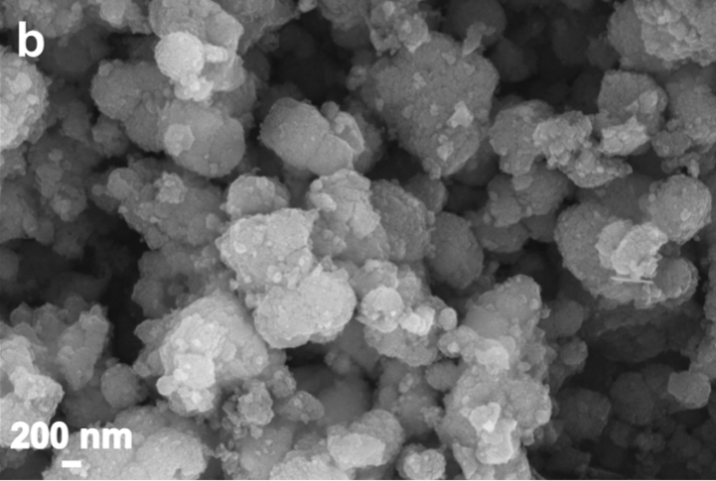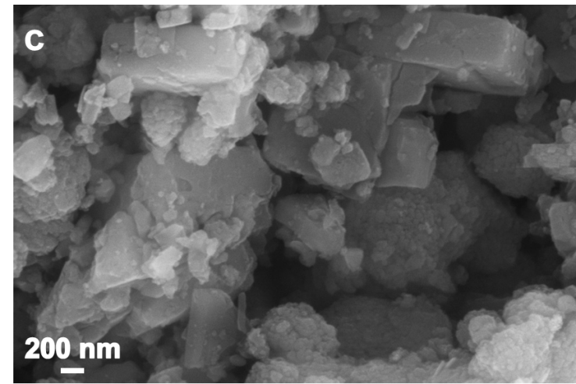
Fig. S9 SEM images of spent catalysts: (a) ZZO/2SP34-spent, (b) ZZO/2Z5-spent, and (c) ZZO/2SP34/Z5-spent.

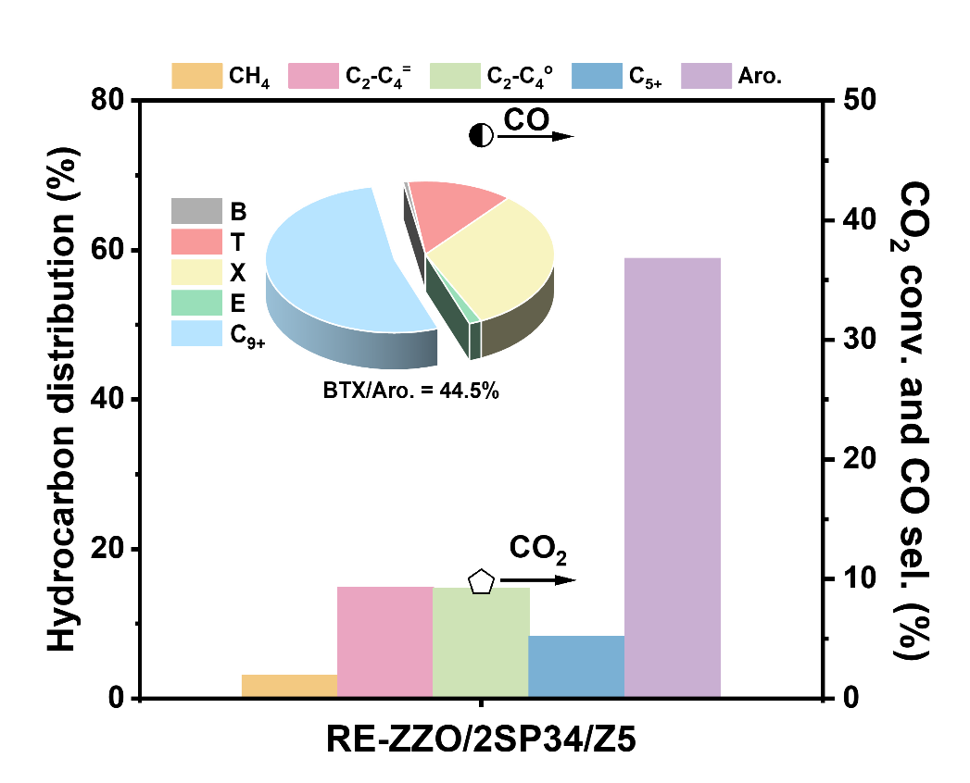
Fig. S10 The catalytic performance in CO₂ hydrogenation of the regenerated ZZO/2SP34/Z5 by calcination at 550 °C for 4 h.

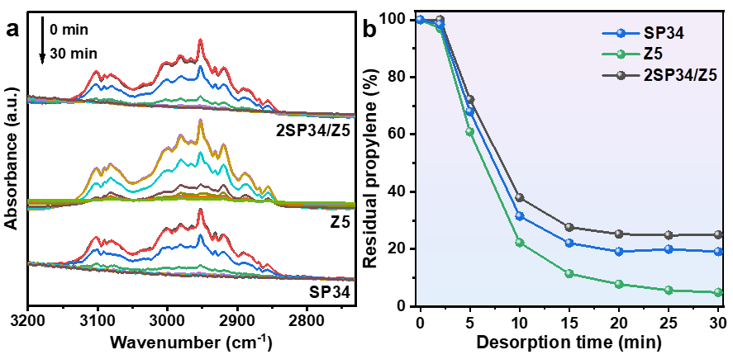
Fig. S11 (a) Propylene-desorption DRIFTS spectra over zeolites at different desorption times; (b) the percentage of the remaining propylene as a function of time according to the intensity of the DRIFTS signal at 2953 cm⁻¹.

Supporting tables

Table S1. Catalytic performance of CO₂ hydrogenation over ZZO/xSP34/yZ5 catalysts under the standard reaction conditions.
Mixing proportion | CO₂ conv.  (%) | CO sel. (%) | Hydrocarbon distribution (%) |  |  |  |  | BTX (%) | BTX/Aro. (%)
Mixing proportion | CO₂ conv.  (%) | CO sel. (%) | CH₄ | C₂⁼–C₄⁼ | C₂⁰–C₄⁰ | C₅₊ | Aro. | BTX (%) | BTX/Aro. (%)
1: 2: 0 | 10.5 | 47.4 | 0.9 | 78.0 | 18.8 | 2.3 | 0.0 | 0.0 | 0.0
1: 0: 0ª | 9.1 | 54.2 | 100 | − | − | − | − | − | −
1: 0: 2 | 11.4 | 67.1 | 0.6 | 5.0 | 13.6 | 5.1 | 75.7 | 9.7 | 12.9
1: 1: 2 | 12.9 | 58.3 | 0.4 | 5.9 | 18.3 | 5.4 | 70.0 | 14.0 | 20.0
1: 1: 1 | 10.4 | 52.4 | 0.5 | 10.1 | 12.5 | 8.6 | 68.2 | 19.5 | 28.6
1: 2: 1 | 12.4 | 48.8 | 0.3 | 7.8 | 9.5 | 7.1 | 75.3 | 31.9 | 42.3
1: 3: 1 | 11.2 | 51.2 | 0.4 | 9.5 | 9.1 | 8.1 | 72.9 | 31.5 | 43.2
Reaction condition: 320 °C, 3.0 MPa, 1200 mL g_{cat}⁻¹ h⁻¹ and H₂/CO₂ = 3.
ª The ZZO mass is based on the oxide mass in ZZO/2Z5.

Table S2. Aromatics distributions over ZZO/xSP34/yZ5 catalysts.
Catalysts | Aromatic selectivity (%)
Catalysts | B | T | E | o/p-X | m-X | C₉ | C₁₀
1: 2: 0 | − | − | − | − | − | − | −
1: 0: 2 | 0.3 | 2.1 | 0.4 | 7.9 | 2.2 | 26.8 | 60.3
1: 1: 2 | 0.5 | 3.2 | 0.5 | 12.2 | 3.5 | 38.3 | 41.7
1: 1: 1 | 0.7 | 4.6 | 1.3 | 17.0 | 5.0 | 45.8 | 25.6
1: 2: 1 | 1.0 | 8.5 | 2.3 | 23.8 | 6.8 | 41.3 | 16.3
1: 3: 1 | 1.0 | 8.4 | 2.6 | 24.2 | 7.0 | 42.2 | 14.6

Table S3. Comparison of reported work on CO₂ to aromatics based on CO₂-MeOH route.
Catalysts | T (°C) | P (MPa) | GHSV (mL·h^{–1}·g^{–1}) | CO₂  Conv. (%) | CO  Sel. (%) |  | Aro.  Sel. (%) |  | BTX  Sel. (%) |  | BTX/Aro. (%) |  | Ref.
ZZO/2SP34/Z5 | 320 | 3.0 | 1200 | 12.4 | 48.8 | 75.3 |  | 31.9 |  | 42.3 |  | This work
ZZO/2SP34/Z5 | 320 | 2.0 | 1200 | 10.8 | 50.3 | 68.3 |  | 35.9 |  | 52.5 |  | This work
ZrO₂-Cr(8:1)/HZSM-5@SiO₂ | 390 | 3.0 | 1200 | 13.9 | 45.1 | 76.8 |  | 39.3 |  | 51.2 |  | [1]
Cr₂O₃/H-ZSM-5 | 350 | 3.0 | 1200 | 34.5 | 11.4 | 75.9 |  | 33.1 |  | 43.6 |  | [2]
Cr₂O₃/Zn-ZSM-5@SiO₂ | 350 | 3.0 | 1200 | 22.1 | 35.1 | 70.1 |  | 27.1 |  | 38.7 |  | [3]
ZnAlO_{x}&H-ZSM-5 | 320 | 3.0 | 2000 | 9.1 | 57.4 | 73.9 |  | 10.4 |  | 14.1 |  | [4]
ae-ZnO-ZrO₂/H-ZSM-5 | 340 | 4.0 | 7200 | 15.9 | 34.0 | 76.0 |  | 23.9 |  | 31.4 |  | [5]
ZnCr₂O₄-ZSM-5 | 350 | 4.0 | 1200 | 23.1 | 27.8 | 85.3 |  | 24.1 |  | 28.3 |  | [6]
ZZ/Z5-0.73 | 315 | 3.0 | 1020 | 17.5 | 23.8 | 60.3 |  | 12.3 |  | 20.4 |  | [7]
ZnCrO_{x}/H-ZSM-5(200) | 330 | 3.0 | 3000 | 17.5 | 38.1 | 64.6 |  | 15.8 |  | 24.4 |  | [8]
ZnZrO_{x}/ZSM-5-300 | 320 | 4.16 | 7200 | ~11.0 | ~38.0 | 44.0 |  | 9.7 |  | 22.0 |  | [9]
10In₂O₃-ZnZrO_{x}/NZ5-DS | 320 | 3.0 | 4000 | 22.4 | 11.0 | 92.1 |  | ~7.3 |  | ~8.0 |  | [10]
InZnZrO_{x}/NZ5 | 320 | 3.0 | 4000 | 13.8 | 19.8 | 90.6 |  | 1.6 |  | 1.8 |  | [11]
ZnZrO/ZSM-5 | 320 | 4.0 | 1200 | 14.0 | 44.0 | 73.0 |  | 8.0 |  | 11.0 |  | [12]
ZnO/ZrO₂-Z5-300 | 340 | 3.0 | 2700 | 9.1 | 42.5 | 70.0 |  | 8.4 |  | 12.0 |  | [13]

Table S4. Catalytic performance of CO₂ hydrogenation over ZZO/2SP34/Z5 catalyst under the different mixing methods.
Mixing methods | CO₂ conv.  (%) | CO sel. (%) | Hydrocarbon distribution (%) |  |  |  |  | BTX (%) | BTX/Aro. (%)
Mixing methods | CO₂ conv.  (%) | CO sel. (%) | CH₄ | C₂⁼–C₄⁼ | C₂⁰–C₄⁰ | C₅₊ | Aro. | BTX (%) | BTX/Aro. (%)
Grinding mixing | 12.4 | 48.8 | 0.3 | 7.8 | 9.5 | 7.1 | 75.3 | 31.9 | 42.3
Powder mixing | 9.3 | 54.5 | 0.5 | 9.1 | 12.6 | 10.5 | 67.3 | 27.1 | 40.2
Particle mixing | 8.4 | 36.6 | 0.9 | 26.5 | 21.6 | 27.0 | 24.0 | 5.0 | 20.8
Multi-bed mixing | 4.7 | 85.8 | 8.6 | 14.3 | 56.3 | 18.3 | 2.6 | 0.8 | 29.8
Reaction condition: 320 °C, 3.0 MPa, 1200 mL g_{cat}⁻¹ h⁻¹ and H₂/CO₂ = 3.

Table S5. Aromatics distributions over ZZO/2SP34/Z5 catalyst at different mixing methods.
Mixing methods | Aromatic selectivity (%)
Mixing methods | B | T | E | o/p-X | m-X | C₉ | C₁₀
Grinding mixing | 1.0 | 8.5 | 2.3 | 23.8 | 6.8 | 41.3 | 16.3
Powder mixing | 1.0 | 8.0 | 2.4 | 22.6 | 6.2 | 43.7 | 16.0
Particle mixing | 0.6 | 2.7 | 1.8 | 12.2 | 3.4 | 39.2 | 40.1
Multi-bed mixing | 3.1 | 11.3 | 1.7 | 11.7 | 2.2 | 22.6 | 47.5

Table S6. Catalytic performance of CO₂ hydrogenation over ZZO/2SP34/Z5 catalyst under different temperatures.
T (ºC) | GHSV (mL g_{cat}⁻¹ h⁻¹) | CO₂ conv.  (%) | CO sel. (%) | Hydrocarbon distribution (%) |  |  |  |  | BTX (%) | BTX/Aro. (%)
 |  |  |  | CH₄ | C₂⁼–C₄⁼ | C₂⁰–C₄⁰ | C₅₊ | Aro. | BTX (%) | BTX/Aro. (%)
310 | 1200 | 9.3 | 48.4 | 0.3 | 7.9 | 8.2 | 4.5 | 79.0 | 30.5 | 38.5
320 | 1200 | 12.4 | 48.8 | 0.3 | 7.8 | 9.5 | 7.1 | 75.3 | 31.9 | 42.3
330 | 1200 | 15.3 | 45.3 | 0.5 | 10.9 | 12.4 | 12.1 | 64.1 | 29.0 | 45.3
340 | 1200 | 16.0 | 46.9 | 0.8 | 14.5 | 15.4 | 18.0 | 51.3 | 24.4 | 47.5
Reaction condition: 3.0 MPa and H₂/CO₂ = 3.

Table S7. Aromatics distributions over ZZO/2SP34/Z5 catalyst at different temperatures.
Temperature (ºC) | Aromatic selectivity (%)
Temperature (ºC) | B | T | E | o/p-X | m-X | C₉ | C₁₀
310 | 0.8 | 7.1 | 2.0 | 22.5 | 6.2 | 44.8 | 16.7
320 | 1.0 | 8.5 | 2.3 | 23.8 | 6.8 | 41.3 | 16.3
330 | 1.2 | 9.5 | 2.7 | 24.7 | 7.2 | 41.4 | 13.3
340 | 1.4 | 10.6 | 2.8 | 25.2 | 7.4 | 40.5 | 12.0

Table S8. Catalytic performance of CO₂ hydrogenation over ZZO/2SP34/Z5 catalyst under different GHSV.
T (ºC) | GHSV (mL g_{cat}⁻¹ h⁻¹) | CO₂ conv.  (%) | CO sel. (%) | Hydrocarbon distribution (%) |  |  |  |  | BTX (%) | BTX/Aro. (%)
 |  |  |  | CH₄ | C₂⁼–C₄⁼ | C₂⁰–C₄⁰ | C₅₊ | Aro. | BTX (%) | BTX/Aro. (%)
320 | 600 | 14.1 | 46.9 | 0.5 | 9.3 | 12.9 | 12.0 | 65.3 | 25.8 | 39.6
320 | 1200 | 12.4 | 48.8 | 0.3 | 7.8 | 9.5 | 7.1 | 75.3 | 31.9 | 42.3
320 | 1800 | 8.7 | 55.0 | 0.4 | 8.5 | 8.7 | 6.1 | 76.4 | 30.7 | 40.1
320 | 2400 | 5.4 | 61.6 | 0.7 | 12.7 | 7.8 | 8.6 | 70.2 | 26.6 | 37.8
Reaction condition: 3.0 MPa and H₂/CO₂ = 3.

Table S9. Aromatics distributions over ZZO/2SP34/Z5 catalyst at different GHSV.
GHSV (mL g_{cat}^{–1} h^{–1}) | Aromatic selectivity (%)
GHSV (mL g_{cat}^{–1} h^{–1}) | B | T | E | o/p-X | m-X | C₉ | C₁₀
600 | 1.0 | 8.0 | 2.2 | 22.1 | 6.2 | 41.4 | 19.0
1200 | 1.0 | 8.5 | 2.3 | 23.8 | 6.8 | 41.3 | 16.3
1800 | 0.9 | 7.5 | 2.2 | 23.0 | 6.5 | 43.8 | 16.1
2400 | 0.8 | 6.6 | 2.1 | 22.2 | 6.1 | 43.4 | 18.8

Table S10. Catalytic performance of CO₂ hydrogenation over ZZO/2SP34/Z5 catalyst under different pressures.
T (ºC) | Pressure (MPa) | CO₂ conv.  (%) | CO sel. (%) | Hydrocarbon distribution (%) |  |  |  |  | BTX (%) | BTX/Aro. (%)
 |  |  |  | CH₄ | C₂⁼–C₄⁼ | C₂⁰–C₄⁰ | C₅₊ | Aro. | BTX (%) | BTX/Aro. (%)
320 | 1 | 5.6 | 48.0 | 0.5 | 25.7 | 7.0 | 7.6 | 59.2 | 27.0 | 45.6
320 | 2 | 10.8 | 50.3 | 0.3 | 11.6 | 10.6 | 9.2 | 68.3 | 35.9 | 52.5
320 | 3 | 12.4 | 48.8 | 0.3 | 7.8 | 9.5 | 7.1 | 75.3 | 31.9 | 42.3
320 | 4 | 12.8 | 48.7 | 0.5 | 8.3 | 11.4 | 10.2 | 69.6 | 26.5 | 38.1
Reaction condition: 1200 mL g_{cat}⁻¹ h⁻¹ and H₂/CO₂ = 3.

Table S11. Aromatics distributions over ZZO/2SP34/Z5 catalyst at different pressures.
Pressure (MPa) | Aromatic selectivity (%)
Pressure (MPa) | B | T | E | o/p-X | m-X | C₉ | C₁₀
1 | 1.2 | 9.4 | 3.11 | 25.2 | 6.7 | 37.7 | 16.6
2 | 1.4 | 11.5 | 3.0 | 28.8 | 7.8 | 38.3 | 9.2
3 | 1.0 | 8.5 | 2.3 | 23.8 | 6.8 | 41.3 | 16.3
4 | 0.9 | 7.2 | 2.2 | 21.8 | 6.1 | 45.2 | 16.7

Table S12. CO₂ adsorption capacity of samples.
Samples | CO₂ adsorption capacity (μmol·g⁻¹)
Samples | Weak adsorption capacity | Strong adsorption capacity | Total adsorption capacity
ZZO | 10.7 | 0.4 | 11.1
SP34 | 0.8 | 0.4 | 1.2
Z5 | 0.2 | 0.3 | 0.5
ZZO/2SP34 | 10.3 | 6.4 | 16.7
ZZO/2Z5 | 12.4 | 3.1 | 15.5
ZZO/2SP34/Z5 | 7.9 | 6.9 | 14.8

Table S13. Methanol conversion performance over Z5 and 2SP34/Z5.
Catalysts | MeOH WHSV  (h^{–1}) | MeOH conv. (%) | Hydrocarbon distribution (%) |  |  |  |  | BTX (%) | BTX/Aro. (%)
Catalysts | MeOH WHSV  (h^{–1}) | MeOH conv. (%) | CH₄ | C₂⁼–C₄⁼ | C₂⁰–C₄⁰ | C₅₊ | Aro. | BTX (%) | BTX/Aro. (%)
Z5ª | 0.06 | 100.0 | 0.4 | 41.6 | 8.4 | 16.2 | 33.4 | 21.3 | 63.7
Z5ª | 0.6 | 99.9 | 0.3 | 37.2 | 9.1 | 29.7 | 23.7 | 12.7 | 53.5
2SP34/Z5ª | 0.06 | 100.0 | 0.4 | 58.0 | 11.9 | 21.7 | 8.1 | 5.1 | 63.4
2SP34/Z5ª | 0.6 | 99.9 | 0.4 | 59.3 | 11.7 | 21.8 | 6.8 | 4.0 | 59.6
2SP34/Z5^{b} | 0.06 | 100.0 | 0.4 | 47.6 | 11.1 | 23.0 | 17.9 | 10.7 | 59.8
2SP34/Z5^{b} | 0.6 | 99.9 | 0.4 | 41.6 | 10.9 | 30.2 | 17.0 | 9.3 | 54.6
Reaction conditions: 320 ºC, 0.1 MPa, Carrier gas (Ar) flow rate =25 mL min^{–1}. Mass of loaded catalyst: ª 0.5 g, ^{b} 1.5 g.

Table S14. Aromatics distributions of methanol conversion over Z5 and 2SP34/Z5.
Catalysts | MeOH WHSV (h^{–1}) | Aromatic selectivity (%)
Catalysts | MeOH WHSV (h^{–1}) | B | T | E | o/p-X | m-X | C₉ | C₁₀
Z5ª | 0.06 | 16.4 | 14.0 | 3.0 | 23.7 | 6.6 | 28.8 | 7.5
Z5ª | 0.6 | 1.2 | 10.2 | 3.1 | 32.0 | 7.0 | 34.5 | 12.0
2SP34/Z5ª | 0.06 | 2.4 | 15.7 | 4.7 | 34.9 | 5.7 | 33.2 | 3.4
2SP34/Z5ª | 0.6 | 1.3 | 10.0 | 4.0 | 39.6 | 4.6 | 34.8 | 5.6
2SP34/Z5^{b} | 0.06 | 1.7 | 14.2 | 4.2 | 32.1 | 7.5 | 31.9 | 8.3
2SP34/Z5^{b} | 0.6 | 1.2 | 10.3 | 3.3 | 33.7 | 6.1 | 33.2 | 12.1
Reaction conditions: 320 ºC, 0.1 MPa, Carrier gas (Ar) flow rate =25 mL min^{–1}. Mass of loaded catalyst: ª 0.5 g, ^{b} 1.5 g.

Table S15. C₂H₄ conversion performance over Z5 and 2SP34/Z5.
Catalysts | C₂H₄ WHSV  (h^{–1}) | C₂H₄ conv. (%) | Hydrocarbon distribution (%) |  |  |  |  | BTX (%) | BTX/Aro. (%)
Catalysts | C₂H₄ WHSV  (h^{–1}) | C₂H₄ conv. (%) | CH₄ | C₂⁼–C₄⁼ | C₂⁰–C₄⁰ | C₅₊ | Aro. | BTX (%) | BTX/Aro. (%)
Z5 | 0.06 | 98.7 | 0.0 | 29.1 | 14.7 | 25.0 | 31.2 | 18.7 | 60.0
Z5 | 0.6 | 90.9 | 0.0 | 38.9 | 12.3 | 33.9 | 14.9 | 7.1 | 47.7
2SP34/Z5 | 0.06 | 91.6 | 0.1 | 31.7 | 17.2 | 27.8 | 23.2 | 11.5 | 49.4
2SP34/Z5 | 0.6 | 27.8 | 0.0 | 50.4 | 14.5 | 32.2 | 2.9 | 1.5 | 51.1
Reaction conditions: 320 ºC, 0.1 MPa, C₂H₄/Ar/N₂ = 2/7/1. Mass of loaded catalyst: 0.5 g.

Table S16. Aromatics distributions of C₂H₄ conversion over Z5 and 2SP34/Z5.
Catalysts | C₂H₄ WHSV (h^{–1}) | Aromatic selectivity (%)
Catalysts | C₂H₄ WHSV (h^{–1}) | B | T | E | o/p-X | m-X | C₉ | C₁₀
Z5 | 0.06 | 2.8 | 21.4 | 7.4 | 22.5 | 5.9 | 29.8 | 10.2
Z5 | 0.6 | 1.6 | 14.3 | 6.1 | 22.4 | 3.3 | 37.3 | 15.0
2SP34/Z5 | 0.06 | 2.2 | 15.2 | 5.2 | 22.6 | 4.2 | 33.6 | 16.9
2SP34/Z5 | 0.6 | 3.4 | 19.8 | 8.3 | 14.4 | 5.2 | 32.0 | 17.0
Reaction conditions: 320 ºC, 0.1 MPa, C₂H₄/Ar/N₂ = 2/7/1. Mass of loaded catalyst: 0.5 g.

Supporting references

1. Zhang L, Gao W, Wang F, et al. Highly selective synthesis of light aromatics from CO₂ by chromium-doped ZrO₂ aerogels in tandem with HZSM-5@SiO₂ catalyst. Applied Catalysis B-Environment and Energy, 2023, 328: 122535
2. Wang Y, Tan L, Tan M, et al. Rationally designing bifunctional catalysts as an efficient strategy to boost CO₂ hydrogenation producing value-added aromatics. ACS Catalysis, 2019, 9(2): 895‒901
3. Wang Y, Gao W, Kazumi S, et al. Direct and oriented conversion of CO₂ into value-added aromatics. Chemistry-A European Journal, 2019, 25(20): 5149‒5153
4. Ni Y M, Chen Z Y, Fu Y, et al. Selective conversion of CO₂ and H₂ into aromatics. Nature Communications, 2018, 9: 3457
5. Zhou C, Shi J, Zhou W, et al. Highly active ZnO-ZrO₂ aerogels integrated with H-ZSM-5 for aromatics synthesis from carbon dioxide. ACS Catalysis, 2020, 10(1): 302‒310
6. Gao W Z, Guo L S, Cui Y, et al. Selective conversion of CO₂ into para-xylene over a ZnCr₂O₄-ZSM-5 catalyst. ChemSusChem 2020, 13(24): 6541‒6545
7. Wang T, Yang C, Gao P, et al. ZnZrO_{x} integrated with chain-like nanocrystal HZSM-5 as efficient catalysts for aromatics synthesis from CO₂ hydrogenation. Applied Catalysis B-Environment and Energy, 2021, 286: 119929
8. Guo S, Fan S, Wang H, et al. Selective conversion of CO₂ to trimethylbenzene and ethene by hydrogenation over a bifunctional ZnCrO_{x}/H-ZSM-5 composite catalyst. ACS Catalysis, 2024, 14(1): 271‒282
9. Nezam I, Zhou W, Shah D R, et al. Role of catalyst domain size in the hydrogenation of CO₂ to aromatics over ZnZrO_{x}/ZSM-5 catalysts. Journal of Physical Chemistry C, 2023, 127(13): 6356‒6370
10. Liu B, Wang Y, Xie Y, et al. yIn₂O₃-ZnZrOx/hierarchical ZSM-5 tandem catalysts for CO₂ hydrogenation to aromatics rich in tetramethylbenzene. ACS Sustainable Chemistry & Engineering, 2023, 11(49): 17340‒17354
11. Xin Q, Guo H, Wang Y, et al. Indium-promoted znZrOx/nano-ZSM-5 for efficient conversion of CO₂ to aromatics with high selectivity. Journal of Environmental Chemical Engineering, 2022, 10(3): 108032
12. Li Z, Qu Y, Wang J, et al. Highly selective conversion of carbon dioxide to aromatics over tandem catalysts. Joule, 2019, 3(2): 570‒583
13. Zhang X, Zhang A, Jiang X, et al. Utilization of CO₂ for aromatics production over ZnO/ZrO₂-ZSM-5 tandem catalyst. Journal of CO2 Utilization, 2019, 29: 140‒145

