Supplementary Material
Realizing fast oxygen redox through flexible Al-O bonds in P2-type layered oxides for sodium battery
Xinyin Cai¹, Nan Wang², Xun-Lu Li³, Haobo Bai¹, Lu Ma⁴, Zulipiya Shadike¹(), Junliang Zhang¹()
1 Institute of Fuel Cells, School of Mechanical Engineering, Shanghai Jiao Tong University, Shanghai 200240, China.
2 Department of Materials Science, Department of Chemistry, Shanghai Key Laboratory of Molecular Catalysis and Innovative Materials, Fudan University, Shanghai 200433, China.
3 Future Battery Research Center, Global Institute of Future Technology, Shanghai Jiao Tong University, Shanghai 200240, China.
4 National Synchrotron Light Source II, Brookhaven National Laboratory, Upton, NY 11973, USA.

Figures and captions
Fig. S1 Analysis of Mn valence in pristine LAM. Mn valence in LAM was calculated to be approximately +3.83, suggesting a mixture of 83% Mn(IV) and 17% Mn(III).
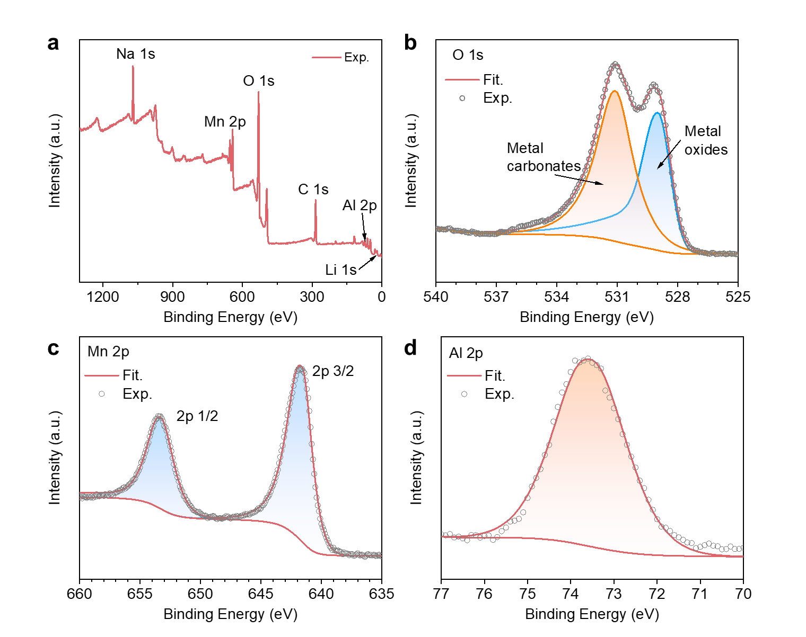
Fig. S2 (a) XPS full-spectrum analysis of prepared LAM. XPS spectra of (b) O 1s, (c) Mn 2p and (d) Al 2p in the prepared LAM.

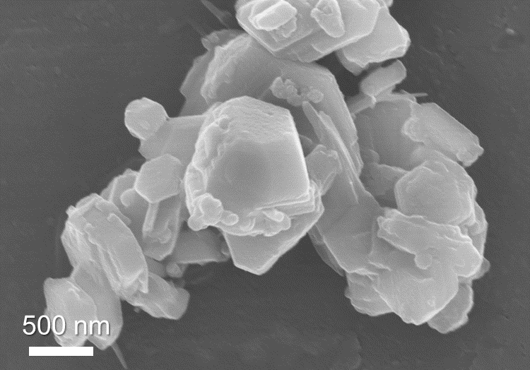
Fig. S3 SEM image of the prepared LAM sample.
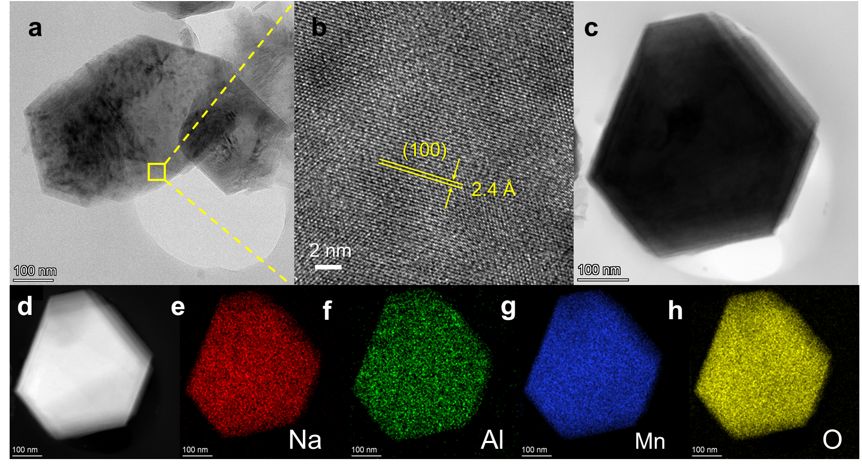
Fig. S4 (a) TEM image, (b) HAADF-STEM image, (c) BF-STEM image, (d) HAADF-STEM image and EDX elemental mappings of (e) Na, (f) Al, (g) Mn, (h) O for LAM cathode material.

Fig. S5 Powder XRD patterns of P2-type LM and the corresponding Rietveld refinement fitting results. The peak around 2θ ≈18 is not the characteristic peak of P2, which can be attributed to the unidentified in-plane ordering scheme between Li and Mn [1].
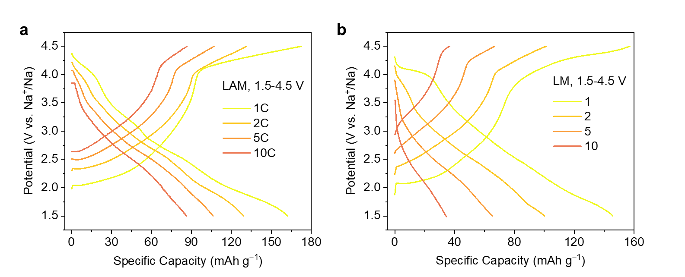
Fig. S6 GCD curves of (a) LAM and (b) LM cathodes at various current densities within 1.5–4.5 V.
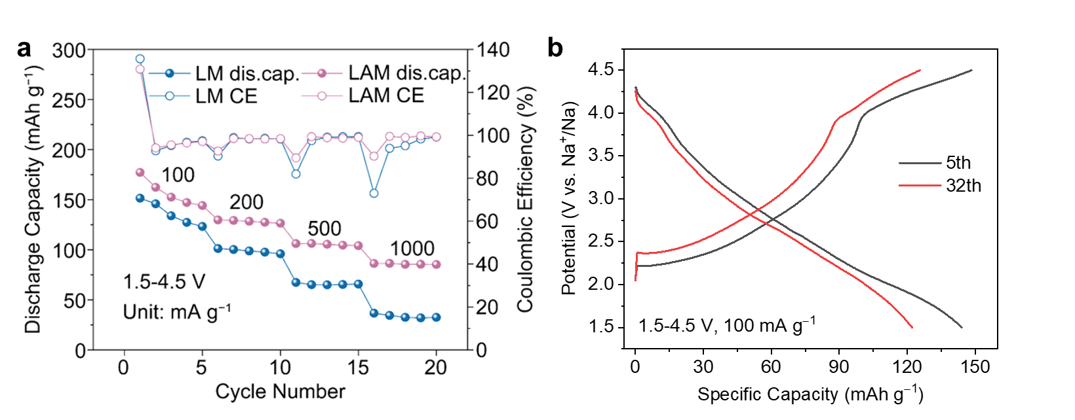
Fig. S7 (a) Rate capabilities of LAM and LM at various current densities from 100 to 1000 mA/g within 1.5–4.5. (b) GCD curves extracted from Fig. 2(d) in 5th and 32ed cycles at the same current density of 100 mA/g.
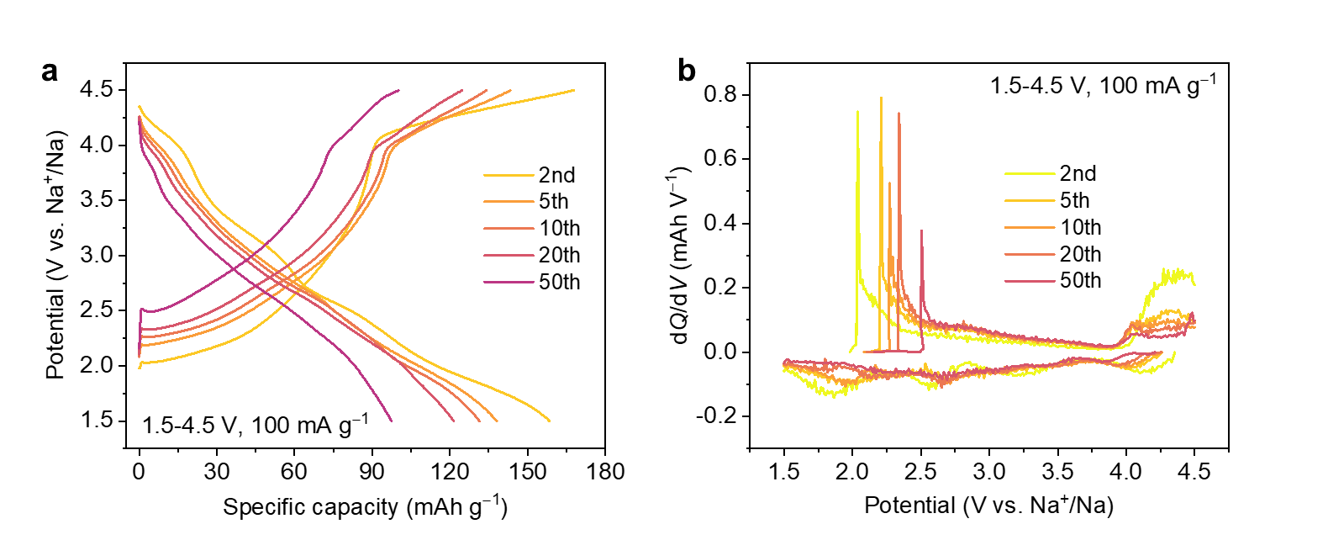
Fig. S8 (a) GCD curves and (b) dQ/dV profiles of LAM cathode upon cycles at the current density of 100 mA/g between 1.5–4.5 V.
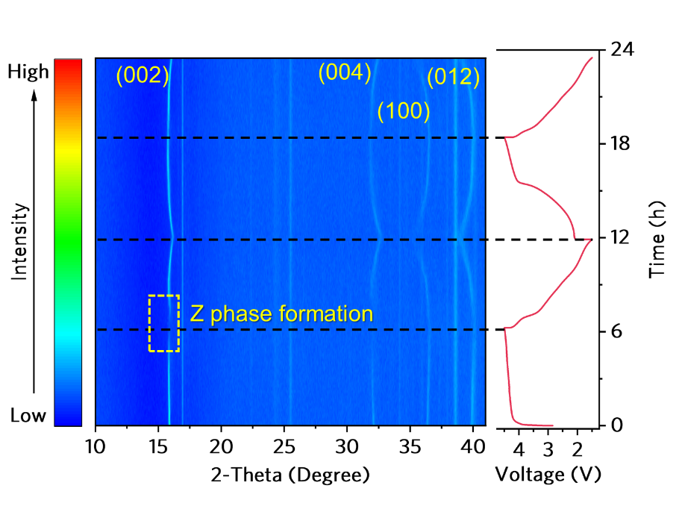
Fig. S9 Two-dimensional contour map of in-situ XRD for LAM cathode at the current density of 30 mA/g.
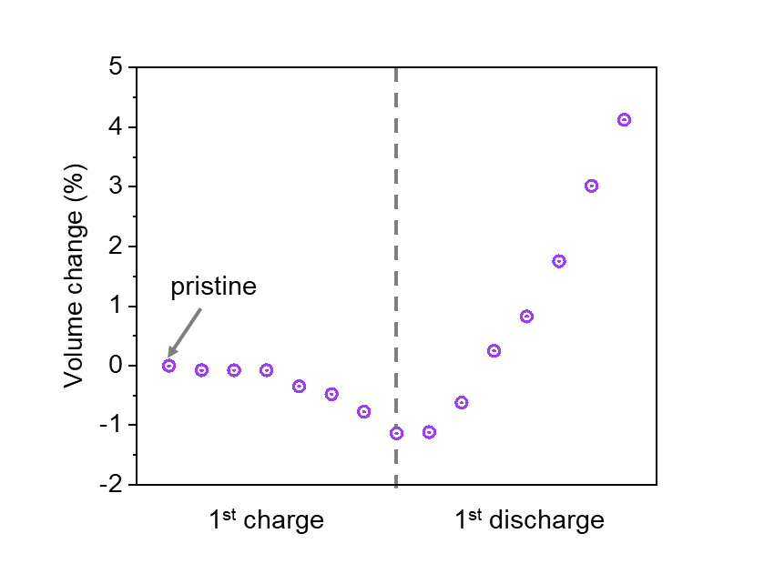
Fig. S10 Volume changes of LAM crystal during the first charge/discharge process.
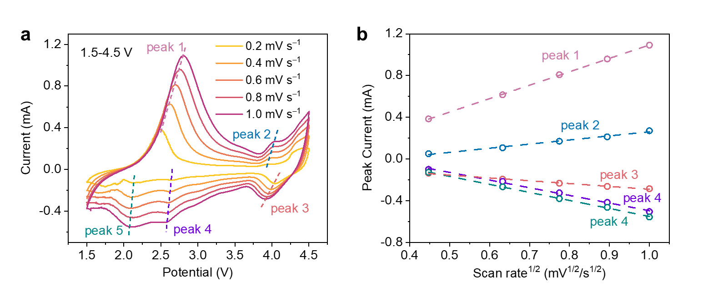
Fig. S11 (a) CV curves of LAM cathode at various scan rates. (b) The plot of peak currents (I_{p}) vs. square root of scan rates (ν^{1/2}) (The minus values of the currents represent the discharge process.)
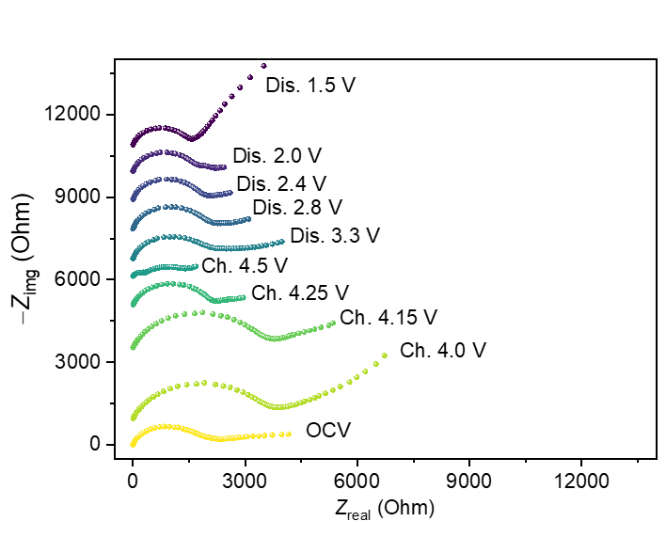
Fig. S12 Nyquist plots of the LAM cathodes based on in-situ EIS tests.

Fig. S13 The Fourier transformed EXAFS spectra extracted from hard XAS spectra of Mn K-edge at different states of charge in LAM.

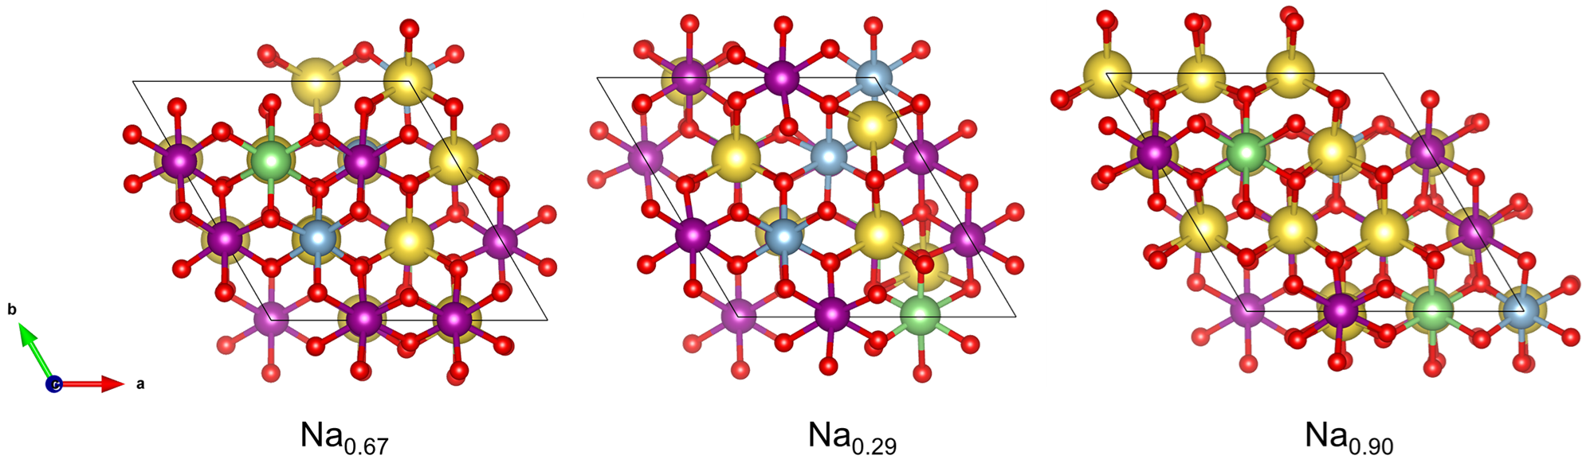
Fig. S14 The structural models of LAM crystal at different states of charge.
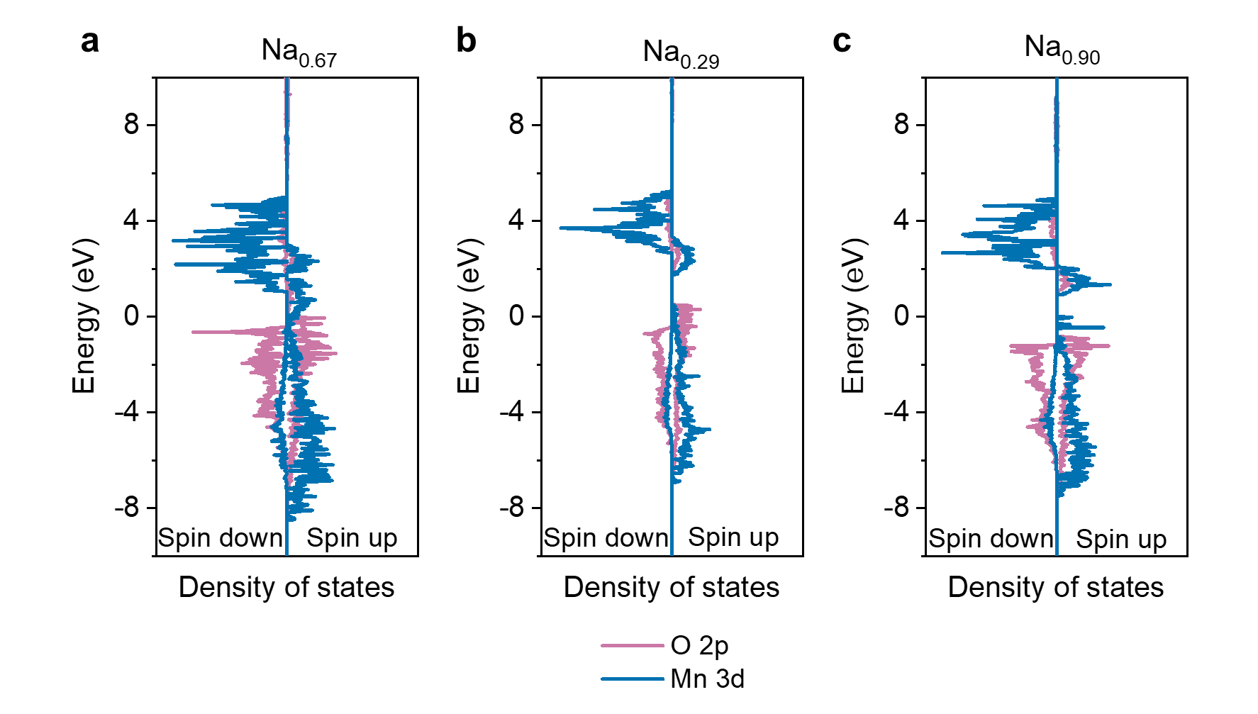
Fig. S15 Partial density of states (pDOS) of (a) pristine, (b) desodiated and (c) sodiated LAM. The energy range used to describe the LHB and UHB was defined as [−3, 3] eV.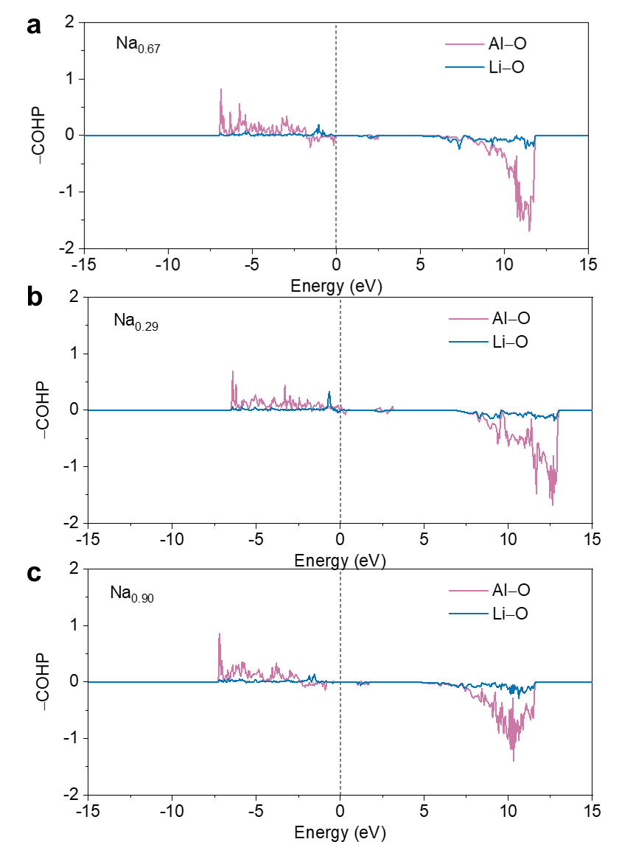
Fig. S16 Projected crystal orbital Hamilton population (pCOHP) profiles of “Al−O(2)−Li” in LAM.
Tables
Table S1 Crystallographic and Rietveld refinement data of the P2-Na_{2/3}Li_{1/6}Al_{1/6}Mn_{2/3}O₂ compound
Space group | P6₃/mmc - hexagonal
Wavelengths | 1.5406 Å
Cell parameters | a = b = 2.86005 Å
Cell parameters | c = 11.16965 Å
Cell parameters | α = β = 90°
Cell parameters | γ = 120°
Cell parameters | V = 79.126 Å³
Reliability factors | R_{wp} = 6.703%
Reliability factors | Gof = 2.84

Table S2 Atomic coordinates, occupancies and anisotropic displacement parameters (Å²) of P2-Na_{2/3}Li_{1/6}Al_{1/6}Mn_{2/3}O₂ compound
 | Mult. | x | y | z | Occupancy | U_{iso}
Na1 | 2 | 0 | 0 | 0.25 | 0.260 | 0.0784
Na2 | 2 | 0.667 | 0.333 | 0.25 | 0.400 | 0.5749
Li6 | 2 | 0 | 0 | 0 | 0.167 | 0.0805
Al5 | 2 | 0 | 0 | 0 | 0.167 | 0.0175
Mn1 | 2 | 0 | 0 | 0 | 0.667 | 0.0012
O1 | 4 | 0.667 | 0.333 | 0.078 | 1 | 0.0485
Table S3 Stoichiometry of P2-Na_{2/3}Li_{1/6}Al_{1/6}Mn_{2/3}O₂ compound determined by inductively coupled plasma atomic emission spectrometry (ICP-AES)
Samples | Li | Mn | Al | Ratio of Li: Mn: Al
Na_{2/3}Li_{1/6}Al_{1/6}Mn_{2/3}O₂ | 0.168 | 0.689 | 0.151 | 1.11 : 4.56 : 1

Table S4 Crystallographic and Rietveld refinement data of the as-prepared P2-Na_{2/3}Li_{2/9}Mn_{7/9}O₂ compound
Space group | P6₃/mmc - hexagonal
Wavelengths | 1.5406 Å
Cell parameters | a = b = 2.86223 Å
Cell parameters | c = 11.08552 Å
Cell parameters | α = β = 90°
Cell parameters | γ = 120°
Cell parameters | V = 78.65 Å³
Reliability factors | R_{wp} = 6.172%
Reliability factors | Gof = 3.21

Table S5 Atomic coordinates, occupancies and anisotropic displacement parameters (Å²) of P2-Na_{2/3}Li_{2/9}Mn_{7/9}O₂ compound
 | Mult. | x | y | z | Occupancy
Na1 | 2 | 0 | 0 | 0.25 | 0.180
Na2 | 2 | 0.667 | 0.333 | 0.25 | 0.470
Li5 | 2 | 0 | 0 | 0 | 0.222
Mn1 | 2 | 0 | 0 | 0 | 0.778
O1 | 4 | 0.667 | 0.333 | 0.082 | 1
References in Supplementary Material
[1] Marie J, Jenkins M, Chen J, et al. Reversible Electron–Holes on O in P2-type Na_{0.67}Li_{0.1}Ni_{0.3}Mn_{0.6}O₂. Advanced Energy Materials 2024, 14, 2401935.

E-mail: zshadike@sjtu.edu.cn; junliang.zhang@sjtu.edu.cn

