Supporting Information

Ultrasmall palladium nanoparticles supported on zirconium phosphate for electrochemical CO₂ reduction to ethanol

Bowen Zhong^{12#}, Chengwei Hu^{2#}, Kaian Sun^{2*}, Wei Yan^{2*}, Jiujun Zhang^{2*}, and Zailai Xie^{1*}

1 College of Chemistry, Fuzhou University, Fuzhou 350108, China.
2 College of Materials Science and Engineering, Fuzhou University, Fuzhou 350108, China

# These authors contributed equally to this work.

Table of Contents
1. Computational method.
2. Supporting Figures.
3. Supporting Tables
4. References

1 Computational method

The Vienna AbInitio Simulation Package was utilized to perform DFT calculations [1]. The modeling of interactions between valence electrons and ion cores involved the use of projector augmented wave based potentials. The electron exchange and correlation energy were investigated with the generalized gradient approximation in the Perdew−Burke−Ernzerhof functional (GGA-PBE) [2]. A kinetic energy cutoff of 500 eV was used for the plane-wave expansion of the electronic wave functions, and the convergence criteria of force and energy were set to 0.01 eV/Å and 10^{–5} eV, respectively. The Brillouin zone was sampled using a Monkhorst-Pack 3 × 3 × 1 k-point grid. To prevent interactions between neighboring surfaces, a large vacuum slab of 15 Å was inserted in the z direction. The long-range dispersion correction was incorporated within the PBE using Grimme's D3 dispersion correction (PBE + D3) [3].

2 Supporting figures
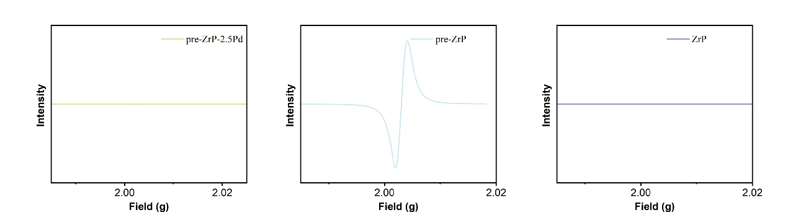
Fig. S1 EPR image of pre- ZrP, ZrP and pre-ZrP-2.5Pd.
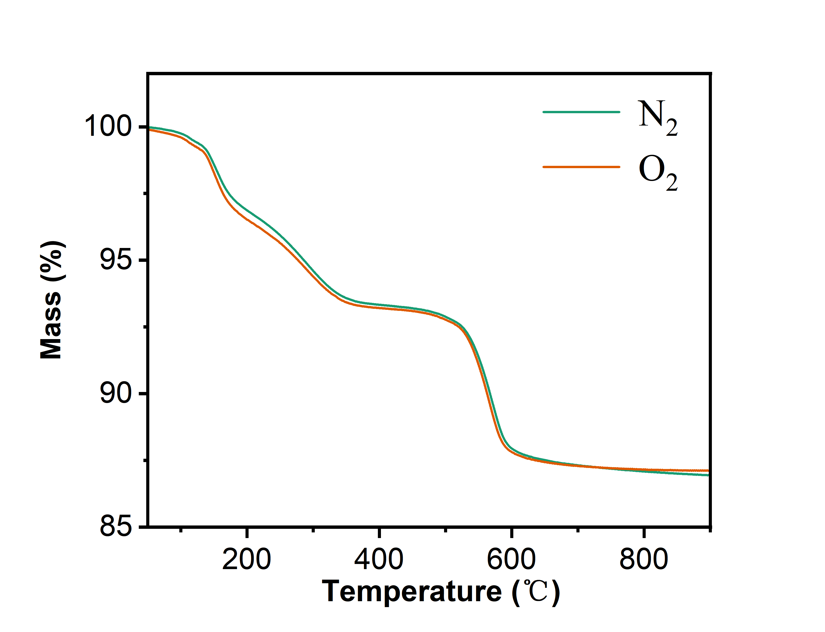
Fig. S2 Thermogravimetric analysis (TGA) curves under nitrogen and oxygen atmospheres of ZrP .
Fig. S3 XRD pattern of ZrP, pre-ZrP-1.5Pd, pre-ZrP-2.5Pd and pre-ZrP.

Fig. S4 Normalized XRD pattern of ZrP and pre-ZrP, the (002) peak intensity normalized to 1.
Fig. S5 XPS image of pre-ZrP-2.5Pd.
Fig. S6 XPS image of ZrP.

Fig. S7 XPS image of pre-ZrP-1.5Pd.
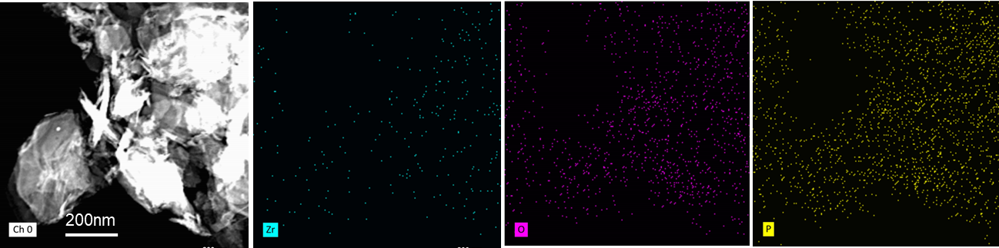
Fig. S8 EDS elemental mapping of pre-ZrP.
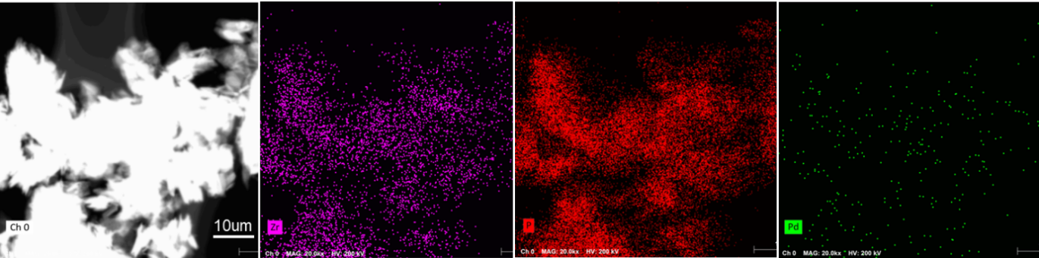
Fig. S9 EDS elemental mapping of pre-ZrP-1.5Pd.

Fig. S10 Figure of pre-ZrP-5Pd's electroreduction performance for CO₂.

Fig. S11 Figure of Pd's electroreduction performance for CO₂.

Fig. S12 Figure of pre-ZrP's electroreduction performance for CO₂.

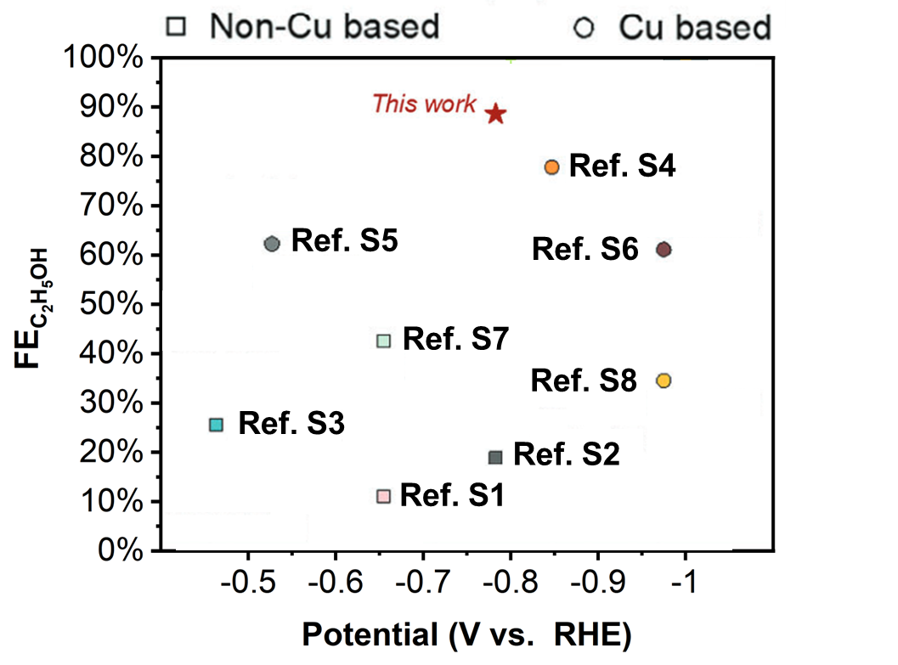
Fig. S13 Schematic diagram comparing the ethanol selectivity of copper-based and non-copper-based catalysts.

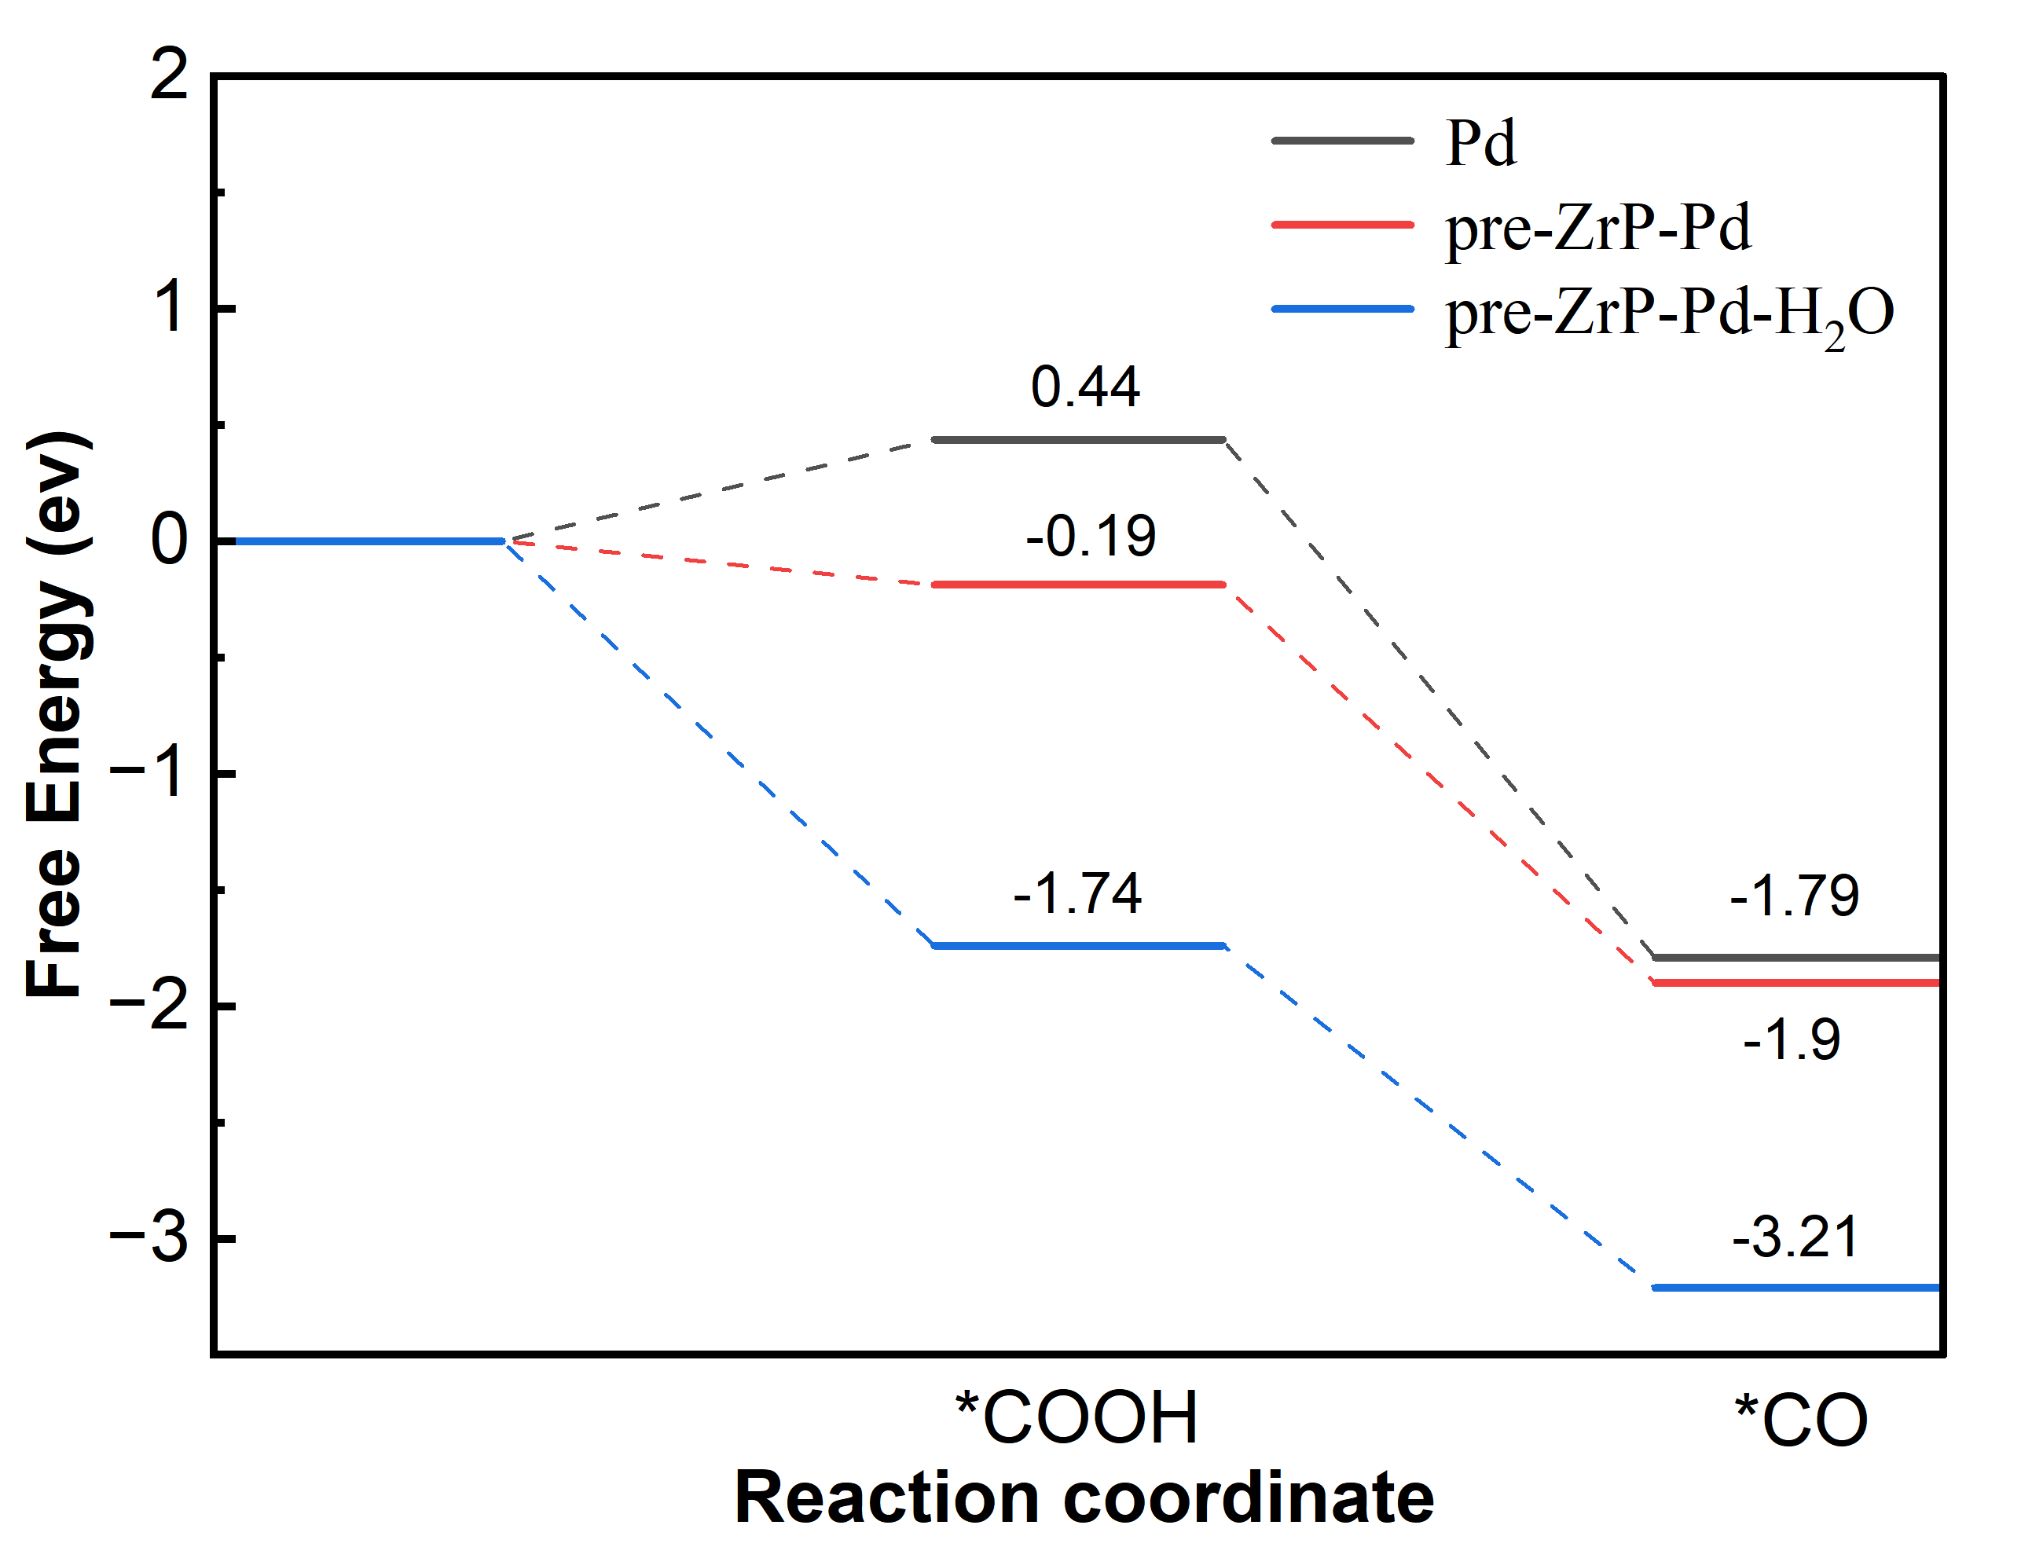
Fig. S14 The Gibbs free energy of CO₂ to *COOH step under water conditions.
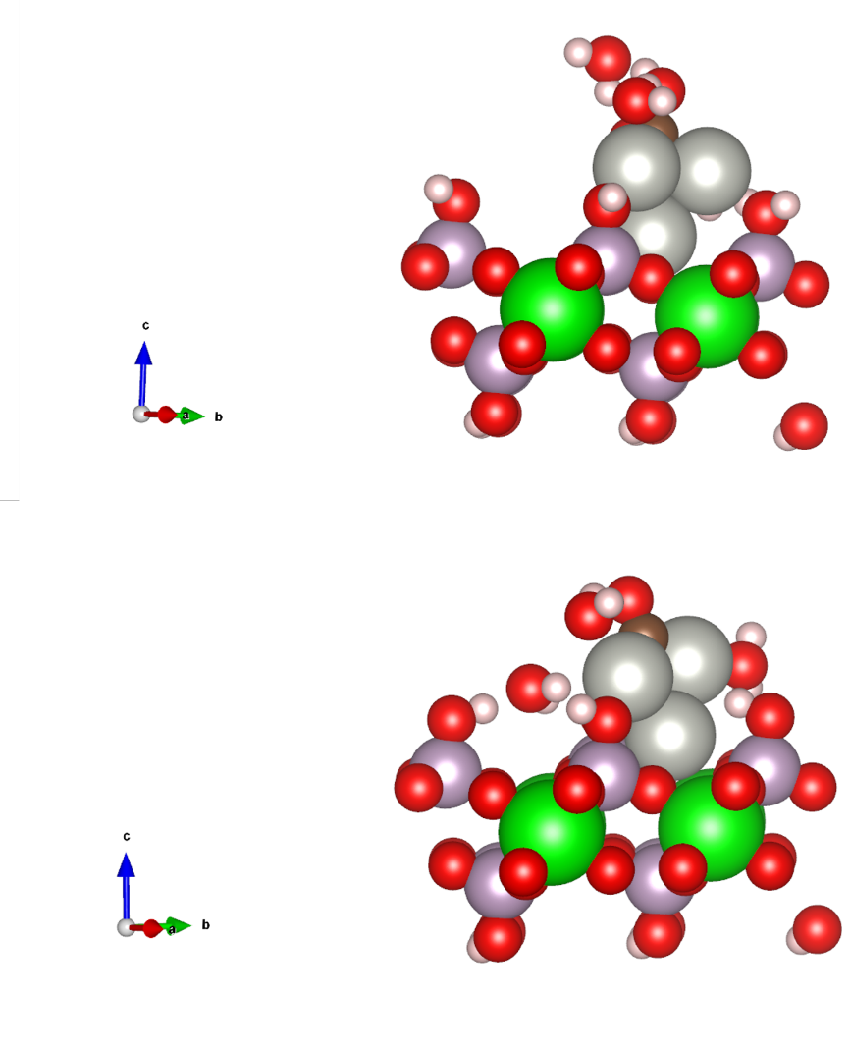
Fig. S15 The charge difference density profile of the adsorbed *CO and *COOH, pink, gray, red, brown, green spheres present P, H, Pd, O, C and Zr atoms, respectively.
Fig. S16 The Gibbs free energy of CO₂ to CO step at the experimental potential (–0.8 V vs. RHE).
3 Supporting tables
Table S1 EXAFS fitting parameters at the Pd K-edge for various samples

Sample | Shell | ªCN | ^{b}R/Å | ^{c}σ² | ^{d}ΔE₀/eV | R factor
Pd foil | Pd-Pd | 12* | 2.75±0.002 | 0.005±0.0004 | -5.94±0.39 | 0.002
pre-ZrP-1.5Pd | Pd-Pd | 4.5 ±0.80 | 2.74±0.02 | 0.005±0.002 | 5.52±0.26 | 0.04
pre-ZrP-2.5Pd | Cu-N | 6.9±0.90 | 2.74±0.05 | 0.005±0.003 | 7.29±0.89 | 0.05
Notes: ªCN, coordination number; ^{b}R, distance between absorber and backscatter atoms; ^{c}σ², Debye-Waller factor to account for both thermal and structural disorders; ^{d}ΔE₀, inner potential correction; R factor indicates the goodness of the fit. S₀² was fixed to 0.75 for Pd, according to the experimental EXAFS fit of Pd foil by fixing CN as the known crystallographic value.

Table S2 DFT total energy (EDFT), Zero -point energy (ZPE), Entropy multiplied by temperature (TΔS) and free energy (G) for both Pd and pre-ZrP-Pd systems
 | Pd-H | Pd-CO | Pd-COOH | Pd-OCHO | ZrP-Pd-H | ZrP-Pd-CO | ZrP-Pd-COOH | ZrP-Pd-OCHO
EDFT | –161.22 | –174.89 | –184.54 | –184.64 | –396.11 | –409.10 | –419.24 | –418.72
ZPE | 0.138047 | 0.193333 | 0.600351 | 0.614888 | 0.189848 | 0.216551 | 0.594232 | 0.610177
TΔS | 0.099389 | 0.112408 | 0.192989 | 0.204097 | 0.009371 | 0.114254 | 0.207876 | 0.221733
G | 0.0327 | –1.791 | 0.4374 | 0.3513 | –0.7668 | –1.9 | –0.1878 | 0.3471

4 References
- Kresse G, Furthmüller J. Efficient iterative schemes for ab initio total-energy calculations using a plane-wave basis set. Phy. Rev. B, 1996, 54:11169–11186.
- Perdew J P, Burke K, Ernzerhof M. Generalized gradient approximation made simple. Phys. Rev. Lett., 1996, 77: 3865–3868.
- Grimme S, Antony J, Ehrlich S, et al. A consistent and accurate ab initio parametrization of density functional dispersion correction (DFT-D) for the 94 elements H-Pu. J. Chem. Phys. 2010, 32:154104
- Yin J, Yin Z, Jin J, et al. A new hexagonal cobalt nanosheet catalyst for selective CO₂ conversion to ethanal. J. Am. Chem. Soc. 2021, 143:15335–15343.
- Zhu W, Liu S, Zhao K, et al. Adv. Funct. Mater. 2024.
- Ji L, Chang L, Zhang Y, et al. Electrocatalytic CO₂ reduction to alcohols with high selectivity over a two-dimensional Fe₂P₂S₆ nanosheet, ACS Catal. 2019, 9: 9721–9725.
- Xu F, Feng B, Shen Z, et al. J. Am. Chem. Soc. 2024.
- Ding L, Zhu N, Hu Y, et al. Over 70 % Faradaic efficiency for CO₂ electroreduction to ethanol enabled by Potassium dopant-tuned interaction between copper sites and intermediates. Angew. Chem. Int. Ed., 2022, 61: e202209268.
- Zhang L, Feng J, Wu L, et al. Oxophilicity-controlled CO₂ electroreduction to C₂₊ alcohols over Lewis acid metal-doped Cu^{δ+} catalysts. Chem. Soc., 2023, 145: 21945–21954.
- Liu X, Hou Y, Yang F, et al. Selective CO₂ electroreduction to ethanol on encapsulated nickel nanoparticles by N-doped carbon nanotubes. Carbon, 2023, 201: 460–466.
- Liu H, Yang C, Bian T, et al. Bottom-up growth of convex sphere with adjustable Cu(0)/Cu(I) interfaces for effective C₂ production from CO₂ electroreduction. Angew. Chem. Int. Ed., 2024, 63: e202404123.

