Supporting Information
Molecular iron phthalocyanines anchoring onto ZIF-67-Derived cobalt-carbon nanomaterials as bifunctional oxygen catalysts
Table of Contents
1. Material Synthesis and Characterization 3
2. Additional SEM and TEM Images 11
3. Additional XPS Data 15
4. Additional Electrochemical and Theoretical Data 17
5. Additional Tables 22
6. References 26

1 Material synthesis and characterization

1.1 Chemicals
All chemicals were employed as received without undergoing any additional purification steps. Cobalt nitrate hexahydrate (Co(NO₃)₂·6H₂O, AR, Aladdin), 2-methylimidazole (2-MI, AR, 99%, Aladdin), methanol (MeOH, 99.5%, Aladdin), iron(II) phthalocyanine (FePc, AR, > 98.0%, Aladdin), N,N-dimethylformamide (DMF, 99%, Aladdin), N,N-dimethylacetamide (DMA, 99%, Aladdin), potassium hydroxide (KOH, AR, 95.0%, Aladdin) zinc acetate dihydrate (Zn(CH₃COO)₂), Pt/C(20 wt%, JM), RuO₂(Alfa-Aesar), 5 wt% Nafion ionomer(Aladdin), distilled water and ethanol (EtOH, moisture content ≤ 0.3% from Aladdin, 99.9% from J&K).

1.2 Synthesis of Co-ZIF
Typically, Co-ZIF crystals were conveniently synthesized using a simple method. Specifically, 2.09 g of Co(NO₃)₂·6H₂O was dissolved in 200 mL MeOH within a breaker to form the A solution. Moreover, 2.63 g 2-MI was dissolved in 200 m L MeOH to constitute the B solution. Then the mixture of the A and B solution was heated at 70 ℃ for 1 hours with continuous stirring. The resulting purple precipitates were collected by centrifugation, rinsed MeOH three times, and subsequently dried at 85 °C overnight.

1.3 Synthesis of CoNC
The as-obtained Co-ZIF were placed in a CVD tube furnace and heated to 950 °C for 2 hours at a heating rate of 10 °C min⁻¹ under a continuous flow of nitrogen. After the thermal treatment, the furnace was allowed to cool naturally to room temperature, resulting in a black powder identified as Co nano-particle on N-doped carbon (CoNC). The yield of CoNC following carbonization at 950 °C from the composite Co-ZIF was determined to be approximately 31.6%.

1.4 Synthesis of CoNC@FePc
After 1 hour of ultrasonication, the CoNC (20 mg) was dispersed in 10 mL of EtOH (Solution A). Simultaneously, 4 mg of FePc was dispersed in 10 mL of DMF through 1 hour of ultrasonication to form Solution B. Solution B was then gradually added to Solution A with continuous stirring. After 3 hours of stirring, the mixture was collected by centrifugation, washed with ethanol, and subsequently dried at 85 °C overnight, yielding CoNC@FePc.

Material characterization
Morphological analysis of the samples was conducted using a Nova NanoSEM 200 scanning electron microscope (FE-SEM, FEI Inc.) and transmission electron microscope (JEOL JEM-2100F). Powder X-ray diffraction (PXRD) patterns of the products were obtained using a Bruker D8 Advance powder diffractometer. The measurements were conducted at room temperature with the instrument operating at 40 kV and 40 mA. Graphite-monochromated Cu Kɑ radiation (λ = 1.54 Å) was utilized, and the scan rate was set at 10° per minute with a step size of 0.025. The Raman spectrometer (Renishaw in Via, England), which used the 532 nm line for excitation, was calibrated based on the silicon peak at 520.7 cm^{–1}. A cumulative time of 10 seconds was set for the measurements, allowing for the acquisition of the corresponding carbon layer signal. N₂ adsorption studies were conducted using the Specific Surface Area & Pore Size Analyzer (BSD-PS1, Beishide Instrument Technology (Beijing) Co., Ltd.) After being activated at 100 ℃, the samples were transferred to a clean ultra-high vacuum system and measurements were taken at a cryogenic temperature of 77 K. Furthermore, X-ray photoelectron spectroscopy (XPS, PHI-5000VPIII) was performed to analyze the elemental valence of the products.

Electrochemical measurements
Electrochemical measurements for the Oxygen Reduction Reaction (ORR) were carried out using a CHI 760E electrochemical workstation (CH Instruments, Inc., Shanghai). This workstation was connected to rotation-control equipment (Pine Instrument Company, USA). The experiments utilized a standard three-electrode system in 0.1 M KOH as the electrolytes. A glassy carbon rotating ring-disk electrode (RRDE) with a diameter of 5.6 mm was used as the working electrode. The catalyst was loaded onto the electrode at a loading of 0.8 mg cm⁻². The electrocatalyst ink was prepared as follows: initially, 5 mg of the synthesized catalyst powder was dispersed in a mixed solution consisting of 300 μL of ethanol (EtOH), 150 μL of water (H₂O), and 50 μL of a 5 wt% Nafion solution. This mixture was then ultrasonicated for 1 hour to form a homogeneous ink.
Subsequently, the electrocatalytic activities of the catalysts toward the ORR were assessed at room temperature. The measured potentials, referenced to the Ag/AgCl electrode, were converted to a Reversible Hydrogen Electrode (RHE) potential using the Nernst equation:
$E_{RHE}=E_{Ag/AgCl}+0.0592×pH+{E^{Θ}}_{Ag/AgCl} ,{E^{Θ}}_{Ag/AgCl}=0.198 V$. (1)
Prior to conducting ORR measurements, a series of cyclic voltammograms (CV) were executed at a scan rate of 100 mV/s, typically for a minimum of 40 cycles. This process was employed to clean and stabilize the electrocatalyst surface. Then the formal CV test was conducted at a rate of 5 mV/s.Subsequently, Linear Scan Voltammetry (LSV) measurements were recorded at a scan rate of 5 mV/s under various rotation rates (100, 400, 900, 1600, and 2500 r/min) for obtaining the polarization curves in N₂-/O₂-saturated 0.1 M KOH solution. The corresponding electron transfer number (n) was determined using Koutechy-Levich (K-L) equation:
$\frac{1}{J}=\frac{1}{J_{L}}+\frac{1}{J_{K}}=\frac{1}{{Bω}^{\frac{1}{2}}}+ \frac{1}{J_{K}},$ (2)
$J_{L}= 0.2 FC_{0}D_{0}^{2/3}v^{-1/6}ω^{1/2}= Bω^{1/2},$ (3)
where J, represents the measured; J_{L}, and J_{k} are diffusion-limiting, and kinetic current density, respectively; ω is the angular velocity of the electrode; n represents the number of electrons; F is the Faraday constant (F = 96485 C/mol⁼); C₀ is the saturated O₂ concentration (1.21×10^{–6} mol/cm³); D₀ is the diffusion coefficient of O₂ in 0.1 M KOH (1.9×10^{–5} cm²/s); ν is the kinetic viscosity (0.01 cm²∙s). The double-layer capacitance (Cdl) of electrocatalyst was derived from CV curves in the non-Faradic potential region with different scan rate from 5 to 120 mV/s. Electrochemical impedance spectroscopy (EIS) measurements were conducted in the frequency range from 10⁶ Hz to 0.01 Hz with a voltage amplitude of 5 mV at 0.7 V vs. RHE. The electrons transferred number (n) and the percentage of peroxide (HO₂– %) were calculated via the following equations, based on the disk current (Id) and ring current (Ir).
$n=\frac{4\left|I_{d}\right|}{\left|I_{d}\right|+I_{r}/N}$. (4)
$HO_{2}^{-}\left(\%\right)= \frac{2I_{r}/N}{\left|I_{d}\right|+I_{r}/N} ×100 \%.$ (5)
Therein, the H₂O₂ collection coefficient (N) at the ring in RRDE experiments is 0.37.
The resistance to methanol solution (3.0 M) was conducted at 0.367 V vs. RHE by chronoamperometry. And the long-term stability of electrocatalyst was investigated by chronoamperometric responses (CA) at a constant potential of 0.367 V vs. RHE with a rotation rate of 1600 r/min and a constant O₂ flow.
For the Oxygen Evolution Reaction, 1.0 M KOH solution was used as the alkaline electrolyte. The LSV measurements were recorded with a scan rate of 5 mV s⁻¹ The overpotential (η) of OER was calculated by η = E_{RHE} – 1.23 V.

Zinc-air battery measurement
The zinc-air battery was tested in a CHI 760E electrochemical workstation (CH Instruments, Shanghai). A polished Zn plate as the anode and a catalyst-coated carbon paper as the cathode were assembled a home-made Zn-air battery, and the electrolyte was set to 6 M KOH and 0.2 M Zn(CH₃COO)₂. To prepare the electrocatalyst ink, 4 mg of catalyst was dispersed in a mixture of 400 μL EtOH and 40 μL Nafion (the mass loading is calculated to be ~ 1.0 mg/cm²). Both the effective electrode are of Zn anode and carbon paper were 1 cm^{–2}. All the Zn-air batteries were assessed under standard ambient conditions. The discharge power density was calculated using the discharge polarization profiles with the following equation:
$P= U_{d}× J_{d},$ (6)
where the P, U_{d}, J_{d} are the discharge power density, discharge voltage, and discharge current density, respectively.

DFT Calculation
The density functional theory was used to carry out all the calculations with the Perdew-Burke-Ernzerh exchange-correlation functional of generalized gradient approximation and the projector-augmented wave method, which was implemented through Vienna Ab-initio Simulation Package (VASP). The input model structure file was created by VESTA.[1] The plane wave-basis expansion cutoff energy was fixed at 450 eV, and atomic relaxation was conducted until the force exerted on atoms was less than 0.02 eV Å⁻¹ and energy was concurrently converged to 1×10^{–5} eV.
The Gibbs free energy change (ΔG) of each lithiation step was defined as:
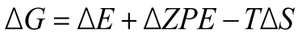, (7)
where ΔE is the electronic energy difference directly obtained from DFT calculations, ΔZPE is the change in zero-point energy, T is the temperature (T= 298.15 K) and ΔS is the change in the entropy, respectively[2]. The zero-point energy and entropy were obtained through vibrational frequencies.
Conventionally, in an alkaline electrolyte, the anode reactions after oxygen adsorption can be written as:
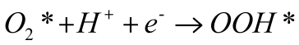 (8)
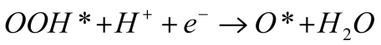 (9)
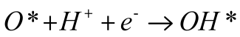 (10)
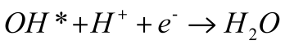 (11)

- Additional SEM and TEM images

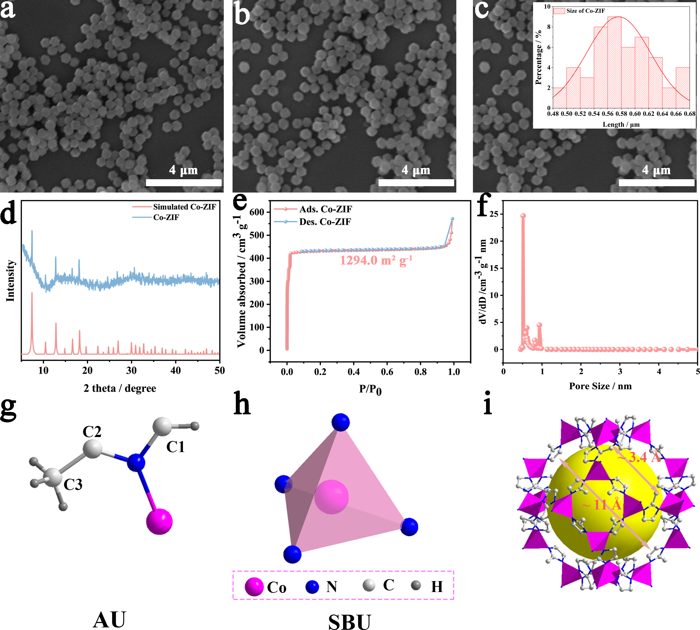
Fig. S1 (a–c) SEM images of Co-ZIF; (d) PXRD patterns of Co-ZIF; (e) N₂ isotherms; (f) pore size distribution of Co-ZIF. Crystal structure and coordination environment of Co-ZIF: (g) AU; (h) SBU and (i) the discrete nanosized cage in Co-ZIF.

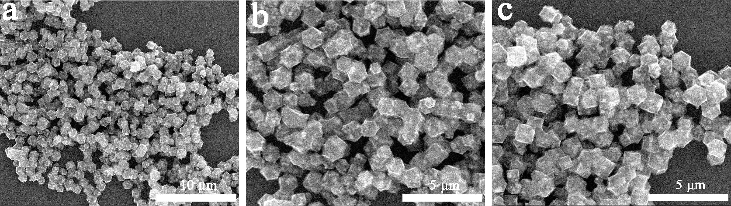
Fig. S2 SEM images of (a-c) CoNC.

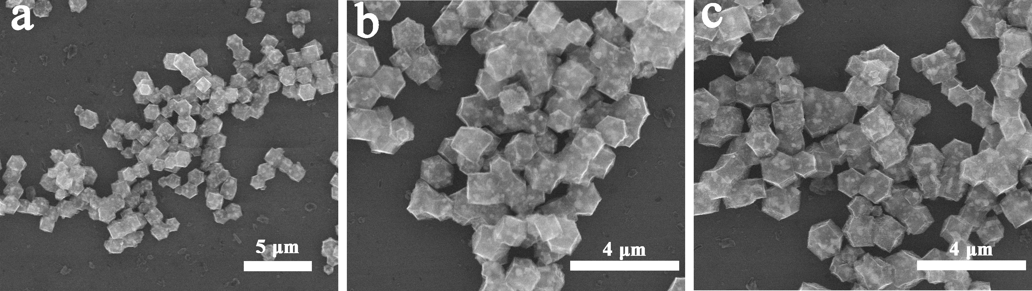
Fig. S3 SEM images of (a‒c) CoNC@FePc.

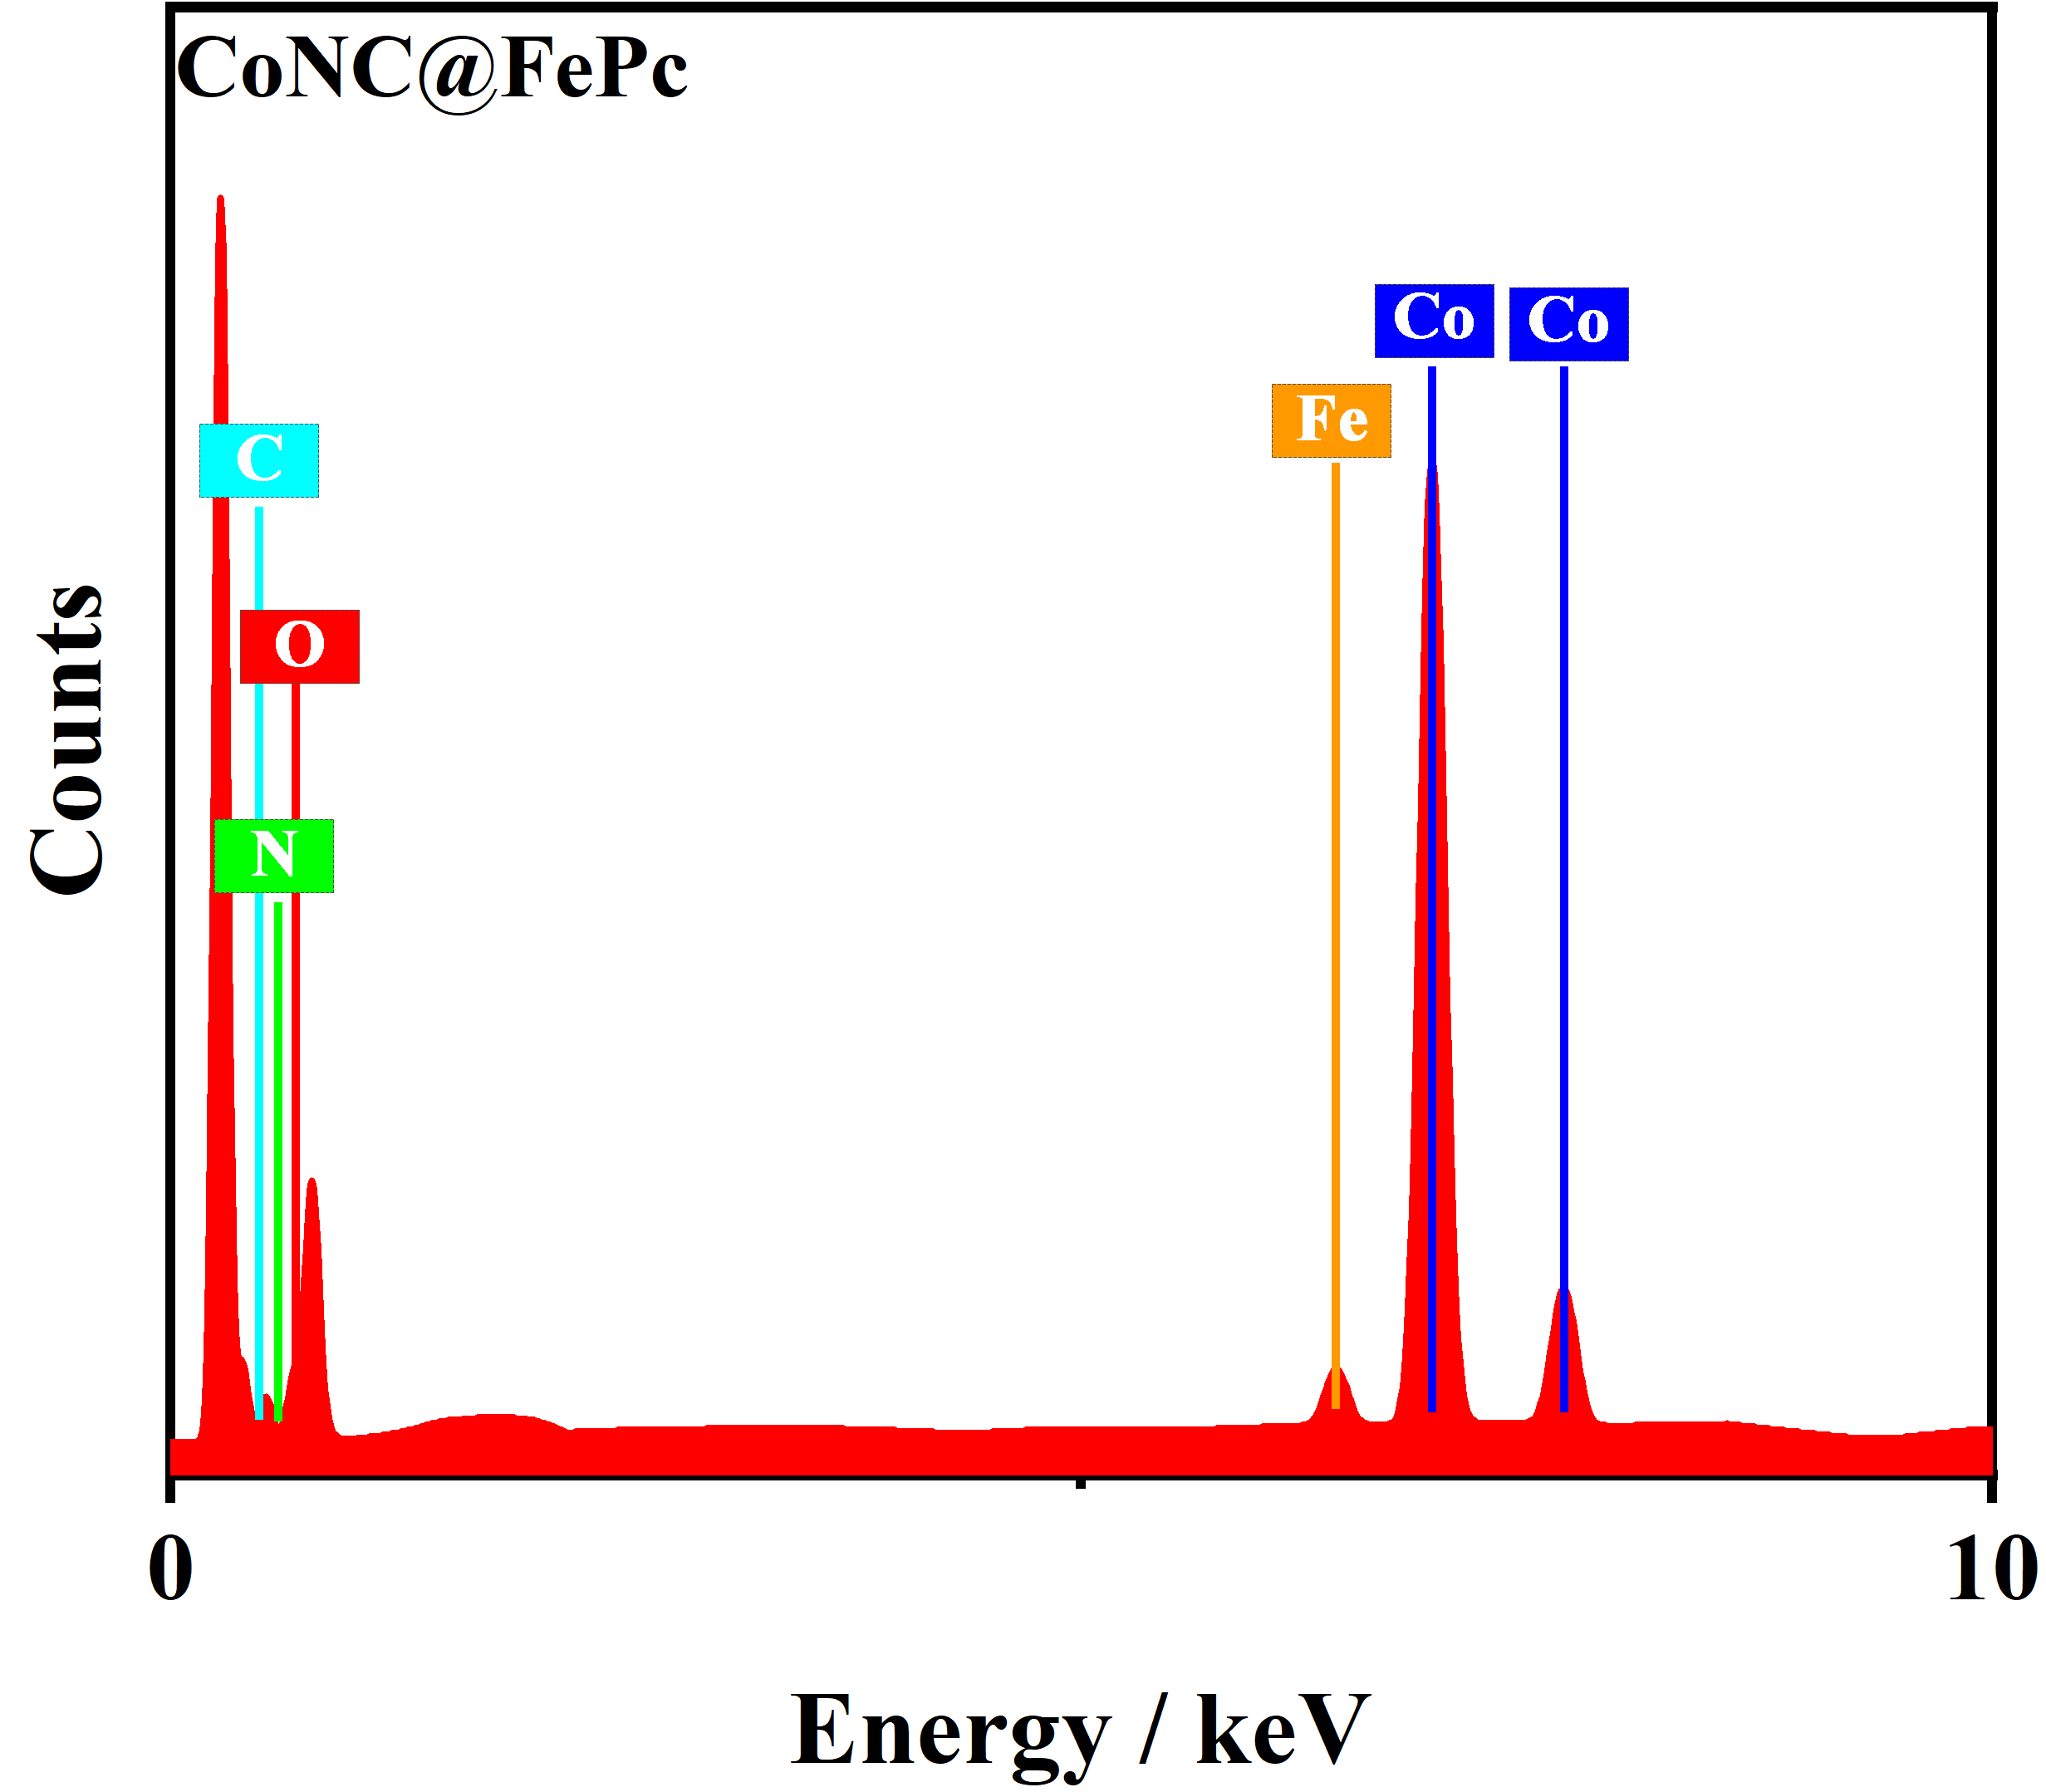
Fig.S4 The EDS pattern of CoNC@FePc.

- Additional XPS data

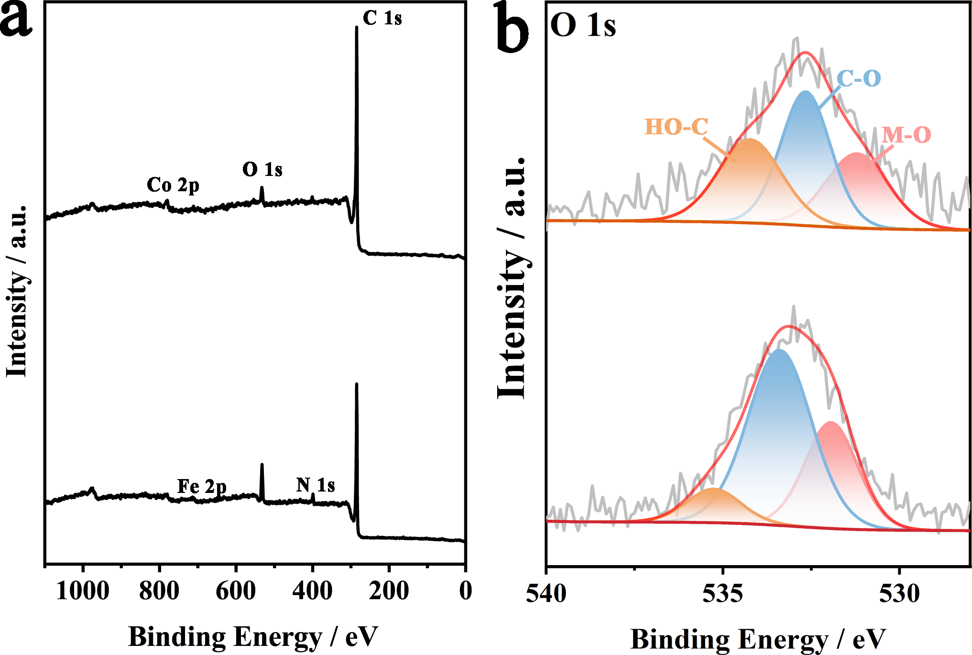
Fig. S5 (a) XPS full-survey spectra; (b) the high-resolution O 1s spectra of CoNC and CoNC@FePc.

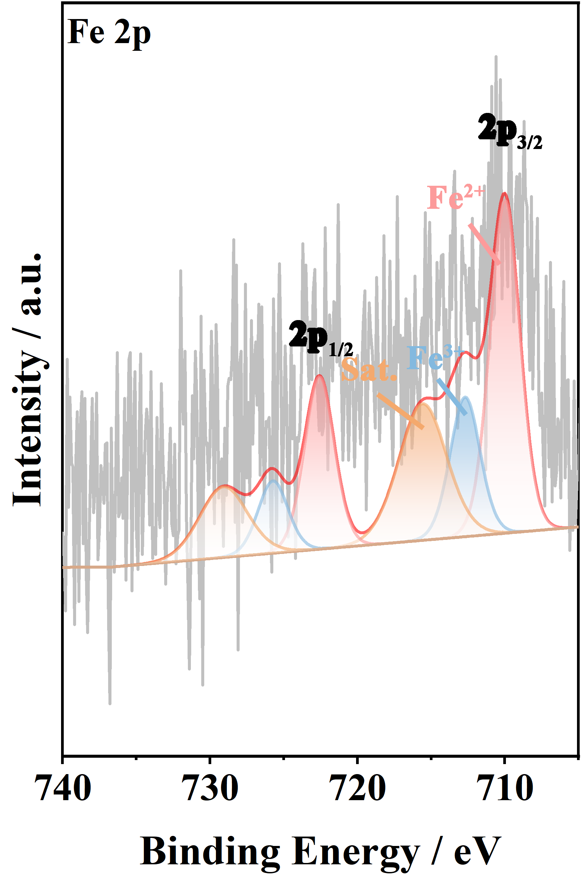
Fig. S6 The deconvoluted Fe 2p spectra of CoNC@FePc.

4 Additional electrochemical and theoretical data
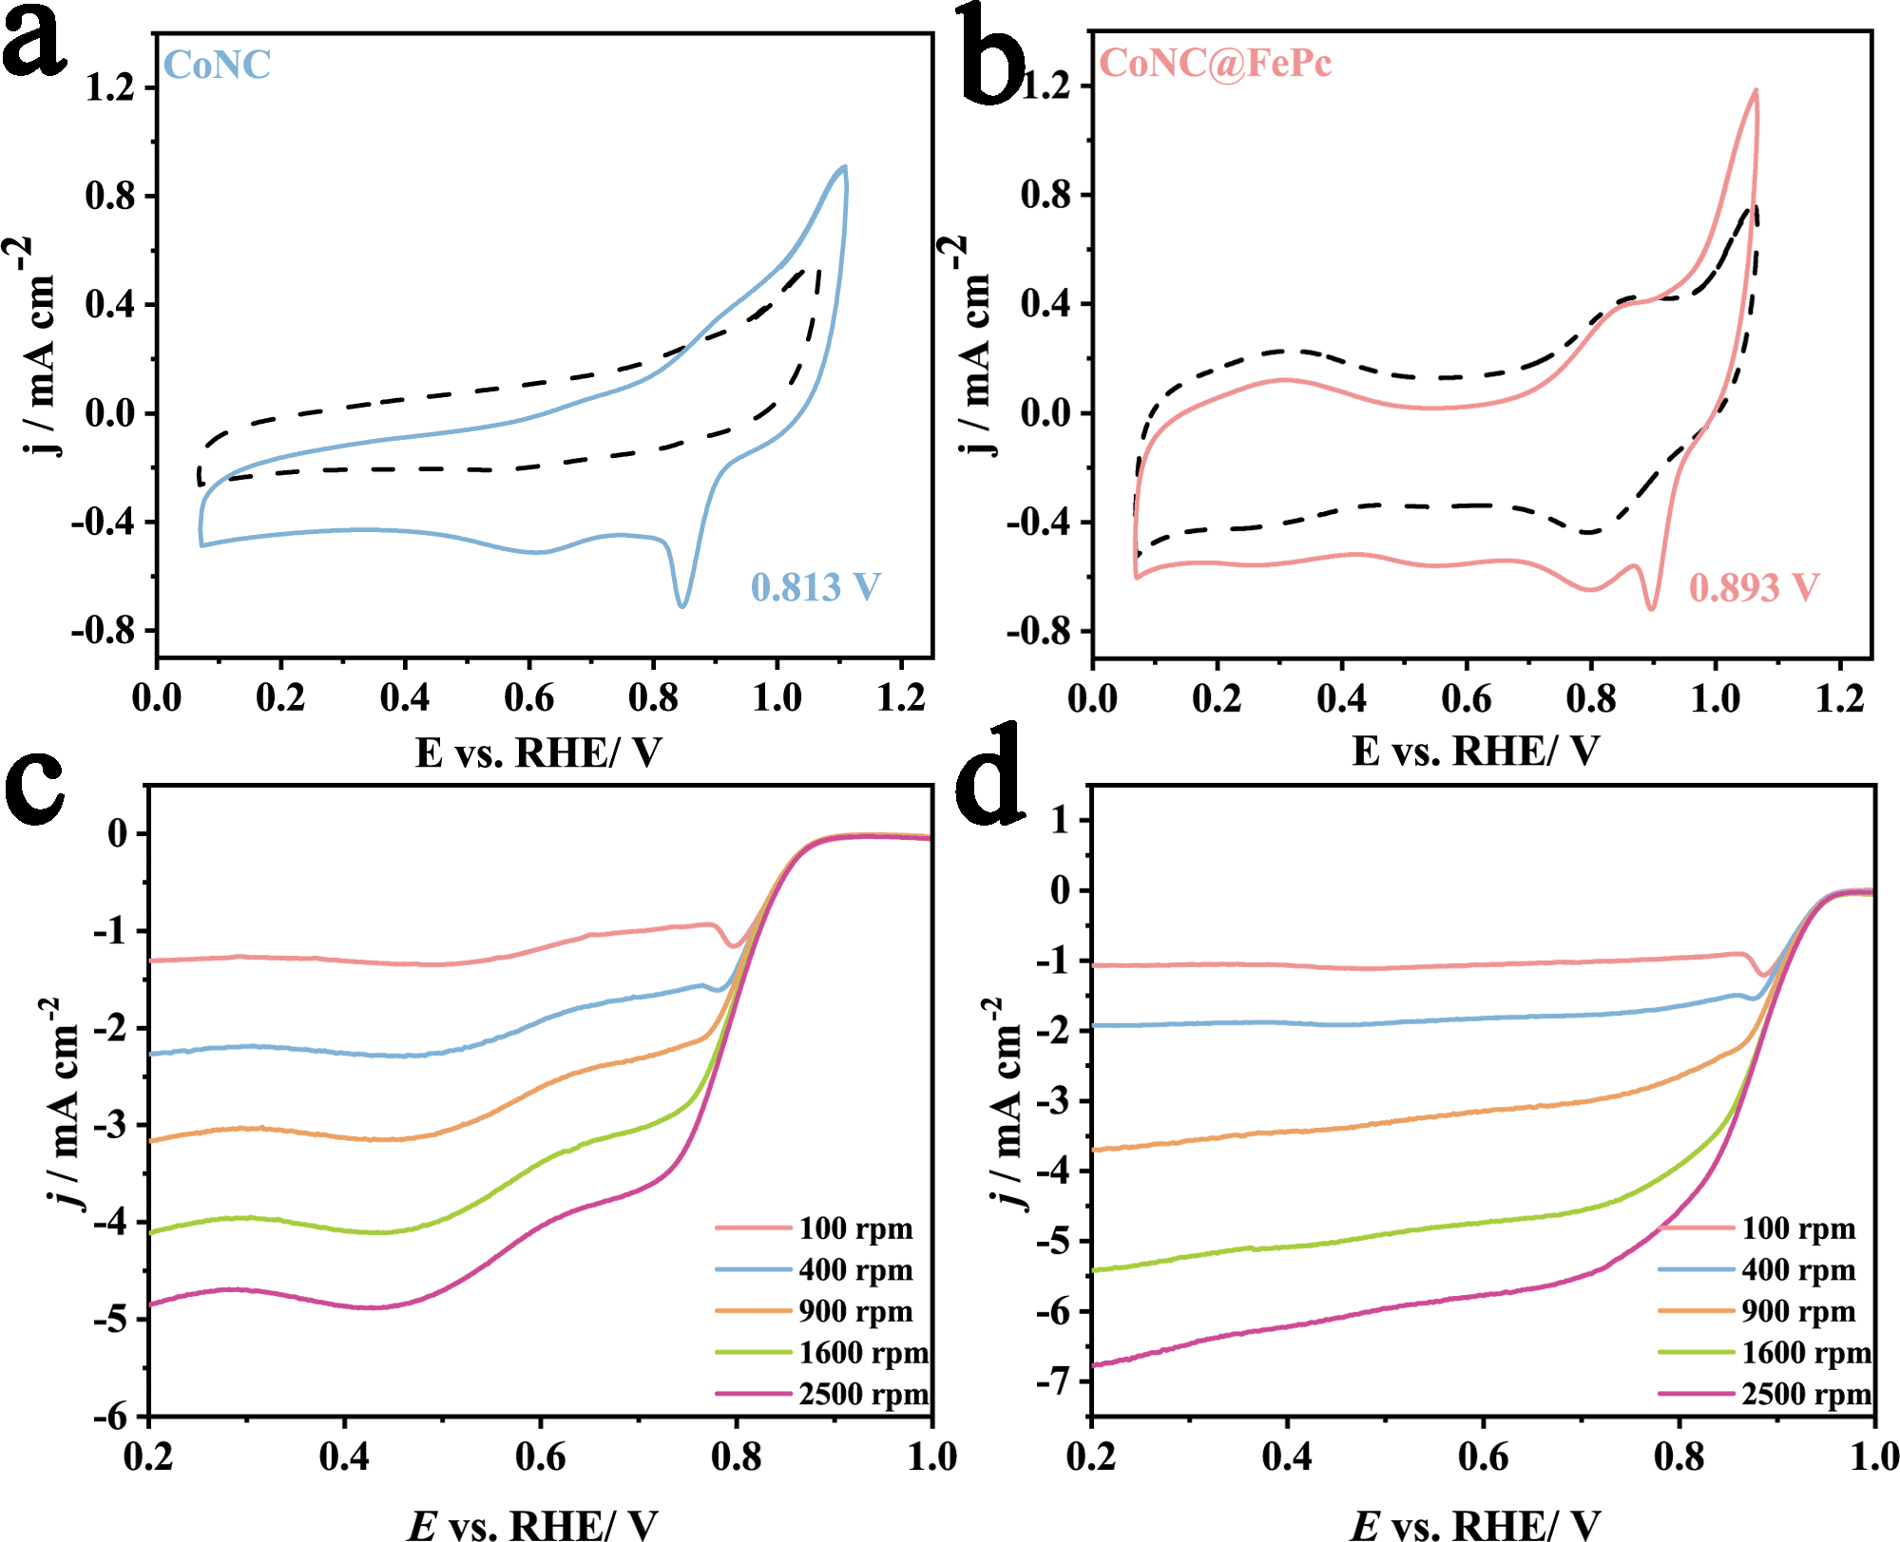
Fig. S7 CV curves for (a) CoNC, and (b) CoNC@FePc in N₂-/O₂-saturated 0.1 M KOH at 5 mV/s; LSV curves at various rotating speeds from 100 to 2500 r/min: (c) CoNC, and (d) CoNC@FePc.

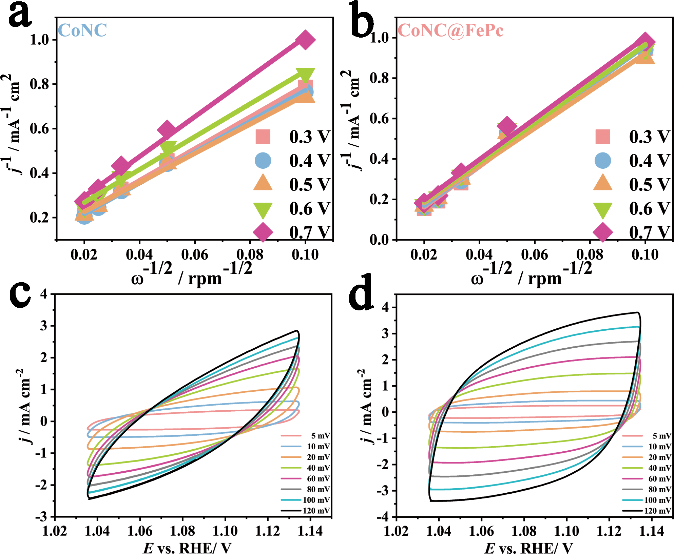
Fig. S8 K-L plots at various potentials from 0.3–0.7 V for (a) CoNC, and (b) CoNC@FePc; CV curves at different sweep speeds from 5 to 120 mV/s: (c) CoNC, and (d) CoNC@FePc.

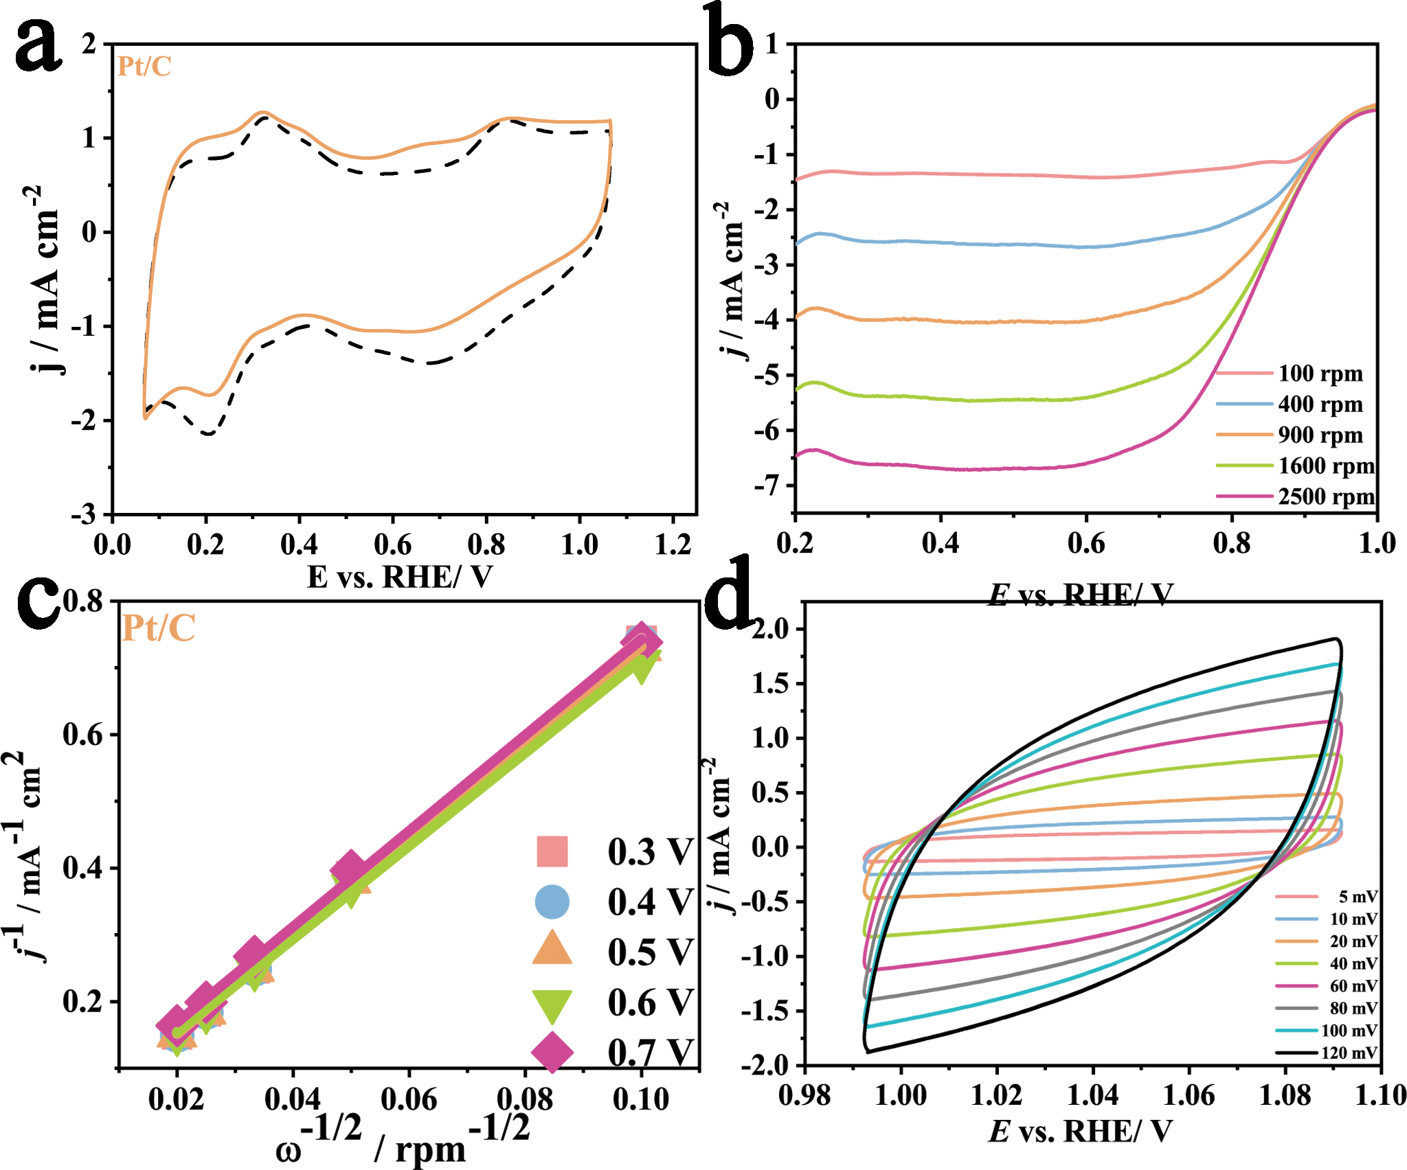
Fig. S9 Supplementary electrochemical data of Pt/C. (a) CV curve, (b) LSV curve, (c) K-L plots and (d) CV curve at different sweep speeds from 5 to 120 mV/s.

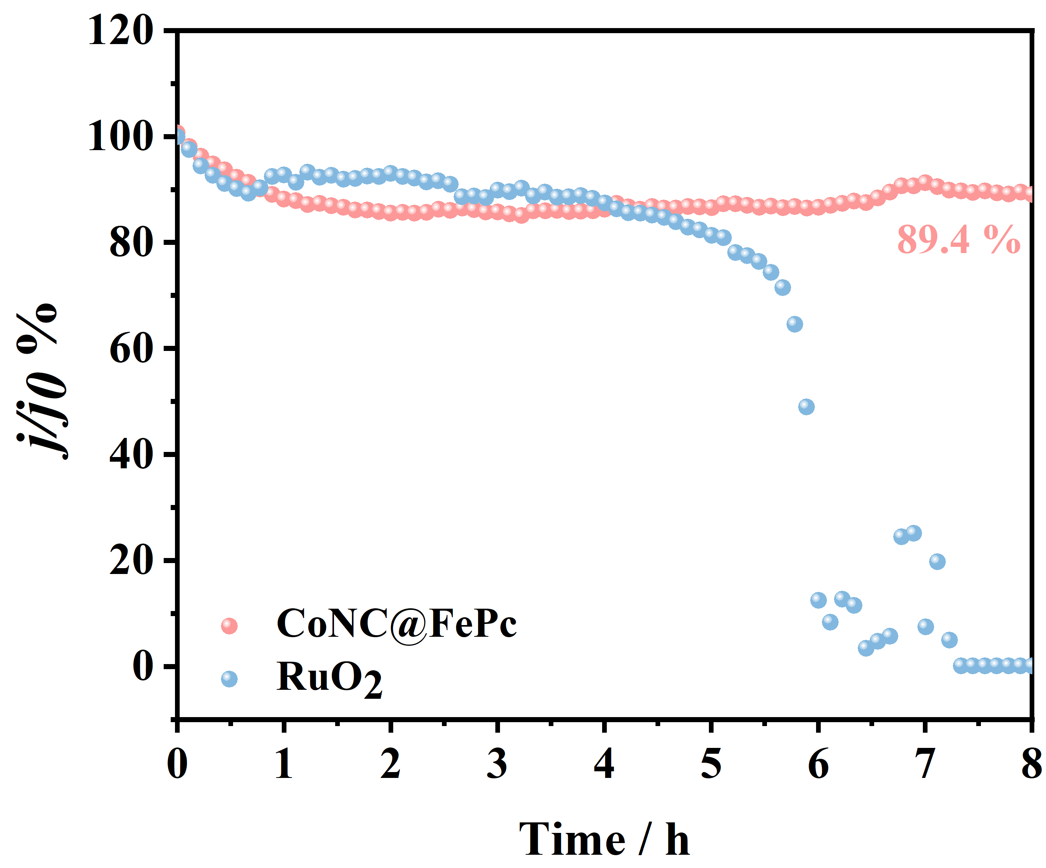
Fig. S10 The current density retention after long-term durability of OER test.

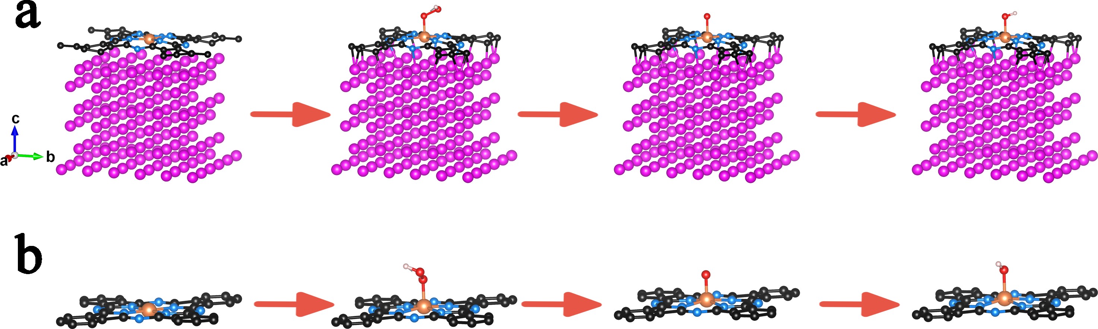
Fig. S11 Top view and side view of the optimized configurations of oxygen intermediates (OOH*, O*, and OH*) adsorbed on (a) Co@FePc and (b) FePc.

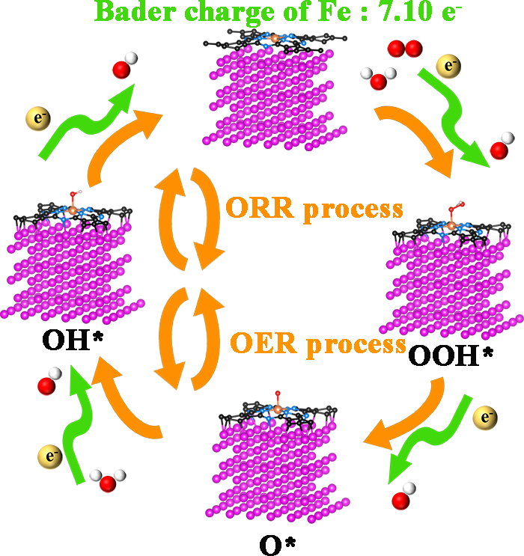
Fig. S12 ORR/OER mechanisms for CoNC@FePc.

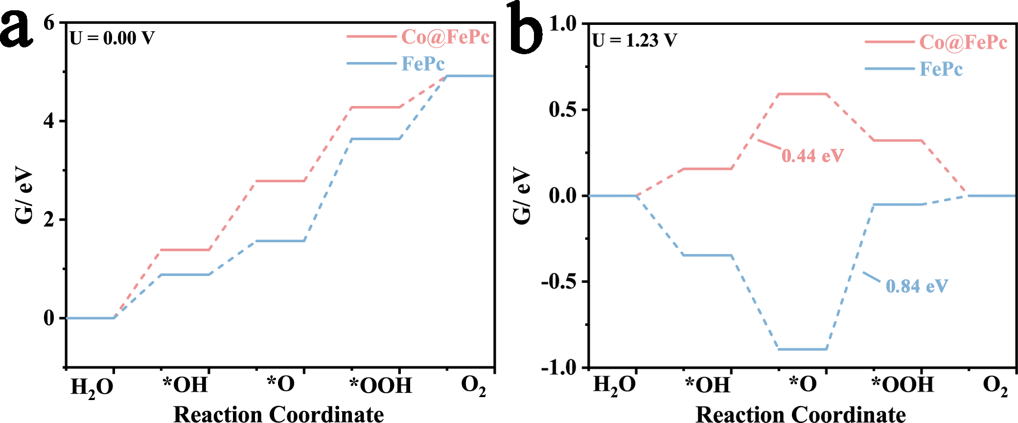
Fig. S13 OER free energy diagrams at (a) 0.00 V and (b) 1.23 V.

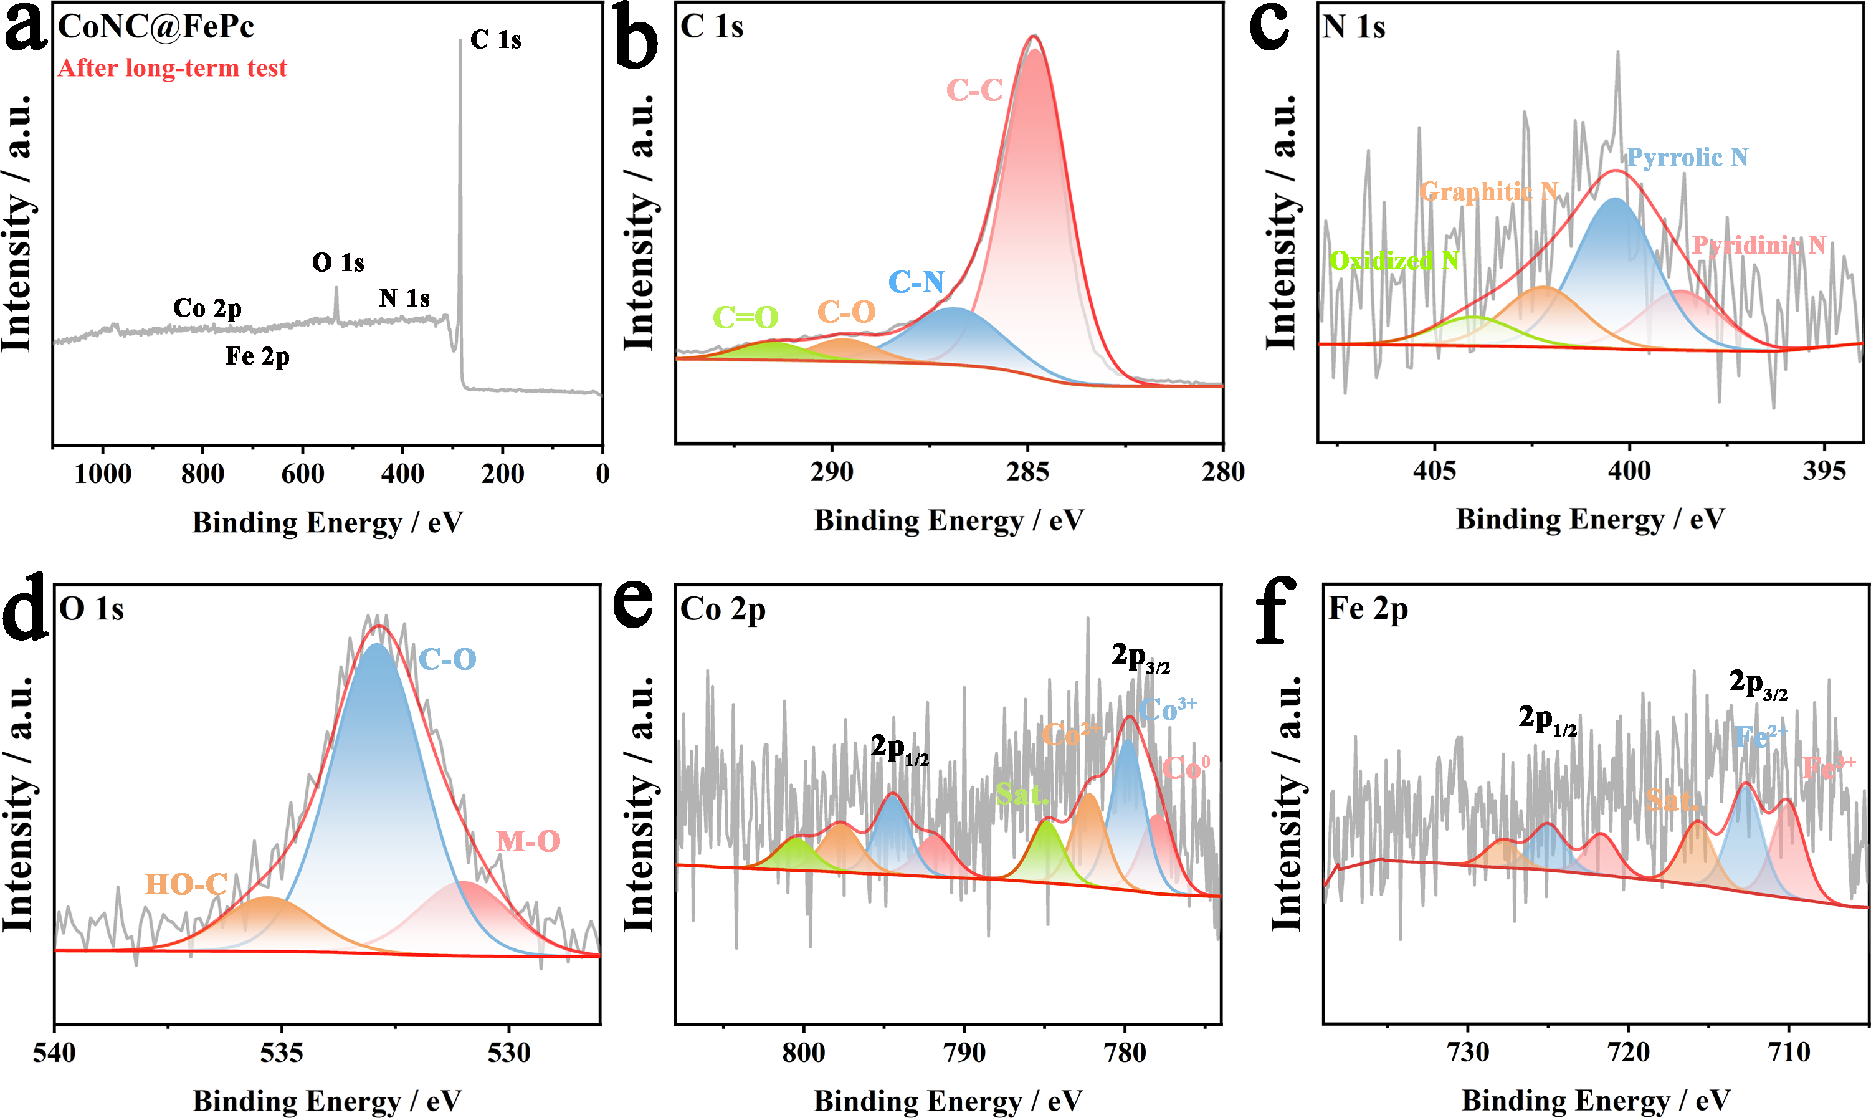
Fig. S14 After long-term test. (a) XPS full-survey spectrum, the deconvoluted XPS spectra of (b) C 1s, (c) N 1s, (d) O 1s, (e) Co 2p and (f) Fe 2p.

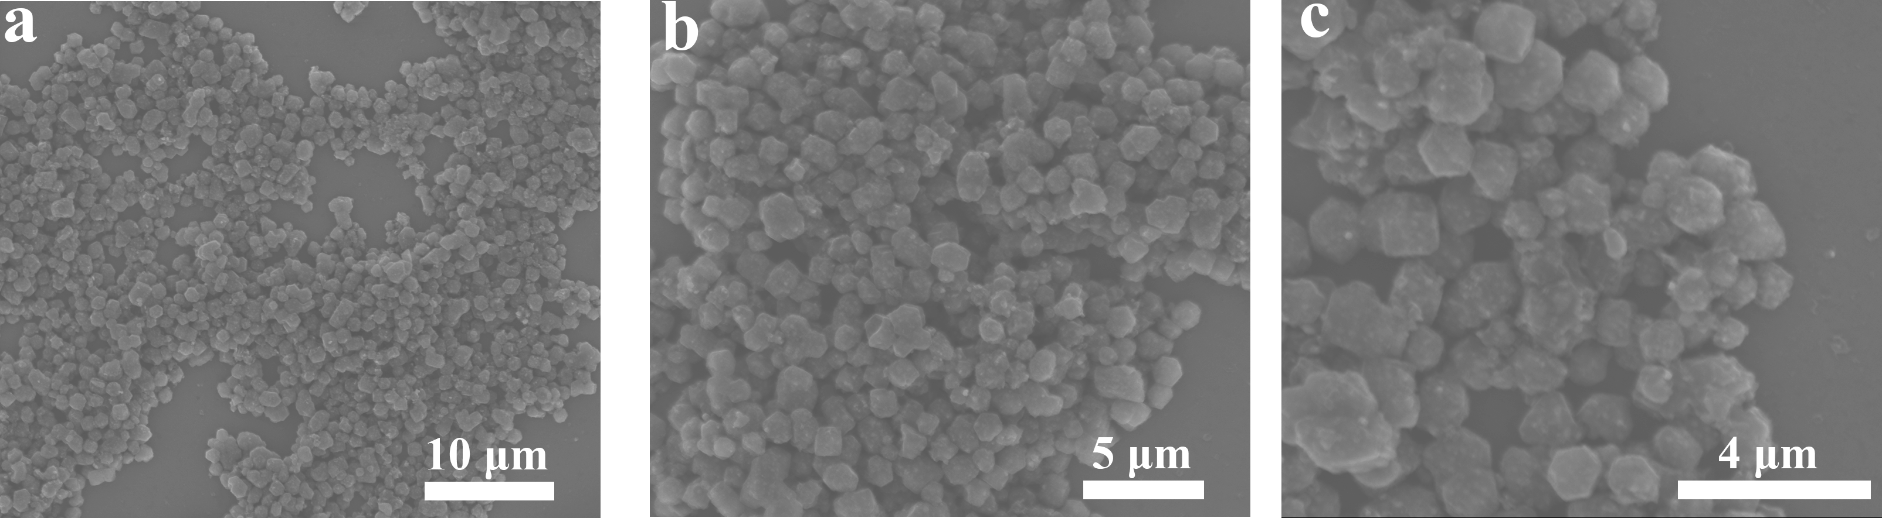Fig. S15 SEM images of (a-c) CoNC@FePc after the long-term durability test.

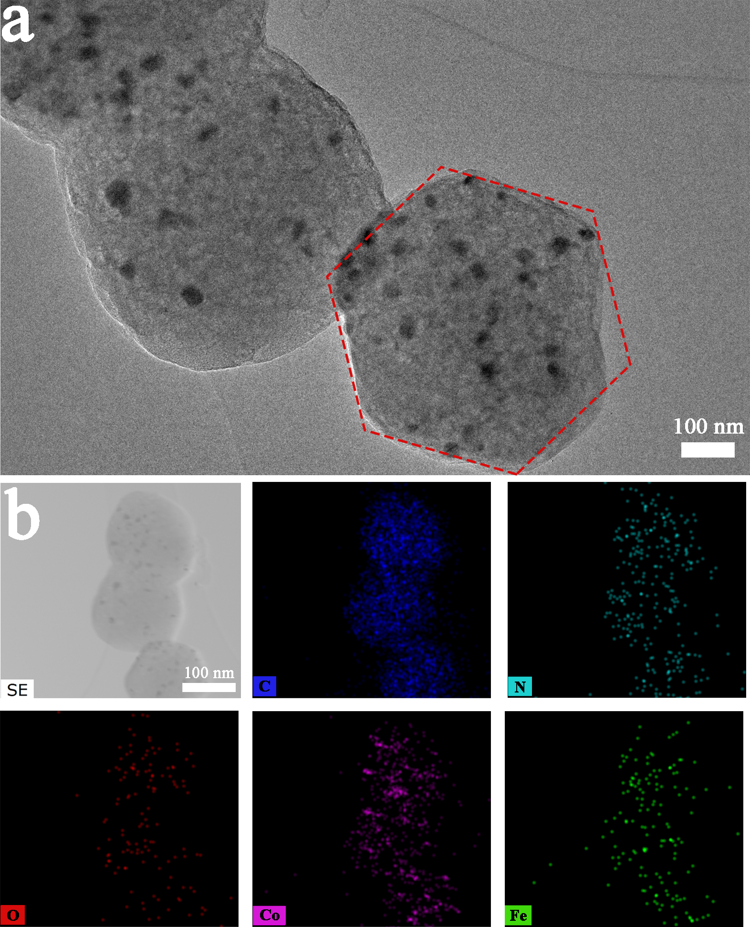
Fig. S16 (a) TEM image and (b) EDS mapping images of CoNC@FePc after long-term test.

5Additional tables
Table S1 The BET surface area and total pore volume of the samples
Sample | BET surface area/(m²∙g^{–1}) | Total pore volume/(cm³∙g^{–1})
CoNC | 106.2 | 0.20
CoNC@FePc | 34.2 | 0.11

Table S2 N dopant proportions of these carbon materials measured from fitting of the N 1s XPS
Samples | Relative content of different N species / 100%
Samples | Pyridinic-N | Pyrrolic-N | Graphitic-N | Oxidized-N
CoNC | 37.7 | 29.9 | 12.2 | 20.2
CoNC@FePc | 44.9 | 36.7 | 8.6 | 9.8

Table S3 Comparison of CoNC@FePc with recently reported ORR/OER electrocatalysts
Catalyst name | Electrochemical performance |  |  |  | Reference
Catalyst name | η₁₀/mV | Tafel slope of OER/(mV∙(°)^{–1}) | E_{1/2}  (V vs. RHE) | Tafel slope of ORR/(mV∙(°)^{–1}) | Reference
CoNC@FePc | 314 | 73.4 | 0.87 | 38.8 | This Work
CoNC | 377 | 91.2 | 0.79 | 53.3 | This Work
CoFe-FeNC | 296 | 44.76 | 0.876 | 80.8 | [3]
Co@CNx | 480 | 239 | 0.84 | 62.0 | [4]
Fe₃C-NCNTs 90 min CC⁻¹ | 281 | 51.5 | 0.85 | / | [5]
NDC-800 | 380 | 170.3 | 0.88 | 79.5 | [6]
Fe_{SA}/NCZ | 320 | 51.0 | 0.87 | 70.0 | [7]
CoS₂ (400)/N,S-GO | 380 | / | 0.79 | / | [8]
Co-ZIF1.5/10CNF2 | 390 | 122 | 0.85 | 65 | [9]
Co/N–C-800 | 274 | 43.6 | 0.82 | 103.8 | [10]
FeNC/Fe₃C-op | 349 | 83.4 | 0.91 | 85.3 | [11]
CCSO/NC-2 | 340 | 121.3 | 0.82 | 69.3 | [12]
m-Fe/NC@CNT | 338 | 104.9 | 0.85 | 92.5 | [13]
P-Co3Fe1/NC-700–10 | 391 | 116 | 0.84 | 80 | [14]
N─FeN4 | 360 | 104.7 | 0.91 | 64.9 | [15]
Fe3N/FeNP-N-C-6.6% | 294 | 93.8 | 0.867 | 63.9 | [16]
NiFe LDH A-FeSACoSA-FeCoAlloy-CNT/NC | 330 | 125.5 | 0.84 | / | [17]
Co3O4-S/NSG | 323 | 98.7 | 0.75 | 71.8 | [18]

Table S4 Comparison of Zn-air battery performance among CoNC@FePc and other previously reported similar electrocatalysts
Catalyst | Peak power  density/(mW∙cm^{–2}) | Specific capacity/(mAh∙g^{–1}) | Reference
CoNC@FePc | 150.2 | 846.5 | This work
CoFe-FeNC | 120.8 | 767.5 | [3]
Fe₃C-NCNTs 90 min CC⁻¹ | 139.2 | / | [5]
FeNC/Fe₃C-op | 137.4 | 818.1 | [11]
Co@N-CNTs/NSs | 142.3 | 800.8 | [19]
Fe-CNCs-800 | 110.2 | 801.21 | [20]
CoFe/SNC | 130 | 814 | [21]
S-FeCo3P/NPSG | 118 | 731 | [22]
CoFe–N–C | 142 | / | [23]
Co‐NCNT | 144.6 | / | [24]
CNCo-Fe3C | 124.0 | 796.0 | [25]
Fe/Co–N/S _{1.9} -C | 138.0 | 763.2 | [26]
Fe-SA/N-C | 144.3 | 800.9 | [27]
Fe₃Co-NC@900 | 62.8 | 746.4 | [28]
FeCo/LDH-NGCP | 155.9 | 792.7 | [29]
FeCo@1D-CNTs/2D-NC | 98.2 | 741.0 | [30]
NPC-Fe_{0.3} | 99.0 | / | [31]
Fe_{x}NC@NiFe(OH)_{x} | 85.1 | 785.2 | [32]

6 References
1. Momma, K.; Izumi, F., VESTA 3 for three-dimensional visualization of crystal, volumetric and morphology data. Journal of Applied Crystallography 2011, 44 (6): 1272-1276.
2. Cao, J.; Zhang, X.; Zhao, S.; Lu, X.; Ma, H., Mechanism of the two-dimensional WSeTe/Zr₂CO₂ direct Z-scheme van der Waals heterojunction as a photocatalyst for water splitting. PCCP 2022, 24 (35): 21030-21039.
3. Zhang, S.; Yang, J.; Yang, L.; Yang, T.; Liu, Y.; Zhou, L.; Xu, Z.; Zhou, X.; Tang, J., Boosting ORR/OER bifunctional electrocatalysis by promoting electronic redistribution of Fe-N-C on CoFe-FeNC for ultra-long rechargeable Zn-air batteries. Applied Catalysis B: Environment and Energy 2024, 359: 124485.
4. Quílez-Bermejo, J.; García-Dalí, S.; Daouli, A.; Zitolo, A.; Canevesi, R. L. S.; Emo, M.; Izquierdo, M. T.; Badawi, M.; Celzard, A.; Fierro, V., Advanced design of metal nanoclusters and single atoms embedded in C₁N₁-derived carbon materials for ORR, HER, and OER. Advanced Functional Materials 2023, 33 (21): 2300405.
5. Chen, G.; Liu, Y.; Xue, S.; Zhang, R.; Lv, H.; Zhang, J.; Wu, L.; Che, R., Exceptionally bifunctional ORR/OER performance via synergistic atom–cluster interaction. Small 2024, 20 (19): 2308192.
6. Li, P.; Wen, J.; Xiang, Y.; Li, M.; Zhao, Y.; Wang, S.; Dou, J.; Li, Y.; Ma, H.; Xu, L., Hierarchical mesoporous N-doped carbon as an efficient ORR/OER bifunctional electrocatalyst for rechargeable zinc–air battery. Inorganic Chemistry Frontiers 2024, 11 (16): 5345-5358.
7. Jiao, C.; Xu, Z.; Shao, J.; Xia, Y.; Tseng, J.; Ren, G.; Zhang, N.; Liu, P.; Liu, C.; Li, G.; Chen, S.; Chen, S.; Wang, H.-L., High-density atomic Fe-N₄/C in tubular, biomass-derived, nitrogen-rich porous carbon as air-electrodes for flexible Zn-air batteries. Advanced Functional Materials 2023, 33 (20): 2213897.
8. Ganesan, P.; Prabu, M.; Sanetuntikul, J.; Shanmugam, S., Cobalt sulfide nanoparticles grown on nitrogen and sulfur codoped graphene oxide: An efficient electrocatalyst for oxygen reduction and evolution reactions. ACS Catalysis 2015, 5 (6): 3625-3637.
9. Zhu, S.; Ding, L.; Zhang, X.; Wang, K.; Wang, X.; Yang, F.; Han, G., Biaxially-strained phthalocyanine at polyoxometalate@carbon nanotube heterostructure boosts oxygen reduction catalysis. Angew. Chem. Int. Ed. 2023, 62 (42): e202309545.
10. Fan, X.-Z.; Du, X.; Pang, Q.-Q.; Zhang, S.; Liu, Z.-Y.; Yue, X.-Z., In situ construction of bifunctional N-doped carbon-anchored Co nanoparticles for OER and ORR. ACS Applied Materials & Interfaces 2022, 14 (6): 8549-8556.
11. Chang, J.; Zhang, Q.; Yu, J.; Jing, W.; Wang, S.; Yin, G.; Waterhouse, G. I. N.; Lu, S., A Fe single atom seed-mediated strategy toward Fe₃C/FeNC Catalysts with outstanding bifunctional ORR/OER activities. Advanced Science 2023, 10 (22): 2301656.
12. Cai, J.; Zhang, H.; Zhang, L.; Xiong, Y.; Ouyang, T.; Liu, Z.-Q., Hetero-anionic structure activated CoS bonds promote oxygen electrocatalytic activity for high-efficiency zinc-air batteries. Advanced Materials 2023, 35 (36): 2303488.
13. Gan, R.; Song, Y.; Ma, C.; Shi, J., In situ growth of N-doped carbon nanotubes in Fe-N_{x}/Fe₂O₃/Fe₃O₄-encapsulated carbon sheets for efficient bifunctional oxygen catalysis. Applied Catalysis B: Environmental 2023, 327: 122443.
14. Xiong, Y.; Jiang, Z.; Gong, L.; Tian, X.; Song, C.; Maiyalagan, T.; Jiang, Z.-J., Construction of Co/FeCo@Fe(Co)₃O₄ heterojunction rich in oxygen vacancies derived from metal-organic frameworks using O₂ plasma as a high-performance bifunctional catalyst for rechargeable zinc-air batteries. Journal of Colloid and Interface Science 2023, 649: 36-48.
15. Qiao, J.; Lu, C.; Kong, L.; Zhang, J.; Lin, Q.; Huang, H.; Li, C.; He, W.; Zhou, M.; Sun, Z., Spin engineering of Fe-N-C by axial ligand modulation for enhanced bifunctional oxygen catalysis. Advanced Functional Materials 2024, n/a (n/a): 2409794.
16. Wang, K.; Qiu, C.; Wang, Z.; Chen, Q.; Pan, J.; Li, J.; Wu, M.; Dong, H.; Shi, K.; Liu, Q., Job-synergistic engineering from Fe₃N/Fe sites and sharp-edge effect of hollow star-shaped nitrogen-doped carbon structure for high-performance zinc-air batteries. Carbon 2023, 214: 118333.
17. Hong, W.-X.; Wang, W.-H.; Chang, Y.-H.; Pourzolfaghar, H.; Tseng, I. H.; Li, Y.-Y., A Ni-Fe layered double hydroxide anchored FeCo nanoalloys and Fe-Co dual single-atom electrocatalysts for rechargeable and flexible zinc-air and aluminum-air batteries. Nano Energy 2024, 121: 109236.
18. Meng, L.; Liu, W.; Lu, Y.; Liang, Z.; He, T.; Li, J.; Nan, H.; Luo, S.; Yu, J., Lamellar-stacked cobalt-based nanopiles integrated with nitrogen/sulfur co-doped graphene as a bifunctional electrocatalyst for ultralong-term zinc-air batteries. Journal of Energy Chemistry 2023, 81: 633-641.
19. Wu, J.; Zheng, Z.; Chi, H.; Jiang, J.; Zhu, L.; Ye, Z., Ultrasensitive and exclusive chemiresistors with a ZIF-67-derived oxide cage/nanofiber Co₃O₄/In₂O₃ heterostructure for acetone detection. ACS Appl. Mater. Interfaces 2024, 16 (7): 9126-9136.
20. Tian, Y.; Han, Y.; Wang, X.; Ma, Z.; Sun, G.; Li, Y., A lignin–derived N-doped carbon-supported iron-based nanocomposite as high-efficiency oxygen reduction reaction electrocatalyst. International Journal of Biological Macromolecules 2024, 257: 128317.
21. Li, G.; Tang, Y.; Fu, T.; Xiang, Y.; Xiong, Z.; Si, Y.; Guo, C.; Jiang, Z., S, N co-doped carbon nanotubes coupled with CoFe nanoparticles as an efficient bifunctional ORR/OER electrocatalyst for rechargeable Zn-air batteries. Chemical Engineering Journal 2022, 429: 132174.
22. Ren, J.-T.; Ying, Y.-D.; Liu, Y.-P.; Li, W.; Yuan, Z.-Y., Charge redistribution caused by sulfur doping of bimetal FeCo phosphides supported on heteroatoms-doped graphene for Zn-air batteries with stable cycling. Journal of Energy Chemistry 2022, 71: 619-630.
23. Zhou, X.; Gao, J.; Hu, Y.; Jin, Z.; Hu, K.; Reddy, K. M.; Yuan, Q.; Lin, X.; Qiu, H.-J., Theoretically revealed and experimentally demonstrated synergistic electronic interaction of CoFe dual-metal sites on N-doped carbon for boosting both oxygen reduction and evolution reactions. Nano Letters 2022, 22 (8): 3392-3399.
24. Pei, Z.; Huang, Y.; Tang, Z.; Ma, L.; Liu, Z.; Xue, Q.; Wang, Z.; Li, H.; Chen, Y.; Zhi, C., Enabling highly efficient, flexible and rechargeable quasi-solid-state Zn-air batteries via catalyst engineering and electrolyte functionalization. Energy Storage Materials 2019, 20: 234-242.
25. Li, S.; Chang, F.; Yuan, Y.; Zhu, K.; Chen, W.; Zhang, Q.; Lu, Z.; Bai, Z.; Yang, L., Co-Fe₃C pair sites catalyst with heterometallic dual active sites for efficient oxygen reduction reaction. Journal of Colloid and Interface Science 2023, 651: 734-741.
26. Cai, J.; Xu, Y.; Sun, Y.; Zhao, H.; Ye, D.; Tang, Y.; Sun, C.; Liu, L.; Zhang, J., Regulating the coordination environment of Fe/Co-N/S-C to enhance ORR and OER bifunctional performance. Inorganic Chemistry Frontiers 2023, 10 (6): 1826-1837.
27. Li, L.; Li, N.; Xia, J.; Xing, H.; Arif, M.; Zhao, Y.; He, G.; Chen, H., Post-synthetic electrostatic adsorption-assisted fabrication of efficient single-atom Fe-N-C oxygen reduction catalysts for Zn-air batteries. Science China Materials 2023, 66 (3): 992-1001.
28. Srinivas, K.; Yu, H.; Chen, Z.; Chen, A.; Zhu, M.-q.; Chen, Y.; Yang, C., Densely accessible Fe/Co-N_{x} dual-atom site coupled core–shell Co₃Fe₇@C as an efficient bifunctional oxygen electrocatalyst for rechargeable zinc-air batteries. Journal of Materials Chemistry A 2024, 12 (27): 16863-16876.
29. Zhang, F.; Lei, Y.; Li, G.; Xie, Y.; Guo, X.; Zhang, X.; Wang, X., FeCo bimetallic ZIF derivatives decorated with CoFe-LDH to promote bifunctional oxygen electrocatalysis activation. ChemSusChem 2024, n/a (n/a): e202401556.
30. Qin, J.-F.; Wang, B.; Zhang, Y.-Z.; Zhang, X.-H.; Hong, M.; Du, C.-C.; Chen, J.-H., Construction of 1D/2D hierarchical carbon structure encapsulating FeCo alloys by one-step annealing leaf-like ZnFeCo-ZIF for highly-efficient bifunctional oxygen electrocatalysis in reversible Zinc-air battery. Journal of Alloys and Compounds 2024, 982: 173710.
31. Yang, T.; Chen, Y.; Liu, Y.; Liu, X.; Gao, S., Self-sacrificial template synthesis of Fe, N co-doped porous carbon as efficient oxygen reduction electrocatalysts towards Zn-air battery application. Chinese Chemical Letters 2022, 33 (4): 2171-2177.
32. Luo, H.; Li, Y.; Wang, W.; Zhou, T.; Guo, Z., A highly durable zinc-air battery from a directly integrated Fe_{x}NC@NiFe(OH)_{x} bifunctional catalyst. Inorganic Chemistry Frontiers 2023, 10 (6): 1758-1768.

