Supporting information for
Scalable Synthesis of IrO_{x}/Ir-Co₃O₄ Heterostructure for Efficient and Stable Acidic Oxygen Evolution

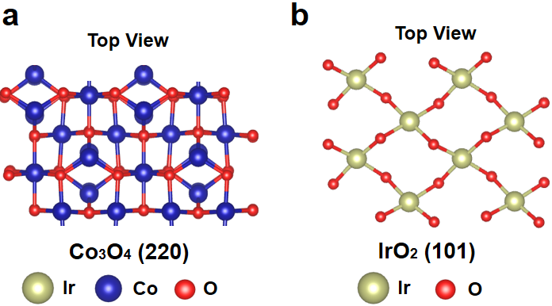
Fig. S1 (a) Top view of the Co₃O₄ (220) surface. (b) Top view of the IrO₂ (101) surface.

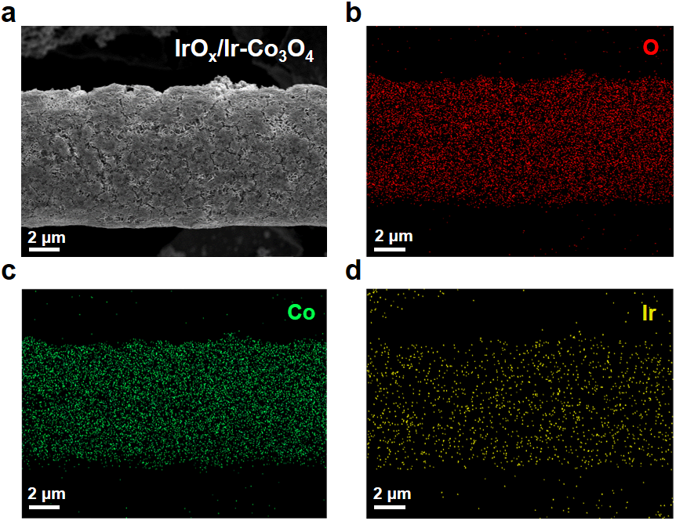
Fig. S2 (a) SEM image of IrO_{x}/Ir-Co₃O₄. Element mappings of (b) O, (c) Co, and (d) Ir for IrO_{x}/Ir-Co₃O₄.

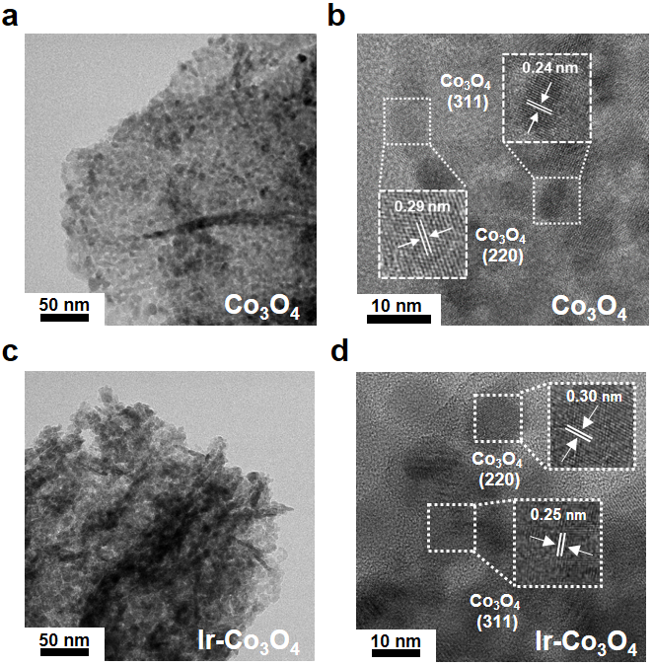
Fig. S3 (a) TEM image of Co₃O₄. (b) Enlarged TEM image of Co₃O₄ (inset is the magnified view of selected area). (c) TEM image of Ir-Co₃O₄. (d) Enlarged TEM image of Ir-Co₃O₄ (inset is the magnified view of selected area).

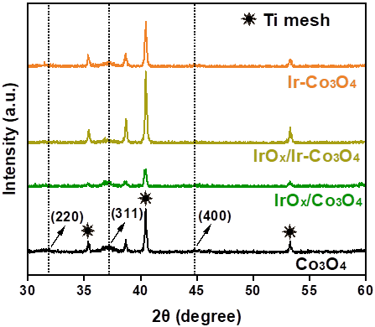
Fig. S4 XRD patterns of Co₃O₄, IrO_{x}/Co₃O₄, Ir-Co₃O₄, and IrO_{x}/Ir-Co₃O₄.

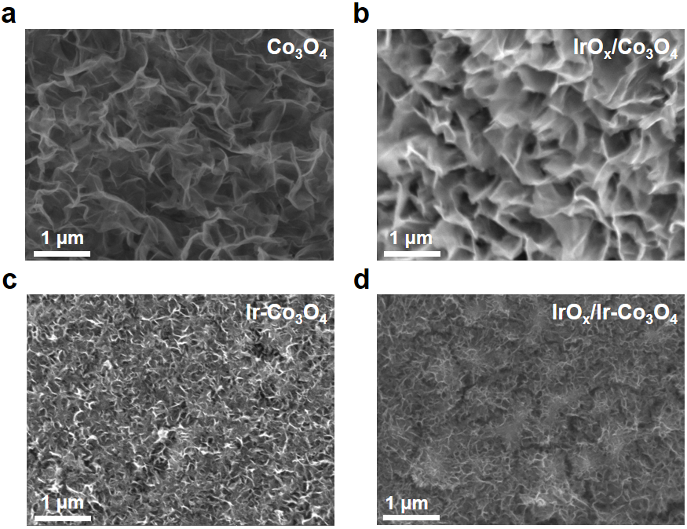
Fig. S5 SEM images of (a) Co₃O₄, (b) IrO_{x}/Co₃O₄, (c) Ir-Co₃O₄, and (d) IrO_{x}/Ir-Co₃O₄.

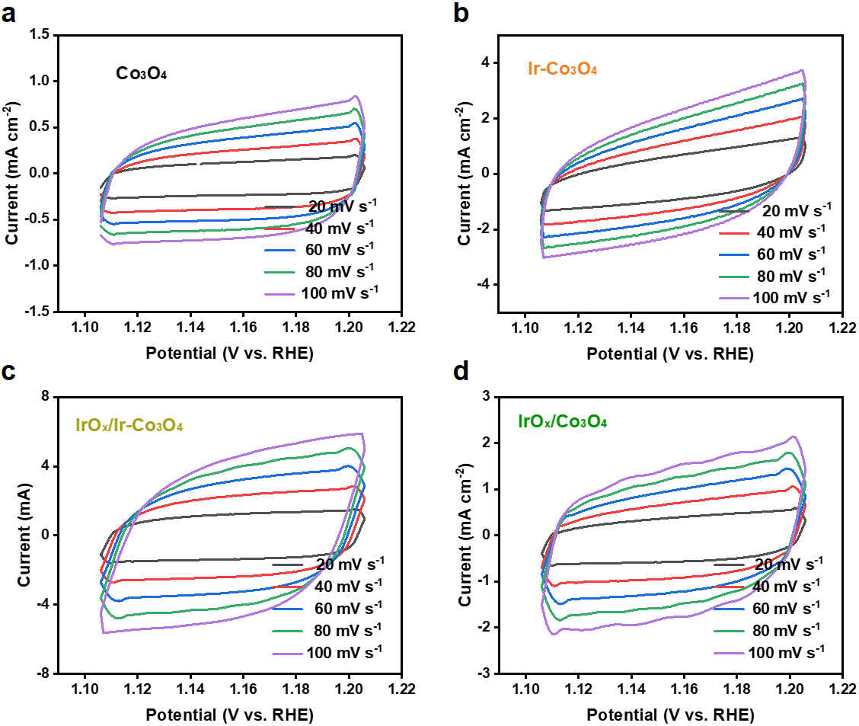
Fig. S6 CV curves at non-Faradaic potential ranges of the (a) Co₃O₄, (b) Ir-Co₃O₄, (c) IrO_{x}/Ir-Co₃O₄, and (d) IrO_{x}/Co₃O₄ catalysts with different scan rates (20-100 mV s⁻¹) from 1.116 to 1.216 V vs. RHE.

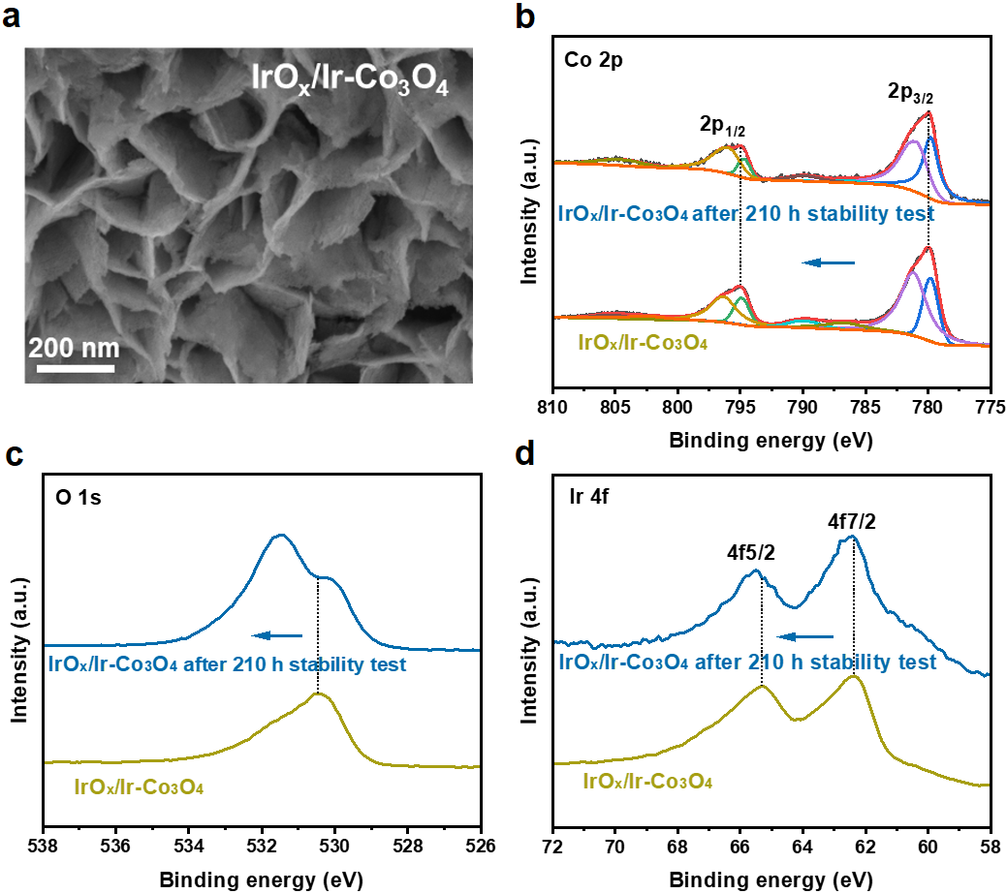
Fig. S7 (a) SEM images of IrO_{x}/Ir-Co₃O₄ after 210 h chronopotentiometry test. (b) Co 2p, (c) O 1s, and (d) Ir 4f XPS spectra of IrO_{x}/Ir-Co₃O₄ after 210 h chronopotentiometry test.

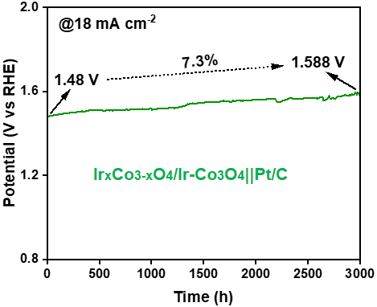
Fig. S8 Long-term stability test of Ir_{x}Co_{3-x}O₄/Ir-Co₃O₄||Pt/C MEA in PEMWE at a constant current density of 18 mA cm⁻².

Table S1 Ir and Co loading for IrO_{x}/Ir-Co₃O₄.
IrO_{x}/Ir-Co₃O₄ | Content (mg cm⁻²) | Mass radio of Ir to Co
Ir | 0.13 | 0.02
Co | 6.36 | 0.02

Table S2 ECSA, ECSA-normalized activity, Ir loading and mass activity for IrO₂ and IrO_{x}/Ir-Co₃O₄.
Electrocatalysts | Geometric area activity @1.5 V vs. RHE (mA cm⁻²) | ECSA (cm²) | ECSA-normalized Activity @1.5 V vs. RHE (mA cm⁻²) | Ir loading (mg cm⁻²) | Mass activity @1.5 V vs. RHE (A g_{Ir}⁻¹)
IrO₂ | 6.46 | 934 | 0.007 | 1.073 | 6.02
IrO_{x}/Ir-Co₃O₄ | 29.85 | 1194 | 0.025 | 0.13 | 230

Table S3 The performance evaluation indicators summary of Ir-based acidic OER electrocatalysts.
Electrocatalysts | Overpotential @ 10 mA cm⁻² | Stability | Ir loading | Mass activity@1.5 V vs RHE | Ref.
IrO_{x}/Ir-Co₃O₄ | 237 mV | 210 h@100 mA cm⁻² | 0.13 mg cm⁻² | 230 A g _{Ir}⁻¹ | This work
IrRu_{x}@Ir | 288 mV | 24 h@10 mA cm⁻² | 0.07 mg cm⁻² | 68.6 A g _{Ir}⁻¹ | [1]
20-Ir-C-1000-300 | 383 mV | 1000 CV cycles | 0.028 mg cm⁻² | 16.1 A g _{Ir}⁻¹ | [2]
CoIr-CL | 320 mV | 13.5 h@1.6 V | 0.0153 mg cm⁻² | 224 A g _{Ir}⁻¹ | [3]
Ir@WO_{3-x} | 276 mV | 100 h@10 mA cm⁻² | 0.07 mg cm⁻² | 48.1 A g _{Ir}⁻¹ | [4]
Ir/ATO | 318 mV | Not provided | ~0.12 mg cm⁻² | 31.7 A g _{Ir}⁻¹ | [5]
IrO_{x}/WO₃ | 260 mV | 100 h@10 mA cm⁻² | 0.18 mg cm⁻² | 180 A g _{Ir}⁻¹ | [6]
Ir-CeO₂-C-350 NFs | 283 mV | 10 h@10 mA cm⁻² | 0.47 mg cm⁻² | 13.8 A g _{Ir}⁻¹ | [7]
La₃Ir_{1-x}Mn_{x}O₇ | 276 mV | 175 h@10 mA cm⁻² | ~0.013 mg cm⁻² | 78.8 A g _{Ir}⁻¹ | [8]
Ir_{0.5}W_{0.5}/CNT | 283 mV | 10 h@10 mA cm⁻² | 0.057 mg cm⁻² | 224 A g _{Ir}⁻¹ | [9]
Tpyp-Ir(IrO_{x})-25 | 259 mV | 20 h@10 mA cm⁻² | 0.051 mg cm⁻² | 588 A g _{Ir}⁻¹ | [10]
Ir-Ta₂O₅ | 218 mV | 200 h@100 mA cm⁻² | 0.064 mg cm⁻² | 416 A g _{Ir}⁻¹ | [11]
GB-rich Ir NTs | 263 mV | 350 h@10 mA cm⁻² | 0.04 mg cm⁻² | 375 A g _{Ir}⁻¹ | [12]
5Ir-Co₃O₄-bilayer | 316 mV | 1000 h@10 mA cm⁻² | 0.0066 mg cm⁻² | 303 A g _{Ir}⁻¹ | [13]

Table S4 ICP test for IrO_{x}/Ir-Co₃O₄||Pt/C MEA after 160 h stability.
IrO_{x}/Ir-Co₃O₄ | Initial content (mg cm⁻²) | Dissolved amount | Dissolution rate (μg h⁻¹)
Ir | 0.13 | 0.0975 | 0.61
Co | 6.36 | 0.46 | 2.87

References
- Zheng Y, Zhang F R, Wang G L, et al. CO induced phase-segregation to construct robust and efficient IrRu_{x}@Ir core-shell electrocatalyst towards acidic oxygen evolution. Journal of Power Sources, 2022, 528: 231189
- Sadeghi E, Morgen P, Makovec D, et al. Scalable solid-state synthesis of carbon-supported Ir electrocatalysts for acidic oxygen evolution reaction: Exploring the structure-activity relationship. ACS Applied Materials & Interfaces, 2024, 16(40): 53750–53763
- Ying Y F, Godínez Salomón J F, Lartundo-Rojas L, et al. Hydrous cobalt-iridium oxide two-dimensional nanoframes: insights into activity and stability of bimetallic acidic oxygen evolution electrocatalysts. Nanoscale Advances, 2021, 3(7): 1976–1996
- Ma X J, Yang C L, Zhang F R, et al. Oxygen-vacancy-rich tungsten oxide boosted ultrasmall iridium nanoparticles for acidic oxygen evolution. International Journal of Hydrogen Energy, 2023, 48(94): 36776–36783
- Jang H, Lee J H, Lee J R, et al. Metal-support interaction can deactivate IrO_{x}/Sb:SnO₂ OER catalysts in polyol process. ACS Applied Energy Materials, 2022, 5(8): 9297–9302
- Guan Z Y, Weng Y X, Li J K, et al. Interfacial engineering to construct an IrO_{x}/WO₃ hetero-structured catalyst for efficient acidic OER catalysis. New Journal of Chemistry, 2024, 48(6): 2505–2514
- Chen X J, Liao W Y, Zhong M X, et al. Rational design of robust iridium-ceria oxide-carbon nanofibers to boost oxygen evolution reaction in both alkaline and acidic media. Nano Research, 2023, 16(5): 7724–7732
- Gao H Y, Jang H S, Liu S G, et al. Stabilizing reconstructed Ir-O motifs by Mn doping for enhanced acidic water oxidation. ACS Sustainable Chemistry & Engineering, 2025, 13(9): 3512–3521
- Chang C F, Xie Y H, Luo F, et al. Weakening s-d orbital hybridization of metallic iridium by tungsten atoms for acidic water splitting. Applied Catalysis A: General, 2023, 649: 118941
- Yang X, Liu Y Q, Niu X H, et al. Porphyrin-confined supported ultrasmall Ir clusters as oxygen evolution catalysts for water electrolysis. Inorganic Chemistry, 2024, 63(42): 19798–19808
- Qiao Y J, Luo M, Cai L B, et al. Constructing nanoporous Ir/Ta₂O₅ interfaces on metallic glass for durable acidic water oxidation. Small, 2024, 20(2): 2305479
- Sun M Z, Huang H L, Niu X F, et al. Grain boundary-derived local amorphization enhances acidic OER. ACS Catalysis, 2024, 14(20): 15764–15776
- Li G N, Priyadarsini A, Xie Z H, et al. Achieving higher activity of acidic oxygen evolution reaction using an atomically thin layer of IrO_{x} over Co₃O₄. Journal of the American Chemical Society, 2025, 147(8): 7008–7016

