Supplementary Information
Experimental
Synthetic procedures
The synthesis of 5,10,15,20-tetra (4-tert-butylphenyl) porphyrin (abbreviated as t-TPPY)
Firstly, 5,10,15,20-tetra (4-tert-butylphenyl) porphyrin (abbreviated as t-TPPY) is synthesized using the propionic acid reflux method. The specific steps are: Measure 10.1 mL of pyrrole and 24.4 mL of p-tert-butylbenzaldehyde, add them to 340 mL of propionic acid, and then heat the mixture under reflux at 150 °C for 2 hours. After the reaction mixture cools to room temperature, purple crystalline product cakes are obtained through suction filtration and washed sequentially with anhydrous ethanol, deionized water, and acetone until the filtrate is clear and transparent. Subsequently, the product is transferred to an oven at 80°C and dried overnight. The TPPY molecule is prepared from the tetra-phenyl porphyrin (abbreviated as TPPY) as precursor instead of t-TPPY.

The synthesis of tert-butyl iron metalloporphyrin (t-Fe-TPPY)
The t-TPPY molecules are synthesized from t-TPPY precursor. Weigh 500 mg of t-TPPY (0.6 mmol) and dissolve it in 150 mL of chloroform (CHCl₃) to obtain solution A. At the same time, weigh 1.2 g of FeCl₂·4H₂O (6 mmol) and dissolve it in a small amount of methanol (CH₃OH) to obtain solution B. Mix solution A with solution B and stir evenly. Add 2 mL of pyridine and then reflux at 70°C for 5 hours. Monitor the reaction progress using thin-layer chromatography (TLC) with a solvent system of methanol: dichloromethane of 2:98. After the reaction is completed, remove the solvent by rotary evaporation. Add 150 mL of 1 M HCl, and ultrasonicate for 30 minutes to dissolve excess iron chloride salt. Subsequently, obtain a brownish-colored cake through suction filtration, wash it with 1 M HCl 2-3 times, and then wash it multiple times with deionized water until the filtrate is clear and transparent. Transfer the cake to an oven at 80 °C and dry it overnight and the target product t-Fe-TPPY is obtained. The controlled Fe-TPPY sample is prepared from TPPY.

The preparation of t-Fe-800@CB
Weigh 160 mg of iron porphyrin t-Fe-TPPY and 50 mg of conductive carbon black (abbreviated as CB, Vulcan XC-72R), and add them together to 10 mL of CHCl₃. Ultrasonicate the mixture for 1 hour while continuously shaking to ensure uniformity. Afterward, separate the solid through centrifugation, dry the obtained solid in an oven at 80 °C, and grind it into a powder. Transfer the aforementioned Fe-TPPY@CB material to a tube furnace and pyrolyze it under an argon inert atmosphere by heating at a rate of 5°C/min to 800°C and holding at this temperature for 3 hours. After heat treatment, grind the material thoroughly and soak it in a 2 M HCl aqueous solution while stirring for 24 hours. Subsequently, collect the solid through centrifugation and wash it with deionized water until it is neutral. Finally, dry the solid in an oven at 80°C to obtain the t-Fe-800@CB material. The controlled sample Fe-800@CB is prepared from Fe-TPPY precursor instead of t-Fe-TPPY.

Physicochemical characterizations
Powder X-ray diffraction (PXRD) patterns were collected on a PANalytical X'Pert3 diffractometer (Netherlands) using Cu Kα radiation (λ = 1.54 Å) operated at 40 kV and 40 mA. The morphological features and particle sizes were examined by transmission electron microscopy (TEM) using a HITACHI H-7700 instrument (100 kV), while high-resolution TEM (HRTEM) images and lattice fringes were obtained on an FEI Tecnai G2 F20 S-Twin microscope operated at 200 kV. X-ray photoelectron spectroscopy (XPS) measurements were performed on a ULVAC-PHI Quantera SXM spectrometer with monochromatic Al Kα radiation (250 kV, 55 eV). All spectra were calibrated using the C 1s peak at 284.8 eV and analyzed using XPSPEAK41 software with Shirley background subtraction. Raman spectra were recorded on a HORIBA JY HR800 confocal Raman microscope with a 633 nm Ar-ion laser. High-angle annular dark-field scanning TEM (HAADF-STEM) images were acquired on a JEOL Grand ARM-300CF microscope equipped with a cold field-emission gun (80 kV) and spherical aberration corrector. The images were processed using DigitalMicrograph software with Bandpass filter for background removal. Nitrogen adsorption-desorption isotherms were measured at 77 K using a Quantachrome ASiQMVH002-5 analyzer. Prior to measurements, samples were degassed at 60°C under vacuum for 12 h. The specific surface areas were calculated using the Brunauer-Emmett-Teller (BET) method, while pore size distributions were determined by non-local density functional theory (NLDFT). Electrochemical measurements were conducted on a CHI760E electrochemical workstation (Shanghai Chenhua). X-ray absorption spectroscopy (XAS) at the Fe K-edge was performed at the 1W1B-XAFS beamline of Beijing Synchrotron Radiation Facility (BSRF). The fluorescence yield data were collected using a Lytle detector in total electron yield (TEY) mode, with samples uniformly dispersed on adhesive tape. Data processing was performed using the ATHENA module of the Demeter software package.

Electrochemical measurements
Electrochemical testing: All electrochemical tests were conducted using the CHI760E electrochemical workstation from Chenhua Instruments in Shanghai, China. Preparation of Catalyst Ink: 5 mg of the sample to be tested was dispersed in 495 μL of isopropanol and 495 μL of deionized water. Then, 10 μL of a 5% Nafion membrane solution was added, and the mixture was shaken uniformly. It was then sonicated for 1 hour, with ice packs added during the sonication process to prevent overheating and ensure uniform dispersion.
Preparation of catalyst working electrode: 5 μL of the catalyst ink was dropped onto the glassy carbon disk of a rotating ring-disk electrode (disk area: 0.2475 cm², ring area: 0.1866 cm²). After drying, another 5 μL of catalyst ink was added, and the electrode was dried with the assistance of an infrared lamp, taking care to avoid overheating. The catalyst loading was 0.2 mg cm⁻².
ORR performances testing: The electrolyte was 0.1 mol·L⁻¹ KOH (pH=13.00). A reversible hydrogen electrode (RHE) was used as the reference electrode, and carbon rod served as the counter electrode. The working electrode, counter electrode, and reference electrode were inserted into a KOH solution that had been pre-saturated with nitrogen gas for about 30 minutes. The rotation speed was set to 1600 r min⁻¹. Cyclic voltammetry (CV) scanning was performed at a scan rate of 100 mV s⁻¹ for 20 cycles, with a scanning range of 1.2 to 0.2 V vs. RHE. After the CV curves stabilized, one cycle of CV data was collected. Subsequently, linear sweep voltammetry (LSV) data was collected at a scan rate of 10 mV s⁻¹ within the same scanning range, using 95% IR compensation as a background that was subtracted later to avoid gas interference.
The process was repeated with the KOH solution saturated with oxygen gas for about 30 minutes. CV scanning was performed as before, followed by LSV testing. Then, LSV tests were conducted at different rotation speeds (400, 625, 900, 1225, 1600, 2025, 2500 r min⁻¹). The formulas used to calculate the yield of H₂O₂ and the number of electrons transferred using a rotating ring-disk electrode are as follows:
Yield (H₂O₂) = 2(I_{R}/N)/[(I_{R}/N) + I_{D}] （1）
Eectron transfer count n = 4I_{D}/ [(I_{R}/N) + I_{D}] （2）
where I_{D} and I_{R} represent the disk current and ring current, respectively, and the ring current collection efficiency N is 0.37.
The Tafel slope of the electrochemical oxygen reduction process was obtained by fitting the linear part of the Tafel plot using the Tafel equation. In a saturated inert gas electrolyte, the double-layer capacitance (Cdl) was measured by cyclic voltammetry (CV) in the non-Faradaic potential range of 0.75 to 1.15 V vs. RHE at scan rates of 20, 40, 60, 80, 100, 120, 140, and 160 mV s⁻¹. Electrochemical impedance spectroscopy (EIS) was performed at open-circuit voltage with test frequencies ranging from 0.1 to 10⁶ Hz, and the data was fitted using ZView software. The electrochemical stability was tested using the accelerated stability test (AST) method, which involves multiple CV cycles in an O₂-saturated electrolyte within the potential range of 0.6 to 1.0 V vs. RHE, and comparing the changes in ORR performance before and after cycling.
The kinetic current density of the catalyst was calculated using the following formula:
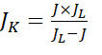 （3）
where J_{k} represents the kinetic current density, J is the measured current density, and J_{L} is the diffusion-limited current density.
To compare the intrinsic activity, the mass activity (MA) is calculated as follows:

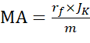 （4）
where J_{k} represents the kinetic current density, m is the mass loading of the electrocatalyst, and r_{f} is the roughness factor.
The roughness factor r_{f} can be calculated as follows:
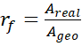 （5）
where A_{real} represents the true surface area of the electrocatalyst, and A_{geo} represents the geometric area of the working electrode. In this work, A_{real} refers to the electrochemically active surface area (ECSA) measured through the CV curve.
Therefore, the mass activity ratio of the catalyst is (translated as):
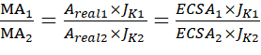 （6）
Active Site Quantification in Fe-N/C Catalysts via the Nitrite Probe Method
The reaction mechanism is as follows:
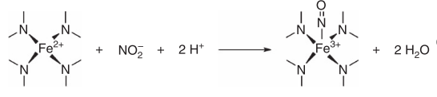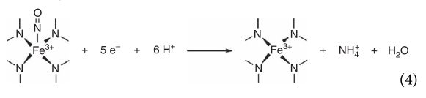

Electrode Preparation and Conditioning: A catalyst ink (5 mg catalyst, 475 µL IPA, 475 µL water, 50 µL 5 wt% Nafion) was drop-cast onto a glassy carbon electrode (loading ~0.27 mg cm⁻²). The electrode was cycled in 0.5 M acetate buffer (pH 5.2) as follows until stable CVs were obtained: first, in N₂-saturated electrolyte between 1.05 and -0.4 V vs. RHE for 20 cycles at 100 mV s⁻¹ followed by 10 cycles at 10 mV s⁻¹; then, in O₂-saturated electrolyte between 1.0 and 0.3 V vs. RHE for 6 cycles at 5 mV s⁻¹. This sequence was repeated 3-4 times.
Unpoisoned State Test: ORR Performance: Polarization curves from 1.0 to 0.3 V vs. RHE were recorded in O₂-saturated electrolyte at 5 mV s⁻¹.
Background CVs: Both wide-range (1.0 to 0.3 V, 10 mV s⁻¹) and narrow-range (0.4 to -0.3 V, 10 mV s⁻¹) background CVs were recorded in N₂-saturated electrolyte.
Poisoning Treatment: The electrode was immersed in 0.125 M NaNO₂ solution and held at open-circuit potential for 5 min (300 rpm), followed by thorough sequential washing with ultrapure water, acetate buffer, and ultrapure water again.
Post-Poisoning Test: ORR Performance: ORR polarization curves after poisoning were recorded in O₂-saturated electrolyte at 5 mV s⁻¹.
Background CVs: Both wide-range and narrow-range background CVs (same parameters as above) were recorded again in N₂-saturated electrolyte after poisoning.
Reductive Stripping Test and Post-Stripping Recovery Test: ORR polarization curves were recorded again in O₂-saturated electrolyte at 5 mV s⁻¹ to verify activity recovery.
Background CVs: Both wide-range and narrow-range background CVs were recorded once more in N₂-saturated electrolyte after the stripping step.
Data Processing: The charge difference between the poisoned and unpoisoned narrow-range CVs was integrated to obtain the stripping charge (Q_{strip}). The massic site density (MSD) was calculated using a 5-electron transfer model:
MSD ($molg^{−1}$) =$\frac{Q_{strip}(Cg^{−1})}{n_{strip} × F(C{mol}^{−1})}$
where F is Faraday's constant (96485 C mol⁻¹).
The turnover frequency (TOF) was calculated from the difference in kinetic current (${Δi}_{k}$) at 0.8 V vs. RHE before and after poisoning:
TOF(s⁻¹) =$\frac{{Δi}_{k} (Ag^{−1})}{ F(As{mol}^{−1}) MSD (molg^{−1})}$
where F is Faraday's constant (96485 C mol⁻¹).

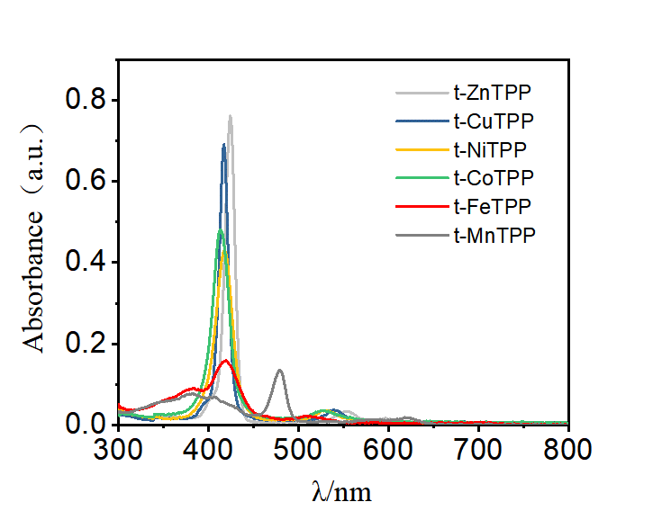
Figure S1 UV-Vis spectra of metalloporphyrins

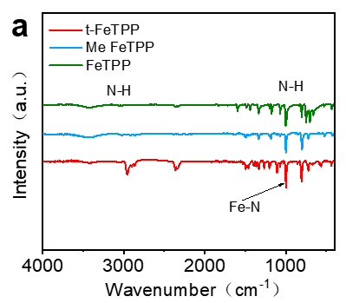
Figure S2 Fourier transform infrared spectroscopy of porphyrin. (a) t-FeTPP, Me FeTPP and FeTPP (b) t-FeTPP and t-TPP (c) FeTPP and TPP (d) Me FeTPP and Me TPP

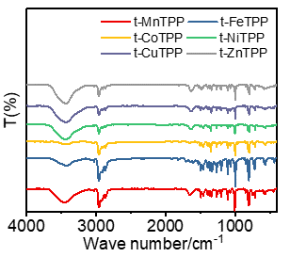
Figure S3 Fourier transform infrared spectroscopy of t-MnTPP, t-FeTPP, t-CoTPP, t-NiTPP, t-CuTPP and t-ZnTPP

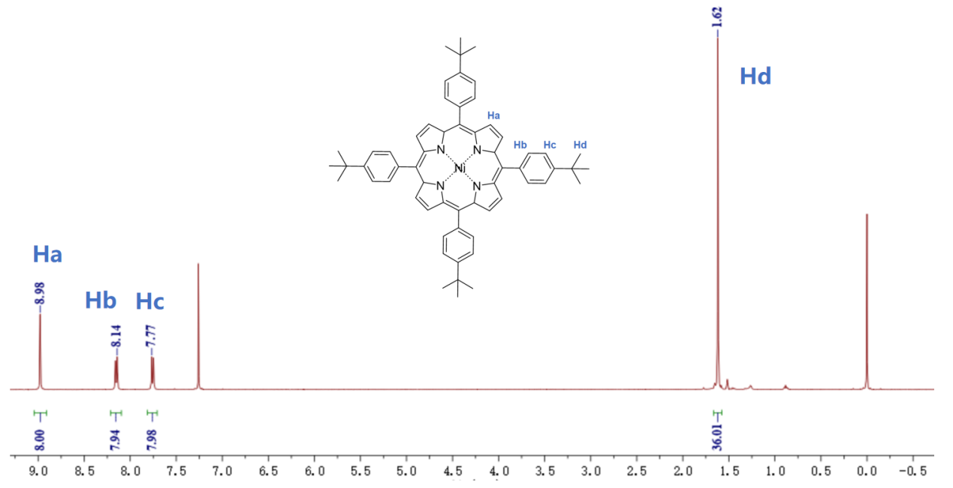
Figure S4 NMR spectroscopy of t-NiTPP

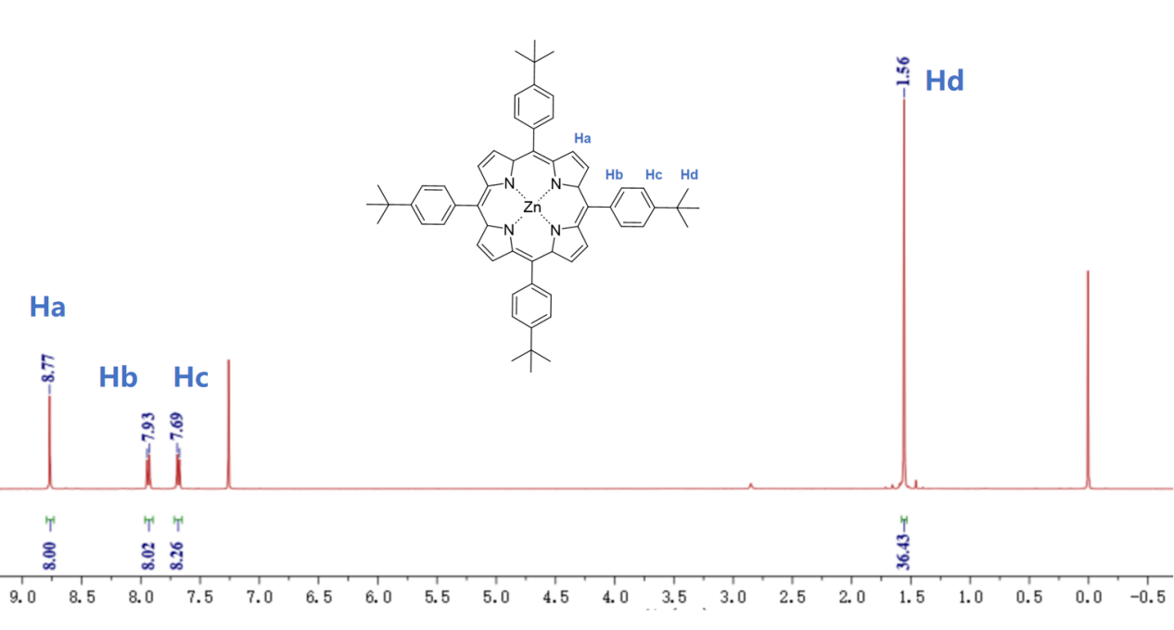
Figure S5 NMR spectroscopy of t-ZnTPP

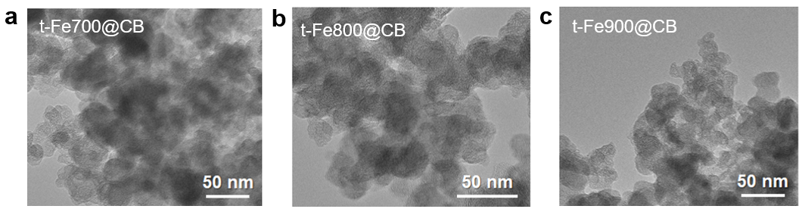
Figure S6 TEM of (a) t-Fe700@CB, (b) t-Fe800@CB and (c) t-Fe900@CB

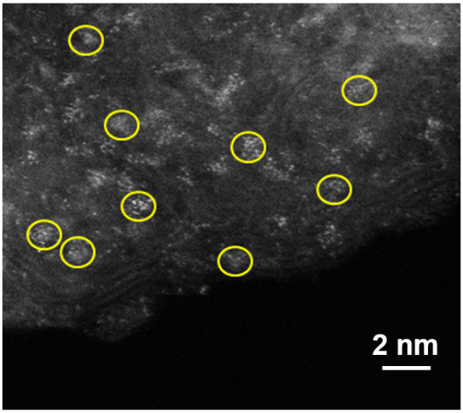
Figure S7 HAADF-STEM of t-Fe900@CB

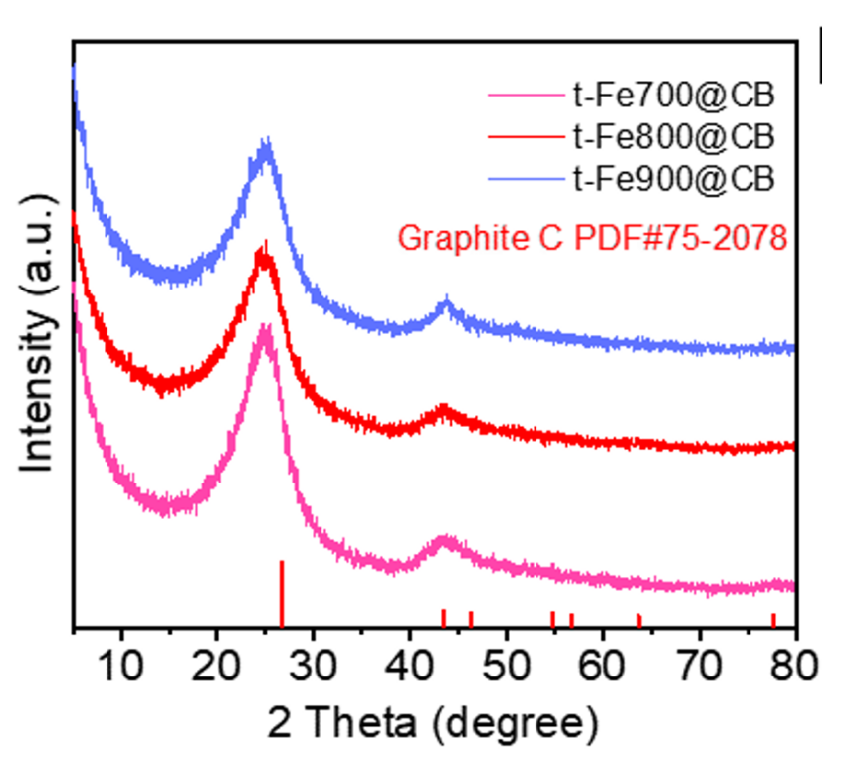
Figure S8 XRD patterns of t-Fe700@CB, t-Fe800@CB, and t-Fe900@CB.

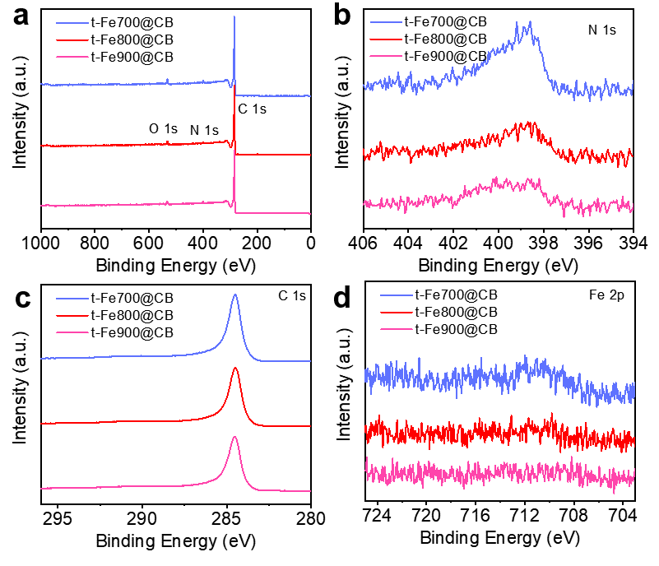
Figure S9 X-ray photoelectron spectroscopy of t-Fe700@CB, t-Fe800@CB and t-Fe900@CB (a) XPS spectra, (b) N 1s, (c) C 1s and (d) Fe 2p

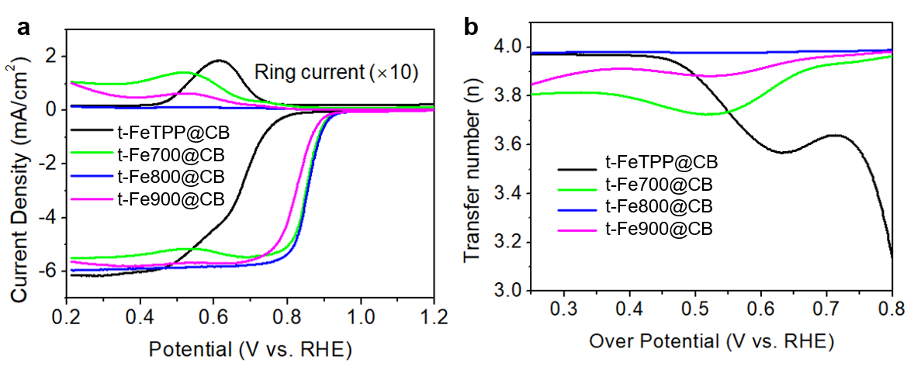
Figure S10 ORR performance of different metal center catalysts. (a) LSV, (b) transfer electron number

Figure S11 XRD spectra of samples t-Fe-800@CB and Fe-800@CB

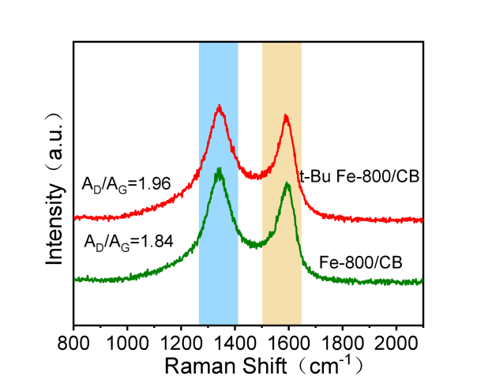
Figure S12 Raman spectra of t-Fe-800@CB and Fe-800@CB

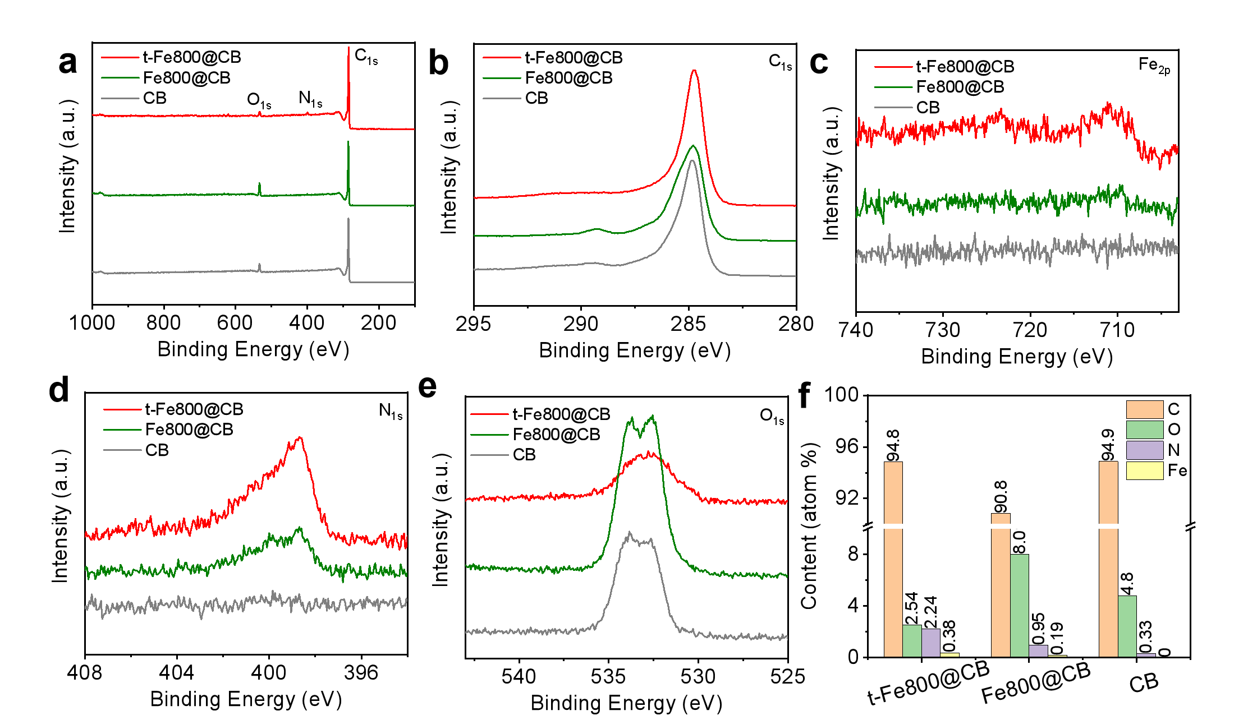Figure S13 XPS analysis of t-Fe-800@CB, Fe-800@CB and CB. (a)XPS survey spectrum, (b)C1s (c)Fe 2p, (d)N 1s, (e)O 1s and (f) the comparison histogram of element composition content

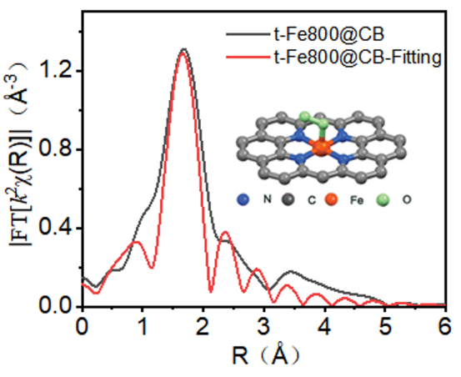
Figure S14 Fe K-edge EXAFS fitting analysis in R space.

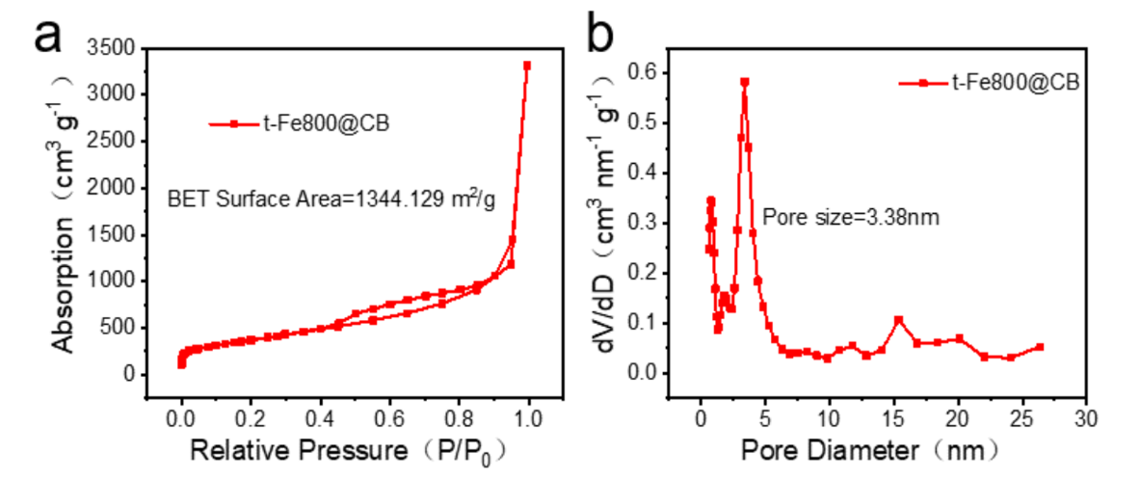
Figure S15 (a) N₂ adsorption-desorption isotherm of t-Fe-800@CB. (b) Hole sizedistribution of t-Fe-800@CB. (c) N₂ adsorption-desorption isotherm of 20%Pt/C. (d) Hole sizedistribution of 20%Pt/C.

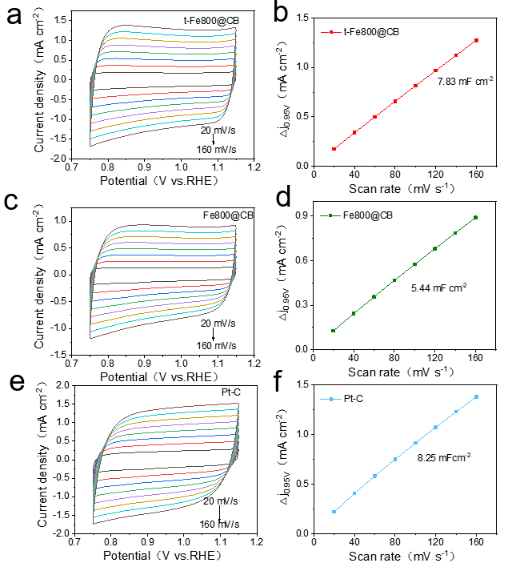
Figure S16 Cdl of (a)~(b) t-Fe800@CB, (c)~(d) Fe800@CB and (e)~(f) Pt-C.

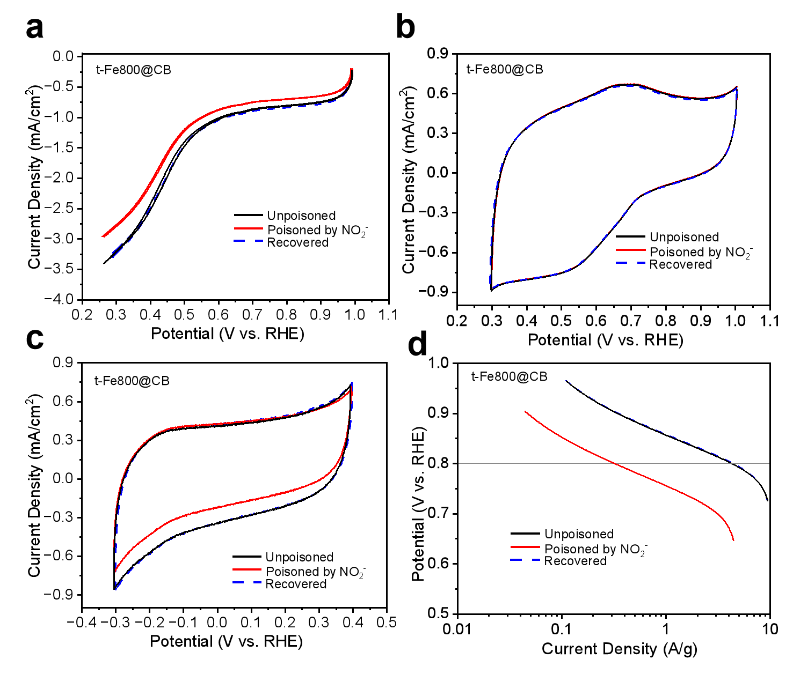
Figure S17 the t-Fe800@CB catalyst. All measurements were conducted in 0.5 M acetate buffer (pH 5.2) with a catalyst loading of 0.27 mg cm⁻² and an electrode rotation rate of 1600 rpm. (a) ORR polarization curves before and after poisoning, measured in O₂-saturated electrolyte at a scan rate of 5 mV s⁻¹. (b) Background cyclic voltammograms in N₂-saturated electrolyte over a wide potential range (1.0 to 0.3 V vs. RHE) at 10 mV s⁻¹. (c) Stripping voltammograms in N₂-saturated electrolyte over the reductive potential range (0.4 to -0.3 V vs. RHE) at 10 mV s⁻¹, showing the reductive desorption peak of adsorbed nitrite. (d) Corresponding kinetic current densities (iₖ) derived from (a), plotted against potential.

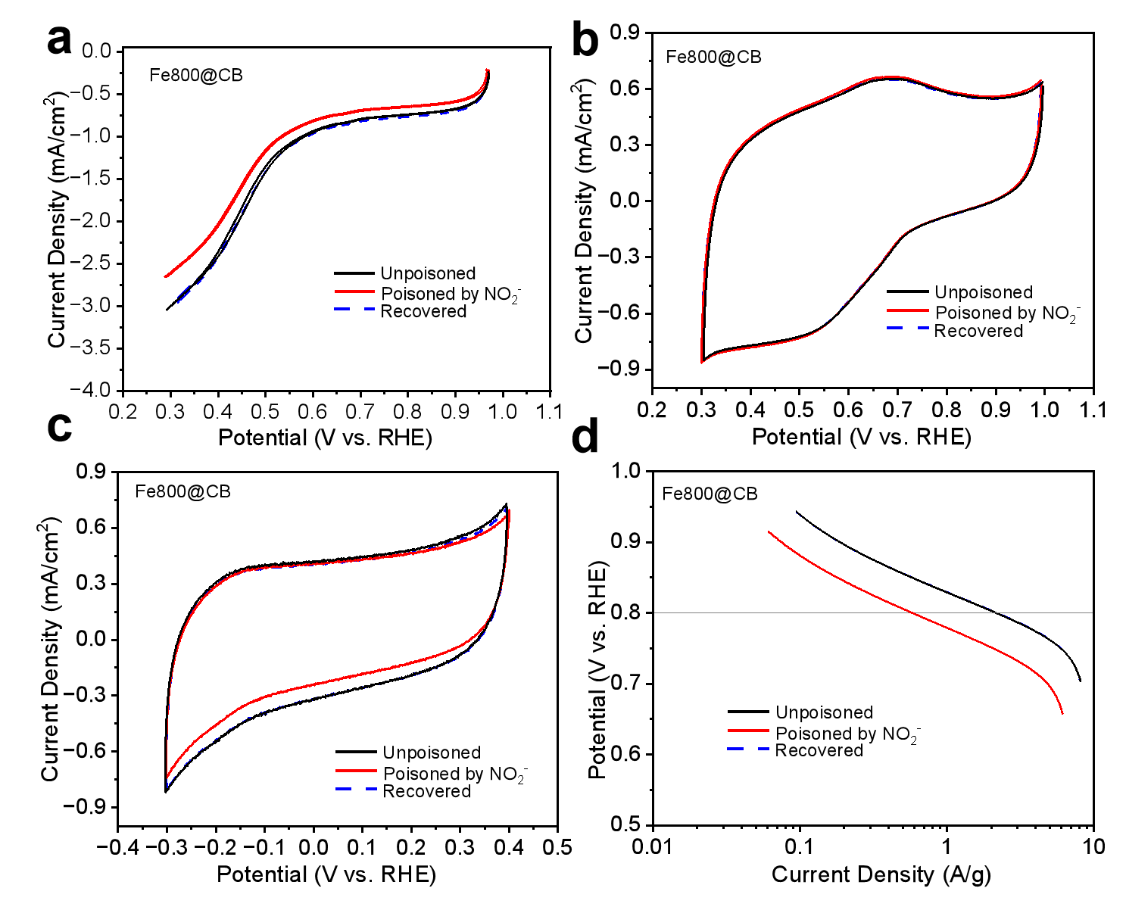
Figure S18 the Fe800@CB catalyst. All measurements were conducted in 0.5 M acetate buffer (pH 5.2) with a catalyst loading of 0.27 mg cm⁻² and an electrode rotation rate of 1600 rpm. (a) ORR polarization curves before and after poisoning, measured in O₂-saturated electrolyte at a scan rate of 5 mV s⁻¹. (b) Background cyclic voltammograms in N₂-saturated electrolyte over a wide potential range (1.0 to 0.3 V vs. RHE) at 10 mV s⁻¹. (c) Stripping voltammograms in N₂-saturated electrolyte over the reductive potential range (0.4 to -0.3 V vs. RHE) at 10 mV s⁻¹, showing the reductive desorption peak of adsorbed nitrite. (d) Corresponding kinetic current densities (iₖ) derived from (a), plotted against potential.

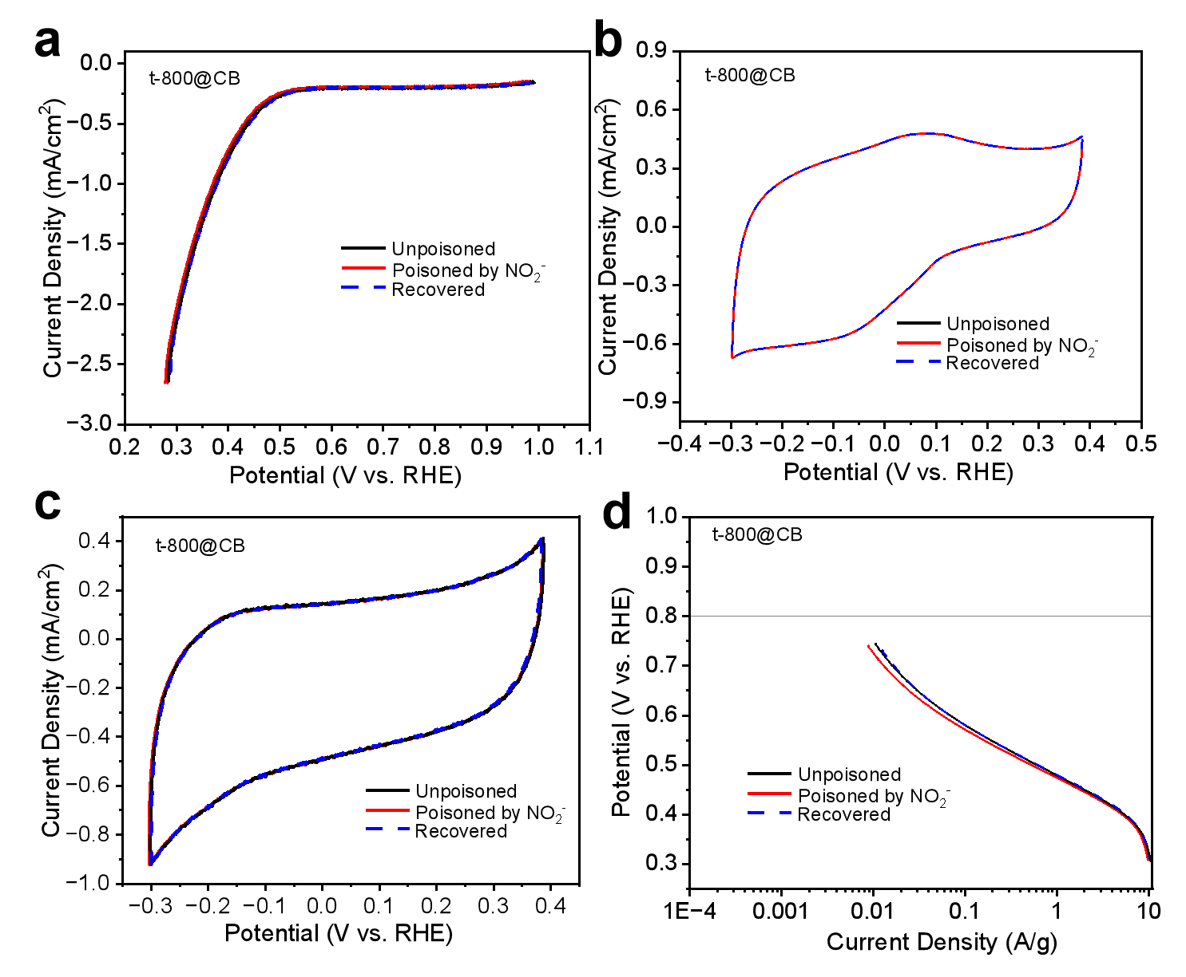
Figure S19 the t-800@CB catalyst. All measurements were conducted in 0.5 M acetate buffer (pH 5.2) with a catalyst loading of 0.27 mg cm⁻² and an electrode rotation rate of 1600 rpm. (a) ORR polarization curves before and after poisoning, measured in O₂-saturated electrolyte at a scan rate of 5 mV s⁻¹. (b) Background cyclic voltammograms in N₂-saturated electrolyte over a wide potential range (1.0 to 0.3 V vs. RHE) at 10 mV s⁻¹. (c) Stripping voltammograms in N₂-saturated electrolyte over the reductive potential range (0.4 to -0.3 V vs. RHE) at 10 mV s⁻¹, showing the reductive desorption peak of adsorbed nitrite. (d) Corresponding kinetic current densities (iₖ) derived from (a), plotted against potential.
Figure S20 MSD and TOF of t-Fe800@CB and Fe800@CB

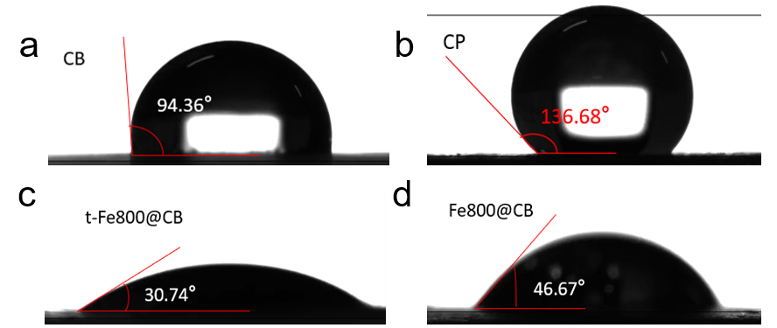
Figure S21 The hydrophilic and hydrophobic properties tested by contact angle of (a) powder CB, (b) hydrophobic CP, (c) t-Fe800@CB and (d) Fe800@CB.

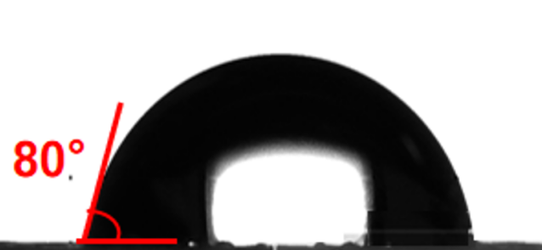
Figure S22 The hydrophilic and hydrophobic properties tested by contact angle of 20% Pt-C.

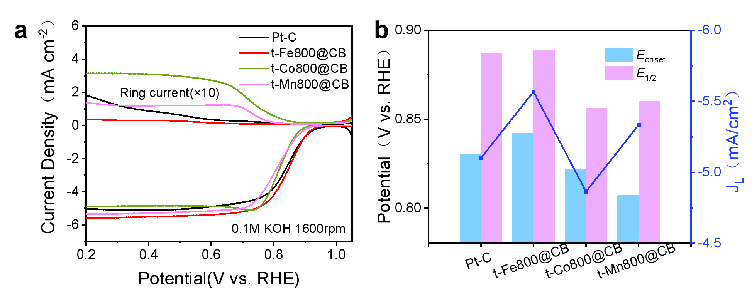
Figure S23 ORR performance of different catalysts. (a) LSV. (b) half-wave potential, onset potential and limiting current density comparison diagram.

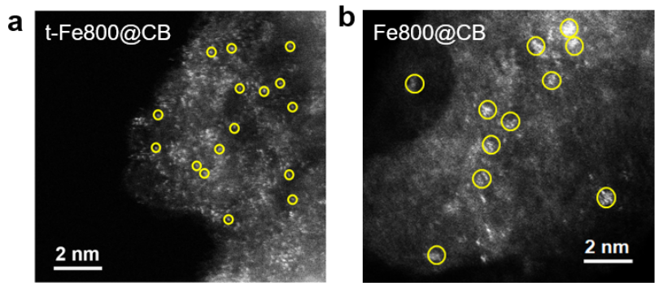
Figure S24 HAADF-STEM of (a) t-Fe-800@CB and (b) Fe-800@CB (Fe single atoms or Fe clusters are highlighted in yellow circles).

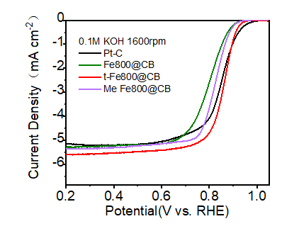
Figure S25 ORR polarization curves for t-Fe800@CB、Fe800@CB、Me Fe800@CB and Pt-C (0.2 mg cm⁻², 0.1 M KOH, 1600 rpm)

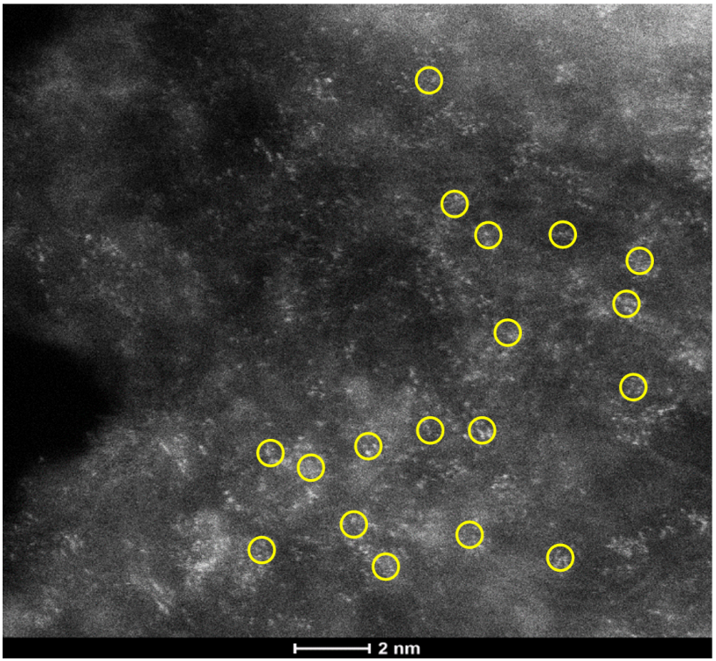
Figure S26 HAADF-STEM of t-Fe-800@CB after 10000 CV cycles operation.

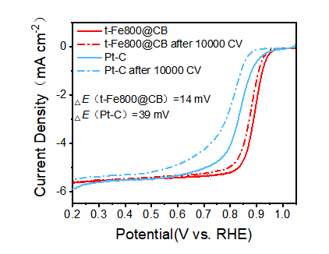
Figure S27 ORR polarization curves for t-Fe-800@CB and commercial Pt-C before and after 10000 CV cycles.

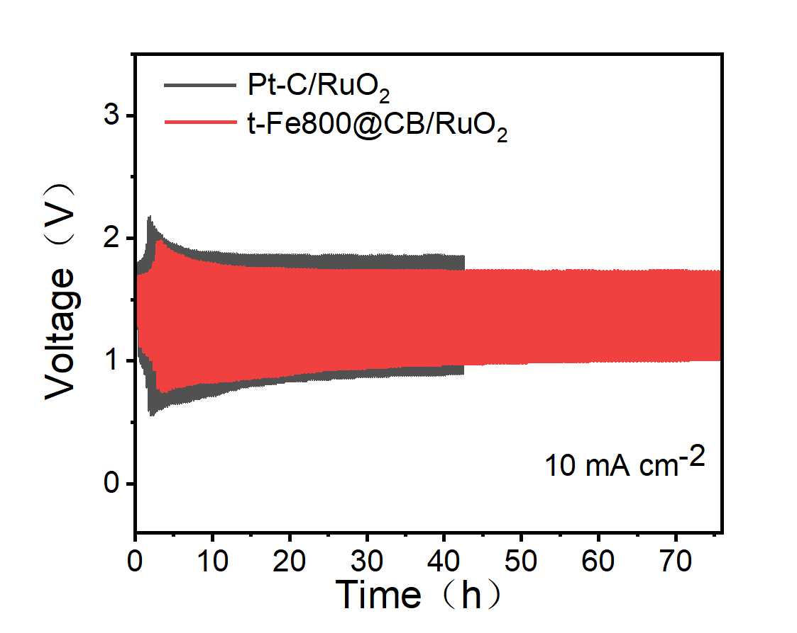
Figure S28 discharge/charge cycling curves of Zn-Air batteries using the t-Fe-800/CB ǁ RuO₂ and Pt/C ǁ RuO₂ couple as electrodes at 10 mA cm⁻².

Table S1 Summary of elemental analysis of electrocatalysts based on XPS and ICP-MS.
Samples | O (at.%) | N (at.%) | Fe (at.%) | ICP-MS Fe (wt.%) | N:Fe
t-Fe800@CB | 2.54 % | 2.24 % | 0.38% | 3.01% | 5.89:1
Fe800@CB | 8.0% | 0.95% | 0.19% | 2.84% | 5:1

Table S2 The performance of different Fe-N-C catalysts reported in the literature in the last 10 years is compared.
Samples | E_{onset} (mV) | E_{1/2} (mV) | References
t-Fe800@CB | 0.99 | 0.89 | This work
Fe-N-C | 0.98 | 0.854 | Appl. Catal. B: Environ., 2022, 305, 121058
Fe/Meso-NC-1000 | 0.97 | 0.885 | Adv. Mater., 2022, 34, 2107291
Fe/N-G-SAC | 0.99 | 0.89 | Adv. Mater., 2020, 32, 2004900
Fe₃Co₇-NC | 1.02 | 0.893 | Adv. Funct. Mater., 2023, 33, 2212299
FeCo-N-HCN | 0.98 | 0.86 | Adv. Funct. Mater., 2021, 31, 2011289
Co₂Fe₁@NC | 0.99 | 0.85 | J. Am. Chem. Soc., 2020, 142, 7116
Fe-N/P-C-700 | 0.941 | 0.867 | J. Am. Chem. Soc., 2020, 142(5): 2404-2412
Fe-N-C HNSs | 1.046 | 0.87 | Adv. Mater., 2019, 31, 180631
SA-Fe/NG | 1 | 0.88 | PNAS, 2018, 115, 6626-6631.
Fe-N₄ SAs/NPC | 0.972 | 0.885 | Angew.Chem. Int.Ed., 2018, 57,8614-8618
Fe₁Co₃-NC 1100 | 1.05 | 0.877 | ACS Catal., 2022, 12, 1216-1227
Fe/OES | 1 | 0.85 | Angew. Chem. Int. Ed., 2020, 132(19): 7454-7459.
Fe-SAs/NSC | 1 | 0.87 | J. Am. Chem. Soc., 2019, 141(51): 20118-20126.
Fe-SA/PNC | 1.045 | 0.921 | Angew. Chem. Int. Ed., 2023, 62, 202307504.
Fe1-NS_{1.3}C | 0.97 | 0.86 | Angew. Chem. Int. Ed., 2021, 60, 25404.
Fe SA-NSC | 0.94 | 0.86 | ACS Energy Lett., 2021, 6, 379.
Fe/NCFs-NH₃ | 1.02 | 0.89 | Adv. Mater., 2022, 34, 2105410.
Fe-CNSs-N | 0.948 | 0.828 | Appl. Catal., 2020, 260, 118198.
Fe@NC(10+900) | 0.94 | 0.82 | Inorg. Chem. Front., 2022, 9(11), 2557-2567.
Fe/Fe-N-C-3 | 0.87 | 0.87 | J. Mater. Chem. A, 2022, 10(39), 20993-21003.
FeSA/N-PSCS | 0.976 | 0.87 | Energy Storage Mater., 2023, 59, 102790.
FeN/C-800 | 0.77 | 0.6 | J. Am. Chem. Soc., 2015, 137(4): 1436-1439.
Fe,N,P-CNSs/Fe₂P | 0.955 | 0.854 | Nano Energy, 2023, 108, 108179.

Table S3 List of experimental reagents
Reagent Name | Molecular Formula | Purity | Source
Pyrrole | C₄H₅N | AR，99% | Aladdin
Pyridine | C₅H₅N | AR，99.5% | Aladdin
Benzaldehyde | C₇H₆O | ≥99.0% | Aladdin
4-Bromobenzaldehyde | C₇H₅BrO | 99% | Aladdin
4-Methylbenzaldehyde | C₈H₈O | 97% | Aladdin
4-tert-Butylbenzaldehyde | C₁₁H₁₄O | 97% | Aladdin
Manganese(II) acetate tetrahydrate | Mn(CH₃COO) ₂•4H₂O | AR | Beijing Chemical Works
Iron(II) chloride tetrahydrate | FeCl₂•4H₂O | AR | Beijing Chemical Works
Cobalt(II) acetate tetrahydrate | Co(Co(CH3COO) ₂•4H₂O | AR | Beijing Chemical Works
Zinc acetate dihydrate | Zn(CH₃COO) ₂•2H₂O | AR，99% | Aladdin
Iron(II) sulfate heptahydrate | FeSO₄·7H₂O | AR | Sinopharm Chemical Reagent
Iron(III) nitrate nonahydrate | FeN₃O₉·9H₂O | 99.9% | Shanghai Macklin Biochemical Technology Co., Ltd.
Propionic acid | C₃H₆O₂ | AR，≥99.% | Aladdin
Acetone | C₃H₆O | AR | Tianjin Fuyu Chemical
Isopropanol | C₃H₈O | AR，≥99.7% | Sinopharm Chemical Reagent
Dichloromethane | CH₂Cl₂ | AR，≥99.5% | Sinopharm Chemical Reagent
Chloroform | CHCl₃ | AR，≥99% | Sinopharm Chemical Reagent
Methanol | CH₃OH | AR | Tianjin Fuyu Fine Chemical Co., Ltd.
Potassium hydroxide | KOH | 95% | Shanghai Macklin Biochemical Technology Co., Ltd.
Absolute Ethanol | C₂H₅OH | AR，≥99.7% | Tianjin Fuyu Fine Chemical Co., Ltd.
Conductive Carbon Black Vulcan XC-72R | - | powder | Cabot
20% Platinum on Carbon | Pt/C | 20%Pt | Shanghai Hesen Electric Co., Ltd.
Ruthenium Oxide | RuO | 99.9% | Shanghai Macklin Biochemical Technology Co., Ltd.
Nafion Membrane Solution | - | 5 wt% | Dupont
Hydrophobic Carbon Paper |  |  | Shanghai Hesen Electric Co., Ltd.

