Supplemental information for
Anti-Corrosion Carbon Support for Mass Transfer Enhancement in Low-Platinum loaded Fuel Cells

Supplementary Figures
Fig. S1 The product formation rate of ZIF-8s under different molar ratios of 2-MIM to Zn(NO₃)₂·6H₂O.
Fig. S2 SEM images of ZIF-8 produced at the water bath of 30 ℃, when the molar ratios of 2-MIM to Zn(NO₃)₂·6H₂O were (A) 2:1, (B) 4:1, (C) 8:1, (D) 16:1. SEM images of ZIF-8 produced at the water bath of 40 ℃, when the molar ratios of 2-MIM to Zn(NO₃)₂·6H₂O were (E) 2:1, (F) 4:1, (G) 8:1, (H) 16:1. SEM images of ZIF-8 produced at the water bath of 60 ℃, when the molar ratios of 2-MIM to Zn(NO₃)₂·6H₂O were (I) 2:1, (J) 4:1, (K) 8:1, (L) 16:1.
Fig. S3 SEM images of NCs without the addition of PVP, when the molar ratios of 2-MIM to Zn(NO₃)₂·6H₂O were (A) 2:1, (B) 4:1, (C) 8:1, (D) 16:1. SEM images of NCs with the addition of PVP, when the molar ratios of 2-MIM to Zn(NO₃)₂·6H₂O were (E) 2:1, (F) 4:1, (G) 8:1, (H) 16:1.
Fig. S4 High-resolution HADDF-STEM image and corresponding elemental mapping images of ZIF-8 after pyrolysis at 950 ℃ for 2 h.
Fig. S5 High-resolution HADDF-STEM image and corresponding elemental mapping images of ZIF-8 after pyrolysis at 1150 ℃ for 2 h
Fig. S6 Changes in particle size after calcination for ZIF-8 produced under different molar ratios of 2-MIM to Zn(NO₃)₂·6H₂O.
Fig. S7 Particle size statistics for NCs produced under molar ratios of 2-MIM to Zn(NO₃)₂·6H₂O of (A) 2:1, (B) 4:1, (C) 8:1, (D) 16:1.
Fig. S8 SEM images of MWCNTs

Fig. S9 BET surface area of different carbon supports.
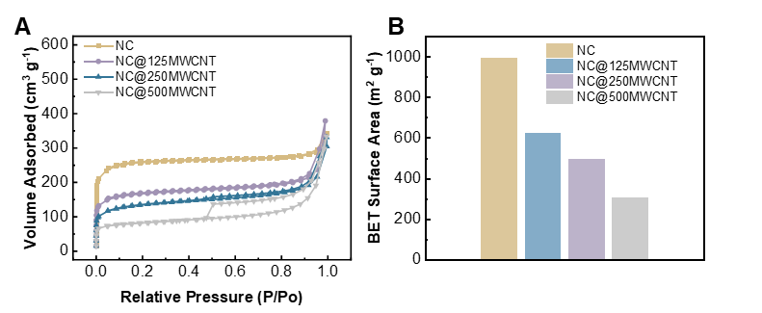
Fig. S10 (A)N₂ adsorption desorption isotherms and (B) BET surface area of NC and NC@MWCNT with different additions of MWCNT.

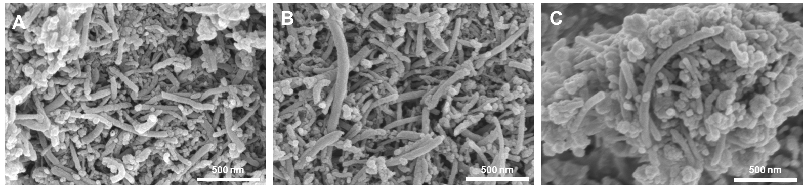
Fig. S11 SEM images of NC@MWCNT with MWCNT addition of (A)125 mg, (B) 250 mg, and 500 mg.

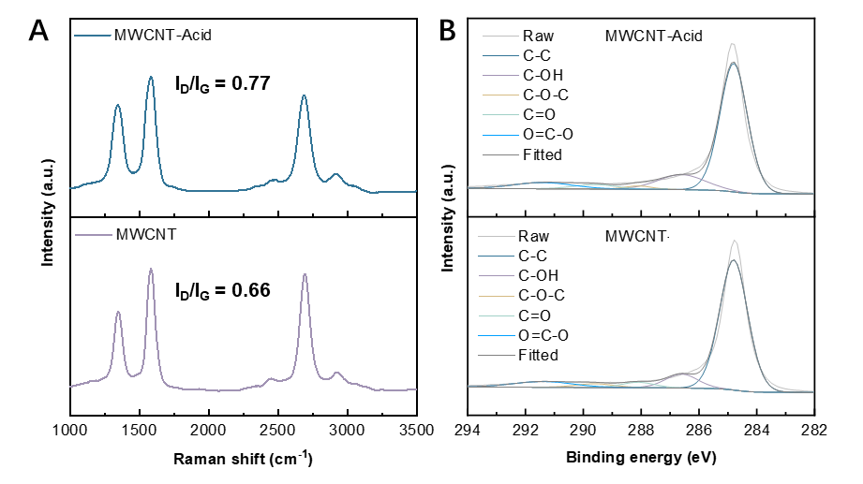
Fig. S12 (A) Raman spectra and (B) high-resolution C1s XPS spectra of the MWCNT and the MWCNT treated by acid.
Fig. S13 Pore size distribution of MWCNT, NC@MWCNT, T-NC and NC.

Fig. S14 SEM images of the T-NC
Fig. S15 Attachment trends of Pt particles in the Pt/T-NC.
Fig. S16 Particle size statistics for T-NCs after different treatment methods.
Fig. S17 The CCM thickness comparison under 0.2 mg_{Pt} cm⁻² of Pt loading in the cathode while 0.1 mg_{Pt} cm⁻² in the anode, whose cathode CLs were sprayed by Pt/T-NCs with D50s of (A) 8.33 μm, (B) 6.72 μm, and (C) 2.66 μm.
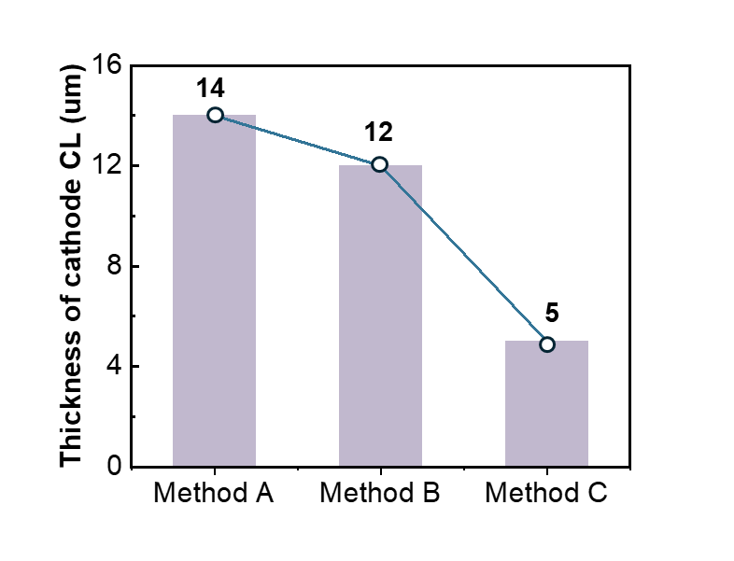
Fig. S18 The cathode CL thickness comparison under 0.2 mg_{Pt} cm⁻² of Pt loading, which was sprayed by Pt/T-NC s with D50s of (A) 8.33 μm, (B) 6.72 μm, and (C) 2.66 μm.
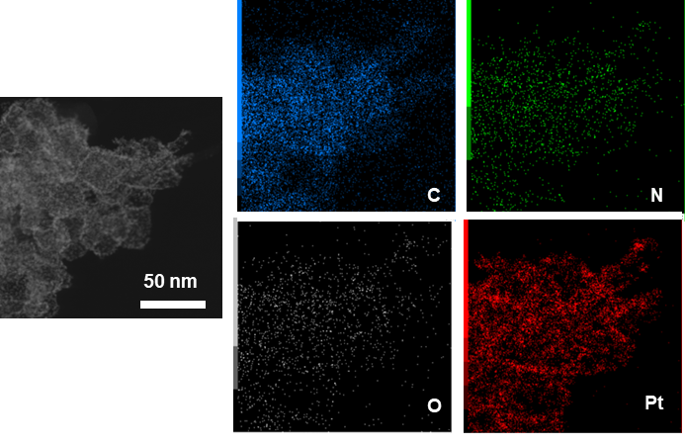
Fig. S19 High-resolution HADDF-STEM images and elemental mappings of high Pt loading Pt/T-NC.
Fig. S20 RDE polarization curves of different samples in O₂-saturated 0.1 M HClO₄ with a sweep rate of 10 mV s⁻¹ and rotation rate of 1600 rpm.

Fig. S21 The performance comparison between Pt/C and Pt/T-NC under H₂/air (70°C, 150 kPa, 100% RH), when the Pt loadings of anode and cathode are 0.1 mg_{Pt} cm⁻² and 0.2 mg_{Pt} cm⁻², respectively.
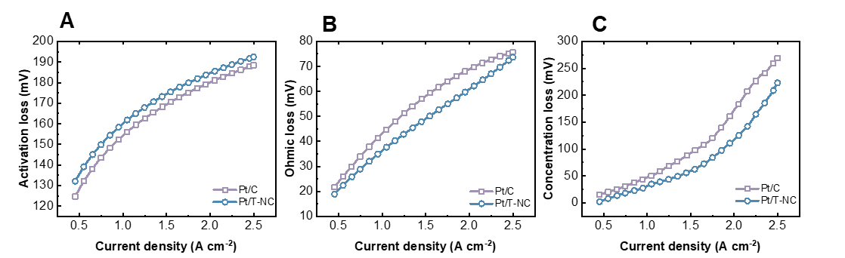
Fig. S22 Fitted (A) activation loss, (B) ohmic loss, and (C) concentration loss comparison between Pt/C and Pt/T-N at selected current densities, when the Pt loadings of anode and cathode are 0.1 mg_{Pt} cm⁻² and 0.2 mg_{Pt} cm⁻², respectively.
Fig. S23 Cathodic MA Tafel plots derived from the MEA measurement under H₂/O₂ (70°C, 150 kPa, 100% RH), while the Pt loading of the cathode and anode was 0.1 mg_{Pt} cm⁻² and 0.05 mg_{Pt} cm⁻², respectively.
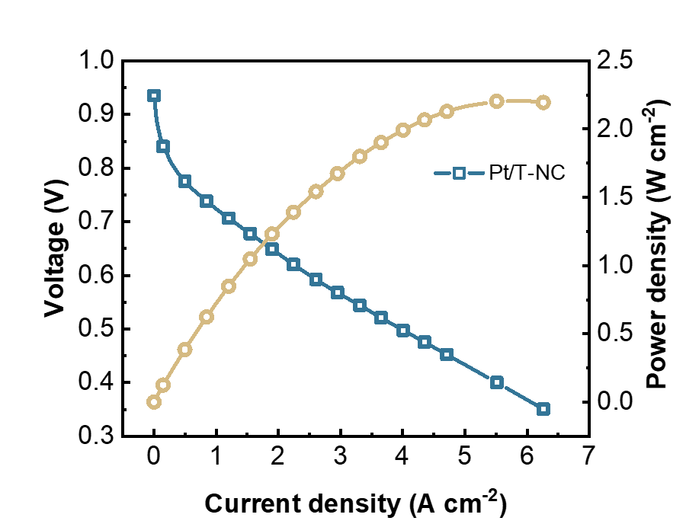
Fig. S24 Polarization curve derived from the MEA measurement under H₂/O₂ (70°C, 150 kPa, 100% RH), while the Pt loading of the cathode and anode was 0.1 mg_{Pt} cm⁻² and 0.05 mg_{Pt} cm⁻², respectively.
Fig. S25 Cathodic MA Tafel plots derived from the MEA measurement under H₂/O₂ (70°C, 150 kPa, 100% RH), while the Pt loading of the cathode and anode was 0.1 mg_{Pt} cm⁻² and 0.05 mg_{Pt} cm⁻², respectively.
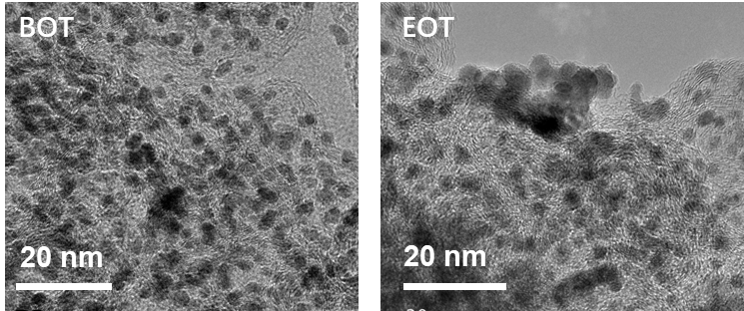
Fig. S26 TEM images for Pt/C.
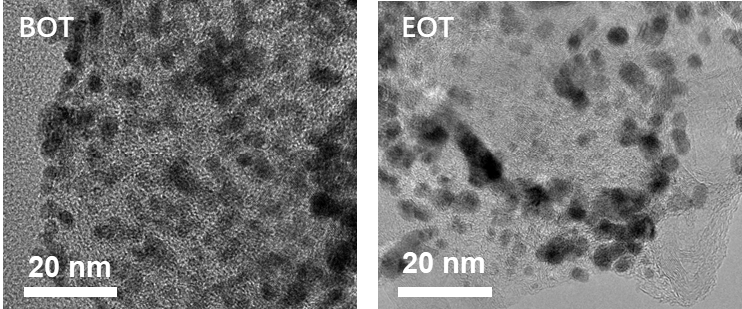
Fig. S27 TEM images for Pt/T-NC.

Supplementary Tables
Table. S1 The relative amount of different C configurations on the material surface via XPS analysis.
Sample | C-C at% | C-OH at% | C-O-C at% | C=O at% | C=O-C at%
MWCNT | 76.58 | 9.44 | 3.05 | 3.76 | 7.17
MWCNT-Acid | 72.20 | 14.50 | 1.84 | 3.90 | 7.55

Table. S2 Comparison of MEA mass activity and peak power density of Pt/T-NC with representative Pt-based catalysts in literature.
Catalyst | Pt-loading | PEM | Mass activity@0.9 V  (A/mg_{Pt}) | Operation conditions | Peak power density  (W cm⁻²) |  | Ref
 |  |  |  |  | H₂/O₂ | H₂/Air | Ref
Pt/T-NC | 0.05/0.1 | Gore M775.15 | 0.216 | 70℃, 100% RH;  150 kPa  H₂/Air flow: 400/800 sccm  H₂/O₂ flow: 300/600 sccm | 2.21 | 0.93 | This work
Surf-IM-PtFe NWs/C | 0.1/0.1 | Gore,  15 μm | 0.47 | 80°C, 100% RH;  150 kPa for O2  250 kPa for Air  H₂/Air flow: 2000/3000 sccm  H₂/O₂ flow: 2000/3000 sccm | ~1.42 | 0.95 | [1]
L1₀-PtCoIn@Pt/C | 0.1/0.1 | NA | 0.73 | 80°C, 100% RH;  250 kPa  H₂/Air flow: 500/1000 sccm  H₂/O₂ flow: 500/1000 sccm | 1.99 | 0.994 | [2]
Pt@Gnp/KB | 0.025/0.25 | NA,12μm | 0.74 | 94°C, 100% RH;  250 kPa for Air  H₂/Air flow: 168/531 sccm | NA | 1.25 | [3]
L1₀-PtZn/Pt-C | 0.1/0.104 | Nafion 211 | 0.52 | 80°C, 100% RH;  150 kPa  H₂/Air flow: 500/1000 sccm  H₂/O₂ flow: 500/1000 sccm | 2 | ~0.8 | [4]
PtCo/KB-NH2 | 0.1/0.1 | Gore M820.15 | 0.691 | 80°C, 150 kPa;  H₂/Air flow: 500/1000 sccm, 100% RH/75% RH;  H₂/O₂ flow: 200/400 sccm,  100% RH/100% RH. | ~2.65 | ~1.06 | [5]
L1₀-PtCo/Co-N-PCNF | 0.1/0.1 | Nafion 211 | 0.61 | 80°C, 100% RH;  250 kPa;  H2/Air flow: 500/1000 sccm,  H2/O2 flow: 200/500 slpm, | 2.18 | 1.095 | [6]
L1₀-N-PtCo-H@Pt/C | 0.05/0.1 | Nafion 211 | 0.88 | 80°C, 100% RH;  150 kPa  H₂/Air flow: 300/1000 sccm  H₂/O₂ flow: 300/1000 sccm | ~1.73 | 0.96 | [7]
L1₀-  Pt₅₀Ni₃₅Ga₁₅/C | 0.05/0.1 | Gore,  15 μm | 0.7 | 80°C, 100% RH;  150 kPa  H₂/Air flow: 1000/2000 sccm  H₂/O₂ flow: 200/500 sccm | NA | 1.1 | [8]
PtFe@Fe_{SAs}-NC | 0.12/0.2 | NA | 0.75 | 80°C, 100% RH;  28 psi  H₂/Air flow: 300/800 sccm  H₂/O₂ flow: 300/400 sccm | 1.24 | ~0.7 | [9]
PtNiMoAu NWs/C | 0.05/0.1 | Nafion 211 | 0.93 | 80°C, 100% RH;  150 kPa  H₂/Air flow: 200/500 sccm  H₂/O₂ flow: 200/500 sccm | 1.71 | 0.93 | [10]

References
1. Ma Y, Peng J, Gao W, et al. Highly stable and active catalyst in fuel cells through surface atomic ordering. Science Advances, 2024, 10(42): eado4935.
2. Zhao L, Zhu Z, Wang J, et al. Robust p‐d orbital coupling in PtCoIn@Pt core–shell catalysts for durable proton exchange membrane fuel cells. Angewandte Chemie International Edition, 2025. https://doi.org/10.1002/anie.202501805.
3. Liu Z, Peng B, Tsai Y J, et al. Pt catalyst protected by graphene nanopockets enables lifetimes of over 200,000 h for heavy-duty fuel cell applications. Nature Nanotechnology, 2025. https://doi.org/10.1038/s41565-025-01895-3.
4. Liang J, Zhao Z, Li N, et al. Biaxial strains mediated oxygen reduction electrocatalysis on fenton reaction resistant L10‐PtZn fuel cell cathode. Advanced Energy Materials, 2020, 10(29). https://doi.org/10.1002/aenm.202000179.
5. Gong Q, Zhang H, Yu H, et al. Amino-tethering synthesis strategy toward highly accessible sub-3-nm L10-PtM catalysts for high-power fuel cells. Matter, 2023, 6(3): 963-982. https://doi.org/10.1016/j.matt.2022.12.011.
6. Lai J, Chen S, Liu X, et al. Synergy between intermetallic Pt alloy and porous Co–N4 carbon nanofibers enables durable fuel cells with low mass transport resistance. ACS Catalysis, 2023, 13(18): 11996-12006. https://doi.org/10.1021/acscatal.3c02152.
7. Maulana M I, Jo T H, Lee H-Y, et al. Cobalt nitride-implanted PtCo intermetallic nanocatalysts for ultrahigh fuel cell cathode performance. Journal of the American Chemical Society, 2024, 146(45): 30922-30932. https://doi.org/10.1021/jacs.4c09514.
8. Liang J, Wan Y, Lv H, et al. Metal bond strength regulation enables large-scale synthesis of intermetallic nanocrystals for practical fuel cells. Nature Materials, 2024, 23(9): 1259-1267. https://doi.org/10.1038/s41563-024-01901-4.
9. Xue D, Yuan Y, Yu Y, et al. Spin occupancy regulation of the Pt d-orbital for a robust low-Pt catalyst towards oxygen reduction. Nature Communications, 2024, 15(1). https://doi.org/10.1038/s41467-024-50332-x.
10. Gao L, Sun T, Chen X, et al. Identifying the distinct roles of dual dopants in stabilizing the platinum-nickel nanowire catalyst for durable fuel cell. Nature Communications, 2024, 15(1). https://doi.org/10.1038/s41467-024-44788-0.

