Supplementary Material
Efficient electrochemical methane coupling by stabilizing oxygen species during oxygen evolution in solid oxide electrolyzer incorporated with CO₂ electrolysis

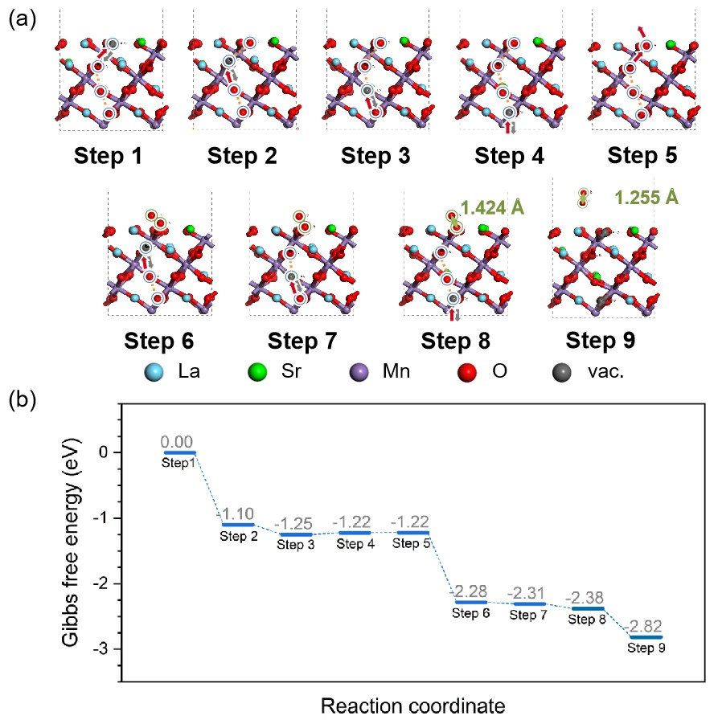
Supplementary Figure 1. Reaction pathways of oxygen evolution reaction on LSM surface at 850 °C at a positive potential of 1.0 V_{SHE}. (a) Structures for each reaction step. (b) Free energy diagram.

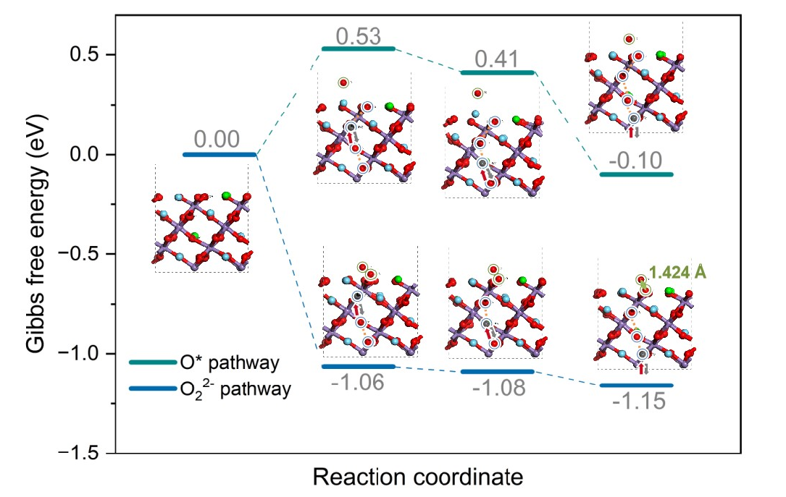
Supplementary Figure 2. Reaction free energy and structures of the reaction step to form O* or O₂²⁻ species.
Supplementary Figure 3. Chronopotentiometry profile of electrolysis at 100 mA cm⁻² using SiO₂ as support in the anode.

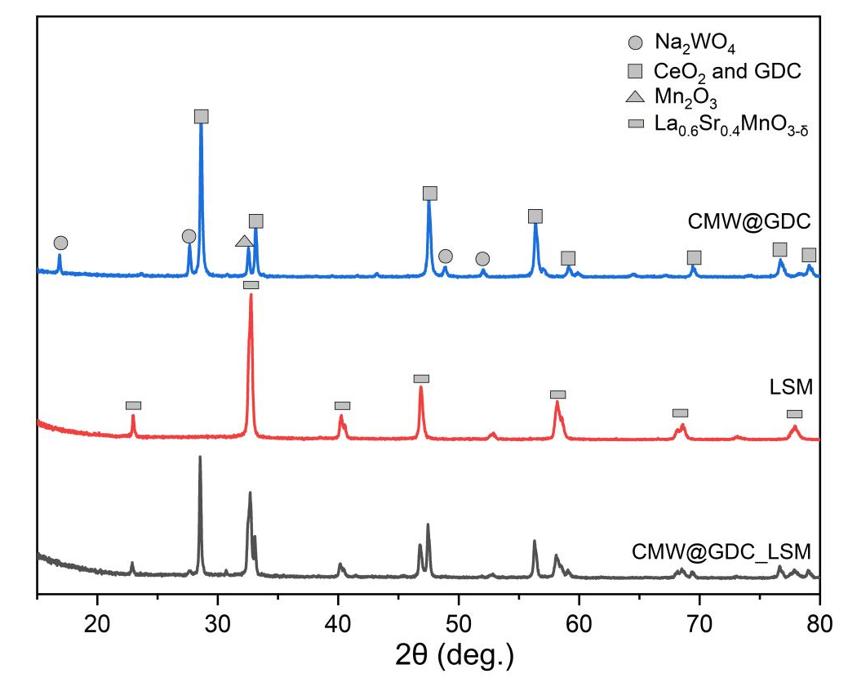
Supplementary Figure 4. XRD patterns of the CMW@GDC, LSM and CMW@GDC_LSM catalysts.
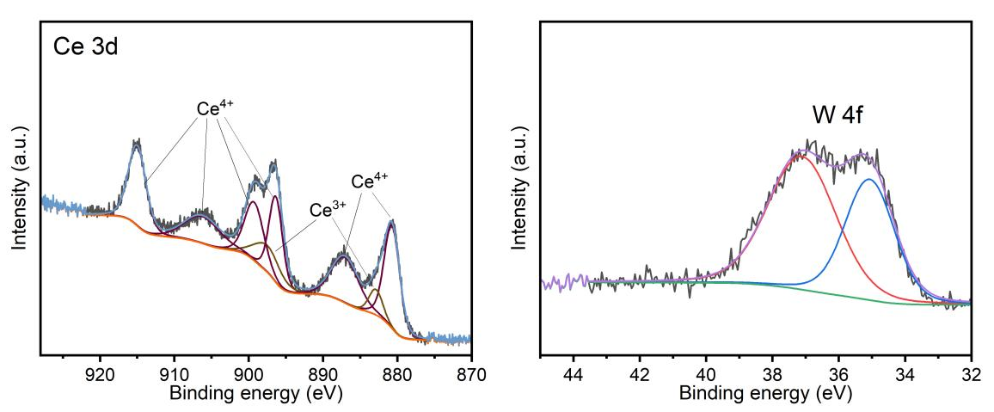
Supplementary Figure 5. XPS spectra of Ce 3d and W 4f of the GDC-supported Ce-Mn-W catalysts.
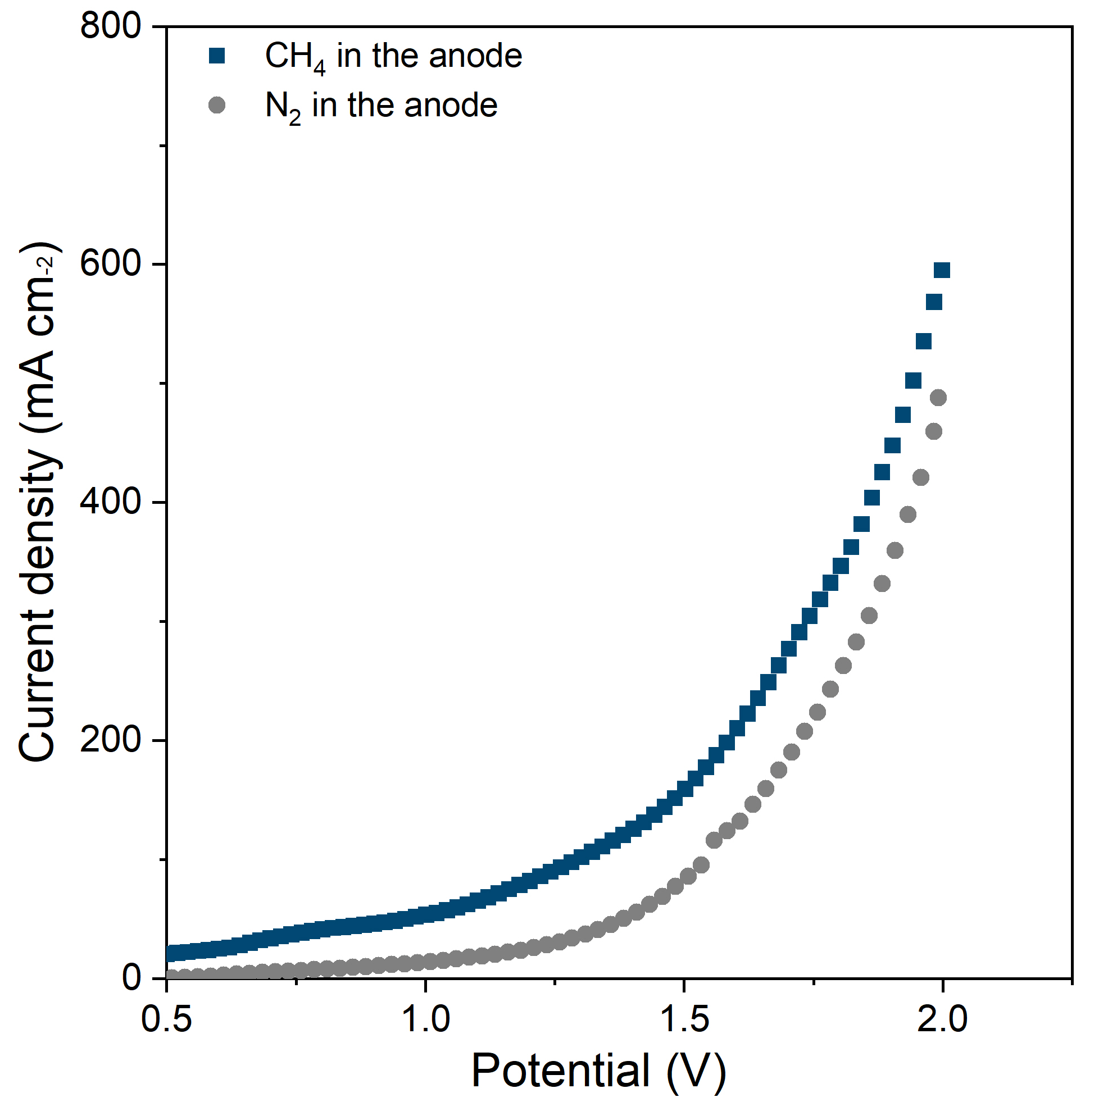
Supplementary Figure 6. Comparison of LSV curves between CH₄ in the anode and N₂ in the anode on composite electrode.

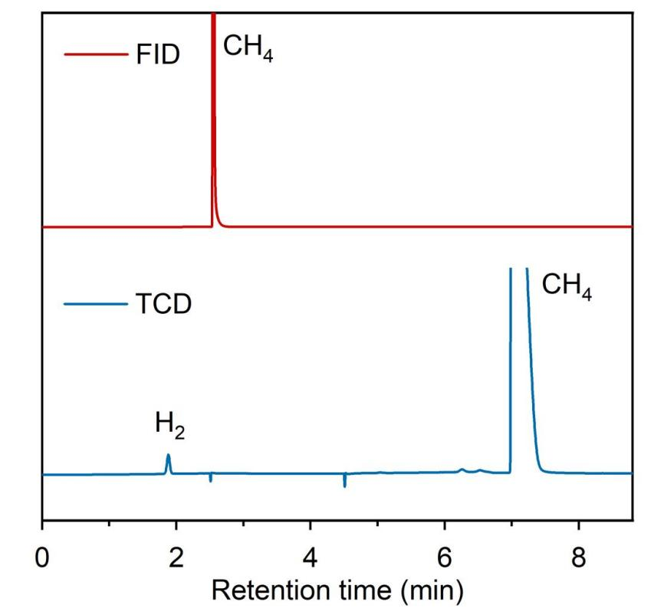
Supplementary Figure 7. GC profile of methane thermal splitting at 850 ℃.

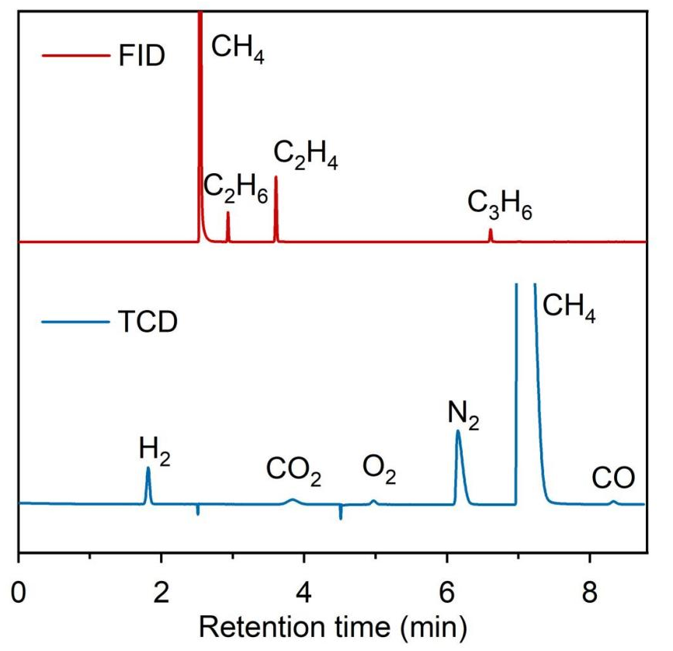
Supplementary Figure 8. GC profile of electrolysis of oxidative coupling of methane using CMW@GDC/LSM as catalyst at 850 ℃.

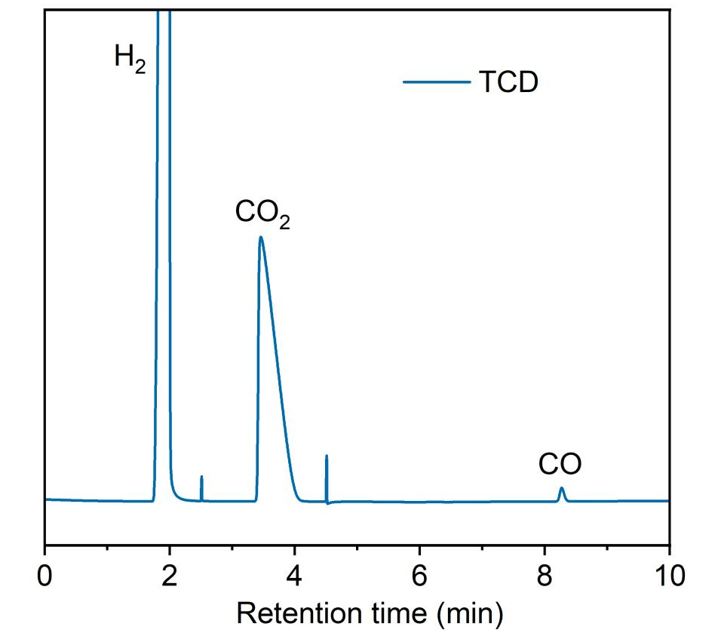
Supplementary Figure 9. GC profile of CO₂ electrolysis coupled with oxidative coupling of methane at 850 ℃.

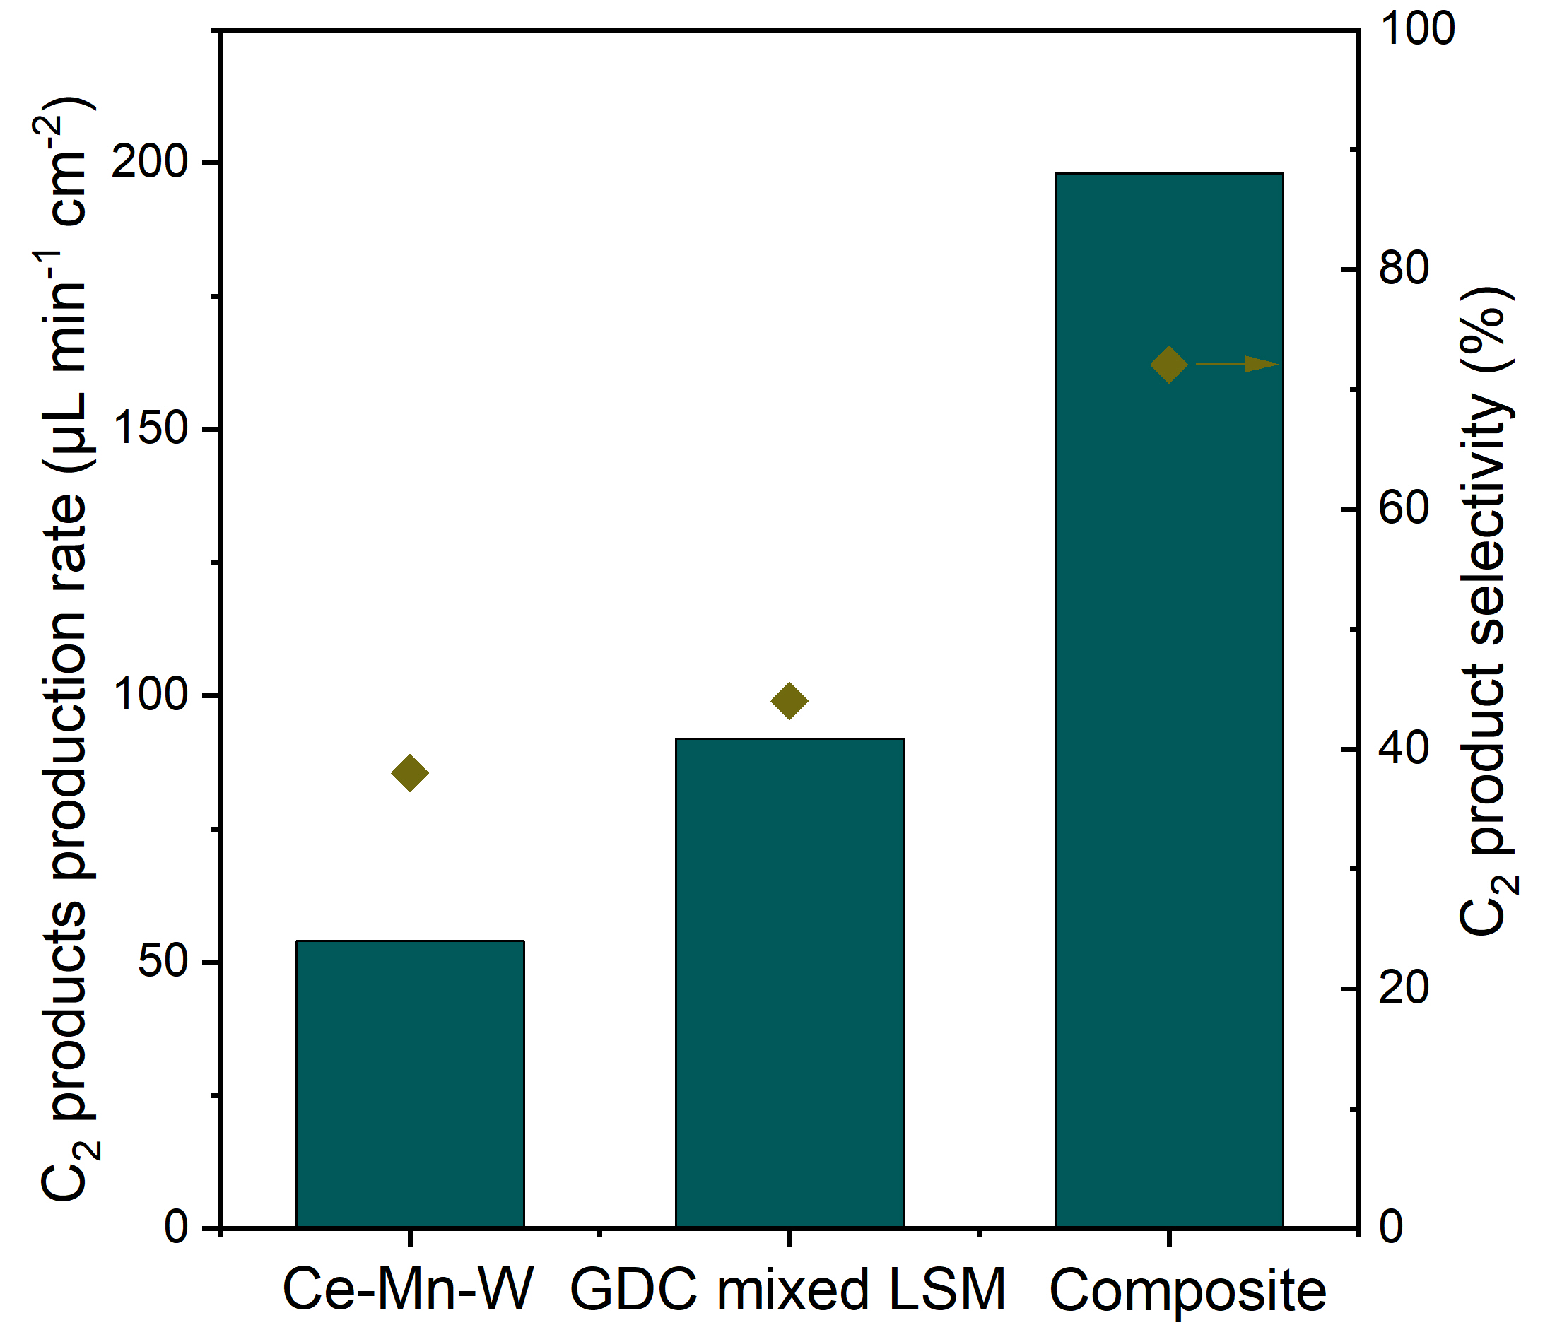
Supplementary Figure 10. Comparison of production rates and selectivity of C2 products on Ce-Mn-W, GDC mixed LSM and composite electrode at 200 mA cm⁻² electrolysis of electrochemical methane coupling.

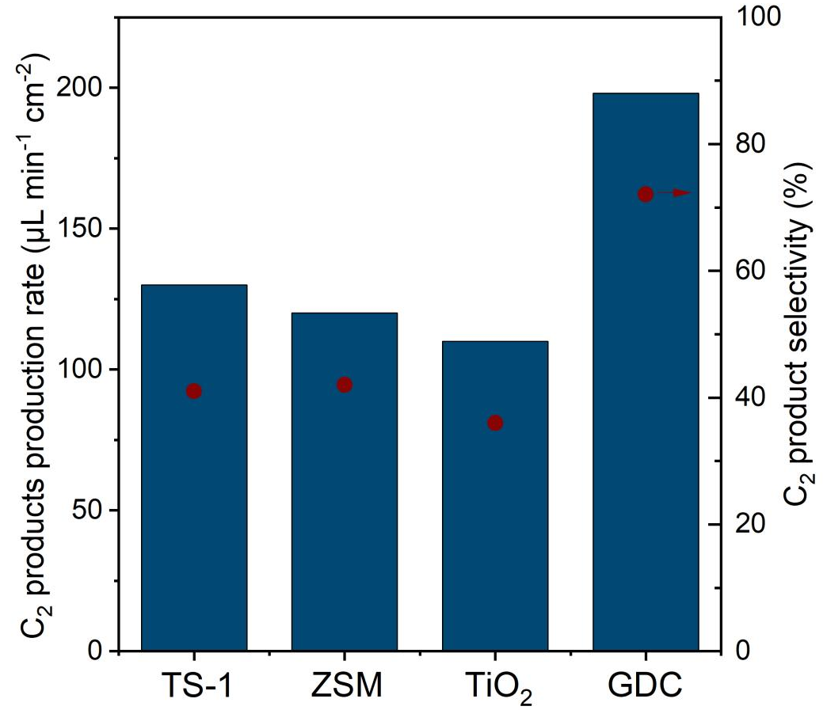
Supplementary Figure 11. Comparison of production rates and selectivity of C₂ products when using TS-1, ZSM, TiO, and GDC to support Ce-Mn-W materials at 200 mA cm⁻² electrolysis of electrochemical methane coupling.

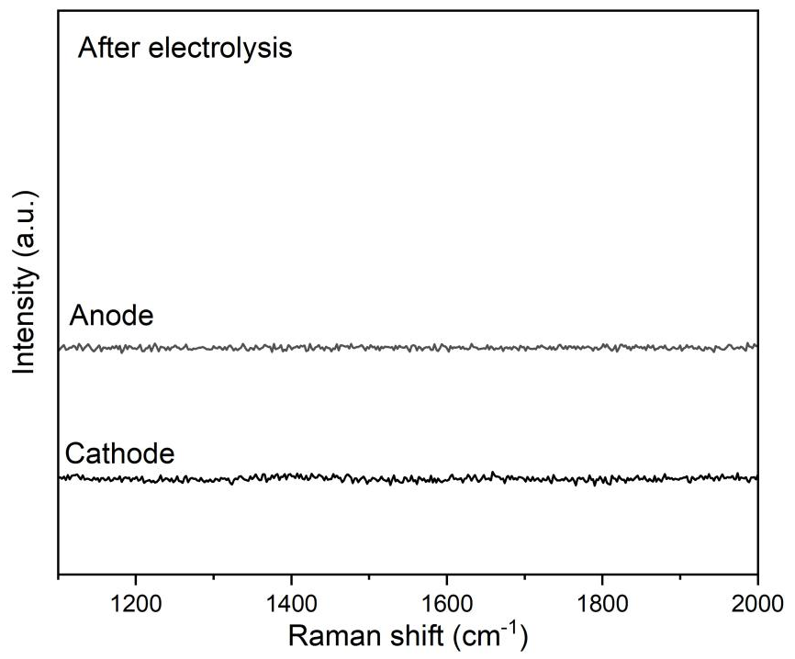
Supplementary Figure 12. Raman spetra of anode and cathode after electrolysis.

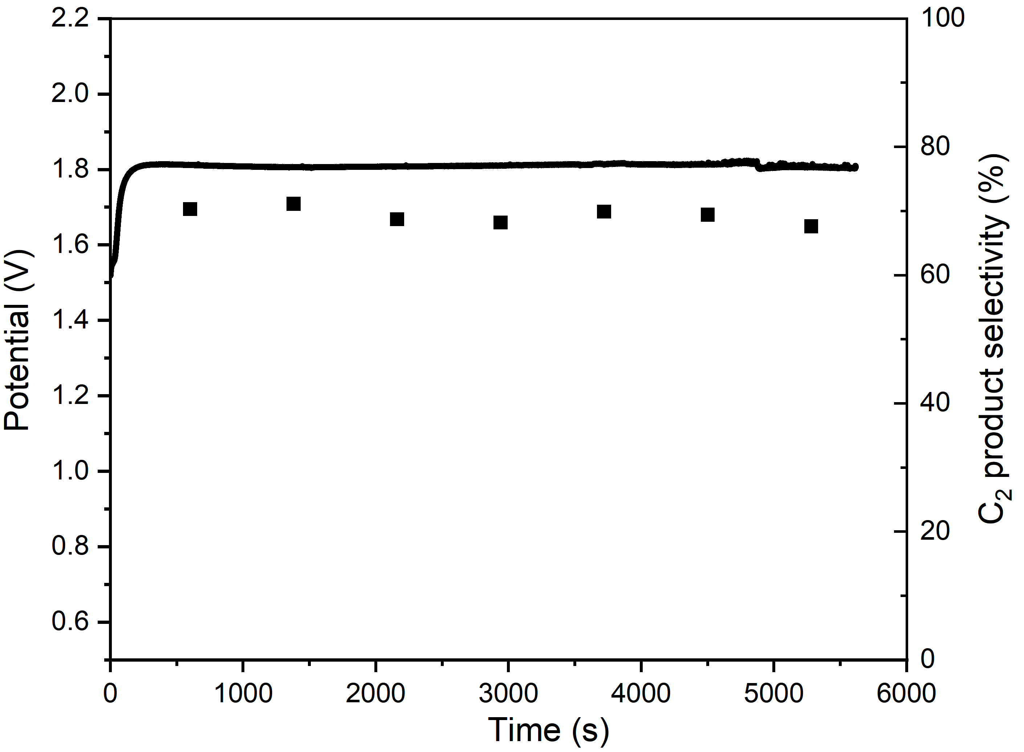
Supplementary Figure 13. Chronopotentiometry profile of electrolysis as well as C₂ product selectivity of electrochemical oxidative coupling of methane at 200 mA cm⁻² using CMW@GDC / LSM as catalyst.
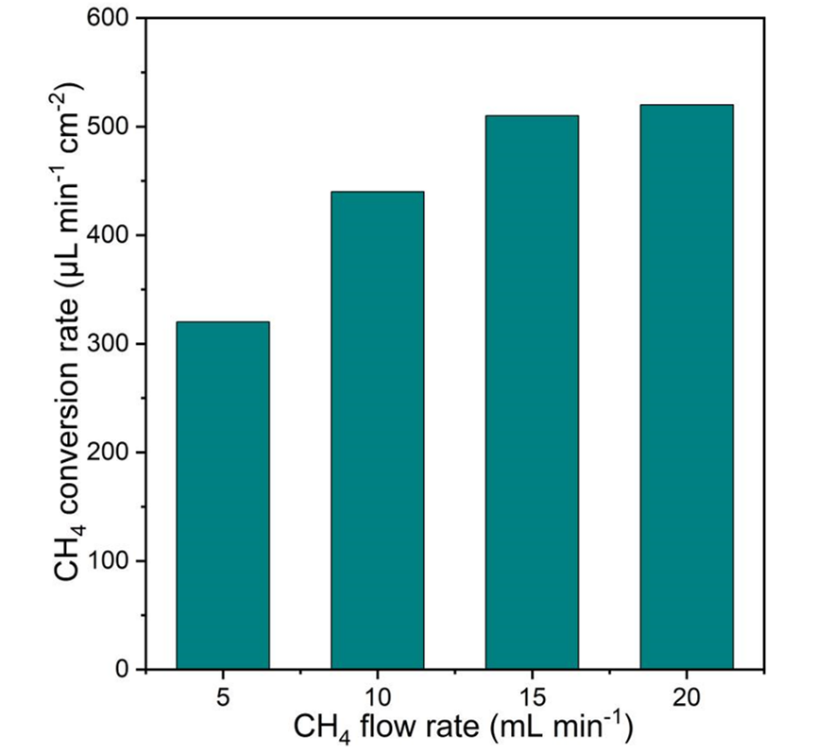
Supplementary Figure 14. Methane conversion rates at various gas flow rate at 200 mA cm⁻² electrolysis.

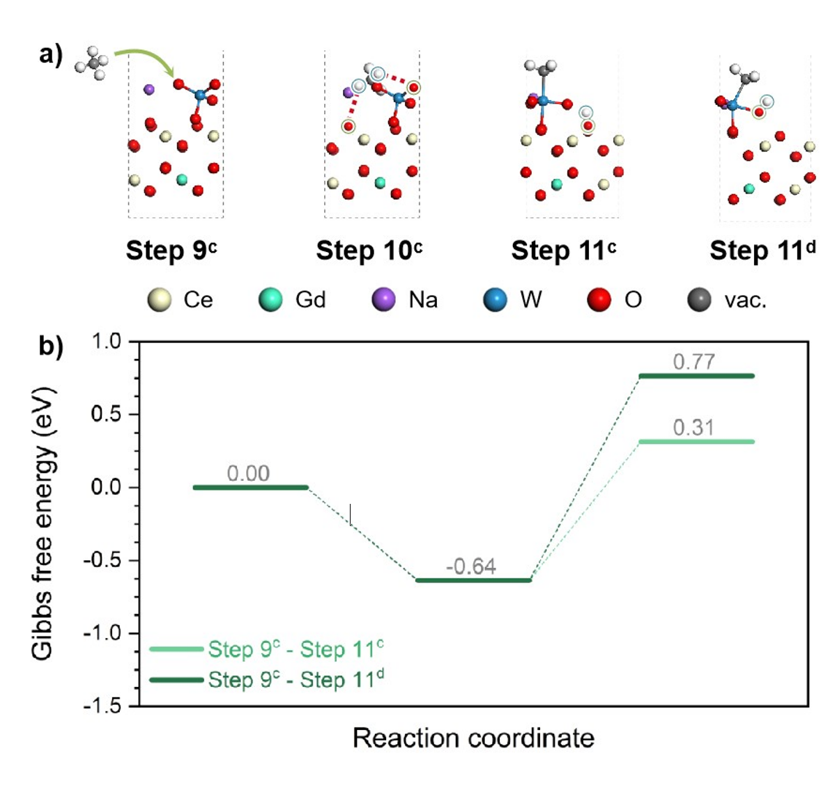
Supplementary Figure 15. (a) Structures and (b) reaction free energy of the C-H bond cleavage on Na₂WO₄@GDC without O₂²⁻.

Table S1 Comparison of the electrochemical methane coupling performance between this work and previous studies
Catalyst | C₂ product production rate  (μL min⁻¹ cm⁻²) | C₂ product selectivity (%) | Reference
Ce-Mn-Na₂WO₄@GDC/LSM | 313 | 80.3 | This Work
La_{0.7}Sr_{0.2}TiO_{3−d} | 163 | 72 | [1]
BaMg_{0.33}Nb_{0.67−x} Fe_{x}O_{3−δ} | 103.4 | 50.3 | [2]
Ag | 21 | 55 | [3]
Ag+Mn-Ce-Na₂WO₄/SiO₂ | 70 | 56 | [4]
La_{0.3}Sr_{0.7}TiO₃ | 13.44 | 40 | [5]
BaCO₃ | 8 | 86.1 | [6]
Bi₂O₃ | 4 | 76.9 | [6]
SrZr_{0.95}Y_{0.05}O_{3−α} | 26.88 | 40 | [7]
LiCl-NiO | 44.8 | 60 | [8]
LSCF/Ag | 76.8 | 18.3 | [9]

References
[1] Xu X, Li H, Han X, Zheng Y. Enhancing electrochemical methane coupling in solid oxide cells by tuning oxygen species in the catalyst. J Mater Chem A., 2024, 12: 5115-5123.
[2] Denoyer LH, Benavidez A, Garzon FH, Ramaiyan KP. Highly stable doped barium niobate based electrocatalysts for effective electrochemical coupling of methane to ethylene. Adv Mater Interfaces., 2022, 9: 2200796.
[3] Caravaca A, de Lucas-Consuegra A, González-Cobos J, Valverde JL, Dorado F. Simultaneous production of H₂ and C₂ hydrocarbons by gas phase electrocatalysis. Appl Catal, B., 2012: 113-114: 192-200.
[4] Caravaca A, de Lucas-Consuegra A, Ferreira VJ, Figueiredo JL, Faria JL, Valverde JL, et al. Coupling catalysis and gas phase electrocatalysis for the simultaneous production and separation of pure H₂ and C₂ hydrocarbons from methane and natural gas. Appl Catal, B., 2013, 142-143: 298-306.
[5] Kodama S, Kikuchi R, Fujiwara N, Tada S, Kobayashi Y, Oyama ST. Oxidative coupling of methane in solid oxide electrolysis cell. ECS Trans., 2019, 91: 2697-705.
[6] Otsuka K, Suga K, Yamanaka I. Oxidative coupling of methane applying a solid oxide fuel cell system. Catal Today., 1990, 6: 587-592.
[7] Kyriakou V, Garagounis I, Stoukides M. Steam electrolysis with simultaneous production of C₂ hydrocarbons in a solid electrolyte cell. Int J Hydrogen Energy, 2014, 39: 675-683.
[8] Otsuka K, Suga K, Yamanaka I. Electrochemical enhancement of oxidative coupling of methane over LiCl-doped NiO using stabilized zirconia electrolyte. Catal Lett., 1988, 1: 423-428.
[9] Tsiakaras P, Athanasiou C, Marnellos G, Stoukides M, ten Elshof J E, Bouwmeester H J M. Methane activation on a La_{0.6}Sr_{0.4}Co_{0.8}Fe_{0.2}O₃ perovskite. Appl Catal, A., 1998, 169: 249-61.

