Supporting Information

Heterogeneous cathode structure engineering for upgraded kinetics in lithium-ion batteries via deep learning
Shaoyu Wang^{1,2}, Xueshi Bai¹,Yingjun Lei¹,Junhao Pei¹, Liang Ma³, Rui Long^{1,2}*, Zhichun Liu¹, and Wei Liu¹
¹School of energy and power engineering, Huazhong University of Science and Technology, Wuhan 430074, China.
²China-EU Institute for Clean and Renewable Energy,
Wuhan University of Technology, Wuhan, 430070, China
³School of Chemistry, Guangzhou Key Laboratory of Materials for Energy Conversion and Storage, South China Normal University, Guangzhou 510006, China
*Correspondence authors: r_long@hust.edu.cn

Table S1. Conditions for real and generated curves for Figure S5
 | Group 1 | Group 2 | Group 3 | Group 4
Thickness | 150 μm | 60 μm | 70 μm | 130 μm
Discharge rate | 4 C | 4 C | 2 C | 2 C
Porosity P1 | 0.525857 | 0.848945 | 0.239021 | 0.582539
Porosity P2 | 0.715675 | 0.26144 | 0.632861 | 0.585579
Porosity P3 | 0.689326 | 0.432679 | 0.612959 | 0.686176
Porosity P4 | 0.573163 | 0.568327 | 0.462525 | 0.849246
Porosity P5 | 0.344426 | 0.372649 | 0.215833 | 0.860947
Porosity P6 | 0.309877 | 0.58003 | 0.311476 | 0.832284
Porosity P7 | 0.481568 | 0.746607 | 0.554741 | 0.622874
Porosity P8 | 0.506303 | 0.565318 | 0.75102 | 0.848347
Porosity P9 | 0.882544 | 0.852365 | 0.733426 | 0.281862
Porosity P10 | 0.848721 | 0.302978 | 0.854027 | 0.438561
Porosity P11 | 0.415645 | 0.491736 | 0.756626 | 0.225711
Porosity P12 | 0.803808 | 0.396205 | 0.517983 | 0.576859
Porosity P13 | 0.592159 | 0.61867 | 0.441079 | 0.71606
Porosity P14 | 0.580914 | 0.225532 | 0.293002 | 0.326856
Porosity P15 | 0.789596 | 0.244581 | 0.592864 | 0.498373
Porosity P16 | 0.75158 | 0.426018 | 0.345331 | 0.268718
Porosity P17 | 0.57546 | 0.268865 | 0.282605 | 0.412255
Porosity P18 | 0.201281 | 0.319031 | 0.737358 | 0.746086
Porosity P19 | 0.459107 | 0.459815 | 0.520079 | 0.575872
Porosity P20 | 0.505285 | 0.227833 | 0.70809 | 0.73835
 | Group 5 | Group 6 | Group 7 | Group 8
Thickness | 130 μm | 40 μm | 130 μm | 70 μm
Discharge rate | 1 C | 1 C | 0.5 C | 0.5 C
Porosity P1 | 0.228554 | 0.299843 | 0.436248 | 0.883312
Porosity P2 | 0.389086 | 0.424287 | 0.500605 | 0.747076
Porosity P3 | 0.325264 | 0.833325 | 0.755645 | 0.854908
Porosity P4 | 0.56941 | 0.629909 | 0.299097 | 0.717407
Porosity P5 | 0.714553 | 0.211129 | 0.625671 | 0.377534
Porosity P6 | 0.842343 | 0.417976 | 0.85144 | 0.703475
Porosity P7 | 0.221419 | 0.33494 | 0.645511 | 0.685459
Porosity P8 | 0.776953 | 0.392828 | 0.233439 | 0.741323
Porosity P9 | 0.793176 | 0.218697 | 0.688842 | 0.723052
Porosity P10 | 0.528745 | 0.781448 | 0.379977 | 0.422869
Porosity P11 | 0.459223 | 0.734995 | 0.683631 | 0.557302
Porosity P12 | 0.252946 | 0.70481 | 0.454226 | 0.741147
Porosity P13 | 0.31897 | 0.775902 | 0.579319 | 0.600971
Porosity P14 | 0.670375 | 0.735181 | 0.355499 | 0.867695
Porosity P15 | 0.61309 | 0.284397 | 0.833841 | 0.320101
Porosity P16 | 0.667452 | 0.469032 | 0.461479 | 0.835065
Porosity P17 | 0.515182 | 0.219546 | 0.255172 | 0.726554
Porosity P18 | 0.754361 | 0.200913 | 0.221651 | 0.400323
Porosity P19 | 0.519059 | 0.204899 | 0.638831 | 0.639187
Porosity P20 | 0.826126 | 0.317449 | 0.855898 | 0.52398

Table S2: Repeated PSO optimization results for electrode thickness and discharge capacity under different discharge rates.
Discharge rate | Thickness (μm) | Discharge capacity (mAh)
0.5C | 150 | 5.1472
0.5C | 150 | 5.1478
0.5C | 150 | 5.1387
0.5C | 150 | 5.1532
0.5C | 150 | 5.1394
1C | 150 | 4.725
1C | 150 | 4.7258
1C | 150 | 4.7221
1C | 150 | 4.7252
1C | 150 | 4.7263
2C | 128 | 3.0891
2C | 128.6 | 3.0914
2C | 130.6 | 3.0892
2C | 128.2 | 3.0912
2C | 131.1 | 3.09551
4C | 71.7 | 1.6299
4C | 71.9 | 1.6267
4C | 71.8 | 1.6261
4C | 72.1 | 1.6317
4C | 71.5 | 1.6285
Table S2 summarizes the repeated PSO optimization results under different discharge rates. Five independent PSO runs were conducted for each discharge rate to evaluate the repeatability of the optimization results. The optimized discharge capacities obtained from different runs are close to each other, and the optimized electrode thickness shows a consistent rate-dependent trend, indicating that the main optimization results are reproducible.

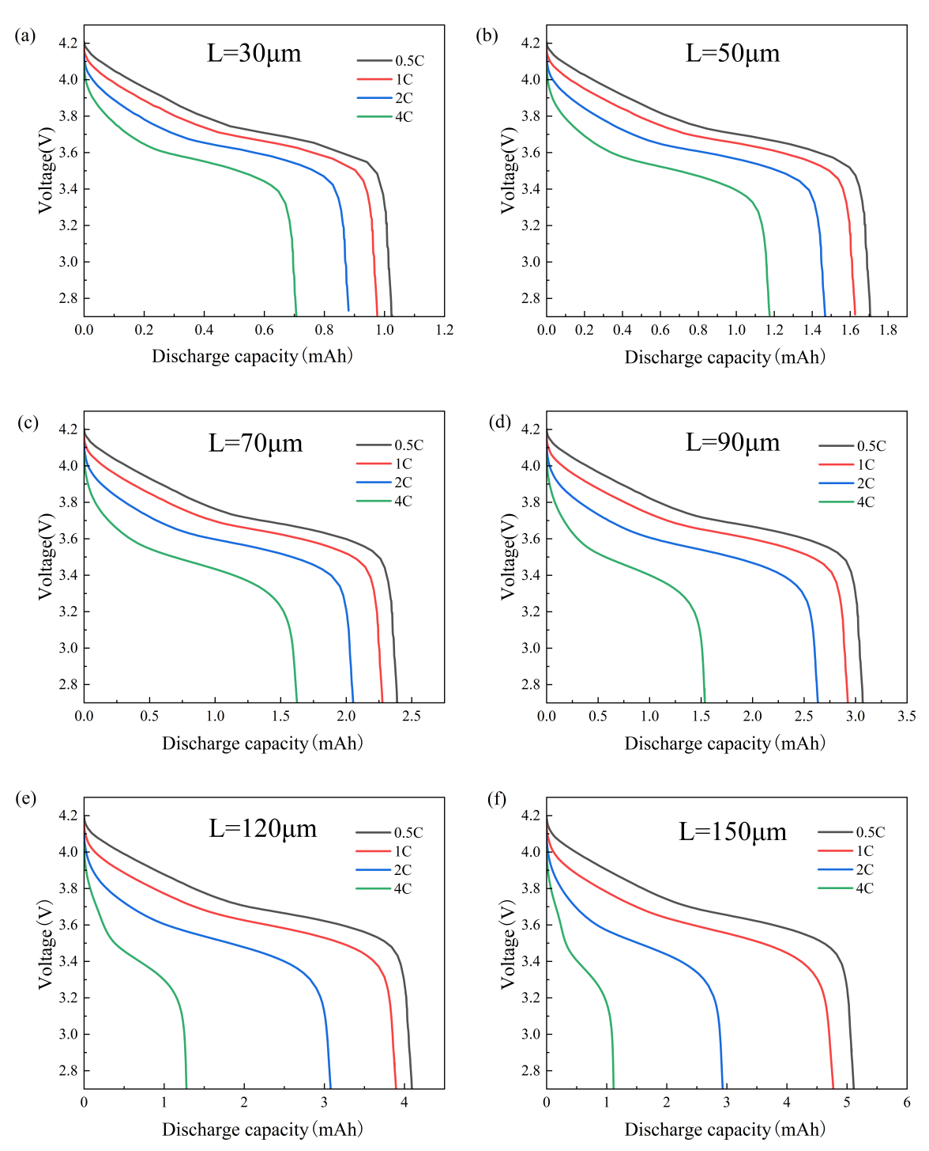
Figure S1. Discharge voltage–capacity curves at different electrode thicknesses under various discharge rates: (a) 30 μm; (b) 50 μm; (c) 70 μm; (d) 90 μm; (e) 120 μm; (f) 150 μm

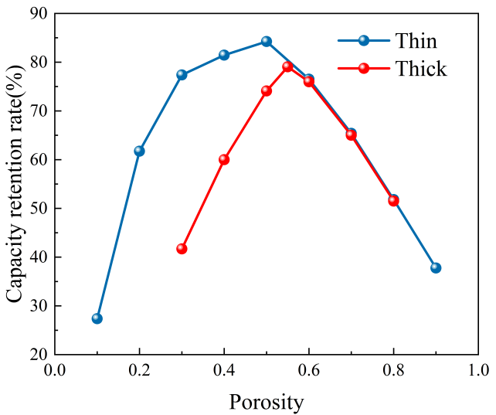
Figure S2. Capacity retention of thin and thick electrodes under different porosities

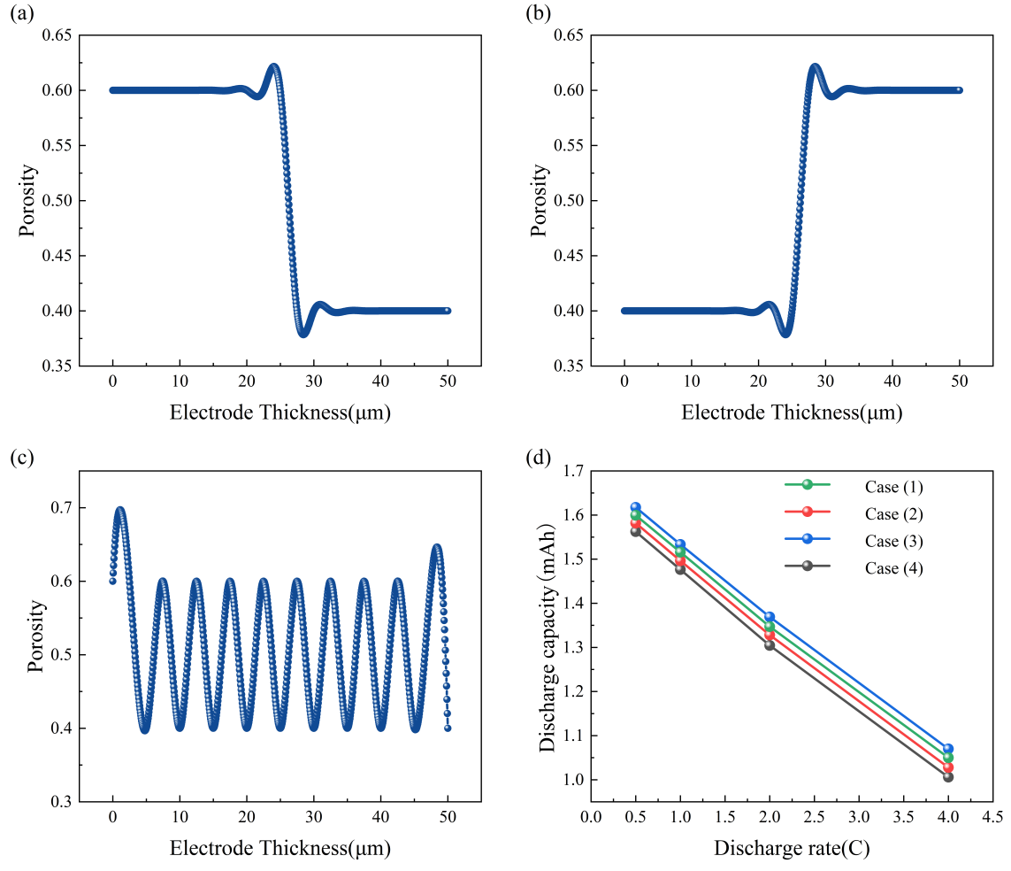
Figure S3. Representative porosity distributions and corresponding discharge capacities under different discharge rates. (a) Porosity distribution with high porosity near the current collector side and low porosity near the separator side; (b) porosity distribution with low porosity near the current collector side and high porosity near the separator side; (c) alternating porosity distribution; (d) discharge capacity under different porosity distributions and discharge rates.
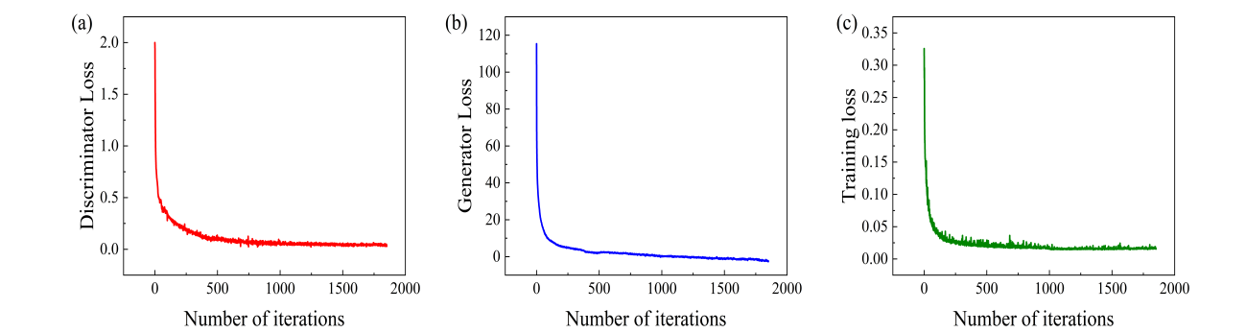
Figure S4. Training loss curves of the cGAN model: (a) generator loss; (b) discriminator loss; (c) validation loss.

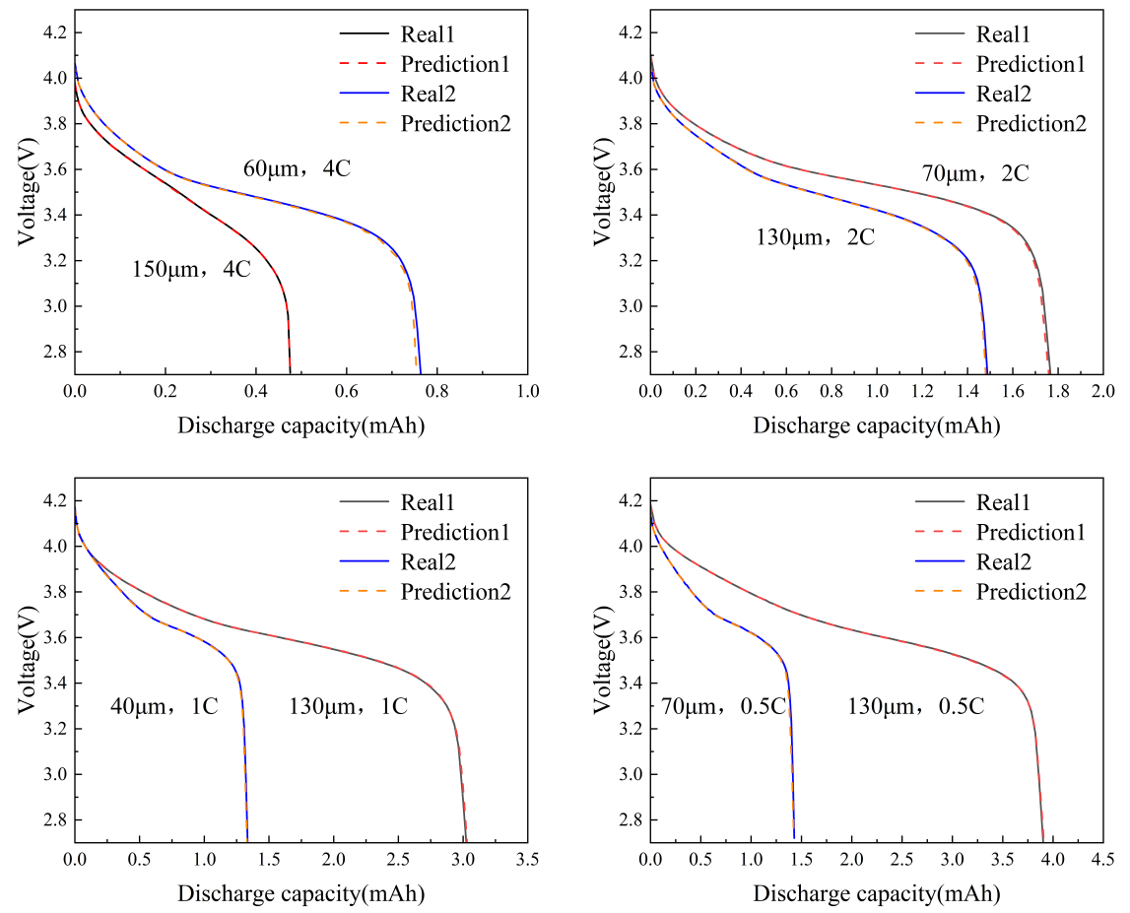
Figure S5. Representative comparisons between simulated and cGAN-generated discharge voltage-capacity curves under different conditions.
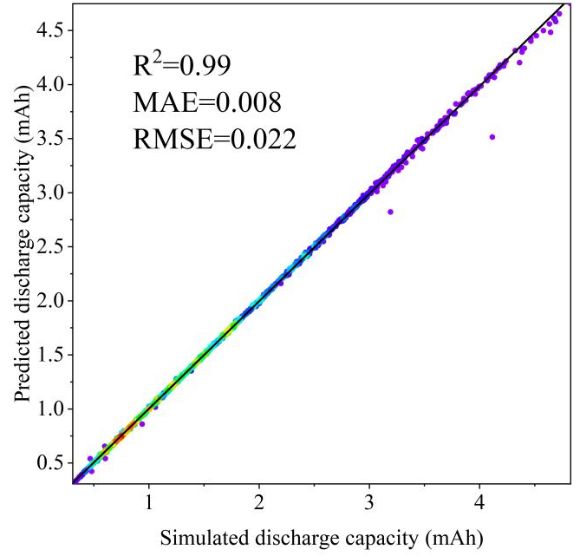
Figure S6. Density-colored scatter plot comparing cGAN-predicted and P2D-simulated discharge capacities on the validation set

