Supporting Information
Oxygen Reduction Reaction Performance of Fe-N-C Catalyst with Dual Nitrogen Source
Yuan Zhao^{1,2}, Quan Wang¹, Rongrong Hu¹, Wenqiang Liu¹, Xiaojuan Zhang¹, Wei Wang¹ (✉), Nicolas Alonso-Vante³, Dongdong Zhu⁴
¹ School of Materials Engineering, Jinling Institute of Technology, Nanjing 211169, China
² School of Energy and Power Engineering, Nanjing University of Science and Technology, Nanjing 210094, China
³ IC2MP, UMR-CNRS 7285, University of Poitiers, F-86022 Poitiers Cedex, France
⁴ School of Chemistry and Materials Science, Institute of Advanced Materials and Flexible Electronics (IAMFE), Nanjing University of Information Science and Technology, Nanjing 210044, China
(✉) Corresponding author. Fax: Tel/Fax: +86-25-52112626
E-mail: wangwei@jit.edu.cn (Wei Wang);

Characterizations.
X-ray diffraction (XRD) data were recorded on Ultima IV in the scattered angle region from 10° to 60° with a step scan of 10° min⁻¹. Raman spectroscopy (RS) was carried out on Via of Renishaw using the air cooled 532 nm Ar-ion laser. The BET specific surface area, and pore size distribution of the samples were characterized by nitrogen sorption using an Autosorb AS-6B instrument from Quantachrome. X-ray photoelectron spectroscopy (XPS) was carried out using an ESCALAB 210 XPS system. Binding energy calibration was carried out by setting the binding energy of C1s peak at 284.8 eV. Field emission scanning electron microscope (FE-SEM) was implemented on HITACHI SU-4800 microscope, and transmission electron microscopy (TEM) was taken on FEI Tecnai G2 T20.
Electrochemical Measurements.
Electrochemical measurements of the catalysts were carried out on a conventional three-electrode system on a CHI 660D electrochemical workstation (Shanghai Chenhua, China). A rotating disk electrode (RDE, Pine Research Instrumentation, USA) of catalyst-coated glassy carbon (GC, 5 mm diam.) was used as working electrode, saturated calomel electrode and carbon plate was utilized as reference and counter electrode, respectively. The ink consisting of 25 µL of the catalyst suspension, prepared by mixing 5.0 mg catalyst, 1.0 mL of ethanol and water (V_{ethanol}: V_{water} = 4:1), and 50 μL of 5% Nafion®, was dropped onto the GC and dried at room temperature. ORR data were obtained at 25 °C in 0.1 M KOH. The mass loading, on the glassy carbon electrode surface, of commercial Pt/C (20 wt.%) was 12.755 μg cm⁻². The ORR activity of commercial Pt/C was also tested under the same conditions. The cyclic voltammetry (CV) curves of the catalysts were measured in 0.1 M KOH solution saturated with O₂ or N₂ in the potential region from -0.8 to 0.2 V (vs. SCE) at a scan rate of 50 mV s⁻¹. Linear sweep voltammetry (LSV) plots of the catalysts were implemented in 0.1 M KOH solution saturated with O₂ in a potential range of -0.8 to 0 V (vs. SCE) at a scan rate of 5 mV s⁻¹, at RDE rotation speeds from 400 to 2025 rpm. The methanol-tolerance capacity of the catalysts was measured by adding 3.0 M methanol in O₂-saturated 0.1 M KOH after 100 s of chronoamperometric testing. In this work, all potentials are quoted versus the reversible hydrogen electrode (RHE) scale. The Koutecky–Levich equation shown below was used to analyze the kinetic activity and mas transport in the system ²⁷:
(1)
(2)
Where J is the overall current density, J_{L} is the diffusion-limiting current density, J_{K} is the kinetic current density, ω is the angular velocity of the disk (ω = 2πN; N is the linear rotation speed), F is the Faraday constant (F = 96485 C mol⁻¹), C_{O2} is the concentration of O₂ in 0.1 M KOH (C_{O2}=1.2×10^{–6} mol cm⁻³), D_{O2} is the diffusion coefficient of O₂ in 0.1 M KOH (1.9×10⁻⁵ cm² s⁻¹), ν is the kinematic viscosity of the electrolyte (ν =0.01 cm² s⁻¹), and n is the overall number of electrons transferred in the oxygen reduction process. According to equations (1) and (2), the electron transfer number (n) can be obtained from the slope of the Koutecky–Levich plots.
The EASA is the area of the working electrode participating in the double-layer charge and is related to the gravimetric double layer capacitance C(F/g) at a given scan rate, C = I/(υ m), where I is the current, m is the electrode mass loading, and υ is the scan rate. The EASA can be estimated as the specific value from the gravimetric capacitance C of carbon support materials by the equation. EASA = C/C_{GC}，where C_{GC} is the double layer capacitance (F/m²) of the glassy carbon electrode surface, for which the typical value of 0.2 F/m² was used

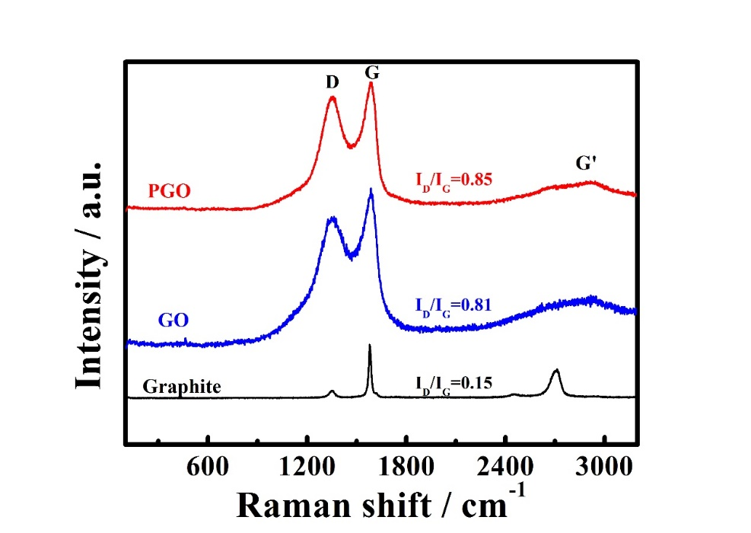
Fig. S1. Raman spectra of graphite, GO and PGO.
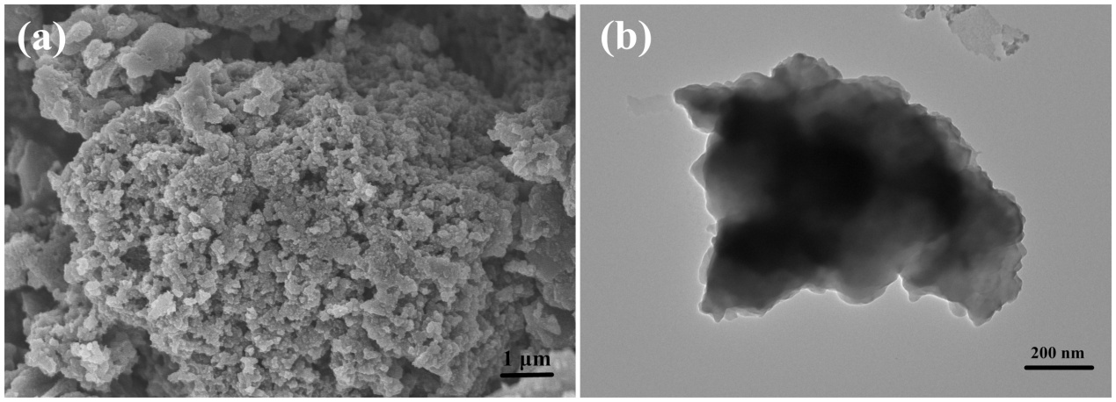
Fig. S2 (a) SEM, and (b) TEM images of the precursor of Fe-PD/PGO.
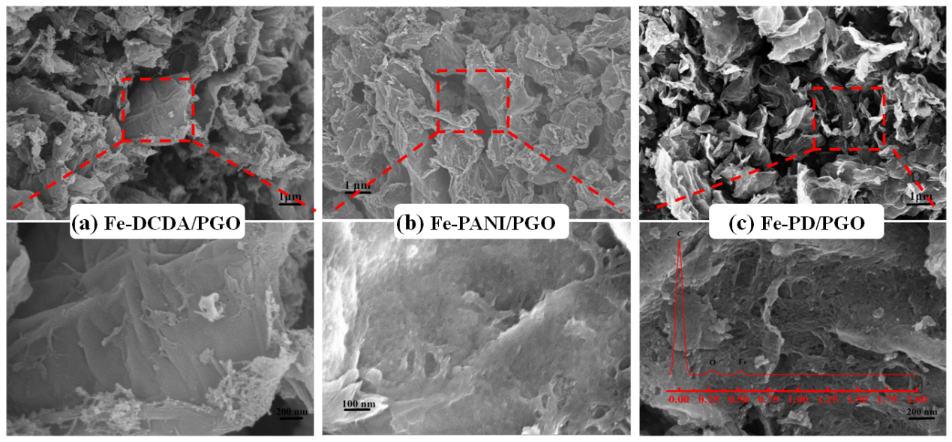
Fig. S3 SEM images of (a) Fe-DCDA/PGO, (b) Fe-PANI/PGO, and (c) SEM image and EDX analyses of Fe-PD/PGO.

Fig. S4 (a) XPS survey spectra and (b) XPS high-resolution Fe 2p spectra for Fe-DCDA/PGO, Fe-PANI/PGO, and Fe-PD/PGO catalysts
Fig. S5 Polarization curves and K-L equation of (a) (b) Fe-PANI/PGO, (c) (d) Fe-PD/PGO, and (e) (f)Pt/C catalysts
Fig. S6 (a) CV and (b) LSV plots of catalysts prepared with different PANI/DCDA ratios in 0.1 mol·L⁻¹ KOH saturated with N₂ and O₂, respectively; (c) Tafel slope; (d) performance parameter bar chart

Table S1 Tafel slope of catalysts prepared from different nitrogen sources.
Catalysts | Tafel slope（mV·dec⁻¹）
Fe-DCDA/PGO | 96.0
Fe-PANI/PGO | 82.6
Fe-PD/PGO | 76.8
Pt/C | 77.9

Table S2 Tafel slope of catalysts prepared with different PANI/DCDA ratios.
Catalysts | Tafel slope（mV·dec⁻¹）
Fe-PD(1:1)/PGO | 79.5
Fe-PD(2:3)/PGO | 83.1
Fe-PD(1:2)/PGO | 79.2
Fe-PD(2:5)/PGO | 75.9
Fe-PD(1:3)/PGO | 82.6

