Supplementary Material
Tailoring GaN Nanorods with MoS₂ on Tungsten Foil for Enhanced Photoelectrochemical Performance

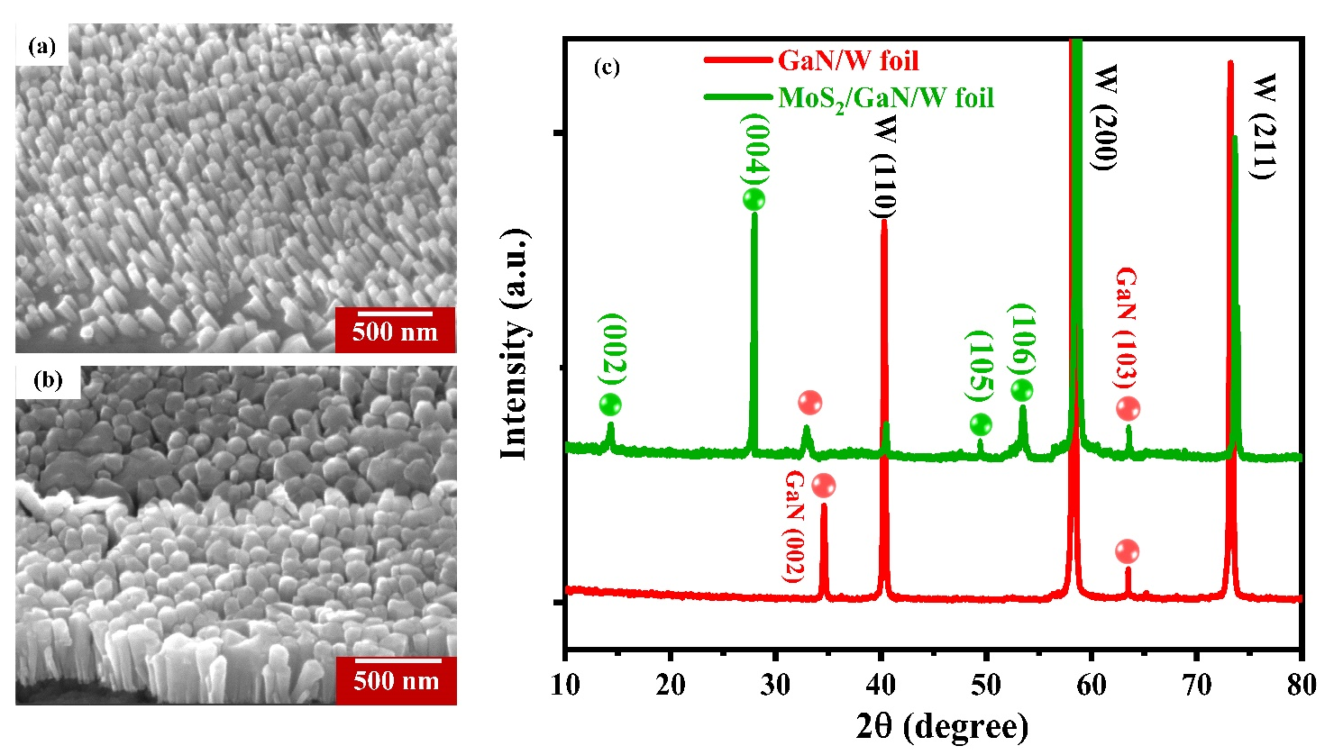

Supplementary Fig. S1. The 45° tilted view FESEM images of: (a) GaN nanorods and (b) MoS₂ coated GaN on W foil. (c) XRD pattern of GaN and MoS₂ coated GaN on W foil.

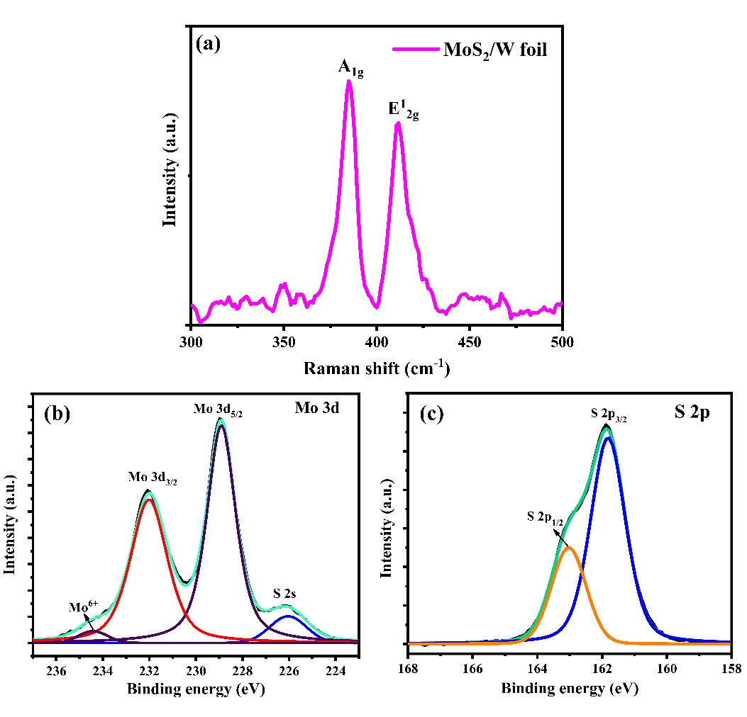

Supplementary Fig. S2. (a) Raman spectrum of MoS₂ on W foil. Chemical composition of MoS₂ grown on bare W foil; XPS core level scan of (b) Mo 3d and (c) S 2p.

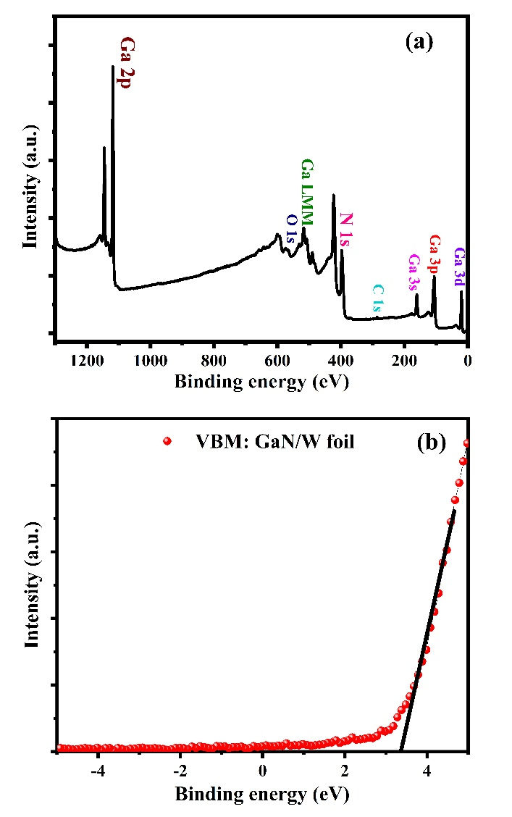

Supplementary Fig. S3. (a) XPS survey scan of GaN/W foil containing Ga, and N elements at surface (b) VBM spectrum of GaN/W foil.

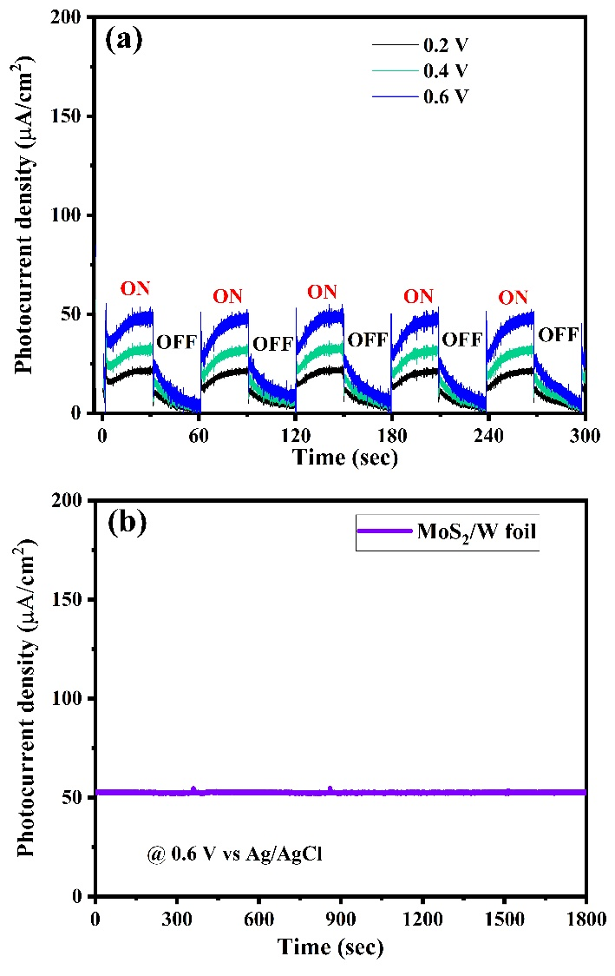

Supplementary Fig. 4. (a) The I-t curve of MoS₂ on W foil at 0.2 V, 0.4 V and 0.6 V vs Ag/AgCl and (b) PEC stability of MoS₂ on W foil in 0.5 M Na₂SO₄ electrolyte at 0.6 V vs Ag/AgCl.

