Supporting information:
Three-phase anode enabling high water splitting performance of protonic solid oxide electrolysis cell
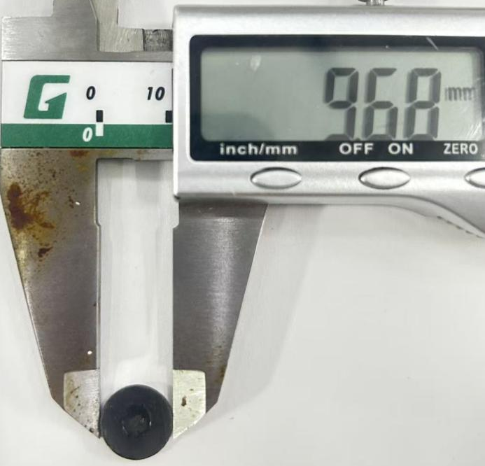
Fig. S1 Photograph of a representative single cell (button cell) with a diameter of approximately 10 mm.

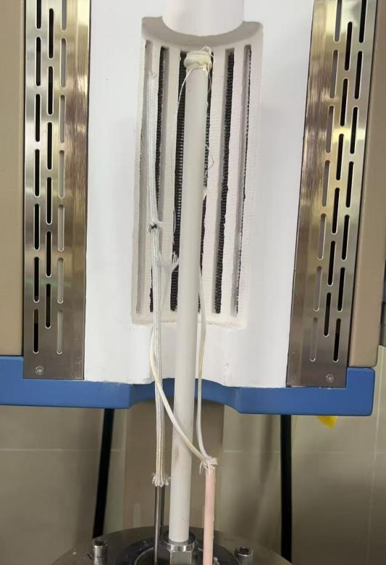
Fig. S2 Photograph of the actual P-SOEC testing setup
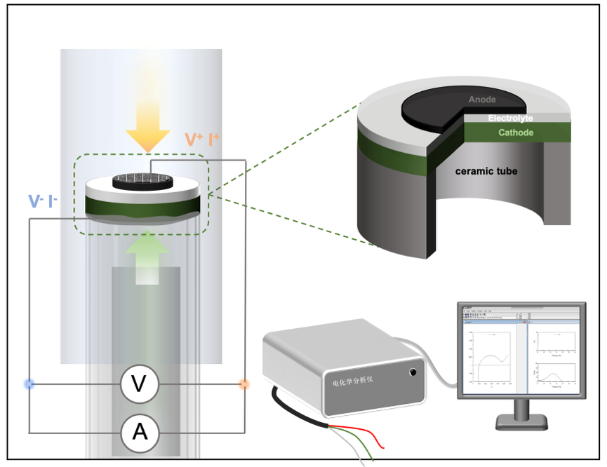
Fig. S3 Schematic diagram of the P-SOEC testing setup, illustrating the measurement configuration.

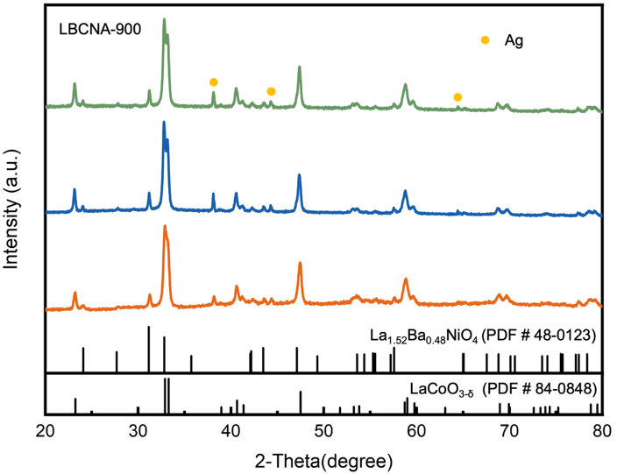
Fig. S4 XRD patterns of three independently synthesized batches of LBCNA-900 prepared using the same citric acid sol-gel method.

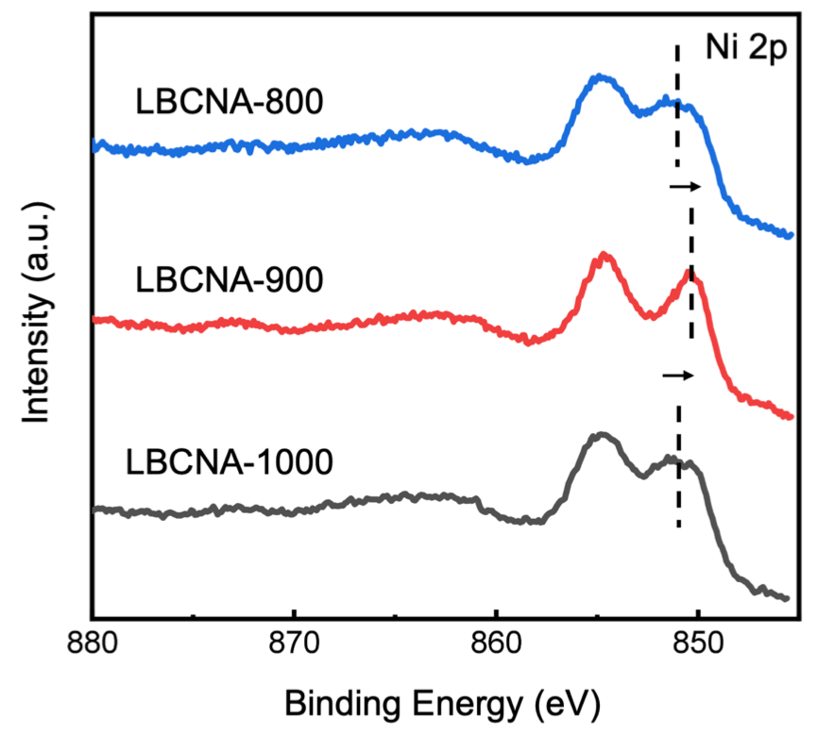
Fig. S5 XPS spectra of Ni 2p for three LBCNA oxides.

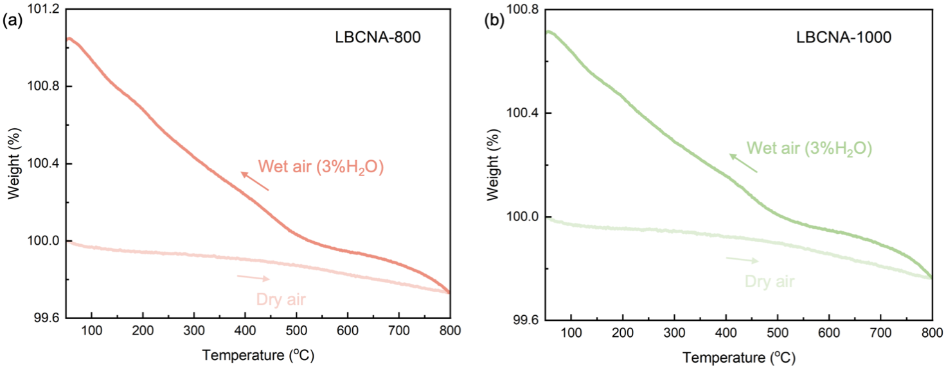
Fig. S6 TG results of (a) LBCNA-800 and (b) LBCNA-1000 sample under dry and humid air (p_{H2O} = 0.02 atm) from 50 to 800 °C;

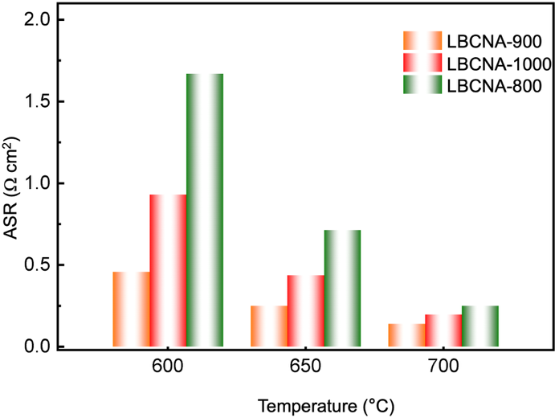
Fig. S7 The EIS of GDC electrolyte-supported symmetrical cells: the comparison of ASR for three electrodes.

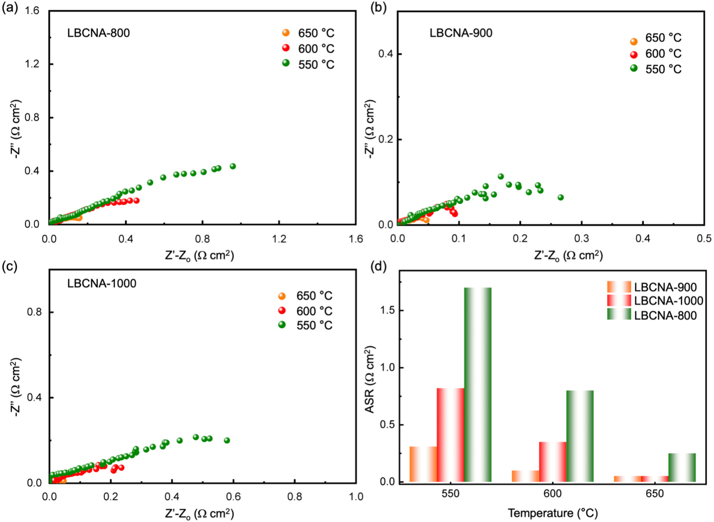
Fig. S8 The EIS of BZCYYb4411 electrolyte-supported symmetrical cells with (a) LBCNA-800, (b) LBCNA-900, and (c) LBCNA-1000 electrodes. (d) The comparison of ASR for three electrodes.
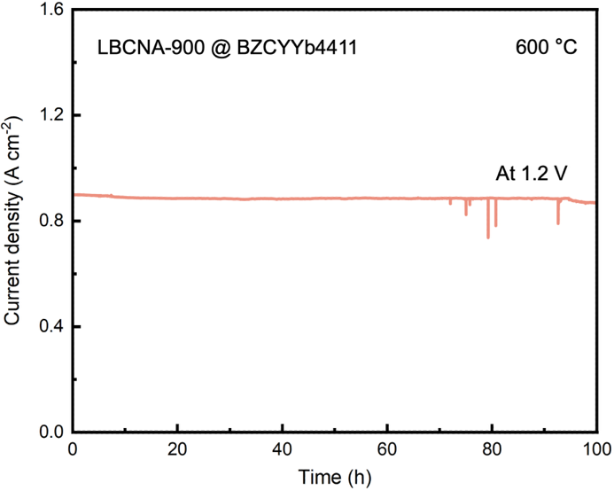
Fig. S9 the stability of P-SOEC with LBCNA-900 anode at 600 °C and a constant voltage of 1.2 V.

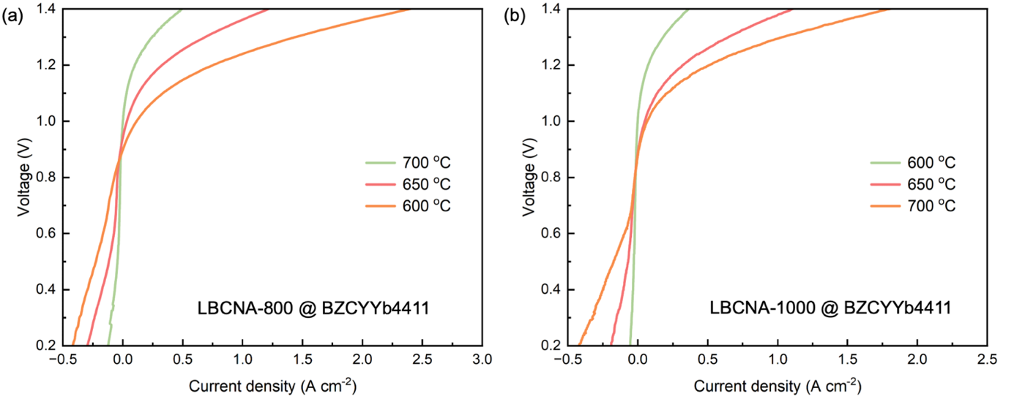
Fig. S10. (a) I-V curves of P-SOEC with (a) LBCNA-800 and (b) LBCNA-1000 anode at 600-700 °C

Table S1 XRD refinement results of LBCNA oxides.

LBCNA-800 | a(Å) | b(Å) | c(Å) | R_{p} (%) | R_{wp} (%) | R_{exp} (%) | Chi² | Space group
R-LBCNA | 5.4521 | 5.4521 | 13.1616 | 9.48 | 12.1 | 10.25 | 1.39 | $$\text{R}\overline{\text{3}}\text{c}$$
RP-LBCNA | 3.8559 | 3.8559 | 12.8123 |  |  |  |  | I4/mmm
Ag | 4.0847 | 4.0847 | 4.0847 |  |  |  |  | Fm$\overline{\text{3}}$m

LBCNA-900 | a(Å) | b(Å) | c(Å) | R_{p} (%) | R_{wp} (%) | R_{exp} (%) | Chi² | Space group
R-LBCNA | 5.4489 | 5.4489 | 13.1493 | 2.18 | 2.81 | 1.95 | 2.07 | $$\text{R}\overline{\text{3}}\text{c}$$
RP-LBCNA | 3.8541 | 3.8541 | 12.8189 |  |  |  |  | I4/mmm
Ag | 4.0849 | 4.0849 | 4.0849 |  |  |  |  | Fm$\overline{\text{3}}$m

LBCNA-1000 | a(Å) | b(Å) | c(Å) | R_{p} (%) | R_{wp} (%) | R_{exp} (%) | Chi² | Space group
R-LBCNA | 5.4546 | 5.4546 | 13.1769 | 4.52 | 5.67 | 7.72 | 0.54 | $$\text{R}\overline{\text{3}}\text{c}$$
RP-LBCNA | 3.8556 | 3.8556 | 12.8138 |  |  |  |  | I4/mmm
Ag | 4.0864 | 4.0864 | 4.0864 |  |  |  |  | Fm$\overline{\text{3}}$m

Table S2 XPS fitting results of O 1s spectra for LBCNA oxides.
Samples |  | O1s
 |  | Lattice oxygen | Adsorbed oxygen | hydroxylated oxygen species | Absorbed surface water
 |  | O_{lat} | O_{ad} | O_{OH} | O_{H2O}
LBCNA-800 | Position (eV) | 528.74 | 529.70 | 531.21 | 532.73
LBCNA-800 | Area ratio (%) | 29.9 | 8.58 | 46.04 | 15.48
LBCNA-900 | Position (eV) | 528.87 | 529.87 | 531.20 | 532.70
LBCNA-900 | Area ratio (%) | 38.66 | 13.68 | 37.07 | 10.59
LBCNA-1000 | Position (eV) | 528.65 | 529.65 | 531.17 | 532.71
LBCNA-1000 | Area ratio (%) | 29.06 | 9.10 | 43.41 | 18.43

Table S3 XPS fitting results of Ba 3d+Co 2p spectra for LBCNA oxides.
Samples |  | Ba 3d+Co 2p
 |  | Co³⁺ | Co²⁺ | Ba²⁺
LBCNA-800 | Position (eV) | 778.5/793.6 | 781.04/796.55 | 779.91/795.1
LBCNA-800 | Area ratio (%) | 18.90 | 26.46 | 47.67
LBCNA-900 | Position (eV) | 778.5/793.7 | 781.00/796.66 | 780.00/795.3
LBCNA-900 | Area ratio (%) | 28.98 | 19.64 | 51.39
LBCNA-1000 | Position (eV) | 778.5/793.7 | 781.00/796.64 | 780.18/795.4
LBCNA-1000 | Area ratio (%) | 28.65 | 21.84 | 42.81

Table S4 XPS fitting results of Ag 3d spectra for LBCNA oxides.
Samples |  | Ag 3d
 |  | Ag⁺ | Ag⁰
LBCNA-800 | Position (eV) | 368.50/374.46 | 368.90/374.94
LBCNA-800 | Area ratio (%) | 69.18 | 30.82
LBCNA-900 | Position (eV) | 368.22/374.24 | 368.68/374.64
LBCNA-900 | Area ratio (%) | 78.49 | 21.51
LBCNA-1000 | Position (eV) | 368.3/374.3 | 368.70/374.70
LBCNA-1000 | Area ratio (%) | 77.25 | 22.75

Table S5 The summary of ASR values for this work and other reported excellent anodes.

Anodes | Temperature (°C) | ASR(Ω cm²) | Refs
BaCo_{0.4}Fe_{0.4}Zr_{0.2}O_{3-δ}  (BCFZ) | 650 | 0.61 | [1]
BaCo_{0.4}Fe_{0.4}Zr_{0.2}O_{3-δ}  (BCFZ) | 600 | 1.03 | [1]
BaCo_{0.4}Fe_{0.4}Zr_{0.2}O_{3-δ}  (BCFZ) | 550 | 1.92 | [1]
Nd_{0.5}Ba_{0.5}Fe_{0.9}Co_{0.1}O_{3-δ}  (NBFC) | 650 | 0.39 | [2]
Nd_{0.5}Ba_{0.5}Fe_{0.9}Co_{0.1}O_{3-δ}  (NBFC) | 600 | 1 | [2]
Nd_{0.5}Ba_{0.5}Fe_{0.9}Co_{0.1}O_{3-δ}  (NBFC) | 550 | - | [2]
Ba₂Co_{1.5}Mo_{0.25}Nb_{0.25}O_{6-δ}  (BC1.5MN) | 650 | 0.6 | [3]
Ba₂Co_{1.5}Mo_{0.25}Nb_{0.25}O_{6-δ}  (BC1.5MN) | 600 | 1.0 | [3]
Ba₂Co_{1.5}Mo_{0.25}Nb_{0.25}O_{6-δ}  (BC1.5MN) | 550 | 1.8 | [3]
Ba_{0.5}Sr_{0.5}Co_{0.8}Fe_{0.2}O_{3-δ}  (BSCF) | 650 | 0.79 | [4]
Ba_{0.5}Sr_{0.5}Co_{0.8}Fe_{0.2}O_{3-δ}  (BSCF) | 600 | 1.31 | [4]
Ba_{0.5}Sr_{0.5}Co_{0.8}Fe_{0.2}O_{3-δ}  (BSCF) | 550 | 1.99 | [4]
La_{0.6}Sr_{0.4}Co_{0.2}Fe_{0.8}O_{3-δ}  (LSCF) | 650 | 0.18 | [5]
La_{0.6}Sr_{0.4}Co_{0.2}Fe_{0.8}O_{3-δ}  (LSCF) | 600 | 0.51 | [5]
La_{0.6}Sr_{0.4}Co_{0.2}Fe_{0.8}O_{3-δ}  (LSCF) | 550 | 1.05 | [5]
BaCo_{0.4}Fe_{0.4}Zr_{0.1}Y_{0.1}O_{3-δ}  (BCFZY) | 650 | 0.40 | [6]
BaCo_{0.4}Fe_{0.4}Zr_{0.1}Y_{0.1}O_{3-δ}  (BCFZY) | 600 | 0.85 | [6]
BaCo_{0.4}Fe_{0.4}Zr_{0.1}Y_{0.1}O_{3-δ}  (BCFZY) | 550 | 1.15 | [6]
Sr₂Sc_{0.1}Nb_{0.1}Co_{1.5}Fe_{0.3}O_{6-δ}  (SSNCF) | 650 | 0.11 | [7]
Sr₂Sc_{0.1}Nb_{0.1}Co_{1.5}Fe_{0.3}O_{6-δ}  (SSNCF) | 600 | 0.23 | [7]
Sr₂Sc_{0.1}Nb_{0.1}Co_{1.5}Fe_{0.3}O_{6-δ}  (SSNCF) | 550 | 0.47 | [7]
Ba_{0.5}Sr_{0.5}Sc_{0.175}Nb_{0.025}Co_{0.8}O_{6-δ}  (BSSNC) | 650 | 0.25 | [8]
Ba_{0.5}Sr_{0.5}Sc_{0.175}Nb_{0.025}Co_{0.8}O_{6-δ}  (BSSNC) | 600 | 0.66 | [8]
Ba_{0.5}Sr_{0.5}Sc_{0.175}Nb_{0.025}Co_{0.8}O_{6-δ}  (BSSNC) | 550 | 1.86 | [8]
SrCo_{0.8}Fe_{0.15}Zr_{0.05}O_{3-δ}  (SCFZ) | 650 | 0.15 | [9]
SrCo_{0.8}Fe_{0.15}Zr_{0.05}O_{3-δ}  (SCFZ) | 600 | 0.38 | [9]
SrCo_{0.8}Fe_{0.15}Zr_{0.05}O_{3-δ}  (SCFZ) | 550 | 1.01 | [9]
PrBa_{0.8}Sr_{0.2}Co₂O_{6-δ}  (PBSC) | 650 | 0.15 | [10]
PrBa_{0.8}Sr_{0.2}Co₂O_{6-δ}  (PBSC) | 600 | 0.35 | [10]
PrBa_{0.8}Sr_{0.2}Co₂O_{6-δ}  (PBSC) | 550 | 0.95 | [10]
Pr_{0.2}Ba_{0.2}Sr_{0.2}La_{0.2}Ca_{0.2}CoO_{3-δ}  (PBSLCC) | 650 | 0.12 | [10]
Pr_{0.2}Ba_{0.2}Sr_{0.2}La_{0.2}Ca_{0.2}CoO_{3-δ}  (PBSLCC) | 600 | 0.26 | [10]
Pr_{0.2}Ba_{0.2}Sr_{0.2}La_{0.2}Ca_{0.2}CoO_{3-δ}  (PBSLCC) | 550 | 0.75 | [10]
Ba(Co_{0.4}Fe_{0.4}Zr_{0.1}Y_{0.1})_{0.95}Ni_{0.05}F_{0.1}O_{2.9-δ}  (BCFZYNF) | 650 | 0.075 | [11]
 | 600 | 0.17 | [11]
 | 550 | 0.41 | [11]
La(Co_{0.2}Cu_{0.2}Fe_{0.2}Ni_{0.2}Cr_{0.2})O_{3-δ}  (LCCFN-Cr) | 650 | 0.22 | [12]
 | 600 | 0.27 | [12]
 | 550 | 0.46 | [12]
LBCNA-800 | 650 | 0.25 | This work
LBCNA-800 | 600 | 0.80 | This work
LBCNA-800 | 550 | 1.7 | This work
LBCNA-900 | 650 | 0.051 | This work
LBCNA-900 | 600 | 0.10 | This work
LBCNA-900 | 550 | 0.31 | This work
LBCNA-1000 | 650 | 0.052 | This work
LBCNA-1000 | 600 | 0.35 | This work
LBCNA-1000 | 550 | 0.82 | This work

Table S6 Summary of current density for LBCNA-900 and other recently reported advanced anodes based on fuel-electrode-supported single button cells.
Time | Materials |  | Inlet gas composition |  | I  (A cm^{–2})
Time | Anode | Electrolyte | Anode | Cathode | I  (A cm^{–2})
2018[13] | PBSCF | BZCYYb | Air (12% H₂O) | 5% H₂/Ar | 0.74
2018[14] | NBSCF/BZCYYb | BZCYYb | Air (10% H₂O) | H₂ (10% H₂O) | 0.75
2019[15] | BCFZY | BZCYYb | Air | - | 1
2019[16] | PBSCF | BZCYYb4411 | Air (3% H₂O) | 97% H₂(3% H₂O) | 1.18
2020[17] | PNC55 (3D) | BZCYYb4411 | Air (10% H₂O) | 10% H₂/Ar | 1.17
2020[18] | PBCC95 | BZCYYb4411 | Air (20% H₂O) | 97% H₂(3% H₂O) | 0.72
2021[19] | YEBCG | BZCYYb1711 | Air (20% H₂O) | 10% H₂/N₂ | 1.19
2021[20] | SCFN | BZCYYb1711 | Air | 100% H₂ | 0.36
2022[21] | BCFZYM | BZCYYb1711 | Air (10% H₂O) | 97% H₂(3% H₂O) | 1.24
2022[22] | BSCFP | BZCYYb1711 | Air (10% H₂O) | 100% H₂ | 1
2022[3] | BC1.5MN | BZCYYb1711 | Air (3% H₂O) | 97% H₂(3% H₂O) | 1.34
2022[23] | PBCFN | BZCYYb1711 | Air (3% H₂O) | 97% H₂(3% H₂O) | 1.04
2022[24] | LCCN7382 | BZCYYb4411 | Air (3% H₂O) | 97% H₂(3% H₂O) | 0.88
2023[25] | LCN91 | BZCYYb4411 | Air (3% H₂O) | 97% H₂(3% H₂O) | 0.84
2023[26] | BCFNbS | BZCYYb1711 | Air (3% H₂O) | 97% H₂(3% H₂O) | 0.91
2023[27] | BSCFE | BZCYYb1711 | Air (5% H₂O) | 97% H₂(3% H₂O) | 0.98
2023[28] | BCFZYN | BZCYYb1711 | Air (5% H₂O) | 97% H₂(3% H₂O) | 1.2
2024[29] | SFN | BZCYYb1711 | Air (3% H₂O) | 100% H₂ | 0.8
2024[30] | PSCN | BZCYYb1711 | Air | 97% H₂(3% H₂O) | 1.25
2024[11] | BCFZYNF | BZCYYb1711 | Air (3% H₂O) | 100% H₂ | 1.1
This work | LBCNA-800 | BZCYYb4411 | Air (3% H₂O) | 97% H₂(3% H₂O) | 0.5
This work | LBCNA-1000 | BZCYYb4411 | Air (3% H₂O) | 97% H₂(3% H₂O) | 0.25
This work | LBCNA-900 | BZCYYb4411 | Air (3% H₂O) | 97% H₂(3% H₂O) | 1.8
PBSCF= PrBa_{0.5}Sr_{0.5}Co_{1.5}Fe_{0.5}O_{5+δ} [13], PBSCF=PrBa_{0.5}Sr_{0.5}Co_{1.5}Fe_{0.5}O_{5+δ} [16], PNC=PrNi_{0.5}Co_{0.5}O_{3-δ} [17], PBCC95=(PrBa_{0.8}Ca_{0.2})_{0.95}Co₂O_{6-δ} [18], YEBCG=Y_{0.8}Er_{0.2}BaCo_{3.2}Ga_{0.8}O_{7+δ} [19], SCFN= Sr_{0.9}Ce_{0.1}Fe_{0.8}Ni_{0.2}O_{3-δ} [20], BCFZYM=Ba(Co_{0.4}Fe_{0.4}Zr_{0.1}Y_{0.1})_{0.95}Mg_{0.05}O_{3-δ} [20], BSCFP= Ba_{0.5}Sr_{0.5}(Co_{0.8}Fe_{0.2})_{0.95}P_{0.05}O_{3-δ} [22], BCMN=Ba₂Co_{1.5}Mo_{0.25}Nb_{0.25}O_{6-δ} [31], PBCFN=PrBaCo_{1.6}Fe_{0.2}Nb_{0.2}O_{5+δ} [23], LCCN7382=La_{0.7}Co_{0.3}Co_{0.8}Ni_{0.2}O_{3-δ} [24], LCN91= LaCo_{0.9}Ni_{0.1}O_{3-δ} [25], BCFNS= BaCo_{0.4}Fe_{0.4}Nb_{0.1}Sc_{0.1}O_{3-δ} [26], BSCFE= Ba_{0.5}Sr_{0.5}(Co_{0.8}Fe_{0.2})_{0.9}Er_{0.1}O_{3-δ} [27], BCFZYN= Ba_{0.95}(Co_{0.4}Fe_{0.4}Zr_{0.1}Y_{0.1})_{0.95}Ni_{0.05}O_{3-δ} [28], SFN= Sr_{2.8}Fe_{1.8}Nb_{0.2}O_{7-δ} [29], PSCN= PrSrCo_{1.8}Nb_{0.2}O_{6-δ} [30], BCFZYNF= Ba(Co_{0.4}Fe_{0.4}Zr_{0.1}Y_{0.1})_{0.95}Ni_{0.05}F_{0.1}O_{2.9-δ} [11], BCFZY=Ba(Co_{0.4}Fe_{0.4}Zr_{0.1}Y_{0.1})O_{3-δ} [15], NBSCF= NdBa_{0.5}Sr_{0.5}Co_{1.5}Fe_{0.5}O_{5+δ} [14], BZCYYb1711= BaZr_{0.1}Ce_{0.7}Y_{0.1}Yb_{0.1}O_{3-δ}.

References
[1] Shang M, J Tong, and R O'Hayre. A promising cathode for intermediate temperature protonic ceramic fuel cells: BaCo_{0.4}Fe_{0.4}Zr_{0.2}O_{3−δ}. RSC Advances, 2013, 3(36): 15769–15775.
[2] Lyagaeva J, N Danilov, A Tarutin, et al. Designing a protonic ceramic fuel cell with novel electrochemically active oxygen electrodes based on doped Nd_{0.5}Ba_{0.5}FeO_{3−δ}. Dalton Transactions, 2018, 47(24): 8149–8157.
[3] He F, S Liu, T Wu, et al. Catalytic self-assembled air electrode for highly active and durable reversible protonic ceramic electrochemical cells. Advanced Functional Materials, 2022, 32(48): 2206756.
[4] Bi L, E Fabbri, and E Traversa. Novel Ba_{0.5}Sr_{0.5}(Co_{0.8}Fe_{0.2})_{1−x}Ti_{x}O_{3−δ} (x=0, 0.05, and 0.1) cathode materials for proton-conducting solid oxide fuel cells. Solid State Ionics, 2012, 214(1–5).
[5] Zhou Y, E Liu, Y Chen, et al. An active and robust air electrode for reversible protonic ceramic electrochemical cells. ACS Energy Letters, 2021, 6(4): 1511–1520.
[6] Matsui T, N Kunimoto, K Manriki, et al. Oxygen reduction reaction over (Ba,Sr)₆RE₂Co₄O₁₅–Ba(Ce,Pr,Y)O₃ composite cathodes for proton-conducting ceramic fuel cells. Journal of Materials Chemistry A, 2021, 9(27): 15199–15206.
[7] Zhou C, J Sunarso, Y Song, et al. New reduced-temperature ceramic fuel cells with dual-ion conducting electrolyte and triple-conducting double perovskite cathode. Journal of Materials Chemistry A, 2019, 7(21): 13265–13274.
[8] Zhang Y, A Zhu, Y Guo, et al. Electrochemical performance and effect of moisture on Ba_{0.5}Sr_{0.5}Sc_{0.175}Nb_{0.025}Co_{0.8}O_{3-δ} oxide as a promising electrode for proton-conducting solid oxide fuel cells. Applied Energy, 2019, 238(344–350).
[9] Lv X, H Chen, W Zhou, et al. A CO₂-tolerant SrCo_{0.8}Fe_{0.15}Zr_{0.05}O_{3−δ} cathode for proton-conducting solid oxide fuel cells. Journal of Materials Chemistry A, 2020, 8(22): 11292–11301.
[10] He F, Y Zhou, T Hu, et al. An efficient high-entropy perovskite-type air electrode for reversible oxygen reduction and water splitting in protonic ceramic cells. Advanced Materials, 2023, 35(16): 2209469.
[11] Chen X, N Yu, Y Song, et al. Synergistic bulk and surface engineering for expeditious and durable reversible protonic ceramic electrochemical cells air electrode. Advanced Materials, 2024, 36(32): 2403998.
[12] Zhang X, C Tang, Y Yang, et al. Novel high-entropy air electrodes enhancing electrochemical performances of reversible protonic ceramic cells. Advanced Functional Materials, 2025, 2421083.
[13] Wu W, H Ding, Y Zhang, et al. 3D self‐architectured steam electrode enabled efficient and durable hydrogen production in a proton‐conducting solid oxide electrolysis cell at temperatures lower than 600 C. Advanced Science, 2018, 5(11): 1800360.
[14] Kim J, A Jun, O Gwon, et al. Hybrid-solid oxide electrolysis cell: A new strategy for efficient hydrogen production. Nano Energy, 2018, 44: 121–126.
[15] Duan C. Selective CO₂ electrohydrogenation. Nature Catalysis, 2021, 4(4): 264–265.
[16] Choi S, T C Davenport, and S M Haile. Protonic ceramic electrochemical cells for hydrogen production and electricity generation: exceptional reversibility, stability, and demonstrated faradaic efficiency. Energy & Environmental Science, 2019, 12(1): 206–215.
[17] Ding H, W Wu, C Jiang, et al. Self-sustainable protonic ceramic electrochemical cells using a triple conducting electrode for hydrogen and power production. Nature Communications, 2020, 11(1): 1907.
[18] Tang W, H Ding, W Bian, et al. Understanding of A-site deficiency in layered perovskites: promotion of dual reaction kinetics for water oxidation and oxygen reduction in protonic ceramic electrochemical cells. Journal of Materials Chemistry A, 2020, 8(29): 14600–14608.
[19] Shin J-S, H Park, K Park, et al. Activity of layered swedenborgite structured Y_{0.8}Er_{0.2}BaCo_{3.2}Ga_{0.8}O_{7+δ} for oxygen electrode reactions in at intermediate temperature reversible ceramic cells. Journal of Materials Chemistry A, 2021, 9(1): 607–621.
[20] Song Y, J Liu, Y Wang, et al. Nanocomposites: A new opportunity for developing highly active and durable bifunctional air electrodes for reversible protonic ceramic cells. Advanced Energy Materials, 2021, 11(36): 2101899.
[21] Liang M, Y Song, D Liu, et al. Magnesium tuned triple conductivity and bifunctionality of BaCo_{0.4}Fe_{0.4}Zr_{0.1}Y_{0.1}O_{3-δ} perovskite towards reversible protonic ceramic electrochemical cells. Applied Catalysis B: Environmental, 2022, 318: 121868.
[22] Liu Z, D Cheng, Y Zhu, et al. Robust bifunctional phosphorus-doped perovskite oxygen electrode for reversible proton ceramic electrochemical cells. Chemical Engineering Journal, 2022, 450: 137787.
[23] Xu K, H Zhang, Y Xu, et al. An efficient steam‐induced heterostructured air electrode for protonic ceramic electrochemical cells. Advanced Functional Materials, 2022, 32(23): 2110998.
[24] Wang N, B Yuan, C Tang, et al. Machine‐learning‐accelerated development of efficient mixed protonic–electronic conducting oxides as the air electrodes for protonic ceramic cells. Advanced Materials, 2022, 34(51): 2203446.
[25] Wang N, B Yuan, F Zheng, et al. Machine‐learning assisted screening proton conducting Co/Fe based oxide for the air electrode of protonic solid oxide cell. Advanced Functional Materials, 2023, 34(12): 2309855.
[26] Lu C, R Ren, Z Zhu, et al. Ba Co_{0.4}Fe_{0.4}Nb_{0.1}Sc_{0.1}O_{3-δ} perovskite oxide with super hydration capacity for a high-activity proton ceramic electrolytic cell oxygen electrode. Chemical Engineering Journal, 2023, 472(144878).
[27] Liu Z, Y Lin, H Nie, et al. Highly active nanocomposite air electrode with fast proton diffusion channels via Er doping‐induced phase separation for reversible proton ceramic electrochemical cells. Advanced Functional Materials, 2024, 34(7): 2311140.
[28] Liang M, Y Wang, Y Song, et al. High-temperature water oxidation activity of a perovskite-based nanocomposite towards application as air electrode in reversible protonic ceramic cells. Applied Catalysis B: Environmental, 2023, 331(122682.
[29] Yu N, I T Bello, X Chen, et al. Rational design of Ruddlesden–Popper perovskite ferrites as air electrode for highly active and durable reversible protonic ceramic cells. Nano-Micro Letters, 2024, 16(1): 177.
[30] Kang Zhu L Z, Nai Shi, Bingbing Qiu, Xueyu Hu, Daoming Huan, Changrong Xia, Ranran Peng, Yalin Lu. A superior catalytic air electrode with temperature-induced exsolution toward protonic ceramic cells. ACS Nano, 2024, 18(6): 5141–5151.
[31] He F, S Liu, T Wu, et al. Catalytic self‐assembled air electrode for highly active and durable reversible protonic ceramic electrochemical cells. Advanced Functional Materials, 2022, 32(48): 2206756.

