Supporting Information

Flame-retardant polybenzimidazole-based composite separator for enhanced high-temperature performance and fire safety of lithium-ion batteries

Experimental section
Materials and Solvents: N-methyl pyrrolidinone (NMP, 99.5%) and absolute ethanol (>99 %, AR) were supplied by Sinopharm Chemical Reagent Co., Ltd. Poly(aryl ether benzimidazole) was procured from JunSheng Technology Co., Ltd. HNTs was purchased from Shandong JiNa New Material Technology Co., Ltd. The cathode active materials of lithium iron phosphate (LFP), conductive agent of super P and binder of polyvinylidene fluoride (PVDF) were bought from Kelude Co., Ltd. The three-layer structured polyolefin separator (Celgard 2325) was purchased from Celgard, LLC, USA. The liquid electrolyte consisting of 1 M dissolved in EC: DMC=1:1 by volume was bought from Dodo Chem.
Pretreatment of halloysite: The raw HNTs was dispersed into a 0.5 M of sulfuric acid and kept at 80 °C under vigorous stirring for the purification for 24 h. Afterwards, the sample was centrifuged and washed by distilled water for 3 times. Subsequently, the obtained solid was dispersed into 1.0 M of LiOH solution and vigorously stirred for 24 h, followed by washing with distilled water. Lastly, the collected sample was freeze-dried and then vacuum-dried at 200 °C for 12 h to obtain the lithiated HNTs (HNTs-Li) ^{[1]}.
Preparation of Nanocomposite Separator of P@HLi: The synthesis of the P@HLi membrane was carried out using a conventional (NIPS) process. 1.0 g of OPBI was dissolved in 8 mL of NMP and stirred at 90 °C for 10 hours. 2 mL of NMP was used to dissolve HNTs-Li, followed by ultrasonic dispersion for 1 hour. The HNTs-Li suspension was then added to the OPBI solution and magnetically stirred at 90 °C for 6 hours to form a homogeneous casting solution. To create separators with uniform porosity, the casting solution was scraped onto a glass plate using a stainless steel blade. The glass plate was briefly immersed in 90 % ethanol solution for 10 minutes, followed by air-drying at room temperature. Depending on the mass percentage of HNTs-Li added (0 %, 10 %, 20 %, and 30 %), the composite membranes were labeled as OPBI, P@HLi-10, P@HLi-20, and P@HLi-30, respectively.
Materials and Separators Characterizations: The morphologies of separators and deposited lithium were characterized using a scanning electron microscope (SEM) with element mapping modules. The thermogravimetric analyzer (TGA, Q5000) was employed to examine the thermal stability of the separators under a nitrogen atmosphere, with a testing temperature range from room temperature to 800 ℃, and a controlled heating rate of 20 ℃·min^{–1}. Similarly, differential scanning calorimetry (DSC) was employed to test the melting temperature of the separators with heating rate of 10 ℃ min^{–1}. The micro combustion calorimeter (MCC, GOVMARK) was utilized to measure the heat release rate (HRR) and total heat release (THR) of the separators with heating rate of 1 ℃·s^{‒1}. The coupled thermogravimetry-infrared analysis (TG-IR) was employed to detect the decomposition products of the separators at high temperatures, aiming to investigate the flame-retardant mechanism of the separator. X-ray diffraction (XRD, TTR-III, Rigaku) equipped with a Cu Kα tube and a Ni filter (λ = 0.1542 nm) was utilized to detect crystallization information in the separator before and after combustion. Xray photoelectron spectroscopy (XPS, Thermo ESCALAB 250Xi) with an excitation source of monochromatized Al Ka (hv =1486.6 eV) and a pass energy of 30 eV was introduced to analysis the surface composition and contents of separator before and after cycled.
The porosity (P) of separators was examined by employing n-butanol to occupy the interstices of the separator, and subsequently utilizing the alteration in mass to compute the porosity. The formula is derived as follows:
P(%)=$\frac{W_{w}-W_{d}}{ρ_{s}×V_{d}}×100\%$
Within this equation, W_{w} represents the initial mass of the dry separator, while W_{d} stands for the mass of the diaphragm when fully saturated with n-butanol. ρ_{s} denotes the density of n-butanol, and V_{d} represents the total volume of the dry separator. The electrolyte uptake of separator (U) was measured by recording the change in mass of the separator before and after immersion in the electrolyte for 30 min, and then calculated using the following formula:
U(%)=$\frac{W_{a}-W_{b}}{W_{b}}×100 \%$
where W_{b} and W_{a} represent the mass of the separator before and after immersion in the electrolyte, respectively. The ionic conductivity of separators σ was calculated by acquiring the impedance and then derived using the following formula:
$$σ=\frac{T}{R×S}$$
where T is the thickness of dry separator, and S represents the effective area directly opposite the stainless steel electrode. R is the impedance of the cell assembled by stainless steel//separator stainless steel. The results of P, U, and σ were each tested at least 4 times, and the average value was taken as the final result ^{[2]}.
Electrochemical Measurements: The impedance of separator and the electrochemical impedance spectroscopy (EIS) were recorded by electrochemical workstation (CHI 760E, Shanghai Chenhua) at a frequency range of 0.1–10⁶ Hz. The electrochemical working window of the separator was similarly measured by the linear sweep voltammetry (LSV) module of the electrochemical workstation at the scan rate of 0.001 V·s^{–1}. The Li symmetric cells were operated at a current density of 1.0 mA·cm^{‒2} with a total charge control of 1.0 mAh·cm^{‒2}. Similarly, containing various separator LFP//Li cells cycling and C-rate tests were also conducted on the LAND apparatus, wherein the cathode comprised LFP: Super P: PVDF = 8:1:1, with an active material loading of approximately 2.0 mg·cm^{‒2}. Specifically, the cycling test cell, after a low-current activation for 10 cycles at 0.2 C, stably operated at 1 C current within a voltage range of 2.5‒4.2 V. The C-rate performance was conducted at a current range of 0.1‒8 C. All the cells were prepared in a glove box under argon atmosphere, and all the electrochemical tests were carried out at a constant temperature of 25 ℃.
Combustion Behavior of Separators and Flexible Packaged Cells: The combustion behavior of diaphragms can be directly assessed by igniting the diaphragm with an igniter and observing the combustion phenomena. The fire hazard assessment of flexible pack cells utilizes a combination of a heated platform, a digital camera, an infrared thermal imager and a cone calorimeter. The heated platform is used to continuously heat the flexible pack cell, with a temperature limit of 600 ℃, until the cell is ignited and then turned off. An infrared thermal imager was used to observe the temperature distribution and temperature measurements on the surface of the battery, a digital camera was used to record the thermal runaway behavior of the battery, and a cone calorimeter was used to obtain the rate of heat release and total heat release from the battery during combustion.
Computational Simulations: The charge distribution and electrostatic potential mapping were conducted in Gaussian 16W software suite of quantum chemical packages. The basis 6-311G++G (d, p) was adopted basing on the Lee–Yang–Parr correlation functional (B3LYP) ^{[3]}.

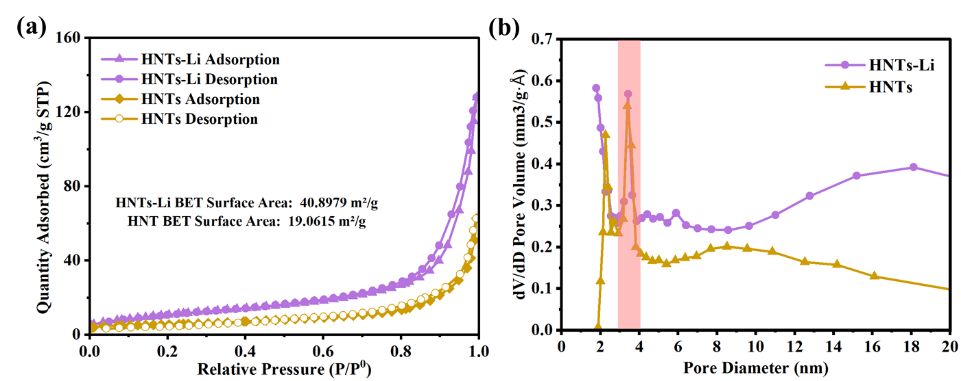
Figure S1. (a) N₂ adsorption/desorption isotherms of HNTs-Li and HNTs. (b) The pore size distribution of HNTs-Li and HNTs.

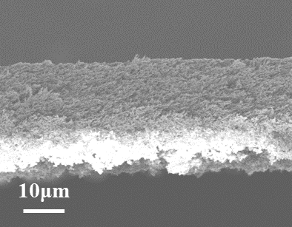
Figure S2. SEM images of P@HLi-10 separator.
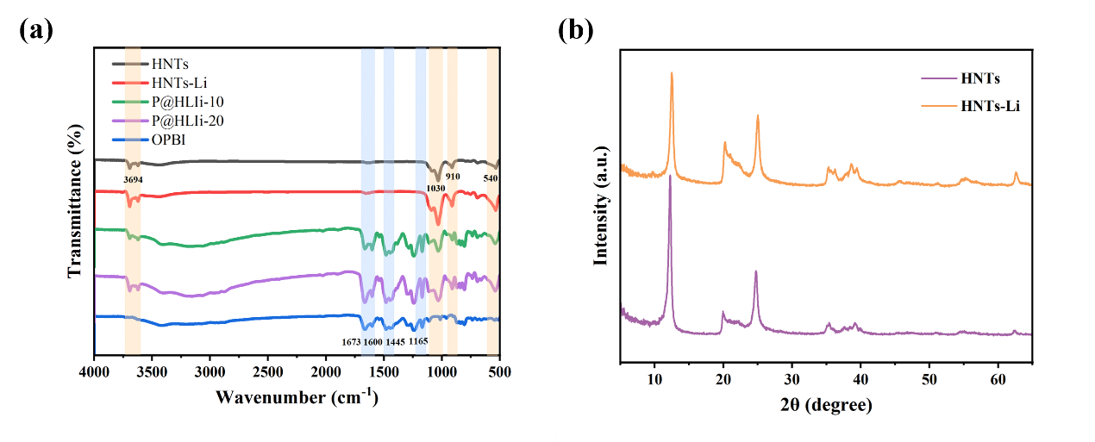
Figure S3. (a) Fourier transform infrared (FTIR) spectroscopy of HNTs and separators, (b) XRD curves of HNTs and HNTs-Li.

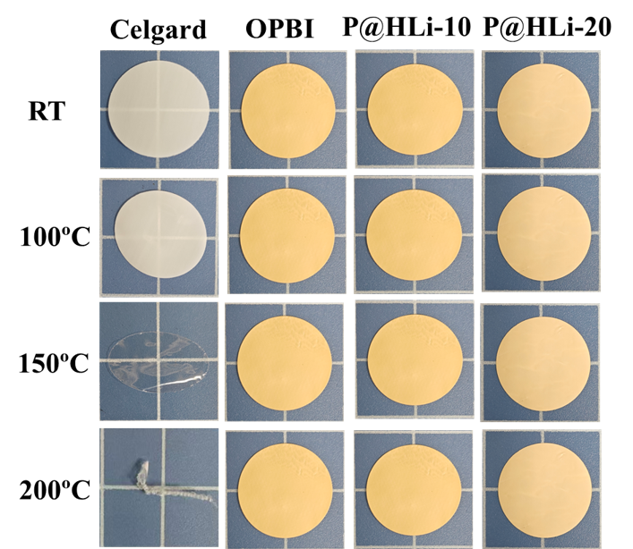
Figure S4. The digital photos of various separators after high temperature treatment for 30 min.
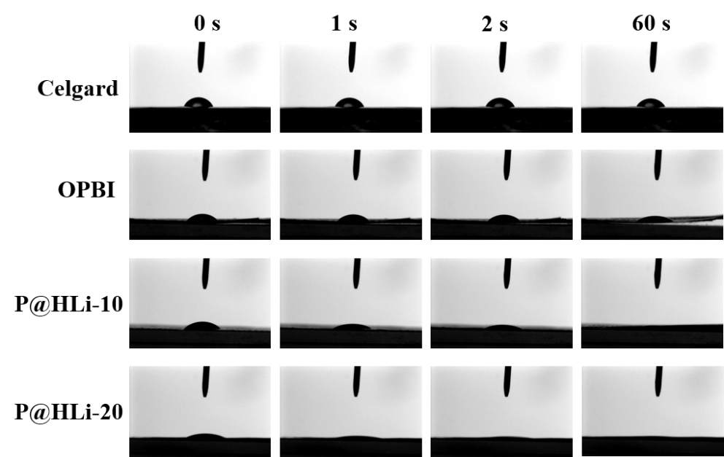
Figure S5. Photographs of different separators-electrolyte contact angles over time.
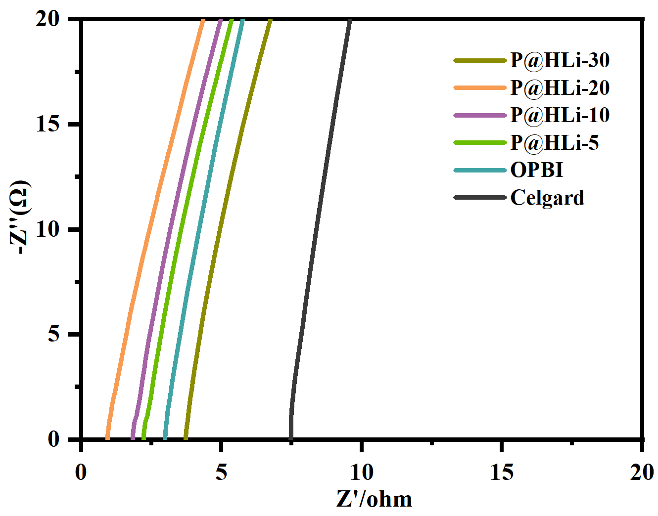
Figure S6. EIS plots of the cells assembled with the form of stainless steel//separator// stainless steel.
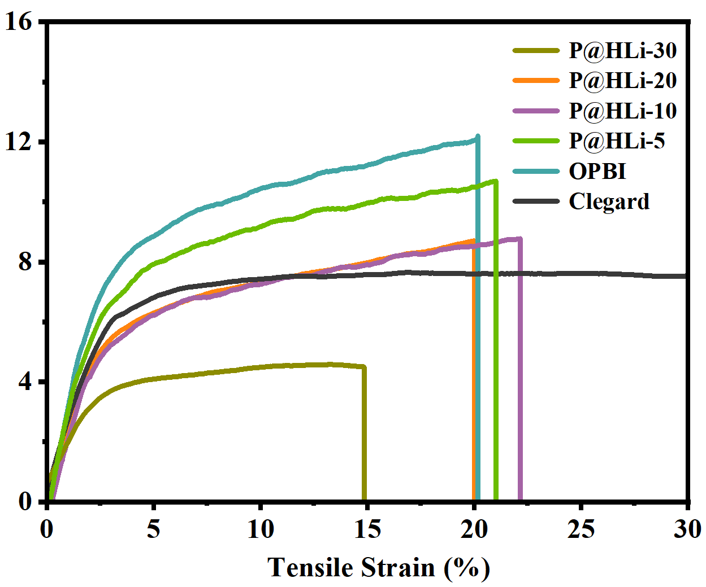
Figure S7. Stress-strain curves of different separators
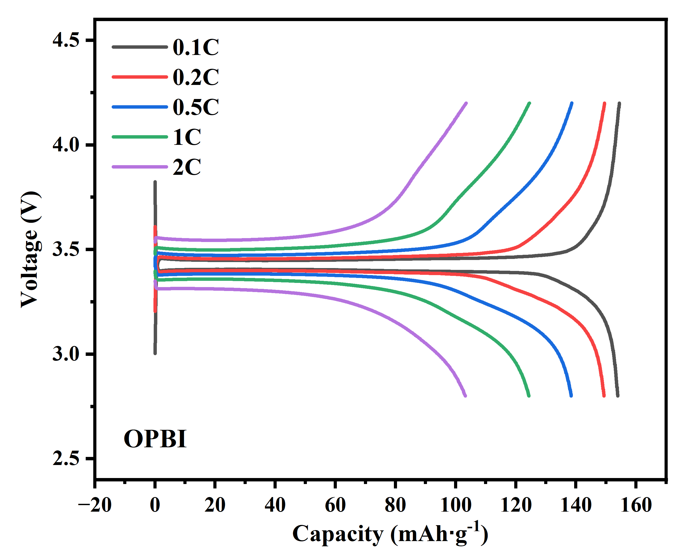
Figure S8. Capacity-voltage curves of cells with OPBI separators at different multiplications.
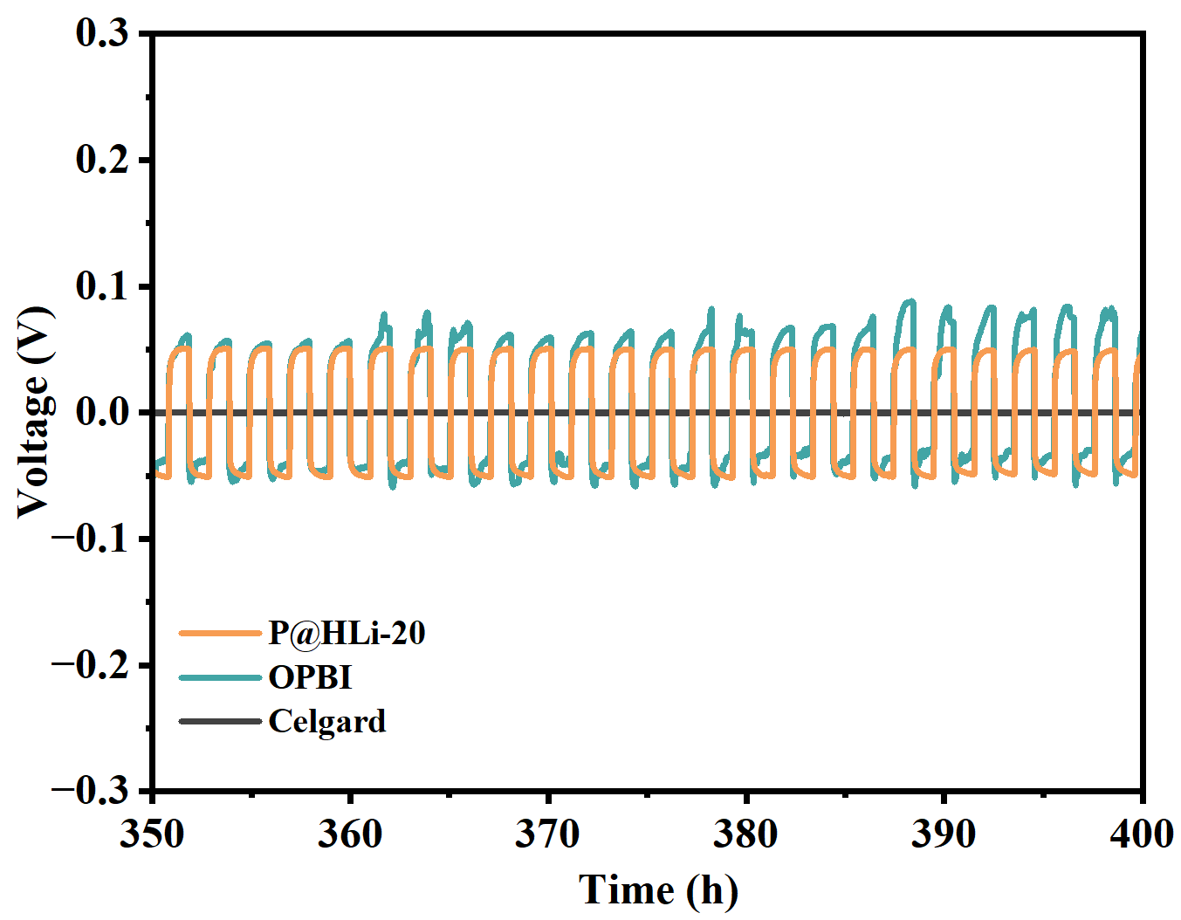
Figure S9. The enlarged voltage-time curves of Li symmetric cells using different separators at 350 h-400 h.

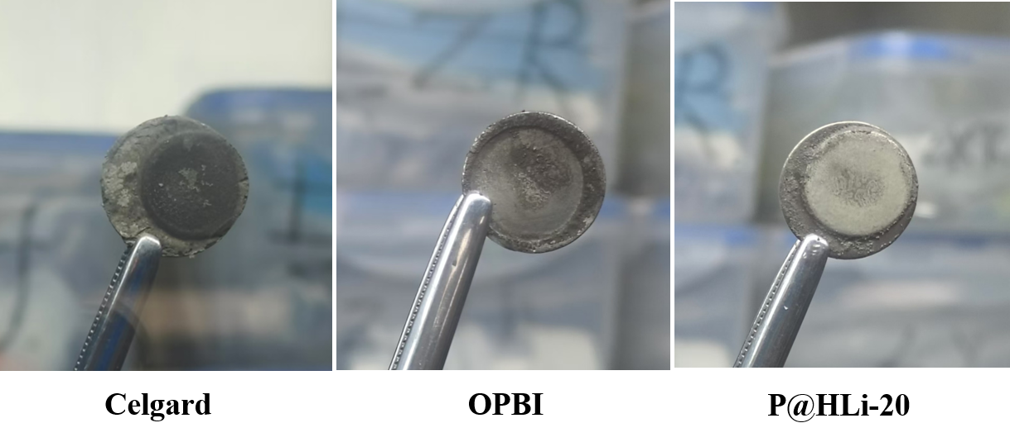
Figure S10. Digital image of lithium metal surface after 100 h cycling in Li//Li battery with different separators
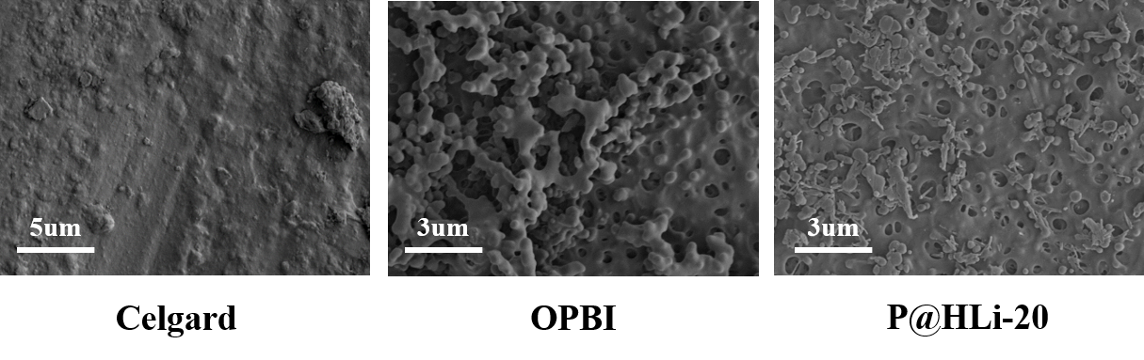
Figure S11. SEM images of different separators after 100 h cycling in Li//Li batteries

Table S1. Phsical parameters of various separator.
Sample | Thickness  (μm) | Ionic conductivity（mS cm⁻¹) | Porosity  (%) | Uptake  (%)
Celgard | 25.0±2.00 | 0.1670±0.0133 | 49.2±3.62 | 73.54±5.48
OPBI | 26±3.36 | 0.6613±0.0394 | 67.42±4.04 | 335.94±15.36
P@HLi-10 | 25±3.27 | 0.9456±0.0584 | 84.09±3.03 | 354.65±10.73
P@HLi-20 | 19±2.21 | 1.551±0.0786 | 90.92±4.09 | 368.32±16.57

Table S2. Specific discharge capacity of different separators at different multiplication rates
Sample | Discharge Capacity (mAh·g⁻¹) at Different Current Densities
 | 0.1 C | 0.2 C | 0.5 C | 1 C | 2 C | 4 C | 8 C
Celgard | 148.4 | 146.8 | 135.0 | 125.5 | 96.6 | 60.4 | 22.9
OPBI | 155.3 | 150.9 | 140.1 | 125.5 | 103.6 | 75.2 | 45.8
P@HLi-20 | 161.1 | 157.2 | 147.9 | 135.5 | 116.6 | 88.1 | 54.1

References
[1] Liu H, Tao R, Guo C, et al. Chemical Engineering Journal 2022, 429, 132239.
[2] a) Dai J, Shi C, Li C, et al. Energy Environ. Sci. 2016, 9, 3252; b) Lagadec M F, Zahn R, Wood V. Nature Energy 2019, 4, 16; c) Lee H, Yanilmaz M, Toprakci O, et al. Energy Environ. Sci. 2014, 7, 3857.
[3] a) Waqas M, Ali S, Lv W, et al. Adv. Mater. Interf. 2019, 6, 1801330; b). Yuan B, He N, Liang Y, et al. Energy Chem. 2023, 76, 398.

