Supplement Information
Construction of CuCo-TA@FeOOH heterojunction with high efficiency and stability for electrocatalytic seawater splitting
1.1 Materials and reagents
Nickel foam (1.5 mm thick), Cobalt(II) nitrate hexahydrate (Co(NO₃)₂ 6H₂O, AR, 99%), Copper(II) nitrate trihydrate (Cu(NO₃)₂ 3H₂O, AR, 99%), Iron(Ⅱ) chloride tetrahydrate (FeCl₂ 4H₂O, AR, 99%), 2-Methylimidazol (C₄H₆N₂, AR, 99%), cetyltrimethylammonium bromide (C₁₉H₄₂BrN, AR, 99%), Tannic acid (C₇₆H₅₂O₄₆, AR, 99%) Ethanol (EtOH, AR, 98%), Hydrochloric acid (HCl, AR), Potassium hydroxide (KOH, AR), Sodium chloride (NaCl, 99.8%) and Naftion solution ((C₇HF₁₃O₅SC₂F₄)_{x}, 10 wt % in H₂O) were used in this study. Unless otherwise specified, all aqueous solutions are prepared using deionized (DI) water. seawater was taken from the Baishamen coast of Haikou City, Hainan Province, China (110.33°E, 20.07°N), All the chemicals were used directly without any further purification. The chemicals were utilized straightaway without undergoing any additional purification process.
1.2 Materials characterizations
The XRD results were obtained utilizing the LabX XRD-6100 X-ray diffractometer equipped with Cu Kα radiation (40 kV, 30 mA). The Raman spectra were acquired through the Horiba Labram HR800 Evolution spectrometer, utilizing a 532 nm excitation laser. The FTIR spectra were monitored within the range of 400-4000 cm⁻¹ using the WQF-520 Fourier Transform Infrared (FTIR) spectrometer, employing the KBr pellet technique. X-ray Photoelectron Spectroscopy (XPS) was performed on the Kratos Amicus X-ray Photoelectron Spectrometer. Scanning Electron Microscopy (SEM) images were collected using the SU8010 at an accelerating voltage of 5.0 kV. Transmission Electron Microscopy (TEM) images were acquired utilizing the JEM2100F instrument. Elemental mapping of the samples was carried out using the Energy-Dispersive X-ray Spectroscopy (EDS) accessory attached to the TEM.
1.3 Preparation of alkaline seawater
The collected natural seawater was filtered through a 0.22-micron membrane to remove contaminants. Following this, potassium hydroxide (KOH) was added to the seawater to achieve an alkaline condition.

Figure S1. SEM images of ZIF-67.

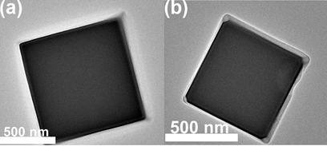
Figure S2. TEM images of ZIF-67 (a) and CuCo-ZIF NCs (b).
Figure S3. XRD pattern of ZIF-67 and CuCo-ZIF NCs^{[3]}.

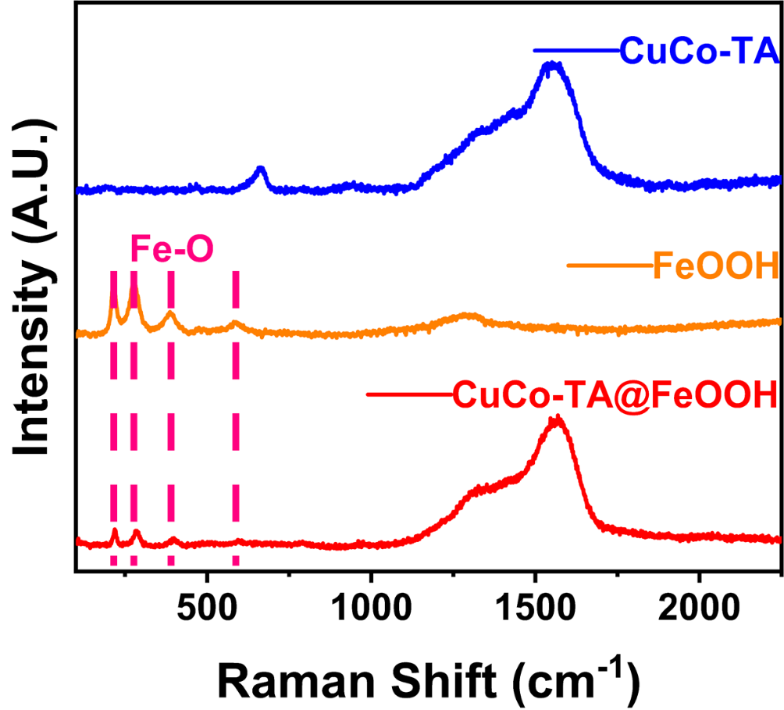
Figure S4. The Raman spectra of CuCo-TA NBs, FeOOH, and CuCo-TA@FeOOH.

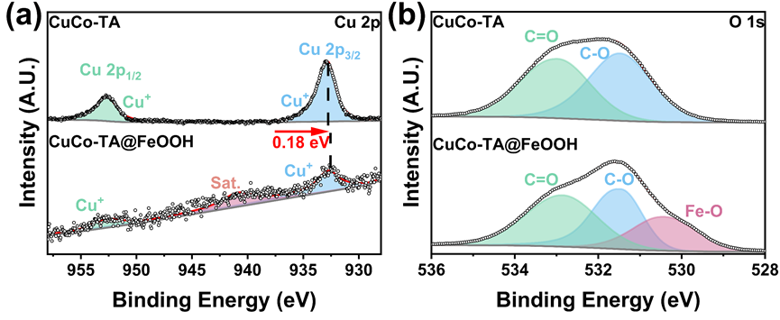
Figure S5. The XPS spectra of (a) Cu 2p, (b) C 1s and (c) O 1s in both CuCo-TA NBs and CuCo-TA@FeOOH.

Figure S6. The LSV curves of various CuCo-TA NBs (150mg, 300mg, and 450mg) in 1 M KOH solution.
Figure S7. Cyclic voltammetry scans were performed on CuCo-TA NBs, FeOOH, and CuCo-TA@FeOOH at various scan rates of 20, 40, 60, 80, 100, 120, 140, and 160 mV s⁻¹ in three different electrolyte solutions: 1 M KOH (a-c), 1 M KOH + 0.5 M NaCl (d-f), and 1 M KOH + seawater (g-i).
Figure S8. The EIS Nyquist plots of CuCo-TA NBs, FeOOH, and CuCo-TA@FeOOHF tested at various potentials (1.42-1.52 V_{RHE}) in 1 M KOH solution (a-c), 1 M KOH + 0.5 M NaCl solution (d-f), and 1 M KOH + seawater (g-i) is presented.

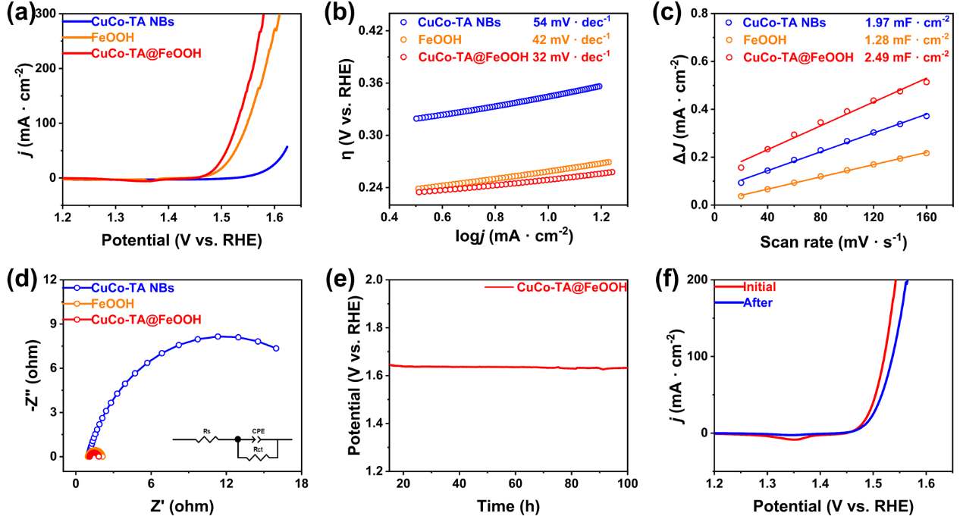
Figure S9. The electrocatalytic performance of CuCo-TA NBs, FeOOH, and CuCo-TA@FeOOH in a 1 M KOH with 0.5 M NaCl solution. (a) LSV curves; (b) Tafel slope plots; (c) corresponding C_{dl} fitting curves; (d) corresponding EIS spectra (inset is the equivalent circuit model); (f) (100 mA cm⁻², 1 M KOH + 0.5 M NaCl) stability test; (e) (h) The LSV curves initial and after 100 hours of stability testing at a current density of 100 mA cm⁻².

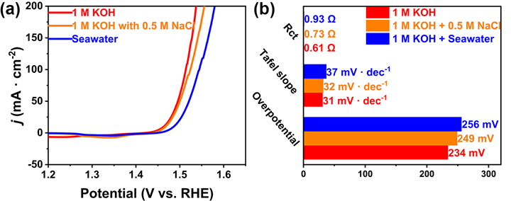
Figure S10. (a) A comparative analysis of the polarization curves for CuCo-TA@FeOOH during OER testing in different electrolytes; (b) A comprehensive comparison of the electrocatalytic performance of CuCo-TA@FeOOH across various electrolyte environments.
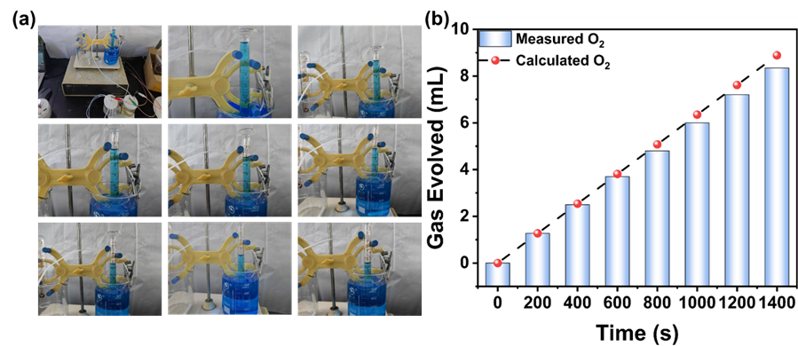
Fig.S11. (a) The photograph of system that collects gas by water displacement method. Volume of O₂ gas collected at the CuCo-TA@FeOOH electrode in alkaline seawater solution at a time gradient of 200 s⁻¹ at 100 mA cm ⁻².

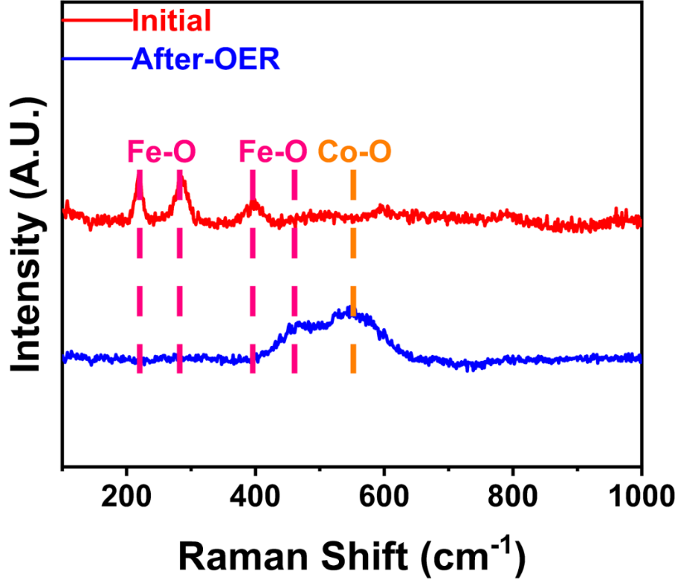
Figure S12. Raman spectra of CuCo-TA@FeOOH initial and after the CP test.

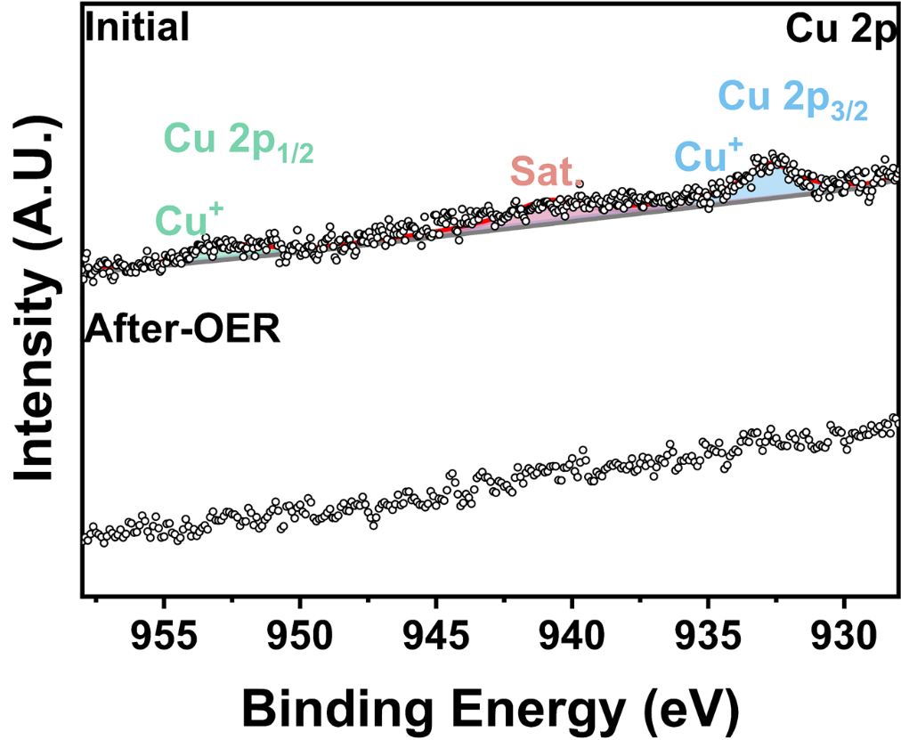
Figure S13. The XPS high-resolution spectra of Cu 2p after the CP test.

Table S1. EIS calculation parameters of CuCo-TA NBs, FeOOH, and CuCo-TA@FeOOH for OER in 1 M KOH solution.
Sample | CuCo-TA NBs | FeOOH | CuCo-TA@FeOOH
R_{s} (Ω) | 1.0504 | 1.0851 | 1.0074
R_{ct} (Ω) | 11.673 | 1.0664 | 0.60997
CPE-T (Ω) | 0.12891 | 0.084425 | 0.16514
CPE-P (Ω) | 0.83818 | 0.73713 | 0.73083

Table S2. EIS calculation parameters of CuCo-TA NBs, FeOOH, and CuCo-TA@FeOOH for OER in 1 M KOH with 0.5 M NaCl solution.
Sample | CuCo-TA NBs | FeOOH | CuCo-TA@FeOOH
R_{s} (Ω) | 0.99169 | 0.95478- | 1.0941
R_{ct} (Ω) | 21.58 | 1.1759 | 0.73522
CPE-T (Ω) | 0.26873 | 0.029643 | 0.13675
CPE-P (Ω) | 0.82447 | 0.8217 | 0.8175

Table S3. EIS calculation parameters of CuCo-TA NBs, FeOOH, and CuCo-TA@FeOOH for OER in 1 M KOH with seawater solution.
Sample | CuCo-TA NBs | FeOOH | CuCo-TA@FeOOH
R_{s} (Ω) | 1.0393 | 1.0826 | 1.0429
R_{ct} (Ω) | 23.939 | 1.6303 | 0.93004
CPE-T (Ω) | 0.222 | 0.035555 | 0.12958
CPE-P (Ω) | 0.81594 | 0.91327 | 0.80333
Table S4. Comparison of the OER performance of CuCo-TA@FeOOH catalyst with the OER performances of the recently reported catalysts.
Material | Electrolyte | η (mV) | Current density  (mA/cm⁻²) | Refs
G@Ni₃Fe | 1.0 M KOH | 246 | 10 | [2]
C@FeMoNi/CC | 1.0 M KOH | 244 | 10 | [3]
CoFeNi/ZP NC | 1.0 M KOH | 244 | 10 | [4]
CoCu@HNC | 1.0 M KOH | 289 | 10 | [5]
CuCo-MOF NBs | 1.0 M KOH | 271 | 10 | [6]
TA-Fe@Ni-WO_{x} | 1.0 M KOH | 240 | 20 | [7]
Ni-MOF-3/TA | 1.0 M KOH | 227 | 10 | [8]
TA-Co_{0.84}Ni_{1.69}/MWCNTs | 1.0 M KOH | 294 | 10 | [9]
CuCo-TA@FeOOH | 1.0 MKOH | 234 | 10 | This work

Reference
- Bai W, Chen J, Wang X, et al. Transformation of ZIF-67 nanocubes to ZIF-L nanoframes[J]. Journal of the American Chemical Society, 2023, 146(1): 79-83.
- Zhao M, Li H, Yuan W, et al. Tannic acid-mediated in situ controlled assembly of NiFe alloy nanoparticles on pristine graphene as a superior oxygen evolution catalyst[J]. ACS Applied Energy Materials, 2020, 3(4): 3966-3977.
- Zhou Q, Liu X, Deng K, et al. Ultrasmall FeMoNi Tri-Metal nanoparticles confined by tannic acid-derived carbon as bi-functional electrocatalyst for oxygen evolution and urea oxidation[J]. Chemical Engineering Science, 2023, 268: 118402.
- Shen X, Huang L, Li S, et al. Trimetallic MOF-derived CoFeNi/ZP NC nanocomposites as efficient catalysts for oxygen evolution reaction[J]. Dalton Transactions, 2023, 52(47): 17711-17716.
- Zhang Z, Zhang Z, Chen X, et al. Metal–organic framework-derived hollow nanocubes as stable noble metal-free electrocatalyst for water splitting at high current density[J]. CCS Chemistry, 2024, 6(5): 1324-1337.
- Cheng W, Wu Z P, Luan D, et al. Synergetic cobalt‐copper‐based bimetal–organic framework nanoboxes toward efficient electrochemical oxygen evolution[J]. Angewandte Chemie, 2021, 133(50): 26601-26606.
- Wang Y, Wang Y, Bai J, et al. Fe ion-chelated tannic acid layer coordinates the electronic structure of Ni-WO_{x} to enhance oxygen evolution performance[J]. Journal of Alloys and Compounds, 2022, 928: 167225.
- Gopi S, Yun K. Revolutionizing electrocatalysis through surface engineering of Ni-MOFs using tannic acid for enhanced oxygen evolution reaction efficiency[J]. Applied Materials Today, 2025, 43: 102658.
- Wang R, Zhang L, Wang N, et al. Transforming electrochemical hydrogen production: Tannic acid-boosted CoNi alloy integration with multi-walled carbon nanotubes for advanced bifunctional catalysis[J]. Journal of Colloid and Interface Science, 2024, 661: 113-122.

