Electronic Supplementary Information

Figure S1. The linear sweep voltammetry polarization curves of (a) M-P (M = Ni, Co; M-P = 1:1, 2:3, 1:2, 2:5 and 1:3) @Ag NWs. (b) NiCoP (Ni:Co = 1:1, 2:1, 3:1 and 4:1) @Ag NWs. (c) NiCoP@Ag NWs with different electrodeposition time (t = 200, 300, 400 and 500 s).

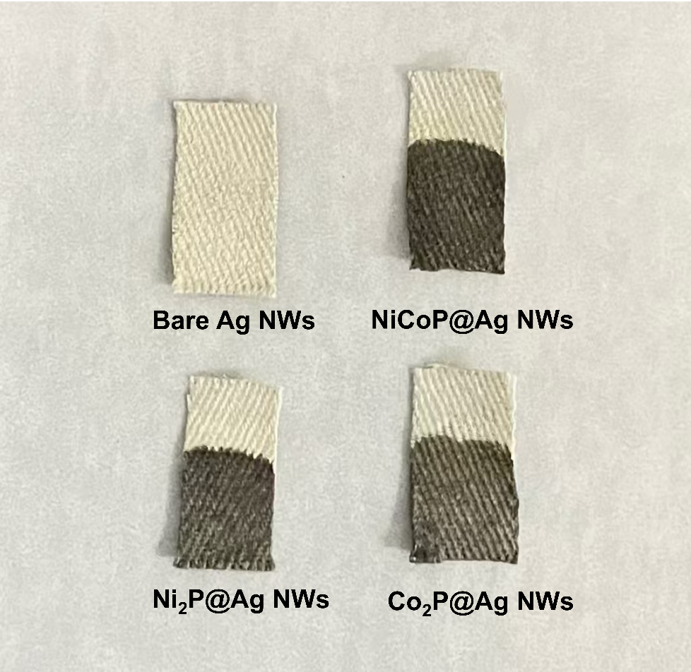
Fig. S2. The naked eye observed the morphology of bare Ag NWs, NiCoP@Ag NWs, Ni₂P@Ag NWs, and Co₂P@Ag NWs.

Fig. S3. The line profiles of NiCoP@Ag NWs

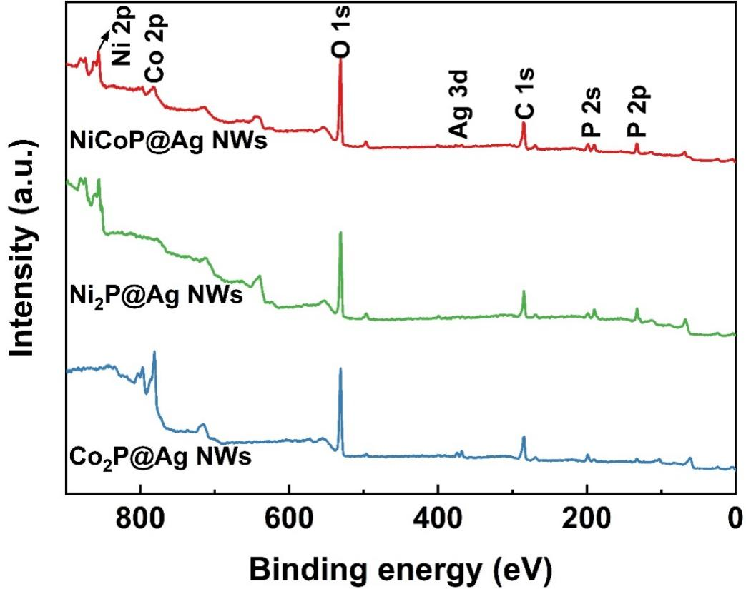
Fig. S4. The XPS survey spectra of NiCoP@Ag NWs, Ni₂P@Ag NWs,
and Co₂P@Ag NWs.

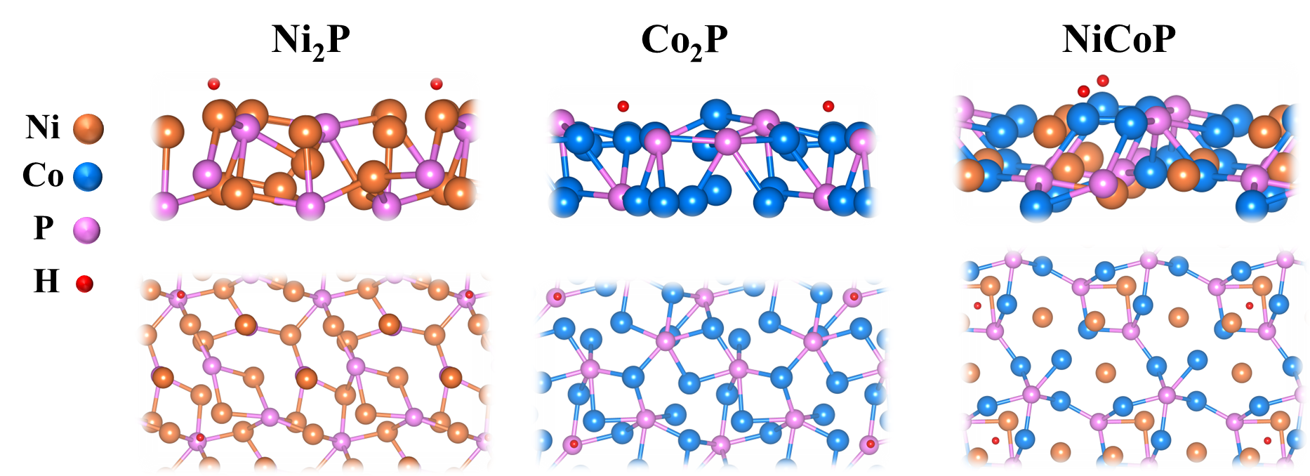
Fig. S5. The optimal absorption site of H.

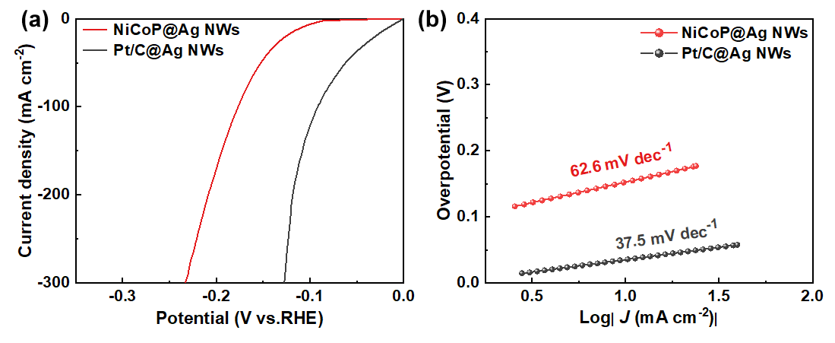
Fig. S6. Comparison of performance between NiCoP@Ag NWs and Pt/C@Ag NWs catalyst. (a) HER polarization curves. (b) Tafel slopes.

Fig. S7. Cyclic voltammograms (CV) curves for ECSA measurements in the non-Faradaic region over (a) NiCoP@Ag NWs, (b) NiCoP@NF, (c) Ni₂P@Ag NWs and (d) Co₂P@Ag NWs.

Fig. S8. SEM image of the NiCoP@Ag NWs after stability test.

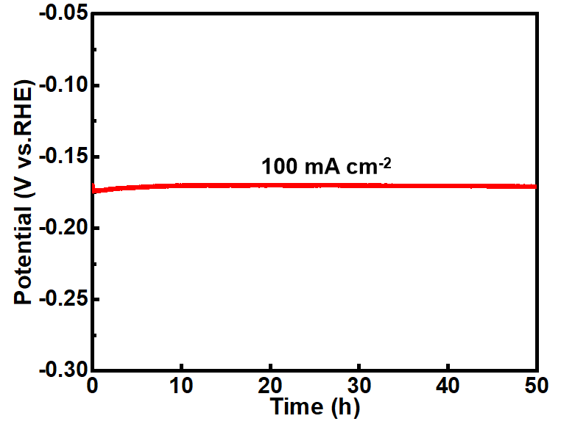
Fig. S9. The stability test of NiCoP@Ag NWs at a constant current density of 100 mA cm⁻² for 50 h.

Table S1. Comparison of the HER performance of NiCoP@Ag NWs in 0.5 M H₂SO₄ with reported non-noble metal-based catalysts.
Electrocatalysts | $η_{{10mA cm}^{-2}}$  (mV) | Tafel  (mV dec⁻¹) | References
NiCoP@Ag NWs | 109 | 62.6 | This work
MoO₃/MoS₂ | 250 | 125 | [1]
NiCoP fibers | 146 | 97.8 | [2]
FeCoP₂@NPPC | 114 | 79 | [3]
Co-MoS₂ | 151 | 64 | [4]
V-doped WS₂ | 185 | 61 | [5]
Nb_{0.7}V_{0.3}Se₂ | 236 | 72 | [6]
Frenkel-defected MoS₂ | 164 | 36 | [7]
m-CoSe₂ | 124 | 37 | [8]
FePSe₃@N-C/GCE (GCE:Glassy carbon electrode) | 118.5 | 53 | [9]
Ni₂P/NF | 176 | 138 | [10]
Ni-P/NF | 189 | 74 | [11]
Cu@MoS₂ | 131 | 51 | [12]
V_{Se}–NiCo₂Se₄-NWs/NCNFs | 168 | 49.8 | [13]
NiCo₂Se₄-NWs/NCNFs | 200 | 55.9 | [13]
WS₂/CoS₂/CC | 146 | 64 | [14]
CoSe₂@MoSe₂ | 131 | 48 | [15]
CoSe₂@MoSe₂/GCE | 183 | 43.37 | [15]
NiCoP/CC | 197 | 86.7 | [16]
CoMn-P@NG | 159(20 mA cm⁻²) | 64.85 | [17]
Mo₂C/C | 264 | 88 | [18]
(Mo/β-Mo₂C)@C | 152 | 51.7 | [19]
MoSe₂-CoP | 298 | 114 | [20]
316 L SS-1600 | 209.8 | 115.6 | [21]
CoTe₂@NF | 111 | 79 | [22]
V-MoS₂ | 194 | 59 | [23]
CoN/MoC/NMCNFs | 199.2 | 97.2 | [24]
SS-MoC | 182 | 48 | [25]
B–MoC | 285 | 128 | [26]
Ni-MoC@NGC | 202 | 69 | [27]
Terraced α-Mo₂C | 294 | 63 | [28]
MoC-MoP/BCNC NFs | 158 | 58 | [29]
Mo₂C&MoS₂@NSC | 209 | 85.5 | [30]
Fe-CoP/PCNF | 151 | 53.9 | [31]
FeNiP/NPC800 | 277 | 95 | [32]
4%-SPCNF | 310.86 | 95.93 | [33]

References
[1] L. Sharma, T. Botari, C.S. Tiwary, A. Halder. Hydrogen evolution at the in situ MoO₃/MoS₂ heterojunctions created by nonthermal O₂ plasma treatment. ACS Applied Energy Materials, 3 (2020) 5333‒5342
[2] C. Bera, M. Streckova, R. Orinakova, A. Guboova, T. Bystron, V. Girman, F. Kromka, M. Podobova, K. Bouzek. NiCoP fibers as novel catalysts for hydrogen evolution in alkali and acidic environment. International Journal of Hydrogen Energy, 60 (2024) 118‒132
[3] Y.-N. Wang, Z.-J. Yang, D.-H. Yang, L. Zhao, X.-R. Shi, G. Yang, B.-H. Han. FeCoP₂ nanoparticles embedded in N and P co-doped hierarchically porous carbon for efficient electrocatalytic water splitting. ACS Applied Materials & Interfaces, 13 (2021) 8832‒8843
[4] H. Duan, C. Wang, G. Li, H. Tan, W. Hu, L. Cai, W. Liu, N. Li, Q. Ji, Y. Wang. Single‐atom‐layer catalysis in a MoS₂ monolayer activated by long‐range ferromagnetism for the hydrogen evolution reaction: beyond single‐atom catalysis. Angewandte Chemie, 133 (2021) 7327‒7334.
[5] A. Han, X. Zhou, X. Wang, S. Liu, Q. Xiong, Q. Zhang, L. Gu, Z. Zhuang, W. Zhang, F. Li. One-step synthesis of single-site vanadium substitution in 1T-WS₂ monolayers for enhanced hydrogen evolution catalysis. Nature Communications, 12 (2021) 709.
[6] I.H. Kwak, I.S. Kwon, G.M. Zewdie, T.T. Debela, S.J. Lee, J.Y. Kim, S.J. Yoo, J.-G. Kim, J. Park, H.S. Kang. Polytypic phase transition of Nb_{1–x}V_{x}Se₂ via colloidal synthesis and their catalytic activity toward hydrogen evolution reaction. ACS nano, 16 (2022) 4278‒4288.
[7] J. Xu, G. Shao, X. Tang, F. Lv, H. Xiang, C. Jing, S. Liu, S. Dai, Y. Li, J. Luo. Frenkel-defected monolayer MoS₂ catalysts for efficient hydrogen evolution. Nature communications, 13 (2022) 2193.
[8] X.-L. Zhang, S.-J. Hu, Y.-R. Zheng, R. Wu, F.-Y. Gao, P.-P. Yang, Z.-Z. Niu, C. Gu, X. Yu, X.-S. Zheng. Polymorphic cobalt diselenide as extremely stable electrocatalyst in acidic media via a phase-mixing strategy, Nature Communications, 10 (2019) 5338.
[9] J. Yu, W.-J. Li, H. Zhang, F. Zhou, R. Li, C.-Y. Xu, L. Zhou, H. Zhong, J. Wang. Metallic FePSe₃ nanoparticles anchored on N-doped carbon framework for All-pH hydrogen evolution reaction. Nano Energy, 57 (2019) 222-229.
[10] H. Yang, P. Guo, R. Wang, Z. Chen, H. Xu, H. Pan, D. Sun, F. Fang, R. Wu. Sequential phase conversion‐induced phosphides heteronanorod arrays for superior hydrogen evolution performance to Pt in wide pH media. Advanced Materials, 34 (2022) 2107548.
[11] J. Zhang, Z. Zhang, Y. Ji, J. Yang, K. Fan, X. Ma, C. Wang, R. Shu, Y. Chen. Surface engineering induced hierarchical porous Ni₁₂P₅-Ni₂P polymorphs catalyst for efficient wide pH hydrogen production. Applied Catalysis B: Environmental, 282 (2021) 119609.
[12] L. Ji, P. Yan, C. Zhu, C. Ma, W. Wu, C. Wei, Y. Shen, S. Chu, J. Wang, Y. Du. One-pot synthesis of porous 1T-phase MoS₂ integrated with single-atom Cu doping for enhancing electrocatalytic hydrogen evolution reaction. Applied Catalysis B: Environmental, 251 (2019) 87‒93.
[13] W. Zong, R. Lian, G. He, H. Guo, Y. Ouyang, J. Wang, F. Lai, Y.-E. Miao, D. Rao, D. Brett. Vacancy engineering of group VI anions in NiCo₂A₄ (A= O, S, Se) for efficient hydrogen production by weakening the shackles of hydronium ion. Electrochimica Acta, 333 (2020) 135515.
[14] J. Wu, T. Chen, C. Zhu, J. Du, L. Huang, J. Yan, D. Cai, C. Guan, C. Pan. Rational construction of a WS₂/CoS₂ heterostructure electrocatalyst for efficient hydrogen evolution at all pH values. ACS Sustainable Chemistry & Engineering, 8 (2020) 4474‒4480.
[15] Z. Chen, W. Wang, S. Huang, P. Ning, Y. Wu, C. Gao, T.-T. Le, J. Zai, Y. Jiang, Z. Hu. Well-defined CoSe₂@ MoSe₂ hollow heterostructured nanocubes with enhanced dissociation kinetics for overall water splitting. Nanoscale, 12 (2020) 326‒335.
[16] K. Jiang, J. Li, Z. Zheng, T. Zhang, G. Wang, C. Shi, X. Hou. Bimetallic phosphide NiCoP electrocatalyst synthesized by one-step electrodeposition for efficient hydrogen evolution in acidic and alkaline solution. ACS Applied Energy Materials, 7 (2024) 7895‒7905.
[17] J. Liu, W. Li, Z. Cui, J. Li, F. Yang, L. Huang, C. Ma, M. Zeng. CoMn phosphide encapsulated in nitrogen-doped graphene for electrocatalytic hydrogen evolution over a broad pH range. Chemical Communications, 57 (2021) 2400‒2403.
[18] G. Wang, J. Li, B. Zhang, T. Zhang, Z. Zheng, K. Jiang. One-step molten-salt synthesis of adjustable composition molybdenum carbide-based electrocatalysts for hydrogen evolution in both acidic and alkaline media. Sustainable Energy & Fuels, 7 (2023) 5352‒5360.
[19] W. Zhu, Z. Jiang, X. Peng, Z. Li, A.R. Woldu, F. Lu, Y. Fang, P.K. Chu, L. Hu. Janus (Mo/β-Mo₂C)@C heterostructure as an efficient electrocatalyst for the hydrogen evolution reaction in acidic and alkaline media. Nanotechnology, 34 (2022) 055704.
[20] A. Kagkoura, C. Stangel, R. Arenal, N. Tagmatarchis. Molybdenum diselenide and tungsten diselenide interfacing cobalt-porphyrin for electrocatalytic hydrogen evolution in alkaline and acidic media. Nanomaterials, 13 (2022) 35.
[21] Y. Liu, K. Zhang, D. Zhang, W. Dong, T. Jiang, H. Zhou, L. Li, B. Mao. Industrial stainless steel meshes for efficient electrocatalytic hydrogen evolution. Journal of Energy Storage, 41 (2021) 102844.
[22] Y. Yin, J. Xu, W. Guo, Z. Wang, X. Du, C. Chen, Z. Zheng, D. Liu, D. Qu, Z. Xie. A single-step fabrication of CoTe₂ nanofilm electrode toward efficient overall water splitting. Electrochimica Acta, 307 (2019) 451‒458.
[23] S. Bolar, S. Shit, J.S. Kumar, N.C. Murmu, R.S. Ganesh, H. Inokawa, T. Kuila. Optimization of active surface area of flower like MoS₂ using V-doping towards enhanced hydrogen evolution reaction in acidic and basic medium. Applied Catalysis B: Environmental, 254 (2019) 432‒442.
[24] L. Wang, W. He, D. Yin, H. Zhang, D. Liu, Y. Yang, W. Yu, X. Dong. CoN/MoC embedded in nitrogen-doped multi-channel carbon nanofibers as an efficient acidic and alkaline hydrogen evolution reaction electrocatalysts. Renewable and Sustainable Energy Reviews, 181 (2023) 113354.
[25] X. Zhang, T. Liu, T. Guo, Z. Mu, X. Hu, K. He, X. Chen, V.P. Dravid, Z. Wu, D. Wang. High-performance MoC electrocatalyst for hydrogen evolution reaction enabled by surface sulfur substitution. ACS applied materials & interfaces, 13 (2021) 40705‒40712.
[26] Q. Lin, C. Shang, Z. Chen, X. Wang, G. Zhou. Boron-doped molybdenum carbide as a pH-independent electrocatalyst for the hydrogen evolution reaction. International Journal of Hydrogen Energy, 45 (2020) 30659‒30665.
[27] S. Roy, D. Bagchi, L. Dheer, S.C. Sarma, V. Rajaji, C. Narayana, U.V. Waghmare, S.C. Peter. Mechanistic insights into the promotional effect of Ni substitution in non-noble metal carbides for highly enhanced water splitting. Applied Catalysis B: Environmental, 298 (2021) 120560.
[28] J. Bang, I.K. Moon, K. Choi, J. Oh. Phase-engineering terraced structure of edge-rich α-Mo₂C for efficient hydrogen evolution reaction. Materials Today Energy, 26 (2022) 100981.
[29] N. Chen, Q. Mo, L. He, X. Huang, L. Yang, J. Zeng, Q. Gao. Heterostructured MoC-MoP/N-doped carbon nanofibers as efficient electrocatalysts for hydrogen evolution reaction. Electrochimica Acta, 299 (2019) 708-716.
[30] Q. Wang, R. Yu, D. Shen, G. Liu, K.H. Luo, C. Wu, S. Gu. One-pot synthesis of Mo₂C&MoS₂ loaded on N/S co-doped carbon materials as the electrocatalyts for hydrogen evolution reaction. Fuel, 318 (2022) 123615.
[31] X. Chen, B. Yu, Y. Dong, X. Zhu, W. Zhang, S. Ramakrishna, Z. Liu. Electrospun porous carbon nanofibers decorated with iron-doped cobalt phosphide nanoparticles for hydrogen evolution. Journal of Alloys and Compounds, 918 (2022) 165733.
[32] Y. Gong, L.-H. Xu, J. Li, D. Shan. Confinement of transition metal phosphides in N, P-doped electrospun carbon fibers for enhanced electrocatalytic hydrogen evolution. Journal of Alloys and Compounds, 875 (2021) 159934.
[33] H. He, Y. Zhang, W. Zhang, Y. Li, X. Zhu, P. Wang, D. Hu. Porous carbon nanofibers derived from silk fibroin through electrospinning as N-doped metal-free catalysts for hydrogen evolution reaction in acidic and alkaline solutions. ACS Applied Materials & Interfaces, 14 (2021) 834‒849.

