Supplementary Information
Regulating reactive oxygen species balance at the WO₃/BN interface for selective photooxidation of methane to methanol

Table of contents

Characterization 3
Supporting Figures 4
1. TEM and HRTEM images of WO₃ 4
2. TEM and HRTEM images of BN 5
3. XRD patterns of BN 6
4. XPS spectra of BN and WO₃/BN-1:1 catalysts 7
5. XPS spectra of WO₃ and WO₃/BN-1:1 catalysts 8
6. Time-dependent product evolution profiles 9
7. Stability test of WO₃/BN-1:1 10
8. XRD patterns of fresh and used WO₃/BN-1:1 11
9. XPS spectra of fresh and used WO₃/BN-1:1 12
10. Photocatalytic CH₄ oxidation under different reaction conditions 13
11. Band structure 14
12. PL spectra of WO₃ and WO₃/BN-1:1 15
13. Valence-band structure and band alignment of BN and WO₃ 16
14. EPR signal intensities and radical trapping experiments 17
15. In situ DRIFTS spectra of WO₃ 18
16. In situ DRIFTS spectra of WO₃/BN-1:1 19
17. In situ DRIFTS spectra of BN 20
Supporting Tables 21
1. Performance of CH₄ photooxidation 21
2. Control experiments 22
3. Comparison of productivity of photocatalytic CH₄ conversion to CH₃OH 23
4. Radical trapping experiments 24
Supporting References 25

Characterization
X-ray diffraction (XRD) measurements were performed on an X’Pert PRO MPD diffractometer using Cu Kα radiation (λ = 1.5406 Å) at an operating voltage of 40 kV and a current of 40 mA to characterize the crystal structures of the as-prepared photocatalysts. High-resolution transmission electron microscopy (HRTEM) and high-angle annular dark-field scanning transmission electron microscopy (HAADF-STEM) observations were carried out using a JEM-2100F microscope to examine the morphology and microstructure of the samples. X-ray photoelectron spectroscopy (XPS) measurements were performed on a Thermo Scientific K-Alpha spectrometer equipped with an Al Kα X-ray source to analyze the elemental composition and chemical states of the sample surfaces and interfaces. Ultraviolet-visible diffuse reflectance spectroscopy (UV-vis DRS) measurements were performed using a Shimadzu UV-2600 UV-vis spectrophotometer equipped with an integrating sphere, with BaSO₄ used as the reference, to investigate the optical absorption properties of the samples. Steady-state photoluminescence (PL) measurements were performed using a Hitachi F-7000 fluorescence spectrophotometer at an excitation wavelength of 320 nm to investigate the photoluminescence properties of the samples. Transient surface photovoltage (TPV) measurements were performed using a PL-TPV transient surface photovoltage spectrometer (Beijing Perfectlight Technology Co., Ltd., China) to investigate the separation and recombination dynamics of photogenerated charge carriers in the samples. Electron paramagnetic resonance (EPR) measurements were performed using a CIQTEK EPR200M spectrometer, with 5,5-dimethyl-1-pyrroline N-oxide (DMPO) as the spin-trapping agent, to detect radical species generated in the reaction system.

Supporting Figures

1. TEM and HRTEM images of WO₃
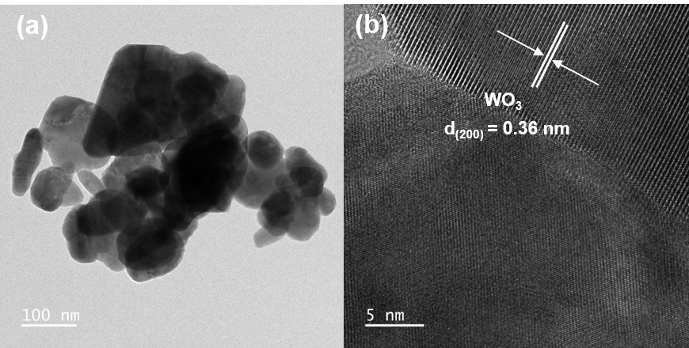
Figure S1. TEM and HRTEM images of WO₃.

2. TEM and HRTEM images of BN
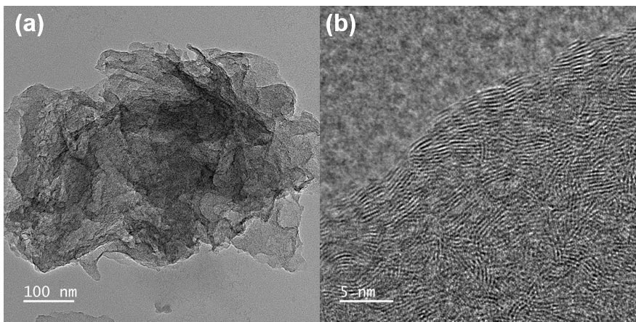
Figure S2. (a) TEM and (b) HRTEM images of BN.

3. XRD patterns of BN
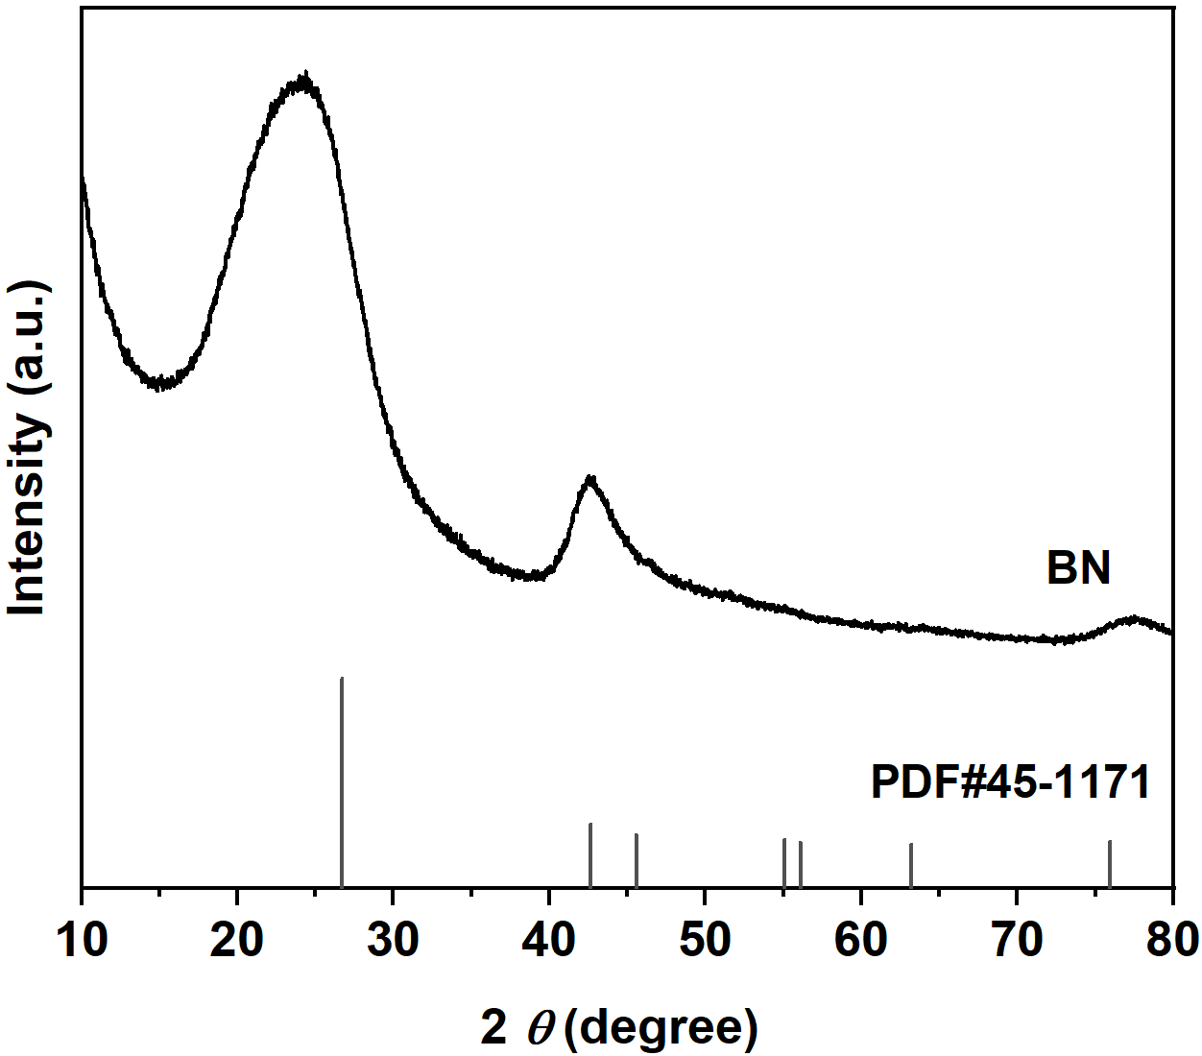
Figure S3. XRD patterns of BN.

4. XPS spectra of BN and WO₃/BN-1:1 catalysts
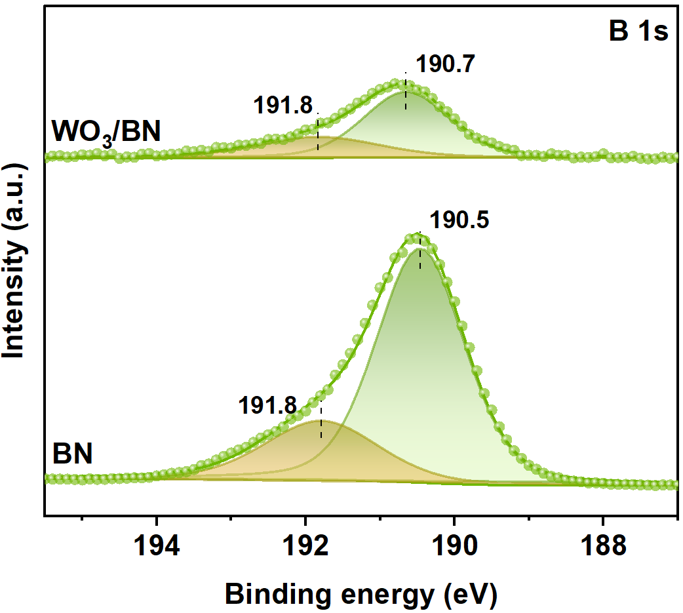
Figure S4. XPS spectra of B 1s on BN and WO₃/BN-1:1 catalysts.

5. XPS spectra of WO₃ and WO₃/BN-1:1 catalysts
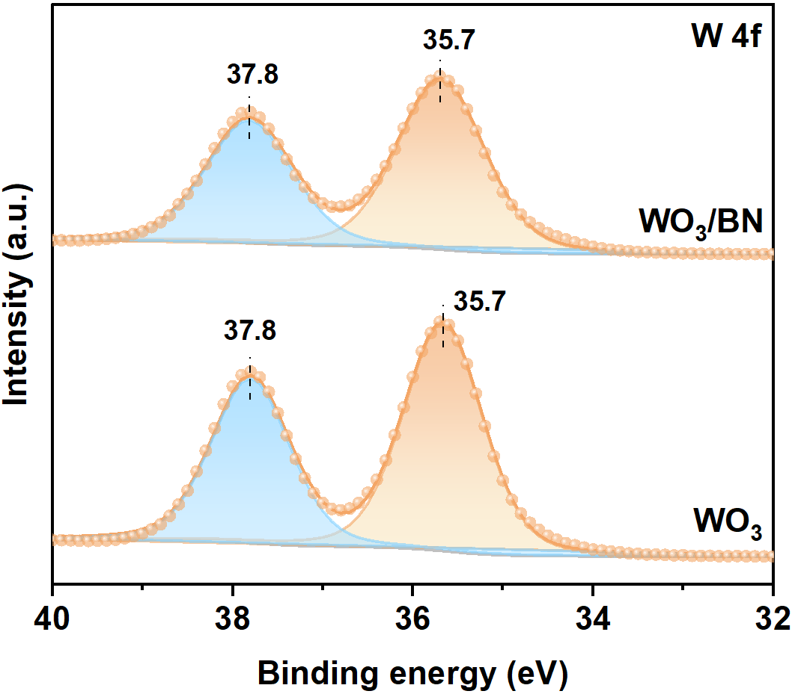
Figure S5. XPS spectra of W 4f on WO₃ and WO₃/BN-1:1 catalysts

6. Time-dependent product evolution profiles
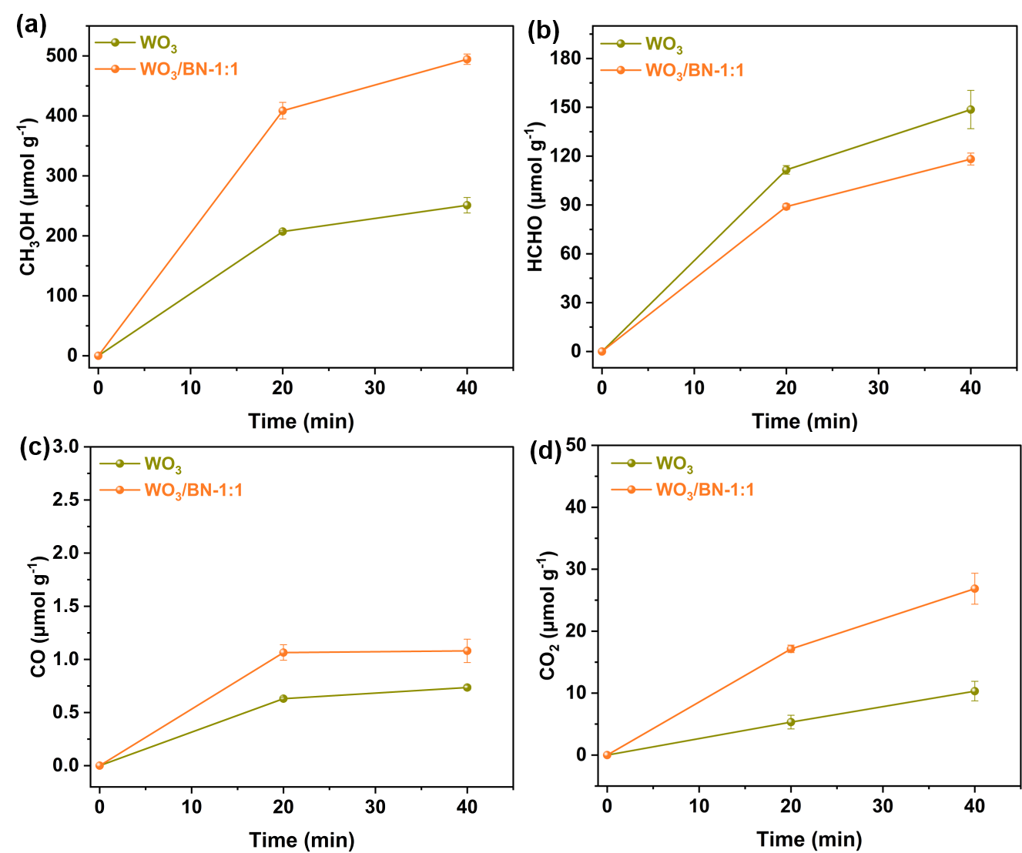
Figure S6. Time-dependent product evolution profiles of WO₃/BN-1:1 and WO₃: (a) CH₃OH; (b) HCHO; (c) CO; (d) CO₂;

7. Stability test of WO₃/BN-1:1
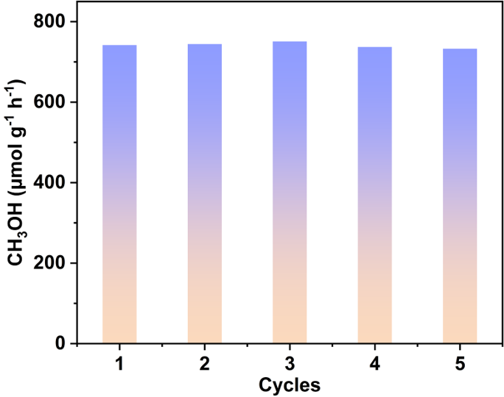
Figure S7. Five-cycle CH₄ photooxidation performance over WO₃/BN-1:1.

8. XRD patterns of fresh and used WO₃/BN-1:1
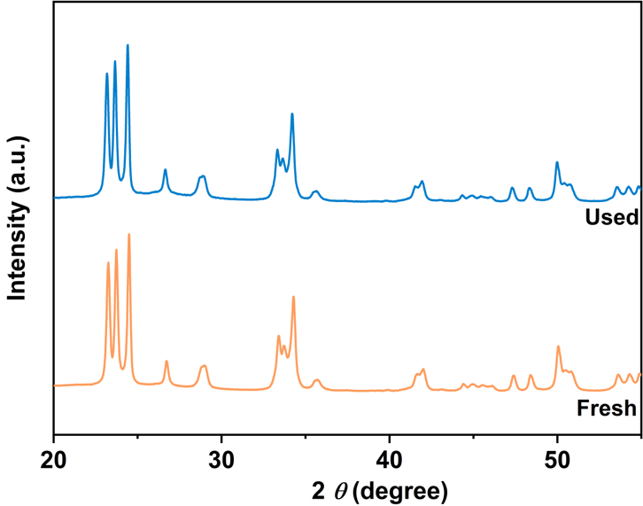
Figure S8. XRD patterns of fresh and used WO₃/BN-1:1 catalyst after cyclic photocatalysis.

9. XPS spectra of fresh and used WO₃/BN-1:1
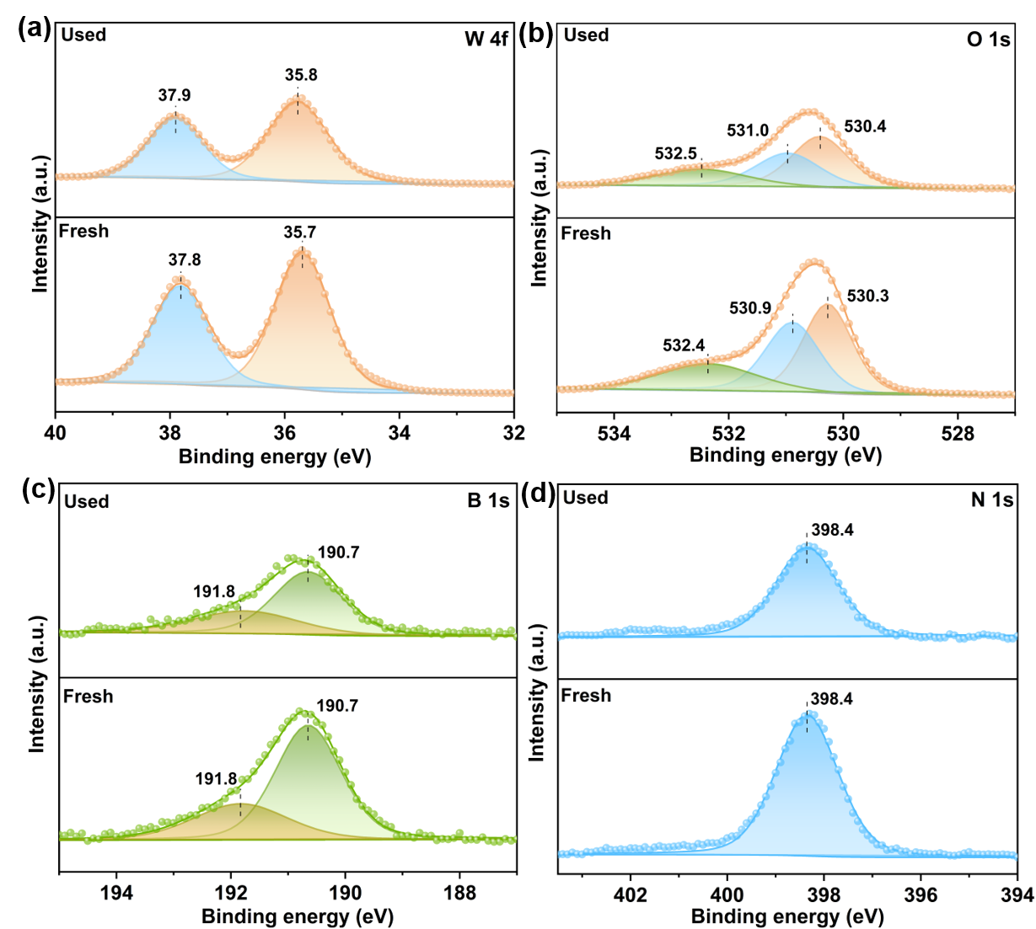
Figure S9. XPS spectra of fresh and used WO₃/BN-1:1 catalyst after cyclic photocatalysis.

10. Photocatalytic CH₄ oxidation under different reaction conditions
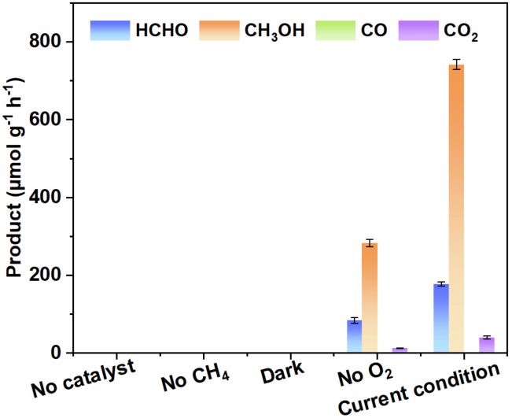
Figure S10. Photocatalytic CH₄ oxidation under different reaction conditions of WO₃/BN-1:1 catalyst.

11. Band structure
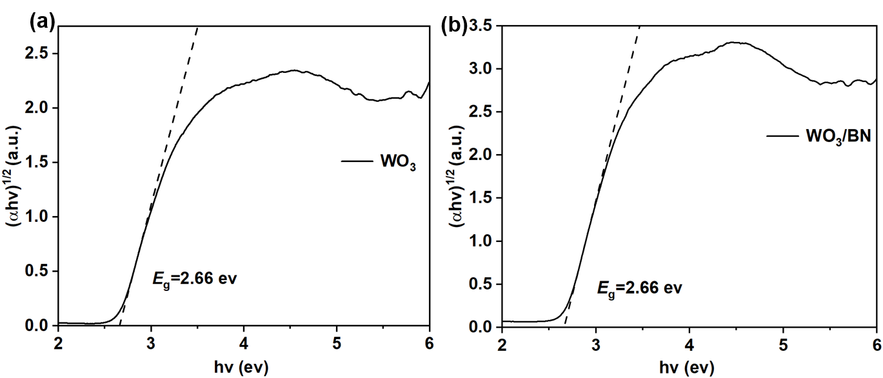
Figure S11. Tauc plots of (a) WO₃ and (b)WO₃/BN-1:1 derived from UV-vis DRS spectra.

12. PL spectra of WO₃ and WO₃/BN-1:1
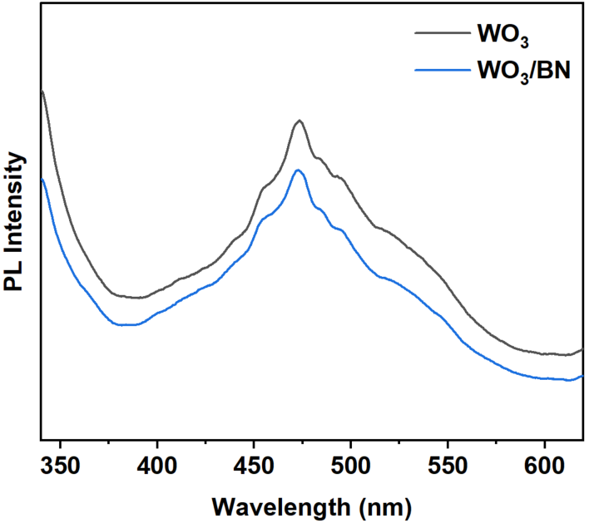
Figure S12. PL spectra of WO₃ and WO₃/BN-1:1

13. Valence-band structure and band alignment of BN and WO₃
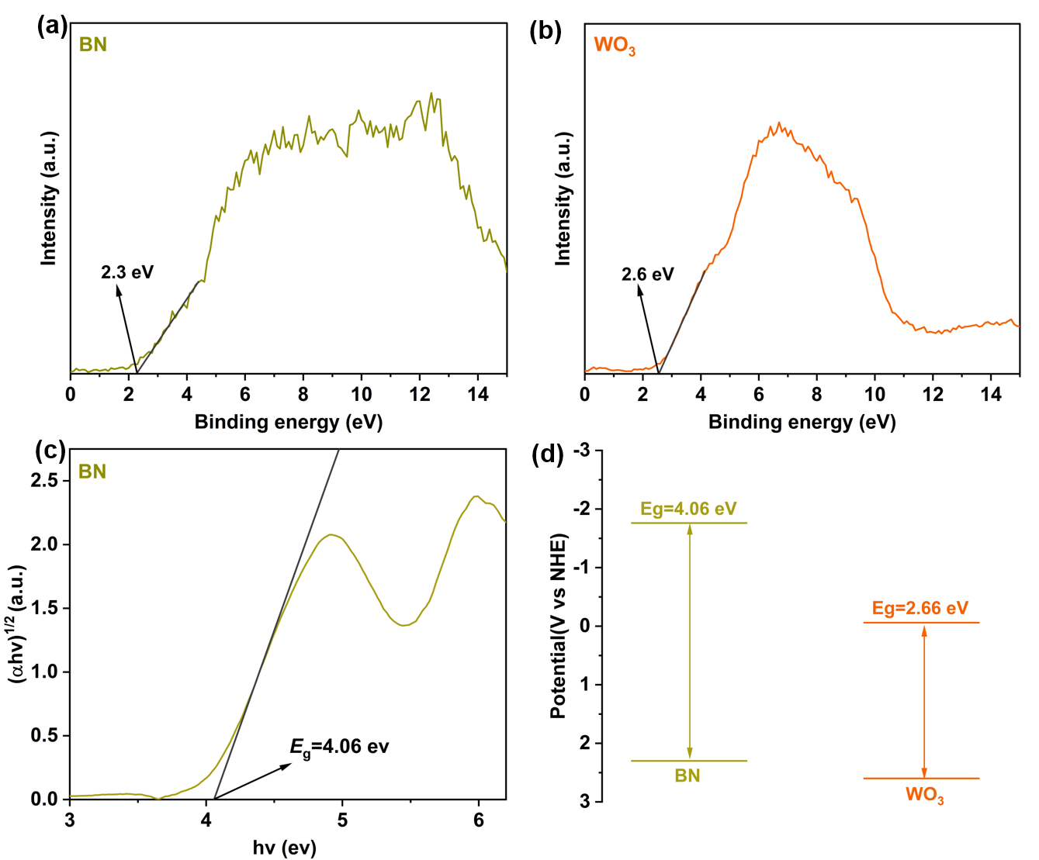
Figure S13. Band-structure analysis of BN and WO₃. Valence-band XPS spectra of (a) BN and (b) WO₃; (c) Tauc plot of BN; (d) schematic band alignment of BN and WO₃.

14. EPR signal intensities and radical trapping experiments
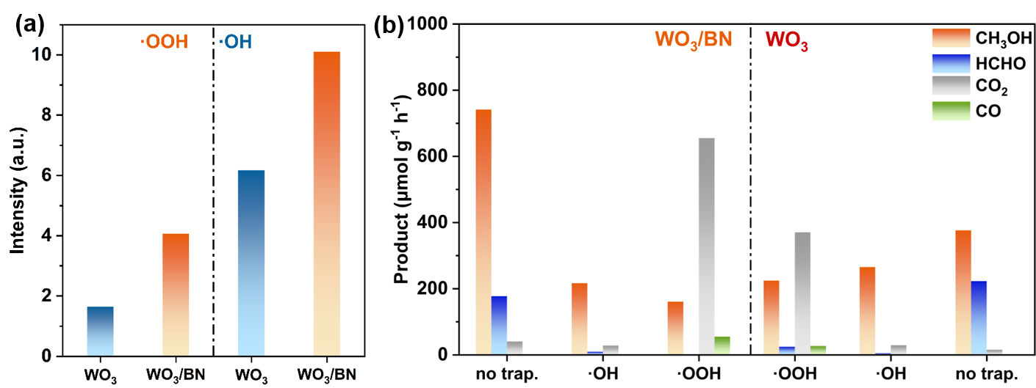
Figure S14. (a) Relative DMPO-OOH and DMPO-OH EPR signal intensities over WO₃ and WO₃/BN-1:1; (b) radical trapping experiments for photocatalytic methane oxidation over WO₃/BN-1:1 and WO₃

15. In situ DRIFTS spectra of WO₃
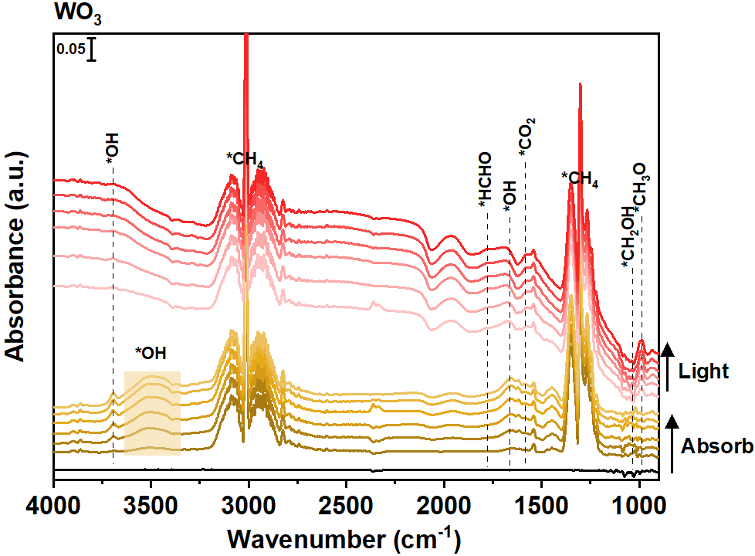
Figure S15. In situ DRIFTS spectra of WO₃

16. In situ DRIFTS spectra of WO₃/BN-1:1
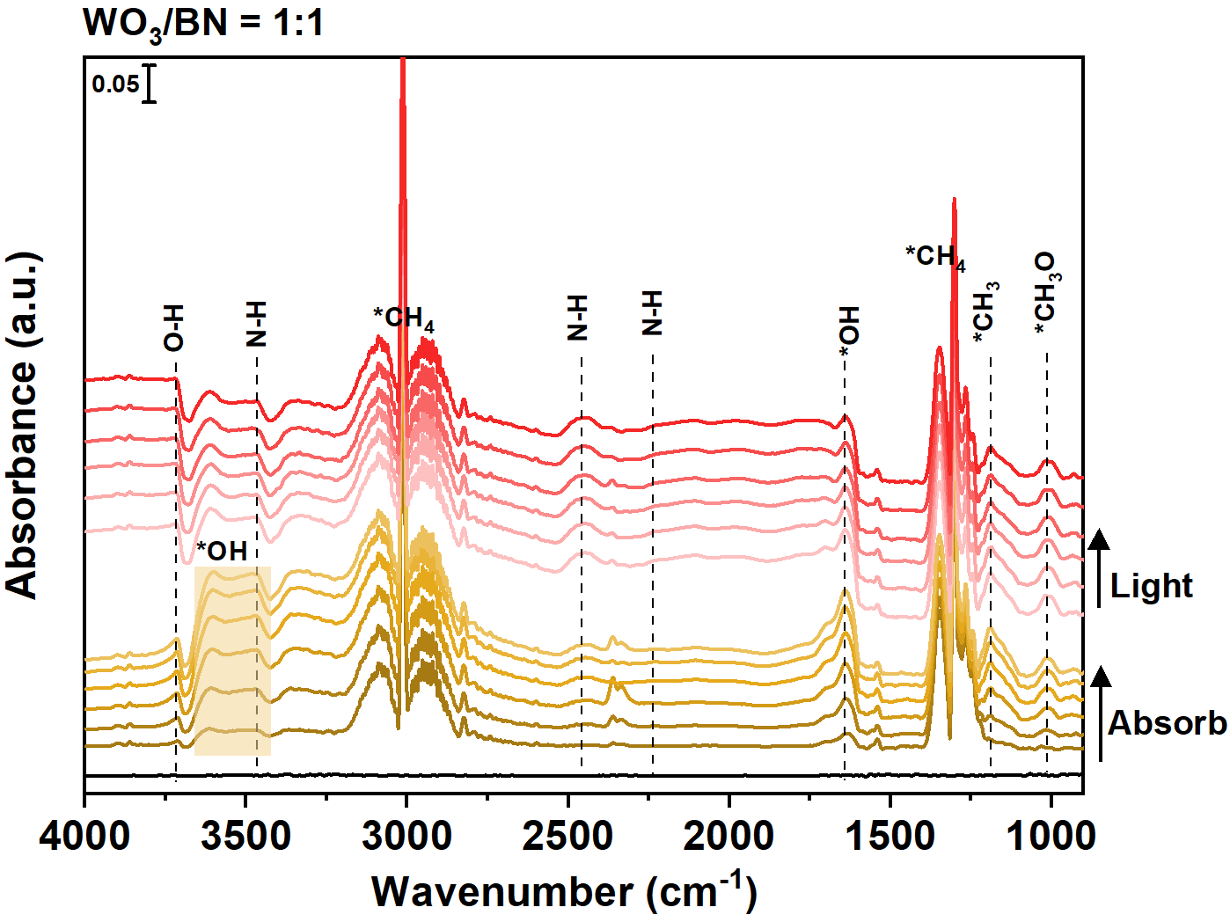
Figure S16. In situ DRIFTS spectra of WO₃/BN-1:1

17. In situ DRIFTS spectra of BN
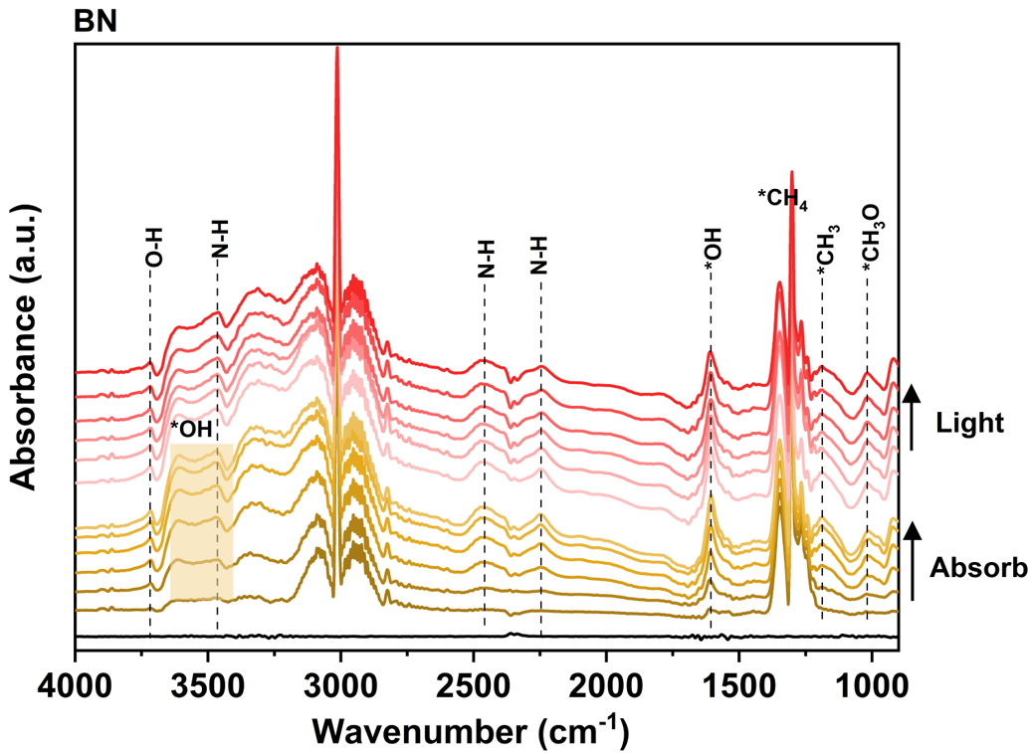
Figure S17. In situ DRIFTS spectra of BN

Supporting Tables

1. Performance of CH₄ photooxidation
Table S1. Performance of CH₄ photooxidation on WO₃ and WO₃/BN catalysts; Reaction conditions: 20 mL water, 5 mL CH₄, atmospheric pressure, 60 °C, 300 W Xe lamp (600 mW cm⁻²).
Samples | CH₃OH  (μmol g⁻¹ h⁻¹) | HCHO  (μmol g⁻¹ h⁻¹) | CO  (μmol g⁻¹ h⁻¹) | CO₂  (μmol g⁻¹ h⁻¹) | CH₃OH selectivity in total products  (%) | CH₃OH proportion in liquid products (%)
BN | 202.5 | 104.2 | 0.5 | 10.7 | 63.7 | 66.0
WO₃/BN-1:2 | 594.0 | 134.3 | 2.3 | 26.2 | 78.5 | 81.6
WO₃/BN-1:1 | 741.6 | 177.3 | 1.6 | 40.3 | 77.2 | 80.7
WO₃/BN-2:1 | 418.2 | 349.1 | 2.9 | 33.6 | 52.0 | 54.5
WO₃ | 376.5 | 222.8 | 1.1 | 15.5 | 61.1 | 62.8
CH₃OH proportion in liquid products was calculated as CH₃OH/ (CH₃OH + HCHO) × 100%

2. Control experiments
Table S2. Control experiments under different reaction conditions of WO₃/BN-1:1 catalyst.
Reaction condition | CH₃OH  (μmol g⁻¹ h⁻¹) | HCHO  (μmol g⁻¹ h⁻¹) | CO₂  (μmol g⁻¹ h⁻¹) | CO  (μmol g⁻¹ h⁻¹)
Without catalyst | 0.0 | 0.0 | 0.0 | 0.0
Without CH₄ | 0.0 | 0.0 | 0.0 | 0.0
Dark | 0.0 | 0.0 | 0.0 | 0.0
Without O₂ | 282.7 | 83.9 | 12.4 | 0.5

3. Comparison of productivity of photocatalytic CH₄ conversion to CH₃OH
Table S3. Comparison of productivity of photocatalytic CH₄ conversion to CH₃OH.
Catalysts | Extra oxidants | P  (bar) | Catalyst  (mg) | CH₃OH  (μmol g⁻¹ h⁻¹) | Reference
WO₃ | H₂O₂ | 20 | 20 | 253.0 | [1]
Au_{Ps}/WO₃ | H₂O₂ | 20 | 20 | 367.0 | [1]
Au₁/WO₃ | H₂O₂ | 20 | 20 | 589.0 | [1]
0.15 wt% Pd₁/2DT | H₂O₂ | 20 | 20 | 43.8 | [2]
0.33 _{metal} wt%FeO_{x}/TiO₂ | H₂O₂ | 1 | 10 | 352.0 | [3]
Au₁/BP | O₂ | 33 | 200 | 56.8 | [4]
Au_{0.25}/WO₃ | O₂ | 30 | 10 | 124 | [5]
Pt_{0.25}/WO₃ | O₂ | 30 | 10 | 602 | [5]
Pd_{0.25}/WO₃ | O₂ | 30 | 10 | 716 | [5]
0.1 wt% Pd/ZnO | O₂ | 21 | 10 | 3035.0 | [6]
0.1 wt% Au/ZnO | O₂ | 21 | 10 | 2060.0 | [6]
0.1 wt% Pt/ZnO | O₂ | 21 | 10 | 2225.0 | [6]
0.1 wt% Ag/ZnO | O₂ | 21 | 10 | 365.0 | [6]
TiO₂ | O₂ | 21 | 10 | 950.0 | [7]
2.1% Ag/TiO₂ | O₂ | 21 | 10 | 3280.0 | [7]
3.2% Ag/TiO₂ | O₂ | 21 | 10 | 4770.0 | [7]
ZnO | O₂ | 20 | 10 | 89.0 | [8]
Au_{0.3}/ZnO | O₂ | 20 | 10 | 998.0 | [8]
3.6-Co-SrTiO₃ | / | 10 | 50 | 172.0 | [9]
BN | O₂ | 1 | 20 | 76.9 | [10]
ZnO/BN-0.1:1 | O₂ | 1 | 20 | 684.5 | [11]
1 wt% Fe/BN | O₂ | 1 | 20 | 257.8 | [12]
Ga₂O₃/BN-1:1 | O₂ | 1 | 20 | 618.9 | [13]
BiOI/BN | O₂ | 1 | 20 | 238.0 | [14]
WO₃/BN-1:1 | O₂ | 1 | 20 | 741.6 | This work

4. Radical trapping experiments
Table S4. Radical trapping experiments over WO₃ and WO₃/BN-1:1.
Radical scavenger | Samples | CH₃OH  (μmol g⁻¹ h⁻¹) | HCHO  (μmol g⁻¹ h⁻¹) | CO  (μmol g⁻¹ h⁻¹) | CO₂  (μmol g⁻¹ h⁻¹) | CH₃OH selectivity  (%) | CH₃OH retention  (%)
Salicylic acid (·OH scavenger) | WO₃/BN-1:1 | 216.6 | 9.3 | 1.6 | 28.3 | 84.7 | 29.2
Salicylic acid (·OH scavenger) | WO₃ | 265.2 | 4.9 | 2.3 | 29.0 | 88.0 | 70.4
p-Benzoquinone (·OOH scavenger) | WO₃/BN-1:1 | 160.6 | 0 | 55.2 | 655.4 | 18.4 | 21.7
p-Benzoquinone (·OOH scavenger) | WO₃ | 224.4 | 24.5 | 27.0 | 370.5 | 34.7 | 59.6
No scavenger | WO₃/BN-1:1 | 741.6 | 177.3 | 1.6 | 40.3 | 77.2 | 100
No scavenger | WO₃ | 376.5 | 222.8 | 1.1 | 15.5 | 61.1 | 100
CH₃OH retention (%) = r_{CH3OH, with scavenger}/r_{CH3OH, without scavenger} × 100%

Supporting References
1. Zeng Y, Tang Z, Wu X, et al. Photocatalytic oxidation of methane to methanol by tungsten trioxide-supported atomic gold at room temperature. Applied Catalysis B: Environmental, 2022, 306: 120919.
2. Wu X, Zhang Q, Li W, et al. Atomic-scale Pd on 2D titania sheets for selective oxidation of methane to methanol. ACS Catalysis, 2021, 11(22): 14038-14046.
3. Xie J, Jin R, Li A, et al. Highly selective oxidation of methane to methanol at ambient conditions by titanium dioxide-supported iron species. Nature Catalysis, 2018, 1(11): 889-896.
4. Luo L, Luo J, Li H, et al. Water enables mild oxidation of methane to methanol on gold single-atom catalysts. Nature Communications, 2021, 12(1): 1218.
5. Jiang Y, Fan Y, Liu X, et al. Steering photooxidation of methane to formic acid over a priori screened supported catalysts. Journal of the American Chemical Society, 2024, 146(23): 16039-16051.
6. Song H, Meng X, Wang S, et al. Direct and selective photocatalytic oxidation of CH₄ to oxygenates with O₂ on cocatalysts/ZnO at room temperature in water. Journal of the American Chemical Society, 2019, 141(51): 20507-20515.
7. Feng N, Lin H, Song H, et al. Efficient and selective photocatalytic CH₄ conversion to CH₃OH with O₂ by controlling overoxidation on TiO₂. Nature Communications, 2021, 12(1): 4652.
8. Zhou W, Qiu X, Jiang Y, et al. Highly selective aerobic oxidation of methane to methanol over gold decorated zinc oxide via photocatalysis. Journal of Materials Chemistry A, 2020, 8(26): 13277-13284.
9. Zhang Z, Zhang J, Zhu Y, et al. Photo-splitting of water toward hydrogen production and active oxygen species for methane activation to methanol on Co-SrTiO₃. Chem Catalysis, 2022, 2(6): 1440-1449.
10. Cao Y H, Yu W, Han C Q, et al. Methane photooxidation with nearly 100% selectivity towards oxygenates: Proton rebound ensures the regeneration of methanol. Angewandte Chemie International Edition, 2023, 62(18): e202302196.
11. Yu W, Zhang X, Cao Y, et al. Ultrafast interfacial charge-delivery gating enables radical-suppressed photocatalytic methane-to-C₁ oxygenates. Applied Catalysis B: Environment and Energy, 2026, 394: 126819.
12. He Y, Yu W, Cao Y, et al. Fe-enhanced proton capture on boron nitride surfaces for improved photocatalytic methane conversion to C1 chemicals. Small Science, 2026, 6(5): e70302.
13. Yu W, Yang Y, Cao Y, et al. In situ H-bond-mediated intermediate stabilization on Ga₂O₃/BN for highly selective photocatalytic methane oxidation to methanol. Applied Catalysis B: Environment and Energy, 2026, 385: 126333.
14. Cao Y H, Yu W, Li Y, et al. Engineering ultrafast photo-induced charge and carbon intermediates transfer at interface to break the activity-selectivity trade-off in direct conversion of methane to methanol. Advanced Energy Materials, 2025, 15(6): 2404871.

